Invitation to the :
3GPP-T3 AH #82 23.048 Testing
OCTOBER 07 (at 9:30) – 08 (by 17:00), 2002
and
3GPP-T3 AH#83 Java API testing
OCTOBER 09 (at 9:30) – 11 (by 17:00), 2002
La Ciotat (France)

Dear Colleagues,

It’s a great pleasure for Gemplus to invite you to the above meetings.
They will be held at the "La Vigie" Gemplus building, in La Ciotat.

Meeting directions and general information are provided in the following pages.

Please take a few minutes and register for the meeting(s). This can be done on-line at the website mentioned on page 4 of this invitation.

Please direct any questions regarding the logistical arrangements of this meeting to the meeting coordinators:

For hotels arrangements :
- Véronique HEGEDUS, tel. +33 4 4236 4239, veronique.hegedus@gemplus.com

For the 3GPP-T3 AH#82 23.048 Testing and 3GPP-T3 AH#83 Java API testing meetings :
- François Lebreton, tel. +33 4 4236 3066, francois.lebreton@gemplus.com

We are looking forward to seeing you in La Ciotat.

Best regards,

François Lebreton
Gemplus
General Meeting Information

Meetings:
3GPP-T3 AH #82 23.048 Testing & 3GPP-T3 AH#83 Java API testing

Dates:
AH#82: October 07th – 08th 2002
AH#83: October 09th – 11th 2002

Location:
GEMPLUS La Vigie
Avenue du Jujubier
ZI Athélia IV
13705 LA CIOTAT Cédex
France

Note: Gemplus building is quit far from the hotels or the downtown, therefore it's better for you to come by car (taxi or a rented one).

Host:
Gemplus

Access:

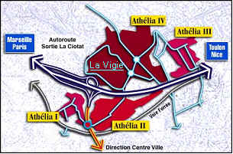

Driving directions:
See on page 6 to get to the "La CIOTAT" highway exit, and then follow the next map.
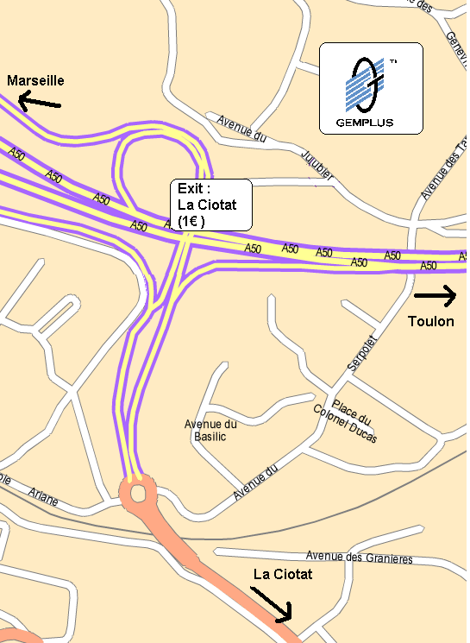
Meeting Registration:

Your completed registration is very important to the accurate planning of the meetings. Please take a few minutes and fill out the on-line registration form as follows:

For 3GPPT3- AH#82 23.048 TESTING (07th – 08th):
http://webapp.etsi.org/3GPPRegistration/fMain.asp?mid=22921

For 3GPPT3-AH#83 JAVI API TESTING (09th – 11th):
http://webapp.etsi.org/3GPPRegistration/fMain.asp?mid=22922

****DOCUMENTS AND INFORMATION SOURCES****

If you wish to submit an input document to the meeting, please obtain a document number by following the instructions at:
http://www.3gpp.org/ftp/TSG_T/WG3_USIM/www/DocNumberAllocation.htm

Server location for documents :
AH#82 ftp://ftp.3gpp.org/TSG_T/WG3_USIM/adhocs/82-0210-LaCiotat/
AH#83 ftp://ftp.3gpp.org/TSG_T/WG3_USIM/adhocs/83-0210-LaCiotat/

Email lists:

Any further information about this meeting will be distributed via the email list 3GPP_TSG_T_WG3_TEST. You can subscribe to these email lists (or view the archives) by going to:

http://list.3gpp.org/3gpp_tsg_t_wg3_test.html

Note that like recent meetings, only electronic copies of the documents will be made available before and during the meeting. i.e. it is necessary to bring a portable PC, with a 3.5" floppy disk drive and preferably a LAN card..

****DEADLINES****

Meeting registration: AH#82 Monday 30th September, 2002

AH#83 Monday 02nd October, 2002
Submission of documents to email list: Thursday 03rd October, 12:00 noon CET.
Documents not submitted by this time may receive a lower priority in the agenda

Hotel booking: Monday 30th September, 2002

Location Information:

Airports:
Marseille-Provence Airport (MRS) –60 km-
http://www.marseille.aeroport.fr/English/index.html

Alternatively :

Toulon-Hyeres Airport (TLN) – 55 km -
Nice-Cote d’Azur Airport (NCE) – 170 km -

Taxi:
A one-way trip from Marseille Airport or Toulon-Hyeres Airport to La Ciotat will cost you approximately € 60 (day tarif). Taxis don’t accept credit cards.

Rental Car:
At the Marseille airport, you’ll find the following companies:
Hertz, Avis, ADA, Europcar, Budget, Sixt, National/Citer.

Hotel:
"CIOTEL LE CAP " Hotel
Corniche du Liouquet
13600 LA CIOTAT (France)
Tel : +33 4 42 83 90 30
Fax : +33 4 42 83 04 17
http://www.leciotel.com/anglais/demarrage.htm
Room Rate:
Deadline for room reservation : 30th of September.
Room : € 68
Breakfast : € 10
Reservations: (see booking form on the last page)
Please call the hotel directly at +33 4 42 83 90 30, or send a fax to: +33 4 42 83 04 17.
You must mention GEMPLUS 3GPP Meeting.

King Hotel Restaurant
av St Jean 13600 LA CIOTAT
Tel: +33 4 42 83 14 57
Fax : +33 4 42 08 53 22
http://www.le-king.com/home.htm

Le Miramar Hotel
3 av Beaurivage 13600 LA CIOTAT
Tél/Fax : .+33 4 42 83 33 79

Local Information:
Visit :
http://www.mairie-laciotat.fr/
http://www.provenceweb.com/e/bouches/laciotat/laciotat.htm

Weather:
The weather in La Ciotat at the time of the meetings should be sunny, and the temperature approximately 25 degrees C. For weather forecasts visit :
http://weather.yahoo.com/forecast/Marseille_FR_c.html
DRIVING DIRECTIONS TO "LE CIOTEL" HOTEL

Location of the hotel : approximately 60 km from the airports. A one-way taxi ride would cost you around € 60, so the best solution is probably to rent a car.

FROM THE MARSEILLE-PROVENCE AIRPORT | FROM TOULON-HYERES AIRPORT
- Take the A55 freeway (Autoroute du Littoral), following the signs to Marseille/Vieux-Port  - Take the Prado-Carenage toll tunnel (€ 2.30, major credit cards accepted)  - Upon leaving the tunnel, follow the A50 freeway toward Toulon/Aubagne  - Keep following the signs to Toulon | - Take the A570 then the A57 freeways, following the signs to Toulon  - Arriving at Toulon, take the tunnel, following the signs to Marseille  - Upon leaving the tunnel, follow the A50 tollway toward Marseille(€ 1.50, major credit cards accepted)  - Keep following the signs to Marseille

- Exit at "La Ciotat" (toll is € 1, major credit cards accepted)
- At the roundabout after the toll both, follow the signs toward "La Ciotat – centre ville"
- At the next roundabout, take left toward "Bandol-St Cyr"
- 2 km after the exit of the town, turn right toward "Le Liouquet"
- The hotel is just on the right.

HOTEL CIOTEL LE CAP – LA CIOTAT

RESERVATION FORM

Corniche du Liouquet
13600 LA CIOTAT (France)

Tel : +33 4 42 83 90 30
Fax : +33 4 42 83 04 17

For the ad-hoc meetings, 07-11 October 2002

Please complete ALL sections in BLOCK CAPITALS and send it as soon as possible directly to the hotel.

The special Gemplus rate is € 78 (single room, breakfast included).

I will arrive on ________________ at ______________
I will depart on ________________ at ______________

Name: _________________________________________
Company: __________________________________________________
Address: __________________________________________________
__________________________________________________
__________________________________________________
Fax*: __________________________________________________
Tel*: __________________________________________________
(* = including country code)

