3GPP TSG-T2 #14  Edinburgh, Scotland  3-7 September 2001 | Unnumbered

Agenda Item:

Source: BT

Title: Getting to The George Intercontinental in Edinburgh

Document for: Information

___________________________________________________________________________

The airport at Edinburgh is quite small and friendly, and it should be easy to find your way through. I would recommend taking the bus to the hotel. The bus runs every 10 minutes (from 04:50-00:20 Mon-Sat and 0530-0000 Sun) and takes 25 minutes. It is unlikely that you will get there any quicker in a taxi, which costs around £15-£20.

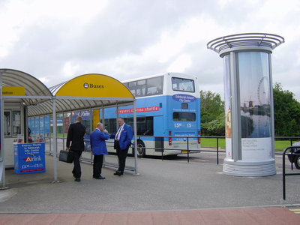

You need to get off at Princes Street, which is just past the large church on your right:

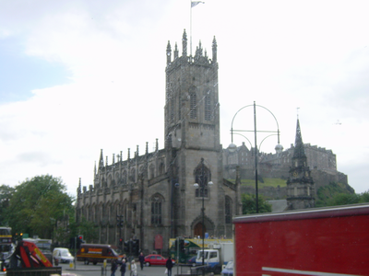

This is where you get off the bus:

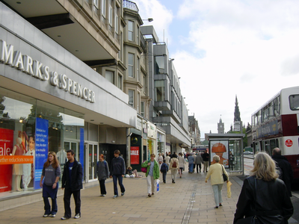

Then you proceed in the same direction as the bus to the corner of Hanover Street and then turn left up the hill. You will see this monument at the top of the hill:

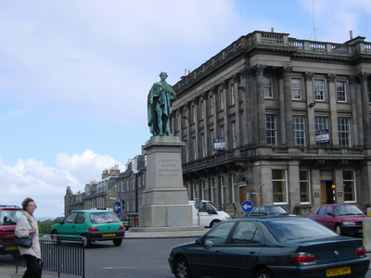
At this point you turn right and you will find the hotel on your left

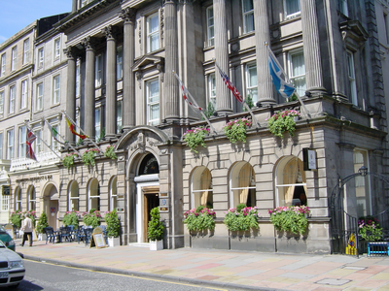

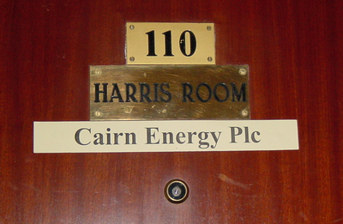
Once inside you can marvel at the names on the doors of the rooms

You can also take a trip up to the castle and see which mobile operators you can find:

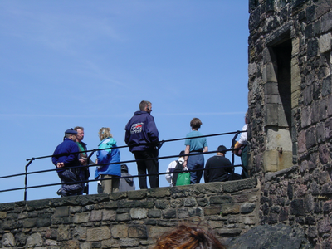

…and keep your fingers crossed for good weather…

… for the evenings this looks like a good place to look for restaurants:

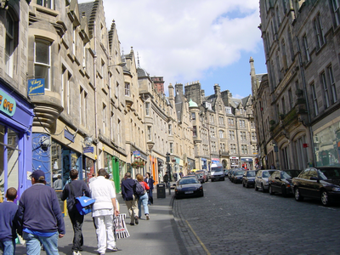
It's called Cockburn Street.

Finally, if you need help, please feel free to contact me.

Kevin Holley
Tel: +44 1473 605604
Mobile: +44 7802 220811

