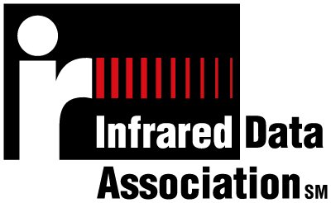

November 22, 1999

Third Generation Partnership Project (3GPP)
C/O Robert Lockhart
Motorola
3301 Quantum Blvd.,
Q10
Boynton Beach, FL 33426-8292

Dear 3GPP :

The Infrared Data Association (IrDA) welcomes the opportunity to work with the Third Generation Partnership Project (3GPP) and its TSG-T2-WG2_SWG2 Terminal Interface group on wireless data synchronization.

With respect to the two 3GPP requests that,

1. The IrDA permit 3GPP to use IrMC Sync and OBEX in a manner similar in nature to that granted to other similar consortiums.
2. The IrDA permit IrMC to set up a cross-SDO effort with SWG2 to address the wide area network issues with IrMC Sync and OBEX.

The IrDA has (1) drafted and supplied a Memorandum of Understanding (MoU) covering the use of the IrDA’s intellectual property in the manner requested and (2) already put in place the requested cross-SDO effort to address the noted wide area network issues with IrMC Sync and OBEX.

We would also like to take this opportunity to thank 3GPP for providing update presentations on SWG2’s progress to date to the IrMC working group, the ‘Meeting of the Whole’, and the IrDA’s Board of Directors during the IrDA’s most recent meeting during the week of 18th October in Burlingame, CA, in the USA. We would also be willing to provide such an update on the progress of the cross-SDO team to SWG2 and the TSG-T2 Plenary during the next 3GPP TSG-T2 meeting.

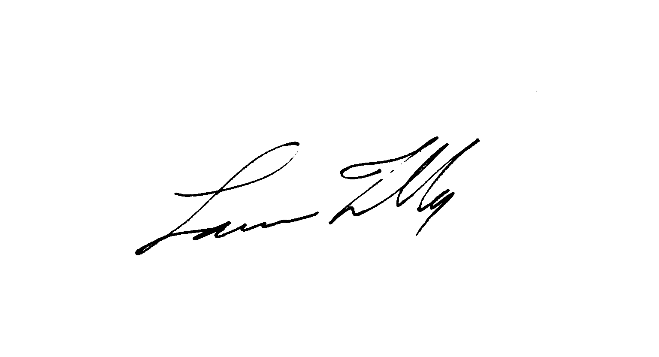The contact person in IrDA’s IrMC and OBEX groups is James Scales (james.scales@nokia.com).

Sincerely,

Lawrence Faulkner
Executive Director, IrDA

