Memorandum of Understanding
between
Infrared Data Association (IrDA) and the Third Generation Partnership Project (3GPP)

The IrDA is working to establish and promote infrared standards that provide convenient cordless connectivity and fosters application interoperability across a broad range of consumer, computing and communication platforms and devices.

The Third Generation Partnership Project (3GPP) is working for the production of a complete set of globally applicable Technical Specifications for a 3rd Generation Mobile System based on the evolved GSM core networks and the radio access technologies supported by 3GPP partners that, in part, support the IrDA infrared technology specifications.

In recognition of synergies between the organizations, IrDA and 3GPP agree to the following objectives:

- That IrDA and 3GPP agree to exchange information on common technologies and their uses.
- That 3GPP agrees to follow the IrDA policies and provisions for intellectual property protection, licensing and usage with respect to incorporated IrDA technologies.
- That IrDA authorizes 3GPP to reproduce free of charge the IrDA specifications required for incorporation into 3GPP specifications. However, that reproduction rights granted by IrDA to 3GPP do not include ownership rights of the incorporated IrDA specifications.
- That updates to any 3GPP published material that incorporate IrDA specifications occur based on the timing and release of updates by IrDA to the IrDA specifications incorporated by 3GPP.
- That 3GPP will reference IrDA as the owner of the IrDA specifications incorporated by 3GPP and that compliance to the specifications is solely determined by IrDA or its authorized agents based on its current published specifications. IrDA grants 3GPP the ability to determine and manage compliance to the referenced specifications in 3GPP implementations.

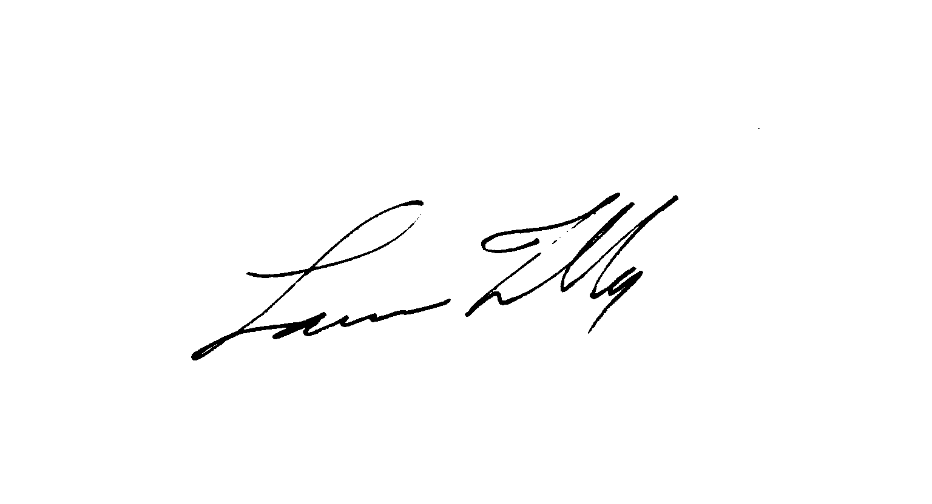
Infrared Data Association (IrDA): 3GPP:

Date:__11/22/99___________________ Date:____________________________

Signature: _______________________ Signature: _______________________

Print Name: _Lawrence Faulkner______ Print Name: ______________________
Executive Director

