3GPP TSG-SA5 Meeting #143e S5-223446

Electronic meeting, online, 09 - 17 May 2022

Source: Huawei

Title: pCR TR 28.863 Key Issue # 3: Solution of evaluation of KQI for Video Uploading

Document for: Approval
Agenda Item: 6.5.20

1 Decision/action requested
This contribution is proposed to be approved.

2 References
[1] 3GPP TS 28.863v0.1.0: "Study on Key Quality Indicators (KQIs) for 5G service experience"
[2] ITU-T P.1201 “Models and tools for quality assessment of streamed media”

3 Rationale
The document gives the description of evaluation of KQI for Video Uploading.

4 Detailed proposal
It is proposed to apply the following changes as below in TR 28.863 [1].
Start of the first change

4.3.2 Potential solutions

4.3.2.c Potential solution #X: Evaluation of KQI for Video Uploading

4.3.2.c.1 Introduction
This clause describes the evaluation of KQI for Video Uploading.

4.3.2.c.2 Description
The evaluation of KQI for Video Uploading is described as E-Score:
In the fomular the MQI (media quality indicators) is evaluated as follows:
In which QA (Audio quality) is calculated as follows:
is the predicted audio quality. is the quality impairment caused by audio compression. is the impact of different audio encoding formats . The score of the PCM (Pulse-Code Modulation) encoding format is 100, and other audio encoding formats (AAC-LC, HE-AACv2, MPEG1-LII, AC3) all have quality impairment.
Table: Audio model coefficients for different audio codecs (coding degradations only), from Table 1 of ITU-T P.1201.2
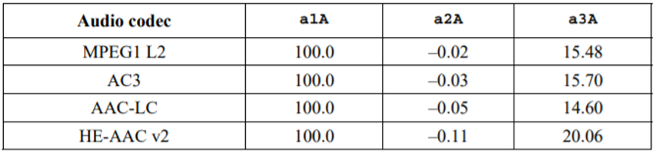
QV (Video quality) is calculated as follows:
is the predicted video quality，is the quality impairment caused by video compression.
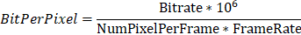
ResC = ContentComplexity. ResC and Res are related to the video resolution. For example, ResC and Res corresponding 1080p are related to a video encoding/decoding format. A quantity of quantized pixels in each frame varies according to encoding.

For the evaluation of presentation quality, there are two models as two options to evaluate:
Mode0
Of which:
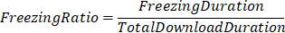
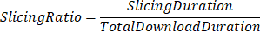
In the fomular the Freezing Duration could be replaced by Stall Duration.
[Mode1]
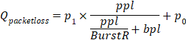
In the formula, indicates the KQI of burst packet loss on services compared with random packet loss. For live video, the value is fixed.

The evaluation of Interaction quality is described as follows:
The Qup refer to the user-plane response model
The Qsp refer to the control-plane response model
In the formula, can be obtained in different methods. Some applications may directly obtain the value from a control-plane interaction message, and others may obtain the value from a protocol. For a play action in the RTSP protocol, , and for a pause action, .
Note: All of the variables, if not specially defined, are from the abbreviations of the KQIs of Video Uploading.
End of the first change

