3GPP TSG-SA5 Meeting #143e S5-223443

Electronic meeting, online, 09 - 17 May 2022

Source: Huawei

Title: pCR TR 28.863 Key Issue # 3: Solution of Key influencing factors for service experience of Video Uploading

Document for: Approval
Agenda Item: 6.5.20

1 Decision/action requested
This contribution is proposed to be approved.

2 References
[1] 3GPP TS 28.863v0.1.0: "Study on Key Quality Indicators (KQIs) for 5G service experience"

3 Rationale
The document gives the key influence factors for the service experience of video uploading. The key influence factors are the most important factors which will influence the service experience for a specific service.

4 Detailed proposal
It is proposed to apply the following changes as below in TR 28.863 [1].

Start of the first change

4.3 Key Issue # 3: KQIs for Video Uploading

4.3.1 Description

This clause provides the description of KQIs for Video Uploading. The proposed detailed aspects as separate solutions are as follows:
Key influencing factors for service experience of Video Uploading;
KQIs for Video Uploading;
The evaluation of related KQI for Video Uploading
The related KPIs which will influence the KQIs.

4.3.2 Potential solutions

4.3.2.a Potential solution #1: Key influencing factors for service experience of Video Uploading

4.3.2.a.1 Introduction
This clause describes the potential solutions of key indluencing factors for service experience of Video Uploading.

4.3.2.a.2 Description
The key influencing factors for the service experience of Video Uploading are provided as follows

4.3.2.a.2.1 Bitrate
Bitrate is the number of audio or video bits transmitted or processed per unit of time. Bitrate is a more general measure of audio and video quality. High resolution, high frame rate, and low compression rate usually result in increased bit rate in the same encoding environment.

4.3.2.a.2.2 Frame Rate
The Frame Rate refers to the frequency at which images in the unit of frames are continuously displayed on the display. The frame rate of the video content must be compatible with the frame rate attribute of the display device. Live TV services have higher requirements on frame rate stability. Due to real-time requirements, frame rate fluctuation may deteriorate the quality of video uploding.

4.3.2.a.2.3 Resolution
The Resolution refers to the number of pixels contained in the video content. The resolution of the video content must be compatible with the resolution of the display device. Otherwise, the video resolution may decrease or even fail to be displayed. For the live TV uploading service, the resolution is fixed and closely related to the capability of the terminal device (for example, a camera).

4.3.2.a.2.4 Packet Loss
Packet Loss greatly degrades the quality of multimedia content because in the event of a packet loss containing an I-frame, all subsequent frames of the same group of pictures depending on that I-frame will be lost, which may cause pixelation, frame blocking, and video output stall; Audio streams have the same problem. During packet loss measurement, packet loss is classified into average packet loss ratio measurement and burst packet loss ratio measurement. Burst packet loss has greater impact and needs to be considered separately.

4.3.2.a.2.5 Packet Delay
There is a propagation delay as packets travel from source to destination. If this delay reaches a high value, picture blocking and image corruption may occur.

4.3.2.a.2.6 Jitter
The propagation delay is not constant over time, the delay varies throughout the signal propagation. The measure of this variability is jitter. Real-time streaming services require stable IP streams. Jitter may cause buffer overflows and underloads, resulting in pixelation and frame freezing of the viewed content.

4.3.2.a.2.7 Throughput
The throughput is a key indicator to ensure the quality of video uploading, which includes average throughput and peak throughput. The average throughput is insufficient. The peak throughput is the maximum throughput that can be reached instantaneously. This throughput reflects the transmission capability of a pipe to some extent. For video uploading scenarios, the key factor is the uplink throughput.

4.3.2.a.2.9 The throughput swing index
The throughput swing index is defined as the ratio of the throughput exceeding the upper or lower bound and represents the volatility of the throughput. In the video uploading service, the file size varies according to enterprise requirements. When a large file is transmitted and the transmission delay is long, the second-level throughput must be relatively stable. In this case, the throughput fluctuation affects the waiting duration and video frame transmission duration, affecting user experience. The average throughput cannot totally reflect the user experience of video uploading scenario. Burst congestion or deterioration may lead to poor user experience.

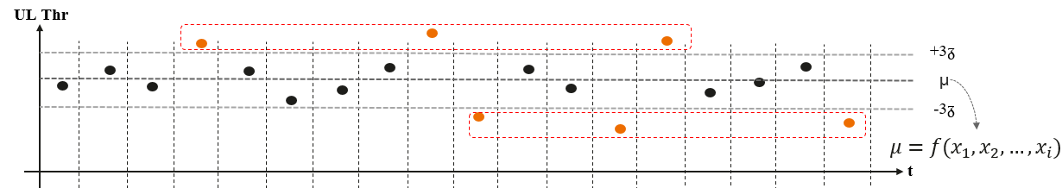

In the figure, μ is the average throughput and +3δ and -3δ is the fluctuation range. Use the "swing index" method to reflect the ratio of the index volatility to the range where the upward movement exceeds μ+3σ, which is the upswing index. The proportion of the downward movement beyond the range of μ-3σ is the downswing index; The downswing index is the most significant signal of quality deterioration. For uplink real-time uploading services, a lower wobble index indicates more stable transmission performance and better user experience. From the perspective of real-time measurement, the values of μ and 3δ are calculated as the mean and variance of the current time, and therefore change dynamically.
Use the "swing index" method to reflect the ratio of the index volatility to the range where the upward movement exceeds upswing bound. The proportion of the downward movement beyond the bound of the downswing index; the downswing index is the most significant signal of quality deterioration. For uplink real-time uploading services, a lower wobble index indicates more stable transmission performance and better user experience.

4.3.2.a.2.10 Mobility interruption time
Mobility interruption time is used to measure the service interruption delay when the terminal is moving. Fixed terminals do not have this counter.

4.3.2.a.2.11 Interaction Delay
Interaction Delay indicates the delay when a user performs a camera change or performs a video playback or pause. This delay affects user experience on real-time operation.

End of the first change

