**3GPP TSG-SA5 Meeting #138-e *S5-214175***

**e-meeting, 23 - 31 August 2021**

**Source: Huawei**

**Title: Conclusion and enhanced solution for Key Issue #7**

**Document for: Approval**

**Agenda Item: 6.5.1**

# 1 Decision/action requested

***The group is asked to discuss and approval the proposal.***

# 2 References

[1] 3GPP TR 28.813: Study on new aspects of Energy Efficiency (EE) for 5G v1.0.0

# 3 Rationale

By introducing AI (Artificial Intelligence) technology, 3GPP management system can provide centralized ES for RAN domain area with following improvements while keeping KPIs (e.g. RRC connections setup success rate, E-RAB setup success rate, Handover success rate, UE throughput) stable:

- ES in more areas: more areas in which there are multi-RAT co-coverage can be found, more cells can be decided as candidate ES cells.

- ES in more accurate time periods: based on historical traffic data and predicted traffic data, more accurate time periods for cell energy saving can be decided.

- ES with longer time: based on historical traffic data and predicted traffic data, longer time periods for cell energy saving can be decided.

It is proposed to enhance the potential solution for centralized energy saving for RAN domain area and add the conclusion.

# 4 Detailed proposal

This document proposes the following changes in TR 28.813 [1].

|  |
| --- |
| **1st Change** |

4.7.2 Potential solutions

4.7.2.1 Potential solution #1: Centralized energy saving for RAN domain area

4.7.2.1.1 Introduction

In this potential solution, 3GPP management system provides centralized ES for RAN domain area.

4.7.2.1.2 Description

Figure 4.7.2.1.2-1 describes the 3GPP management system provides centralized ES for RAN domain area:

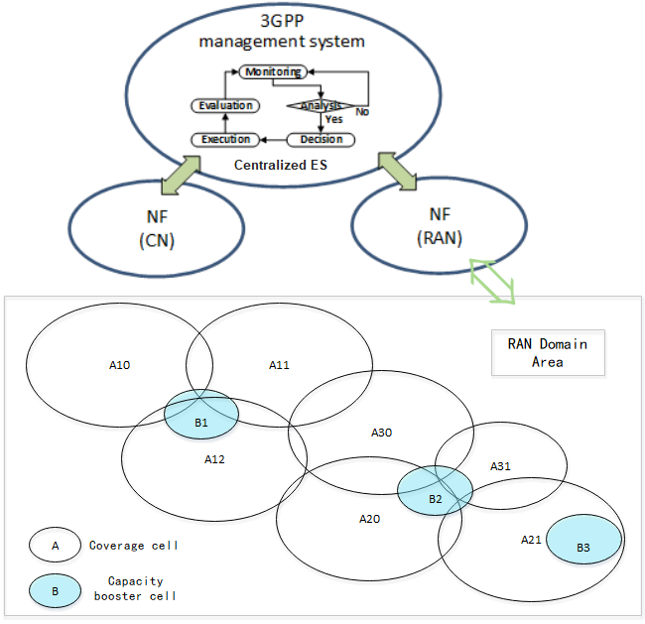

**Figure 4.7.2.1.2-1: 3GPP management system provides centralized ES for RAN domain area**

In this figure:

- RAN Network Function (NF) corresponds to RAN domain area in which there are multiple capacity booster cells and coverage cells which provide basic coverage for the whole area.

- To provide centralized ES for RAN domain area, 3GPP management system performs the following functionalities:

- **Monitoring**: 3GPP management system, for ES purpose, collects the information of the capacity booster cells and coverage cells inside the RAN domain area, which may include current load information, historical load information which was logged, cell priority information, or traffic service type information of the capacity booster cells and coverage cells. Other than traditional ES solutions which consider the capacity booster cells and their first-level (direct) neighboring cells as candidate cells for ES, to provide centralized ES for RAN domain area, 3GPP management system considers capacity booster cells with their multiple-level neighboring cells as candidate cells for ES. The first-level neighboring cell is the direct neighboring cell of source cell, the second-level neighboring cell is the direct neighboring cell of the first-level neighboring cell of source cell, etc.

- **Analysis and Decision**: For capacity booster cells and coverage cells in the area, based on the monitoring information of current load information, historical load information, cell priority information, or traffic service type information of those cells, 3GPP management system makes the analysis and decision for ES based on the full view of the corresponding cells in the area.

- For example, neighboring cells of capacity booster cell B3 are cell B2, A12, A20, A21, A30 and A31. A21 is first-level neighbor of B3. A20, A31 and B2 are first-level neighbours of A21 and are therefore second-level neighbours of B3. A30 and A12 are third-level neighbours of B3. Based on the historical load information, cell priorities, or traffic service types of those neighboring cells B2, A12, A20, A21, A30 and A31, 3GPP management system may determine the ES candidate cells of B3 are cells B2, A20, A21 and A31. At moment T1, the capacity booster cell B3 is in low load state and may be qualified for 3GPP management system to determine to enter into energy saving state. However, according to analysis of the historical load information of the candidate capacity booster cell B2, 3GPP management system concludes that cell B2 will also be in a low load state shortly after T1. In this case, 3GPP management system determines whether or not to allow energy saving for cell B2 and cell B3 based on the analysis of historical load information, current load status, priority or traffic service type of corresponding candidate cells A20, A21 and A31. As an example, in case the 3GPP management system estimates that, according to historical load information of cell A21, the load of cell A21 will soon increase high at moment T3 which is shorter after moment T2 which is between moment T1 and T3, the decision from the 3GPP management system regarding the allowing energy saving of cell B2 and B3 may vary including one of the following cases:

1. Only cell B2 is allowed to enter into the energy saving state and no energy saving of cell B3. In this case, cell B3, A20, or A31 provides network services for some UEs from the high load cell A21 at T3.
2. Only cell B3 is allowed to enter into energy saving state. In this case, cell B2, A20 or A31 provides network services for some UEs from the high load cell A21 at T3.
3. Both cell B2 and cell B3 enter into energy saving state. In this case, cell A20 or A31 provides network services for some UEs from the high load cell A21 at T3.
4. Both cell B2 and cell B3 do not enter into the energy saving state. In this case, cell B2 and cell B3 need to provide network services for some UEs from the high load cell A21 at T3.

- **Execution**: 3GPP management system decides the activation and/or deactivation on the related cells inside RAN domain area. For example, see figure 4.7.2.1.2-1, coordinated cell activation/deactivation decisions made from 3GPP management system for capacity cell B1, B2 and B3 avoids Ping-Pong ES activation/deactivation effect on the related cells (i.e. some capacity cells of B1, B2 and B3 and corresponding coverage cells) in the RAN domain area.

- **Evaluation**: 3GPP management system evaluates whether the ES actions have been optimized, and may apply further ES management actions.

By introducing AI (Artificial Intelligence) technology, 3GPP management system can provide centralized ES for RAN domain area with following improvements while keeping KPIs (e.g. RRC connections setup success rate, E-RAB setup success rate, Handover success rate, UE throughput) stable:

- ES in more areas: more areas can be found, in which more cells can be decided as candidate ES cells.

- ES in more accurate time periods: based on historical traffic data and predicted traffic data, more accurate time periods for cell energy saving can be decided.

- ES with longer time: based on historical traffic data and predicted traffic data, longer time periods for cell energy saving can be decided.

Figure 4.7.2.1.2-2, as an example, shows 3GPP management system providing additional ES periods with adaptive AI ES threshold setting comparing with manual ES threshold setting:

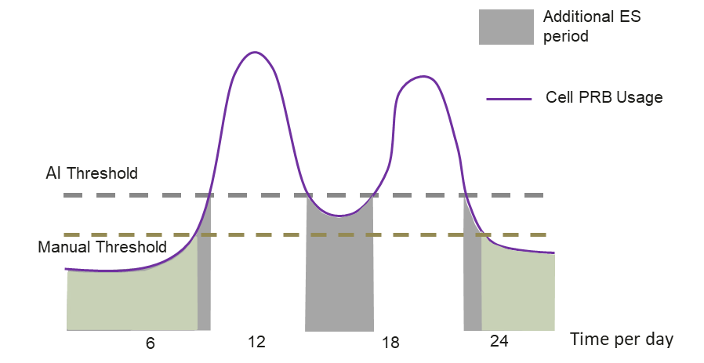

**Figure 4.7.2.1.2-2: Additional ES periods by adaptive ES threshold setting with AI**

In this figure:

With AI technology, 3GPP management system can set different ES thresholds for different cells in the ES targeting area adaptively. Using cell PRB usage as an example for traffic load threshold for ES, comparing with manual PRB usage threshold setting, additional ES time periods, as the result of more accurate PRB usage threshold setting from AI, can be identified to save more energy for the cells while keeping basic KPIs stable for SLA assurance.

4.7.3 Conclusion - Impact on normative work

4.7.3.1 Conclusion for potential solutions #1

To provide centralized ES for RAN domain area, 3GPP management system performs the functionalities as monitoring, analysis, decision, execution and evaluation. With AI technology, 3GPP management system can provide more efficient ES for RAN domain area while keeping basic KPIs stable for SLA assurance.

Consequently, it is proposed to introduce the potential solution #1 which with AI technology in further normative work for Rel-18.

|  |
| --- |
| **End of change** |