Source: SA4 Chair
Title: Proposed meeting agenda for new Rel-20 topics during SA4#134
Document for: your information
Agenda Item: 17

Informative SA4 workplan at the start of SA4#134
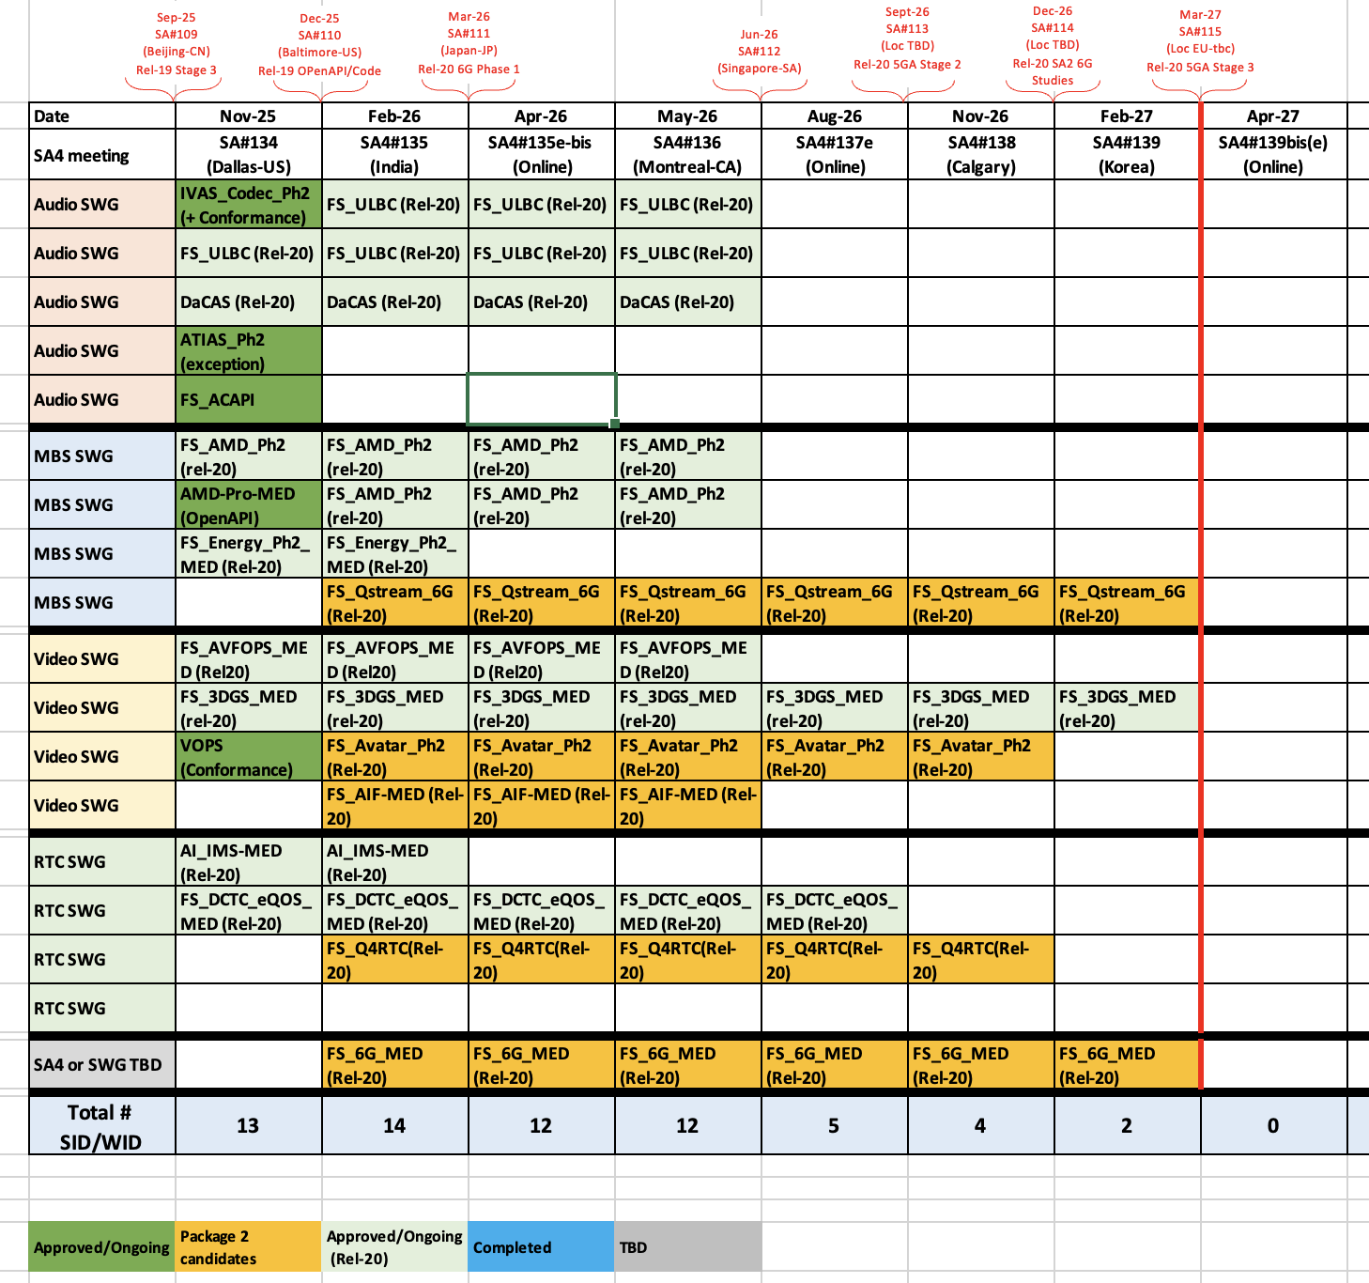

17. New Work / New Work Items and Study Items
17.1 New Work Items and Study Items for Rel-20 5G-Advanced
Existing Package 2 candidates
Tdoc | Title | Status
QUIC-related studies
S4-251633 | New SID on QUIC-based media delivery for real-time communication (FS_Q4RTC-MED)
S4-251651 | Draft Work Plan for FS_Q4RTC-MED
S4-251870 | Study on evaluation of QUIC-based protocols for on-demand and live video services (FS_QStream-MED)
S4-251871 | Draft Work Plan for FS_QStream-MED
Avatar_Ph2
S4-251634 | Study on Avatar communication Phase 2
Image formats
S4-251781 | Draft New study on image formats
S4-251782 | Draft Work Plan study on image formats
New Work item proposals
Tdoc | Title | Status
DC enhancements
S4-251734 | WID on IMS Data Channel Enhancements
S4-251892 | Proposed Timeplan for DC Enhancements WI
ATIAS_Ph3
S4-251662 | New WID on Terminal Audio quality performance and Test methods for Immersive Audio Services, Phase 3 (ATIAS_Ph3)
New Study Item proposals
Tdoc | Title | Status
FS_Beyond2D_Ph2
S4-251816 | Draft New SID on Beyond 2D Video Phase 2 | Revised to 1865
S4-251865 | Draft New SID on Beyond 2D Video Phase 2 | Revised to 1947
S4-251947 | Draft New SID on Beyond 2D Video Phase 2
S4-251880 | Draft Work Plan for Beyond 2D Video Phase 2
Ultra Low latency
S4-251861 | New SID on Ultra-Low Latency Video Communication Characterization and Evaluation
S4-251862 | Draft Work Plan on Ultra-Low Latency Video Communication Characterization and Evaluation
17.2 New Study Items for Rel-20 FS_6G
Tdoc | Title | Status
S4-251790 | New SID on Ultra-Low Latency Video Communication Characterization and Evaluation | withdrawn
FS_6G_MED
S4-251720 | New Study on Media Aspects for 6G System | Revised to 1937
S4-251937 | New Study on Media Aspects for 6G System | Rev1
S4-251721 | [Draft TR] Media Aspects for 6G System
S4-251722 | [Draft] Work Plan for Media Aspects for 6G System
S4-251763 | [6G Media] SA1 use case categories and potential SA4 Contribution to the 6G era
EVI
S4-251826 | Discussion on a 6G Use Case: Embodied Video Internet (EVI)
17.3 Other
Tdoc | Title | Status
S4-251977 | Draft Reply LS on IMS DC Automatic Resumption | missing

_____________________
Tdoc “color code”: black = submitted for the meeting by the Tdoc submission deadline
gray = submitted for the meeting after the Tdoc submission deadline
blue = postponed from an earlier SA4 meeting
red = covered during this meeting
Highlighted = missing document
Highlighted = email agreement ongoing
Highlighted = status defined from email agreement process
Highlighted = go to SA4 plenary
strikethrough = withdrawn
Conclusion codes: n: noted, r: revised, a: agreed, awp: agreed without presentation, w: withdrawn, pl: go to plenary, nt: not treated

Meeting schedule (Including Indicative tropics per session)

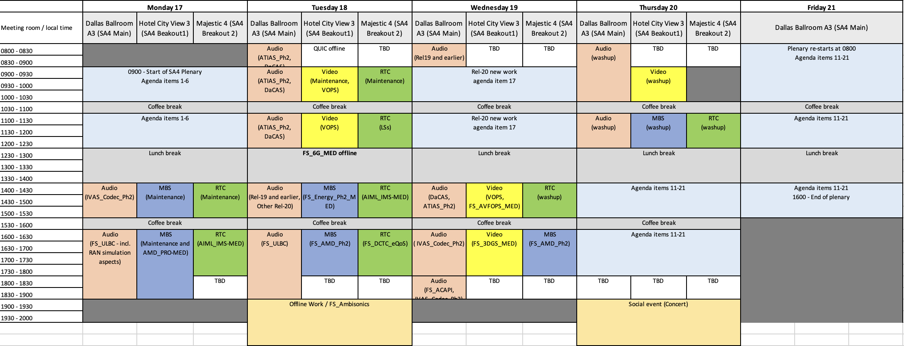
Annex A – Documents’ status
Tdoc number | Title | Source | SA4 Agenda Item | Replaced by | SA4 Status
S4-251633 | New SID on QUIC-based media delivery for real-time communication (FS_Q4RTC-MED) | Nokia, Interdigital, Lenovo, NTT, BBC, Fraunhofer HHI, Dolby Laboratories Inc | 17.1
S4-251634 | Study on Avatar communication Phase 2 | Vodafone Group Plc., Qualcomm Incorporated | 17.1
S4-251651 | Draft Work Plan for FS_Q4RTC-MED | Nokia | 17.1
S4-251662 | New WID on Terminal Audio quality performance and Test methods for Immersive Audio Services, Phase 3 (ATIAS_Ph3) | HEAD acoustics GmbH | 17.1
S4-251720 | New Study on Media Aspects for 6G System | Qualcomm Incorporated, Thales, Dolby Laboratories Inc., NTT, Orange, Ericsson LM | 17.2 | S4-251937 | revised
S4-251721 | [Draft TR] Media Aspects for 6G System | Qualcomm Germany | 17.2
S4-251722 | [Draft] Work Plan for Media Aspects for 6G System | Qualcomm Germany | 17.2
S4-251734 | WID on IMS Data Channel Enhancements | Qualcomm Sweden | 17.1
S4-251763 | [6G Media] SA1 use case categories and potential SA4 Contribution to the 6G era | HUAWEI TECH. GmbH | 17.2
S4-251781 | Draft New study on image formats | Apple Inc., Nokia, Dolby, Beijing Xiaomi mobile software | 17.1
S4-251782 | Draft Work Plan study on image formats | Apple Inc. | 17.1
S4-251790 | New SID on Ultra-Low Latency Video Communication Characterization and Evaluation | Pengcheng Laboratory, Huawei, OPPO, ZTE, China Telecom, Hisilicon | 17.2 |  | withdrawn
S4-251816 | Draft New SID on Beyond 2D Video Phase 2 | China Mobile (Hangzhou) Inf., InterDigital Communication | 17.1 | S4-251865 | revised
S4-251826 | Discussion on a 6G Use Case: Embodied Video Internet (EVI) | China Mobile (Hangzhou) Inf. | 17.2
S4-251861 | New SID on Ultra-Low Latency Video Communication Characterization and Evaluation | Pengcheng Laboratory, Huawei, OPPO, vivo, ZTE, China Telecom, Hisilicon | 17.1
S4-251862 | Draft Work Plan on Ultra-Low Latency Video Communication Characterization and Evaluation | Pengcheng Laboratory, Huawei, OPPO, vivo, ZTE, China Telecom, Hisilicon | 17.1
S4-251865 | Draft New SID on Beyond 2D Video Phase 2 | China Mobile Com. Corporation, InterDigital Communication, Pengcheng Laboratory, LG Electronics, CATT, Deutsche Telekom, ZTE, Nokia, Samsung | 17.1 | S4-251947 | revised
S4-251870 | Study on evaluation of QUIC-based protocols for on-demand and live video services (FS_QStream-MED) | Beijing Xiaomi Mobile Software, Apple Inc., Dolby Laboratories Inc., Huawei, HiSilicon, InterDigital Communications | 17.1
S4-251871 | Draft Work Plan for FS_QStream-MED | Beijing Xiaomi Mobile Software | 17.1
S4-251880 | Draft Work Plan for Beyond 2D Video Phase 2 | China Mobile (Hangzhou) Inf. | 17.1
S4-251892 | Proposed Timeplan for DC Enhancements WI | Qualcomm Sweden | 17.1
S4-251937 | New Study on Media Aspects for 6G System | Qualcomm Incorporated, Thales, Dolby Laboratories Inc., NTT, Orange, Ericsson LM, Interdigital Communication | 17.2
S4-251947 | Draft New SID on Beyond 2D Video Phase 2 | China Mobile Com. Corporation, InterDigital Communication, Pengcheng Laboratory, LG Electronics, CATT, Deutsche Telekom, ZTE, Nokia, Samsung, KDDI | 17.1
S4-251977 | Draft Reply LS on IMS DC Automatic Resumption | Qualcomm Sweden | 17.3
Tdoc number | Title | Source | Agenda item | Replaced by | SWG status

Gilles TENIOU, TENCENT ; teniou@global.tencent.com

