3GPP TSG-SA4 Meeting #134 S4-252103

Dallas, United States, 17th Nov 2025 - 21st Nov 2025 revision of S4-251818
CR-Form-v12.4
CHANGE REQUEST
 | 26.942 | CR | 0008 | rev | 3 | Current version: | 19.0.0
For HELP on using this form: comprehensive instructions can be found at
https://www.3gpp.org/Change-Requests.

Proposed change affects: | UICC apps |  | ME | x | Radio Access Network |  | Core Network | x

Title: | [FS_Energy_Ph2_MED]: Solution for KI1 for collecting and reporting an Energy of Service Metric to authorized 3rd parties
Source to WG: | InterDigital France R&D, SAS
Source to TSG: | S4
Work item code: | FS_Energy_Ph2_MED |  |  |  |  |  | Date: |  |  | 2025-11-10
Category: | B |  |  |  |  |  | Release: |  |  | Rel-19
 | Use one of the following categories:  F (correction)  A (mirror corresponding to a change in an earlier release)  B (addition of feature),  C (functional modification of feature)  D (editorial modification)  Detailed explanations of the above categories can  be found in 3GPP TR 21.900. |  |  |  |  |  |  |  | Use one of the following releases:  Rel-8 (Release 8)  Rel-9 (Release 9)  Rel-10 (Release 10)  Rel-11 (Release 11)  …  Rel-17 (Release 17)  Rel-18 (Release 18)  Rel-19 (Release 19)  Rel-20 (Release 20)
Reason for change: |  | Addition of solutions to Key Issue 1 and Key Issue 4 on Energy-related Collection and Reporting to the 5G media
Summary of change: |  | - Proposal to split the initial contribution as listed hereafter:  - In the current contribution, in addition to the 1st and 2nd changes, keep the solution #10 named “the Media Application Service Energy Metrics Reporting Configuration”  - In another contribution, propose the solution #12 named “The Media Application Service Energy metrics collection and reporting using new reference points”  - In Table 7.11.2.2-1,  - remove the power consumption scheme to be aligned with the requirements of the study.  - add the two schemes “energy renewable source ratio” and “energy contribution ratio”.  - Add a new reporting scope for a slice  - Add Energy renewable source flag  - In clause 7.11.2.1, add the hierarchy of the Media Application Service Energy metrics reporting configuration
Consequences if not approved: |  | No collection and reporting mechanisms for Energy-related information
Clauses affected:
 |  | Y | N
Other specs |  |  | x | Other core specifications |  |  |  | TS/TR ... CR ...
affected: |  |  | x | Test specifications |  |  |  | TS/TR ... CR ...
(show related CRs) |  |  | x | O&M Specifications |  |  |  | TS/TR ... CR ...
Other comments:
This CR's revision history: |  | Revision of S4aI250197  Revision of S4-251818

1ST Change
…
[88] 3GPP TS 26.510: "Media delivery; interactions and APIs for provisioning and media session handling".
[89] 3GPP TS 26.531: "Data Collection and Reporting".
2nd Change

7.1 Mapping of Solutions to Key Issues
Table 7.1-1: Mapping of solutions to Key Issues
Solutions
 | KI#1 | KI#2 | KI#3 | KI#4
#1 |  |  | X
#2 |  |  | X
#3 |  | X
#4 | X
#5 | X
#6 | X | X
#7 | X
#8 |  | X
#9 | X
#10 | X |  |  | X

(All new text)

7.11 Solution #10: Media Application Service Energy Metrics Reporting Configuration

7.11.1 Key Issue mapping
This Candidate Solution addresses Key Issue #1 described in clause 6.2and Key Issue #4 described in clause 6.4.

7.11.2 Functional description

7.11.2.1 Introduction
This Candidate Solution addresses the definition of the Energy Information Exposure Specification of the solution #7 in clause 7.8 by proposing to reuse the existing 3GPP Metrics Reporting configuration and extend it for reporting some Media Application Service Energy metrics as shown on the
Similar to QoE metrics, the new Media Application Service Energy metrics are defined in the context of the Metrics Reporting provisioning feature at reference point M1 (see [88]). The Metrics Reporting Configurations provided by the Media Application Provider determines what energy-related information associated with a downlink or uplink direction is to be collected and reported (to the instances listed) by the UE, Application Server and the Core Network, and how often. The Media Application Provider shall use the operations specified in clause 5.2.11 of [88].

7.11.2.2 Metrics Reporting Configuration: extensions for Media Application Service Energy
Up to and including Release 19, the Metrics Reporting Configuration resource defined in TS 26.501 [26501] is limited to configuring the reporting of Quality of Experience (QoE) metrics. This clause specifies extensions enabling Energy-related reporting in addition to QoE in table 7.5.2.2-1.
Consequently, the scope of the Metrics Reporting Configuration is extended to cover either QoE metrics reporting or Media Application Service Energy metrics reporting.
Table 7.11.2.2-1: Baseline Media Application Service Energy Metrics Reporting Configuration parameters
Abstract element | Semantics / constraints (abstract)
Metrics scheme | Four Media Application Service Energy metrics schemes are defined (NOTE 1):  - carbon intensity; for which metrics are reported in $g CO_{2}$-e / $Wh$  - energy consumption for which metrics are reported in $Wh$  - energy renewable source ratio scheme  - energy contribution ratio schemeW  The Media Application Provider may provision any number of the above metrics schemes, each with the separate set of Metrics Reporting Configuration parameters.  All fourth schemes indicate that the metrics to be collected and reported pertain to energy-related information reporting and determine the format of the Aggregated Energy-Related metrics report published by the Energy Information Collector on the UE and the Energy Information AF in AF(Collected from the EIF for the Core Network and RAN energy information and by the Media AS for the Application Server energy information)(See TR 26.942 solutions for architecture mapping proposals).
Reporting scope | Scope of Media Application Service Energy metrics to be collected and reported:  - For a slice identified by its NSSAI, the sum of the energy metric value of all the media delivery sessions of the application during the sampling period.  - For each media delivery session, the sum of the energy metric value of all the components of the session during the sampling period.  - Aggregated energy metric value across all the active sample media delivery sessions  - For each media delivery session, the energy metric value of all the components of the session or only the ones of content type given by the element “component content type” below,
Component content types filter | MIME content types (e.g., video/mp4) used to filter components included in per‑component reporting (NOTE 2).
Contribution ratio flag | If true, include contribution ratio information across UE, RAN, CN and AS in the report.
Energy renewable source flag | If true, include renewable source ratio information UE, RAN, CN and AS in the report.. A detailed energy source mix information can be included as an ordered list of percentages of energy coming from Petroleum, Coal, Nuclear, Solar, Wind, Hydro.
Metrics to be reported | A controlled vocabulary of Media Application Service Energy metrics to be reported. All three Media Application Service Energy metrics schemes indicated by Metrics scheme share the same controlled vocabulary of metrics.
NOTE 1: The new metrics scheme identifiers shall be defined.

NOTE 2: The applicability of the Component content types filter to any metrics reporting scheme, not just energy-related ones, is for further study.

7.11.2 Procedures
Procedures for handling Media Application Service Energy Metrics Reporting Configuration are proposed in the solutions of architecture for collection and exposure of energy-related information.
(ALL NEW text)
Figure 7.11.2.1-1 illustrates the hierarchy of the Media Application Service Energy metrics reporting configuration.
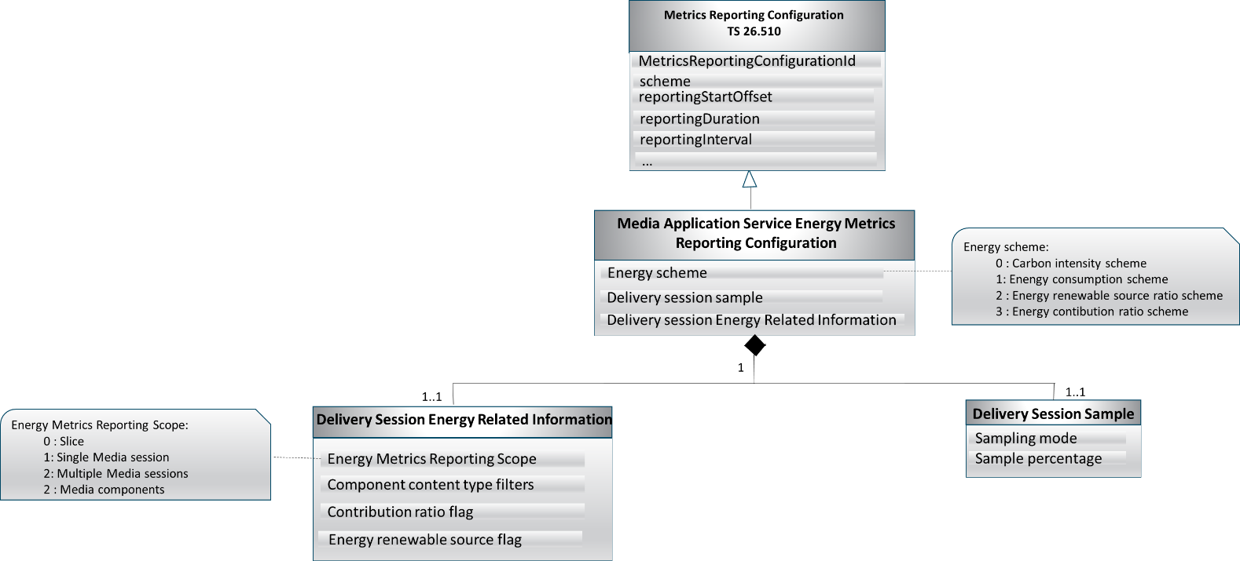
Figure 7.11.2.1-1: Media Application Service Energy Metrics reporting hierarchy
E

nd of changes

