3GPP TSG-SA4 Meeting #134 S4-252103

Dallas, United States, 17th Nov 2025 - 21st Nov 2025 revision of S4-251818
CR-Form-v12.4
CHANGE REQUEST
 | 26.942 | CR | 0008 | rev | 3 | Current version: | 19.0.0
For HELP on using this form: comprehensive instructions can be found at
https://www.3gpp.org/Change-Requests.

Proposed change affects: | UICC apps |  | ME | x | Radio Access Network |  | Core Network | x

Title: | [FS_Energy_Ph2_MED]: Solution for KI1 for collecting and reporting an Energy of Service Metric to authorized 3rd parties
Source to WG: | InterDigital France R&D, SAS
Source to TSG: | S4
Work item code: | FS_Energy_Ph2_MED |  |  |  |  |  | Date: |  |  | 2025-11-10
Category: | B |  |  |  |  |  | Release: |  |  | Rel-19
 | Use one of the following categories:  F (correction)  A (mirror corresponding to a change in an earlier release)  B (addition of feature),  C (functional modification of feature)  D (editorial modification)  Detailed explanations of the above categories can  be found in 3GPP TR 21.900. |  |  |  |  |  |  |  | Use one of the following releases:  Rel-8 (Release 8)  Rel-9 (Release 9)  Rel-10 (Release 10)  Rel-11 (Release 11)  …  Rel-17 (Release 17)  Rel-18 (Release 18)  Rel-19 (Release 19)  Rel-20 (Release 20)
Reason for change: |  | Addition of solutions to Key Issue 1 and Key Issue 4 on Energy-related Collection and Reporting to the 5G media
Summary of change: |  | TODO
Consequences if not approved: |  | No collection and reporting mechanisms for Energy-related information
Clauses affected: |  | 2, 7.1
 |  | Y | N
Other specs |  |  | x | Other core specifications |  |  |  | TS/TR ... CR ...
affected: |  |  | x | Test specifications |  |  |  | TS/TR ... CR ...
(show related CRs) |  |  | x | O&M Specifications |  |  |  | TS/TR ... CR ...
Other comments:
This CR's revision history: |  | Revision of S4aI250197  Revision of S4-251818

1ST Change

2 References
…
[26531] 3GPP TS 26.531: "Data Collection and Reporting".
2nd Change

7.1 Mapping of Solutions to Key Issues
Table 7.1-1: Mapping of solutions to Key Issues
Solutions
 | KI#1 | KI#2 | KI#3 | KI#4
#1 |  |  | X
#2 |  |  | X
#3 |  | X
#4 | X
#5 | X
#6 | X | X
#7 | X
#8 |  | X
#9 | X
#10 | X |  |  | X
#11 | X |  |  | X
#12 | X |  |  | X

(All new text)

7.11 Solution #10: Media Application Service Energy Metrics Reporting Configuration

7.11.1 Key Issue mapping
This Candidate Solution addresses Key Issue #1 described in clause 6.2and Key Issue #4 described in clause 6.4.

7.11.2 Functional description

7.11.2.1 Introduction
This Candidate Solution addresses the definition of the Energy Information Exposure Specification of the solution #7 in clause 7.8 by proposing a Media Application Service Energy metrics configuration inspired by the existing AF-based QoE Metrics Reporting configuration defined in clause 4.0.9 of TS 26.501 [4].
The Media Application Service Metrics Reporting Configuration(s) provided by the Media Application Provider determine what energy-related information associated with the downlink or uplink direction is to be collected and reported (to the instances listed) by the UE, Application Server and the Core Network, and how often.
Editor’s Note: Introduce the two/three different "energy exposing modes". Under what circumstances would a Media Application Provider provision one of these rather than the others?
The different energy metrics reports outlined in the following clauses of this Candidate Solution assume minimal processing by the Energy Information AF or by the Energy Information Collector in the UE. Rather, these functions collate metrics reports from different sources and simply align them in the time domain before passing them on. The collated energy metrics report ultimately exposed to a Media-aware Application still contains the "raw" information collected from the different sources.

7.11.2.2 Metrics Reporting Configuration for Media Application Service Energy
Up to and including Release 19, the Metrics Reporting Configuration resource defined in TS 26.501 [26501] is limited to configuring the reporting of Quality of Experience (QoE) metrics. This clause specifies extensions enabling Energy-related reporting in addition to QoE in table 7.5.2.2-1. Consequently, the scope of the Metrics Reporting Configuration is extended to cover either QoE metrics reporting or Media Application Service Energy metrics reporting.
Table 7.11.2.2-1: Baseline parameters of the
Media Application Service Energy Metrics Reporting Configuration
Abstract element | Semantics / constraints (abstract)
Metrics scheme | Three Media Application Service Energy metrics schemes are defined, corresponding to the energy exposing modes:  - carbon intensity; for which metrics are reported in $g CO_{2}$-e / $Wh$  - energy consumption for which metrics are reported in $Wh$.  - power consumption, for which metrics are reported in. $W$.  The Media Application Provider may provision any number of the above metrics schemes, each with the separate set of Metrics Reporting Configuration parameters.  All three schemes indicate that the metrics to be collected and reported pertain to energy-related information reporting and determine the format of the Aggregated Energy-Related metrics report published by the Energy Information AF (including energy information collected from the EIF for the Core Network, RAN and UE energy information and by the Media AS for the Application Server energy information) and collected by the Energy Information Collector in the Media Session Handler of the UE Media Client. (See NOTE 1.)
Reporting scope | Scope of Media Application Service Energy metrics to be collected and reported:  - For each media delivery session, the sum of the energy metric value of all the components of the session during the sampling period.  - For each media delivery session, the energy metric value of all the components of the session or only the ones of content type given by the element “component content type” below,  - Aggregated energy metric value across all the active sample media delivery sessions.
Component content types filter | MIME content types (e.g., video/mp4) used to filter components included in per‑component reporting (NOTE 2).
Contribution ratio flag | If true, include contribution ratio information across UE, RAN, CN and AS in the report.
Metrics to be reported | A controlled vocabulary of Media Application Service Energy metrics to be reported. All three Media Application Service Energy metrics schemes indicated by Metrics scheme share the same controlled vocabulary of metrics.
NOTE 1: Architecture mapping proposals in clauses 7.12.3 and 7.13.3.
NOTE 2: The applicability of the Component content types filter to any metrics reporting scheme, not just energy-related ones, is for further study.

7.11.2.3 Media AS Energy Report
This is the metrics report generated periodically by the Application Server describing its energy consumption over the last sampling period.
Table 7.11.2.3-1: Baseline parameters of the Media AS energy metrics report
Abstract element | Semantics / constraints (abstract)
Timestamp | The start date–time of the sampling period described by this report.
Duration | The duration of the sampling period described by this report.
Media delivery session identifier | A string that uniquely identifies a media delivery session in the Media Delivery System for the purpose of collating information from different system functions.
Energy exposing mode | The type of energy information reported by the Media Application Server (energy consumption or carbon equivalent emission) as provisioned in the Media Application Service Energy Metrics Reporting Configuration.
Media delivery session energy | The energy consumption or the carbon equivalent emission (depending on the indicated energy exposing mode | depending on the provisioned metrics scheme) of the Media Application Server that was needed to convey the media data of the media delivery session during the sampling period described by this report.
Media component energy | A list of Media Component objects, each one indicating the energy consumption or the carbon equivalent emission (depending on the indicated energy exposing mode | depending on the provisioned metrics scheme) of a media component of the media delivery session during the sampling period described by this report.
Renewable ratio | The ratio of renewable to non-renewable energyused by the Media Application Server during the sampling period described by this report.

7.11.2.4 Processed EIF Energy Report
This is the metrics report generated periodically by the Energy Information AF function describing the energy consumption of the 5G Core over the last sampling period. The information obtained from the EIF is cast into the context of a particular media delivery session by the Energy Information AF and is shared with the UE(s) involved in this media delivery session.
Table 7.11.2.3-1: Baseline parameters of the Processed EIF energy metrics report
Abstract element | Semantics / constraints (abstract)
Timestamp | The start date–time of the sampling period described by this report.
Duration | The duration of the sampling period described by this report.
Media delivery session identifier | A string that uniquely identifies a media delivery session in the Media Delivery System for the purpose of collating information from different system functions.
Energy exposing mode | The type of energy information reported by the 5G Core (energy consumption or carbon equivalent emission), as provisioned in the Media Application Service Energy Metrics Reporting Configuration.
Media delivery session slice energy | The energy consumption or the carbon equivalent emission of a network slice of the 5G Core (depending on the indicated energy exposing mode | depending on the provisioned metrics scheme) that was needed to convey the media data of the Media Delivery Session.
Media delivery session energy | The energy consumption or the carbon equivalent emission of the 5G Core (depending on the indicated energy exposing mode | depending on the provisioned metrics scheme) that was needed to convey the media data of the Media Delivery Session during the sampling period described by this report.
Media component energy | A list of Media Component objects, each one indicating the 5G Core energy consumption or the carbon equivalent emission (depending on the indicated energy exposing mode | depending on the provisioned metrics scheme) that was needed to convey each media component of the Media Delivery Session during the sampling period described by this report.
Radio Access Network energy | A value that indicates the energy consumption or the carbon equivalent emission of the Radio Access Network to convey the media data of the Media Delivery Session during the sampling period described by this report.
Core Network Energy (UPF) | A value that indicates the energy consumption or the carbon equivalent emission of the Core Network (depending on the indicated energy exposing mode | depending on the provisioned metrics scheme) that was needed by the UPF to convey the media data of the Media Delivery Session during the sampling period described by this report.
Energy credits | The remaining energy credits for the Media Delivery Session.
Renewable ratio | The ratio of renewable to non-renewable energy used by the 5G Core and RAN during the sampling period described by this report.

7.11.2.5 Processed Media Session Handler aggregated metrics report
The aggregated processed metrics report is a set of Media Application Service Energy information aggregated by the UE based on the processed metrics report received from the network (see clause 7.11.2.4 above) and Media Application Service Energy metrics received from the UE itself. It is intended to be exposed to the Media-aware Application.
Table 7.11.2.5-1: Baseline parameters of the processed metrics report
Abstract element |  | Semantics / constraints (abstract)
Timestamp |  | The start date–time of the sampling period described by this report.
Duration |  | The duration of the sampling period described by this report.
Media delivery session identifier |  | A string that uniquely identifies a media delivery session in the Media Delivery System for the purpose of collating information from different system functions
Energy exposing mode |  | The type of energy information reported by the 5G Core (energy consumption or carbon equivalent emission), as provisioned in the Media Application Service Energy Metrics Reporting Configuration.
Network energy information |  | Energy information about the media delivery session obtained from the EIF.
 | Media delivery session slice energy | The energy consumption or the carbon equivalent emission of a network slice of the 5G Core (depending on the indicated energy exposing mode | depending on the provisioned metrics scheme) that was needed to convey the media data of the Media Delivery Session.
 | Delivery session energy | The energy consumption or the carbon equivalent emission of the 5G Core (depending on the indicated energy exposing mode | depending on the provisioned metrics scheme) that was needed to convey the media data of the Media Delivery Session during the sampling period described by this report.
 | Media component energy | A list of Media Component objects, each one indicating the 5G Core energy consumption or the carbon equivalent emission (depending on the indicated energy exposing mode | depending on the provisioned metrics scheme) that was needed to convey each media component of the Media Delivery Session during the sampling period described by this report.
 | Radio Access Network energy | A value that indicates the energy consumption or the carbon equivalent emission of the Radio Access Network to convey the media data of the Media Delivery Session during the sampling period described by this report.
 | Core Network Energy (UPF) | A value that indicates the energy consumption or the carbon equivalent emission of the Core Network (depending on the indicated energy exposing mode | depending on the provisioned metrics scheme) that was needed by the UPF to convey the media data of the Media Delivery Session during the sampling period described by this report.
 | Energy credits | The remaining energy credits for the Media Delivery Session.
 | Renewable ratio | The ratio of renewable to non-renewable energy used by 5G Core and RAN during the sampling period described by this report.
Application Server energy information |  | Energy information about the media delivery session obtained from the Media AS.
 | Media delivery session energy | A value that indicates the Energy consumption or the carbon equivalent emission of the Application Server to convey the media data of the Media Delivery Session.
 | Media component energy | A list of Media Component objects that indicates the energy consumption or the carbon equivalent emission of each media component of the Media Delivery Session
 | Renewable ratio | The ratio of renewable to non-renewable energy used by the Media Application Server during the sampling period described by this report.
UE energy information |  | Energy information about the media delivery session obtained from the Media Access Function of the UE Media Client.
 | Media delivery session energy | The energy consumption or the carbon equivalent emission of the UE to access the media data of the Media Delivery Session.
 | Media Component list | A list of Media Component objects that indicates the Energy consumption or the Carbon equivalent emission to access each Media component of the Media Delivery Session
 | Renewable ratio | The ratio of renewable to non-renewable energy fused by the UE during the sampling period described by this report.

7.11.2.6 Media Application Service Energy metrics event
The Media Application Service metrics event is a collection of Media Application Service metrics reports exposed by the Data Collection AF to subscribing event consumers. It is reported on a per-UE basis. Similar to the processed metrics report described in clause 7.11.2.4 above, the information conveyed is based on per-UE NF Energy Reports received from the EIF and per-UE aggregated Application Service Energy Reports received from the Application Server.
Table 7.11.2.6-1: Baseline parameters of the Media Application Service Energy metrics event
Abstract element | Semantics / constraints (abstract)

7.11.2 Procedures
Procedures for handling Media Application Service Energy Metrics Reporting Configuration are proposed in clause 7.12.3 and 7.13.3.
(All new text)

7.12 Solution #11: Media Application Service Energy metrics collection and reporting using existing reference points

7.12.1 Key Issue mapping
This Candidate Solution addresses Key Issue #1 described in clause 6.1 and Key Issue #4 described in clause 6.4.

7.12.2 Functional description

7.12.2.1 Introduction
In line with [PR 1-1] of TR 26.942, this Candidate Solution to Key Issue #1intends to reuse existing 3GPP mechanisms for reporting Media Application Service Energy Metrics after provisioning the Metrics Reporting Configuration of solution #10 provided by the Media Application Provider.

7.12.2.2 Architecture mapping
The approach combines the metrics reporting architecture of Release 19, a part of the architecture for collection and exposure of energy (see clause 7.6.2.2) and an additional reference point E4 to expose Energy-of-media Service reports to Data Collection AF.
Figure 7.12.2.2-1 illustrates how the approach could be instantiated.

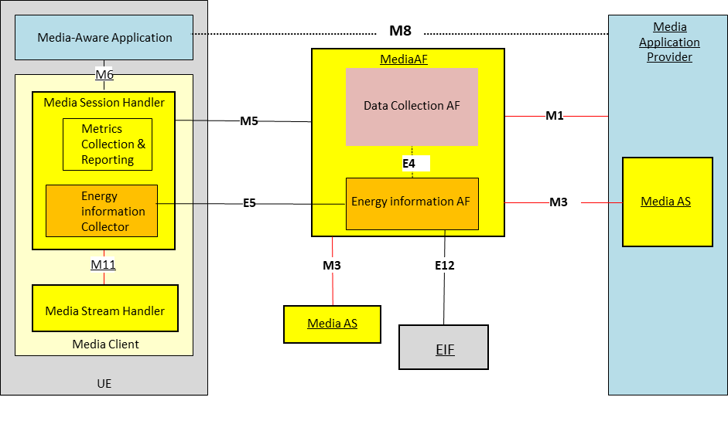
Figure 7.12.2.2-1: Metrics reporting feature in the Release 19 Metrics Reporting architecture updated with the generic reference architecture for collection and exposure of energy-related information (clause 7.6.2.2)
The following functions defined in clause 7.6.2.4 are relevant to this Candidate Solution:
- The Energy Information AF instantiated in the Media AF has the following responsibilities, depending on its current provisioning state obtained from the Media AF:
- Collecting energy-related information from the EIF and Media AS, and creating energy-related information reports to be shared with Media Clients.
- The Energy Information Collector instantiated in the Media Session Handler of the Media Client has the following responsibilities:
- Acquires an Energy Information collection configuration from the enclosing Media Session Handler that was conveyed in the form of a metrics reporting configuration embedded in the complete Service Access Information the Media Session Handler has acquired at reference point M5.
- Subscribes to and consumes via reference point E5 Network Energy Information from the Energy Information AF according to the Energy Information collection configuration.
- Collects UE Energy Information from the Media Access Function via the Media Session Handler at reference point M11 according to the Energy Information collection configuration. Collects Media Application Service Energy metrics, creates the metrics report aligned with the Media Application Service Energy metrics scheme of the configuration.
The following reference points are involved in the proposed approach to reporting Media Application Service Energy:
M1 Network API used by the Media Application Provider to provision Media Application Service Energy reporting in the Energy Information AF by means of the existing Metrics Reporting Configuration. This determines whether and which energy-related information is submitted by the Media Session Handler for the UE, the Media AS and the EIF for the Core Network.
E12 This reference point is used by the EIF to provide energy-related information reports to the Energy Information AF instantiated in the Media AF. The Energy Information AF receives the information and creates the report aligned with the provisioned Media Application Service Energy metrics scheme.
M3 After provisioning of Metrics Reporting in the Media AF and the configuration of Content Hosting in the Media AS, the Media AS obtains a client metrics reporting configuration embedded in Service Access Information. Based on this configuration, the Media AS collects Media Application Service Energy metrics, creates metrics reports aligned with the Media Application Service Energy metrics scheme of the configuration, and uses this reference point to transmit Media Application Service Energy metrics reports to the Media AF which are passed to the Energy Information AF instantiated in the Media AF.
M5 Network API used by the Media Session Handler to obtain an Media Application Service Energy Metrics Reporting configuration from the Media AF. The configuration information is embedded in Service Access Information.
E5 Network API used by the Energy Information Collector instantiated in the Media Session Handler to subscribe to and receive Network Energy Information from the Energy Information Media AF. Network Energy Information exposed to the Energy Information Collector relates to a specific Application Service Provider. In particular, this API allows the UE to receive reports aligned with the Media Application Service Energy metrics scheme of the configuration from the Energy Information AF and propagate them to the Media-aware Application (via reference point M6) and, optionally, to the Media Application Provider (via reference point M8).
E4 Network API used by the Data Collection AF instantiated in the Media AF to subscribe to and receive Network Energy Information from the Energy Information AF instantiated in the Media AF. Network Energy Information exposed to the Data Collection AF relates to a specific Application Service Provider. In particular, this API allows the Data Collection AF instantiated in the Media AF to receive the aggregated reports aligned with the Media Application Service Energy metrics scheme of the configuration from the Energy Information AF instantiated in the Media AF, and to expose them to event consumers via reference point R6 (not illustrated) (see TS 26.531 [26531]).
M6 Client API used by the Media-aware Application to subscribe to receive Media Application Service Energy Metrics notifications from the Energy Information Collector instantiated in the Media Session Handler.
M8 Network API used by the Media Application Provider to receive energy-related information from the Media-aware Application. This reference point is beyond the scope of 3GPP standardisation.

7.12.3 Procedures
Figure 7.12.3-1 below details the different steps for Media Application Service Energy Metrics Reporting for the Approach in the system outlined in clause 7.12.2.2 (based on figure 5.5.3-1 of TS 26.501 [23] but updated so that it applies to the generalised media delivery architecture defined in clause 4.1.2 of [23]).

Figure 7.12.3-1: Procedures for Energy-of media-Service collection and reporting
The steps of the call flow are as follows. Differences from the baseline procedure requiring normative specification are highlighted in boldface.
1: The Media AF is provisioned by the Media Application Provider with one or more Media Application Service Energy Metrics Reporting configurations , each pertaining to metrics collection by the Media Access Function and/or the EIF and/or the Media AS.
The configurations are transmitted to the Energy Information AF to collect and generate the metrics reports regarding required post-processing functionality and deliver to the Media Application Provider.
The Energy Information AF subscribes to the EIF network function to receive Energy-related information from the Core Network.
NOTE: This step is based on Candidate Solution #10 in clause 7.11.
2: The Media-Aware Application triggers the Service Announcement and Content Discovery procedure. The Service Announcement includes the whole Service Access Information that contains metric configuration information for Media Application Service Energy metrics scheme.
3: Time passes until the UE initiates session establishment and media delivery.
4: The Media-Aware Application informs the Media Access Function of impending media delivery.
5: The Media Session Handler requests the establishment of a streaming session with the Media AF which confirms successful establishment of the media delivery session.
6: The Media processing pipeline is set up between the Media Access Function, the Media AS and the Media Application Provider.
7: Service Access Information is retrieved by the Media AS via reference point M3, which includes one or more Media Application Service Energy Metrics Reporting configurations.
8: Service Access Information is retrieved by the Media Session Handler via reference point M5, which includes Media Application Service Energy Metrics Reporting configuration.
9: Using the Metrics reporting procedures specified in clause 4.9.2 of TS 26.512 [26512] at reference point M11,the Media Session Handler queries the Media Access Function on its capability to perform metrics collection (measurement and logging function) in accordance with Media Application Service Energy metrics scheme as defined by its Metrics Reporting configuration. At this step it is checked if the Media Access Function can support the reporting of Media Application Service Energy metrics.
10: The Media Access Function acknowledges its support for the collection of the required metric of the configured scheme.
11: The Media Access Function notifies the Media Session Handler of the start of media delivery, causing the Media Session Handler to initialize and begin countdown of separate metrics reporting interval timers for the Media Application Service Energy metrics scheme.
During the course of media playback, steps 12–28 below may be repeated, depending on the duration of the playback and the frequency of metrics reporting as set by the metrics configuration for the Media Application Service Energy metrics scheme.
12: The Media AS initializes and begins countdown of its metrics reporting interval timer for the Media Application Service Energy metrics scheme.
13: The Media Session Handler initializes and begins countdown of its metrics reporting interval timer for the Media Application Service Energy metrics scheme.
14: The Media Access Function accesses media content at the Media AS.
15: Upon expiration of the timer (associated with the Media Application Service Energy metrics scheme), the Media AS retrieves the logged metrics according to that scheme.
16: The Media AS reports the logged metrics to the Media AF and subsequently to the Energy Information AF sub-entity.
17: The Energy Information AF processes the information according to the Media Application Service Energy metrics scheme.
18:The timer associated with the Media Application Service Energy metrics scheme expires in the Media Session Handler.
19: The Media Session Handler retrieves the energy metrics from the Media Access Function according to the Media Application Service Energy metrics scheme.
20: In accordance with its metrics reporting configuration as provisioned in step 1, a metrics report for Media Application Service Energy metrics scheme is sent from the Media Session Handler to the Energy Information Collector.
21: The Energy Information Collector processes the information according to the Media Application Service Energy metrics scheme.
22: The EIF publishes an NF Energy Information Report to the Energy Information AF.
23: The Energy Information AF publishes a Media Application Service Energy metric report to the Media Application Provider.
The following steps may occur to expose Media Application Service Energy metrics to the Media-aware Application:
24: The Energy Information AF publishes a Media Application Service Energy metrics report to the UE Energy Information Collector via reference point E5 to allow the Media Session Handler to report to the Media-aware Application.
25: The Energy Information Collector collates the Media Application Service Energy metric reports of the Media Client and the ones received from the Energy Information AF.
25a. The Energy Information Collector shares the collated Media Application Service Energy Metrics Report with the Media AF via an internal interface that is not standardised.
25b. The Media AF publishes the Media Application Service Energy Metrics report to the Application via reference point M6.
26: The Media aware Application may publish the Media Application Service Energy Metrics report to the Media Application Provider via reference point M8.
If exposure of Media Application Service Energy events is provisioned in the Media AF:
27: The Energy Information AF shares the Media Application Service Energy metrics with the Data Collection AF instantiated in the same Media AF via an internal interface that is not specified.
28: The Data Collection AF exposes a Media Application Service Energy Metrics event to the Event Consumer AF via reference point R6 as specified in TS 26.531 [26531].
Upon the termination of media delivery (as notified by the Media-Aware Application to the Media Access Function) a final round of metrics collection and reporting is performed.

7.12.4 Impacts on existing services, entities and interfaces

7.12.4.1 Media AF
The Media AF would be required to support additional Media Application Service Energy metrics reporting schemes as part of the existing Metrics Reporting Configuration.

7.12.4.2 Energy Information AF
The Energy Information AF is instantiated as a subfunction of the Media AF to:
1. Collect energy-related information per application, per media session, and per media component, from the Media AS via reference point M3
2. Collect partial energy-related information about the 5G Core and the RAN from the EIF at reference point E12.

Collected information is reported to the UE Energy Information Collector instantiated within the Media Session Handler via reference point E5 to be propagated to the Media-aware Application at reference point M6 and, optionally, to the Media Application Provider at reference point M8.
Collected information is shared with a Data Collection AF instantiated within the same Media AF prior to exposure to authorized third parties at reference point R6, after privacy-preserving post-processing has been applied.

7.12.4.3 Energy Information Collector
Editor’s Note: TODO

7.12.4.4 Reference point M1
At reference point M1, the Media Application Provider creates one or more Metrics Reporting Configuration resources associated with the target Provisioning Session to enable Media Application Service Energy collection and reporting. The provisioning information provided includes the baseline parameters proposed in clause 7.11.2.2.

7.12.4.5 Reference point E12
Existing procedures are used by the Energy Information AF at reference point E12 to subscribe to receive NF Energy Information Reports, and existing procedures are used to receive those reports.
Editor’s Note: Which granularities of subscription are relevant to this Candidate Solution?

7.12.4.6 Reference point M3
Editor’s Note: TODO

7.12.4.7 Reference point M5
Editor’s Note: TODO

7.12.4.8 Reference point M6
Editor’s Note: TODO

7.12.4.9 Reference point M8
Editor’s Note: TODO
(All new text)

7.13 Solution #12: Media Application Service Energy metrics collection and reporting using new reference points

7.13.1 Key Issue mapping
This Candidate Solution addresses Key Issue #1 described in clause 6.2 and Key Issue #4 described in clause 6.4.

7.13.2 Functional description

7.13.2.1 Introduction
In contrast with Candidate Solution #11, this solutionuses reference points E3 and E5 to retrieve the Media Application Service Energy Metrics Reporting configuration from the Energy Information AF instead of overloading the existing QoE metrics reporting configuration in the Service Access Information provided at reference points M3 and M5 respectively.
Figure 7.13.2.1-1 illustrates how the approach could be instantiated.

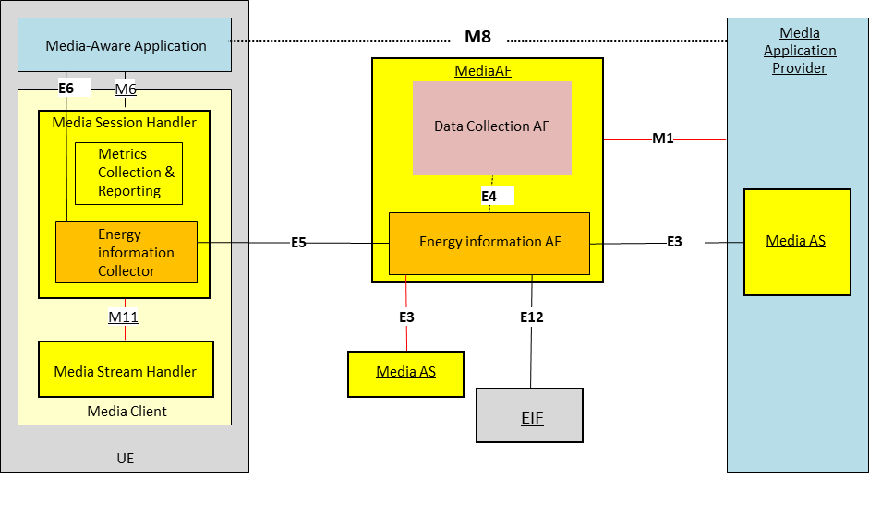
Figure 7.13.2.1-1: Metrics reporting feature with the overall generic reference architecture for collection and exposure of energy-related information (clause 7.6.2.2)
The following functions defined in clause 7.6.2.4 are relevant to this Candidate Solution:
- The Energy Information AF instantiated in the Media AF has the following responsibilities, depending on its current provisioning state obtained from the Media AF:
- Collecting energy-related information and creating energy-related information reports.
- The Energy Information Collector instantiated in the Media Session Handler of the Media Client has the following responsibilities:
- Acquires an Energy Information collection configuration from the Energy Information AF via reference point E5 based on an endpoint address configured by the Media Session Handler that was embedded in the Service Access Information the Media Session Handler has acquired.
- Subscribes to and consumes via reference point E5 Network Energy Information from the Energy Information AF according to the Energy Information collection configuration.
- Collects UE Energy Information from the Media Access Function via the Media Session Handler at reference point M11 according to the Energy Information collection configuration.
The following reference points are involved in the proposed to reporting Media Application Service Energy metrics:
M1 Network API used by the Media Application Provider to provision Media Application Service Energy reporting in the Energy Information AF instantiated in the Media AF by means of a new Media Application Service Energy Metrics Reporting Configuration. This determines whether and which energy-related information submitted by the Energy information Collector for the UE, the Media AS and the EIF for the Core Network. The Energy Information AF instantiated in the Media AF collects the Energy-related information and creates Energy related information reports as it is in the Release 19 architecture.

E12 This reference point is used by the EIF to provide energy-related information reports to the Energy Information AF instantiated in the Media AF. The Energy Information AF receives the information and creates the report aligned with the provisioned Media Application Service Energy metrics scheme.
E3 After provisioning of Media Application Service Energy Metrics Reporting in the Energy Information instantiated in the Media AF and the configuration of Content Hosting in the Media AS, the Media Application Service Energy Metrics Reporting configuration is obtained by the Media AS from the Energy Information AF instantiated in the Media AF. Based on this configuration, the Media AS collects Media Application Service Energy metrics, creates metrics reports aligned with the Media Application Service Energy metrics scheme of the configuration and uses this reference point to transmit Media Application Service Energy metrics reports to the Energy Information AF instantiated in the Media AF.
E5 Network API used by the Energy Information Collector instantiated in the Media Session Handler to obtain a Media Application Service Energy Metrics Reporting configuration from the Energy Information AF.
The Energy Information Collector fetches the collected Media Application Service Energy metrics, creates the metrics report aligned with the Media Application Service Energy metrics scheme of the configuration.
This API also allows the UE Energy Information Collector to receive the aggregated reports aligned with the Media Application Service Energy metrics scheme of the configuration from the Energy Information AF and propagate to the Media-aware application (via reference point E6) and optionally, to the Media Application Provider (via reference point M8).
Also used by the Energy Information Collector instantiated in the Media Session Handler to subscribe to and receive Network Energy Information from the Energy Information Media AF. Network Energy Information exposed to the Energy Information Collector relates to a specific Application Service Provider. In particular, this API allows the UE to receive reports aligned with the Media Application Service Energy metrics scheme of the configuration from the Energy Information AF and propagate them to the Media-aware Application (via reference point M6) and, optionally, to the Media Application Provider (via reference point M8).
E4 Network API used by the Data Collection in AF instantiated in the Media AF to subscribe to and receive Network Energy Information from the Energy Information AF instantiated in the Media AF. Network Energy Information exposed to the Data Collection AF relates to a specific Application Service Provider. In particular, this API allows the Data Collection AF instantiated in the Media AF to receive the aggregated reports aligned with the Media Application Service Energy metrics scheme of the configuration from the Energy Information AF instantiated in the Media AF, and to expose them to event consumers via reference point R6 (not illustrated) (see TS 26.531 [26531]).
M6 Client API used by the Media-aware Application to subscribe to receive Media Application Service Energy Metrics notifications from the Energy Information Collector instantiated in the Media Session Handler.
M8 Network API used by the Media Application Provider to receive energy-related information from the Media-aware Application. This reference point is beyond the scope of 3GPP standardisation.

7.13.3 Procedures
Figure 7.13.3-1 below details the different steps for Media Application Service Energy Metrics Reporting for the approach in the system outlined in clause 7.13.2.1 (based on figure 5.5.3-1 of TS 26.501 [23] but updated so that it applies to the generalised media delivery architecture defined in clause 4.1.2 of [23]).

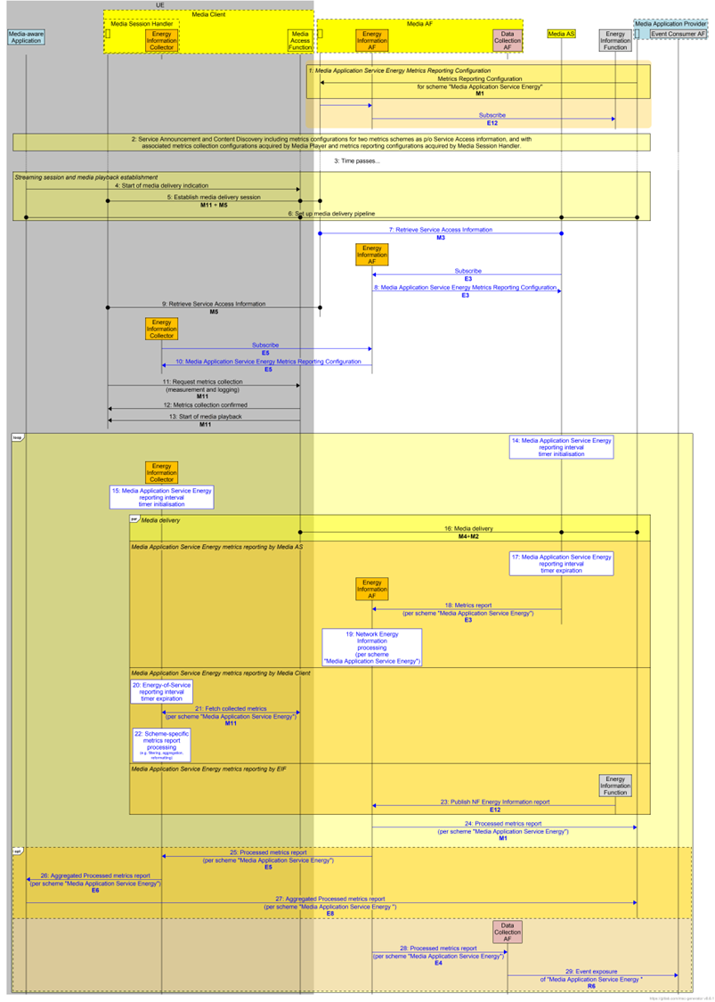
Figure 7.13.3-1: Procedures for Energy-of Service collection and reporting
The steps of the call flow are as follows. Differences from the baseline procedure requiring normative specification are highlighted in boldface.
1: The Media AF is provisioned by the Media Application Provider with one or more Media Application Service Energy Metrics Reporting configurations , each pertaining to metrics collection by the Media Access Function and/or the EIF and the Media AS functions.
The configurations are transmitted to the Energy Information AF to collect and generate the metrics reports regarding required post-processing functionality and deliver to the Media Application Provider.
The Energy Information AF subscribes to the EIF network function to receive Energy-related information from the Core Network.
NOTE: This step is based on Candidate Solution #10 in clause 7.11.
2: The Media-Aware Application triggers the Service Announcement and Content Discovery procedure. The Service Announcement includes the whole Service Access Information that contains metric configuration information for Media Application Service Energy metrics scheme.
3: Time passes until the UE initiates session establishment and media delivery.
4: The Media-Aware Application informs the Media Access Function of impending media delivery.
5: The Media Session Handler requests the establishment of a media delivery session with the Media AF which confirms successful establishment of the media delivery session.
6: The media processing pipeline is set up between the Media Access Function, the Media AS and the Media Application Provider.
7: Service Access Information is retrieved by the Media AS via reference point M3, including the endpoint address of the Energy Information AF to be used for interacting with it at reference point E3.
8: Using the endpoint address obtained in the previous step, the Media AS retrieves its Media Application Service Energy Metrics Reporting configuration from the Energy Information AF via reference point E3.
9: Service Access Information is retrieved by the Media Session Handler via reference point M5, including the endpoint address of the Energy Information AF to be used for interacting with it at reference point E5.
10: The Energy Information Collector retrieves its Media Application Service Energy Metrics Reporting configuration from the Energy Information AF via reference point E5.
11: Using the Metrics reporting procedures specified in clause 4.9.2 of TS 26.512 [26512] at reference point M11, the Energy Information Collector queries the Media Access Function on its capability to perform metrics collection in accordance with Media Application Service Energy metrics scheme as defined by its Metrics Reporting configuration. At this step it is checked if the Media Access Function can support the reporting of Media Application Service Energy metrics.
12: The Media Access Function acknowledges its support for the collection of the required metrics of the configured scheme.
13: The Media Access Function notifies the Media Session Handler of the start of media delivery, causing the Media Session Handler to initialize and begin countdown of separate metrics reporting interval timers for the Media Application Service Energy metrics scheme.
During the course of media playback, steps 14–29 below may be repeated, depending on the duration of the playback and the frequency of metrics reporting as set by the metrics configuration for the Media Application Service Energy metrics scheme.
14: The Media AS initializes and begins countdown of its metrics reporting interval timer for the Media Application Service Energy metrics scheme.
15: The Energy Information Collector initializes and begins countdown of itsmetrics reporting interval timer for the Media Application Service Energy metrics scheme.
16: The Media Access Function accesses media content at the Media AS.
17: Upon expiration of the timer (associated with the Media Application Service Energy metrics scheme), the Media AS retrieves the logged metrics according to that scheme.
18: The Media AS reports the logged metrics to the Energy Information AF.
19: The Energy Information AF processes the information according to the Media Application Service Energy metrics scheme.
20: The timer associated with the Media Application Service Energy metrics scheme expires in the Media Session Handler.
21: The UE Energy Information Collector retrieves the energy metrics from the Media Player according to Media Application Service Energy metrics scheme.
22: The Energy Information Collector processes the information according to the Media Application Service Energy metrics scheme.
23: The EIF publishes an NF Energy Information Report to the Energy Information AF.
24: The Energy Information AF publishes a Media Application Service Energy metrics report to the Media Application Provider.
The following steps may occur to expose Media Application Service Energy metrics to the Media-aware Application:
25: The Energy Information AF publishes a Media Application Service Energy metrics report to the UE Energy Information Collector via reference point E5 to allow the Media Session Handler to report to the Media-aware Application.
26: The Energy Information Collector collates the Media Application Service Energy Metric reports of the Media Client and the ones received from the Energy Information AF.
26a: The Energy Information Collector shares the collated Media Application Service Energy Metrics Report with the Media AF via an internal interface that is not standardised.
26b: The Media AF publishes the final Media Application Service Energy metrics reports to the Application at reference point M6.
27: The Media Aware Application may publish Media Application Service Energy Metrics reports to the Media Application Provider via M8 reference point
If exposure of Media Application Service Energy events is provisioned in the Media AF:
28: The Energy Information AF shares the Media Application Service Energy metrics with the Data Collection AF instantiated in the same Media AF via an internal interface that is not specified.
29: The Data Collection AF exposes a Media Application Service Energy Metrics event to the Event Consumer AF via reference point R6 as specified in TS 26.531 [26531].
Upon the termination of media delivery (as notified by the Media-Aware Application to the Media Access Function) a final round of metrics collection and reporting is performed.

7.13.4 Impacts on existing services, entities and interfaces

7.13.4.1 Media AF
The Media AF would be required to support an Media Application Service Energy Metrics Reporting Configuration resource as part of the Provisioning Session.

7.13.4.2 Energy Information AF
The Energy Information AF is instantiated as a subfunction of the Media AF to:
1. Collect energy-related information per application, per media session, and per media component, from the Media AS via reference points E3.
2. Collect partial energy-related information about the 5G Core and the RAN from the EIF at reference point E12.

Collected information is reported to the UE Energy Information Collector instantiated within the Media Session Handler via reference point E5 to be propagated to the Media-aware Application at reference point m6 and, optionally, to the Media Application Provider at reference point M8.
Collected information is shared with a Data Collection AF instantiated within the same Media AF prior to exposure to authorized third parties at reference point R6, after privacy-preserving post-processing has been applied.

7.12.4.3 Energy Information Collector
Editor’s Note: TODO

7.13.4.4 Reference point M1
At reference point M1, the Media Application Provider creates one or more Media Application Service Energy Metrics Reporting Configuration resources associated with the target Provisioning Session to enable Media Application Service Energy collection and reporting. The provisioning information provided includes the baseline parameters proposed in clause 7.11.2.2.

7.13.4.5 Reference point E12
Existing procedures are used by the Energy Information AF at reference point E12 to subscribe to receive NF Energy Information Reports, and existing procedures are used to receive those reports.
Editor’s Note: Which granularities of subscription are relevant to this Candidate Solution?

7.13.4.6 Reference point E3
Editor’s Note: TODO

7.13.4.7 Reference point E5
Editor’s Note: TODO

7.13.4.8 Reference point M6
Editor’s Note: TODO

7.13.4.9 Reference point M8
Editor’s Note: TODO
End of changes

