3GPP TSG-S4 Meeting #134 S4-252096

Dallas, USA, 17th November – 21st November 2025 revision of S4-251924
CR-Form-v12.0
CHANGE REQUEST
 | 26.942 | CR | 0016 | rev | 1 | Current version: | 19.0.0
For HELP on using this form: comprehensive instructions can be found at
http://www.3gpp.org/Change-Requests.

Proposed change affects: | UICC apps |  | ME | X | Radio Access Network |  | Core Network | X

Title: | [FS_Energy_Ph2_MED] Solution for Key #6 on Client-driven switching between multipath and single path media delivery based on energy information
Source to WG: | Samsung Electronics Co. Ltd., Nokia
Source to TSG: | S4
Work item code: | FS_Energy_Ph2_MED |  |  |  |  |  | Date: |  |  | 2025-11-10
Category: | B |  |  |  |  |  | Release: |  |  | Rel-20
 | Use one of the following categories:  F (correction)  A (mirror corresponding to a change in an earlier release)  B (addition of feature),  C (functional modification of feature)  D (editorial modification)  Detailed explanations of the above categories can  be found in 3GPP TR 21.900. |  |  |  |  |  |  |  | Use one of the following releases:  Rel-8 (Release 8)  Rel-9 (Release 9)  Rel-10 (Release 10)  Rel-11 (Release 11)  …  Rel-15 (Release 15)  Rel-16 (Release 16)  Rel-17 (Release 17)  Rel-18 (Release 18)
Reason for change: |  | A Key Issue on client-driven management of media delivery service energy optimization was agreed during S4-MBS SWG AH. No solutions exist for this Key Issue.
Summary of change: |  | Addition of solution to key issue#6 on client-driven management of media delivery service energy optimization. The solution proposes to use the energy consumption information received from the network to make a decision on switching between multipath and single path transport sessions.
Consequences if not approved: |  | Study on energy management for media delivery would be incomplete.
Q
Clauses affected: |  | 2, 7.1, 7.X (new)
 |  | Y | N
Other specs |  |  | X | Other core specifications
affected: |  |  | X | Test specifications
(show related CRs) |  |  | X | O&M Specifications
Other comments:
This CR's revision history: |  | S4-251924: Initial contribution on switching from multipath to single path based on energy consumption information  S4-252096: Previous revision updated with comments during SA4#134 meeting
CHANGE 1

2 References
The following documents contain provisions which, through reference in this text, constitute provisions of the present document.
- References are either specific (identified by date of publication, edition number, version number, etc.) or non-specific.
- For a specific reference, subsequent revisions do not apply.
- For a non-specific reference, the latest version applies. In the case of a reference to a 3GPP document (including a GSM document), a non-specific reference implicitly refers to the latest version of that document in the same Release as the present document.
[1] 3GPP TR 21.905: "Vocabulary for 3GPP Specifications".
…
[26804] 3GPP TR 26.804: "Study on 5G media streaming extensions".
[26512] 3GPP TS 26.512: "5G Media Streaming(5GMS); Protocols".
CHANGE 2

7.1 Mapping of Solutions to Key Issues
Table 7.1-1: Mapping of solutions to Key Issues
Solutions
 | KI#1 | KI#2 | KI#3 | KI#4 | KI#5 | KI#6
#1 |  |  | X
#2 |  |  | X
#3 |  | X
#4 | X
#5 | X
#6 | X | X
#7 | X
#8 |  | X
#9 | X
#X |  |  |  |  |  | X

These solutions are simply candidate solutions. Their inclusion in the following clauses does not imply that they have been agreed upon or endorsed. Any decisions and work to be done for the normative work will be detailed in the conclusions of this Technical Report.
CHANGE 3
(All NEW TEXT)

7.X Solution #X: Client-driven switching between multipath and single path media delivery based on energy information

7.X.1 Key Issue mapping
This Candidate Solution addresses Key Issue #6.

7.X.2 Functional description

7.X.2.1 Introduction
Clause 5.18 of TR 26.804 [26804] describes the feature for multi-access media delivery. With this feature, the Media Access Function of a Media Client may make transparent use of multipath transport protocols such as MPTCP or MPQUIC to set up a multipath transport session with the Media AS for delivery of Media delivery content over multiple different access networks without the active participation of either the Media Client or the Media AS beyond enabling the feature in the Media Access Function. For example, in the case of downlink media streaming, clause 13.2.4 of TS 26.512 [26512] specifies the Configuration and Settings API exposed by the Media Player to the 5GMSd-Aware Application and Media Session Handler at reference points M7d and M11d respectively for configuration of multipath operation over the underlying transport session.
The multipath transport session may span one or more access network available to the UE. The multiple paths may be used to improve resilience against packet loss or to increase data throughput as specified in clause 4.6.2 of TS 26.512 [26512].
At the UE, supporting a multipath transport session may require activating and using multiple access network endpoints. In the network, a multi-access delivery session might be using multiple access network nodes such as one or more gNodeBs, zero or more Non-3GPP nodes such as N3IWF etc. for transport of media application session content.
This Candidate Solution introduces a mechanism for switching between a multipath transport session, potentially over one or more access networks, and a single-path session based on energy consumption information sent from the network to the UE. The solution assumes that the splitting and/or switching of traffic between the transport protocol paths made available by the currently active access networks is transparent to the application layer, hidden behind a single virtual tunnel network interface, as described in clause 5.32.2 of TS 23.501 [72].

7.X.2.2 Access Network Energy Cost Information
To determine the relative cost of establishing a transport connection over one or other type of Access Network available to the UE, it needs to be provided with at least the information outlined in table 7.X.2.2-1.
Table 7.X.2.2-1: Baseline Access Network Energy Cost Information
Abstract element | Semantics / constraints (abstract)

7.X.2.3 Reference architecture for client-driven switching from multipath to single path based on energy information from the network
Based on the reference architecture instantiated in clause 7.6.2.4, figure 7.X.2.4-1 depicts a reference architecture that realises this candidate solution in the generalised Media Delivery architecture defined in clause 4.1.2 of TS 26.501 [23]. No new reference points between the entities in the network and the UE are defined in this solution.
Figure 7.X.2.3-1: Reference architecture for client driven switching from multipath transport session to a single path transport session
The Energy Information Function performs collection of energy consumption information for the application session as specified in clause 5.51.2.2 of TS 23.501 [72]. This solution delivers this energy consumption information to the Energy Information AF instantiated in the Media AF and forwards the information to the Energy Information Collector instantiated in the Media Client over reference point E5. The Media Client and the Media-Aware Application then decide whether to switch between a single-path transport session and a multipath transport session at reference point M4 for delivering media traffic.
The solution reuses an existing function already defined for collection and exposure of energy-related information:
- The Energy Information AF instantiated in the Media AF.
- The Energy Information Collector instantiated in the Media Session Handler of the Media Client.

7.X.3 Procedures
Figure 7.X.3-1 details the steps for the procedure on client-driven switching between a multipath transport session and a single-path transport session as outlined in clause 7.X.2.
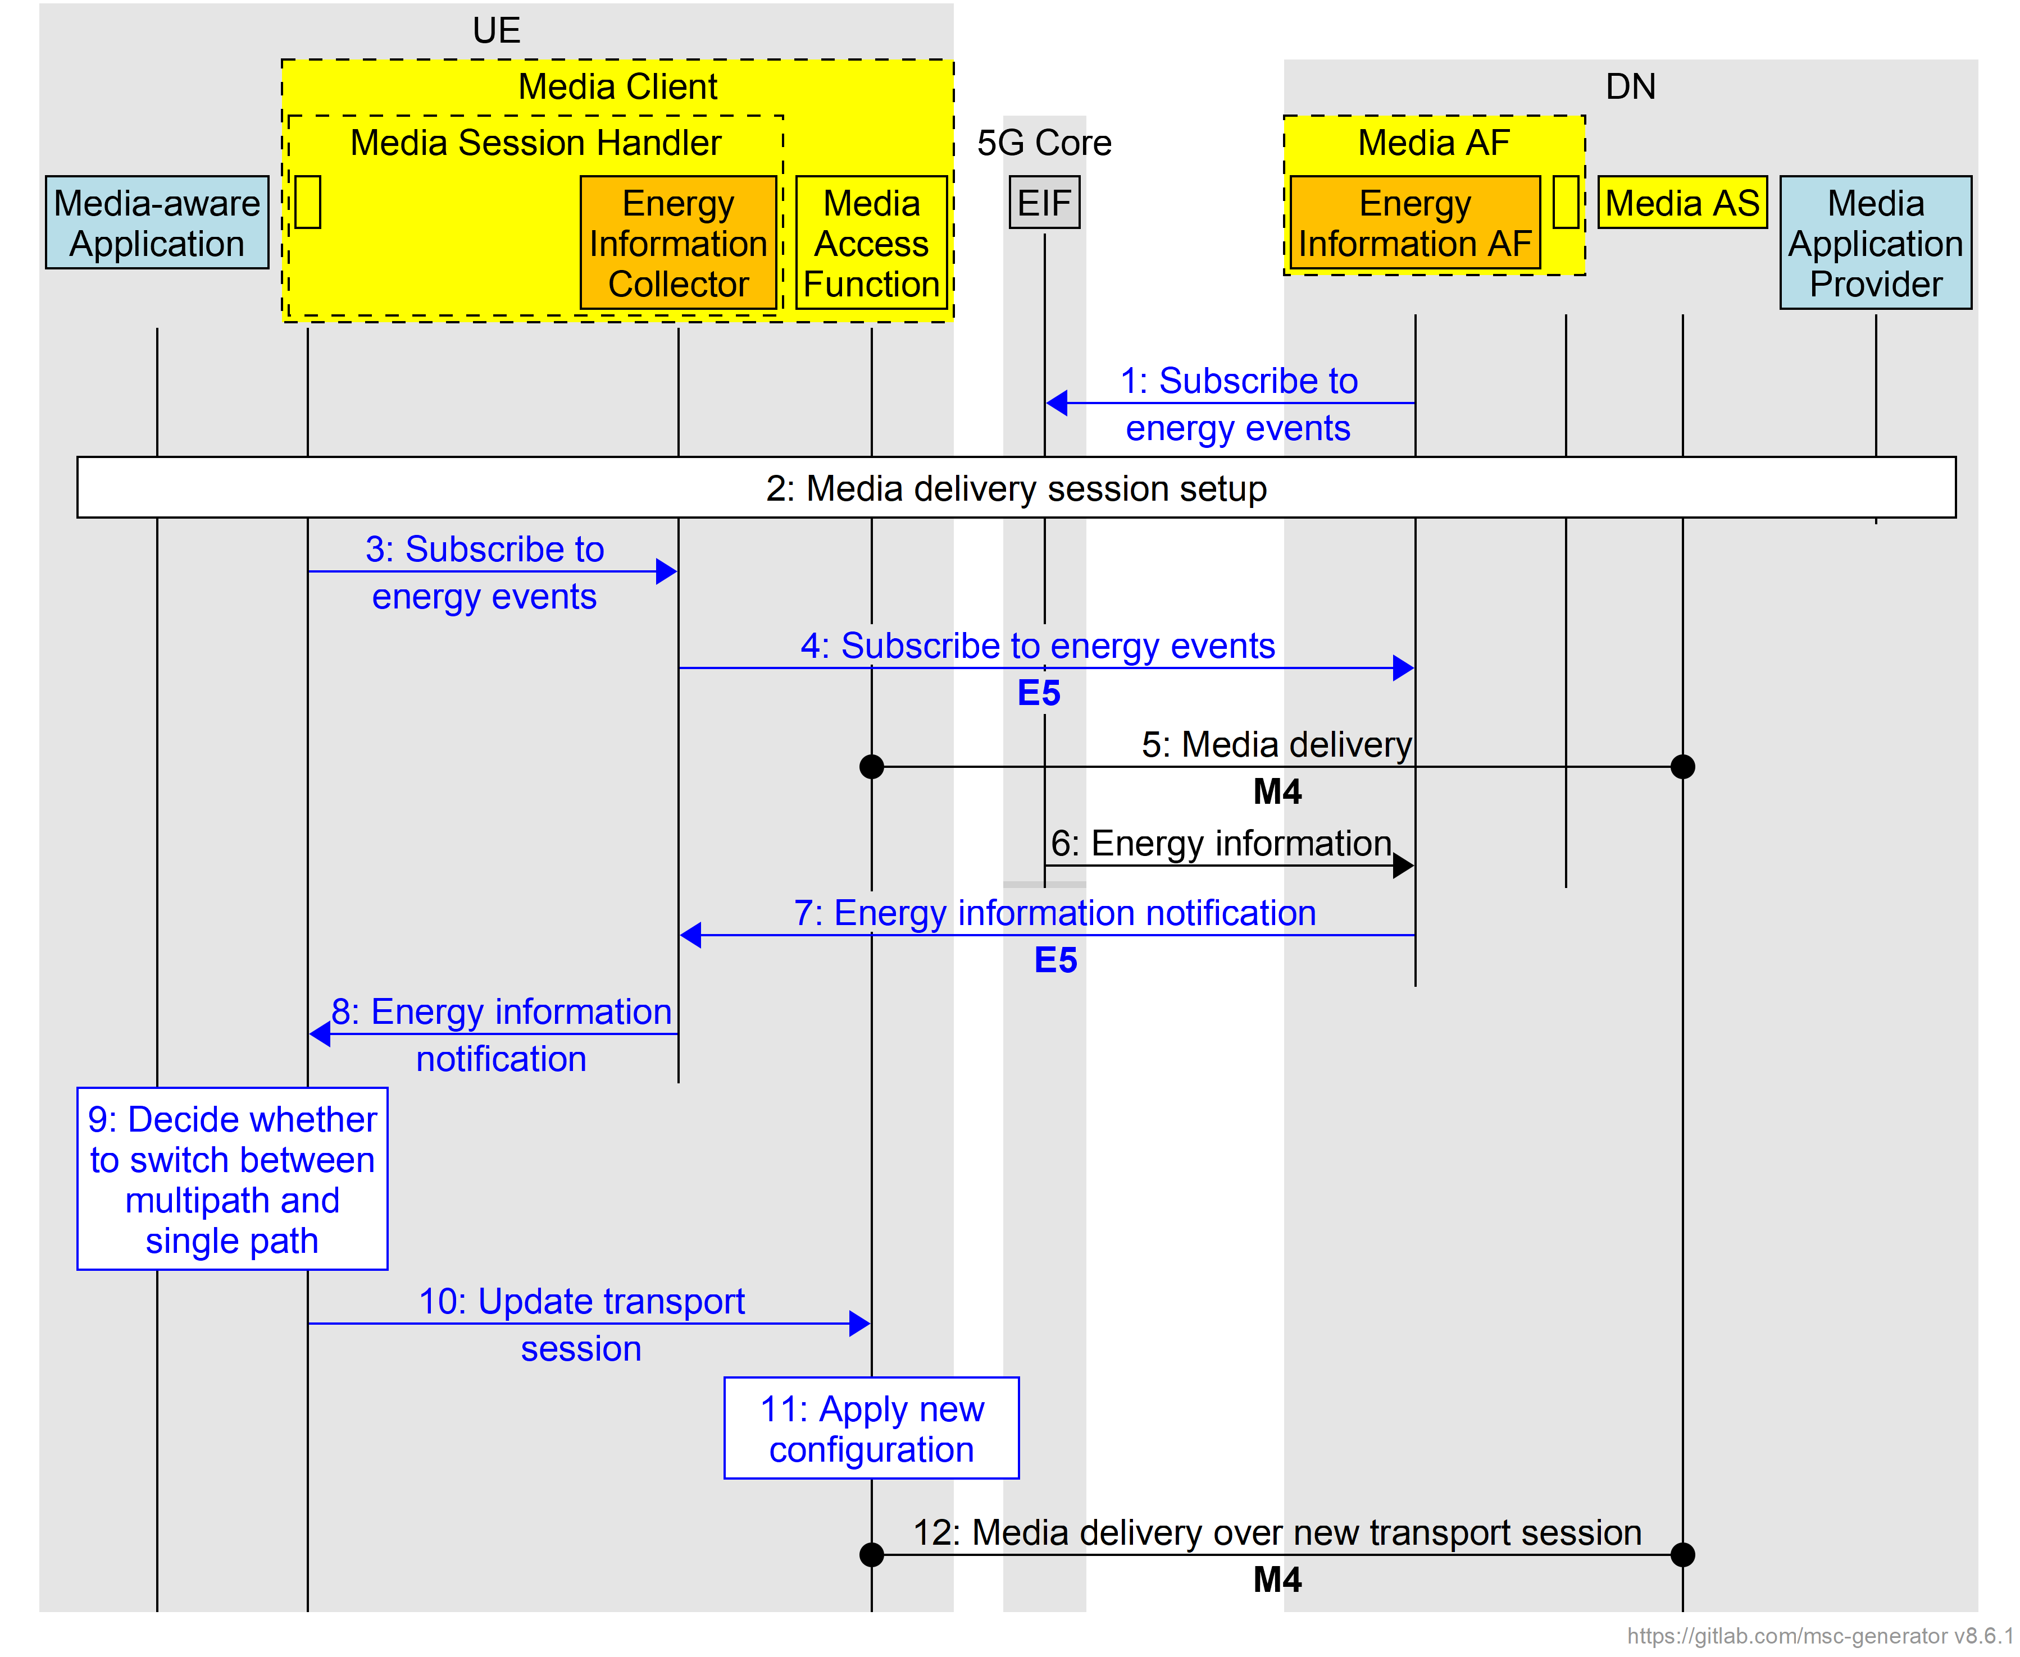
Figure 7.X.3-1: Procedures for client-driven switching of a Media Delivery session from multipath to a single path session
1. The Energy Information AF subscribes to receive energy events from the Energy Information Function as specified in clause 5.51.2.4 of TS 23.501 [23501].
2. A media delivery session is established between the media delivery architecture entities in the UE and those in the network. The Media delivery session may be using a multipath transport session as described in clause 5.18.4 of TR 26.804 [26804].
3. The Media Session Handler configures the Energy Information Collector to subscribe to energy events from the Energy Information AF using an internal client API.
4. The Energy Information Collector subscribes to receive energy events from the Energy Information AF over reference point E5.
5. M4 media flows are exchanged between the Media Access Function in the UE’s Media Client and the Media AS.
6. The Energy Information Function provides NF energy information related to the media delivery session to the Energy Information AF instantiated in the Media AF at different granularities, including per UE, as specified in clause 5.51.2.2 of TS 23.501 [23501]. If the media delivery session is conveyed over a Multi-Access PDU Session, the energy information includes a UE-specific estimate of energy consumption for each of the access networks that are being used by the media delivery session. (This information may be relayed via the NEF if the Media AF is untrusted.)
7. The Energy Information AF forwards the energy consumption information for the media delivery session to the Energy Information Collector instantiated in the Media Session Handler over reference point E5. The details of this energy information is described in clause 7.X.2.3 of the present document
8. The Energy Information Collector forwards the Energy information received in the previous step to the Media Session Handler using an internal client API.
9. The Media Session Handler and the Media-aware Application decide whether to switch between a multipath transport session and a single-path transport session. In making this decision, the Media-aware Application and the Media Session Handler may consider the energy consumption inside the UE to support the multipath session over multiple access networks along with the information received from the Media AF.
10. If needed, the Media Session Handler updates the transport session parameters as described in clause 13.2.4 of TS 26.512 [26512].
11. The Media Access Function applies the updated configuration to the media delivery transport session.
12. The Media Access Function in the UE Media Client and the Media AS switch to a new transport session for carrying the M4 application flows of the media delivery session.

7.X.4 Summary
Editor’s Note: TODO.

7.X.5 Potential normative work
Editor’s Note: TODO.
end of CHANGEs

