3GPP SA4 WG4 meeting #134 S4-251822r01

Dallas, Texas, 17-21 November 2025
CR-Form-v12.0
CHANGE REQUEST
 | 26.942 | CR | 0014 | rev | 0 | Current version: | 19.0.0
For HELP on using this form: comprehensive instructions can be found at
http://www.3gpp.org/Change-Requests.

Proposed change affects: | UICC apps |  | ME | X | Radio Access Network |  | Core Network | X

Title: | [FS_Energy_Ph2_MED] Solution for KI5 Media Application Server Energy management
Source to WG: | Nokia
Source to TSG: | S4
Work item code: | FS_Energy_Ph2_MED |  |  |  |  |  | Date: |  |  | 2025-11-17
Category: | B |  |  |  |  |  | Release: |  |  | Rel-20
 | Use one of the following categories:  F (correction)  A (mirror corresponding to a change in an earlier release)  B (addition of feature),  C (functional modification of feature)  D (editorial modification)  Detailed explanations of the above categories can  be found in 3GPP TR 21.900. |  |  |  |  |  |  |  | Use one of the following releases:  Rel-8 (Release 8)  Rel-9 (Release 9)  Rel-10 (Release 10)  Rel-11 (Release 11)  …  Rel-15 (Release 15)  Rel-16 (Release 16)  Rel-17 (Release 17)  Rel-18 (Release 18)
Reason for change: |  | Addtion of a solution to Key Issue 5 on Media Application Server Energy management.
Summary of change: |  | Addition of a clause 7.13 adding a solution to Key Issue #5 on Media Application Server Energy management.
Consequences if not approved: |  | KI#5 will not be solved.
Q
Clauses affected: |  | 7.1, 7.13
 |  | Y | N
Other specs |  |  | X | Other core specifications
affected: |  |  | X | Test specifications
(show related CRs) |  |  | X | O&M Specifications
Other comments:
This CR's revision history:

1ST Change

7.1 Mapping of Solutions to Key Issues
Table 7.1-1: Mapping of solutions to Key Issues
Solutions
 | KI#1 | KI#2 | KI#3 | KI#4 | KI#5 | KI#6
#1 |  |  | X
#2 |  |  | X
#3 |  | X
#4 | X
#5 | X
#6 | X | X
#7 | X
#8 |  | X
#9 | X
#10 |  |  |  |  |  | X
#11(a) |  |  |  |  | X
#11 (b) |  |  |  |  | X

These solutions are simply candidate solutions. Their inclusion in the following clauses does not imply that they have been agreed upon or endorsed. Any decisions and work to be done for the normative work will be detailed in the conclusions of this Technical Report.

2nd change
(All new text)

7.13 Solution #11 (b): Media Application Server (AS) selection based on energy characteristics

7.13.1 Key Issue mapping
This solution candidate addresses Key Issue #5 (Media Application Server Energy management) described in clause 6.5.

7.13.2 Functional description

7.13.2.1 Introduction
This candidate solution proposes a method that allows to re-selectApplication Servers (ASs) hosting different multimedia contents like audio codecs, video codecs, sensor servers from multiple different service locations to collaborate for (downlink) media delivery session when a UE client downloads multimedia contents such as video, audio and sensor signals from individual ASs service locations based on the UE application QoE requirements (e.g., resolution, bit rate, etc.) while taking also into account the various characteristics (e.g. AS load, AS energy consumption, AS current QoE metrics, etc.) of each individual ASs which are delivering the media contents. As a concrete example, "F-droid" is an Android app which allows the user to stream real-time sensor data from a UE to WebSocket clients, etc.
This solution leverages interfaces at existing reference points in the Media Delivery System enabling communication between a Media Application Provider and the 5G System, particularly for exchanging Quality of Experience (QoE) data. These interfaces are enhanced with network energy-related characteristics, allowing the Media Application Provider to use this information for service location reselection. In particular the solution leverages extensions for edge processing defined for the 5GMS System in clause 4.5 of TS 26.501 [26501] and for the RTC System in clause 6 of TS 26.506 [26506] in which instances of the Media AS are deployed as Edge Application Server (EAS) instances and they offer different service locations to the Media Client.

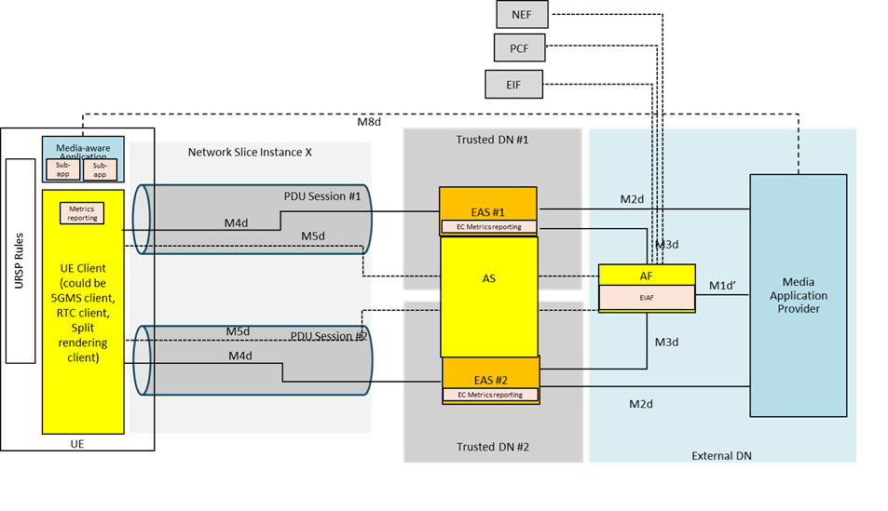
Figure 7.13.2-1: Illustration of application servers reselection based on energy characteristics
This collaboration scenario shown in figure 7.13.2-1 represents the case of accessing two different Data Networks using the same network slice. A CDN server (e.g., 5GMS AS service location) is either deployed in each of the trusted Data Networks, or presents a multi-homed interface at reference point M4 through each of the trusted DNs.
The Media Application Provider negotiates with the MNO to provision a network slice as described in clause 4.3 of TR 26.941. The operator provisions the network slice, and provides connectivity services to both the DNs through the slice.
The Media Application Provider may deliver Service Access Information through reference point M8. The Service Access Information delivered to the Media-aware Application may have information about different service locations accessible through each of the DNs. For example, an enterprise may utilise an enterprise-specific CDN (e.g., hosting enterprise-related video tutorials). 5G Media Streaming sessions for enterprise-related video tutorials use the PDU Session terminating in the enterprise-specific service location, while some other video tutorial requests are sent through PDU Sessions terminating at a different service location.
In the above architecture, how to relocate the Edge AS based on the QoE requirements of the UE in combination with energy usage/characteristics of the AS? Imagine a case when the media application is accessing media content from AS#1. Can the AF relocate the UE now to AS#2 based on: (a) the energy consumption of AS#1? (b) the QoE requirements of the application?
The Application Function (AF) may need to relocate the Edge AS considering different scenarios e.g. AS load, AS energy consumption, AS current QoE metrics, etc. In some deployments this would require collective relocation.

7.13.3 Procedures
Figure 7.12.3-2 below details the different steps for application server re-selection process.
Figure 7.13.3-1: Procedures for application server re-selection based on energy characteristics
The call flows and procedures are described below:
Assumption: The Application Provider may deliver Service Access Information through reference point M8. The Service Access Information delivered to the media aware Application may have information about different Service Operation Points accessible through each of the DNs. For example, an enterprise may utilise an enterprise-specific CDN (e.g., hosting enterprise-related video tutorials). 5G Media Streaming sessions for enterprise-related video tutorials use the PDU Session terminating in the enterprise-specific CDN, while some other video tutorial requests are sent through PDU Sessions terminating in a different CDN.
Scenario 1: Scenario 1 is where the Media Session Handler (MSH) provides the Media Player Entries to the Media Access Function (MAF) to choose the application server (AS) based on EC characteristics of the UE: It is described in detail below:
- In the below call flow, steps 1 to 8 are retained from TS 26.501, which is common steps followed to establish any media downlink session establishment.
- These steps follow the usual step-up while establishing a downlink media delivery session between the UE and the media application server. The media application requests a downlink media session, following which an downlink media session is established, and the media is transferred to the UE client from the Application Provider. Downlink media session starts at Step 8.
Step 9-11: Reporting UE-related and apps-related metrics.
- Based on Step 1 to 8, an on-going media session is established.
- Following this, once the session is established, in step 9, the UE periodically reports QoE metrics to the Media AF, configured via service access information.
- where UE provides application relevant metrics, limited to a certain duration of X ms, in order to protect the user privacy.
Step 12-17: Reporting Application Server related metrics.
- The EIAF requests the EIF to report the energy-related characteristics of individual application servers in step 12.
- Now in step 13, EIF collects (or retrieves) the energy-related information of each AS.
- In step 14, EIF reports this energy-related information to the EIAF.
- In step 15, the EIAF forwards this information to the AF.
- Based on this information, the AF now internally processes the received energy-related information about the ASs. This is carried out in step 16.
- In step 17, the AF maps the UEs with ASs, based on the BaseURL of the AS as well as based on the reported UE-related metrics and the AS energy-related information.
Step 18 to 25: Application Server re-selection based on the reported energy-related characteristics.
- In step 18, the AF sends the new configuration information to the UE client (Media session Handler), with the list of new available application servers (ASs) with their service locations, as per clause 5.19.3.3. of the present document. This could be sent as a meta-data to the UE client, via M5 interface via Service Access Information which may include Media Player Entry URLs and BaseURL of the AS endpoint.
- In step 19, the UE client is allowed to select another new AS most suitable for its current session without modifying the on-going session.
- This is done based on the information provided in the Media Player Entry by the Media Session Handler, the Media Access Function request a new energy-efficient AS and as a result a new AS is selected in step 20.
- The UE client sends a new request to modify the existing session to the AF in step 21, which is forwarded to the respective Application Server from the AF in step 22, as per clause 5.1 of TS 26.501.
- The existing media delivery session now successfully modified with the new AS in step 23.
- Media transfer continues in step 24.
Scenario 2: Steps 26 to 33: Scenario 2 is where the Application Function (AF) chooses the application server based on EC characteristics of the AS:
- Here, all steps are similar to alternative 1 mentioned above, except for step 26, where the application server selection is done by the AF.
- This selected AS is sent to the UE client without sending a list of available AS as meta-data in step 27.
- The UE client connects to the new Application Server (AS) in step 29.
- The UE client sends a new request to modify the existing session to the AF in step 31, which is forwarded to the respective Application Server from the AF in step 32.
- The existing downlink media delivery session now successfully modified with the new AS in step 33.
- Media transfer continues in step 34 and 35.

7.13.4 Summary
This candidate solution introduces a mechanism for enabling Media Application Providers to dynamically select the most energy-efficient Media AS service location based on the following factors:
- UE application and characterisation data: Information pertaining to the User Equipment (UE), factors such as, current QoE, and application-specific needs (e.g., resolution, bit rate).
- Energy efficiency metrics from Network Operator: Energy-related characteristics of the application servers, provided by the mobile network operator. These metrics, including server power consumption profiles and energy performance indicators, are transmitted through the Energy Information Function (EIF) to the Energy and Infrastructure Application Function (EIAF) within the Media Application Function (Media AF).

- Dynamic steering and load balancing by the Media AF: The Media AF serves as a steering entity that processes the collected data and applies intelligent algorithms to dynamically select the most energy-efficient server or delivery path. This ensures that the UE is routed to a Media AS service location with the optimal energy efficiency characteristics, based on both real-time network conditions and the UE’s application needs.
This approach aims to optimise the energy consumption of multimedia content delivery, particularly video streaming services, while maintaining service quality within defined thresholds.
By leveraging existing adaptive streaming protocols (e.g., MPEG-DASH and HLS), this solution can be seamlessly integrated into current infrastructure, providing an environmentally sustainable solution for mobile media delivery.
The solution operates entirely within the network layer, which involves the UE, QoE characteristics as the steering and optimisation mechanisms are fully supported by standard adaptive streaming frameworks. This ensures compatibility with existing adaptive streaming ecosystems, preserving end-user experience while reducing the environmental footprint of content delivery.
End of changes

