3GPP TSG-SA4 Meeting #134 S4-251818

Dallas, United States, 17th Nov 2025 - 21st Nov 2025 revision of S4aI250197
CR-Form-v12.4
CHANGE REQUEST
 | 26.942 | CR | 0008 | rev | 2 | Current version: | 19.0.0
For HELP on using this form: comprehensive instructions can be found at
https://www.3gpp.org/Change-Requests.

Proposed change affects: | UICC apps |  | ME |  | Radio Access Network |  | Core Network

Title: | [FS_Energy_Ph2_MED]: Solution for KI1 for collecting and reporting an Energy of Service Metric to authorized 3rd parties
Source to WG: | InterDigital France R&D, SAS
Source to TSG:
Work item code: | FS_Energy_Ph2_MED |  |  |  |  |  | Date: |  |  | 2025-11-10
Category: | B |  |  |  |  |  | Release: |  |  | Rel-19
 | Use one of the following categories:  F (correction)  A (mirror corresponding to a change in an earlier release)  B (addition of feature),  C (functional modification of feature)  D (editorial modification)  Detailed explanations of the above categories can  be found in 3GPP TR 21.900. |  |  |  |  |  |  |  | Use one of the following releases:  Rel-8 (Release 8)  Rel-9 (Release 9)  Rel-10 (Release 10)  Rel-11 (Release 11)  …  Rel-17 (Release 17)  Rel-18 (Release 18)  Rel-19 (Release 19)  Rel-20 (Release 20)
Reason for change: |  | Addtion of a solution to Key Issue 1 on Energy-related Collection and Reporting to the 5G media
Summary of change: |  | - Consider the comments during the SA4-SA4-e (AH) MBS SWG post 133-e (2025-10-23 - Online)  - Consider the BBC comments  - Propose architecture mappings in clause 7.5.2.2.1 and 7.5.2.2.2  - Propose procedures in clause 7.5.3
Consequences if not approved: |  | No collection and reporting mechanisms for Energy-related information
Clauses affected:
 |  | Y | N
Other specs |  |  |  | Other core specifications |  |  |  | TS/TR ... CR ...
affected: |  |  |  | Test specifications |  |  |  | TS/TR ... CR ...
(show related CRs) |  |  |  | O&M Specifications |  |  |  | TS/TR ... CR ...
Other comments:
This CR's revision history: |  | Revision of S4aI250197

1ST Change
…
[88] 3GPP TS 26.510: "Media delivery; interactions and APIs for provisioning and media session handling".
[89] 3GPP TS 26.531: "Data Collection and Reporting".
2ND Change
(All new text)

7.5 Solution #10: Energy-related metrics collection and reporting

7.5.1 Key Issue mapping
This Candidate Solution addresses Key Issue #1.

7.5.2 Functional description

7.5.2.1 Introduction
In line with [PR 1-1] of TR 26.942, this Candidate Solution to Key Issue #1intends to reuse existing 3GPP mechanisms for reporting an energy-related metrics and to extend them for the 5GMS System, as illustrated in figure 7.5.2.1-1.
Similar to QoE metrics, the new "Energy-of-Service" (EoS) metric is defined in the context of the Metrics Reporting provisioning feature at reference point M1 (see [88]). The Metrics Reporting Configurations provided by the Media Application Provider determines what energy-related information is to be collected and reported (to the instances listed) by the UE, Application Server and the Core Network, and how often.
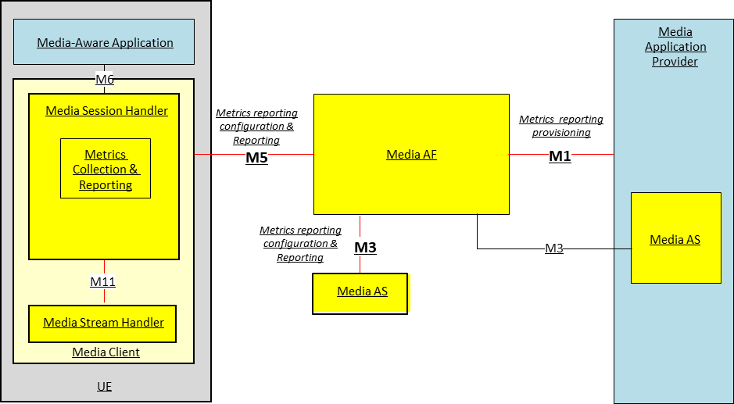
Figure 7.5.2.1-1 : Architecture for collection and reporting of Metrics in the 5G Media System
The reference points involved in the metrics reporting are defined as follows:
M1 Provisioning of Metrics Reporting Configuration in Media AF.
M5 Configuration of Media Client metrics reporting via the Media Session Handler and Media AF.and collection of Metrics Reports.
M3 Configuration of Media AS metrics reporting by Media AF and sending of Metrics Reports.

7.5.2.2 Metrics Reporting Configuration: extensions for Energy-of-media Service (EoS)
Up to and including Release 19, the Metrics Reporting Configuration resource defined in TS 26.501 [26501] is limited to configuring the reporting of Quality of Experience (QoE) metrics. This clause specifies extensions enabling Energy-related reporting (EoS metrics) in addition to QoE in table 7.5.2.2-1. Consequently, the scope of the Metrics Reporting Configuration is extended to cover either QoE metrics reporting or EoS metrics reporting.
Table 7.5.2.2-1: EoS extensions of the Metrics Reporting Configuration
Abstract element | Semantics / constraints (abstract)
Metrics scheme | Three additional EoS schemes are defined:  - carbon intensity; for which metrics are reported in $g CO_{2}$-e / $Wh$  - energy consumption for which metrics are reported in $Wh$  - power consumption, for which metrics are reported in. $W$.  The Media Application Provider may provision any number of the above metrics schemes, each with the separate set of Metrics Reporting Configuration parameters.  All three schemes indicate that the metrics to be collected and reported pertain to energy-related information reporting and determine the format of the Energy-Related metrics report submitted by the Media Session Handler for the UE energy information, by the EIF for the Core Network energy information and by the Media AS for the Application Server energy information. (See clauses 7.5.2.2.1 and 7.5.2.2.2 for architecture mapping proposal.)
Reporting scope | Scope of EoS metrics to be collected and reported:  - For each media delivery session, the sum of the energy metric value of all the components of the session during the sampling period.  - For each media delivery session, the energy metric value of all the components of the session or only the ones of content type given by the element “component content type” below  - Aggregated energy metric value across all the active sample media delivery sessions.
Component content types filter | MIME content types (e.g., video/mp4) used to filter components included in per‑component reporting.
Contribution ratio flag | If true, include contribution ratio information across UE, RAN, and CN in the report.
Metrics to be reported | A controlled vocabulary of EoS energy metrics to be reported. All three EoS schemes indicated by Metrics scheme share the same controlled vocabulary of metrics.
NOTE: When the metrics scheme of the Metrics Reporting Configuration indicates a QoE metrics scheme, behaviour remains as specified in Release 19; the EoS specific constraints above do not apply.

Note: The applicability of the Component content types filter to any metrics reporting scheme, not just energy-related ones is FFS.

7.5.2.2 Architecture mapping

7.5.2.2.1 Introduction
Two approaches for EoS Metrics Reporting are proposed.

7.5.2.2.2 Approach A
Approach A combines the metrics reporting architecture of Release 19 and a part of the architecture for collection and exposure of energy (see clause 7.6.2.2).
Figure 7.5.2.2.2-1 illustrates how Approach A could be instantiated.
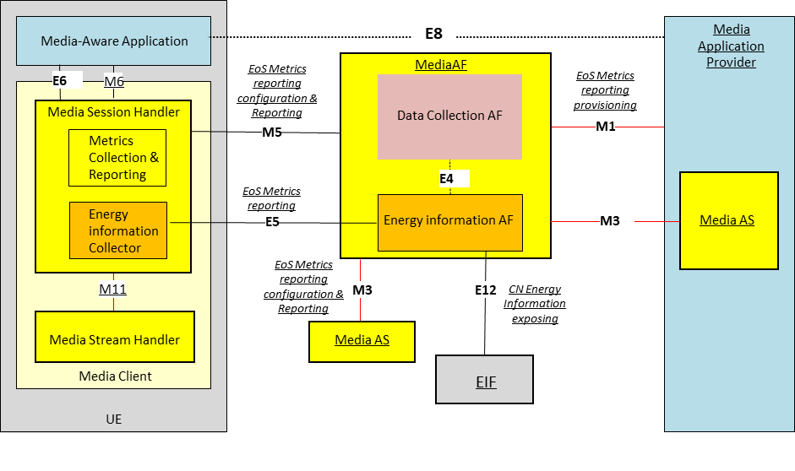
Figure 7.5.2.2.1-1: Metrics reporting feature in the Release 19 Metrics Reporting architecture updated with the generic reference architecture for collection and exposure of energy-related information (clause 7.6.2.2)
The following reference points are involved in the proposed approach A EoS Metrics Reporting:
M1 Network API used by the Media Application Provider to provision the Energy-of-Service Metrics Reporting Configuration to the Media AF. This determines whether and which energy-related information submitted by the Media Session Handler for the UE, the Media AS and the EIF for the Core Network. The Energy Information AF collects the Energy-related information and creates Energy-related information reports as it is in the Release 19 architecture.
E12 This reference point is used by the EIF to provide Energy-related information reports to the Energy Information AF instantiated in the Media AF. The Energy Information AF receives the information and creates the report aligned with the Energy-of-Service scheme of the configuration.
M3 After provisioning of Metrics Reporting in the Media AF and the configuration of Content Hosting in the Media AS, the Media AS obtains a client metrics reporting configuration embedded in the Service Access Information. Based on this configuration, the Media AS collects Energy-of-Service metrics, creates metrics reports aligned with the Energy-of-Service scheme of the configuration, and uses this reference point to transmit metrics reports to the Media AF which are passed to the Energy Information AF instantiated in the Media AF.
M5 Network API used by the Media Session Handler to obtain an Energy-of-Service Metrics Reporting configuration from the Media AF. The configuration information is embedded in Service Access Information. The Energy Information Collector instantiated in the Media Session Handler collects Energy-of-Service collected metrics, creates the metrics report aligned with the Energy-of-Service scheme of the configuration and uses the reference point to transmit metrics reports to the Media AF which are passed to the Energy Information AF instantiated in the Media AF.
E5 Network API used by the Energy Information Collector in the UE to subscribe to and receive Network Energy Information from the Energy Information Media AF. Network Energy Information exposed to the Energy Information Collector relates to a specific Application Service Provider. In particular, this API allows the UE to receive reports aligned with the Energy-of-Service scheme of the configuration from the Energy Information AF and propagate them to the Media-aware Application (via reference point E6) and, optionally, to the Media Application Provider(via reference point E8).
E4 Network API used by the Data Collection AF instantiated in the Media AF to subscribe to and receive Network Energy Information from the Energy Information AF instantiated in the Media AF. Network Energy Information exposed to the Data Collection AF relates to a specific Application Service Provider. In particular, this API allows the Data Collection AF to receive the reports aligned with the Energy-of-Service scheme of the configuration from the Energy Information AF instantiated in the Media AF, and to expose them to event consumers via reference points R5 and/or R6 (not illustrated)(see TS 26.531 specification).

7.5.2.2.3 Approach B
Approach B is based on the architecture for collection and exposure of energy (see clause 7.6.2.2) for Energy-of-Service metrics reporting at the exception of the M1 reference point for provisioning the EoS Metrics Reporting configuration to keep existing mechanism for the Media Application Provider.
Figure 7.5.2.2.2-1 illustrates how the approach B could be instantiated.
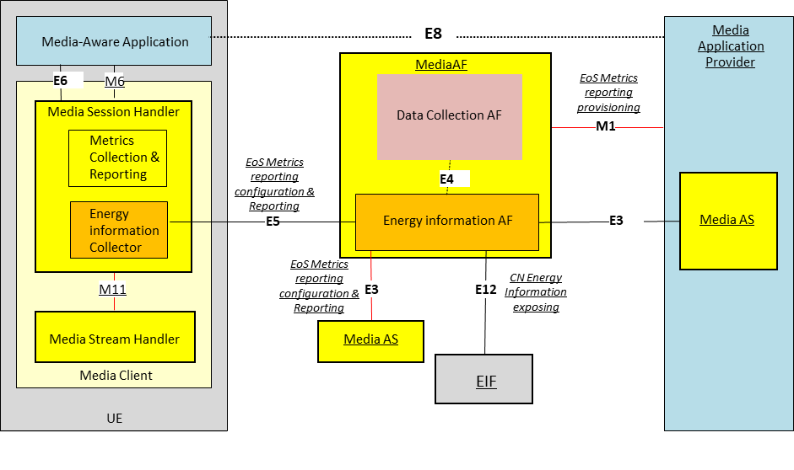
Figure 7.5.2.2.2-1: Metrics reporting feature with the overall generic reference architecture for collection and exposure of energy-related information (clause 7.6.2.2)
The following reference points are involved in the proposed EoS Metrics Reporting approach B:
M1 Network API used by the Media Application Provider to provision the Energy-of-Service Metrics Reporting Configuration to the Media AF. This determines whether and which energy-related information submitted by the Energy information Collector for the UE, the Media AS and the EIF for the Core Network. The Energy Information AF instantiated in the Media AF collects the Energy-related information and and creates Energy related information reports as it is in the Release 19 architecture.
Note: For backward compatibility of Metrics Reporting configuration provisioning, M1 is involved and the use of the reference point E1 is FFS.

E12 This reference point is used by the EIF to provide Energy-related information reports to the Energy Information AF instantiated in the Media AF. The Energy Information AF receives the information and creates the report aligned with the Energy-of-Service scheme of the configuration.
E3 After provisioning of Metrics Reporting in the Media AF and the configuration of Content Hosting in the Media AS, the Energy-of-Service Metrics Reporting configuration is obtained by the Media AS from the Energy information AF instantiated in the Media AF. Based on this configuration, the Media AS collects Energy of Service metrics, creates metrics reports aligned with the Energy-of-Service scheme of the configuration and uses this reference point to transmit the report to the Energy Information AF instantiated in the Media AF.
E5 Network API used by the UE Energy Information Collector instantiated in the Media Session Handler to obtain an Energy-of-Service Metrics Reporting configuration from the Energy Information AF. The configuration information is embedded in Service Access Information. The Energy Information Collector fetches the collected Energy-of-Service metrics, creates the metrics report aligned with the Energy-of-Service scheme of the configuration and uses the reference point to transmit the report to the Energy Information AF. This API also allows the UE Energy Information Collector to receive the aggregated reports aligned with the Energy-of-Service scheme of the configuration from the Energy Information AF and propagate to the Media-aware application (via reference point E6) and optionally, to the Media Application Provider(via reference point E8).
E4 Network API used by the Data Collection in AF to subscribe to and receive Network Energy Information from the Energy Information AF. Network Energy Information exposed to the Data collection relates to a specific Application Service Provider. In particular, this API allows the Data Collection AF instantiated in the Media AF to receive the aggregated reports aligned with the Energy-of-Service scheme of the configuration from the Energy Information AF, and to expose them to event consumers via reference points R5 and/or R6 (not illustrated)(see TS 26.531 specification)..

7.5.3 Procedures

7.5.3.1 Approach A procedures
Figure 7.5.3.1-1 below details the different steps for Energy-of-Service Metrics Reporting for the Approach Ain the system outlined in clause 7.5.2.2.2 (based on figure 5.5.3-1 of TS 26.501 [26501] but updated to generalise):
Figure 7.5.3.1-1: Procedures for Energy-of Service collection and reporting
The steps of the call flow are as follows:
1: The Media AF is provisioned with the Energy of Service metrics reporting configuration by the Media Application Provider, each pertaining to metrics collection by the Media Player and the EIF and the Media AS functions. The configuration is transmitted to the Energy Information AF to collect and generate the metrics reports regarding required post-processing functionality and deliver to the Media Application Provider. The Energy Information AF subscribe to the EIF network function to get the Energy-related information from the Core Network.
2: The Media-Aware Application triggers the Service Announcement and Content Discovery procedure. The Service Announcement includes the whole Service Access Information that contains metric configuration information for Energy of Service scheme
3: Time passes until the UE initiates session establishment and media playback.
4: The Media-Aware Application informs the Media Player of impending media playback.
5a: The Media Player requests the establishment of a streaming session with the Media Session Handler which acknowledges the request.
5b: The Media Session Handler requests the establishment of a streaming session with the Media AF which confirms the streaming session establishment.
5c: The Media Session Handler informs the Media Player of the successful set-up of the streaming session.
6: Media playback pipeline is set up between the Media Player, the Media AS and the Application Provider.
7: The Service Access Information is retrieved by the Media AS to get the Energy of Service Metrics Reporting configuration.
8: The Service Access Information is retrieved by the Media Session Handler to get the Energy of Service Metrics Reporting configuration.
9: The Media Session Handler queries the Media Player on its capability to perform metrics collection (measurement and logging function) in accordance with Energy of Service scheme as defined by its Metrics Reporting configuration. At this step it is checked if the Media player can support the reporting of Energy of Service metric.
10: The Media Player acknowledges its support for the collection of the required metric of the configured scheme.
During the course of media playback, steps 11–23 below may be repeated, depending on the duration of the playback and the frequency of metrics reporting as set by the metrics configuration for the Energy of Service scheme.
11: Assuming a live streaming service, media content is delivered via push ingest from the Media Application Provider to the Media AS.
12: Causing the Media AS to initialize and begin countdown of Energy of Service metrics reporting interval timer for Energy of Service scheme.
13: The Media Player fetches media content from the Media AS and begins media playback.
14: The Media Player notifies the Media Session Handler of the start of media playback, causing the Media Session Handler to initialize and begin countdown of separate metrics reporting interval timers for the Energy of Service scheme.
15: Upon expiration of the timer (associated with the Energy of Service scheme), the Media AS retrieves the logged metrics measurements according to scheme.
16: The Media AS reports the logged metrics measurements to the Media AF and subsequently to the Energy Information AF sub-entity.
17: The EIF network function of the Core Network publishes the Energy related Information to the Energy Information AF sub-entity.
18: The Energy Information AF processes the information according to the Energy of Service scheme
19-20: Upon expiration of the timer (associated with the Energy of Service scheme), the Media Session Handler retrieves the logged metrics measurements from the Media Player according to Energy of Service scheme.
21: In accordance with its metrics reporting configuration as provisioned in step 1, a metrics report for Energy of Service scheme is sent from the Media Session Handler to the AF and subsequently to the Energy Information AF sub-entity.
22: In accordance with its metrics reporting configuration as provisioned in step 1, the Media AF performs the aggregation of the logged metrics measurements received from the Media Session Handler, the Media AS and the EIF network function and perform post-processing in accordance with the Energy of Service scheme(e.g. filtering, aggregation, reformatting, privacy).
23: The Energy Information AF publishes the final Energy of Service Metric reports to the Media Application Provider.
24: Optionally, the Energy Information AF publishes the final Energy of Service Metric reports to the UE Energy Information Collector via reference point E2 reference point to allow the UE to report to the Application.
25: Optionally, the Energy Information AF publishes the final Energy of Service Metric reports to the AF Data Collection thru E4 reference point to allow the existing Data Collection function to expose the Energy of Service information as it is in the state of the art.
Upon the termination of media playback (as notified by the Media-Aware Application to the Media Player) a final round of metrics collection and reporting is performed.

7.5.3.2 Approach B procedures
Figure 7.5.3.2-1 below details the different steps for Energy-of-Service Metrics Reporting for the Approach B in the system outlined in clause 7.5.2.2.3 (based on figure 5.5.3-1 of TS 26.501 [26501] but updated to generalise):
Figure 7.5.3.2-1: Procedures for Energy-of Service collection and reporting
The steps of the call flow are as follows:
1: The Media AF is provisioned with the Energy of Service metrics reporting configuration by the Media Application Provider, each pertaining to metrics collection by the Media Player and the EIF and the Media AS functions. The configuration is transmitted to the Energy Information AF to collect and generate the metrics reports regarding required post-processing functionality and deliver to the Media Application Provider. The Energy Information AF subscribe to the EIF network function to get the Energy-related information from the Core Network.
2: The Media-Aware Application triggers the Service Announcement and Content Discovery procedure. The Service Announcement includes the whole Service Access Information that contains metric configuration information for Energy of Service scheme
3: Time passes until the UE initiates session establishment and media playback.
4: The Media-Aware Application informs the Media Player of impending media playback.
5a: The Media Player requests the establishment of a streaming session with the Media Session Handler which acknowledges the request.
5b: The Media Session Handler requests the establishment of a streaming session with the Media AF which confirms the streaming session establishment.
5c: The Media Session Handler informs the Media Player of the successful set-up of the streaming session.
6: Media playback pipeline is set up between the Media Player, the Media AS and the Application Provider.
7: The Service Access Information is retrieved by the Media Session Handler to get the Energy of Service Metrics Reporting configuration.
8: The Media AF set the Energy of Service Metrics Reporting configuration to the Energy Information AF.
9: The Energy Information AF set the Energy of Service Metrics Reporting configuration to the Media AS via reference point E3.
10: The Media Session Handler set the Energy of Service Metrics Reporting configuration to the Energy Information Collector.
11: The Energy Information Collector queries the Media Player on its capability to perform metrics collection (measurement and logging function) in accordance with Energy of Service scheme as defined by its Metrics Reporting configuration. At this step it is checked if the Media Player can support the reporting of Energy of Service metric.
12: The Media Player acknowledges its support for the collection of the required metric of the configured scheme.
During the course of media playback, steps 13–23 below may be repeated, depending on the duration of the playback and the frequency of metrics reporting as set by the metrics configuration for the Energy of Service scheme.
13: Assuming a live streaming service, media content is delivered via push ingest from the Media Application Provider to the Media AS.
14: Causing the Media AS to initialize and begin countdown of Energy of Service metrics reporting interval timer for Energy-of-Service scheme.
15: The Media Player fetches media content from the Media AS and begins media playback.
16: The Media Player notifies the Media Session Handler of the start of media playback, causing the Media Session Handler to initialize and begin countdown of separate metrics reporting interval timers for the Energy of Service scheme.
17: Upon expiration of the timer (associated with the Energy of Service scheme), the Media AS retrieves the logged metrics measurements according to scheme.
18: The AS reports the logged metrics measurements to the Energy Information AF.
19: The EIF network function of the Core Network publishes the Energy related Information to the Energy Information AF sub-entity.
20: The Energy Information AF processes the information according to the Energy of Service scheme.
21-22: Upon expiration of the timer (associated with the Energy of Service scheme), the UE Energy Information Collector retrieves the logged metrics measurements from the Media Player according to Energy of Service scheme.
23: In accordance with its metrics reporting configuration as provisioned in step 1, a metrics report for Energy of Service scheme is sent from the UE Energy Information Collector to the Energy Information AF.
24: In accordance with its metrics reporting configuration as provisioned in step 1, the Energy Information AF performs the aggregation of the logged metrics measurements received from the UE Energy Information Collector, the Media AS and the EIF network function and perform post-processing in accordance with the Energy of Service scheme (e.g. filtering, aggregation, reformatting, privacy).
25: The Energy Information AF publishes the final Energy of Service Metric reports to the Media Application Provider.
26: Optionally, the Energy Information AF publishes the final Energy of Service Metric reports to the UE Energy Information Collector thru E5 reference point to allow the UE to report to the Application.
27: Optionally, the Energy Information AF publishes the final Energy of Service Metric reports to the AF Data Collection thru E4 reference point to allow the existing Data Collection function to expose the Energy of Service information as it is in the state of the art.
Upon the termination of media playback (as notified by the Media-Aware Application to the Media Player) a final round of metrics collection and reporting is performed.

7.5.4 Impacts on existing services, entities and interfaces

7.5.4.1 Media AF
In both approaches, the Media AF would be required to support an Energy of Service Metrics Reporting Configuration as part of the Metrics Reporting Configuration.

7.5.4.2 Energy Information AF
The Energy Information AF is instantiated as a subfunction of the Media AF to collect energy-related information per application, per media session, and per media component, at multiple granularities and across UE, CN, and AS domains at reference points M3, M5 and E12 for approach A and at reference points E3, E5 and E12 for Approach B.
Collected information can be reported by the existing mechanisms of the Release 19 architecture.
Collected information can be reported to the UE Energy Information Collector instantiated within the Media Session Handler to be propagated to the Media-aware Application at reference point E6 and, optionally, to the Media Application Provider at reference point E8.
Collected information can be reported to a Data Collection AF instantiated within the Media AF via the reference point E4 prior to exposure to authorized third parties, privacy-preserving post-processing being applied.

7.5.4.3 Reference point M1
In both approaches, at reference point M1, the Media Application Provider shall instantiate a Metrics Reporting Configuration resource associated with the target Provisioning Session to enable Energy-of-Service-Service collection and reporting
End of changes

