3GPP TSG-SA WG4 Meeting #134 S4-251812r01 is revision of S4-251401
Dallas, Texas, 17-21 November 2025

Source: Nokia
pCR Title: SDP answer when DC application is not available
Draft Spec: 3GPP TS 26.114
Agenda item: 7.4
Document for: Discussion and agreement
Contact:

1. Introduction
In S4-250008 SA2 has discussed one scenario of standalone IMS data channel session in which an originating UE initiates SIP INVITE request towards terminating UE with an initial SDP offer including BDC media, ADC media, and APP ID associated with the ADC. In this scenario, if the DC application is not available, i.e., needs to be downloaded by the terminating UE, it needs to indicate in the SDP answer to the initial SDP offer that the ADC is not able to be established due to downloading required.
A liaison was sent to SA4 where SA2 has asked SA4 to provide feedback on how to specify the required response as depicted above, in the SDP response to the received SDP offer. SA4 has replied to the liaison to SA2 in S4-251403 and in this discussion paper, we give detailed explanations on this.

2. Discussions
- SDP Offer and SDP Answer
The Session Description Protocol's (SDP) Offer/Answer Model is used by two entities to reach agreement on session description, such as which media streams are in the session, the codecs, etc. The offerer indicates the desired session description in the offer. The answerer replies to the offer by indicating the desired session description from the answerer's viewpoint. The Offer/Answer Model can be used to create sessions or to modify an existing session. There are, however, restrictions on what can appear in an offer and answer. The Offer/Answer Model is described in more detail in RFC3264.
The current core specification for SDP itself is RFC8866, though as this was only published in 2021 most implementations are based on RFC4566 (the previous version). The other core specification is one that defines how SDP negotiation between two entities is performed, which is the basis of SDP’s usage in SIP, WebRTC, etc. This is currently defined in RFC3264, which defines the SDP Offer/Answer Model.
- The a=3gpp-req-app SDP attribute
When a DCMTSI client in a UE (sometimes DCMTSI client and UE are used interchangeable) initiates the addition of application data channel(s) to a call with a peer DCMTSI client for different applications, the SDP offer/answer shall identify the applications and which data channels are to be created for them by signaling the identification for that application via the media level "a=3gpp-req-app" attribute added to the media lines describing application data channels for the application as discussed in section 6.2.10.1 of TS 26.114. The application identification can be included in the data channel application.
Both DCMTSI clients negotiating application data channels for a call between them shall identify the application requesting application data channel(s) to be established via the "req-app-id" parameter of an "a=3gpp-req-app" media-level SDP attribute that conveys a value set by the application launched on a UE, and configured on that application when it is made available for retreival via a bootstrap data channel. The "a=3gpp-req-app" attribute may also include an "endpoint" parameter to allow the UEs to identify the endpoints for the application data channels used for communication to a network server or to the remote UE. The combination of "req-app-id" and "app-dc-info" parameters allows the communicating UEs to bind the offers and answers for each data channel being negotiated for the identified application. When applications already retrieved by a UE still need to be retrieved by the remote UE as part of a call upgrade (re-INVITE), the "a=3gpp-req-app" attribute may also include a "bootstrap" parameter with a value that identifies the bootstrap stream ID from where the remote UE receiving an SDP offer would retrieve the corresponding application.
- The a= “inactive” SDP attribute
In the context of the 3GPP TS 26.114 specification, the attribute a=inactive in Session Description Protocol (SDP) plays a crucial role in signalling when a media stream should be "inactive" or not transmitted.
The attribute a=inactive is used within an SDP message to indicate that a particular media stream should be considered inactive, i.e., it is not intended to carry any media traffic. This is typically used to signal that no media transmission will occur for a given stream, even though the session is still being established or remains open.
In the context of 3GPP TS 26.114, the a=inactive attribute in this context is specifically used for situations where:
- No Media Transmission Expected: The media stream is not active, and no data will be transmitted for that stream. This can happen in cases where the media session is still being negotiated, or a participant might choose not to send or receive media at the moment, but they wish to maintain the session.
- Resource Management: It is a way to signal the system that no bandwidth or resources are needed for the particular stream, which can be helpful in managing resources, especially in situations like multimedia messaging or during the negotiation phase of a session.
- Partial Media Offer: Sometimes, the offer for the session may include multiple media streams, but not all of them are active at the moment. For example, a user may send a message with a media stream for video, but not immediately want to activate the video stream for transmission. Using a=inactive in the SDP would tell the other party that the video stream should not be used at that time.

Example of SDP with a=inactive:
Here's an example of an SDP offer that includes an inactive media stream:
SDP offer
v=0
o=- 2890844526 2890842807 IN IP4 192.0.2.1
s=Session SDP
c=IN IP4 192.0.2.1
t=0 0
m=audio 49170 RTP/AVP 0
a=inactive
m=video 51372 RTP/AVP 99
a=inactive

In this example:
- The audio and video streams are both included in the SDP offer.
- However, the a=inactive attribute indicates that neither the audio nor the video stream is active at the moment. These streams are part of the session, but no media will be transmitted for them unless the session's status changes.
In summary, the a=inactive attribute in 3GPP TS 26.114 is used within an SDP message to signify that a media stream is currently inactive, meaning no media will be transmitted on that stream. It helps in negotiating the setup of a session where some streams may not be actively used, but the session still includes them for future potential use. This is particularly useful in resource management and for partial session negotiation, ensuring that media streams are managed according to the session’s requirements.
In SA4#133-e, a= inactive was proposed as a solution to the question asked by SA2 in S4-250008. It was suggested that on receiving an offer for an application DC for an application identified by the a=3gpp-req-app SDP attribute, a terminating UE may indicate that an IMS DC app is not downloaded yet by replying with an SDP answer with a=inactive attribute under the m line corresponding to the application data channel. We believe this solution does not answer the question from SA2 as a=inactive for data channels is not defined and using it would be ambiguous as it does not tell the offering UE that the IMS DC application has not been downloaded yet. Given the current definitions for a=inactive and the usage proposed in SA4#133-e an offering UE cannot distinguish between the following scenarios:
i. Terminating UE possesses the application identified by a=3gpp-req-app and accepts the other data channel configurations (e.g., qos hints, latency and jitter configurations) in the offer, but desires not to start data transmission.
ii. Terminating UE does not possess the application identified by a=3gpp-req-app and does not know whether to accept the other data channel configurations (e.g., qos hints, latency and jitter configurations) in the offer.
iii. Terminating UE is downloading the application identified by a=3gpp-req-app and wishes to establish the application data channel when the application has been downloaded with same or different data channel configurations.
iii. Terminating UE cannot download the application identified by a=3gpp-req-app from its “home” MF but wishes to establish the application data channel when the application has been downloaded.
In summary, we believe using a=inactive instead of informing UE1 of whether the IMS DC application identified by a=3gpp-req-app is available, introduces ambiguity in the SIP dialogue, possibly making it unnecessarily longer and impacting session startup latency.

2.1 Problem statement
TS 26.114 gives a detailed description of generating SDP offer from an originating client in clause 6.2.10.2, generating SDP answer from the terminating client in clause 6.2.10.3 and receiving SDP answer from the terminating client to the originating client in clause 6.2.10.4.
When a DCMTSI client initiates the addition of application data channel(s) to a call with a peer DCMTSI client for different applications, the SDP offer/answer shall identify the applications and which data channels are to be created for them by signalling the identification for that application via the media level "a=3gpp-req-app" attribute added to the media lines describing application data channels for the application as discussed in section 6.2.10.1 of TS 26.114. The application identification can be included in the data channel application.
Both DCMTSI clients negotiating application data channels for a call between them shall identify the application requesting application data channel(s) to be established via the "req-app-id" parameter of an "a=3gpp-req-app" media-level SDP attribute that conveys a value set by the application launched on a UE, and configured on that application when it is made available for retrieval via a bootstrap data channel. When an offerer sends an initial offer, for a data channel, the offerer shall include an “a=3gpp-req-app” attribute associated with the data channel in the "m=" section used to realize the data channel, as discussed in section 6.2.10.1 of TS 26.114.
However, one scenario of standalone IMS data channel session in which offerer initiates SIP INVITE request towards the answerer with an initial SDP offer including BDC media, ADC media, and APP ID associated with the ADC. In this scenario, if the DC application is not available, i.e., needs to be downloaded by the terminating UE, it needs to indicate in the SDP answer to the initial SDP offer that the ADC is not able to be established due to downloading required. This is illustrated below:

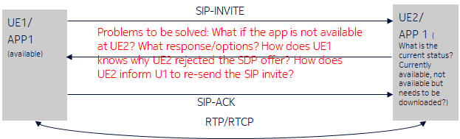
Figure 1: illustration of a scenario when DC app is not downloaded at the terminating end.

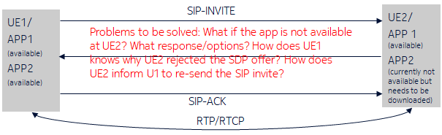
Figure 2: illustration of a scenario of two DC apps when one DC app is not downloaded at the terminating end.

2.2 Proposed solution
At a high level, the proposed solution enables a terminating UE, which receives an SDP offer from an originating UE to establish an IMS DC application channel for an app it has not downloaded yet, to respond to the offer with additional information informing the originating UE that the terminating UE cannot accept the offer because the app must be first downloaded. After the terminating UE has successfully downloaded the app, it updates the session towards the originating UE and informs the originating UE that it has now downloaded the app, and the ADC can be established (either from originating or terminating UE).
To convey the information about availability of an app in the UE, we propose a new a-line attribute to be added in the SDP answer:
- a=3gpp-req-app-hint
When a UE initiates an IMS session containing application data channel(s) with a peer UE and at least one of the applications is currently not available at the terminating UE, the SDP answer from the terminating UE shall indicate the applications that are currently not available via the media level "a=3gpp-req-app-hint" attribute. The terminating UE shall include the newly proposed “a=3gpp-req-app-hint” attribute and indicate to the originating UE that the application is currently being downloaded via the "req-app-status" parameter of an "a=3gpp-req-app-hint" media- level SDP attribute. The "a=3gpp-req-app-hint" attribute may also include a " pending" parameter to allow the originating UE to identify the current progress of the application to which the SDP offer has been sent.. This could be shown below:
a=3gpp-req-app-hint: status= "pending””
The newly proposed parameters and values for the SDP “a=3gpp-req-app” attribute enhances the method on how a terminating UE can reply to an offer for establishing an application data channel associated with an IMS DC application identified by the “3gpp-req-app-id” value of a “3gpp-req-app” parameter in the SDP, by enabling the terminating UE to indicate the reason for accepting, denying or delaying the establishment of the offered application data channel. The reasons may include the status of availability of the IMS DC application at the terminating UE. The proposed solution enables UEs to identify the availability of the applications for which a new offer for data channel is sent. The inclusion of an identification in the SDP Offer/Answer about the availability of application would resolve ambiguities for the UEs participating in the call to better understand how long to wait and when to re-send an SDP offer after an initial offer has been sent. This solution captures the changes to TS 26.114 to include this information via the SDP. Through this new attribute to the SDP offer/answer exchanges, we enable UEs to identify applications which are present or not and bind them to the data channels established for the respective applications.
As stated above, we provide solutions to the two potential scenarios described in figure 3 and figure 4.
For scenario 1, the case of only one app, when the originating UE1 sends an offer to a terminating UE2 after the establishment of BDC, an example call flow is shown below:
- UE1 establishes bootstrap data channel; downloads the application list from the Dc repository (local or remote)
- UE2 establishes bootstrap data channel; downloads the application list from the Dc repository (local or remote)
- UE1, after downloading the app1 sends a SIP INVITE to establish an ADC to UE2 app1 ( without knowing any information about app1 in UE2).
- UE2 which has not yet downloaded the app1, now decides to inform this to UE1, via the newly proposed a=3gpp-req-app-hint.
- UE1 is now aware of the availability information of app1 on UE2 side.
  - There are two options here:
    - Either UE1 re-invites UE2 after the expiry of the timer, based on the value indicated in the “pending” parameter
    - UE2 updates UE1 about the status of the app, in this case the “pending” parameter need not be sent to UE1.
- UE1 waits till the progress about app 1 on UE2 is known. (this could be several options, for example, notified with waiting timer)
- UE1 upon expiry of the timer, now re-invites a SDP offer to UE2 (which has now the app downloaded).
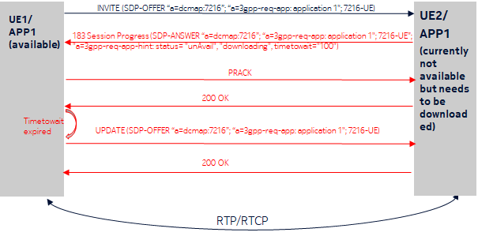
Figure 3: Illustration of UPDATE with SDP offer from originating UE for the case of only one application on both ends

For the scenario 2, the case of only two apps (app1 and app2), when the originating UE1 sends an offer to a terminating UE2, where UE 1 has app 1 and app2 downloaded, but UE2 has only app1 downloaded but app 2 is not yet downloaded , an example call flow is shown below:
An example call flow is shown below:
- UE1 sends SIP INVITE with one SDP offer containing a-lines for 2 apps. We assume app2 is not downloaded so far in UE2, but app1 is available locally in UE2.
- UE2 sends SIP 183 message to UE1 indicating in the SDP answer that app2 is not available and app1 is available.
- UE1 responds with PRACK.
- UE2 downloads app2.
- Option 1: UE2 sends SIP UPDATE with new SDP offer to UE1 containing a-lines for app1 and app2 to establish/update ADC for app1 and app2. UE1 answers with 200 OK to the UPDATE, UE2 sends 200 OK to the INVITE (shown in the below call flow Option 1).
- Option 2: UE1 sends UPDATE with SDP offer for both apps to UE2 once the wait timer provided by UE2 has expired. UE2 responds with 200 OK to the UPDATE. (shown in the below call flow Option 2).
Option 1:
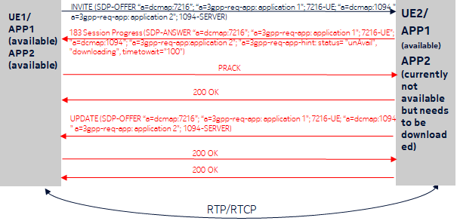
Figure 4: Illustration of SIP UPDATE with SDP offer from terminating UE for Option 1

Option 2:
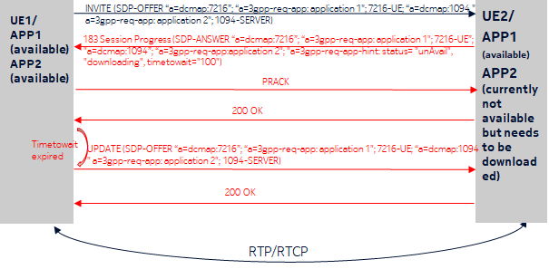
Figure 5: Illustration of SIP UPDATE with SDP offer from originating UE for Option 2

Call flows above demonstrate an example SDP offer that adds an application data channel (ADC) stream used by a data channel application retrieved via the bootstrap data channel. In the above SDP signaling example, as it could be seen, UE1 sends an SDP offer to UE2. The SDP offer is for 2 different applications, application 1 and application 2. Application 1 and 2 uses one application data channel on that same SDP media description for communication with different end points, via the different "adc-stream-id-endpoint" parameter values, e.g., a server versus the remote UE. In this case, UE2 will respond to UE1 accepting the offer for application 1 since application 1 is currently available. In case of application 2, as per the state of the art, there is no solution yet. As per our proposed solution, UE2 will now be able to indicate to UE1 that application 2 is currently unavailable and must be downloaded and the waiting time to download is for instance 10 seconds. This SDP response could be, for example, sent as below:

SDP-ANSWER a=3gpp-req-app:"application 2";1094-Server
SDP-ANSWER a=3gpp-req-app-hint: status= "pending” ms"

Following this SDP response, UE1 now an idea about the offer sent for the application data channel(s) to a call with UE2 for application2 which is currently not available at the terminating DCMTSI client. Therefore, UE1 will acknowledge this and re-send an SDP offer for application 2 after the waiting time. Following this, UE2 could either accept the offer if the download process is completed or will again inform the progress of download to UE1 by updating the a=3gpp-req-app-hint attribute.
3. Example
Table A.17.12 demonstrates an example SDP (re-)offer that adds two application data channel streams used by two new data channel applications retrieved via the bootstrap data channel in Table A.17.5. The data channel application streams are three in this example, and they also terminate on different endpoints, e.g., on a server and on the remote UE, but the offering UE uses data channel multiplexing and the data channel application streams are therefore multiplexed on the same SDP media description. The applications using these data channels are identified by the three "a=3gpp-req-app" lines which also indicate in this example that the three data channels are intended for communication with different end points, via the different "adc-stream-id-endpoint" parameter values, e.g., a server versus the remote UE. In this example, application1 multiplexes two application data channels in this SDP media description and application2 uses one application data channel on that same SDP media description.
Table A.17.12: Example SDP offer with multiplexed data channel application streams
SDP offer
c=IN IP4 192.0.2.156
a=ice-options:ice2
a=ice-lite
...
m=application 52834 UDP/DTLS/SCTP webrtc-datachannel
b=AS:500
a=candidate:1 1 UDP 2130706431 192.0.2.156 52718 typ host
a=ice-ufrag:8hhY
a=ice-pwd:asd88fgpdd777uzjYhagZg
a=max-message-size:1024
a=sctp-port:5000
a=setup:actpass
a=fingerprint:SHA-1 4A:AD:B9:B1:3F:82:18:3B:54:02:12:DF:3E:5D:49:6B:19:E5:7C:AB
a=tls-id: abc3de65cddef001be82
a=dcmap:10 subprotocol="http"

m=application 52840 UDP/DTLS/SCTP webrtc-datachannel
b=AS:1000
a=candidate:1 1 UDP 2130706431 192.0.2.156 52840 typ host
a=ice-ufrag:9uB6
a=ice-pwd: YH75Fviy6338Vbrhrlp8Yh
a=max-message-size:1024
a=sctp-port:5000
a=setup:actpass
a=fingerprint:SHA-1 BC:8A:99:A0:E3:28:CA:B3:09:20:1B:FD:21:D5:AC:B6:F3:5E:45:AF
a=tls-id: cd3bea56dced0f35d224
a=dcmap:7216
a=3gpp-req-app:"application1";7216-UE
a=dcmap:38754
a=3gpp-req-app:"application1";38754-Server
a=dcmap:1094
a=3gpp-req-app:"application2";1094-Server

The "a=3gpp-req-app" lines in Table A.17.12 allow the remote UE to answer and accept the three new data channels for the application as Table A.17.12 illustrates, even when application 2 is not available at the time when the originating UE has created application data channels. Table A.17.12 also suggest that the network accepted the different "adc-stream-id-endpoint" values and was capable to de-multiplex to the different applications and endpoints.
Table A.17.12: Example SDP answer with multiplexed data channel application streams
SDP answer
a=ice-options:ice2
a=ice-lite
...
m=application 60938 UDP/DTLS/SCTP webrtc-datachannel
c=IN IP4 192.0.2.1
b=AS:500
a=candidate:1 1 UDP 2130706431 192.0.2.1 52718 typ host
a=ice-ufrag:9uB6
a=ice-pwd:YH75Fviy6338Vbrhrlp8Yh
a=max-message-size:1024
a=sctp-port:5010
a=setup:active
a=fingerprint:SHA-1 BC:8A:99:A0:E3:28:CA:B3:09:20:1B:FD:21:D5:AC:B6:F3:5E:77:22
a=tls-id: cd3bea56dced0f35f156
a=dcmap:10 subprotocol="http"

m=application 62184 UDP/DTLS/SCTP webrtc-datachannel
c=IN IP4 192.0.2.1
b=AS:500
a=candidate:1 1 UDP 2130706431 192.0.2.1 62184 typ host
a=ice-ufrag:3pD2
a=ice-pwd:YH75Fviy6338Vbrhrlrgb2
a=max-message-size:1024
a=sctp-port:5120
a=setup:passive
a=fingerprint:SHA-1 BC:8A:99:A0:E3:28:CA:B3:09:20:1B:FD:21:D5:AC:B6:F3:5E:CC:EE
a=tls-id: cd3bea56dced0f35792e
a=dcmap:7216
a=3gpp-req-app:"application1";7216-UE
a=dcmap:38754
a=3gpp-req-app:"application1";38754-Server
a=dcmap:1094
a=3gpp-req-app:"application2";1094-Server
a=3gpp-req-hint: “”pending”

4. Proposal
This document is presented for discussion and agreement. If the discussed contents are of value, it is proposed to attach the document as part of liaison response to SA2.

References
[1] TS 26.114. IP Multimedia Subsystem (IMS); Multimedia Telephony; Media handling and interaction

