3GPP TSG-SA4 Meeting #134 S4-251712

Dallas, United States, 17th Nov 2025 - 21st Nov 2025
CR-Form-v12.4
CHANGE REQUEST
 | 26.942 | CR | 0010 | rev | - | Current version: | 19.0.0
For HELP on using this form: comprehensive instructions can be found at
https://www.3gpp.org/Change-Requests.

Proposed change affects: | UICC apps |  | ME |  | Radio Access Network |  | Core Network

Title: | [FS_Energy_Ph2_MED] Energy-aware Streaming
Source to WG: | Qualcomm Germany
Source to TSG:
Work item code: | FS_Energy_Ph2_MED |  |  |  |  |  | Date: |  |  | 2025-11-09
Category: | B |  |  |  |  |  | Release: |  |  | Rel-20
 | Use one of the following categories:  F (correction)  A (mirror corresponding to a change in an earlier release)  B (addition of feature),  C (functional modification of feature)  D (editorial modification)  Detailed explanations of the above categories can  be found in 3GPP TR 21.900. |  |  |  |  |  |  |  | Use one of the following releases:  Rel-8 (Release 8)  Rel-9 (Release 9)  Rel-10 (Release 10)  Rel-11 (Release 11)  …  Rel-17 (Release 17)  Rel-18 (Release 18)  Rel-19 (Release 19)  Rel-20 (Release 20)
Reason for change: |  | Energy-aware streaming is tied to 3GPP architecture which is overall limiting
Summary of change: |  | Add access-independent energy-aware streaming and combine with 3GPP.
Consequences if not approved:
Clauses affected: |  | 7.X (new)
 |  | Y | N
Other specs |  | X |  | Other core specifications |  |  |  | TR 26.952 CR 0003  TR 26.952 CR 0004  TR 26.952 CR 0005
affected: |  |  |  | Test specifications |  |  |  | TS/TR ... CR ...
(show related CRs) |  |  |  | O&M Specifications |  |  |  | TS/TR ... CR ...
Other comments:
This CR's revision history:

7.X Solution #X: Energy-aware streaming

7.X.1 Key Issue mapping
This Candidate Solution pre-dominantly addresses the following Key Issues:
- Key Issue #2: Energy-related monitoring and measurement, as introduced in clause 6.2.
- Key Issue #4: Energy-related configuration by the Application Service Provider for media delivery services in clause 6.4.
- Key Issue #5: Media Application Server Energy management in clause 6.5.
- Key Issue #6: Client-driven management of media delivery service energy optimisation in clause 6.6.
The solution primarily addresses streaming services, for example in the context of 5G Media Streaming, and in particular the following aspects:
- The Key Issues introduced above rely to some extent on information that is provided in the user plane, i.e. within the streaming service itself. No specific solution is presented to address these issues.
- There is a general hesitation to introduce and in particular mandate the collection and reporting to the network of energy-related information in a UE.
- At this stage, there is no means for a streaming media client, also referred to as Media Access Function (client) to obtain information about energy-related metrics related to selected streamed and consumed resources. Generally, a streaming media client could benefit from knowledge of the energy attributed to the service – and, even better, to the individual service components – it is consuming.
- Metrics assigned to energy consumption need to be well defined. At this stage there is no single well-defined metric, , that defines energy consumption for streaming services. These metrics are still under development and require testing and feasibility in practice.
- Energy consumption may be considered to address regulatory constraints, see for example Key Issue #1. Providing specific signalling and handling of such information may be required, for example comparable to accessibility information. At this stage there is no explicit indication of energy-related information in the standardized streaming services such as DASH or HLS.
- Generally, media streaming services lack a framework to support reporting of energy-related information. A framework may beneficially be defined.
Based on this discussion, this proposal provides the following high-level aspects:
- Integrate energy-related information into general media streaming services.
- Create an extensible framework that can be used by different environments.
- Combine the general framework with 3GPP services.
In particular, for the first two aspects, collaboration with other organisations may be considered useful.

7.X.2 Functional description

7.x.2.1 Overview
Figure 7.X.2.1-1 provides an overview of a generic streaming workflow. The workflow may be considered as simple, and can obviously be extended for redundant operations, adding DRM, inserting advertisements, and so on. However, for the purpose of the discussion, this is not relevant.
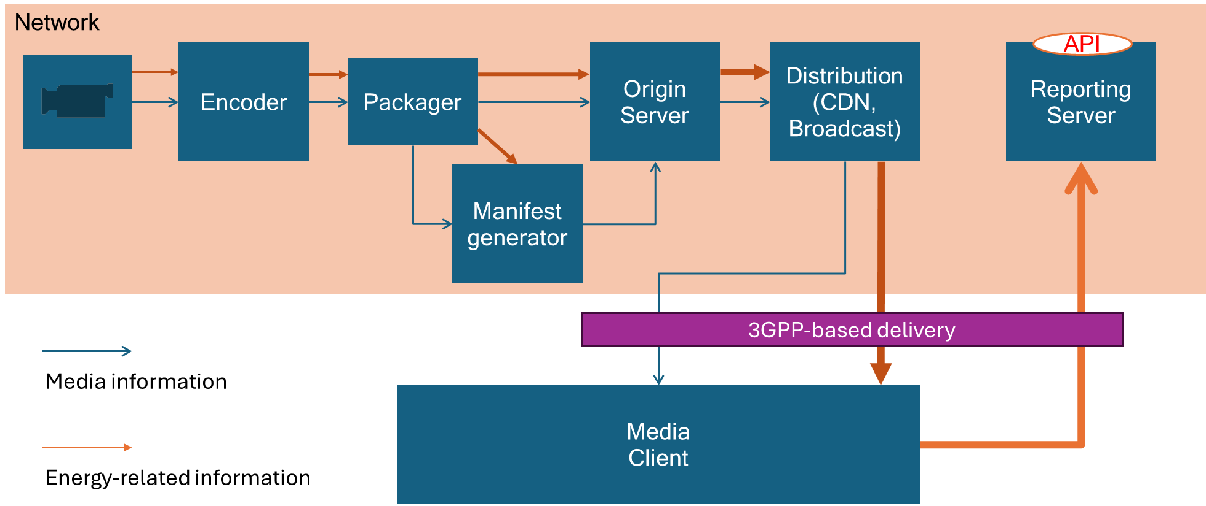
Figure 7.X.2.1-1: Streaming architecture with energy related information workflows
The workflow is as follows:
1. Produced content is provided to a distribution encoder, possibly in multiple variants (for example different resolutions, an SDR and an HDR version, and so on). The captured content may have associated static and/or dynamic information related to the energy needed to produce the content.
2- The encoder encodes the content and aggregates the energy information provided upstream, and the energy/power that it required to encode, possibly also for different variants, for example the encoding technology, the bit rate and so on.
3. The aggregated energy information may then be propagated through the distribution chain, by aggregating and accumulating the energy usage at each stage of the distribution.
A core concept is that the aggregated energy information is included as metadata in the media streaming data, and different options are possible. The media may be delivered via a 3GPP delivery network and reach a media client, but it may also be delivered via other means that are not 3GPP-based. The media client is typically not 3GPP-specific and hence information is expected to be agnostic of the media delivery system and access network(s) used to deliver it. The media client or any node in the network may use information provided in the metadata to optimize the delivery based on energy-related metrics.
In summary, the following functional aspects are considered:
- Propagate energy-related information downstream within the media streaming workflow
- Make the energy-related information accessible at the level of individual media streams, such that nodes in the delivery chain can access the information.
- Allow the energy-related information to be aggregated and/or accumulated at specific nodes in the media delivery path.
- Collect energy-related information at appropriate nodes in the media delivery path and use the provided information for operational decision-making.
- Allow the aggregated and accumulated energy-related information to be reported to reporting servers:
- Excluding the measured energy consumption at the client.
- Including the measured energy consumption at the client.
- Allow the client to select content based on energy-related metrics.
In order to provide meaningful and trustworthy energy reporting, the nodes in the media delivery chain adding energy-related metrics are preferably trusted energy consumption reporters.
In the following, some specific aspects related to this Candidate Solution are discussed.

7.x.2.2 Assignment and aggregation of energy usage

Media resources available on a specific storage or distribution node may include a record of the energy that has been consumed up to the current point in the media delivery chain, for example including production, encoding, distribution and so on. The information may be scaled to the number of users assigned to this resource. Aggregation may be done by summing the energy information or by other means of aggregation, depending on the assigned metrics.
The energy metric may be assigned to the entire media asset, or to a subset of the media asset, for example to a specific variant, to a specific segment or to a time range.

7.x.2.3 Common repository of energy-related metrics
Metrics assigned to energy consumption are currently not well defined, but may improve over time. A framework is expected to be applicable with an evolution of energy metrics. For this purpose it is proposed to create a registry/repository/catalogue for energy-related metrics, similar to MP4RA (https://mp4ra.org/) or DASH-IF identifiers (https://dashif.org/identifiers/introduction/). To each metric a key may be added, for example using a 4CC code or a URN. In addition, the metric is well-defined, typically by reference to a specification and/or implementation. This allows different metrics to be used, and also avoids the need for frameworks to redundantly define the metrics they use. As hypothetical examples:
- Greening of Streaming defines a URN urn:org:gos:energyindex:2025 and/or a 4CC 'eeix' with a well-defined value assigned to it and the energy index expressing the average aggregated consumed energy per second for the media assigned to it.
- French regulator AFNOR defines urn:org:afnor:carbonindex:2025 and/or a 4CC 'eecx' with a well-defined value being assigned to it and the carbon index expresses the average aggregated consumed carbon per second for the media assigned to it.
Such a repository may be hosted by a registration authority, or for example by an organization such as Greening of Streaming.

7.x.2.4 In-band carriage of energy-related metrics
Once the metrics are well defined, for example following what is presented in clause 7.x.2.3, the information may be carried by different means within the media delivery chain. Examples include, but are not limited to:
- Metadata tracks: If the information is dynamic, a metadata track may be used to carry one or different energy-related metrics. Metrics may also be delivered, for example, as part of Addressable Resource Index (ARI) tracks as defined in ISO/IEC 23009-1 [23009-1].
- Common Media Client Data (CMCD) metrics: In the reporting mechanism associated with media delivery, custom energy metric keys may be defined, for example using the definitions in clause 7.x.2.3, and providing the energy related to the consumed assets.
- Common Media Server Data (CMSD) information: In the streaming of media assets, information may be assigned to each resource using data for each segment. This may again use custom energy metric keys.
- SAND information: CMCD- and CMSD-equivalent information may also be provided as part of SAND messages as defined in ISO/IEC 23009-5 [23009-5], for example using custom keys.
- DASH metrics: Equivalently to CMCD, DASH metrics as defined in ISO/IEC 23009-1 [23009-1] may be used to report energy-related information.
- Events and Event Streams: Event Streams as defined in ISO/IEC 23009-1 [23009-1] may carry energy-related information, similarly to CMSD.
- Information in streaming presentation manifest: A DASH MPD may carry information about energy metrics, for more details refer to clause 7.x.2.5.
Equivalently to the information in a DASH MPD, energy metrics may be carried in other streaming manifest formats such as HLS playlists.
- Service Information and API calls as defined in MPEG DASH allow operational information to be carried that defines the API to the client from the application and may provide energy-related information.
The information may be assigned to the entire media delivery chain or parts of the chain.

7.x.2.5 Carriage of energy-related information in streaming presentation manifest
A streaming presentation manifest may carry energy-related information. In the following, examples for a DASH MPD are provided.
- Energy information may be assigned to each resource in the MPD, including all information relevant for the service provider.
- Energy information may be assigned to individual components of the presentation:
- Content – providing information on aggregate energy consumption
- An Adaptation Set
- A Representation
- A Segment
- Service Locations – providing information on the energy required to distribute content from this service location, possibly normalized to the bit rate.
- Adding labels describe energy-related information that can be exposed to the user for selection purposes.
- In order to address regulatory requirements, a dedicated Energy descriptor Energy is added to the DASH manifest that allows carriage and exposure of energy-related information, similar to Accessibility information.
- If information is available on different levels, it may be combined (summed, for example, or combined after scaling appropriately).

7.x.2.6 Usage of energy information in media client or other functions
The information in the presentation manifest, as documented in clause 7.x.2.5 may be used in the media client for different means:
- Exposing energy-related information to the user.
- Exposing energy-related information to the application.
- Based on the above, the user and/or application can use the energy-related information provided to select content based on energy.
- Selecting content and/or service locations based on energy-related information.Today, service locations are selected based on performance, (for example throughput).
- Reporting the aggregated metric to a reporting server, for example using DASH Metrics or CMCD.
- Possibly adding client energy consumption to the aggregated metrics.

Other functions in the media delivery chain may use the in-band information for operational and reporting purposes as well.

7.x.2.7 Integration into 5G System
Generic energy-aware media delivery may be integrated into the 5G System. Examples include:
- The CDN may be a Media AS.
- CDN1 and CDN2 may be mapped to different service locations. Delivery from multiple service locations may be used to optimize energy usage. For example, the client may select statically and/or dynamically service locations with different assigned energy metrics. Content Steering may be used to steer clients to energy-efficient delivery.
- Reporting from the client may include client UE consumption or may just report what was provided from the network, by aggregating the selection.
- The Media AS may collect information from the Media AF/EIF to insert energy-related metrics into the streaming metadata, for example in the presentation manifest or in CMCD data.

7.X.3 Procedures

7.x.3.1 General procedures
Figure 7.X.3.1-1 provides a general high-level call flow for enery-aware streaming.
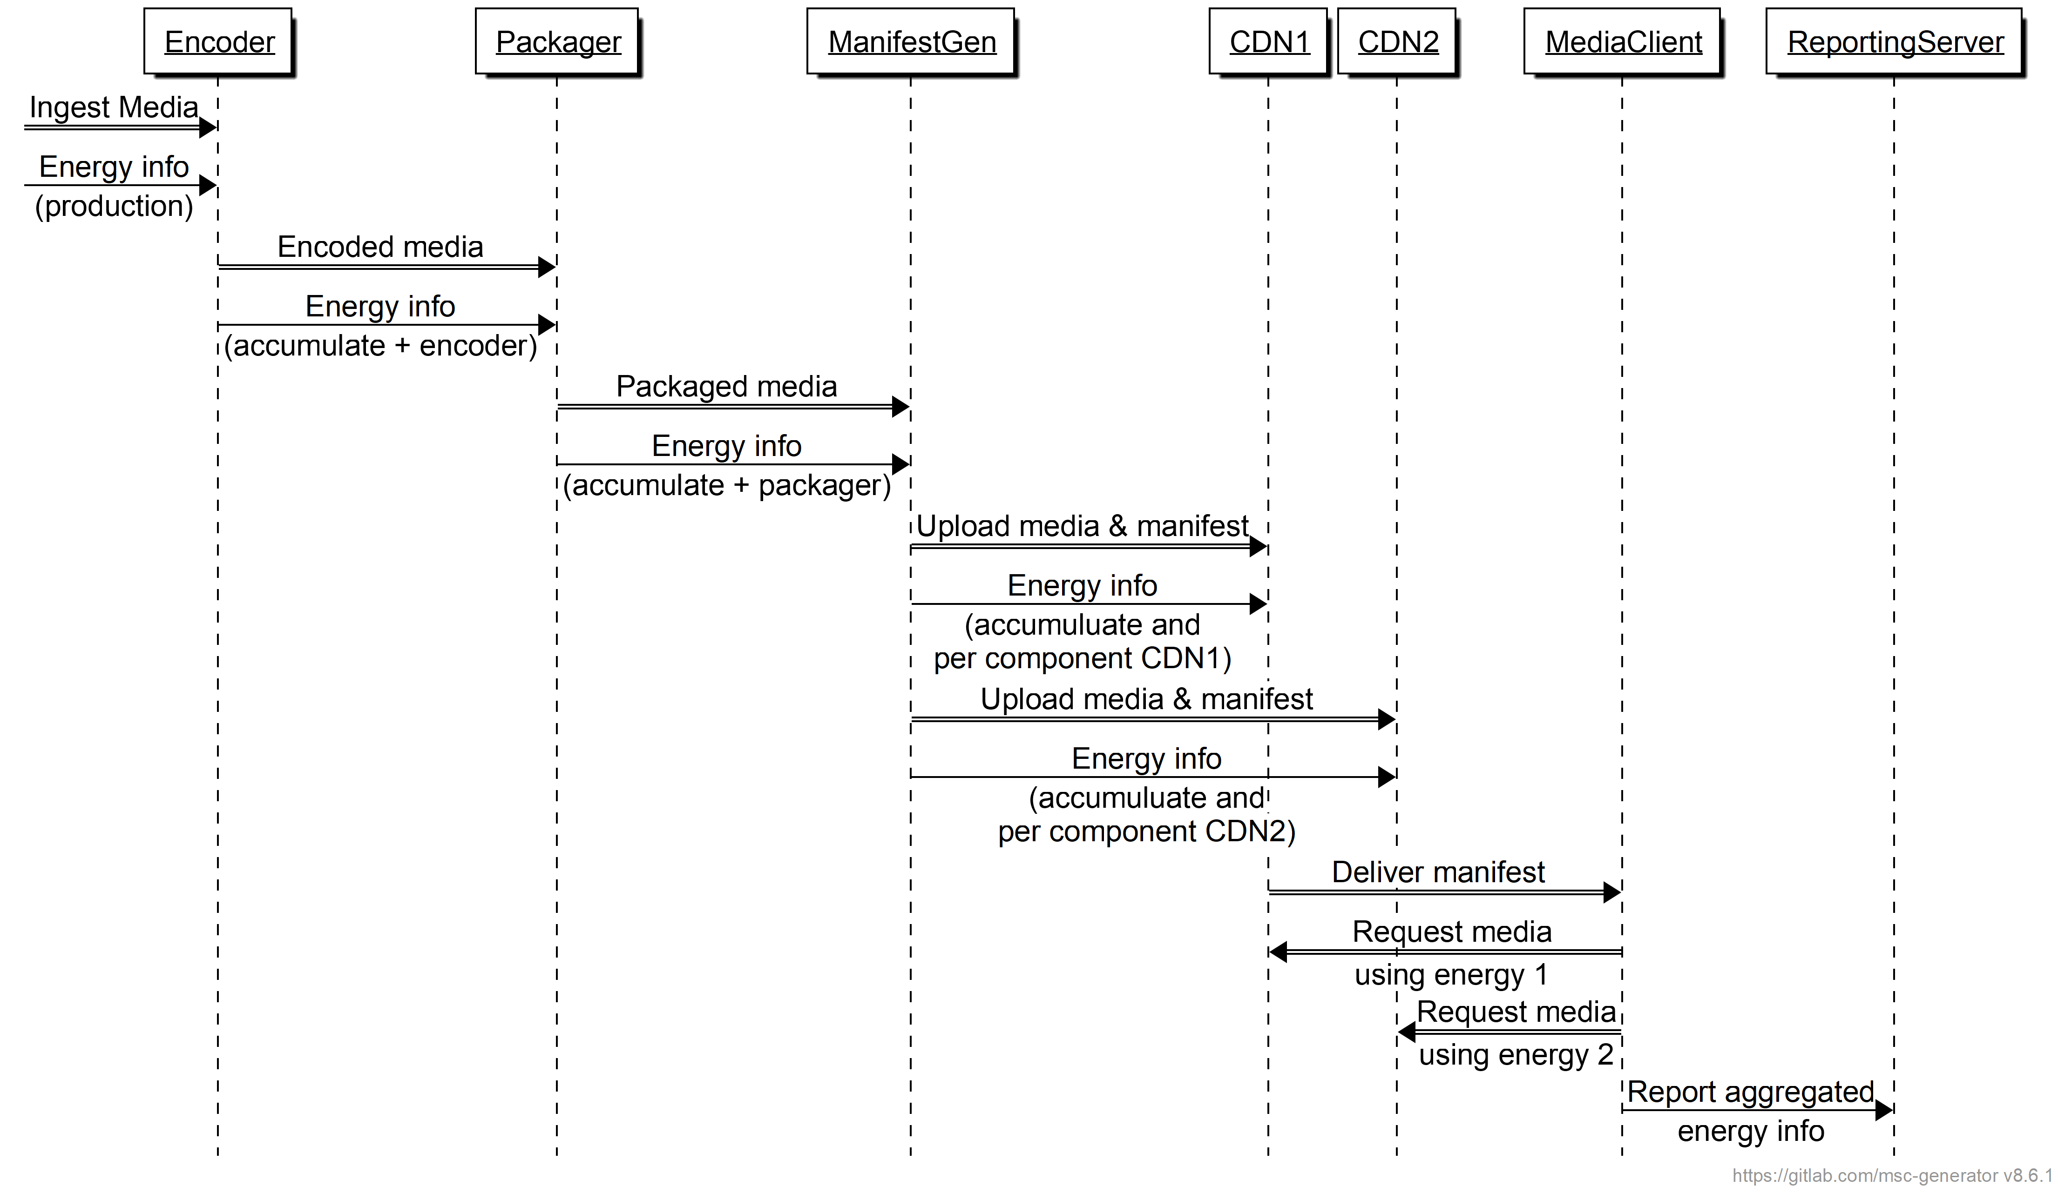
Figure 7.X.3.1-1 General call flow for enery-aware streaming
Here is the description of the call flow:
1. Encoder
a) Processes ingested media.
b) processes energy information (production).
c) Sends encoded media to Packager.
d) Shares accumulated energy info with Packager.
2. Packager
a) Receives encoded media.
b) Packages media.
c) Sends packaged media to Manifest Generator.
d) Shares accumulated energy info with Manifest Generator.
3. Manifest Generator
a) Receives packaged media.
b) Uploads media and manifest to CDN1 and CDN2.
c) Adds energy info for each media component (Adaptation Set, Representation, etc.).
d) Adds energy information for each service location/CDN.
4. Delivery
a) Delivers manifest to Media Client.
b) Media Client request media based on energy information from CDN1 and/or CDN2.
5. Reporting
- Media client reports aggregated energy information to Reporting Server.

7.x.3.2 Integration with 5G Media Streaming
This aspect is for further study.

7.X.4 Summary
This aspect is for further study.

