3GPP TSG-SA4 Meeting #134 S4-251709

Dallas, United States, 17th Nov 2025 - 21st Nov 2025
CR-Form-v12.4
CHANGE REQUEST
 | 26.804 | CR | 0029 | rev | 2 | Current version: | 19.1.0
For HELP on using this form: comprehensive instructions can be found at
https://www.3gpp.org/Change-Requests.

Proposed change affects: | UICC apps |  | ME |  | Radio Access Network |  | Core Network

Title: | [FS_AMD_Ph2] WT#6: Latency Measurement and control
Source to WG: | Qualcomm Germany
Source to TSG:
Work item code: | FS_AMD_Ph2 |  |  |  |  |  | Date: |  |  | 2025-11-09
Category: | B |  |  |  |  |  | Release: |  |  | Rel-20
 | Use one of the following categories:  F (correction)  A (mirror corresponding to a change in an earlier release)  B (addition of feature),  C (functional modification of feature)  D (editorial modification)  Detailed explanations of the above categories can  be found in 3GPP TR 21.900. |  |  |  |  |  |  |  | Use one of the following releases:  Rel-8 (Release 8)  Rel-9 (Release 9)  Rel-10 (Release 10)  Rel-11 (Release 11)  …  Rel-17 (Release 17)  Rel-18 (Release 18)  Rel-19 (Release 19)  Rel-20 (Release 20)
Reason for change: |  | The study item identifies the following work topic  - WT#6: Latency Measurement and control: Media Service quality is often determined by network latency, and controlling latency is an important topic. The support of latency measurements in 5G Media streaming provides opportunities for service and network providers to judge the quality of the service.  The study item identifies the following objectives  1. Document the following additional Key Issues in more detail, in particular how they relate to the 3GPP Media Delivery architecture and/or the MBS User Service architecture:  2. Study collaboration scenarios between the Application Service Provider and the 5G System and for each of the key topics.  3. Based on existing architectures, develop one or more deployment architectures that address the key topics and the collaboration models.  4. Map the key topics to basic functions and develop high-level call flows.  5. Identify the issues that need to be resolved.  6. Provide candidate solutions including call flows, protocols and APIs for each of the identified issues.  7. Coordinate work with other 3GPP groups e.g. SA2, SA3, SA5, SA6 and others as needed.  8. Coordinate work with external organizations such as SVTA, CTA WAVE, ISO/IEC JTC29 WG3 (MPEG Systems), 5G-MAG, DVB or IETF, as needed.  9. Identify gaps and recommend potential normative work for stage-2 and stage-3, including which existing specifications would be impacted and/or if any new specifications would preferably be developed.
Summary of change: |  | The issues are addressed
Consequences if not approved: |  | Feature not supported
Clauses affected:
 |  | Y | N
Other specs |  |  | X | Other core specifications |  |  |  | TS/TR ... CR ...
affected: |  |  | X | Test specifications |  |  |  | TS/TR ... CR ...
(show related CRs) |  |  | X | O&M Specifications |  |  |  | TS/TR ... CR ...
Other comments:
This CR's revision history:

===== CHANGE =====

2 References
The following documents contain provisions which, through reference in this text, constitute provisions of the present document.
- References are either specific (identified by date of publication, edition number, version number, etc.) or non-specific.
- For a specific reference, subsequent revisions do not apply.
- For a non-specific reference, the latest version applies. In the case of a reference to a 3GPP document (including a GSM document), a non-specific reference implicitly refers to the latest version of that document in the same Release as the present document.
[9] DASH-IF/DVB: "Report on Low-Latency Live Service with DASH", July 2017, available here: https://dash-industry-forum.github.io/docs/Report%20on%20Low%20Latency%20DASH.pdf
[10] DASH-IF: "IOP Guidelines v5, Low-latency Modes for DASH", available here: https://dash-industry-forum.github.io/docs/CR-Low-Latency-Live-r8.pdf
[90] "DASH-IF WebRTC-based Streaming", https://dashif.org/news/webrtc/
[105] Consumer Technology Association Specification CTA-5004-A: "Web Application Video Ecosystem – Common Media Client Data", December 2025.
[DIF-WEBRTC] DASH-IF Report: DASH and WebRTC-Based Streaming, https://dashif.org/webRTC/report.html, March 2022.
[TIMBRE] A. Murphy, "BBC Project Timbre: Investigating mobile coverage for live radio streaming on BBC Sounds", March 2024, https://www.bbc.co.uk/rd/blog/2024-03-project-timbre-investigating-mobile-coverage-for-live-radio-streaming-on-bbc-sounds.
[14496-12] ISO/IEC 14496-12: "Information technology — Coding of audio-visual objects; Part 12: ISO base media file format".

===== CHANGE (new clause) =====

5.X Latency measurement and control

5.X.1 Description
Service Latency is known to be an important measure for the quality of experience associated with a service. Several data points on this matter have been collected by DVB and DASH-IF [9], [10], [90], and [DIF-WEBRTC]. Also, in Project Timbre [TIMBRE] the BBC identified latency as an important measure, in particular the delivery latency of each audio segment was identified as a key indicator of Quality of Experience for the listener. However, while it is possible to measure the segment delivery latency in a client application , as was done in Project Timbre, it would also be helpful to be able to measure latency, of one kind or another, from the network side. This information may then be exposed as an API in the network.
More particular, in segmented media streaming as for example assumed in 5G Media Streaming, (typically CMAF objects described by a presentation manifest such as a DASH MPD or HLS playlist), the service provider wants to control the end-to-end latency, possibly also for synchronized playback across clients, but also wants to measure the latency and report this information back to the network or service provider.
Latency is typically measured from glass to glass (i.e., from the camera to the screen) or measured from the encoder to the screen – for details refer to [9] and [DIF-WEBRTC]. Information on the latency may include:
- what the actual latency is
- if a desired target latency is met
- the deviation from the target latency
- The reason for the target latency: late arrival, network issues, user controlled, etc.
The network and/or service provider may use this information to:
- Measure QoE based on the latency for each client
- Do some network improvements if the latency is not met, e.g. Content Steering, QoS, etc.
- Aggregate the information across multiple/all users

5.X.2 Problem statement and collaboration scenarios
Figure 5.X.2-1 provides a basic architecture for latency measurement in a live service aligned with DASH-IF [10].
1. The content capture device (e.g., production camera) and/or the Encoder embed timing information in the media that relates to when the content was produced and/or encoded, respectively, using a Time Synchronisation server to provide a common time reference.
2. After encoding, the content is packaged, a manifest is generated, and it is distributed via a CDN.
3. The Media Client consumes the media, measures the latency it observed by also syncing to the Time Synchronisation Server and provides the latency information to a Reporting Server.
4. The Reporting Server exposes information that can be used in operations or for QoE measurements.
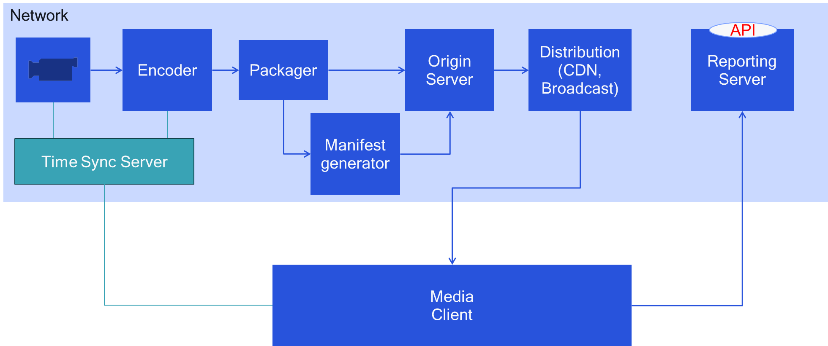
Figure 5.X.2-1 Basic Architecture for latency measurement in a live service aligned with DASH-IF [10]
Latency in a streaming service can be measured for example based on the description in the DASH-IF Low-Latency modes in clause 9.X.6.2.3 of [10]. A summary is provided in the following:
- The Producer Reference Time supplies timestamps corresponding to the production or encoding time of the associated media. This information permits among others to (i) provide media clients with information to enable consumption and production to proceed at equivalent rates, thus avoiding possible buffer overflow or underflow, and (ii) enable measurement of and potentially control over the latency between the production of the media and its presentation.
- The Producer Reference Time as defined in ISO/IEC 14496-12 [14496-12] may be provided in band as part of the Segments (in the prft box), in the DASH MPD or both. In the context of low-latency DASH service offerings, providing information in the MPD is strongly recommended, whereas providing information in band is left to the deployment. The packager can extract the information from CMAF segments and place it into the corresponding presentation manifest.
- The producer reference time permits the DASH client to measure and control the End-to-End Latency (EEL) or the Encoding+Distribution Latency (EDL), and permits the service provider to provide information to the client to control this value.
- Either or both values (capture time and encoding time), can be expressed in the manifest and/or in the segments. It is also possible to create an application-specific anchor for the times embedded in the media.
- Clients synchronized to the same time synchronisation server can now use the information in the media as well as the presentation time to determine the presentation latency. For details, see clause 9.X.5 of [10].
Different collaboration scenarios may be considered, depending on the placement of different functions shown in figure 5.X.2.1-1. The following different deployment options are discussed:
Option 1: The 5GMSd Application Provider runs all encoding and packaging related functions, and the 5GMSd AS only provides content hosting for the DASH Presentation as a CDN. Also, the reporting server is in the 5GMSd Application Provider domain.
Option 2: The 5GMSd System runs a time synchronisation server that is trusted and can be accessed by the 5GMSd Application Provider as well as by the Media Player. The time synchronisation server may be deployed in either the 5GMSd AF or 5GMSd AS.
Option 3: The 5GMSd AS additionally performs manifest generation, requiring functionality to convert in-band timing information to manifest timing information. The time synchronisation server may be internal or external: three sub-options are considered.
Option 4: The 5GMSd System encodes and packages the media and provides a latency from ingest (distribution encoding) to the client. In this case the 5GMSd system controls the latency and does potential operational improvements in encoding, packaging and so on. Reporting may be done between Media Player and AS, or Media Session Handler and AF.
Option 5: The 5GMSd System is responsible only for reporting. This may be done between the Media Player and 5GMSd AS, or between the Media Session Handler and the 5GMSd AF.
Table 5.X.2-1 summarizes the different deployment options on how the latency measurement functions are mapped to the downlink media streaming functions.
Table 5.X.2-1 Possible deployment options to map latency measurement functions
to downlink media streaming functions
Latency measurement function | 5GMSd Application Provider | 5GMSd AS | 5GMSd AF | Media Player | Media Session Handler
Content Generation | 1,2,3,4,5
Time Sync Server | 1,3a,5 | 2a, 3b, 4a | 2b, 3c, 4b
Encoder | 1,2,3,5 | 4
Packager | 1,2,3,5 | 4
Manifest Creator | 1,2,5 | 3,4
Content Hosting |  | 1,2,3,4,5
Media Client Playback |  |  |  | 1,2,3,4a,5a | 4b
Media Client Reporting |  |  |  | 1,2,3,4 | 5b
Reporting Server | 1,2,3 | 4a,5a | 4b,5b

Based on the discussions, Option 1 is basically out of scope of 5G Media Streaming. Option 3 may be considered a subset of Option 4 and hence is not explicitly discussions. For the remaining options 2, 4 and 5, it is worthwhile to consider more detailed architecture mappings and call flows.

5.X.3 Architecture mappings
To be completed – refinements are needed.
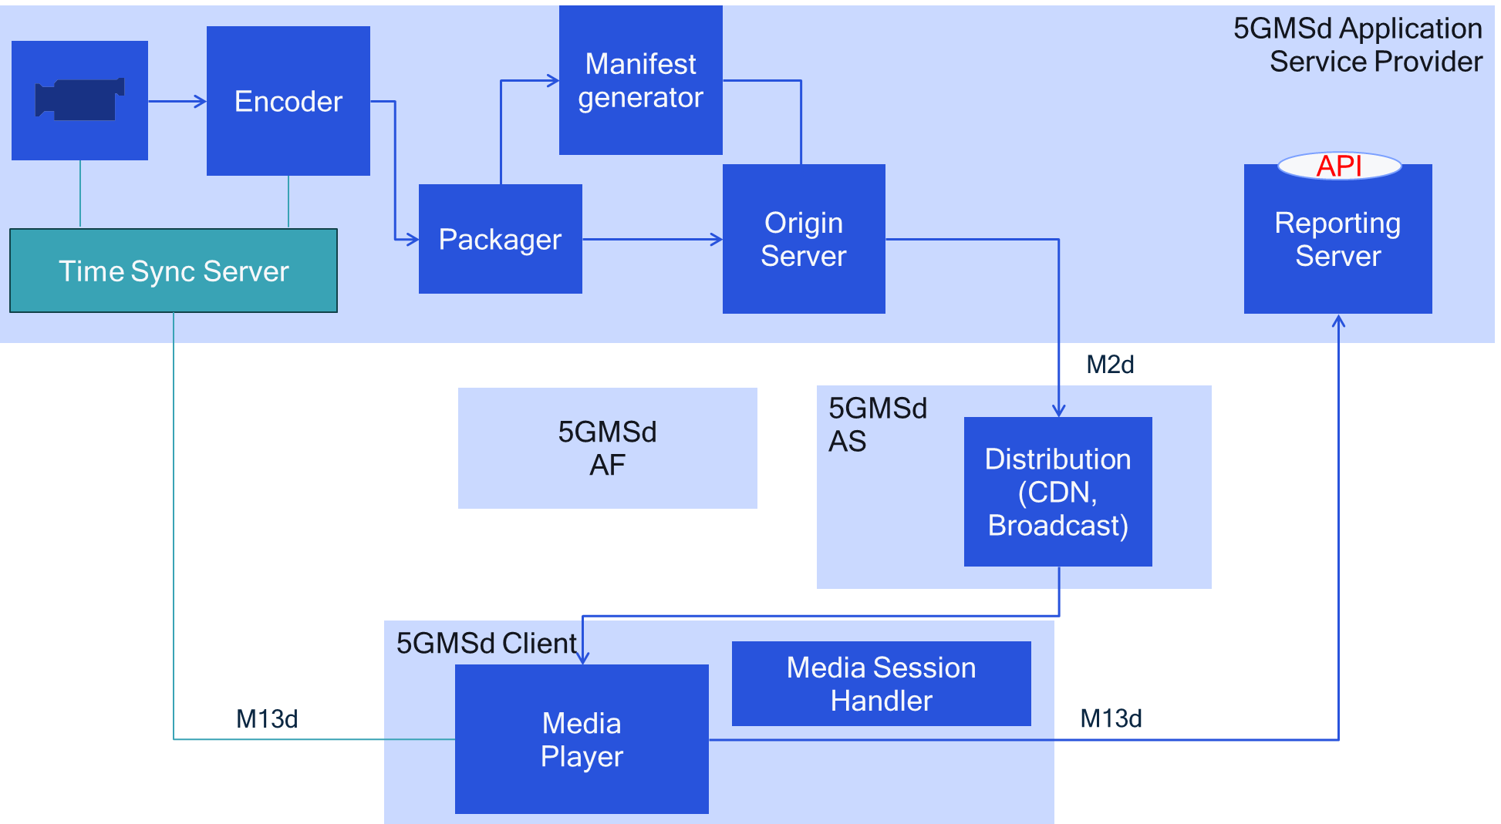
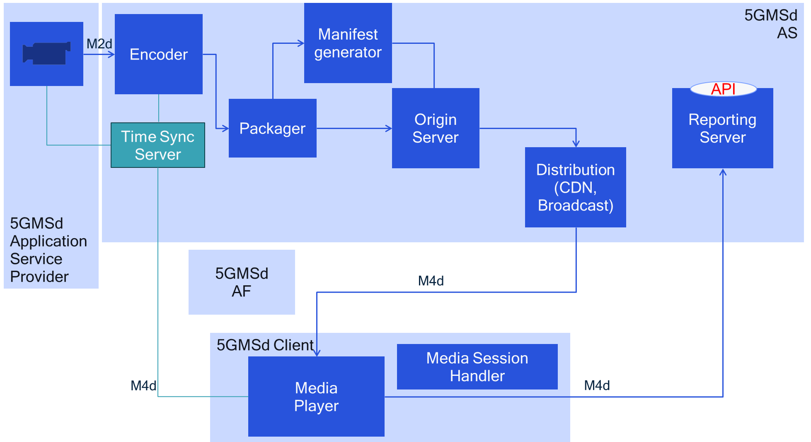

5.X.4 High-level call flows
To be completed

5.X.5 Gap analysis and requirements
The following gaps are identified:
- Provisioning of a Time Synchronisation Service via M4d to the Media Player as well as via an exposure function to the 5GMSd Application Provider via M3d and M1d.
- Addition to producer reference times to media segments and manifests and time synchronization between 5GMSd Client and adder of reference times.
- Implementation of latency measurement in 5GMSd Client.
- Reporting of latency information via M4d and M13d, and possibly M5d.
- Controlling the presentation latency for a client.
- Exposing the latency measurement.

5.X.6 Candidate solutions
Editor’s Note
- The producer reference time may be
  - the capture time of the media sample
  - the encoding time of the media sample
  - Any other relevant time relevant for the network provider
- The Time Synchronization is accomplished by UTC Time Sync in DASH
- Producer reference time can be carried in Segments, Manifest or is implicit (see DASH-IF)
- Reporting of latency may be done in DASH metrics or CMCD
- Latency metric may be measured, but also other information such as latency deviation from target latency, reasons for latency and so on
- API for exposure may use NWDAF or any other defined API

5.X.7 Summary and conclusions
To be completed

