3GPP TSG-SA4 Meeting #134 S4-251707

Dallas, United States, 17th Nov 2025 - 21st Nov 2025 revision of S4aI250188
CR-Form-v12.4
CHANGE REQUEST
 | 26.802 | CR | 0009 | rev | 1 | Current version: | 19.2.0
For HELP on using this form: comprehensive instructions can be found at
https://www.3gpp.org/Change-Requests.

Proposed change affects: | UICC apps |  | ME |  | Radio Access Network |  | Core Network

Title: | [FS_AMD_Ph2] WT#4: Combined Unicast-Multicast-Broadcast
Source to WG: | Qualcomm Germany
Source to TSG:
Work item code: | FS_AMD_Ph2 |  |  |  |  |  | Date: |  |  | 2025-11-09
Category: | C |  |  |  |  |  | Release: |  |  | Rel-19
 | Use one of the following categories:  F (correction)  A (mirror corresponding to a change in an earlier release)  B (addition of feature),  C (functional modification of feature)  D (editorial modification)  Detailed explanations of the above categories can  be found in 3GPP TR 21.900. |  |  |  |  |  |  |  | Use one of the following releases:  Rel-8 (Release 8)  Rel-9 (Release 9)  Rel-10 (Release 10)  Rel-11 (Release 11)  …  Rel-17 (Release 17)  Rel-18 (Release 18)  Rel-19 (Release 19)  Rel-20 (Release 20)
Reason for change: |  | The study item identifies the following work topic  - WT#4: Combined Unicast-Multicast-Broadcast: The combination of unicast with broadcast/multicast as introduced in clause 5.12 of TR 26.804 is expected to be extended, including progressing the documented candidate solutions and further study the combination with deployed media players. It also includes the definition of a RESTful API between the MBSF and the MBS AS (reference point MBS-9) to configure unicast repair.  The study item identifies the following objectives  1. Document the following additional Key Issues in more detail, in particular how they relate to the 3GPP Media Delivery architecture and/or the MBS User Service architecture:  2. Study collaboration scenarios between the Application Service Provider and the 5G System and for each of the key topics.  3. Based on existing architectures, develop one or more deployment architectures that address the key topics and the collaboration models.  4. Map the key topics to basic functions and develop high-level call flows.  5. Identify the issues that need to be resolved.  6. Provide candidate solutions including call flows, protocols and APIs for each of the identified issues.  7. Coordinate work with other 3GPP groups e.g. SA2, SA3, SA5, SA6 and others as needed.  8. Coordinate work with external organizations such as SVTA, CTA WAVE, ISO/IEC JTC29 WG3 (MPEG Systems), 5G-MAG, DVB or IETF, as needed.  9. Identify gaps and recommend potential normative work for stage-2 and stage-3, including which existing specifications would be impacted and/or if any new specifications would preferably be developed.
Summary of change: |  | The issues are addressed
Consequences if not approved: |  | Feature not supported
Clauses affected:
 |  | Y | N
Other specs |  |  | X | Other core specifications |  |  |  | TS/TR ... CR ...
affected: |  |  | X | Test specifications |  |  |  | TS/TR ... CR ...
(show related CRs) |  |  | X | O&M Specifications |  |  |  | TS/TR ... CR ...
Other comments:
This CR's revision history:

===== CHANGE =====

2 References
The following documents contain provisions which, through reference in this text, constitute provisions of the present document.
- References are either specific (identified by date of publication, edition number, version number, etc.) or non-specific.
- For a specific reference, subsequent revisions do not apply.
- For a non-specific reference, the latest version applies. In the case of a reference to a 3GPP document (including a GSM document), a non-specific reference implicitly refers to the latest version of that document in the same Release as the present document.
[1] 3GPP TS 26.501: "5G Media Streaming (5GMS); General description and architecture”".
[2] IETF RFC 2236: "Internet Group Management Protocol, Version 2".
[3] IETF RFC 4604: "Using Internet Group Management Protocol Version 3 (IGMPv3) and Multicast Listener Discovery Protocol Version 2 (MLDv2) for Source-Specific Multicast".
[4] IETF RFC 3376: "Internet Group Management Protocol, Version 3".
[5] 3GPP TR 21.905: "Vocabulary for 3GPP Specifications".
[6] 3GPP TS 23.246: "MBMS Architecture and functional description".
[7] 3GPP TR 23.757: "Study on architecture enhancements for 5G multicast-broadcast services".
[8] 3GPP TS 23.316: "Wireless and wireline convergence access support for the 5G system".
[9] 3GPP TS 23.501: "System architecture for the 5G System (5GS)".
[10] 3GPP TS 23.502: "System architecture for the 5G System (5GS)".
[11] 3GPP TS 23.503: "System architecture for the 5G System (5GS)".
[12] ETSI TS 103 769: "Digital Video Broadcasting (DVB); Adaptive media streaming over IP multicast", v1.1.1, November 2020.
[13] CableLabs OC-TR-IP-MULTI-ARCH-C01: "IP Multicast Adaptive Bit Rate Architecture Technical Report", October 2016. Internet Available https://www.cablelabs.com/specifications/ip-multicast-adaptive-bit-rate-architecture-technical-report
[14] ETSI TS 103 285: "Digital Video Broadcasting (DVB); MPEG-DASH Profile for Transport of ISO BMFF Based DVB Services over IP Based Networks".
[15] 3GPP TS 26.348: "Northbound Application Programming Interface (API) for Multimedia Broadcast/Multicast Service (MBMS) at the xMB reference point".
[16] 3GPP TS 26.346: "Multimedia Broadcast/Multicast Service (MBMS); Protocols and Codecs".
[17] ATSC A/331: "ATSC Standard: Signaling, Delivery, Synchronization, and Error Protection".
[18] 3GPP TS 29.468: "Group Communication System Enablers for LTE (GCSE_LTE); MB2 Reference Point; Stage 3".
[19] 3GPP TS 23.468: "Group Communication System Enablers for LTE (GCSE_LTE); Stage 2".
[20] RFC 6733: "Diameter Base Protocol", October 2012.
[21] 3GPP TS 26.347: "Multimedia Broadcast/Multicast Service (MBMS); Application Programming Interface and URL", Release 16.
[22] 3GPP TS 22.146: "Multimedia Broadcast/Multicast Service (MBMS); Stage 1", Release 16.
[23] RFC 5053: “Raptor Forward Error Correction Scheme for Object Delivery”, October 2007.
[24] RFC 5445: “Basic Forward Error Correction (FEC) Schemes”, March 2009.
[25] RFC 3695: “Compact Forward Error Correction (FEC) Schemes”, February 2004.
[26] 3GPP TS 23.247: "Architectural enhancements for 5G multicast-broadcast services; Stage 2;" Release 17.
[27] 3GPP TS 26.511: "5G Media Streaming (5GMS); Profiles, codecs and formats".
[28] 3GPP TS 26.512: "5G Media Streaming (5GMS); Protocols".
[29] 3GPP TS 26.502: "5G multicast-broadcast services; User service architecture".
[30] 3GPP TS 26.517: "5G Multicast-Broadcast User Services; Protocols and Formats".
[31] ETSI TS 103 720: "LTE-based 5G Broadcast System".
[32] 3GPP TS 23.479: "UE MBMS APIs for Mission Critical Services".
[33] 3GPP TS 23.247: "Architectural enhancements for 5G multicast-broadcast services".
[34] ATSC A/331, "Signaling, Delivery, Synchronization, and Error Protection".
[35] ETSI TR 103 972: "Deployment Guidelines for DVB-I services over 5G Systems".
[36] 3GPP TR 26.804: " Study on 5G media streaming extensions"
[37] Kevin Yao, "Combining dynamic ad insertion and A/B watermarking", 22 FEB 2023 in AWS Elemental MediaTailor, Direct-to-Consumer & Streaming, Media & Entertainment, Media Services, available here: https://aws.amazon.com/blogs/media/combining-dynamic-ad-insertion-and-a-b-watermarking/
[38] ETSI TS 104 002: " Publicly Available Specification (PAS); DASH-IF Forensic A/B Watermarking An interoperable watermarking integration schema".
[39] DASH-IF Special Session: "A/B Watermarking", February 2023, slides available here: https://github.com/Dash-Industry-Forum/Dash-Industry-Forum.github.io/files/10720660/DASH-IF_ServerSideWM_2023.pdf
[40] CTA 5007-A: "Web Application Video Ecosystem - Common Access Token"
[41] DASH-IF Candidate Specification, "Watermarking Encoder API", Community Review version available here https://dashif.org/news/cr-watermarking-api/
[42] ETSI TS 103 998, "Content Steering for DASH".
[43] 3GPP TR 26.247: “Transparent end-to-end Packet-switched Streaming Service (PSS); Progressive Download and Dynamic Adaptive Streaming over HTTP (3GP-DASH)”

===== CHANGE =====

3.2 Abbreviations
For the present document, the abbreviations given in TR 21.905 [5] and the following apply. An abbreviation defined in the present document takes precedence over the definition of the same abbreviation, if any, in TR 21.905.
5G-MAG 5G Media Action Group
5MBS 5G Multicast/Broadcast Service
5GMS 5G Media Streaming.
ABR Adaptive Bit Rate.
AL-FEC Application-Level Forward Error Correction
ATSC Advanced Television Systems Committee
BM-SC Broadcast-Multicast - Service Centre
CDN Content Delivery Network
CMAF Common Media Application Format
DASH Dynamic Adaptive Streaming over HTTP
DNS Domain Name Service
DVB Digital Video Broadcasting
EPC Enhanced Packet Core
EPS Enhanced Packet System
FDT File Delivery Table
FEC Forward Error Correction
FFS For Further Study
FLUTE File deLivery over Unidirectional Transport
FQDN Fully-Qualified Domain Name
GCS Group Communication Service
GCSE Group Communication Service Enabler
HLS HTTP Live Streaming
HPHT High Power High Tower
HTTP HyperText Transfer Protocol
IGMP Internet Group Management Protocol
IPTV Internet Protocol Television
ISO BMFF International Standardization Organization Base Media File Format
LCT Layered Coding Transport
MAA MBMS-Aware Application
MABR Multicast ABR
MBMS Multimedia Broadcast/Multicast Service
MBS Multicast/Broadcast Service
MBSF Multicast/Broadcast Service Function
MBSTF Multicast/Broadcast Service Transport Function
MCPTT Mission Critical Push-To-Talk over LTE
MLD Multicast Listener Discovery
MPEG Moving Picture Experts Group
NAS Non-Access Spectrum
NEF Network Exposure Function
OTT Over-The-Top
PCC Policy and Charging Control
PCF Policy and Charging Function
PDU Protocol Data Unit
PTM Point-To-Multipoint
RedCaP Reduced Capabilities
RoHC Robust Header Compression
ROUTE Real-time transport Object delivery over Unidirectional Transport
RTP Real-time Transport Protocol
RTSP Real-time Streaming Protocol
SACH Service Access CHannel
SCTP Stream Control Transmission Protocol
SDP Session Description Protocol
SFN Single-Frequency Network
SMF Session Management Function
SNTP Simple Network Time Protocol
STB Set-Top Box
TMGI Temporary Mobile Group Identity
TOI Transport Object Identifier
UPF User Plane Function
XML Extensible Markup Language

===== CHANGE =====

5.12 Key Issue #11: Combined MBS multicast and unicast

5.12.1 Description

5.12.1.1 Background and examples
In several deployment scenarios and specifications, the distribution of unicast streaming content such as DASH/HLS/CMAF content over a broadcast/multicast system is considered. Examples include, but are not limited to:
- 5GMS via eMBMS (see TS 26.501 [9], clause 4.9 and 5.10).
- 5GMS via MBS (see TS 26.501 [9], clause 4.11 and 5.12).
- DVB ABR Multicast in ETSI TS 103 769 [12].
- ATSC3.0 specification in A/331 [34].
- ETSI TS 103 720 [31] for 5G Broadcast.
- ETSI TR 103 972 [35] for DVB-I over 5G Broadcast.
Hybrid service concepts are well established, and examples include alternative languages requested over unicast, targeted ad insertion, coverage extensions, and several others.
In study, several cases for potential hybrid services have been identified, and are only partially addressed:
- In-session unicast repair as documented in clause 5.9 of the present document,
- Application Services including hybrid services, as documented in clause 5.11.3.2 of the present document,
- Reporting and metrics as documented in clause 5.11.3.4 of the present document,
- Support for DRM in clause 5.10 of TR 26.804 [36], in particular as mentioned in clause 5.10.4: "The mapping to 5GMS via MBS/MBMS is for further study",
- Common Media Client Data as introduced in clause 5.16 of TR 26.804 [36], in particular as mentioned in clause 6.16, it is recommended "to further study the usage of CMCD when 5GMS is deployed over MBS and/or MBMS.
Other potential functionalities for hybrid services include:
- Targeted Ad Insertion: ISO/IEC 23009-1 6th edition addresses details of this functionality for DASH as Alternative MPD Events and is aligned with HLS interstitials
- Fast Start-up using unicast: ISO/IEC 23009-1 6th edition addresses details of this functionality for DASH using Segment Sequences.
- A/B Watermarking: In order to also provide a more recent mapping not even discussed yet for 5G Media Streaming, a mapping of A/B Watermarking (WM) to Multicast Broadcast. As an example, A/B Watermarking is specified in DASH-IF ETSI TS 104 002 [38]. For more background, there was also a DASH-IF Special session in February 2023 with information available here [39].
This clause addresses the above aspects generalizes the architectural and procedural aspects when combining unicast and broadcast. This aspect also allows to add new functionalities that require selective unicast requests.
In hybrid media cases, the Media Player may simultaneously request and consume resources from a unicast server (CDN) and a local Media Server, attached to the UE. In the example shown in figure 5.12.1-1 taken from ETSI TR 103 972 [35], three options are considered, how the combination of unicast and multicast are carried out to support hybrid services.
1. The broadcast receiver accesses unicast network.
2. The DASH client selects content from different networks.
3. The application (in this case DVB-I client) selects content from different networks.
Figure 5.12.1-1: Different options to combine multicast/broadcast with unicast
(from ETSI TR 103 972 [35])
Many streaming services and experiences nowadays have a certain amount of personalization. In this case, two aspects are of importance:
- Requests from the Media Player may include personalized information such as identifiers for the user, specific tokens, device identifiers, tracking data or other client metadata such as defined in CMCD.
- Responses to requests may be customized by the CDN or some edge server based on information included in requests.
Prominent examples are provided in table 5.12.1-1.
Table 5.12.1-1: Examples for personalized unicast requests and responses
Customized requests | Customized responses
Ad tracking and beaconing | Monetization incentives, ad skipping possible
DRM and License keys requests | License keys
Common Media Client Data | —
Identifiers used by Ad Decision systems | Targeted dynamic ad content
Tokens used by A/B Watermarking schemes | Variants of A/B watermarking

5.12.1.2 High-level solutions
Two high-level solutions may be considered to address the handling unicast requests.
1) Solution 1: Media Player handles unicast requests
- The manifest discriminates requests to the local media server (fed by broadcast/multicast) and the unicast requests by creating different service locations and typically different URLs
- The Media Player handles the unicast requests directly to the network and deals with request issues
- Generally, this is the preferred option for several use cases (alternative language requests, handoff to unicast for coverage extensions, etc.), but there are limitations
- If the request to a broadcast resource is bundled with unicast related data, the information terminates in the local Media Server (CMCD, Tokens, etc.)
- If the differentiated request needs to be obfuscated to the client and the response logic is provided be a network server, instead of done by the client.
- Scalability, too many requests may go to unicast, so only subset needs to be addressed through unicast.
2) Solution 2: MBS/MBMS/5G Broadcast client handles unicast request
- In this case, the Media Player sends conditioned requests to the local or gateway server
- The local/gateway server not only serves the requested resource, but also processes the additional information provided with the request and potentially issues unicast requests based on the resources.
- The requested resource may be served from the broadcast distribution, or it may be served by issuing a unicast request or, as in the case of unicast repair, it may even be a combination of the two.
Solution 1 is well established in MBMS using the generic application service. A more detailed discussion is provided in clause 5.13 in a new key issue. For high-level solution 2, no mechanism is yet provided. The remainder of this clause addresses a mapping of the solution 2 to MBS/MBMS architectures. The solution may be combined with 5G Media Streaming, or may support third-party media streaming services.

5.12.1.3 MBMS Generic Application Service
The Generic Application service specified in clause 7.6 of TS 26.346 [16] is described as follows on a high level:
- The User service announcement contains an explicit Application Service Description, for example a DASH MPD or a HLS M3U8, or both. In this case, all resources that are directly or indirectly referenced in the Application Service Entry Point document instance of this metadata fragment, and are expected to be retrieved by HTTP GET, are delivered as an MBMS User Service. However, the User Service may use MMBS broadcast, or it may use unicast.
- In order to support generic application services in MBMS, the User Service Description contains an Application Service Description which describes the service, including a content-type parameter to describe the information.
- Now if the User Service Description contains a reference to an Application Service Entry document containing broadcast-delivered objects, then:
1) The MBMS User Service is a download delivery service using FLUTE.
2) The MBMS download session delivers objects that are directly or indirectly referenced by the service entry document.
3) If an object is delivered as a FLUTE object with an availability time defined by service is delivered then the MBMS download session delivers the objects such that the last packet of the delivered object is available at the UE latest at its availability time as announced in the application service document and the Content-Location element in the FDT for the delivered object matches the URL in the Application Service document.
4) If an update to the Application Service document is delivered as a FLUTE object then the Content-Location element in the FDT for the delivered object matches the URI of the appropriate referenced Application Service document
For any Application Service which is not a DASH-over-MBMS service, a) its service definition and any specialized handling for service delivery over MBMS, and b) the content format with the exception that it is an HTML5 document, management and hosting of the associated Application Service Description are outside the scope of this specification.
In clause 7.6 of TS 26.346 [16], more details on use cases are discussed. As conveyed by the application service document, an Application Service belonging to a MBMS User Service and carried by the MBMS download delivery method may be made available such that the resources are partly available on broadcast and are partly available in unicast.
Two main use cases are considered in this context:
1) Unicast fallback reception should the UE move outside the MBMS coverage area of the corresponding User Service. Subsequently, should the UE move back into MBMS coverage, it may be required by network operator policy that only broadcast reception of the User Service is permitted (network policy and the means for its delivery and execution is outside the scope of this specification). It may also be desired by the MBMS service provider that reception of individual broadcast resources is restricted by MBMS service area.
2) Unicast-supplemented service offerings, for which certain resources are only available on unicast and these resources provide an additional user experience and therefore should be accessible by the application, regardless of whether the MBMS Client is in the coverage for broadcast reception or not.

5.12.2.2 Techniques for switching between service locations in the MBMS Client

5.12.2.2.1 General
An example addressing both Unicast fallback reception and Unicast-supplemented service offerings is provided in the DASH MPD in listing 5.12.2.2.1-1,
Listing 5.12.2.2.1-1: Extended example from TS 26.347 for an MPD with multiple service locations
<MPD
xmlns:xsi="http://www.w3.org/2001/XMLSchema-instance"
xmlns="urn:mpeg:dash:schema:mpd:2011"
type="dynamic" minimumUpdatePeriod="PT10s"
timeShiftBufferDepth="PT600S"
minBufferTime="PT2S"
profiles="urn:3GPP:PSS:profile:DASH10"
publishTime="2014-10-17T17:17:05Z"
availabilityStartTime="2014-10-17T17:17:05Z">
<Location>http://www.example.com/MPD2.mpd</Location>
<Period id="1" start="PT0S">
<SegmentTemplate media="./$RepresentationID$/$Number$.m4s" initialization="$RepresentationID$-init.mp4"/>
<!–- Video 720p>
<AdaptationSet mimeType="video/mp4" codecs="hvc1.1.2.L93.B0" startWithSAP="1" maxWidth="1280" maxHeight="720" frameRate="30" profile="urn:3GPP:video:op:h265-720p-HD">
<BaseURL serviceLocation="fallback">http://example.com/uc</BaseURL>
<SegmentTemplate timescale="30" duration="60"/>
<Representation id="v2048" bandwidth="2048000">
<BaseURL serviceLocation="broadcast">http://example.com/bc</BaseURL>
</Representation>
<Representation id="v1024" bandwidth="1024000"/>
<Representation id="v512" bandwidth="512000"/>
<Representation id="v128" bandwidth="128000"/>
</AdaptationSet>
<!–- Video HDR>
<AdaptationSet mimeType="video/mp4" codecs="hvc1.2.4.L113.B0" startWithSAP="1" maxWidth="1920" maxHeight="1080" frameRate="30" profile="urn:3GPP:video:op:h265-Full-HD-HDR">
<BaseURL serviceLocation="unicast">http://example.com/suc</BaseURL>
<EssentialDescriptor schemeIdUri="urn:mpeg:mpegB:cicp:MatrixCoefficients" value="9"/>
<EssentialDescriptor schemeIdUri="urn:mpeg:mpegB:cicp:TransferCharacteristics" value="16"/>
<EssentialDescriptor schemeIdUri="urn:mpeg:mpegB:cicp:ColourPrimaries" value="9"/>
<SegmentTemplate timescale="30" duration="60"/>
<Representation id="8M" bandwidth="8192000">
<Representation id="6M" bandwidth="6144000"/>
<Representation id="4M" bandwidth="4096000"/>
<Representation id="2M" bandwidth="2048000"/>
</AdaptationSet>
<!–- Audio English>
<AdaptationSet mimeType="audio/mp4" codecs="mp4a.40.2" segmentAlignment="true" startWithSAP="1" language="en">
<BaseURL serviceLocation="fallback"> http://example.com/uc</BaseURL>
<SegmentTemplate timescale="20" duration="40"/>
<Representation id="a128" bandwidth="128000">
<BaseURL serviceLocation="broadcast"> http://example.com/bc</BaseURL>
</Representation>
<Representation id="a64" bandwidth="64000">
</AdaptationSet>
<!–- Audio Spanish>
<AdaptationSet mimeType="audio/mp4" codecs="mp4a.40.2" segmentAlignment="true" startWithSAP="1" language="es">
<BaseURL serviceLocation="unicast"> http://example.com/suc</BaseURL>
<SegmentTemplate timescale="20" duration="40"/>
<Representation id="a128" bandwidth="128000">
<Representation id="a64" bandwidth="64000">
</AdaptationSet>
</Period>
</MPD>

5.12.2.2.2 Switching service locations using SAND4M
If an MPD that declares multiple service locations (such as that shown in listing 5.13.1.2.1-1) is provided to the DASH client, then the use of SAND4M as defined in TS 26.247 [43] permits signalling from the MBMS Client to the MBMS-Aware Application (e.g. an MBMS-aware DASH client).
Also assume that in the MBMS User Service Bundle Description a generic application service is signalled as follows:
Listing 5.12.2.2.2-1: Example generic application service
as signalled in MBMS User Service Description
<r12:broadcastAppService>
<r12:basePattern>http://example.com/bc</r12:basePattern>
</r12:broadcastAppService>
<r12:unicastAppService>
<r12:basePattern>http://example.com/uc</r12:basePattern>
</r12:unicastAppService>
<r15:supplementaryUnicastAppService>
<r15:basePattern>http://example.com/suc</r15:basePattern>
</r15:supplemenaryUnicastAppService>

In MBMS signal coverage, the following SAND message would be provided from the MBMS Client to the DASH client indicating that only a service location for the MBMS User Service is available, and the supplementary unicast for HDR video and the Spanish language are available via unicast:
Listing 5.12.2.2.2-2: Example SAND message indicating availability of MBMS User Service
<SAND>
<Status baseURL="http://localhost/">
<ResourceStatus status="cached"/>
</Status>
<Status baseURL="http://example.com/uc">
<ResourceStatus status="unavailable"/>
</Status>
<Status baseURL="http://example.com/suc">
<ResourceStatus status="available"/>
</Status>
</SAND>

In case the MBMS Client is out of signal coverage, the MBMS User Service becoming unavailable is signalled by:
Listing 5.12.2.2.2-3: Example SAND message indicating non-availability of MBMS User Service
<SAND>
<Status baseURL="http://localhost/">
<ResourceStatus status="unavailable"/>
</Status>
<Status baseURL="http://example.com/uc">
<ResourceStatus status="available"/>
</Status>
<Status baseURL="http://example.com/suc">
<ResourceStatus status="available"/>
</Status>
</SAND>

5.12.2.2.3 Switching service locations using DASH-IF Content Steering
An alternative solution more broadly supported by clients is Content Steering as defined in ETSI TS 103 998 [42].
An equivalent MBMS User Service Description would be provided, with a generic application service signalled as follows:
Listing 5.12.2.2.3-1: Example generic application service
as signalled in MBMS User Service Description
<r12:broadcastAppService>
<r12:basePattern>http://example.com/bc</r12:basePattern>
</r12:broadcastAppService>
<r12:unicastAppService>
<r12:basePattern>http://example.com/uc</r12:basePattern>
</r12:unicastAppService>
<r15:supplementaryUnicastAppService>
<r15:basePattern>http://example.com/suc</r15:basePattern>
</r15:supplemenaryUnicastAppService>

In MBMS signal coverage, the following Content Steering message message would be provided indicating that only the MBMS User Service service location is available, as well as the supplementary unicast for HDR video and the Spanish language:
Listing 5.12.2.2.3-2: Example Content Steering document
indicating availability of MBMS User Service
{
"VERSION": 1,
"TTL": 5,
"RELOAD-URI": "http://localhost/mbms/steering"
"PATHWAY-PRIORITY": ["broadcast","unicast"]
}

In case the MBMS Client is out of signal coverage, the MBMS User Service becoming unavailable is signalled by:
Listing 5.12.2.2.3-2: Example Content Steering document
indicating non-availability of MBMS User Service
{
"VERSION": 1,
"TTL": 5,
"RELOAD-URI": "http://localhost/mbms/steering"
"PATHWAY-PRIORITY": ["fallback","unicast"]
}

Signalling of the information for the Content Steering server itself may be in the MPD, or it may be provided by other means, for example in CMSD headers.

5.12.2.2.4 Presentation manifest rewriting
In another option, the MBMS Client has an understanding of the streaming presentation manifest, for example the DASH MPD, and is able to rewrite this document. Listing 5.12.2.2.4-1 provides an example where the full MPD is provided, but the MBS Client determines that the broadcast resources are available and hence prunes all Representations falling within the scope of service location fallback.

Listing 5.12.2.2.4-1: Extended example from TS 26.347 for an MPD with multiple service locations
Before rewriting | After rewriting
<MPD  xmlns:xsi="http://www.w3.org/2001/XMLSchema-instance"  xmlns="urn:mpeg:dash:schema:mpd:2011"  type="dynamic" minimumUpdatePeriod="PT10s"  timeShiftBufferDepth="PT600S"  minBufferTime="PT2S"  profiles="urn:3GPP:PSS:profile:DASH10"  publishTime="2014-10-17T17:17:05Z"  availabilityStartTime="2014-10-17T17:17:05Z">  <Location>http://www.example.com/MPD2.mpd</Location>  <Period id="1" start="PT0S">  <SegmentTemplate media="./$RepresentationID$/$Number$.m4s" initialization="$RepresentationID$-init.mp4"/>  <!–- Video 720p>  <AdaptationSet mimeType="video/mp4" codecs="hvc1.1.2.L93.B0" startWithSAP="1" maxWidth="1280" maxHeight="720" frameRate="30" profile="urn:3GPP:video:op:h265-720p-HD">  <BaseURL serviceLocation="fallback">http://example.com/uc</BaseURL>  <SegmentTemplate timescale="30" duration="60"/>  <Representation id="v2048" bandwidth="2048000">  <BaseURL serviceLocation="broadcast">http://example.com/bc</BaseURL>  </Representation>  <Representation id="v1024" bandwidth="1024000"/>  <Representation id="v512" bandwidth="512000"/>  <Representation id="v128" bandwidth="128000"/>  </AdaptationSet>  <!–- Video HDR>  <AdaptationSet mimeType="video/mp4" codecs="hvc1.2.4.L113.B0" startWithSAP="1" maxWidth="1920" maxHeight="1080" frameRate="30" profile="urn:3GPP:video:op:h265-Full-HD-HDR">  <BaseURL serviceLocation="unicast">http://example.com/suc</BaseURL>  <EssentialDescriptor schemeIdUri="urn:mpeg:mpegB:cicp:MatrixCoefficients" value="9"/>  <EssentialDescriptor schemeIdUri="urn:mpeg:mpegB:cicp:TransferCharacteristics" value="16"/>  <EssentialDescriptor schemeIdUri="urn:mpeg:mpegB:cicp:ColourPrimaries" value="9"/>  <SegmentTemplate timescale="30" duration="60"/>  <Representation id="8M" bandwidth="8192000">  <Representation id="6M" bandwidth="6144000"/>  <Representation id="4M" bandwidth="4096000"/>  <Representation id="2M" bandwidth="2048000"/>  </AdaptationSet>  <!–- Audio English>  <AdaptationSet mimeType="audio/mp4" codecs="mp4a.40.2" segmentAlignment="true" startWithSAP="1" language="en">  <BaseURL serviceLocation="fallback"> http://example.com/uc</BaseURL>  <SegmentTemplate timescale="20" duration="40"/>  <Representation id="a128" bandwidth="128000">  <BaseURL serviceLocation="broadcast"> http://example.com/bc</BaseURL>  </Representation>  <Representation id="a64" bandwidth="64000">  </AdaptationSet>  <!–- Audio Spanish>  <AdaptationSet mimeType="audio/mp4" codecs="mp4a.40.2" segmentAlignment="true" startWithSAP="1" language="es">  <BaseURL serviceLocation="unicast"> http://example.com/suc</BaseURL>  <SegmentTemplate timescale="20" duration="40"/>  <Representation id="a128" bandwidth="128000">  <Representation id="a64" bandwidth="64000">  </AdaptationSet>  </Period>  </MPD> | <MPD  xmlns:xsi="http://www.w3.org/2001/XMLSchema-instance"  xmlns="urn:mpeg:dash:schema:mpd:2011"  type="dynamic" minimumUpdatePeriod="PT10s"  timeShiftBufferDepth="PT600S"  minBufferTime="PT2S"  profiles="urn:3GPP:PSS:profile:DASH10"  publishTime="2014-10-17T17:17:05Z"  availabilityStartTime="2014-10-17T17:17:05Z">  <Location>http://www.example.com/MPD2.mpd</Location>  <Period id="1" start="PT0S">  <SegmentTemplate media="./$RepresentationID$/$Number$.m4s" initialization="$RepresentationID$-init.mp4"/>  <!–- Video 720p>  <AdaptationSet mimeType="video/mp4" codecs="hvc1.1.2.L93.B0" startWithSAP="1" maxWidth="1280" maxHeight="720" frameRate="30" profile="urn:3GPP:video:op:h265-720p-HD">  <BaseURL serviceLocation="fallback">http://example.com/uc</BaseURL>  <SegmentTemplate timescale="30" duration="60"/>  <Representation id="v2048" bandwidth="2048000">  <BaseURL serviceLocation="broadcast">http://example.com/bc</BaseURL>  </Representation>  <Representation id="v1024" bandwidth="1024000"/>  <Representation id="v512" bandwidth="512000"/>  <Representation id="v128" bandwidth="128000"/>  </AdaptationSet>  <!–- Video HDR>  <AdaptationSet mimeType="video/mp4" codecs="hvc1.2.4.L113.B0" startWithSAP="1" maxWidth="1920" maxHeight="1080" frameRate="30" profile="urn:3GPP:video:op:h265-Full-HD-HDR">  <BaseURL serviceLocation="unicast">http://example.com/suc</BaseURL>  <EssentialDescriptor schemeIdUri="urn:mpeg:mpegB:cicp:MatrixCoefficients" value="9"/>  <EssentialDescriptor schemeIdUri="urn:mpeg:mpegB:cicp:TransferCharacteristics" value="16"/>  <EssentialDescriptor schemeIdUri="urn:mpeg:mpegB:cicp:ColourPrimaries" value="9"/>  <SegmentTemplate timescale="30" duration="60"/>  <Representation id="8M" bandwidth="8192000">  <Representation id="6M" bandwidth="6144000"/>  <Representation id="4M" bandwidth="4096000"/>  <Representation id="2M" bandwidth="2048000"/>  </AdaptationSet>  <!–- Audio English>  <AdaptationSet mimeType="audio/mp4" codecs="mp4a.40.2" segmentAlignment="true" startWithSAP="1" language="en">  <BaseURL serviceLocation="fallback"> http://example.com/uc</BaseURL>  <SegmentTemplate timescale="20" duration="40"/>  <Representation id="a128" bandwidth="128000">  <BaseURL serviceLocation="broadcast"> http://example.com/bc</BaseURL>  </Representation>  <Representation id="a64" bandwidth="64000">  </AdaptationSet>  <!–- Audio Spanish>  <AdaptationSet mimeType="audio/mp4" codecs="mp4a.40.2" segmentAlignment="true" startWithSAP="1" language="es">  <BaseURL serviceLocation="unicast"> http://example.com/suc</BaseURL>  <SegmentTemplate timescale="20" duration="40"/>  <Representation id="a128" bandwidth="128000">  <Representation id="a64" bandwidth="64000">  </AdaptationSet>  </Period>  </MPD>

5.12.2 Collaboration scenarios
In order to address the functionality of handling a combination of requests from media players to unicast and broadcast, a new function in the Multicast Broadcast client is added that operates based on a policy to steer the client to specific service locations. The application service document is typically requested through the Media Service on the client, i.e. from service location 1. This allows the application of different policy enforcing mechanisms such SAND4M, manifest rewriting or content steering. Figure 5.12.2-1 provides a basic overview of the architecture considered, initially independent of a specific implementation for MBS or MBMS.
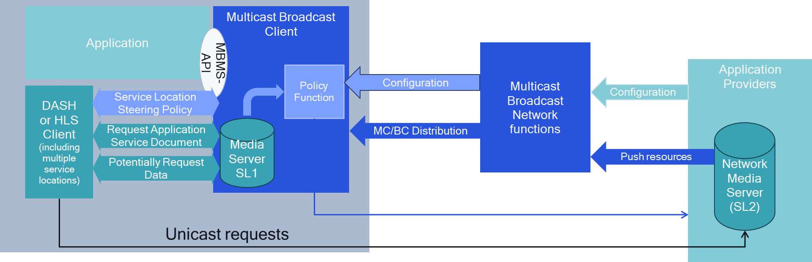
Figure 5.12.2-1: Extension to Multicast Broadcast client to support generic application service
Examples include alternative languages requested over unicast, targeted ad insertion, coverage extensions, and several others.
In order to address the functionality of handling a combination of personalized requests from media players, a new function in the Multicast/Broadcast Client is added that collects information and may communicate with the unicast Application Provider. Figure 5.12.2-2 provides a basic overview of the considered architecture, initially independent of a specific implementation for MBS or MBMS.
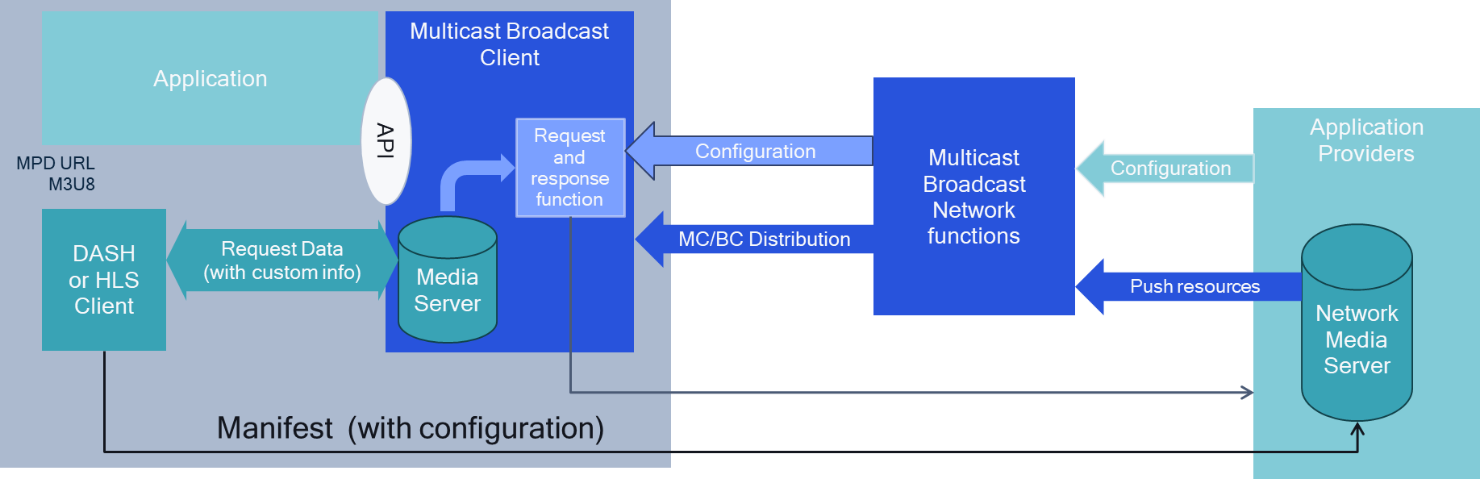
Figure 5.12.2-2: Extension to Multicast Broadcast client to support selected unicast requests
In this case, the application provider configures the Multicast/Broadcast Network Function for distribution. In addition, it provides a configuration instruction, such that Multicast/Broadcast Clients can be configured to manage personalized requests and responses from the Media Clients. This configuration information is provided to the Multicast/Broadcast Client in a service announcement. The Multicast/Broadcast Client uses the request information, possibly adapts the responses and possibly selectively requests information from the unicast server.

5.12.3 Architecture mappings and call flows

5.12.3.1 Introduction
This clause considers different ways in which the collaboration scenarios outlined in clause 5.12.2 can be mapped into the MBS User Services architecture define in TS 26.502 [29] and outlines high-level call flows for procedures between the relevant system actors.

5.12.3.2 Mapping to MBS User Services using MBS AS
The MBS AS is already defined in TS 26.502 [29], but at this stage only has a single functionality, namely object repair. In order to support generic application services, the MBS AS is extended to host content not only for object repair.
NOTE: The logical MBS AS may be co-located with a unicast server that is also used for regular unicast communication.
Figure 5.13.2.2-1 now extends the scope of the MBS AS to support generic application services using the content hosting function.
Figure 5.12.3.2-1: Extensions to MBS User Services network architecture:
Generic application unicast functionality in MBS AS
The client architecture is primarily unmodified, but some of the extensions are provided.
Figure 5.12.3.2-2: Extensions to MBS User Services reference architecture:
Addition of a policy function
Figure 5.12.3.2-2 shows how the MBS User Services reference architecture is extended also in the MBSTF Client to support a steering policy for service locations. The steering policy would generally be created in the MBSF, by preferring the use of MBS delivered media. In this case, the MBSF Client may configure the logic for steering via MBS-6', and the Media Server in the MBSTF Client may also provide a configuration API, for example which requests are served via unicast, or which ones are served via MBS-4-MC. While it is expected that the MBS-Aware Application can issue requests to unicast service locations, the requests are virtually proxied through the Media Server of the MBSTF Client.
The extensions for the high-level baseline procedures in TS 26.502 [29] are a generalization to the procedure extensions in clause 5.9 for generic application service and are provided in figure 5.12.3.2-3 in bold.
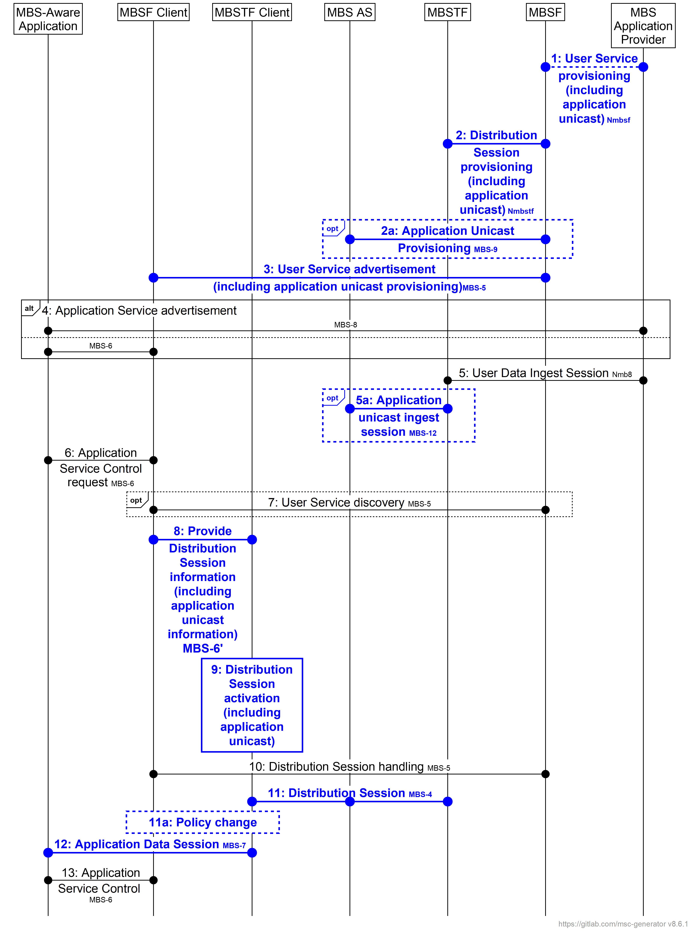
NOTE: In the interests of brevity, the prefix MBS is omitted from the numbered steps in the figure.

Figure 5.12.3.2-2: Extended MBS User Service high-level baseline procedures
The following steps are updated or extended compared to the original high-level call flow:
1. The user service provisioning includes application unicast provisioning.
2. The distribution session provisioning includes that content ingest via MBS-2 is also provisioned to be available on as application unicast.
2a. The MBSF provisions application unicast ingest in the MBS AS via reference point MBS-9.
3. The user service announcement is extended to include instructions for application unicast.
5a. The MBS AS ingests application unicast content from the MBSTF.
8. Configuration of the MBSTF Client by the MBSF Client at reference point MBS-6′ is extended to configure a content steering policy for service locations exposed by the Media Server.
9. Activation of the Distribution Session in the MBSTF Client is extended to include activation of the content steering policy for service locations configured in the previous step.
11.The Distribution Session also uses the MBS AS selectively for unicast requests as follows:
11a. Changes to the content steering policy are made by the MBSF or autonomously by the MBSTF, for example due to non-availability of the MBS User Service. Based on this, use of the Distribution Session by the MBSTF in the previous step may toggle between being multicast at reference point MBS-4-MC with unicast fallback at reference point MBS-4-UC, and being exclusively unicast at reference point MBS-4-UC.
NOTE: In-session or post-session repair may still be configured such that the MBSTF client requests data distributed via MBS-4-MC using MBS-4-UC.
2. Requests from the MBS-Aware Application to the Media Server of the MBSTF Client at reference point MBS-7 may include different service locations.

5.12.3.3 Mapping to MBS User Services using an external unicast server

In a variant of the above, the architecture is extended to support an external unicast server instead of using the MBS AS for serving unicast requests.
Figure 5.12.3.3-1: Extensions to MBS User Services reference architecture:
External Server
Figure 5.12.3.3-1 shows how the MBS User Services reference architecture is extended also in the MBSTF Client to support a reference point MBS-13 that connects to the MBS Application Provider. In this case the unicast traffic is not provisioned via MBS AS, but is retrieved directly from the MBS Application Provider.
NOTE: The MBS Application Provider may also be a 5GMS Application Provider, in which case, reference point MBS-13 could terminate on a 5GMSd AS.
The extensions for the high-level baseline procedures in TS 26.502 [29] are a generalization of the procedure extensions in clause 5.9 for generic application service and are provided in figure 5.12.3.3-2 in bold.
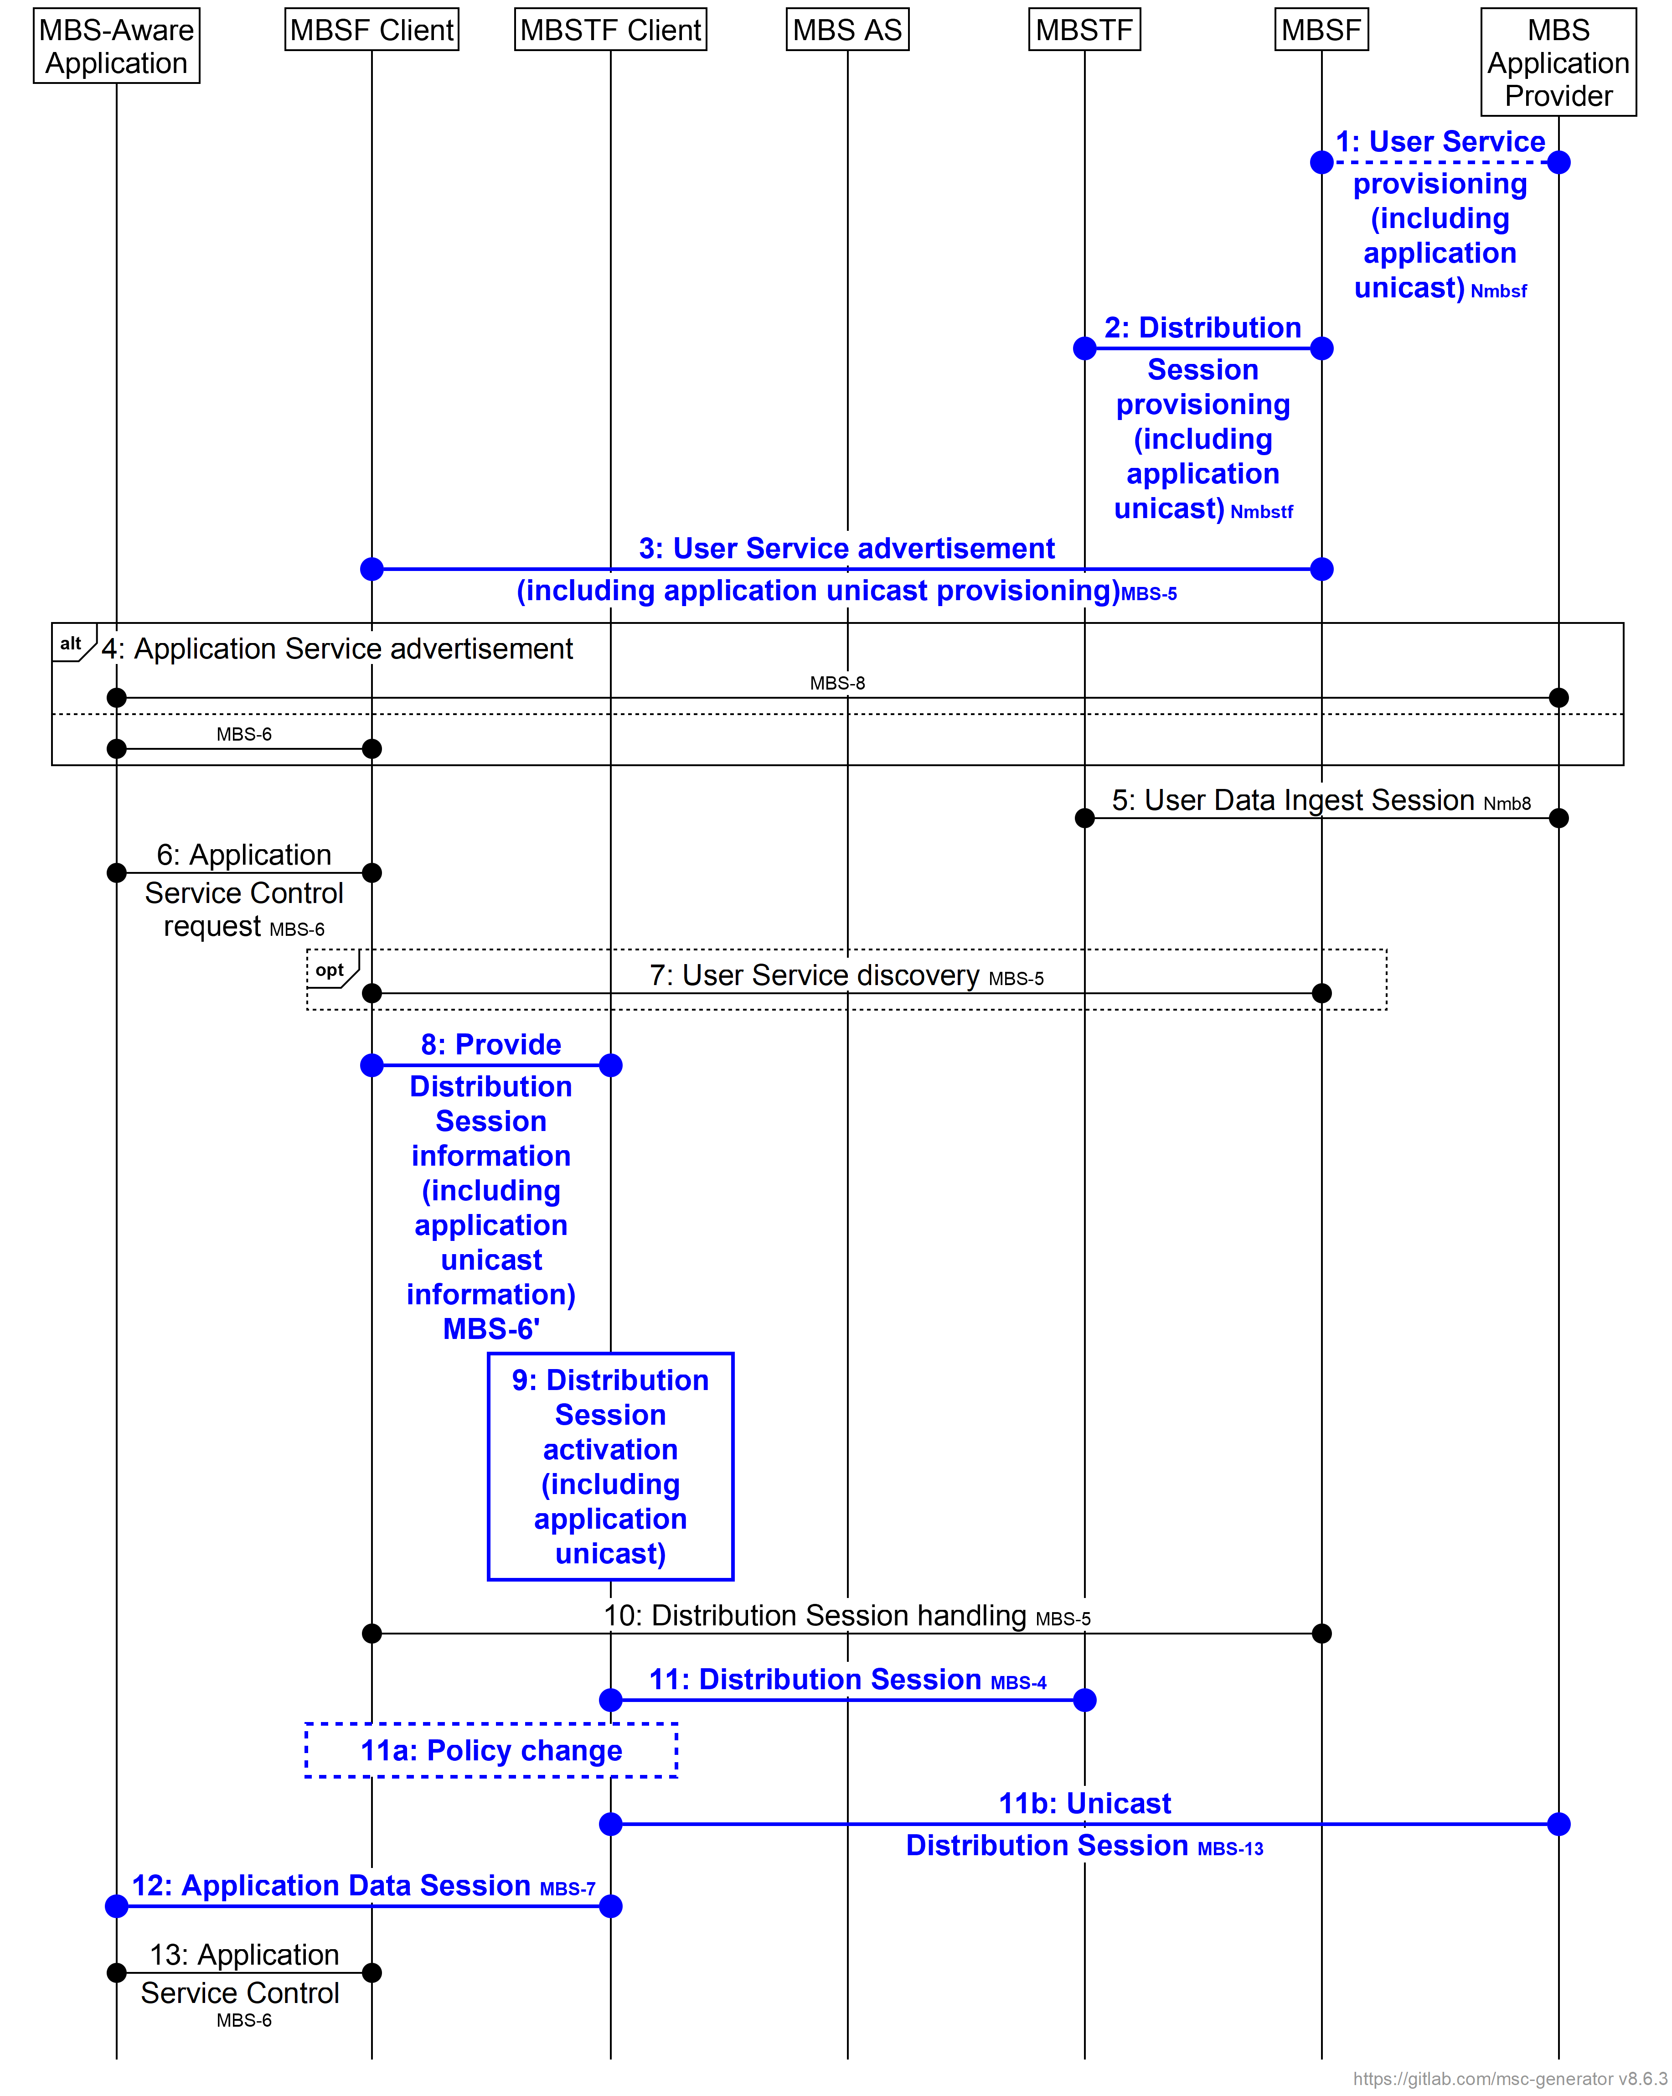
NOTE: In the interests of brevity, the prefix MBS is omitted from the numbered steps in the figure.

Figure 5.12.3.3-2: Extended MBS User Service high-level baseline procedures for external unicast
The following steps are updated or extended compared to the original high-level call flow:
1. The user service provisioning includes application unicast provisioning.
3. The user service announcement is extended to include instructions for application unicast.
8. Configuration of the MBSTF Client by the MBSF Client at reference point MBS-6′ is extended to configure a content steering policy for service locations exposed by the Media Server.
9. Activation of the Distribution Session in the MBSTF Client is extended to include activation of the content steering policy for service locations configured in the previous step.
11.The Distribution Session also uses the external server selectively for unicast requests as follows.
11a. Changes to the content steering policy are made by the MBSF or autonomously by the MBSTF, for example due to non-availability of the MBS User Service. Based on this, use of the Distribution Session by the MBSTF in the previous step may toggle between being multicast at reference point MBS-13 with unicast fallback at MBS-4-UC, and being exclusively unicast at reference point MBS-13.
NOTE: In-session or post-session repair may still be configured such that the MBSTF Client requests data distributed via MBS-4-MC using MBS-4-UC. This is omitted here.
12. Requests from the MBS-Aware Application to the Media Server of the MBSTF Client at reference point MBS-7 may include different service locations.

5.12.3.4 Selective unicast requests from MBS Client

In another variant of what is presented in clauses 5.12.3.2 and 5.12.3.3, unicast requests are selectively chosen based on the request types. The unicast requests may either be issued to the MBS AS, or to an external application server. Figure 5.12.3.4-1 shows how the MBS User Services reference architecture is extended to support a request filter function. The request filter is applied based on the request.
Figure 5.12.3.4-1: Extensions to MBS User Services reference architecture:
Request filter function
The extensions for the high-level baseline procedures in TS 26.502 [29] are a generalization to the procedure extensions in clause 5.9 using a request filter function and possibly and are provided in figure 5.12.3.4-2 in bold.
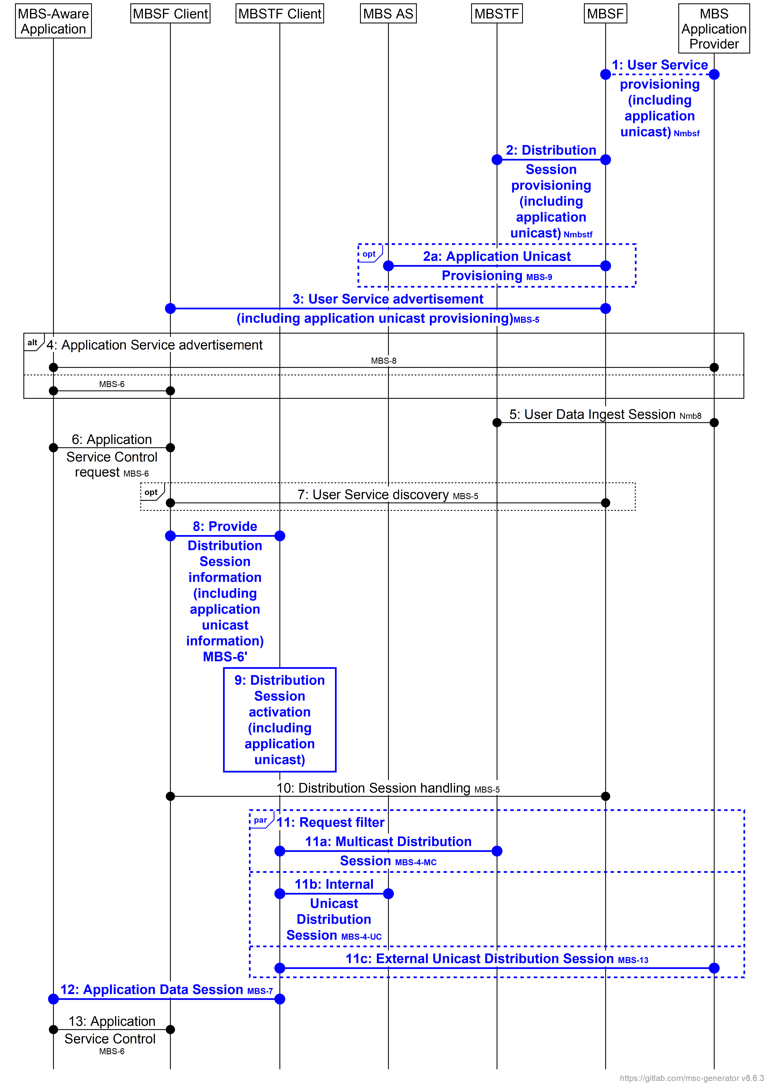
NOTE: In the interests of brevity, the prefix MBS is omitted from the numbered steps in the figure.

Figure 5.12.3.3-2: Extended MBS User Service high-level baseline procedures for external unicast
The following steps are updated or extended compared to the original high-level call flow:
1. The user service provisioning includes application unicast provisioning and request filters.
2. The distribution session provisioning may include that content ingest via MBS-2 is also provisioned to be available on as application unicast on MBS AS.
3. The user service announcement is extended to include instructions for application unicast and request filters.
8. Configuration of the MBSTF Client by the MBSF Client at reference point MBS-6′ is extended to configure a request filter policy for service locations exposed by the Media Server.
9. Activation of the Distribution Session in the MBSTF Client is extended to include activation of the request filter policy for service locations configured in the previous step.
11. The Distribution Session also uses the MBS AS and/or the external server selectively for unicast requests. Based on requests and defined request filters, the different requests are handled either by multicast, by unicast to the MBS AS, or by unicast to an external server.
NOTE: In-session or post-session repair may still be configured such that the MBSTF client requests data distributed via MBS-4-MC using MBS-4-UC.
12. Requests from the MBS-Aware Application to the Media Server of the MBSTF Client at reference point MBS-7 may include different service locations.

5.12.4 Gap analysis and requirements

5.12.4.1 General
This clause identifies gaps addressing the high-level call flows in clause 5.12.3.

5.12.4.2 Mapping to MBS User Services using MBS AS
The following aspects are identified to be missing:
1. Void.
2. MBS User Service provisioning parameters at reference point Nmb10 describing the content steering policy to support application unicast requests.
3. Provisioning of the MBS AS at reference point MBS-9 in order to support application unicast requests.
4. MBS User Service Announcement parameters to support provisioning for application unicast requests for different purposes.
5. Unicast ingest session at reference point MBS-12 to support ingest of unicast content into the MBS AS from the MBSTF.
6. Functional extension of the MBSTF Client to support switching service locations.
7. Support for differentiated requests from the MBS-Aware Application to the Media Server of the MBSTF Client (and either forwarding these requests to the MBS AS or serving them from local cache, as dictated by the content steering policy currently in force).
9. Support for application unicast requests from the MBSTF Client to the MBS AS via reference point MBS-4-UC.

5.12.4.3 Mapping to MBS User Services using an external unicast server

The following aspects are identified to be missing on top of those identified in clause 5.12.4.2:
1. A reference point that permits to connect the MBSTF Client to MBS Application Provider.
2. Provisioning of the MBS AS at reference point MBS-9 in order to support application unicast requests to an external application server.
3. Support for application unicast requests from the MBSTF Client to an external server via reference point MBS-13.

5.12.4.4 Selective Unicast Requests from MBS Client

The following aspects are identified to be missing on top of those identified in clause 5.12.4.3:
1. The user service provisioning for application unicast provisioning and request filters.
2. MBSTF extension to support selective unicast requests based on request filters.
3. Parallel distribution sessions at reference points MBS-4-MC, MBS-4-UC and/or MBS-13.
4. Support for appropriate error codes.

5.12.5 Candidate solutions

5.12.5.1 General

This clause identifies potential solutions addressing the gaps in clause 5.12.4.

5.12.5.2 Mapping to MBS User Services using MBS AS
In order to address the gaps identified in clause 5.12.4.1, the following solutions may be considered:
1. Void.

2. MBS User Service provisioning parameters at reference point Nmb10 describing the content steering policy to support application unicast requests.
- The provisioning may be supported by URL mapping templates such as those used to configure a proxy/edge server aligned with Content Hosting Configuration in 5GMS AS.
4. Provisioning of the MBS AS at reference point MBS-9 in order to support application unicast requests.
- This can be addressed by a generalisation to what is needed for object repair in clause 5.9.
5. MBS User Service Announcement parameters to support provisioning for application unicast requests for different purposes.
- The provisioning may be supported by inclusion of the URL mapping template described under point 2 above in the MBS User Service Announcement.
6. Functional extension of the MBSTF Client to support switching service locations.
- Options include SAND4M (see clause 5.13.1.2.2), presentation manifest rewrite and DASH-IF Content Steering (see clause 5.13.1.2.3). For details also refer to TS 26.501 [26501] and TS 26.512 [26512].
7. Support for differentiated requests from the MBS-Aware Application to the Media Server of the MBSTF Client (and either forwarding these requests to the MBS AS or serving them from local cache, as dictated by the content steering policy currently in force).
- No specific extensions are needed for typical clients.
8. Support for application unicast requests from the MBSTF Client to the MBS AS via reference point MBS-4-UC.
- No specific extensions are needed except for parameters that are processed, including HTTP request headers, request URL query parameters or other parts of HTTP requests.

5.12.5.3 Mapping to MBS User Services using an external unicast server
This aspect is for further study.

5.12.5.4 Selective Unicast Requests from MBS Client
This aspect is for further study.

5.12.6 Summary and conclusions
For combined MBS multicast and unicast, additional study is recommended to discuss different candidate solutions.

===== CHANGE =====

[

8.5 Recommended follow-up work arising from version 20

8.5.1 Introduction
In a third phase of this feasibility study, Key Issues have been further extended.
Based on the study of these, the following next steps are recommended.

8.5.2 Recommendations for stage 2 normative work arising from version 20
It is recommended to provide relevant extensions to TS 26.502 [29] to extend the MBS User Service architecture based on the updated conclusions in clause 5. Candidates for these extensions are:
1. For Key Issue #11: Combined MBS multicast and unicast as introduced in clause 5.12 and based on the conclusions in clause 5.12.4:
a. Add the necessary functional extensions and call flows to support ….

8.5.3 Recommendations for stage 3 normative work arising from version 20
It is recommended to provide relevant extensions to MBS User service protocols and formats specified in TS 26.517 [30] based on the conclusions in clause 5 and the stage-2 extensions above, if applicable. Candidates for these extensions are:
1. For Key Issue #11: Combined broadcast and unicast as introduced in clause 5.12 and based on the conclusions in clause 5.12.6:

8.5.4 Recommendations for coordination arising from version 20
It is recommended to coordinate work with other working groups and organizations as follows:
1. For Key Issue #11: Combined Unicast and Broadcasts as introduced in clause 5.12 and based on the conclusions in clause 5.12.4:
- Validate the approaches by implementation, for example in 5G-MAG Reference Tools
]

