3GPP TSG-SA WG4 Meeting #134 S4-251631

Dallas, Texas, USA, 17 – 21 November 2025 is revision of S4aI250180
CR-Form-v12.0
CHANGE REQUEST
 | 26.942 | CR | 0007 | rev | 1 | Current version: | 19.0.0
For HELP on using this form: comprehensive instructions can be found at
http://www.3gpp.org/Change-Requests.

Proposed change affects: | UICC apps |  | ME | X | Radio Access Network |  | Core Network | X

Title: | [FS_Energy_Ph2_MED] Solution for KI5 Media Application Server Energy management
Source to WG: | Orange
Source to TSG: | S4
Work item code: | FS_Energy_Ph2_MED |  |  |  |  |  | Date: |  |  | 2025-11-10
Category: | B |  |  |  |  |  | Release: |  |  | Rel-20
 | Use one of the following categories:  F (correction)  A (mirror corresponding to a change in an earlier release)  B (addition of feature),  C (functional modification of feature)  D (editorial modification)  Detailed explanations of the above categories can  be found in 3GPP TR 21.900. |  |  |  |  |  |  |  | Use one of the following releases:  Rel-8 (Release 8)  Rel-9 (Release 9)  Rel-10 (Release 10)  Rel-11 (Release 11)  …  Rel-15 (Release 15)  Rel-16 (Release 16)  Rel-17 (Release 17)  Rel-18 (Release 18)
Reason for change: |  | Addtion of a solution to Key Issue 5 on Media Application Server Energy management.
Summary of change: |  | Addition of a clause 7.12 adding a solution to Key Issue 5 on Media Application Server Energy management.
Consequences if not approved: |  | No solution proposed for the KI.
Q
Clauses affected: |  | 2, 7.1, 7.12
 |  | Y | N
Other specs |  |  | X | Other core specifications
affected: |  |  | X | Test specifications
(show related CRs) |  |  | X | O&M Specifications
Other comments:
This CR's revision history:

1ST Change

2 References
The following documents contain provisions which, through reference in this text, constitute provisions of the present document.
- References are either specific (identified by date of publication, edition number, version number, etc.) or non-specific.
- For a specific reference, subsequent revisions do not apply.
- For a non-specific reference, the latest version applies. In the case of a reference to a 3GPP document (including a GSM document), a non-specific reference implicitly refers to the latest version of that document in the same Release as the present document.
[1] 3GPP TR 21.905: "Vocabulary for 3GPP Specifications".
…
[87] Accubattery: https://play.google.com/store/apps/details?id=com.digibites.accubattery
[88] 3GPP TS 26.512: "5G Media Streaming (5GMS); Protocols".
[89] ETSI TS 103 998: "Content Steering for DASH".
2nd Change

7.1 Mapping of Solutions to Key Issues
Table 7.1-1: Mapping of solutions to Key Issues
Solutions
 | KI#1 | KI#2 | KI#3 | KI#4 | KI#5 | KI#6
#1 |  |  | X
#2 |  |  | X
#3 |  | X
#4 | X
#5 | X
#6 | X | X
#7 | X
#8 |  | X
#9 | X
#10 |  |  |  |  |  | X
#11 |  |  |  |  | X

These solutions are simply candidate solutions. Their inclusion in the following clauses does not imply that they have been agreed upon or endorsed. Any decisions and work to be done for the normative work will be detailed in the conclusions of this Technical Report.

3rd change
(All new text)

7.12 Solution #11: Steering server driven selection of delivery paths based on energy characteristics

7.12.1 Key Issue mapping
This solution candidate addresses Key Issue #5 (Media Application Server Energy management) described in clause 6.5.

7.12.2 Functional description

7.12.2.1 Introduction
The main media streaming formats such as MPEG-DASH and HLS have been updated to include additional information in their manifests to specify a server (called a "steering server") capable of dynamically selecting the delivery path to use. Currently, this selection is primarily based on Quality of Service (QoS) criteria.
From Release 19, this feature is already supported in the 5G Media Streaming System whereby the Media Player supports content steering for downlink media streaming as described in clause 10.3A.4 of TS 26.512 [88].
In parallel, networks have collectors of energy-related characteristics, including information that characterizes the network's power supply in terms of energy consumption, energy source, carbon footprint, capacity, and availability. These collectors provide insights into environmental impact at different granularities (per user, per service, etc.). This is notably the case with the Energy Information Function (EIF) defined in the 5G architecture.
However, there is currently no method for using these network energy characteristics to select the video streaming delivery path with the lowest environmental impact.
The proposed solution consists of defining a process that allows steering servers to make this choice based on environmental impact, through the sharing of network energy-related characteristics.
This solution leverages existing interfaces enabling communication between application providers and 5G networks, particularly for exchanging Quality of Experience data. These interfaces are enhanced with network energy-related characteristics, allowing the application provider to use this information on its steering servers.

7.12.2 Reference architecture for steering server driven selection of delivery paths based on energy characteristics
Figure 7.12.2.2-11 depicts a reference architecture that realises this candidate solution in the generalised Media Delivery architecture defined in TS 26.501 [23] and TS 26.506 [59].
NOTE: The Energy Information Collector and reference point E5 are not instantiated in this reference architecture because they are not required by the Candidate Solution.
Figure 7.12.2.2-1: Reference architecture for steering server driven selection of delivery paths based on energy characteristics
The core principle of this architecture revolves around a component called the Energy Information AF, which is instantiated within the Media AF. Its responsibilities vary depending on its current provisioning state, as determined by the Media AF (which includes the Energy Information Exposure Specification provisioned by Media Application Providers – see clause 7.8). These responsibilities may include:
- Subscribing to and consuming NF Energy Information from the Energy Information Function as defined in TS 23.501 [72]) with required granularities (UE, PDU session and/or QoS flow) in accordance with the parameters of the Energy Information Exposure Specifications.
- Subscribing to and consuming AS Energy Information from the Media AS in accordance with the parameters of the Energy Information Exposure Specification.
Unlike other solutions described in this document that utilise the Energy Information AF (e.g. Solution #5 or #10), this approach does not require an Energy Information Collector within the device. The primary goal is to enable selection of the delivery path based on energy characteristics that align with user preferences or service provider criteria. Regardless of the chosen delivery path, the energy characteristics are assumed to remain unchanged on the UE. Therefore, the path selection relies solely on the energy information provided by the network through the Energy Information AF. A second difference is the use of reference point M4, already defined in TS 26.501 [23], to provide steering information to the Media Access Function.

7.12.3 Procedures
Figure 7.12.3-1 below details the different steps for steering server driven selection of delivery paths based on energy characteristics outlined in clause 7.12.2.
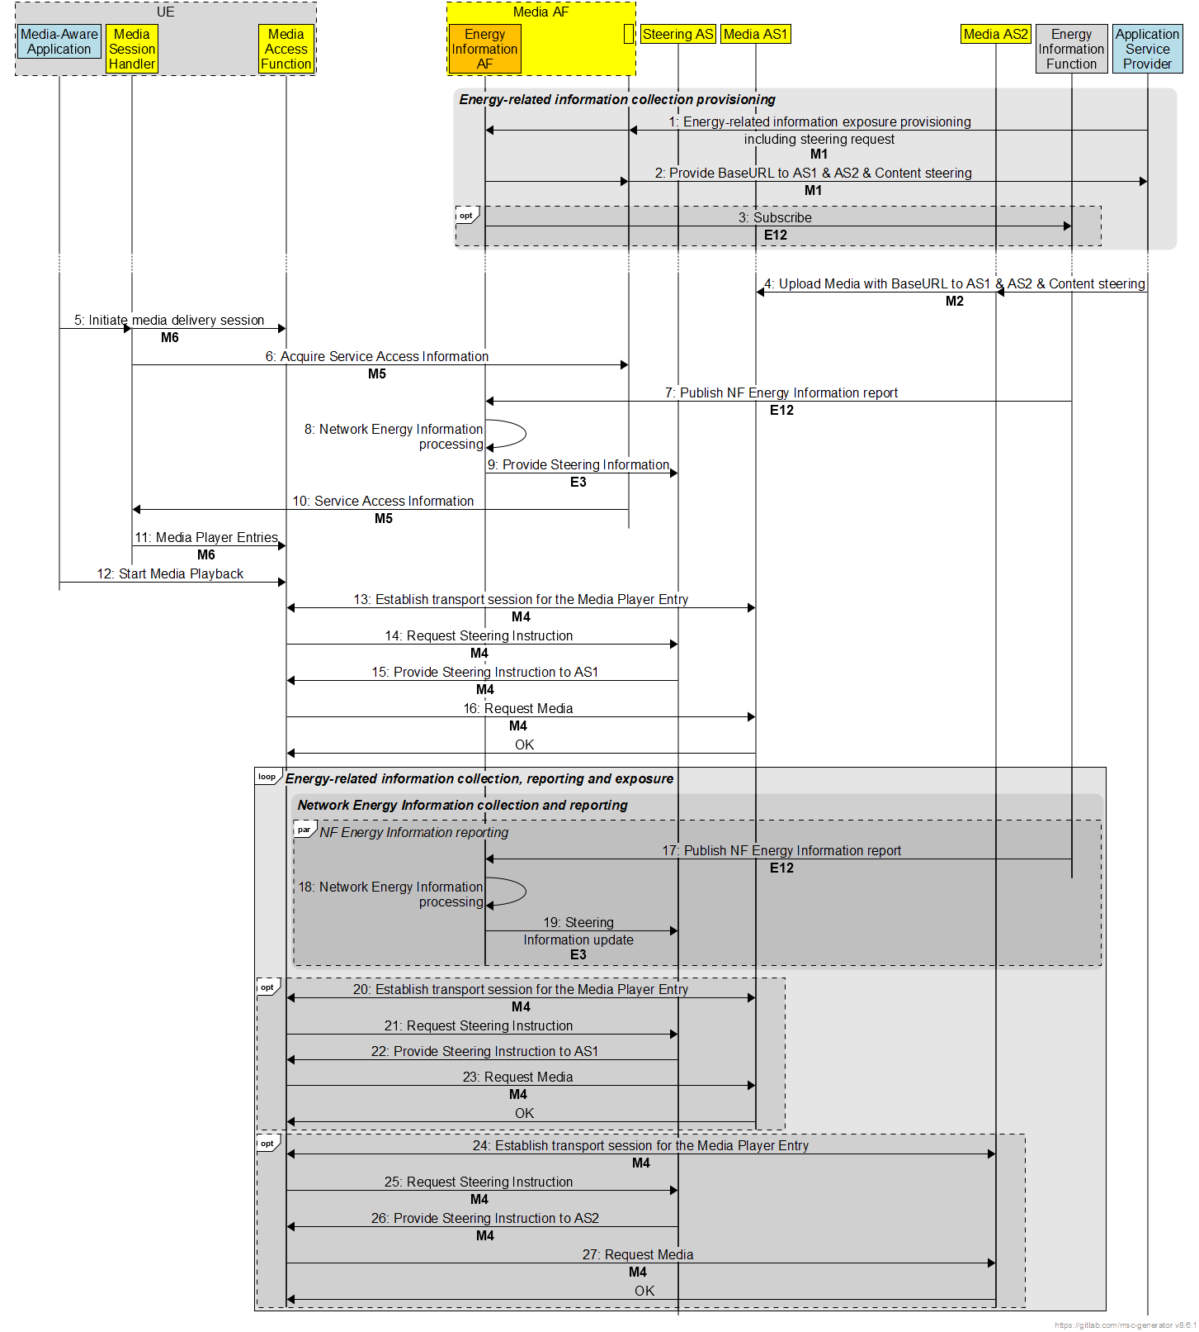
Figure 7.12.3-1: Procedures for steering server driven selection of delivery paths based on energy characteristics
The procedure consists in mixing the typical content steering procedure, for example the one described for DASH in [89], and the provision of the Energy Information AF allowing an additional AS to play the role of steering server enable to decide the delivery path based on energy characteristics of each path.
Steps:
1. The Media Application Provider provisions the Energy Information AF with an Energy Information Exposure Specification via reference point M1. The Energy Information exposure configuration includes a request for using optimization based on content steering.
2. In return, the Media AF provides the base URLs to the provisioned Media AS service locations as well as to the Media AS content steering service.
3. The Energy Information AF subscribes to receive Network Energy Information reporting from the Energy Information Function via reference point E12, if relevant, in accordance with the set of parameters in the Energy Information Exposure Specification.
4. The Media Application Provider generates entry point with the provided information and the media with this information is ingested by the Media AS.
5. The Media-aware Application triggers the Media Client to initiate a media delivery session.
6. The Media Session Handler interacts with the Media AF to acquire the whole Service Access Information. The Service Access Information may include Media Player Entry URLs and Energy Information AF endpoint.
7. The Energy Information Function may submit a Network Energy Information report to the Energy Information AF via reference point E12.
8. The Energy Information AF processes the energy-related information report it has received.
9. The Energy Information AF provides steering information to the Media AS acting as steering server.
10. The service access information is provided by the Media AF to the Media Session Handler.
11. The Media Session Handler provide the Media Player Entries to the Media Access Function.
12. The Media Access Function is invoked with the selected Media Entry Point to start media access and playback.
13. The Media Access Function establishes the transport session for acquiring the Media Player Entry.
14. Thanks to the information provided in the Media Player Entry, the Media Access Function request steering instruction to the content steering service instantiated in the Media AS.
15. The Steering AS provides steering instructions indicating the use of AS1.
16. The Media Access Function requests the media to AS1.
Steps 17 to 19 are identical to steps 7 to 9. They allow energy-related information about the network to be updated during the media delivery session. If it detects a change in this information, the EIAF may decide to update steering instructions.
Steps 20 to 23, and steps 24 to 27 are identical to steps 13 to 16, allowing media playback thanks to the Media AS indicated in the steering instructions.

7.11.4 Summary
This candidate solution proposes a mechanism allowing application providers to select the video streaming delivery path with the lowest environmental impact, based on:
1. The collection of network energy-related characteristics by the mobile network operator. This information is provided by the Energy Information Function to a new component called Energy Information AF, included in the Media AF.
2. Standardised interfaces between the Media AF and the Application Service Provider allowing the Application Service Provider to request the use of steering mechanism for its reducing environmental impact and provision steering information.
3. The use of this information by a Media AS acting as steering server to dynamically direct users toward the delivery paths with the desired energy characteristics.
This approach optimizes the energy efficiency of multimedia content delivery while maintaining acceptable service quality, thus contributing to reducing the environmental footprint of video streaming services.
The solution applies to any streaming service provider delivering videos via mobile networks and integrates naturally into existing adaptive streaming architectures such as MPEG-DASH and HLS.
The solution has no impact on the UE as steering mechanisms are part of adaptive streaming protocols such as MPEG-DASH and HLS.
End of changes

