3GPP TSG-SA WG4 Meeting #134 S4-251630

Dallas, Texas, USA, 17 – 21 November 2025 is revision of S4aI250179
CR-Form-v12.0
CHANGE REQUEST
 | 26.942 | CR | 0006 | rev | 1 | Current version: | 19.0.0
For HELP on using this form: comprehensive instructions can be found at
http://www.3gpp.org/Change-Requests.

Proposed change affects: | UICC apps |  | ME | X | Radio Access Network |  | Core Network | X

Title: | [FS_Energy_Ph2_MED] Solution for KI6 Client-driven management of media delivery service energy optimisation
Source to WG: | Orange
Source to TSG: | S4
Work item code: | FS_Energy_Ph2_MED |  |  |  |  |  | Date: |  |  | 2025-11-10
Category: | B |  |  |  |  |  | Release: |  |  | Rel-20
 | Use one of the following categories:  F (correction)  A (mirror corresponding to a change in an earlier release)  B (addition of feature),  C (functional modification of feature)  D (editorial modification)  Detailed explanations of the above categories can  be found in 3GPP TR 21.900. |  |  |  |  |  |  |  | Use one of the following releases:  Rel-8 (Release 8)  Rel-9 (Release 9)  Rel-10 (Release 10)  Rel-11 (Release 11)  …  Rel-15 (Release 15)  Rel-16 (Release 16)  Rel-17 (Release 17)  Rel-18 (Release 18)
Reason for change: |  | Addtion of a solution to Key Issue 6 on Client-driven management of media delivery service energy optimisation.
Summary of change: |  | Addition of a clause 7.11 adding a a solution to Key Issue 6 on Client-driven management of media delivery service energy optimisation.
Consequences if not approved: |  | No solution proposed for the KI.
Q
Clauses affected: |  | 7.1, 7.11
 |  | Y | N
Other specs |  |  | X | Other core specifications
affected: |  |  | X | Test specifications
(show related CRs) |  |  | X | O&M Specifications
Other comments:
This CR's revision history:

1ST Change

7.1 Mapping of Solutions to Key Issues
Table 7.1-1: Mapping of solutions to Key Issues
Solutions
 | KI#1 | KI#2 | KI#3 | KI#4 | KI#5 | KI#6
#1 |  |  | X
#2 |  |  | X
#3 |  | X
#4 | X
#5 | X
#6 | X | X
#7 | X
#8 |  | X
#9 | X
#10 |  |  |  |  |  | X

These solutions are simply candidate solutions. Their inclusion in the following clauses does not imply that they have been agreed upon or endorsed. Any decisions and work to be done for the normative work will be detailed in the conclusions of this Technical Report.
2nd change
(All new text)

7.11 Solution #10: Client-driven selection of stream variants or delivery paths based on energy characteristics

7.11.1 Key Issue mapping
This Candidate Solution addresses Key Issue #6.

7.11.2 Functional description

7.11.2.1 Introduction

Currently, media players lack the capability to select stream variants or delivery paths based on their environmental impact, in addition to traditional QoS considerations. This limitation hinders the ability to optimize energy efficiency during media playback while still maintaining an acceptable Quality of Experience.
The proposed solution introduces a mechanism for sharing energy-related characteristics throughout the technical delivery chain. This enables more energy-efficient media playback by allowing client devices to make informed decisions about stream selection and delivery paths, considering their environmental impact alongside QoS.
This solution specifically addresses the mechanism for providing energy-related characteristics to the UE. The decision-making process for optimizing video playback is not detailed here, either because it is managed directly by the video player's heuristics for optimizations such as selecting stream variants or because it is already supported by 5GMS. For example, procedures for downlink streaming to Media Players with different presentation manifests (clause 5.2.4 in TS 26.501 [23]) or for streaming from multiple service locations (clause 5.2.6 in TS 26.501 [23]) are already part of the existing 5GMS downlink media streaming procedures.

7.11.2.2 Reference architecture for client-driven selection of stream variants or delivery paths based on energy characteristics in the generalised Media Delivery System
Figure 7.11.2.2-1 depicts a reference architecture that realises this candidate solution in the generalised Media Delivery architecture defined in TS 26.501 [23] and TS 26.506 [59].
Figure 7.11.2.2-1: Reference architecture for client-driven selection of stream variants or delivery paths based on energy characteristics in the generalised Media Delivery System
The core principle of this architecture is to leverage the existing method for collecting and exposing energy-related characteristics, as already outlined in Solution #5 (see clause 7.6). Additionally, it extends this approach by enabling the Media Client to select stream variants or delivery paths based on this information.
The solution is reusing functions already defined for collection and exposure of energy-related information:
- The Energy Information AF.
- The Energy Information Collector.
In the generalised architecture, the Energy Information Collector is integrated in the Media Client, more specifically in the Media Session Handler which communicates with the Media Access Function also part of the Media Client:
- Media Client: A UE-internal function dedicated to Media Delivery comprising:
- Media Session Handler: An entity on the UE that communicates with the Media AF in order to establish, control and support the delivery of a media delivery session.
- Media Access Function: An entity on the UE that communicates with the Media AS in order to access and deliver media content. The media access function for example may be further sub-divided into content delivery protocols, codecs, media types and metadata representation.
The solution also reuses reference points M1, M3, E3, M4, M5, E5, M6, M8, M11 and E12 already defined for collection and exposure of energy-related information in the instantiation in generalised media delivery architecture presented in clause 7.6.

7.11.3 Procedures
Figure 7.11.3-1 below details the different steps for client-driven selection of stream variants or delivery paths based on energy characteristics outlined in clause 7.11.2.2.

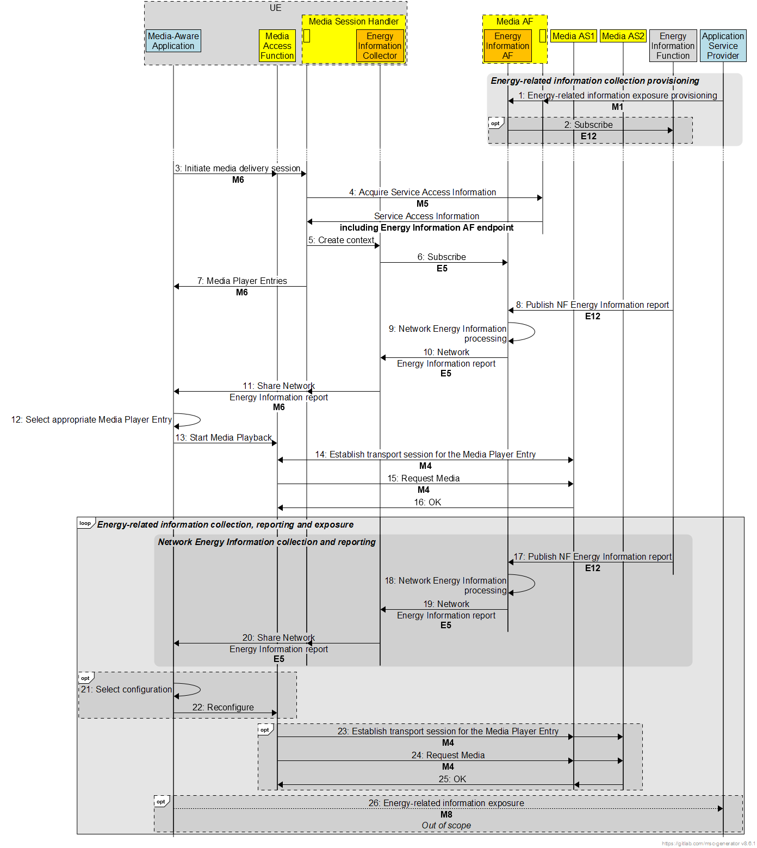
Figure 7.11.3-1: Procedures for client-driven selection of stream variants or delivery paths based on energy characteristics in the generalised Media Delivery System
Steps:
1. The Application Service Provider provisions the Energy Information AF with an Energy Information Exposure Specification via reference point M1. The Energy Information exposure configuration may identify application(s) that fall within its scope.
2. The Energy Information AF subscribes to receive Network Energy Information reporting from the Energy Information Function via reference point E12, if relevant, in accordance with the set of parameters in the Energy Information Exposure Specification.
3. The Media-aware Application triggers the Media Client to initiate a media delivery session.
4. The Media Session Handler interacts with the Media AF to acquire the whole Service Access Information. The Service Access Information may include Media Player Entry URLs and Energy Information AF endpoint.
5. As a consequence of the previous step, the Media Session Handler creates a new energy-related information collection and reporting context with the Energy Information Collector instantiated in it.
6. The Energy Information Collector subscribes to Network Energy Information reporting from Energy Information AF via reference point E5, if relevant, and receives in response a UE Energy Information collection configuration.
7. The Media Session Handler provides the Media Entry Points to the Media-aware Application. The information may indicate a precedence order for these Media Entry Points.
8. The Energy Information Function may submit a Network Energy Information report to the Energy Information AF via reference point E12.
9. The Energy Information AF processes the energy-related information report it has received.
10. The Energy Information AF exposes a processed Network Energy Information report related to the UE to the Energy Information Collector subscriber via reference point E5.
11. The Energy Information Collector exposes energy-related information to the subscribed UE Application via reference point M6.
12. The Media-aware Application selects the appropriate Media Player Entry according to Application Service Provider configuration and/or user preferences.
13. In parallel, the Media Access Function is invoked with the selected Media Entry Point to start media access and playback.
14. The Media Access Function establishes the transport session for acquiring the Media Player Entry.
15. The Media Access Function requests the Media Player Entry.
16. The Media Access Function receives the Media Player Entry.
Steps 17 to 20 are identical to steps 8 to 11. They allow energy-related information about the network to be updated during the media delivery session. If it detects a change in this information, the Media-aware Application may decide to reconfigure the media delivery session:
21. The Media-aware Application selects the appropriate configuration according to energy-related information provided in step 21.
22. If the configuration is different, the Media-aware Application reconfigure the Media Access Function.
Steps 23 to 25 are identical to Step 14 to 16, allowing media playback.
26. The Media-aware Application may expose the received energy-related information to the Application Service Provider via reference point M8 using methods beyond the scope of 3GPP standardisation.

7.11.4 Summary
The proposed solution enables the integration of energy-related characteristics into multimedia content delivery systems. It offers Media Clients the ability to select stream variants or delivery paths based on their environmental impact, while maintaining acceptable Quality of Experience.
This approach is part of a sustainable development approach to multimedia streaming, enabling end-to-end energy optimization, from content production to consumption.
This solution is based on Network Energy Information available from the Energy Information Function as well as the two new functional entities defined in Solution #5 (see clause 7.6): the Energy Information AF and the Energy Information Collector. Leveraging existing mechanisms of the media delivery system, the Media Client is able to make use of energy-related information provided by these functions to optimize energy efficiency during media delivery sessions, while maintaining an acceptable Quality of Experience.
This solution offers several advantages:
1. Reduced environmental impact: The energy consumption and consequent CO₂ emissions associated with multimedia content delivery are minimised.
2. User transparency: The environmental impact of content consumption is made visible without impacting privacy.
3. Flexibility: The approach is compatible with existing 5G System optimizations and existing adaptive streaming protocols (DASH, HLS).
4. Customization: End users can be given the freedom to choose their level of environmental commitment. This could be achieved, for example, by the Media-aware Application offering a menu of energy optimization modes:
- Eco Mode: Prioritizes energy efficiency, even at the slight expense of Quality of Experience.
- Standard Mode: Balance between energy efficiency and Quality of Experience.
- Performance Mode: Prioritizes Quality of Experience over energy consumption.
5. Global optimization: The entire delivery chain, from distribution to consumption, is taken into account.
End of changes

