3GPP TR 26.956 V0.5.0(2025-05)
Technical Report

3rd Generation Partnership Project;
Technical Specification Group Services and System Aspects;
Evaluation and Characterization of Beyond 2D Video Formats and Codecs
(Release 19)
 | 
The present document has been developed within the 3rd Generation Partnership Project (3GPP TM) and may be further elaborated for the purposes of 3GPP.
The present document has not been subject to any approval process by the 3GPP Organizational Partners and shall not be implemented.
This Specification is provided for future development work within 3GPP only. The Organizational Partners accept no liability for any use of this Specification.
Specifications and Reports for implementation of the 3GPP TM system should be obtained via the 3GPP Organizational Partners' Publications Offices.

3GPP
Postal address

3GPP support office address
650 Route des Lucioles - Sophia Antipolis
Valbonne - FRANCE
Tel.: +33 4 92 94 42 00 Fax: +33 4 93 65 47 16
Internet
http://www.3gpp.org

Copyright Notification
No part may be reproduced except as authorized by written permission.
The copyright and the foregoing restriction extend to reproduction in all media.

© 2024, 3GPP Organizational Partners (ARIB, ATIS, CCSA, ETSI, TSDSI, TTA, TTC).
All rights reserved.

UMTS™ is a Trade Mark of ETSI registered for the benefit of its members
3GPP™ is a Trade Mark of ETSI registered for the benefit of its Members and of the 3GPP Organizational Partners
LTE™ is a Trade Mark of ETSI registered for the benefit of its Members and of the 3GPP Organizational Partners
GSM® and the GSM logo are registered and owned by the GSM Association

Contents

Foreword 9
Introduction 10
1 Scope 11
2 References 11
3 Definitions of terms, symbols and abbreviations 19
3.1 Terms 19
3.2 Symbols 19
3.3 Abbreviations 19
4 Beyond 2D Video Formats 19
4.1 Introduction 19
4.2 Reference Model for Beyond 2D Video 20
4.2.1 Overview 20
4.3 Beyond 2D Video Representation Formats 21
4.3.1 Introduction 22
4.3.2 Extensions to Stereoscopic Video Representation Formats 22
4.3.2.1 Definition 22
4.3.2.2 Stereoscopic Video format description according to TS 26.265 22
4.3.2.3 Extensions to Stereoscopic Video Representation formats 23
4.3.2.4 Production and Capturing Systems 26
4.3.2.5 Rendering and Display Systems 27
4.3.2.6 Supporting Information 27
4.3.2.7 Benefits and Limitations 28
4.3.2.7.1 Benefits 28
4.3.2.7.2 Limitations 28
4.3.3 Dense Dynamic Point Cloud representation format 28
4.3.3.1 Definition 28
4.3.3.2 Production and Capturing Systems 29
4.3.3.3 Rendering and Display Systems 29
4.3.3.4 Support Information 30
4.3.3.4.1 Test and reference sequences 30
4.3.3.4.2 Uncompressed data size 30
4.3.3.4.3 Known compression technology 31
4.3.3.4.4 Conversion from other formats 31
4.3.3.4.5 Typical quality criteria 31
4.3.3.5 Benefits and Limitations 31
4.3.3.5.1 Benefits 31
4.3.3.5.2 Limitations 32
4.3.4 Multi-view video Representation Format 32
4.3.4.1 Definition 32
4.3.4.2 Production and Capturing Systems 34
4.3.4.3 Rendering and Display Systems 35
4.3.4.4 Supporting Information 35
4.3.4.4.1 Camera placement 35
4.3.4.4.2 Spatial resolution 36
4.3.4.4.2 Objective metrics 36
4.3.4.4.3 Coding and delivery options 37
4.3.4.5 Benefits and Limitations 37
4.3.4.5.1 Benefits 37
4.3.4.5.2 Limitations 37
4.3.5 Dynamic Mesh Representation Format 37
4.3.5.1 Definition 37
4.3.5.2 Production and Capturing Systems 38
4.3.5.3 Rendering and Display Systems 38
4.3.5.4 Supporting Information 39
4.3.5.4.1 Test and reference sequences 39
4.3.5.4.2 Uncompressed data size 39
4.3.5.4.3 Known compression technologies 39
4.3.5.4.4 Conversion from other formats 40
4.3.5.4.5 Typical Quality Criteria 40
4.3.5.4.5.1 Objective Metrics 40
4.3.5.4.5.2 Subjective Evaluation 41
4.3.2.7 Benefits and Limitations 41
4.3.2.7.1 Benefits 41
4.3.2.7.2 Limitations 42
4.3.6 Formats under Research 42
4.3.6.1 Neural Radiance Fields 42
4.3.6.1.1 Introduction 42
4.3.6.1.2 Definition 42
4.3.6.1.3 Production and Capturing Systems 43
4.3.6.1.4 Rendering and Display Systems 44
4.3.6.1.5 Supporting Information 44
4.3.6.1.6 Benefits and Limitations 45
4.3.6.1.6.1 Benefits 45
4.3.6.1.6.2 Limitations 45
4.3.6.2 Light Fields Video 45
4.3.6.2.1 Definition 45
4.3.6.2.2 Production and Capturing Systems 47
4.3.6.2.3 Rendering and Display Systems 48
4.3.6.2.4 Supporting Information 48
4.3.6.2.5 Benefits and Limitations 48
4.3.6.2.5.1 Benefits 48
4.3.6.2.5.2 Limitations 49
4.3.6.3 3D Gaussian Splatting 49
4.3.6.3.1 Introduction 49
4.3.6.3.2 Overview 50
4.3.6.3.3 Production and Capturing Systems 52
4.3.6.3.4 Rendering and Display Systems 52
4.3.6.3.5 Supporting Information 53
4.3.6.3.6 Benefits and Limitations 53
4.3.6.3.6.1 Benefits 53
4.3.6.3.6.2 Limitations 54
5 Overview of existing "Beyond 2D" Video Capabilities in 3GPP 54
5.1 Introduction 54
5.2 AR Video Capabilities 55
5.3 VR Video Profiles 55
5.4 Messaging Services 56
6 Evaluation and Characterization Framework 56
6.1 Overview 56
6.2 Reference Sequences 57
6.3 Reference Software Tools 57
6.4 Metrics 57
6.5 Encoding Constraints 57
7 Considered Scenarios 58
7.1 Introduction 58
7.2 Scenario 1: UE-to-UE Stereoscopic Video Live Streaming 58
7.2.1 Motivation 58
7.2.2 Description of the Anticipated Application 59
7.2.2.1 Overall Description 59
7.2.2.2 Capturing and processing 59
7.2.2.3 Encoding 61
7.2.2.4 Packing and Delivery 61
7.2.2.5 Decoding 61
7.2.2.6 Rendering 61
7.2.3 Source Format Properties 61
7.2.4 Encoding and Decoding Constraints 61
7.2.5 Performance Metrics 62
7.2.5.1 Objective Metrics for Captured Stereoscopic Video 62
7.2.5.1.1 Quality of individual views 62
7.2.5.1.2 Quality of cyclopean view 63
7.2.5.1.3 Quality of depth maps 63
7.2.5.1.4 Weighting constants 63
7.2.5.2 Objective Metrics for Generated Stereoscopic Video 64
7.2.5.3 Subjective Evaluation 65
7.2.5.4 Correlation between the objective and subjective metrics 66
7.2.6 Interoperability Consideration 66
7.2.7 Reference Sequences 66
7.2.7.1 Candidate Source Stereoscopic 3D Video Sequences 66
7.2.7.1.1 Public Datasets 66
7.2.7.1.2 Self-Converted Sequences 66
7.2.7.1.3 Self-Captured Sequences 67
7.2.8 Test Condition 67
7.2.8.1 Test model and configuration files 67
7.2.8.2 Rate points and test conditions 68
7.2.8.3 Profiles 68
7.2.8.4 Bitstream Generation 68
7.2.9 External Performance data 68
7.2.10 Additional information 69
7.3 Scenario 2: Streaming of professionally produced Volumetric Video with single asset containing people 69
7.3.1 Scenario name 69
7.3.2 Motivation for the scenario 69
7.3.3 Description of the scenario 72
7.3.4 Source format properties 76
7.3.4.1 Conversion and quantization for dense dynamic point cloud format 77
7.3.4.2 Impact of rendering for dense dynamic point cloud format 77
7.3.4.3 Impact of the background 77
7.3.4.5 Visual quality examples sequences in dense dynamic point cloud format 78
7.3.4.5.1 Thomas near with representative renderer (splat blend mode) and neutral background 79
7.3.4.5.2 Thomas near with representative renderer (cube mode) and neutral background 82
7.3.5 Encoding and decoding constraints and settings 85
7.3.6 Performance Metrics and Requirements 85
7.3.6.1 Anchors 85
7.3.6.2 Objective tests 85
7.3.6.3 Subjective tests 86
7.3.6.4 Correlation between the objective and subjective metrics 87
7.3.6.5 Verification and crosscheck 87
7.3.7 Interoperability Considerations for the application 87
7.3.8 Test Sequences 87
7.3.8.1 Candidate source dense point cloud sequences 87
7.3.8.2 Selected source dense point cloud sequences 87
7.3.8.3 Metadata for source dense point cloud sequences 88
7.3.8.3.1 Overview 88
7.3.8.3.2 JSON Scheme 89
7.3.8.3.3 Example 89
7.3.9 Detailed test conditions 90
7.3.9.1 V-PCC test model and configuration files 90
7.3.9.2 Rate points and test conditions 90
7.3.9.3 Profiles 91
7.3.9.4 Bitstream Generation, output 91
7.3.9.5 Videos Generation for subjective tests 93
7.3.9.6 Verification / crosschecks 93
7.3.10 External Performance data 93
7.3.11 Additional information 94
7.4 Scenario 3: Streaming of Multi-view plus depth Produced Content 94
7.4.1 Motivation for the scenario 94
7.4.2 Description of the scenario 94
7.4.3 Source format properties 96
7.4.4 Encoding and decoding constraints and settings 96
7.4.5 Performance Metrics and Requirements 98
7.4.6 Interoperability Considerations for the application 99
7.4.7 Test Sequences 99
7.4.8 Detailed test conditions 99
7.4.9 External Performance data 99
7.4.10 Additional Information 99
7.x Scenario x: <tbd> 100
8 Common Evaluation Features 100
9 Evaluation of Selected Scenarios 100
9.1 Introduction 100
9.2 Scenario 1: <tbd> 100
9.2.1 Evaluation Overview 100
9.2.2 Reference Sequences 100
9.2.3 Performance Metrics 100
9.2.4 Candidate Solutions 100
9.2.4.1 Solution 1: <Name> 100
9.2.4.1.1 Introduction 100
9.2.4.1.2 Reference Software 100
9.2.4.1.3 Parameter Settings 100
9.2.4.1.4 Distribution 100
9.2.4.1.5 Evaluation Results 100
9.2.4.1.6 Network Requirements 100
9.2.4.2 Solution 2: <Name> 101
9.2.4.2.1 Introduction 101
9.2.4.2.2 Reference Software 101
9.2.4.2.3 Parameter Settings 101
8.2.4.2.4 Distribution 101
9.2.4.2.5 Evaluation Results 101
9.2.4.2.6 Network Requirements 101
9.2.5 Summary of Evaluation 101
9.3 Scenario 2: <tbd> 101
9.4 Scenario x: <tbd> 101
10 Gaps and Optimization Potential 101
10.1 Identified Gaps and Deficiencies with Video Capabilities 101
10.2 Potential Requirements for New Video Capabilities 101
10.3 Potential Network Optimizations 101
11 Conclusions and Proposed Next Steps 101
Annex A: Scenario Template 101
A.1 Introduction 101
A.2 Template 102
Annex B: Data Formats and Metrics 104
B.1 Introduction 104
B.2 Raw Video Sequences 104
B.2.1 Overview 104
B.2.2 JSON Schema 104
B.2.3 JSON Scheme for Dense Dynamic Point Cloud 106
Annex C: Reference Sequences 111
C.1 Introduction 111
C.2 Test Sequences for Volumetric Video with single asset containing people 112
C.2.1 Overview 112
C.2.2 Juggle Soccer test sequence 112
C.2.2.1 Description 112
C.2.2.2 Sequence properties 112
C.2.2.3 Copyright and license information 113
C.2.3 Mitch test sequence 113
C.2.3.1 Description 113
C. 2.3.2 Sequence properties 113
C.2.3.3 Copyright and license information 114
C.2.4 Thomas test sequence 114
C.2.4.1 Description 114
C.2.4.2 Sequence properties 115
C.2.4.3 Copyright and license information 115
C.2.5 Nathalie test sequence 115
C.2.5.1 Description 115
C.2.5.2 Sequence properties 115
C.2.5.3 Copyright and license information 116
C.2.6 Steam Roller test sequence 116
C.2.6.1 Description 116
C.2.6.2 Sequence properties 117
C.2.6.3 Copyright and license information 117
C.2.7 Aliyah test sequence 117
C.2.7.1 Description 117
C.2.7.2 Sequence properties 118
C.2.7.3 Copyright and license information 119
C.2.8 Henry test sequence 119
C.2.8.1 Description 119
C.2.8.2 Sequence properties 119
C.2.8.3 Copyright and license information 120
C.2.9 Ultra Video Group of Tampere University test sequences 120
C.2.9.1 Description 120
C.2.9.2 Sequence properties 120
C.2.9.3 Copyright and license information 120
C.2.10 Owlii Inc test sequences 121
C.2.10.1 Description 121
C.2.10.2 Sequence properties 121
C.2.10.3 Copyright and license information 121
C.2.11 Vologram Ltd test sequences 121
C.2.11.1 Description 121
C.2.11.2 Sequence properties 122
C.2.11.3 Copyright and license information 122
C.2.12 Exercise test sequences 122
C.2.12.1 Description 122
C.2.12.2 Sequence properties 123
C.2.12.3 Copyright and license information 123
C.3 Test Sequences for UE-to-UE Stereoscopic Video Live Streaming 123
C.3.1 Overview 123
C.3.2 Street View - captured test sequence 124
C.3.2.1 Description 124
C.3.2.2 Sequence properties 124
C.3.2.3 Copyright and license information 124
C.3.3 Cute Dog - Captured test sequence 124
C.3.3.1 Description 124
C.3.3.2 Sequence properties 125
C.3.3.3 Copyright and license information 125
C.3.4 Moving Girl - Captured test sequence 125
C.3.4.1 Description 125
C.3.4.2 Sequence properties 126
C.3.4.3 Copyright and license information 126
C.3.5 Street View - Generated test sequence 127
C.3.5.1 Description 127
C.3.5.2 Sequence properties 127
C.3.5.3 Copyright and license information 127
C.3.6 Cute Dog - Generated test sequence 127
C.3.6.1 Description 127
C.3.6.2 Sequence properties 127
C.3.6.3 Copyright and license information 128
C.3.7 Moving Girl - Generated test sequence 128
C.3.7.1 Description 128
C.3.7.2 Sequence properties 128
C.3.7.3 Copyright and license information 128
Annex D: Software Package 128
D.1 Introduction 128
D.2 Video Processing 129
D.2.1 Overview 129
D.2.2 Common Color Conversion 129
D.2.3 Video Composition 130
D.2.4 FFmpeg Tools 130
D.3 Scenario 2 Processing 131
D.3.1 Overview 131
D.3.2 Installation 131
D.3.2.1 Cloning 131
D.3.2.2 Working Directory 131
D.3.3 Test sequence preparation 131
D.3.3.1 Dense dynamic point cloud 131
D.3.3.1.1 Generation of target dense dynamic point clouds 131
D.3.4 Bitstream and objective metric generation 132
D.3.4.1 Dense dynamic point cloud 132
D.3.4.1.1 Executing tests 132
D.3.4.1.2 Objective results 134
D.3.5 Video generation 135
D.3.5.1 Dense dynamic point cloud 135
Annex E: Testing support material 135
E.1 3D background models for scenario 2 tests 135
E.1.1 Introduction 135
E.2 Crouch End Station 3D background model 135
E.2.1 Description 135
E.2.2 Copyright and license information 136
E.3 Great Drawing Room 3D background model 136
E.3.1 Description 136
E.3.2 Copyright and license information 136
E.4 Southbank Undercroft Skatepark 3D background model 136
E.4.1 Description 136
E.4.2 Copyright and license information 137
Annex F: Data Management and Hosting 137
F.1 Reference Sequences 137
F.1.1 Hosting 137
F.1.1.1 Scenario 2 138
F.1.2 Uploading 138
F.1.3 Downloading 138
F.2 Anchors and Tests 138
F.2.1 Hosting 138
F.2.1.1 Scenario 2 139
F.2.2 Uploading 140
F.2.3 Downloading 140

For definitive guidance on drafting 3GPP TSs and TRs, see 3GPP TS 21.801 supplemented by the 3GPP web page http://www.3gpp.org/specifications-groups/delegates-corner/writing-a-new-spec.
Ensure all blue guidance text is removed before submitting the TS/TR to the TSG for approval.

Foreword
This Technical Report has been produced by the 3rd Generation Partnership Project (3GPP).
The contents of the present document are subject to continuing work within the TSG and may change following formal TSG approval. Should the TSG modify the contents of the present document, it will be re-released by the TSG with an identifying change of release date and an increase in version number as follows:
Version x.y.z
where:
x the first digit:
1 presented to TSG for information;
2 presented to TSG for approval;
3 or greater indicates TSG approved document under change control.
y the second digit is incremented for all changes of substance, i.e. technical enhancements, corrections, updates, etc.
z the third digit is incremented when editorial only changes have been incorporated in the document.
In the present document, modal verbs have the following meanings:
shall indicates a mandatory requirement to do something
shall not indicates an interdiction (prohibition) to do something
The constructions "shall" and "shall not" are confined to the context of normative provisions, and do not appear in Technical Reports.
The constructions "must" and "must not" are not used as substitutes for "shall" and "shall not". Their use is avoided insofar as possible, and they are not used in a normative context except in a direct citation from an external, referenced, non-3GPP document, or so as to maintain continuity of style when extending or modifying the provisions of such a referenced document.
should indicates a recommendation to do something
should not indicates a recommendation not to do something
may indicates permission to do something
need not indicates permission not to do something
The construction "may not" is ambiguous and is not used in normative elements. The unambiguous constructions "might not" or "shall not" are used instead, depending upon the meaning intended.
can indicates that something is possible
cannot indicates that something is impossible
The constructions "can" and "cannot" are not substitutes for "may" and "need not".
will indicates that something is certain or expected to happen as a result of action taken by an agency the behaviour of which is outside the scope of the present document
will not indicates that something is certain or expected not to happen as a result of action taken by an agency the behaviour of which is outside the scope of the present document
might indicates a likelihood that something will happen as a result of action taken by some agency the behaviour of which is outside the scope of the present document
might not indicates a likelihood that something will not happen as a result of action taken by some agency the behaviour of which is outside the scope of the present document
In addition:
is (or any other verb in the indicative mood) indicates a statement of fact
is not (or any other negative verb in the indicative mood) indicates a statement of fact
The constructions "is" and "is not" do not indicate requirements.

Introduction
In recent years, video services are evolving from traditional two-dimensional formats to beyond 2D video, which offer users a more lifelike and immersive experience. Research studies indicate that the beyond 2D market was valued at approximately multi-million USD in 2023 and is anticipated to register a CAGR (Compound Annual Growth Rate) of over 24.5% between 2024 and 2032 [2][3][4].
A variety of beyond 2D video formats and video compression technologies are available and emerging. Therefore, in order to determine appropriate beyond 2D video formats for different services, it is essential to evaluate their feasibility and performance, considering implementation constraints, performance indicators, and interoperability considerations. In addition, advanced network capabilities and service extension also need to be investigated to meet the delay and data rate requirements of beyond 2D-related services.
This document provides an overview of available and emerging beyond 2D video formats and compression technologies, which are mostly related to specific types of capturing systems and display technologies; documents a set of end-to-end reference scenarios and workflows for beyond 2D video; analyzes 3GPP-defined video compression technologies and potential new technologies to support each documented scenario; identifies gaps and offer recommendations to potentially extend 3GPP video specifications and capabilities.

1 Scope
The present document collects beyond 2D video formats within 3GPP services, as well as a set of beyond 2D video end-to-end reference scenarios and corresponding workflows. It also documents relevant implementation constraints, performance characteristics, and interoperability requirements of existing 3GPP codecs as well as potentially new codecs to support these scenarios. [The primary scope of the present document includes the following aspects:
1. Identify and document beyond 2D formats, that are market-relevant within the next few years, generated from established and emerging capturing systems (including cameras for spatial video capturing), contribution, and usable on display technologies (smartphones, VR HMDs, AR glasses, autostereoscopic and multiscopic displays).
2. Establish and document a set of beyond 2D video end-to-end reference scenarios, including real-time communication, streaming services, split rendering, and messaging and corresponding workflows (capturing, encoding, packaging, delivery, decoding, rendering, including general constraints on latency, as well as complexity) to support 3GPP network related delivery and devices leveraging the generation or display technologies. This includes identifying and defining relevant beyond 2D formats in the context of above workflows, and representation technologies to support delivery of these formats within 3GPP networks.
3. Prioritize the scenarios and the associated formats based on market relevance for further evaluation.
4. Define concrete evaluation framework per scenario (test conditions, KPIs, Metrics, test sequences, agreed reference signals) based on the above prioritized reference scenarios, and evaluate the feasibility and performance of existing 3GPP codecs as well as potentially new codecs to support the scenarios.
5. Based on the findings in steps 1, 2, and 4 document (i) interoperability requirements, (ii) traffic characteristics and (iii) potential QoS optimizations or requirements, to support the above workflows and evaluate the feasibility of new formats with different services, considering the implementation constraints and performance indicators such as encoding, decoding, and rendering complexity, bandwidth utilization, and interoperability considerations.
6. Based on the findings in steps 1, 2, 4 and 5, identify potential gaps or deficiencies of existing 3GPP codecs, and offer recommendations to potentially extend 3GPP video specifications and capabilities.
- Identify potential areas for normative work as the next phase and communicate with other 3GPP WGs regarding relevant aspects related to the study to the extent needed.]
Editor’s note: The scope may be updated as study progressed.

2 References
The following documents contain provisions which, through reference in this text, constitute provisions of the present document.
- References are either specific (identified by date of publication, edition number, version number, etc.) or non-specific.
- For a specific reference, subsequent revisions do not apply.
- For a non-specific reference, the latest version applies. In the case of a reference to a 3GPP document (including a GSM document), a non-specific reference implicitly refers to the latest version of that document in the same Release as the present document.
[1] 3GPP TR 21.905: "Vocabulary for 3GPP Specifications".
[2] Allied Market Research, “3D Technology Market Size, Share, Competitive Landscape and Trend Analysis Report by Product, Application : Global Opportunity Analysis and Industry Forecast, 2021-2030.”, www.alliedmarketresearch.com/3d-technology-market.
[3] Mordor Intelligence, “Mobile 3D Market Size & Share Analysis - Growth Trends & Forecasts (2024 - 2029).”, https://www.mordorintelligence.com/industry-reports/mobile-3d-market.
[4] Grand View Research, “Immersive Technology Market Size, Share & Trends Analysis Report By Component (Hardware, Software, Services), By Technology, By Application, By Industry, By Region, And Segment Forecasts, 2023 - 2030.”, https://www.grandviewresearch.com/industry-analysis/immersive-technology-market-report.
[26955] 3GPP TR 26.955: "Video codec characteristics for 5G-based services and applications".
[26118] 3GPP TS 26.118: "Virtual Reality (VR) profiles for streaming applications".
[26119] 3GPP TS 26.119: "Media Capabilities for Augmented Reality".
[26143] 3GPP TS 26.143: "Messaging Media Profiles".
[26511] 3GPP TS 26.511: "5G Media Streaming (5GMS); Profiles, codecs and formats".
[26966] 3GPP TR 26.966: " Evaluation of new HEVC coding tools".
[26265] 3GPP TS 26.265: "Media Delivery: Video Capabilities and Operating Points".
[S1] Apple HEVC Stereo Video - Interoperability Profile (Beta), Version 0.9, June 21, 2023, https://developer.apple.com/av-foundation/HEVC-Stereo-Video-Profile.pdf
[S2] A. Quested and B. Zegel, "3D-TV production standards - first report of the ITU-R Rapporteurs", EBU Technical Review, 2011 Q2, https://tech.ebu.ch/publications/trev_2011-Q2_3dtv_quested
[S3] Mike Swanson, "Spatial Video", March 7 2024, https://blog.mikeswanson.com/spatial-video/
[S4] Video Contour Map Payload, Version 0.9, June 21, 2023, https://developer.apple.com/av-foundation/Video-Contour-Map-Metadata.pdf
[S5] ITU-T H.273 (09/23), Coding-independent code points for video signal type identification
[S6] M. Satya, "3D Image Reconstruction From Multi-View Stereo", https://medium.com/@satya15july_11937/3d-image-reconstruction-from-multi-view-stereo-782e6912435b, March, 2023.
[S7] S. Khan and S. S. Channappayya, "Estimating Depth-Salient Edges and Its Application to Stereoscopic Image Quality Assessment," IEEE Transactions on Image Processing, vol. 27, no. 12, pp. 5892–5903, 2018, doi: 10.1109/TIP.2018.2860279.
[D1] Greg Turk, The Polygon File Format, Stanford University, 1994.
[D2] Volumetric Format Association VFA, https://www.volumetricformat.org/
[D3] "The OpenGL Graphics System: A Specification" (PDF). 4.0 (Core Profile). March 11, 2010.
[D4] V-PCC, Visual volumetric video-based coding (V3C) and video-based point cloud compression (V-PCC), ISO/IEC 23090-5 2nd Ed, Nov 2023.
[D5] G-PCC, Geometry-based point cloud compression, ISO/IEC 23090-9, Mar 2023
[D6] Draco Bitstream Specification, https://google.github.io/draco/spec/
[D7] MPEG 115, Use cases for Point Cloud Compression, https://mpeg.chiariglione.org/sites/default/files/files/standards/parts/docs/w16331_Use_Cases_for_Point_Cloud_Compression_(PCC)_0.docx
[M1] OpenCV, https://opencv.org.
[M2] Colmap, https://colmap.github.io/index.html.
[M3] AliceVision Photogrammetric Computer Vision Framework, https://alicevision.org.
[M4] Open Multiple View Geometry (openMVG), https://github.com/openMVG/openMVG.
[M5] Immersive Video Depth Estimation (IVDE), https://gitlab.com/mpeg-i-visual/ivde.
[M6] Test model for MPEG immersive video, https://gitlab.com/mpeg-i-visual/tmiv.
[M7] Reference view synthesizer, https://gitlab.com/mpeg-i-visual/rvs.
[M8] Open Realtime Depth Image Based Renderer (OpenDIBR), https://github.com/IDLabMedia/open-dibr.
[M9] A. Dziembowski, D. Mieloch, J. Stankowski and A. Grzelka, "IV-PSNR – the objective quality metric for immersive video applications," in IEEE Transactions on Circuits and Systems for Video Technology, doi: 10.1109/TCSVT.2022.3179575, software: https://gitlab.com/mpeg-i-visual/ivpsnr
[M10] Quality Metrics for Immersive Video (QMIV), https://gitlab.com/mpeg-i-visual/ivpsnr.
[M11] Gerhard Tech, Ying Chen, Karsten Müller, Jens-Rainer Ohm, Anthony Vetro, Ye-Kui Wang, Overview of the Multiview and 3D Extensions of High Efficiency Video Coding, IEEE Transactions on Circuits and Systems for Video Technology, vol. 26, no. 1, January 2016.
[DM-1] MPEG 136, CfP for Dynamic Mesh Coding, https://www.mpeg.org/wp-content/uploads/mpeg_meetings/136_OnLine/w20972.zip
[DM-2] MPEG 134, Use cases for Mesh Coding, https://www.mpeg.org/wp-content/uploads/mpeg_meetings/134_OnLine/w20364.zip
[DM-3] Y. Choi, J. -B. Jeong, S. Lee and E. -S. Ryu, "Overview of the Video-based Dynamic Mesh Coding (V-DMC) Standard Work," 2022 13th International Conference on Information and Communication Technology Convergence (ICTC), Jeju Island, Korea, Republic of, 2022, pp. 578-581, doi: 10.1109/ICTC55196.2022.9952734.
[DM-4] Information technology - Coding of audio-visual objects - Part 16: Animation Framework eXtension (AFX), ISO/IEC 14496-16.
[DM-5] Mammou, K., Kim, J., Tourapis, A. M., Podborski, D., & Flynn, D. (2022, September). Video and subdivision based mesh coding. In 2022 10th European Workshop on Visual Information Processing (EUVIP) (pp. 1-6). IEEE.
[DM-6] HS, Yang. and X. de Foy, "RTP Payload for V-DMC", Work in Progress, Internet-Draft, draft-hsyang-avtcore-rtp-vdmc-00, 18 October 2024, <https://www.ietf.org/id/draft-hsyang-avtcore-rtp-vdmc-00.html>.
[DM-7] ISO/IEC 12113:2022, Information technology — Runtime 3D asset delivery format — Khronos glTF™ 2.0, International Organization for Standardization, 2022.
[DM-8] Dynamic Mesh Documentation - Unigine Developer. Available at: https://developer.unigine.com/en/docs/latest/objects/objects/mesh_dynamic/ (Accessed: 19 February 2025).
[DM-9] OWLII Dynamic Human Textured Mesh Sequence Dataset MPEG Point Cloud Compression. Available at: https://mpeg-pcc.org/index.php/pcc-content-database/owlii-dynamic-human-textured-mesh-sequence-dataset/ (Accessed: 19 February 2025).
[DM-10] Pagés, Rafael & Amplianitis, Konstantinos & Ondrej, Jan & Zerman, Emin & Smolic, Aljosa. (2022). Volograms & V-SENSE Volumetric Video Dataset. 10.13140/RG.2.2.24235.31529/1.
[DM-11] Q. Yang, J. Jung, T. Deschamps, X. Xu and S. Liu, "TDMD: A Database for Dynamic Color Mesh Quality Assessment Study," in IEEE Transactions on Visualization and Computer Graphics, doi: 10.1109/TVCG.2024.3451526.

[DM-12] M. Corsini, E. D. Gelasca, T. Ebrahimi, and M. Barni, “Water marked 3-d mesh quality assessment,” IEEE Trans. Multimedia, vol. 9, no. 2, pp. 247–256, 2007.
[DM-13] FTorkhani, K. Wang, and J.-M. Chassery, “Perceptual quality assessment of 3d dynamic meshes: Subjective and objective studies,” Signal Processing: Image Communication, vol. 31, pp. 185–204, 2015.
[DM-14] B. ITU-R RECOMMENDATION, “Methodology for the subjective assessment of the quality of television pictures,” International Telecommunication Union, 2002.
[DM-15] P. ITU-T RECOMMENDATION, “Subjective video quality assessment methods for multimedia applications,” International Telecommunication Union, 1999.
[DM-16] Y. Nehm´ e, F. Dupont, J.-P. Farrugia, P. Le Callet, and G. Lavou´ e, “Visual quality of 3d meshes with diffuse colors in virtual reality: Subjective and objective evaluation,” IEEE Trans. Visualization and Computer Graphics, vol. 27, no. 3, pp. 2202–2219, 2020.
[DM-17] ITU-T, “Subjective test method for interactive virtual reality applications,” https://www.itu.int/ITU-T/workprog/wp item.aspx?isn= 17817.
[DM-18] MPEG, mpeg-pcc-mmetric, https://github.com/MPEGGroup/mpeg-pcc-mmetric
[DM-19] MPEG, Representative Renderer, https://github.com/MPEGGroup/mpeg-3dg-renderer
[DM-20] ISO/IEC 23090-29 Video-based dynamic mesh coding (V-DMC)
[N1] Ben Mildenhall, Pratul P. Srinivasan, Matthew Tancik, Jonathan T. Barron, Ravi Ramamoorthi, and Ren Ng. 2021. NeRF: representing scenes as neural radiance fields for view synthesis. Commun. ACM 65, 1 (January 2022), 99–106. https://doi.org/10.1145/3503250
[N2] RABBY, AKM SHAHARIAR AZAD and Chengcui Zhang. “BeyondPixels: A Comprehensive Review of the Evolution of Neural Radiance Fields.” ArXiv abs/2306.03000 (2023): n. pag.
[N3] Daniel Duckworth, Peter Hedman, Christian Reiser, Peter Zhizhin, Jean-François Thibert, Mario Lučić, Richard Szeliski, and Jonathan T. Barron. 2024. SMERF: Streamable Memory Efficient Radiance Fields for Real-Time Large-Scene Exploration. ACM Trans. Graph. 43, 4, Article 63 (July 2024), 13 pages. https://doi.org/10.1145/3658193
[N4] Müller, T., Evans, A., Schied, C., & Keller, A. (2022). Instant neural graphics primitives with a multiresolution hash encoding. ACM transactions on graphics (TOG), 41(4), 1-15.
[N5] Gao, Kyle et al. “NeRF: Neural Radiance Field in 3D Vision, A Comprehensive Review.” (2022).
[N6] G. Lafruit, Y. Liao, and G. Bang, “AhG on Implicit Neural Video Representations (INVR),” ISO/IEC JTC1/SC 29/WG04, M60641, Oct. 2022.G. Lafruit, Y. Liao, and G. Bang, “AhG on Implicit Neural Video Representations (INVR),” ISO/IEC JTC1/SC 29/WG04, M60641, Oct. 2022
[N7] Li, Sicheng et al. “NeRFCodec: Neural Feature Compression Meets Neural Radiance Fields for Memory-Efficient Scene Representation.” ArXiv abs/2404.02185 (2024): n. pag.
[N8] Dong-Ha Kim, Jun Young Jeong, Gwangsoon Lee, and Jae-Gon Kim "Compression method of NeRF model using NNC and VVC", Proc. SPIE 13164, International Workshop on Advanced Imaging Technology (IWAIT) 2024, 131642V (2 May 2024); https://doi.org/10.1117/12.3019533
[LF-1] Gershun A (1939) The light field. Moscow, 1936. Translated by Moon P, Timoshenko G in J Math Phys XVIII:51–151
[LF-2] Marc Levoy and Pat Hanrahan. 1996. Light field rendering. In Proceedings of the 23rd annual conference on Computer graphics and interactive techniques (SIGGRAPH '96).
[LF-3] Google Light Stage X4, https://www.fxguide.com/fxfeatured/exclusive-paul-debevec-and-the-light-stage-research-at-google/
[LF-4] USC Lightstage X6, https://vgl.ict.usc.edu/Data/LightStage/
[LF-5] Zhou, Taotao, et al. "Relightable neural human assets from multi-view gradient illuminations." Proceedings of the IEEE/CVF Conference on Computer Vision and Pattern Recognition. 2023.
[LF-6] Michael Broxton, John Flynn, Ryan Overbeck, Daniel Erickson, Peter Hedman, Matthew Duvall, Jason Dourgarian, Jay Busch, Matt Whalen, and Paul Debevec. 2020. Immersive light field video with a layered mesh representation. ACM Trans. Graph. 39, 4, Article 86 (August 2020), 15 pages. https://doi.org/10.1145/3386569.3392485
[LF-7] M. B. de Carvalho et al., "A 4D DCT-Based Lenslet Light Field Codec," 2018 25th IEEE International Conference on Image Processing (ICIP), Athens, Greece, 2018, pp. 435-439, doi: 10.1109/ICIP.2018.8451684.
[LF-8] ISO/IEC JTC 1/SC 29/WG 04, w24268, “Overview of lenslet video coding activities”, MPEG 147, Sapporo.
[LF-9] Daniel, Jamison R. et al. “Initial work on development of an open Streaming Media Standard for Field of Light Displays (SMFoLD).” SD&A (2018).
[LF-10] X. Min, J. Zhou, G. Zhai, P. Le Callet, X. Yang and X. Guan, "A Metric for Light Field Reconstruction, Compression, and Display Quality Evaluation," in IEEE Transactions on Image Processing, vol. 29, pp. 3790-3804, 2020, doi: 10.1109/TIP.2020.2966081.
[LF-11] ISO/IEC JTC 1/SC29/WG1 N100306, REQ "Use Cases and Requirements for Light Field Quality Assessment v5.0", 97th JPEG Meeting, Online, October 2022.
[LF-12] What you should know about light-field, https://www.digitalmedia.fraunhofer.de/en/mediainformation/trendbrochures/trendbrochure-2021/what-you-should-know-about-light-field-.html
[LF-13] "A Visual Introduction to the Past, Present, and Future of Light Field Technology", https://cubicleninjas.com/light-field-technology/
[LF-14] Ruben Verhack, "AI-Driven Breakthroughs in Image-Based Rendering: Light Fields, SMoE, Gaussian Splatting, NeRFs and beyond", https://cubicleninjas.com/light-field-technology/, Tech Posts Computer Graphics, https://blog.datameister.ai/ai-driven-breakthroughs-image-based-rendering, February 2024.
[GS-1] Bernhard Kerbl, Georgios Kopanas, Thomas Leimkuehler, and George Drettakis. 2023. 3D Gaussian Splatting for Real-Time Radiance Field Rendering. ACM Trans. Graph. 42, 4, Article 139 (August 2023), 14 pages. https://doi.org/10.1145/3592433
[GS-2] Wei, Meng et al. “Normal-GS: 3D Gaussian Splatting with Normal-Involved Rendering.” ArXiv abs/2410.20593 (2024): n. pag.
[GS-3] Özyeşil, Onur, et al. "A survey of structure from motion*." Acta Numerica 26 (2017): 305-364.
[GS-5] T. Wu, Y.-J. Yuan, L.-X. Zhang, J. Yang, Y.-P. Cao, L.-Q. Yan, and L. Gao, “Recent advances in 3d gaussian splatting,” Computational Visual Media, pp. 1–30, 2024.
[GS-6] X. Lei, M. Wang, W. Zhou, and H. Li, “Gaussnav: Gaussian splatting for visual navigation,” arXiv preprint arXiv:2403.11625, 2024.
[GS-7] 3DGS.zip: A survey on 3D Gaussian Splatting Compression Methods, https://3dgs.zip/
[GS-8] Dalal, Anurag et al. “Gaussian Splatting: 3D Reconstruction and Novel View Synthesis: A Review.” IEEE Access 12 (2024): 96797-96820.
[GS-9] Dalal, Anurag & Hagen, Daniel & Robbersmyr, Kjell & Knausgård, Kristian. (2024). Gaussian Splatting: 3D Reconstruction and Novel View Synthesis, a Review. 10.48550/arXiv.2405.03417.
[GS-10] Nicolas Moenne-Loccoz, Ashkan Mirzaei, Or Perel, Riccardo de Lutio, Janick Martinez Esturo, Gavriel State, Sanja Fidler, Nicholas Sharp and Zan Gojcic; “3D Gaussian Ray Tracing: Fast Tracing of Particle Scenes”, ACM Transactions on Graphics and SIGGRAPH Asia, 2024.
[GS-11] Zhu, Huixin et al. “Scene reconstruction techniques for autonomous driving: a review of 3D Gaussian splatting.” Artif. Intell. Rev. 58 (2024): 30.
[GS-12] Jorge L. Charco, Angel D. Sappa, Boris X. Vintimilla, and Henry O. Velesaca. 2021. Camera pose estimation in multi-view environments: From virtual scenarios to the real world. Image Vision Comput. 110, C (Jun 2021). https://doi.org/10.1016/j.imavis.2021.104182
[GS-13] Huang, Zhentao and Minglun Gong. “Textured-GS: Gaussian Splatting with Spatially Defined Color and Opacity.” ArXiv abs/2407.09733 (2024): n. pag.

[LS-1] Wang, Y., Lu, Z., Cao, P. et al. How Live Streaming Changes Shopping Decisions in E-commerce: A Study of Live Streaming Commerce. Comput Supported Coop Work 31, 701–729 (2022). https://doi.org/10.1007/s10606-022-09439-2
[LS-2] Xie, Junyuan et al. “Deep3D: Fully Automatic 2D-to-3D Video Conversion with Deep Convolutional Neural Networks.” European Conference on Computer Vision (2016).
[LS-3] Dumic, E. et al.. “Transmission of 3D Video Content. In: Assunção, P., Gotchev, A. (eds) 3D Visual Content Creation, Coding and Delivery.” Signals and Communication Technology (2019). Springer, Cham. https://doi.org/10.1007/978-3-319-77842-6_8
[LS-4] Schierl, Thomas and Sam Narasimhan. “Transport and Storage Systems for 3-D Video Using MPEG-2 Systems, RTP, and ISO File Format.” Proceedings of the IEEE 99 (2011): 671-683.
[LS-5] 3GPP TR 26.905 V 18.0.0: "Mobile stereoscopic 3D video"
[LS-6] A. Banitalebi-Dehkordi, M. T. Pourazad and P. Nasiopoulos, "A human visual system-based 3D video quality metric," 2012 International Conference on 3D Imaging (IC3D), Liege, Belgium, 2012, pp. 1-5, doi: 10.1109/IC3D.2012.6615146.
[LS-7] Banitalebi-Dehkordi, Amin, Mahsa T. Pourazad, and Panos Nasiopoulos. "An efficient human visual system based quality metric for 3D video." Multimedia Tools and Applications 75, no. 8 (2016): 4187-4215.
[LS-8] Recommendation ITU-R BT.500-13, “Methodology for the subjective assessment of the quality of the television pictures”, 2012.
[LS-9] ISO/IEC JTC1/SC29/WG11 (MPEG), Document N12036, “Call for proposals on 3D video coding technology,” 96th MPEG meeting, Geneva, March 2011.
[LS-10] Q. Hyunh-Thu, P. L. Callet, and M. Barkowsky, “Video quality assessment: from 2D to 3D challenges and future trends,” IEEE 17th International Conference on Image Processing, (ICIP), pp.4025-4028, 2010.
[LS-11] Wei Bao, Wei Wang, Yuhua Xu, Yulan Guo, Siyu Hong, Xiaohu Zhang. InStereo2K: A large real dataset for stereo matching in indoor scenes. SCIENCE CHINA Information Sciences. 2020.
[LS-12] D. Scharstein, H. Hirschmüller, Y. Kitajima, G. Krathwohl, N. Nesic, X. Wang, and P. Westling. High-resolution stereo datasets with subpixel-accurate ground truth. In German Conference on Pattern Recognition (GCPR 2014), Münster, Germany, September 2014
[LS-13] HTM Codec Software, version 16.3, https://hevc.hhi.fraunhofer.de/svn/svn_3DVCSoftware/branches/HTM-16.3-fixes/cfg/MV-HEVC/
[LS-14] V. Baroncini, K. Müller, and S. Shinya (editors), "MV-HEVC verification test report", JCT3V-N1001, May 2016.
[LS-15] VQEG 3DTV Group, Test Plan for Evaluation of Video Quality Models for Use with Stereoscopic Three-Dimensional Television Content, 2012
[LS-16] Recommendation ITU-R P.914, “Display requirements for 3D video quality assessment ”, 2016.
[LS-17] Recommendation ITU-R P.915, “Subjective assessment methods for 3D video quality”, 2016.
[LS-18] Recommendation ITU-R P.916, “Information and guidelines for assessing and minimizing visual discomfort and visual fatigue from 3D video”, 2016.
[LS-19] Guodong Chen, Sizhe Wang, Jacob Chakareski, Dimitrios Koutsonikolas, and Mallesham Dasari. 2025. Spatial Video Streaming on Apple Vision Pro XR Headset. In Proceedings of the 26th International Workshop on Mobile Computing Systems and Applications (HotMobile '25). Association for Computing Machinery, New York, NY, USA, 115–120. https://doi.org/10.1145/3708468.3711878
[LS-20] Sizhe Wang, Mingkun Liu, Mallesham Dasari, and Dimitrios Koutsonikolas. 2024. A First Look at Apple’s Stereoscopic Video and its Potential in Live Video Streaming for XR Headsets. In Proceedings of the 30th Annual International Conference on Mobile Computing and Networking (ACM MobiCom '24). Association for Computing Machinery, New York, NY, USA, 1617–1619. https://doi.org/10.1145/3636534.3697437
[Vol-1] KDDI, Transmission experiment using real-time codec compliant with the latest international standard of point cloud compression, https://www.kddi-research.jp/english/newsrelease/2023/012401.html
[Vol-2] SBTVD Forum, Brazilian Forum for digital terrestrial TV, https://forumsbtvd.org.br/tv3_0/
[Vol-3] VFA, The Volumetric Format Association, https://www.volumetricformat.org/
[Vol-4] Arcturus, on-demand streaming of volumetric video, https://arcturus.studio/stream/
[Vol-5] 8i, stream volumetric video to any device, browser, or VR/AR headset, https://8i.com/stream/
[Vol-6] Broadpeak, V3C standardized content distribution at scale, https://broadpeak.tv/newsroom/mpeg-v3c-standardized-content-distribution-at-scale/
[Vol-7] Arcturus, playback solution with broad delivery capabilities, https://arcturus.studio/playback/
[Vol-8] 5G-MAG, V3C Immersive platform, https://5g-mag.github.io/Getting-Started/pages/v3c-immersive-platform/
[Vol-9] DVB project, DVB Study Mission Report S101, DVB Bluebook S101
[Vol-10] Ultra Video Group, Voxelized Point Cloud Dataset for Visual Volumetric Video-based Coding, https://ieeexplore.ieee.org/document/10178589
[Vol-11] ISO/IEC 23090-5 Visual Volumetric Video-based Coding (V3C) and Video-based Point Cloud Compression (V-PCC) – 2nd edition
[Vol-12] ISO/IEC 23090-10 Carriage of visual volumetric video-based coding data – 1st edition
[Vol-13] By C. Guede et al., IBC 2023 Tech Papers, https://www.ibc.org/technical-papers/ibc2023-tech-papers-efficient-delivery-and-rendering-on-client-devices-via-mpeg-i-standards-for-emerging-volumetric-video-experiences/10277.article
[Vol-14] Futuresource Consulting, Spotlight on HEVC, https://www.interdigital.com/white_papers/spotlight-on-hevc-the-codec-of-choice-for-the-video-streaming-industry
[Vol-15] Renderpeople, https://renderpeople.com/
[Vol-16] Volucap, https://volucap.com/
[Vol-16] MPEG WG7, Call for Proposals for Point Cloud Compression V2, https://mpeg.chiariglione.org/standards/mpeg-i/point-cloud-compression/call-proposals-point-cloud-compression-v2.html
[Vol-17] PCQM: A Full-Reference Quality Metric for Colored 3D Point Clouds, Gabriel Meynet, Yana Nehmé, Julie Digne, Guillaume Lavoué, https://hal.science/hal-02529668/document
[Vol-18] MPEG, mpeg-pcc-mmetric V1_1_7, https://github.com/MPEGGroup/mpeg-pcc-mmetric
[Vol-19] MPEG, Representative Renderer release 8.0, https://github.com/MPEGGroup/mpeg-3dg-renderer
[Vol-20] MPEG, Subjective verification test report for V-PCC, https://www.mpeg.org/wp-content/uploads/mpeg_meetings/136_OnLine/w20992.zip
[Vol-21] ISO/IEC 23090-10 Carriage of visual volumetric video-based coding data – 1st edition
[Vol-22] XD Productions, https://xdprod.com/
[Vol-23] Renderpeople free 4D People sample: https://4dpeople.com/samples/
[Vol-24] Renderpeople 4D People catalogue: https://4dpeople.com/
[Vol-25] Ultra Video Group – UVG-VPC Dataset, https://ultravideo.fi/UVG-VPC/index.html
[Vol-26] MPEG, V-PCC test model tmc2 release R25.0, https://github.com/MPEGGroup/mpeg-pcc-tmc2
[Vol-27] MPEG, Random Access configuration, https://github.com/MPEGGroup/mpeg-pcc-tmc2/blob/master/cfg/
[Vol-28] MPEG, Subjective verification test report for V-PCC, https://www.mpeg.org/wp-content/uploads/mpeg_meetings/136_OnLine/w20992.zip
[Vol-29] MPEG, Rate configuration, https://github.com/MPEGGroup/mpeg-pcc-tmc2/tree/master/cfg/rate
[Vol-30] List of camera paths and splat blend parameter options for each tested sequence
[Vol-31] SBTVD, SBTVD TV 3.0 test report for video, https://forumsbtvd.org.br/wp-content/uploads/2021/12/SBTVD-TV_3_0-VC-Report.pdf
[Vol-32] https://www.kddi-research.jp/newsrelease/2025/020601.html
[Vol-33] CfP for Dynamic Mesh Coding, https://www.mpeg.org/wp-content/uploads/mpeg_meetings/136_OnLine/w21000.zip
[Vol-34] Ilola, L., Kondrad, L., Schwarz, S., & Hamza, A. (2022). An overview of the MPEG standard for storage and transport of visual volumetric video-based coding. Frontiers in Signal Processing, 2, 883943.
[Vol-35] Jing, Liqi. “Research on Video-based Dynamic Mesh Compression Technology and Proposed Improvements.” Advances in engineering research/Advances in Engineering Research, 2024, pp. 47–57, doi:10.2991/978-94-6463-518-8_6.
[clause5-1] ITU-T Recommendation H.264 (08/2021): "Advanced video coding for generic audiovisual services".
[clause5-2] ITU-T Recommendation H.265 (08/2021): "High efficiency video coding".
[MD-4] ISO/IEC 23090-10:2022 (Amd1), “Information Technology — Coded Representation of Immersive media — Part 10: Carriage of Visual Volumetric Video-Based Coding Data”
[MD-5] Guede et al., IBC 2023, “Efficient Delivery and Rendering on Client Devices via MPEG-I Standards for Emerging Volumetric Video Experiences”. https://www.ibc.org/technical-papers/ibc2023-tech-papers-efficient-delivery-and-rendering-on-client-devices-via-mpeg-i-standards-for-emerging-volumetric-video-experiences/10277.article
[MD-6] Dziembowski, B. Kroon, J. Jung (Eds.), Common test conditions for MPEG immersive video, ISO/IEC JTC 1/SC 29/WG 04 N 0372, July 2023, Geneva.
[MD-7] D. Mieloch (Ed.), Verification test report of MPEG immersive video, ISO/IEC JTC 1/SC 29/WG 04 N 0341, April 2023, Antalya.
[MD-8] B. Brand, Michel Bätz, Joachim Keinert, Camorph: a toolbox for conversion between camera parameter conversions, The International Archives of the Photogrammetry, Remote Sensing and Spatial Information Sciences, url: https://github.com/Fraunhofer-IIS/camorph, 2022.
[MD-9] ISO/IEC 14496-15:2024: Carriage of network abstraction layer (NAL) unit structured video in the ISO base media file format.
[MD-10] ISO/IEC 23090-12:2023: MPEG immersive video.
[MD-11] ITU-T H.265:2024 | ISO/IEC 23008-2:2024, Annex G: Multiview high efficiency video coding (MV-HEVC).

3 Definitions of terms, symbols and abbreviations
This clause and its three subclauses are mandatory. The contents shall be shown as "void" if the TS/TR does not define any terms, symbols, or abbreviations.

3.1 Terms
For the purposes of the present document, the terms given in 3GPP TR 21.905 [1] and the following apply. A term defined in the present document takes precedence over the definition of the same term, if any, in 3GPP TR 21.905 [1].
Definition format (Normal)
<defined term>: <definition>.
example: text used to clarify abstract rules by applying them literally.

3.2 Symbols
For the purposes of the present document, the following symbols apply:
Symbol format (EW)
<symbol> <Explanation>

3.3 Abbreviations
For the purposes of the present document, the abbreviations given in 3GPP TR 21.905 [1] and the following apply. An abbreviation defined in the present document takes precedence over the definition of the same abbreviation, if any, in 3GPP TR 21.905 [1].
<ABBREVIATION> <Expansion>

4 Beyond 2D Video Formats

4.1 Introduction
This clause provides an overview of the Beyond 2D Video formats that have reached a certain amount of maturity as they can be generated from established and emerging capturing systems (including cameras for spatial video capturing) and can likely be rendered on existing display technologies (smartphones, VR HMDs, AR glasses, autostereoscopic and multiscopic displays). These formats include: stereoscopic 3D video, Multi-view plus Depth, dense dynamic point clouds and dynamic meshes. Emerging formats such as Neural Radiance Fields (NeRF), light fields, and 3D Gaussian Splatting (3DGS) are documented as formats under research. Table 4.1-1 summarizes the Beyond 2D Video formats documented in this study, highlighting their representation principles, advantages, challenges and compression technologies.

Table 4.1-1 Summary of Beyond 2D Video Formats
Name | Example | Definition | Candidate Codecs | Corresponding Section
Stereoscopic 3D and extensions |  | A Stereoscopic View is defined as the perception of depth created by the brain's ability to fuse two slightly different images from each eye, based on the parallax difference between them. | Frame-packing and HEVC  MV-HEVC  ... | 4.3.2
Multi-view Plus Depth |  | Multi-view video is a frame-based representation format whereby each frame of the video represents a still that can be viewed from any perspective within a viewing space that is informed by the provided camera positions. The representation optionally supports depth maps of same resolution. | MV-HEVC  MIV  ... | 4.3.4
Dense Dynamic Point Clouds | 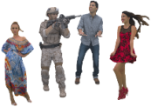 | A volumetric representation using 3D points with spatial coordinates and attributes (e.g., color, reflectance). Contains high-density point sets (>500K points/frame) enabling detailed, closed-surface rendering. | V-PCC  G-PCC  ... | 4.3.3
Dynamic Mesh | 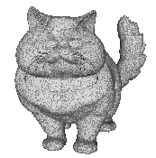 | A dynamic mesh is an object that represents a collection of vertices, edges and triangular faces (organized in polygons) defining the object's geometry that can be modified procedurally. | Draco  V-DMC  ... | 4.3.5
Light Fields | 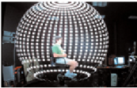 | A light field, or lightfield, is a vector function that describes the amount of light flowing in every direction through every point in a space | LVC  ... | 4.3.6.2
NeRF |  | NeRF is the implicit representation of a 3D scene or object using a fully-connected (non-convolutional) deep network. | Under study | 4.3.6.1
3D Gaussian  Splattings | 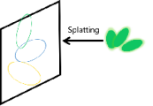 | 3D Gaussian Splatting (3DGS), also referred as Gaussian Splatting Radiance Field, is an explicit radiance field based 3D representation that represents 3D scene or objects using a large number of discrete 3D anisotropic balls or particles, each defined by its spatial mean μ and covariance matric ∑. | Under study | 4.3.6.3

4.2 Reference Model for Beyond 2D Video

4.2.1 Overview
In contrast to well-established 2D-based video formats and work flows, for beyond 2D video a variety of emerging formats and reference workflows are under discussion. This aspect makes it more difficult to harmonize specific interop points and formats, also taking into account new developments in the industry and in research. In addition, without systematic and explicit identification of format interop points, beyond 2D scenarios or workflows may look overly complex.
However, basing beyond 2D workflows and scenarios on 2D reference workflows and formats, as for example evaluated in TR 26.955 [26955] and extending existing workflows seems to be promising way forward. However, when comparing for example to TR 26.955 [26955] for 2D formats or even omnidirectional video formats as defined in TS 26.118 [26118], additional aspects may need to be considered for beyond 2D video. To help the situation, a generic reference model for beyond 2D video content is introduced in this sub-clause. This systematic and accurate identification of interoperability points and subcomponents for Beyond 2D video with a high level of abstraction covers the majority of use cases and scenarios.
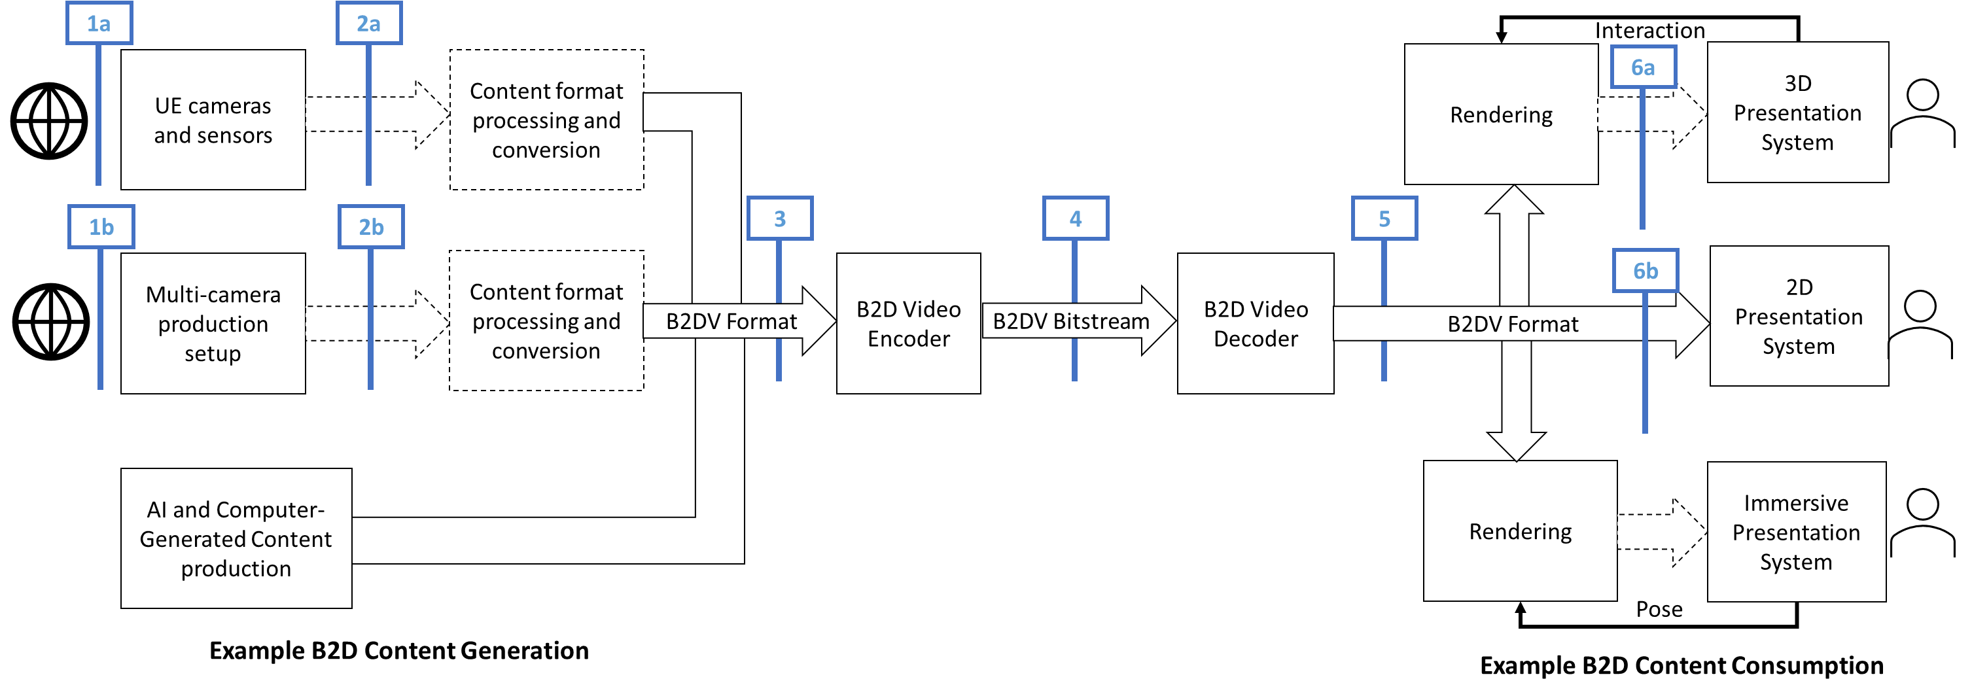
Figure 4.2.1-1 Beyond 2D Video end-to-end reference model
Figure 4.2.1-1 illustrates a generic beyond 2D Video end-to-end reference model. For example, it considers three methods of creation of source content. The first apply a naturalistic way to capture sources indicated in reference point (1) and includes for example variants of UE-based cameras and sensor (1a) or a multi-camera production setup (1b). The third option is based on authoring using computer graphics interfacing technologies or other media production technologies. These may sometimes be combined and, possibly with slight variations, these options cover the majority of media production cases.
The capture of content using cameras, for example light fields using sensors is generalized including traditional passive sensors, cameras, camera arrays, or plenoptic cameras. For simplicity we also include active sensors LiDaR, Time of Flight in this category. These active sensors also transmit a signal before capturing the reflections. Depending on the setup, the collected data may be quite different depending on the capturing system, expressed in reference point (2) with variants (2a) and (2b).
In the general case, some processing based on the captured data would happen to generate a well defined B2DV format, possibly referred to as sensed data converter. This step is mainly about converting the multiple digital image formats plus metadata to a well-defined beyond 2D representation or format, referenced with reference identifier (3).
For typical 5G workflows, a compressed digital representation of the B2DV is needed for efficient transmission. The B2DV Encoder executes a processing step that will result in the compressed Beyond 2D video bitstream that includes a digitally compressed lossy version of the B2DV format and optional metadata, referred to as reference point (4). The B2DV bitstream is typically delivered through content delivery protocols and 5G radio systems, not shown in Figure 4.2.1-1.
The B2DV decoder decodes the B2DV video bitstream and recovers a B2DV format, presented in reference point (5). The recovered signal is forwarded to the rendering and display system. In some cases, one viewport of the B2DV format may for example be displayed directly in a 2D Presentation System. In a 3D Presentation System, interacting with the rendering component may allow to generate different views on the content. In an immersive presentation system, pose information may be used to render the views of the content. The format generated by the renderer for the presentation system, indicated in reference point (6), is implementation specific as shown in Figure 4.2.1-1.
Generally, beyond 2D video performance measurement should typically be between interop points (3) and (5) based on the B2DV formats. The last block in the diagram includes the user interactions. Some B2DV scenarios may involve some types of user interactions, such as changing the viewpoint or other interactions. These are captured in the reference diagram for completeness.

4.3 Beyond 2D Video Representation Formats
Editor’s note: The documented format should be referenced by at least one scenario in clause 5, and the following aspects may be provided.

4.3.1 Introduction
As shown in Figure 4.2.1-1, beyond 2D video representation formats may originate from different production systems and have to target different rendering systems. This clause collects relevant Beyond 2D Video representation formats and provides a discussion on the relevancy of the formats. In order to assess the relevancy of the formats, for each format different aspects are collected, among others:
- Definition of the format, this is preferably backed by a specification.
- Typical applications of the format, e.g. knowledge about support of the format in workflows (tools, etc.)
- Production options of the representation format
- Rendering of the representation format
- Benefits and limitation of the format
- Supporting information
- Typical quality criteria for evaluating the format
- Existing test and reference sequences
- Conversion from other formats (lossless, lossy)
- Uncompressed data size
- Known compression technologies
- Extensibility of the format

4.3.2 Extensions to Stereoscopic Video Representation Formats
Editor’s Note: Some additional references need to be extracted.

4.3.2.1 Definition
Stereoscopic video presents one image to the user’s left eye and another image (typically correlated) to the user’s right eye to produce the stereopsis effect, defined as "the perception of depth produced by the reception in the brain of visual stimuli from both eyes in combination; binocular vision." [S1].

4.3.2.2 Stereoscopic Video format description according to TS 26.265
Stereoscopic video is defined in TS 26.265 [26265]. The focus on the definition in TS 26.265 is on providing a consistent description of stereoscopic video based on professional production, for example Hollywood movies. In this case, a view is available to be presented to the left eye and another view is available to be presented simultaneously to the right eye. The presentation of both the left and right views allows for an effect known as stereopsis which can be defined as "the perception of depth produced by the reception in the brain of visual stimuli from both eyes in combination; binocular vision" For signal representations, [ S2] recommends that and Left and Right eyes comply to regular image formats such as Rec ITU-R BT.709 or Rec ITU-T BT.2100 and any necessary 3D-specific metadata is incorporated with the data. Hence, for stereoscopic video, two synchronized video signals are available, each with identical parameters. The baseline content is described in TS 26.265 as part of the 3GPP Stereoscopic 3D TV Format in clause 4.4.3.4 as follows:
The stereoscopic 3D Cinema format uses two signals, one for the left eye and another view for the right eye as defined in Table 4.4.2-1. The components for each eye closely follow the specifications of the 3GPP HDR signals, but there are some restrictions and extensions, namely:
- Frame rates include high frame rate for movies, namely 48 fps.
- the spatial resolution is restricted to 4K
An informative summary of the parameters of a 3GPP Stereoscopic 3D TV format based on the parameters defined in Table 4.4.2-1 of TS 26.265 is provided in Table 4.3.2.1-1.
Table 4.3.2.1-1 Video Signal Parameters for 3GPP Stereoscopic 3D Cinema format
Parameter | Restrictions
Picture aspect ratio | 16:9
Spatial Resolution width x height | 3 840 × 2 160, 1 920 × 1 080  NOTE: For 1080, typically the encoded signal has 1088 lines and cropping is applied to remove spatial samples that are not presented.
Scan Type | The source scan type of the pictures as defined in clause 7.3 of Rec. ITU-T H.273 is progressive
Chroma format indicator | The chroma format indicator is 4:2:0.
Colour primaries  Transfer Characteristics  Matrix Coefficients | Only the following value combinations are permitted: (1, 1, 1), (9, 16, 9), and (9, 18, 9) for SDR, HDR PQ and HDR HLG, respectively.
Bit depth | The permitted value is 10 bit.
Colour primaries | Only the value 9 as defined in clause 8.2 of Rec. ITU-T H.273 is permitted.
Transfer Characteristics | Only the value 16 (for PQ) as defined in clause 8.2 of Rec. ITU-T H.273 is permitted.
Matrix Coefficients | Only the value 9 as defined in clause 8.2 of Rec. ITU-T H.273 is permitted.
Frame rates | The permitted values are 60, 60/1.001, 48, 48/1.001, 50, 30, 30/1.001, 25, 24, 24/1.001 fps.
Frame packing | No frame packing is applied.
Projection | No projection is used.
Sample aspect ratio | The pixel aspect ratio is 1 (square pixel), i.e. only the value 1 as defined in clause 7.3 of Rec. ITU-T H.273 is permitted.
Chroma sample location type | For SDR, the location of chroma samples relative to the luma samples for progressive frames as defined in Rec. ITU-T H.273, clause 8.7 is set to 0 (Chroma samples are colocated with the luma samples at the top-left corner).  For HDR PQ and HLG, the location of chroma samples relative to the luma samples for progressive frames as defined in Rec. ITU-T H.273, clause 8.7 is set to 2 (chroma samples are centered horizontally between two luma samples).
Chroma sample location type | The location of chroma samples relative to the luma samples for progressive frames as defined in Rec. ITU-T H.273, clause 8.7 is set to 2 (chroma samples are centered horizontally between two luma samples).
Range | Restricted video range is used.
Stereoscopic Video | A signal for the Left and for the Right Eye is provided whereby the signals have the identical parameters as above and are timely synchronized.

The format focuses on existing professionally generated movie content. This study will not evaluate further this format.

4.3.2.3 Extensions to Stereoscopic Video Representation formats
Extensions to the above content format result from different new use cases:
1) User generated stereoscopic content from modern devices that allow to capture beyond 2D video formats.
2) Higher-quality projected stereoscopic video that includes higher resolution and projections for professional content
The above use cases require extensions to the Stereoscopic 3D Cinema format defined in TS 26.265.
For user-generated stereoscopic content production systems as introduced in clause 4.3.2.2, extensions to the above basic signals are to be considered. The major extensions are more flexible spatial resolutions beyond 16:9, as well as additional metadata, including alpha and depth information. Offline postprocess can be used to acquire accompanying depth and such information is beneficial in the rendering to reduce parallax effects.
Stereoscopic video for user-generated content may use projections to left and right eye as follows [S3]:
- rectangular, traditional 3D
- extensions with additional depth data, also referred to as video contour maps [S4].
- extensions with additional alpha maps.
In addition, the detailed signal properties of the video each eye needs to be defined:
- Sample aspect ratio for each eye, defined according to the ITU-T H.273 [S5], SampleAspectRatio. Typical parameters are 1:1 (value 1) or 4:3 (value 14).
- Picture aspect ratio for each eye. Typical parameters are 1:1 or 16:9.
- Resolutions per eye of left eye and right eye are
- for picture aspect ratio 1:1: 1080x1080, 1440x1440, 2160x2160
- for picture aspect ratio 16:9: 1280x720, 1440x1080 (with sample aspect ratio 4:3), 3840x2160
- Framerates for each eye are: 30 fps, 50fps, 60 fps, and 90 fps and possibly fractional variants.
- Signal characteristics
- The video signal is YUV with 4:2:0 chroma subsampling.
- Bit depth: 8 or 10 bits
- Colour primaries, defined according to the ITU-T H.273 [S5], ColourPrimaries. Typical parameters are BT-709 (value 1), and BT-2020/BT-2100 (value 9).
- Transfer characteristics, defined according to the ITU-T H.273 [S5], TransferCharacteristics. Typical parameters are BT-709 (value 1), BT-2020 (value 14), BT-2100 PQ (value 16) and BT-2100 HLG (value 18).
- Matrix coefficients, defined according to the ITU-T H.273 [S5], MatrixCoefficients. Typical parameters are BT-709 (value 1), and BT-2020/BT-2100 non-constant luminance (value 9).
- Typical combined values are BT-709 SDR with (1,1,1) and HDR PQ with (9,16,9).
Additional metadata may be present, either on a static or per frame basis, as follows:
- hero eye: A value that indicates which eye is the primary eye when rendering in 2D.
- camera parameters: camera parameters are typically represented in a 3 × 4 projection matrix called the camera matrix. The extrinsic parameters define the camera pose (position and orientation) while the intrinsic parameters specify the camera image format, specifically:
- extrinsic parameters denote the coordinate system transformations from 3D world coordinates to 3D camera coordinates. For details see: https://en.wikipedia.org/wiki/Camera_resectioning#Extrinsic_parameters
- intrinsic parameters describe a specific camera model. These parameters encompass focal length, image sensor format, and camera principal point. For details see: https://en.wikipedia.org/wiki/Camera_resectioning#Intrinsic_parameters
- disparity adjustment:
- horizontal disparity adjustment, a value that indicates a relative shift of the left and right images, which changes the zero-parallax plane.
- Disparity/depth map: 10bit, same resolution as source content, monochrome, can possibly be sub-sampled
- alpha maps: 8 bit, same resolution as source content
- Line time (per camera) – rolling shutter readout time, only relevant in poorer quality/reduced functionality camera pipelines typically used on HMD tracking cameras.
- Examples: https://github.com/MPEGGroup/FileFormatConformance/tree/m62054_exintrinsics/data/file_features/under_consideration
For higher-quality projected stereoscopic video, the following are the core extensions beyond the TS 26.265 3D TV Format:
- projected video
- higher resolutions up to 8K
- additional depth and alpha data
For higher-quality projected stereoscopic video extensions content may use projections to left and right eye as follows [S3]:
- spherically-projected 3D video as defined in TS 26.118 [26118].
- extended with additional depth data, also referred to as video contour maps [S4].
In addition, the detailed signal properties of the video each eye needs to be defined:
- Sample aspect ratio for each eye, defined according to the ITU-T H.273 [S5], SampleAspectRatio. Typical parameters are 1:1 (value 1) or 4:3 (value 14).
- Picture aspect ratio for each eye. Typical parameters are 1:1 or 16:9.
- Resolutions per eye of left eye and right eye are
- for picture aspect ratio 1:1: 2160x2160, 4320x4320
- for picture aspect ratio 16:9: 3840x2160, 7680x4320
NOTE: 8K resolution is supported in TS 26.118 [26118], and also supported in terms of decoding on modern mobile systems-on-chip. Whether 8K is supported in a full end-to-end workflow is application dependent, but with appropriate capability negotiation, a suitable resolution can be determined.
- Framerates for each eye are: 24 fps, 30 fps, 48fps, 50fps, 60 fps, 90 fps, 120 fps, 144 fps and possibly fractional variants.
NOTE: 120 and 144 fps are supported in terms of decoding on modern mobile systems-on-chip. Whether such high-frame rates supported in a full end-to-end workflow is application dependent, but with appropriate capability negotiation, a suitable resolution can be determined.
- Signal characteristics
- The video signal is YUV with 4:2:0 chroma subsampling.
- Bit depth: 10 bits
- Colour primaries, defined according to the ITU-T H.273 [S5], ColourPrimaries being BT-2100 (value 9).
- Transfer characteristics, defined according to the ITU-T H.273 [S5], TransferCharacteristics. being BT-2100 PQ (value 16).
- Matrix coefficients, defined according to the ITU-T H.273 [S5], MatrixCoefficients being BT-2100 non-constant luminance (value 9).
- The core presentation format is HDR PQ with (9,16,9).
- Projection parameters:
- Projection: fisheye, equirectangular
- Field-of-view and restricted coverage, typically 180 degree.
NOTE: The parameters may be aligned with TS 26.118 [26118]
Additional metadata may be present, either on a static or per frame basis, as follows:
- hero eye: A value that indicates which eye is the primary eye when rendering in 2D.
- disparity adjustment:
- horizontal disparity adjustment, a value that indicates a relative shift of the left and right images, which changes the zero-parallax plane.
- Disparity/depth map: 10bit, same resolution as source content, monochrome, can possibly be sub-sampled.

4.3.2.4 Production and Capturing Systems
The formats as defined in clause 4.3.2.1 may be captured at least with a reduced set of parameters by mobile devices and Head Mounted Displays (HMD) – for more details refer to the following information:
- https://techcrunch.com/2023/12/11/apple-releases-spatial-video-recording-on-iphone-15-pro/
- Spatial Video with 1080p at 30fps
- https://9to5mac.com/2024/01/04/will-the-iphone-16-be-able-to-record-4k-spatial-video/
- Spatial Video with 4K is expected to be available
- https://appleinsider.com/articles/24/03/06/capturing-spatial-video-apple-vision-pro-vs-iphone-15-pro
- The spatial video captured is in a square 1:1 format at 2200 pixels by 2200 pixels. It is a near-perfect recreation of the passthrough viewed by the user.
- Once stereo is captured on supporting phones, offline postprocess can be used to acquire accompanying depth (using for example Depth-Anything https://github.com/DepthAnything/Depth-Anything-V2/tree/main and ZoeDepth https://github.com/isl-org/ZoeDepth or similar).
- Meta Quest™ can record spatial video: https://360rumors.com/quest-3-3d-videos/
- After recording, the video or photo is captured in side-by-side format, with a square aspect ratio. Photos will also be side-by-side but they are stretched vertically, and need to be edited to fix that.
- https://deovr.com/blog/84-record-vr-footage-on-the-meta-quest-3
- The Meta Quest 3™ features two cameras that deliver full-color passthrough, allowing users to record content in 4K (2k per eye), using the Meta Quest Developer HUB (https://developer.oculus.com/documentation/unity/ts-odh).
- The Quest 3's passthrough cameras record footage that is flat 120-100 (possibly 90) degrees.
NOTE: In TV productions it was known that there were issues with visual fatigue, nausea due to bad content production. Guidelines that professional producers can take into account have been provided which minimize these effects. Indications whether this also is an issue for user generated content is for further study.
Beyond user-generated stereoscopic content, an ecosystem is developing around this format including movie production, documentaries and live sports. Examples are mentioned here:
- https://www.apple.com/newsroom/2024/02/2024-mls-season-kicks-off-today-exclusively-on-mls-season-pass-on-apple-tv/
- https://www.apple.com/newsroom/2024/01/apple-previews-new-entertainment-experiences-launching-with-apple-vision-pro/
- https://www.macrumors.com/2024/01/08/vision-pro-movies-games/
Latest information on content production can for example also be found here: https://www.provideocoalition.com/creating-stereoscopic-video-for-the-apple-vision-pro/.

4.3.2.5 Rendering and Display Systems
Stereoscopic video with the above parameters can be viewed on different rendering and display systems, including
- Backward-compatible to 2D (just view one eye), hence can be viewed on regular phones. The stereoscopic effect is lost in this case.
- Apple Vision Pro ™
- Meta Quest ™: https://techcrunch.com/2024/02/01/meta-quest-adds-support-for-apples-spatial-video-ahead-of-vision-pro-launch/
In addition, OpenXR and WebXR define APIs to render stereoscopic video with additional metadata.
- OpenXR APIs exist
- WebXR APIs exist
For rendering multi-view stereo video, including 3D reconstruction, refer to [S6]. It is shown, how additional metadata as defined in clause 4.3.2.1 can be used to improve rendering.

4.3.2.6 Supporting Information
The baseline video can be encoded using HEVC-based encoding tools:
- framepacking (see for example TS 26.118 [26118])
- MV-HEVC (see TR 26.966 [26966] and TS 26.265 [26265])
The content can be delivered using regular ISO BMFF based distribution, including streaming with DASH/HLS/CMAF.
Uncompressed data rate can be computed as 2 x height x width x (1.5 + depthflag + alphaflag) * framerate * bitdepth. Some examples are provided in Table 4.3.2.6-1.
Table 4.3.2.6-1 Uncompressed data rate examples
Signal | Data rate
Stereoscopic 3D TV Format HD | 2 x 1080 x 1920 x (1.5 + 0 + 0) * 24 * 10 = 1.39 Gbit/s
Stereoscopic 3D TV Format UHD | 2 x 2160 x 3840 x (1.5 + 0 + 0) * 24 * 10 = 5.56 Gbit/s
User Generated Stereoscopic Content HD | 2 x 1080 x 1080 x (1.5 + 0 + 0) * 30 * 8 = 800 Mbit/s
User Generated Stereoscopic Content UHD with depth | 2 x 2160 x 2160 x (1.5 + 1 + 0) * 30 * 10 = 6.52 Gbit/s
Higher-quality projected stereoscopic video at 8K with alpha and depth | 2 x 4320 x7680 x (1.5 + 1 + 1) * 60 * 10 = 129.77 Gbit/s

Editor’s Note:
-Typical quality criteria for evaluating the format
- Existing test and reference sequences
-Conversion from other formats (lossless, lossy)
-Extensibility of the format

4.3.2.7 Benefits and Limitations

4.3.2.7.1 Benefits
The extended stereoscopic video format has the following benefits:
- Simplicity: The technology is supported by existing content production workflows
- Device Support: The technology is supported by emerging devices on the market
- In device decoding and rendering: The technology generally allows that decoding and rendering can be done in the device, which makes it robust against impaired or lossy network connections.
- Content Industry starts to embrace the format, for details see clause 4.3.2.2
- The format is extensible to add additional metadata, for details see clause 4.3.2.1
- User-generated content production workflows exist.
- Backward-compatible rendering. The content can be rendered on 2D displays.
- Very good B2D user experiences have been reported, when the content is properly produced and suitable devices for playback and rendering are used [S3].

4.3.2.7.2 Limitations
The format is primarily used to support lean-back and seated experiences, typically head movements with 3DOF and 3DOF+ can be supported, but may be extended in the future to address additional degrees freedom.
Editor’s Note: More Benefits and limitations will be added over time

4.3.3 Dense Dynamic Point Cloud representation format
There are many applications for point clouds such as representing highly accurate maps of landscapes, buildings, infrastructure, etc… but the format is also used to represent people, animals, objects and scenes composed from these. More precisely, for representing people and objects dense dynamic point clouds are in focus.

4.3.3.1 Definition
A point cloud frame is defined as set of (x,y,z) coordinates, where x,y,z have finite precision and dynamic range, ,depending on the data type that is used for representing the coordinates. Each (x,y,z) can have multiple attributes associated to it (a1 ,a2, a3 …), where the attributes may correspond to color, reflectance, transparency, normals or other properties of the object/scene that would be associated with a point. Colour is typically represented as RGB and a normal is a normal to a point which can be used by the renderer for handling lighting. Typically, each point in a point cloud frame has the same number of attributes attached to it. Dynamic point clouds consist of several consecutive point cloud frames with the same coordinate system, precisions and attributes. The number of points typically changes from one frame to the other and there is no relation between a point of one frame to the other frame. A dense point cloud contains a high density of points with close neighbors (typically more than 500.000 points per frame for a person or object), where a renderer is able to produce a closed surface allowing for a highly detailed representation.
A simple and often used file format for point clouds is the Polygon File Format (PLY) that has been developed by Greg Turk at Stanford University in 1994 [D1]. Other formats, like the Object File Format (OBJ) can also be used to represent point clouds.
MPEG has defined in 2016 several use cases for point cloud compression, including Real-time 3D Immersive Telepresence, Content AR/VR viewing with Interactive Parallax and 3D Free viewpoint Sport Replays Broadcasting [VOL-XX]. The typical characteristics of the point clouds in these use cases are summarized in Table. 4.3.3.1-1
Table 4.3.3.1-1 Typical Characteristics of Point Clouds in MPEG-Defined Use Cases

Use Case | Number of Points | Color Representation | Additional Properties
Real-time 3D Immersive Telepresence | To represent a reconstructed human:  Between 100,000 and 10,000,000 points per frame | 8-10 bits per color component | Normals and/or material properties for shader rendering
Content AR/VR Viewing with Interactive Parallax | To represent closeby objects in the scene:  Between 100,000 and 10,000,000 points per frame | 8-10 bits per color component | Global parameters defining the spatial constraints of the rendering viewport
3D Free Viewpoint Sport Replays Broadcasting | 100,000 – 100,000,000 points per frame | 8-12 bits per color component | Can contain multiple clusters/groups of points (different players)

Editor’s Note: Will be completed during study

4.3.3.2 Production and Capturing Systems
Professional capturing of volumetric video is typically done with a rig of synchronized cameras aligned around the asset(s) to be captured. Depending on the rig, there can be one or more layers of cameras at different height positions, with each layer consisting of up to 60 cameras. Cameras can be equipped with depth sensors. Hardware such as cameras and depth sensors are typically off the shelf equipment, but the assembly in the rig is vendor dependent and proprietary.
The various camera and depth sensor signals are fed into a production pipeline that produces the asset. Production includes stitching the various signals, filling holes, correcting occlusions, etc. Persons or physical objects (e.g., a ball or an instrument) can be combined in an asset or separate assets can be used for each person or object. The representation format of a produced asset is typically a dense dynamic point cloud or a dynamic mesh.
The Volumetric Format Association (VFA) [D2] aims to “Drive the development of volumetric video as the next revolution for content creation, editing 3D content, distribution of 3D content and creating entirely new ways to tell stories and communicate with each other”. One result of their work is an end-to-end workflow consisting of Volumetric Capturing, Volumetric Processing, Volumetric Encoding and Decode/Render. The workflow can be downloaded from their website in PDF (https://www.volumetricformat.org/_files/ugd/f2416f_3e1aeca4db234afcae9a8c15ea4f610a.pdf) format. Volumetric Capturing is in line with our description above. Volumetric Processing shows the dynamic point cloud representation format as a central element. First a raw point cloud is created, and which is further processed (e.g. fill holes) and converted to the produced asset. Representation formats for the produced assets is either a dynamic point cloud (in the workflow named as a patch-based format) or a dynamic mesh.
The Volumetric Encoding step includes both options, point cloud and mesh. Once streamed and received on a device, the Decode/Render step includes rendering the mesh, the point-cloud as is or generating mesh or voxels prior to rendering.

4.3.3.3 Rendering and Display Systems
The dense dynamic point cloud representation format can be rendered to 2D displays such as in mobile phones, tablets, TV sets but also to HMDs or other 3D type displays.
The visual viewing quality of the point cloud format depends heavily on how voxels are rendered. Just reconstructing voxels in 3D space may bring a limited viewing experience and holes/cracks may become visible. To show the impact of rendering two renderers are investigated:
- MPEG renderer: Each voxel is replaced by a cube of a configurable fixed size. This renderer is deliberately simple for studying the pure impact of compression.
- Representative renderer: Each voxel is replaced by a splat of a size that depends on the viewing distance and some blending is implemented to avoid flickering of points. There are no sophisticated techniques such as lighting or use of normals integrated. It represents a minimum of what a device manufacturer would do to prevent holes or cracks to preserve a good subjective experience. It is not state-of-the-art or most sophisticated renderer possible.
In the following we give an example of the impact of the renderer on the head of the sequence Thomas with Vox 10 conversion:
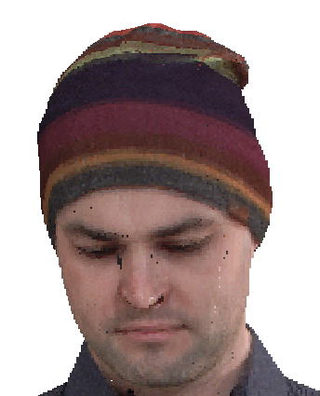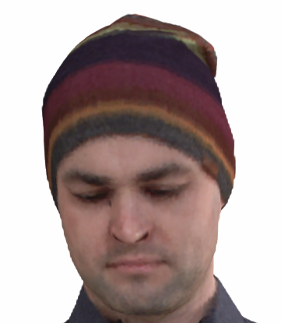
Figure 4.3.3.3-1 Vox 10 MPEG renderer Figure 4.3.3.3-2 Vox 10 Representative renderer
Both snapshots are rendered from the same Vox 10 sequence. In Figure 4.3.3.3-1(content courtesy by Volucap [Vol-16]), we see far more cracks and holes and the borderline of the sequence is less smooth. However, the eyebrows look a bit sharper in Figure 4.3.3.3-2 (content courtesy by Volucap [Vol-16]), a high-end industry renderer may do better than the renderers illustrated here.
When evaluating or comparing the point cloud representation format it is essential to select a renderer that is representative of a minimum of what the industry would implement, as holes and cracks in images would influence evaluations negatively.
More sophisticated renderers in products could fill better potential holes, recreate detail and apply lighting depending on the scene. The point cloud representation format supports normals which are useful for lighting the scene. When rendering a point cloud sequence in a scene, correct lighting including shadows and colour alignment can greatly impact the realism of the resulting experience.
POINTS_GL is the simplest OpenGL[D3] primitive type used for rendering (lines and polygons are others that are also commonly used) and a point cloud can be interpreted as a vertex stream that represents points (after ordering of the points). Therefore, a point cloud can be rendered in an extremely straightforward way using native OpenGL vertex shaders. The supported rendering in the standard OpenGL specified by the Khronos consortium implies that point clouds can be rendered on devices that support OpenGL which is rather common today. OpenGL vertex shader renders points size larger than zero, this can be set GL_PROGRAM_POINT_SIZE as a configuration of the rendering.
Specific optimizations for rendering are device manufacturer dependent.

4.3.3.4 Support Information

4.3.3.4.1 Test and reference sequences
<TBD>

4.3.3.4.2 Uncompressed data size
The uncompressed data size of a point cloud frame depends on the number of points and the number of attributes. The following table gives data size examples and raw bitrates for the sequence Thomas.
Table 4.3.3.4.2-1 Uncompressed data size and bitrate
Sequence | Quantization | #frames | #points | mean frame size (bytes) | bitrate (mbps)
Thomas | Vox10 | 32 | 19012250 | 4010396 | 979.10
Thomas | Vox11 | 32 | 76336020 | 16996692 | 4149.58
Thomas | Vox12 | 32 | 305897397 | 71694702 | 17503.59

4.3.3.4.3 Known compression technology
Visual volumetric video-based coding (V3C) and video-based point cloud compression (V-PCC) [D4]
Geometry-based point cloud compression (G-PCC) [D5]
Draco [D6]

4.3.3.4.4 Conversion from other formats
Point clouds can be obtained by sampling from surface-based formats such as meshes. Such transformation is lossy. There are different sampling methods (e.g. methods based on face sampling, on texture map sampling, on ray casting from a grid, etc.) and it’s up to the content provider to select the appropriate sampling method depending on the content and creative intent.

4.3.3.4.5 Typical quality criteria
The visual quality of a point cloud depends on the number of points (density) in the point cloud. For attributes colour is mandatory and there may be reflectance, transparency and normal. Colour is typically in RGB with each in 8 bits. Reflectance, transparency and normal can be used by the renderer when the point cloud is rendered in a scene.
Point clouds of around 1M points/frame allow to watch from a wider distance (e.g. from 3m*) and 2M points/frame allow to get closer (e.g to around 1.5m distance) at good quality for the target scenario. Emotional facial expressions and buttons and tissue structure of cloths is visible. More points per frame improve the details, but this may not be required for the target scenario. But if a scenario would require it, a professional volumetric video production system is able to capture details from e.g. skin or finer details of tissue and it can be represented with the point cloud representation format.
* A typical demonstration scenario would be to use e.g., a smartphone or tablet running a volumetric video application showing a real person of e.g., 3m distance on the screen captured by the camera and rendering at the same time a second person rendered from a point cloud next to the first person.
Other scenarios may require the representation of the full detail of a person and the number of required points can be approximated as follows:
Assumptions:
- The visual resolution of the human eye is 1/60 of a degree
- Average human body surface is about 1.9m²
- For simplification the body surface is approximated as a square
Number of points = 1.9/((tan1/60 * d)^2), where d is the viewing distance from the person.
This leads to the following number of points:
- 1.5m distance: 10 M pixels
- 3m distance: 2.5 M pixels

4.3.3.5 Benefits and Limitations

4.3.3.5.1 Benefits
Point cloud representation is simple in structure and representation, has high accuracy and resolution, is faithful to original data, and is easy to acquire from sensors or cameras. Point cloud generation needs less pre-processing as there is no need for surface reconstruction, if sensor data is not so noisy.
A point cloud can be rendered in an extremely straightforward way using native OpenGL vertex shaders.

4.3.3.5.2 Limitations
Point-cloud data does not include information on surfaces and is harder to edit or transform.
Editor’s Note: Will be completed during study.

4.3.4 Multi-view video Representation Format

4.3.4.1 Definition
Multi-view video is a frame-based immersive experience whereby each frame of the video represents a still that can be viewed from any perspective within a viewing space that is informed by the provided camera positions. The viewer can interact with the content by seamlessly moving and reorienting a virtual viewport. This serves two goals from the user perspective: it is possible to look around objects, and it is possible to freely choose a viewpoint. The first goal is best achieved by having a dense group of cameras around a scene with nearby subjects. This creates a sense of immersion. The second goal is best achieved by having a sparse group of cameras in an arc around a scene. This creates the free-viewpoint functionality which is arguably less immersive, but enables the viewer to observe an action in more detail, i.e. by "being the director".
Note that in some contexts like in JCT-3V a narrower definition of multi-view was used whereby the cameras are expected to be in a 1D linear or coplanar arrangement [M11]. For this representation there is no such restriction.
Recently, multi-view and multi-view plus depth video representations have been used as an in-between step to create point clouds, meshes, light field and radiance field approximations including NeRF (clause 4.3.6.1) and 3DGS (clause 4.3.6.3). Note that when depth maps are not directly available from range-sensing cameras, they can be estimated using open source or commercial tools. The same holds for the estimation of intrinsic and extrinsic camera parameters. Hence, the multi-view plus depth representation is widely recognized and understood.
The multi-view video representation consists of multiple frames of multiple synchronized physical or virtual camera views. Each camera view is represented by a colour image (YCbCr), camera intrinsics and camera extrinsics. The combination of video and metadata allows for novel view synthesis (6DoF rendering).
A typical spatial resolution for each of the views is 1920 × 1080 (FullHD). For this representation in this study, we expect resolutions in a range around this number. A typical number of views is 2-4 for real-time capture with range-sensing cameras like the Azure KinectTM, and typically 10-20 for offline capture with industrial or professional cameras. Typically, the frame rate is 25 or 30 Hz, and capture beyond 60 Hz is not expected for the coming years.
Optionally there is also a depth image of equal resolution. It is possible to have multi-view content for which some or all views lack depth information. This choice originates from the production and capturing system and thus it is the same for all frames of a view. The depth map image, if present, may also indicate that individual samples are missing. This indication can be used for range-sensing cameras that cannot sense depth in certain situations like object edges, non-reflecting and specular reflecting scene elements. It can also be useful in a production system to remove parts of an image that are not wanted (e.g. revealing camera rigs) or are also present in other views (scene background).
If a view has a depth map, then it must have corresponding depth quantization parameters: quantization type (normalized disparity or linear depth), nearest depth in scene units, furthest depth in scene units, and indication of invalid values. Normalized disparity [m⁻¹] is more commonly used when depth is estimated because it places the code points in a way that correlates with the amount of parallax, and it allows for far away scene elements like the horizon or the star field. Linear depth [m] is commonly used with range-sensing cameras (ToF, LiDAR, etc.) because they often have a limited depth range with equal depth resolution for that entire range.
The camera intrinsics are a model of the projection of points in space in the reference system of the camera to the image sensor (projection plane). Typical parameters include projection type (perspective, fisheye, etc.), and projection-type specific parameters, such as principal point and focal length for perspective projection. Optionally lens distortion parameters may be provided if the camera images are not already corrected for that.
The camera extrinsics model the translation and rotation of a camera in space with respect to the reference system of the scene.
The source format has at least two views. It is expected that most or all test data will have perspective projection (PSP), but test data with equirectangular projection (ERP) may be included.
While this representation allows for 6DoF rendering, it depends on the position and field of view of the cameras, if such a rendering has an acceptable quality. Preferably, the virtual viewpoints are within a viewing space that can be provided as metadata or implicitly derived from the parameters of the set of source views.
Each view has the following video components and metadata:
Component | Texture (mandatory) | Depth (optional)
Spatial resolution | At least 960 × 540  At most 3840 × 2160 | The same as the texture component
Chroma format | YCbCr | Luma only or YCbCr with chroma planes set to neutral gray
Chroma subsampling | 4:2:0 | 4:0:0 or 4:2:0 with chroma planes set to neutral gray
Pixel aspect ratio | 1:1 | 1:1
Frame rate | 30, 50, 60 | The same as the texture component
Colour space format | ITU-R BT.709 or ITU-R BT.2100 | Undefined
Transfer characteristics | Limited range or full range with transfer characteristics matching to the colour space format.  Mastering characteristics such as MDCV (master display colour volume) and CLLI (content light level information) SEI (supplementary enhancement information) messages defined in TS 26.116 Section 4.5.5.7 will be considered. | Full range, linear transfer
Bit depth | Either 8 bits or 10 bits for all channels | At least 8 bits  At most 16 bits
Metadata | Camera intrinsics:  Projection type (Perspective, ERP)  - Projection type (Perspective, ERP)  - For perspective projection:  - Focal length [px]  - Principal point [px × px]  - For equirectangular projection:  - Latitudinal angle range [rad × rad]  - Longitudinal angle range [rad × rad]  - Lens distortion parameters (optional)  Camera extrinsics:  - Camera position (x, y, z) [m]  - Camera orientation as normalized quaternion (q = iq_{x} + jq_{y} + kq_{y} + q_{w}) | Depth quantization parameters:  - Quantization type:  - either: normalized disparity  - or: linear depth  - Near depth [m]  - Far depth [m]  - Has invalid pixels flag

4.3.4.2 Production and Capturing Systems
Multi-view video and multi-view + depth are well-known formats that have many public tools including OpenCV [M1], COLMAP [M2], AliceVision [M3] and OpenMVG [M4]. Also, MPEG has published tools for camera calibration and depth estimation [M5].
There are four typical workflows for multi-view (+ depth):
- Use color cameras to capture multi-view and estimate depth with multi-view consistency.
- Use range-sensing cameras to capture multi-view + depth and refine depth with multi-view consistency.
- Use AI or CG pipelines to raytrace views.
- Combinations of the above.
The beyond 2D video is captured and processed using multiple cameras. Zero or more of those cameras may be range-sensing cameras, and more than one of the cameras has color sensors. In the case of two or more cameras that are not rigidly connected, camera extrinsics are online calibrated. Depth estimation is performed to associate a full depth map with each of the camera views, thus resulting in a multi-view + depth representation.
Additional steps such as object instance segmentation and foreground/background separation may be performed to reduce the sample rate of the representation. This would result in a multi-view + depth + transparency/occupancy representation. All processing may be offline or with a delay of a few seconds.
Figure 4.3.4.2-1 provides an example processing flow with the following operations:
- Multi Camera Capture: capture of images from multiple cameras
- Intrinsic Calibration: estimation of principal point, focal length and distortion parameters
- Extrinsic Calibration: estimation of camera orientation and translation (e.g. using COLMAP)
- Scene Calibration: estimation of static ground plane geometry and background geometry
- Undistort Images: all images undistorted to one and the same reference intrinsics
- Object Instance Segmentation: determine segments for known objects such as ‘person’/’ball’
- Depth Estimation: determine a dense depth map for each view
- Depth Segmentation: determine sub-instance depth segments consisting of smooth surfaces
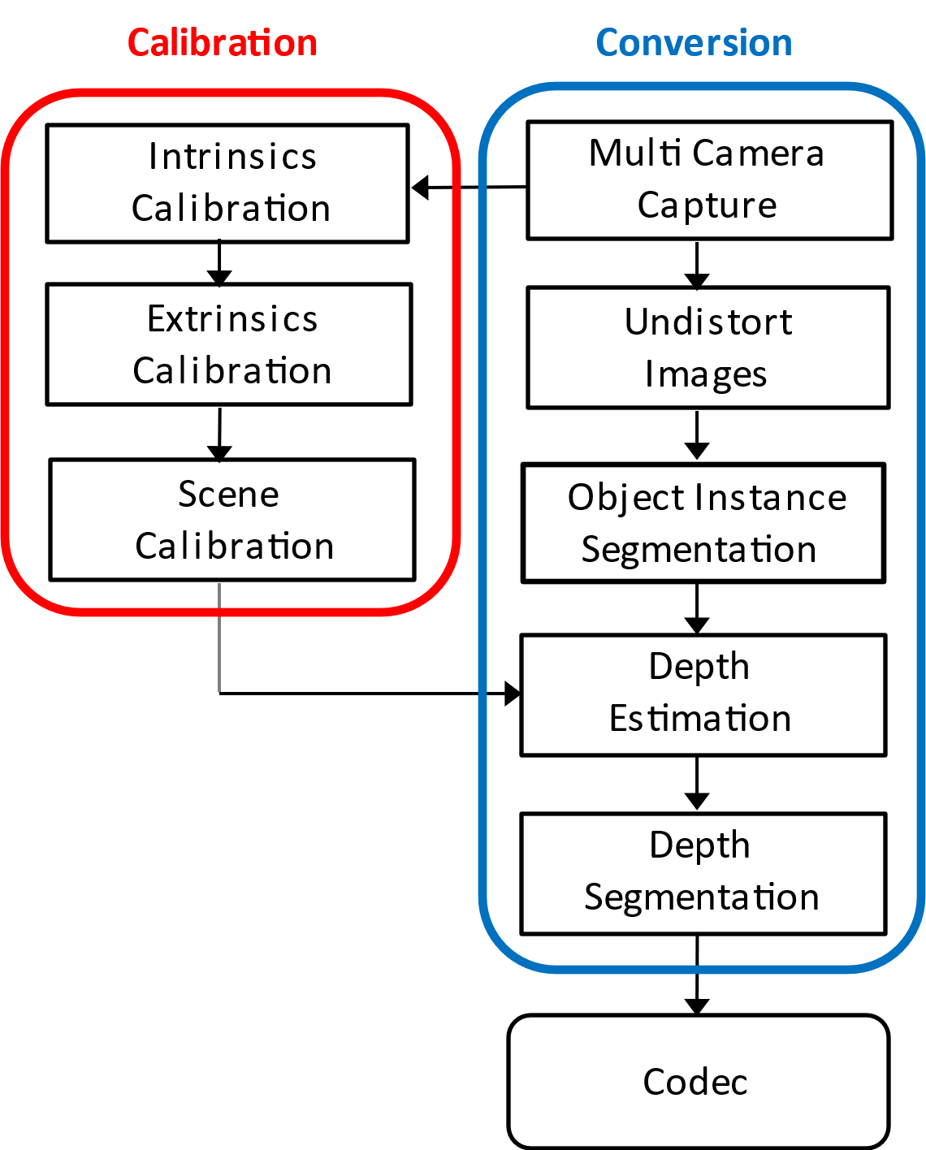
Figure 4.3.4.2-1: Example processing flow

4.3.4.3 Rendering and Display Systems
Some examples of open source rendering implementations for the multi-view representation are the Reference view synthesizer [M6], Test model for MPEG immersive video [M7], and OpenDIBR [M8]. More implementations exist.
Real-time rendering is typically performed on a GPU without dedicated hardware.
Rendering can be on:
- a device for 2D presentation (fixed viewpoint) such as a phone,
- a device for 3D presentation (multiple viewpoints) such as an autostereoscopic display,
- a device for 6DoF presentation (dynamic viewports) such as an HMD or an autostereoscopic display with eye tracking.
When a viewing space is used, then:
- What is rendered is one or two viewports with perspective projection and with 6 degrees of freedom (3-D position and 3-D orientation).
- The pose of the viewport is within a viewing space that can be signaled or implicitly determined from a decoded frame. A viewing space can limit both position, orientation or both in combination. For instance, it is generally not intended for a viewport to intersect with scene elements.
- When a viewport is rendered that is outside of the viewing space, then the renderer has to perform a mitigation to avoid a viewing experience that is not intended by the content provider.

4.3.4.4 Supporting Information

4.3.4.4.1 Camera placement
For range-sensing cameras a minimum requirement is that scene elements are present in at least one view frustum (seen by at least one camera). This implies that view frustums of adjacent cameras are overlapping at and beyond the nearest object distance.
With multi-view depth estimation, the minimum requirement is that scene elements are present in at least two view frustums (seen by at least two cameras). The additional overlap is needed for stereo correspondence checks.
- Given the above, cameras do not have to be placed on a line, plane or any specific geometry.

4.3.4.4.2 Spatial resolution
The 3-D spatial resolution relates to video resolution and depth map bit depth. Because perspective projection and normalized disparity are most common, equations are provided for this case only.
Perspective unprojection maps a sample position x_{image} to a scene position in respect to the camera x_{camera}:
$$x_{camera}=\left[\begin{matrix}x_{camera} \\ y_{camera} \\ z_{camera}\end{matrix}\right]=\frac{r}{f}\left[\begin{matrix}x_{image}−p_{x} \\ y_{image}−p_{y} \\ f\end{matrix}\right],$$
with principal point p and focal length f, both in pixel units. The coordinate system is only a convenient example.
Normalized disparity expansion maps sample value i to depth range value r in scene units, e.g. meters:
$$r=\frac{1}{\frac{1}{r_{far}}+\left(\frac{1}{r_{near}}−\frac{1}{r_{far}}\right)\frac{i}{i_{max}}}=\frac{r_{far}r_{near}}{r_{near}+\left(r_{far}−r_{near}\right)\frac{i}{i_{max}}}$$
One may check that this maps$i∈\left\{0,1…i_{max}\right\}$ to $r∈\left[r_{near}, r_{far}\right]$. Note that nearby objects appear brighter when viewing the depth map directly (as if using a flashlight in a dark room).
In-plane spatial resolution refers to the ability of an imaging system to distinguish between two adjacent points within the same imaging plane. It is a measure of how close two objects can be to each other in the imaging plane while still being resolved as separate entities.
The in-plane spatial resolution can be derived from the first equation:
$$\frac{δx_{camera}}{δx_{image}}=\frac{r}{f}$$
This indicates that a) the in-plane spatial resolution depends on the focal length in pixel units, and b) the spatial resolution decreases with distance from the camera. As an example, when an object is at 1 meter distance, and the focal length is 1000 pixels, a horizontal or vertical shift of one pixel corresponds to a shift of 1 mm in 3-D space.
Out-of-plane spatial resolution refers to the ability of an imaging system to distinguish between points along the axis perpendicular to the imaging plane (typically the z-axis). It represents the system's capability to resolve depth information or separate structures at different depths.
The out-of-plane spatial resolution can be derived by combining the first and second equations:
$$\frac{δz_{camera}}{δi}=\frac{δr}{δi}=\frac{r^{2}}{i_{max}}\frac{r_{far}−r_{near}}{r_{far}r_{near}}$$
With $r_{far}$ much larger than $r_{near}$, this approximates to:
$$\frac{δz_{camera}}{δi}≈\frac{r^{2}}{i_{max}r_{near}}$$
This indicates that a) the out-of-plane spatial resolution depends mainly on the nearest object distance and the depth map bit depth, and b) the spatial resolution decreases quadratically with distance from the camera. As an example, when an object is at $r_{near}=1$ meter distance and bit depth is 8 bit (i_{max} = 255), then $∆z_{camera}≈4 mm$. When instead an object is at 10-meter distance, the step size is about 0.4 m.

4.3.4.4.2 Objective metrics
Objective evaluation on multiview video may be performed by applying 2D video objective metrics (PSNR, SSIM, VMAF, etc.) on each of the source view positions, and averaging them in the correct domain. A higher correlation with subjective evaluation may be obtained by applying immersive video metrics [M9] [M10] that consider that view synthesis may cause pixel shifts that have only a minor influence on subjective scores, but cause PSNR to degrade.

4.3.4.4.3 Coding and delivery options
The content can be encoded using:
- MPEG Immersive Video (MIV)
- MV-HEVC (albeit with some restrictions)
The content can be delivered using regular ISO BMFF based distribution, including streaming with DASH, or delivered in real-time using RTP-based transport.
[Ed.(BK): On acceptance, Philips intend on providing a proposal to rewrite the related scenarios, avoiding overlap with the representation.]

4.3.4.5 Benefits and Limitations

4.3.4.5.1 Benefits
The multiview video representation has the following main benefits:
- Real-time capture is feasible.
- This format is often used as an intermediate step in photogrammetry pipelines such as [ M3].
- The renderings have the appearance of natural video content, as opposed to computer graphics, because all optical effects are baked into the multiple views.

4.3.4.5.2 Limitations
The multiview video representation has the following limitations:
- Need to handle large number of pixels, e.g. by selection.
- For novel view synthesis, multiple views need to be blended for optimal rendering results, to handle non-Lambertian effects.
- Content production depends on the availability of good and efficient depth estimation/refinement tools. Recently, there is a strong progress in the field of computer vision and volumetric approaches specifically, which will benefit applications of this representation.

4.3.5 Dynamic Mesh Representation Format

4.3.5.1 Definition
A mesh is a structure composed of several polygons that define the boundary surface of a volumetric object. It typically includes five components: connectivity information, geometry information, mapping information, vertex attributes, and attribute maps. From MPEG, a dynamic mesh is defined as a mesh where at least one of these five components in varying in time [DM-1]. Such change can result from prescribed motion, flow induced rigid body motion, fluid structure interaction or adaptive mesh refinement. In the industry, a dynamic mesh is an object that represents a collection of vertices, edges and triangular faces (organized in polygons) defining the object's geometry that can be modified procedurally.(e.g., in an avatar’s facial expression or body movement) [DM-8].
Dynamic meshes are one of the immersive contents that are widely used in the commercial markets. For example, they can be used to represent 3D objects or digital avatar in VR/AR, digital twin city and etc. The demand for processing and visualizing such rich 3D content has led to the increasing popularity of dynamic meshes, as they are natively supported by virtually all the 3D software and graphic hardware, friendly to GPU rendering, and have a strong applicability to interactive and real-time 3D task [DM-3].
Many different formats can be used for storing dynamic mesh representation data. For example, the PoLYgon (PLY) format is introduced in section 4.6.3.5.2 of TR 26.928 [26.928], the OBJ file format is used in section 4.3.5.4.1.2, and also the glTF format as specified by the Khronos Group [DM-7].
MPEG has defined in 2021 several use cases for dynamic mesh compression, including Real-time 3D Immersive Telepresence, Content AR/VR viewing with Interactive Parallax and 3D Free viewpoint Sport Replays Broadcasting [DM-2]. The typical characteristics of the meshes in these use cases are summarized in Table. 4.3.5.1-1.
Table 4.3.5.1-1 Typical Characteristics of Meshes in MPEG-Defined Use Cases
Use Case | Triangle Count | Color Representation | Additional Properties
Real-time 3D Immersive Telepresence | To represent a reconstructed human:  - 40,000 – 100,000 triangles (with color per vertex)  - 10,000 – 50,000 triangles (with texture maps) | - Texture maps: 2K–8K square pixels  - Color per vertex | - Normals and/or material properties for shader rendering
Content AR/VR Viewing with Interactive Parallax | To represent a reconstructed human:  - 10,000 – 100,000 triangles | - Texture maps: 2K – 8K square pixels  - Color per vertex | - Normals and/or material properties for shader rendering  - Global parameters for spatial constraints  - The meshes may be a part only of the total content transmitted
3D Free Viewpoint Sport Replays Broadcasting | To represent a reconstructed human:  - 20,000 – 200,000 triangles | - Texture maps: 8 – 12 bits per color component  - Color per vertex | - Multiple clusters/groups of meshes (e.g., different players)

4.3.5.2 Production and Capturing Systems
Dynamic meshes cannot be directly captured through 3D scanning devices. Instead, meshes can be generated either manually by artists or automatically through 3D generation algorithms. The current production methods include:
- Manual Creation: artists use 3D modeling software packages (such as Blender TM, Maya TM, and etc.) to manually create dynamic meshes. The artist-created meshes capture not only the external appearance of objects but also their intrinsic properties and construction details through mesh topology. High-quality meshes used in games and movies are almost exclusively created by artists.
- Volumetric Capture Studio: An array of multi-camera or multi-stereo cameras is placed around a recording space to capture a subject within that space. After the capture, a generation and production process is required to create the dynamic meshes. For further details, refer to Clause 4.6.7 of TR 26.928 [26928].
- Converted from other formats: A mesh can be extracted algorithmically from other beyond 2D representations, such as 3D Gaussians, neural fields, voxels and point clouds.
- AI-generated meshes: An emerging line of research generates 3D meshes in a data-driven fashion by learning from artist-created meshes using machine learning algorithms. For example, PolyGen (https://polygen.io/), MeshGPT (https://nihalsid.github.io/mesh-gpt/), MeshAnything (v1:https://buaacyw.github.io/mesh-anything/ and v2:https://buaacyw.github.io/meshanything-v2/), and MeshXL (https://meshxl.github.io/). These methods show significant promise, particularly in terms of automating 3D asset creation. However, they are still limited by scalability, with the best method handling up to approximately 1.6K faces, and the resulting meshes often exhibit a significant quality gap compared to those crafted by artists.

4.3.5.3 Rendering and Display Systems
Dynamic meshes can be rendered directly on GPUs that are highly optimized for mesh-based rendering. The following are the rendering APIs and engines for dynamic mesh processing:
- Low-Level rendering APIs:
- OpenGL: https://learnopengl.com/Model-Loading/Mesh
- DirectX 12: https://microsoft.github.io/DirectX-Specs/d3d/MeshShader.html
- Vulkan: https://docs.vulkan.org/spec/latest/chapters/VK_NV_mesh_shader/mesh.html
- Graphic Engines:
- Unity TM : https://docs.unity3d.com/6000.0/Documentation/ScriptReference/Mesh.MarkDynamic.html
- Unreal Engine TM: https://dev.epicgames.com/documentation/en-us/unreal-engine/BlueprintAPI/DynamicMesh
- NVIDIA RTX / OptiX TM: https://developer.nvidia.com/rtx/ray-tracing/optix
- Web-Based rendering APIs:
- WebGL:https://www.khronos.org/webgl/
- WebGPU: https://webgpu.github.io/webgpu-samples/?sample=skinnedMesh
- High-level APIs: high-level libraries use WebGL and WebGPU underneath to provide an easy-to-use, lig-htweight, and cross-browser solution for general-purpose 3D rendering. For example, Three.js (https://threejs.org/docs/api/en/objects/Mesh.html); Babylon.js (https://doc.babylonjs.com/features/featuresDeepDive/mesh).
Rendering can be on:
- a device for 2D presentation such as a phone
- a device for 3D presentation such as an autostereoscopic display, providing depth perception for dynamic meshes
- a device for 6DoF presentation such as VR/AR devices like Meta Quest TM, HTC Vive TM, and Apple Vision ProTM support real-time rendering of dynamic content.

4.3.5.4 Supporting Information

4.3.5.4.1 Test and reference sequences
Collected candidate raw dynamic mesh sequences that are available for testing are presented in Annex C.2

4.3.5.4.2 Uncompressed data size
The uncompressed data size of dynamic meshes depends on several factors, including vertex count, attribute information, level of detail (LOD), animation/deformation data and etc. A dynamic mesh sequence may require a large amount of data since it may consist of a significant amount of information changing in time. The size of dynamic mesh sequences typically ranges from a few gigabytes to several dozen gigabytes. For example, the basketball_player sequence proposed by Owlii Inc. contains around 40K triangles, with texture maps at a resolution of 2048 x 2048. With a total of 600 frames, its raw data size is about 45.2GB.

4.3.5.4.3 Known compression technologies
Existing compression technologies for dynamic meshes include:
- Googles’ Draco [D5], a C++ compression library designed for static meshes. Dynamic meshes are typically encoded as independent frame and the temporal coherence and redundancies in dynamic meshes are not leveraged.
- Mesh compression standards such as IC, MESHGRID, and FAMC [DM-4], previously developed by MPEGcan only compress dynamic mesh sequences with constant topological information (same vertex counts and face connections). These method can't handle dynamic meshes with time-varying topology, geometry and attribute information.
- V-DMC [DM-5], a new mesh compression standard to directly handle dynamic meshes with time varying connectivity information and optionally time varying attribute maps.The initial V-DMC test model was released by MPEG in July 2022, it is currently under Draft International Standard (DIS) status, and has been submitted to ISO with the reference ISO/IEC 23090-29. The WD1.0 of V-DMC conformance and the reference software N1047 have also been provided, including streaming with DASH, or transmitted in real-time using RTP-based transport [DM-6].

4.3.5.4.4 Conversion from other formats
Dynamic meshes can be converted from point clouds as defined in clause 4.3.3 or voxels using software like MeshLab (https://github.com/cnr-isti-vclab/meshlab), CloudCompare (https://github.com/CloudCompare/CloudCompare), or Autodesk (https://github.com/Autodesk). Such transformation is lossy.

4.3.5.4.5 Typical Quality Criteria

4.3.5.4.5.1 Objective Metrics
MPEG WG7 proposes two methods for dynamic mesh evaluation: one based on the well-known D1/D2 metric used in point cloud compression (point-based metric), and another one based on evaluation of projected images (image-based metric) Annex B [DM-1]. Both methods are implemented in the mpeg_pcc_mmetric software which is available on the MPEG GIT [DM-18].
For point-based metric, it directly uses the raw data from the reference and distorted meshes to extract features and predict quality. It includes two steps, as shown in Figure 4.3.5.4.5.1-1. First, the input meshes are sampled to be converted into their respective point cloud representations. Second, with the sampled surface point clouds, point cloud objective metrics D1/D2, Y-PSNR, and PCQM are calculated to assess quality. According to experimental results [DM-11], the point-based metrics (particularly PCQM_{P}) show high performance in dynamic mesh quality assessment and do not need rendering. However, these metrics heavily rely on mesh sampling step, which requires dense sampling to achieve accurate results. This can be computationally intensive and significantly increase processing time.

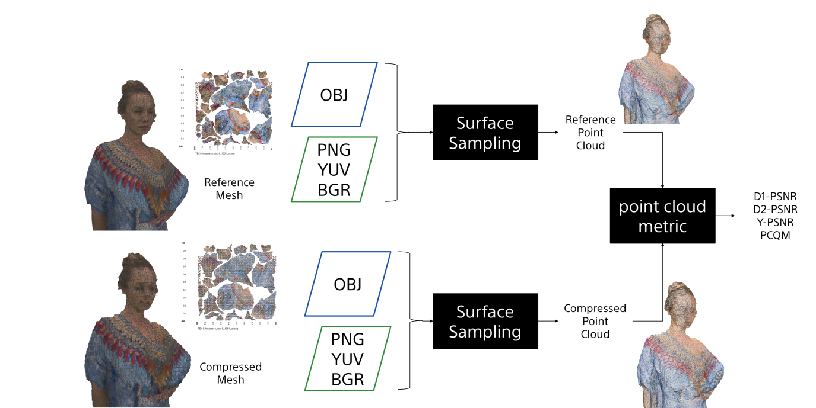
Figure 4.3.5.4.5.1-1: Point-based method for mesh evaluation
For image-based metric as shown in Figure 4.3.5.4.5.1-2, the reference and the distorted meshes are rendered for multiple view directions ${vd}_{i}$, using an orthographic projection. The images obtained from the rendering of reference and distorted models are then compared using some adapted image MSE/PSNR metrics The results are averaged over a set of view directions for the frame and over the frames of the sequence. According to experimental results [DM-11], projecting dynamic mesh into colored image and then applying metrics like rgb_{psnr} and yuv_{psnr} is more effective than only capturing depth information to use geo_{psnr}. In addition, increasing the number of projected images improves the stability of image-based metrics but also leads to a higher calculation complexity.

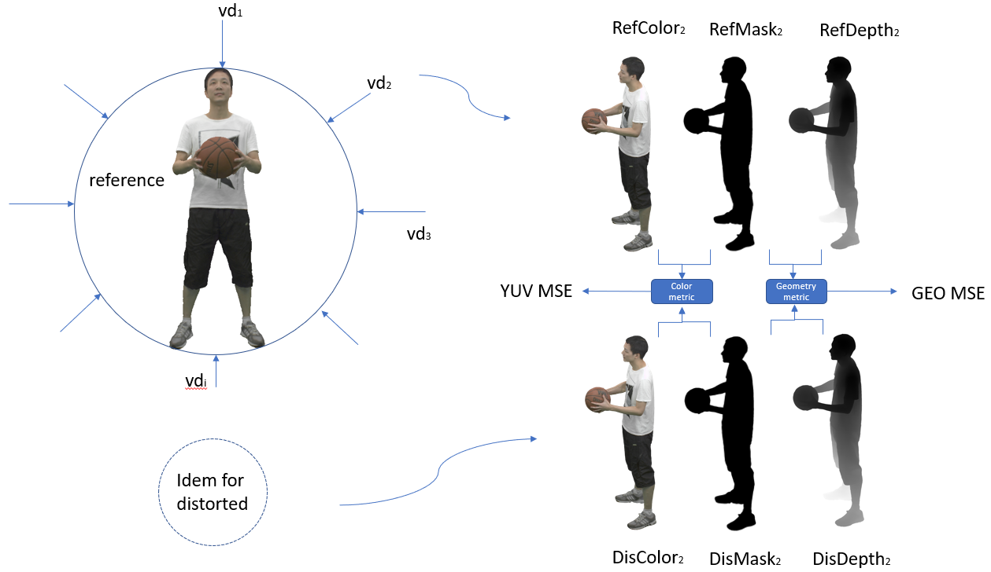
Figure 4.3.5.4.5.1-2: Image-based method for mesh evaluation
Editor’s Note: Other objective metrics for dynamic mesh evaluation may be added.

4.3.5.4.5.2 Subjective Evaluation
There are two prevalent methods to rendering dynamic mesh samples for subjective evaluation: 2D video-based and VR-based methods.
For video-based subjective evaluation [DM-12] [DM-13], it uses a 2D monitor to display dynamic meshes with compression and surface noise distortions, and refer to ITU-R BT.500 [DM-14] and ITU-T P.910 Recommendations [DM-15] to conduct the subjective experiment. MPEG describes a video-based subjective evaluation in Annex D of [DM-1]. The associated renderer is available on the MPEG Git [DM-19].
For VR-based subjective evalution, although there is a lot of academic research to explore the principles of the subjective experiment in a VR environment [DM-16], a standardized protocol has yet to be established. This remains an ongoing effort within ITU-T SG12/Q7 P.IntVR [DM-17].
Editor’s Note: Other subjective methods for dynamic mesh evaluation may be added.

4.3.2.7 Benefits and Limitations

4.3.2.7.1 Benefits
The dynamic mesh format has the following benefits:
- Good visual quality. Meshes define the object's shape and structure in a fairly realistic way, allowing for finer details and realistic shading and rendering through texture mapping, making 3D assets look photorealistic.
- Most important and widely used representation for 3D assets in the commercial market. De facto standard in the film, design and gaming industries.
- Natively supported by virtually all 3D software and graphic hardware.
- Friendly to GPU, can be used for real-time rendering.
- Backward-compatible rendering. The content can be rendered on 2D displays.

4.3.2.7.2 Limitations
A dynamic mesh sequence may require a large amount of data since it may consist of a significant amount of information changing in time.Standardized interoperable efficient compression, storage, and transmission of dynamic meshes have being specified. .

4.3.6 Formats under Research
Editor’s Note: Formats in that section will not be part of the evaluation framework of release 19, due to their maturity status, or complexity. However, it is recommended that 3GPP follows the research work on NERF, INVR and GS and awaits stabilization in the industry to commonly agreed formats.

4.3.6.1 Neural Radiance Fields
Editor’s Note: The copyright for the images under this section needs to be further check.

4.3.6.1.1 Introduction
Neural Radiance Field (NeRF) is a technology at the intersection of Artificial Intelligence (AI) and 3D graphics, and has gained interest based on remarkable progress in computer vision, neural processing units and graphics processing. NeRF was an important research area over the last few years,[but recently the interest in NeRF has declined and more attention is given to other formats documented in the remainder of this clause 4.3.X]. The documentation reflects the state of the art at the time of writing, but the technology has reached a level of maturity.

4.3.6.1.2 Definition
NeRF is the implicit representation of a 3D scene or object using a fully-connected (non-convolutional) deep network, whose input is a single continuous 5D coordinate (spatial location (x, y, z) and viewing direction (Θ,Φ)) and whose output is the volume density (α) and view-dependent emitted radiance (r, g, b) at that spatial location [N1].
[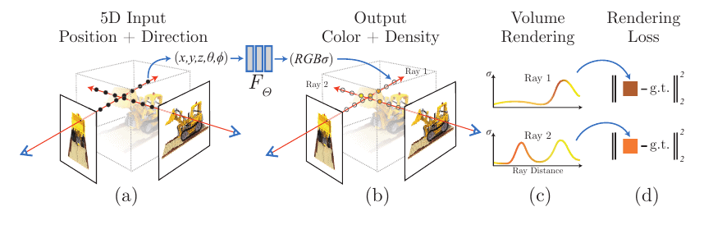]
]Figure.4.3.X.1.1-1 NeRF representation[N1]
The key idea behind NeRF is to represent the appearance of a scene as a function of 3D position and viewing direction, known as the radiance field. The radiance field describes how light travels through the scene and interacts with its surfaces and can be used to generate images from arbitrary viewpoints [N2].
The following is an overview pipeline for NeRF:

Field representation: For each point in space the NeRF represents a view dependent radiance.
Positional encoding: The input coordinates (x,y,z,θ,ϕ) need to be encoded to a higher dimensional space prior to being input into the network.
Rendering: NeRF rely on classic volumetric rendering techniques to composite the points into a predicted color.
Sampling: NeRF use a hierarchical sampling scheme that first uses a uniform sampler and is followed by a PDF sampler.

4.3.6.1.3 Production and Capturing Systems
Mobile apps such as NeRFCapture (https://github.com/jc211/NeRFCapture), Spectacular AI (https://github.com/SpectacularAI), or Record3D (https://record3d.app/) are available to capture NeRFs.
A tutorial for capturing NeRFs is provided here: https://github.com/NVlabs/instant-ngp/blob/master/docs/nerf_dataset_tips.md.
The NeRFCapture app allows any iPhone™ or iPad™ to quickly collect or stream posed images to InstantNGP. If your device has a LiDAR, the depth images will be saved/streamed as well. It has two modes: Offline and Online. In Offline mode, the dataset is saved to the device and can be accessed in the Files App in the NeRFCapture folder. Online mode uses CycloneDDS to publish the posed images on the network. A Python script then collects the images and provides them to InstantNGP.
The Spectacular AI SDK and apps can be used to capture data from various devices:
- iPhonesTM (with LiDAR)
- OAK-D cameras
- RealSenseTM D455/D435i
- Azure Kinect DKTM
The Record3D can create a dataset with an iPhone 12 ProTM or newer (based on ARKit), a python code is needed to convert the captured data to NeRF (https://github.com/NVlabs/instant-ngp/blob/master/scripts/record3d2nerf.py)
The state-of-art of NeRF at the time of writing includes:
- SMERF (Streamable Memory Efficient Radiance Fields for Real-Time Large-Scene Exploration) is a view synthesis approach that achieves state-of-the-art accuracy among real-time methods on large scenes with footprints up to 300 m² at a volumetric resolution of 3.5 mm³ [N3] . It enables fully 6DoF navigation within a web browser, and renders real-time on smartphones and laptops.
- Instant Neural Graphics Primitives (Instant-NGP) using multi-resolution hash encoding to split the processing into multiple chunks and using parallel processing using cuda software to effectively change run time from hours to seconds [N4]. Instant-NGP is a method that uses hash-grid and a shallow MLP to accelerate training and rendering. This method reaches speedups of 1000x and train very fast (~6 min) and renders also fast ~3 FPS.
- NerfStudio (https://docs.nerf.studio/), which is open-source and combines many radiance fields methods, and supports the storage of NeRF data in a structured format, which includes key elements as follows.
Camera intrinsics:
{
"camera_model": "OPENCV_FISHEYE", // camera model type [OPENCV, OPENCV_FISHEYE]
"fl_x": 1072.0, // focal length x
"fl_y": 1068.0, // focal length y
"cx": 1504.0, // principal point x
"cy": 1000.0, // principal point y
"w": 3008, // image width
"h": 2000, // image height
"k1": 0.0312, // first radial distortion parameter, used by [OPENCV, OPENCV_FISHEYE]
"k2": 0.0051, // second radial distortion parameter, used by [OPENCV, OPENCV_FISHEYE]
"k3": 0.0006, // third radial distortion parameter, used by [OPENCV_FISHEYE]
"k4": 0.0001, // fourth radial distortion parameter, used by [OPENCV_FISHEYE]
"p1": -6.47e-5, // first tangential distortion parameter, used by [OPENCV]
"p2": -1.37e-7, // second tangential distortion parameter, used by [OPENCV]
"frames": // ... per-frame intrinsics and extrinsics parameters
}
Camera extrinsics:
{
// ...
"frames": [
{
"file_path": "images/frame_00001.jpeg",
"transform_matrix": [
// [+X0 +Y0 +Z0 X]
// [+X1 +Y1 +Z1 Y]
// [+X2 +Y2 +Z2 Z]
// [0.0 0.0 0.0 1]
[1.0, 0.0, 0.0, 0.0],
[0.0, 1.0, 0.0, 0.0],
[0.0, 0.0, 1.0, 0.0],
[0.0, 0.0, 0.0, 1.0]
]
// Additional per-frame info
}
]
}
Depth images:
{
"frames": [
{
// ...
"depth_file_path": "depth/0001.png"
}
]
}
Masks:
{
"frames": [
{
// ...
"mask_path": "masks/mask.jpeg"
}
]
}

4.3.6.1.4 Rendering and Display Systems
NeRF heavily relies on the volumetric rendering process to obtain rendered pixels. This rendering function is differentiable, so scene representation can be optimized by minimizing the residual between synthesized and ground truth observed images. The rendering process requires sampling tens to hundreds of points along each ray and inputting them into the neural network to produce the final imaging result. Consequently, rendering a single 1080p image necessitates on the order of 108 neural network forward passes, which often takes several seconds [N5].
Display System: VR HMD, mobile devices.

4.3.6.1.5 Supporting Information
- Typical quality criteria for evaluating the format
- Evaluation metrics such as PSNR (Peak Signal-to-Noise Ratio), SSIM (Structural Similarity Index), and LPIPS (LearnedPerceptual Image Patch Similarity)
- Training iteration, training time, inference speed.
- Conversion from other formats (lossless, lossy)
- Meshes, point clouds
- Uncompressed data size
The original NeRF model has 8 fully connected layers, with a layer width of 256, and each pixel is synthesized based on 128 samplings along the ray. The standard NeRF model demands an impractical 5,600 Terabytes cache size.
- Known compression technologies:
Early research on NeRF compression is ongoing. The MPEG established the ad-hoc group called Implicit Neural Visual Representation (INVR) and is currently exploring the potential standardization of 6 Degree of Freedom (6DoF) video compression using NeRF-based technologies[N6]. The following methods are applied in current research for NeRF compression and encoding:
- Parameter quantization techniques, transform coding, and entropy coding [N7]
- VVC and NNC [N8]
- Extensibility of the format
- Mip-NeRF, Point-NeRF, KiloNeRF, Mega-NeRF and etc [N4].

4.3.6.1.6 Benefits and Limitations

4.3.6.1.6.1 Benefits
- High-quality 3D representation: NeRF can create photo-realistic 3D reconstructions of complex scenes, including fine surface details, reflections and realistic lighting effects.
- Improved view synthesis capabilities: NeRF can synthesize novel views of a scene or object from a small number of input images, allowing rendering from any viewpoint.
- Flexibility: NeRF can handle non-rigid and dynamic scenes, adapting well to varying spatial conditions and changes over time.
- Unsupervised training: NeRF can learn to reconstruct a scene or object without explicit supervision.

4.3.6.1.6.2 Limitations
- More computationally demanding and slower to render compared to photogrammetry and 3D Gaussian Splatting.
- Not reductionistic: The entire scene is encoded in a single NeRF function, which makes it challenging to segment the scene into parts, edit individual objects within the scene, or combine different NeRF scenes into one.
- Currently, NeRF representation formats do not seem to effectively handle dynamic content within 3D scenes.

4.3.6.2 Light Fields Video

4.3.6.2.1 Definition
A light field, or lightfield, is a vector function that describes the amount of light flowing in every direction through every point in a space. The term light field was first coined in 1936 by Andrey Gershun [LF-1], for describing the radiometric properties of light in three-dimensional space. Scientifically, light rays are described by the 5-dimensional plenoptic function, which each ray is defined by three coordinates in 3D space (3 dimensions) and two angles to specify their direction in 3D space (2 dimensions).
Light fields were introduced into computer graphics in 1996 for image-based rendering applications, i.e. to compute new views of a scene from pre-existing views without the need for scene geometry [LF-2].
Note that also the term "radiance field" may be used to refer to similar, or identical concepts such as light fields. In an extension, neural radiance fields (NeRFs) a a subject of latest research, for details on NeRFs refer to clause 4.3.Y.1.
Light field representations can be divided into two types:
- the plenoptic function: as shown in Figure 4.3.X.1-1(a), the plenoptic function represents the light field in a 7-dimensional function, which includes the position of viewer’s eye (x, y, z), direction (Θ, Φ in polar coordinates), wavelength (λ), and time (t). However, in practical applications, the 4D light field function L (u, v, s, t) based on two planes, as shown in Figure 4.3.X.1-1(b), is more commonly used. In 4D light field function, (u, v) are the coordinates of the first plane, representing the angular information of the light field, while (s, t) are the coordinates of the second plane, representing the spatial information of the light field.

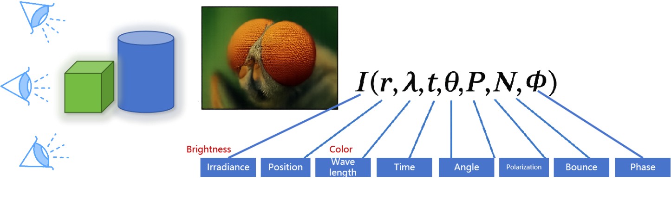

Figure 4.3.X.1-1(a), 7D plenoptic function
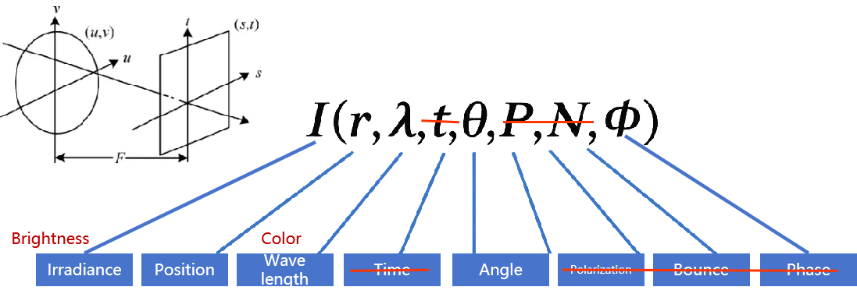

Figure 4.3.X.1-1(b), 4D plenoptic function
- the reflectance field: as shown in Figure 4.3.X.2, the reflectance field corresponds to the plenoptic function but focuses on the emission surface. It describes the transport of light between the incident light on an object and the light exiting from it.
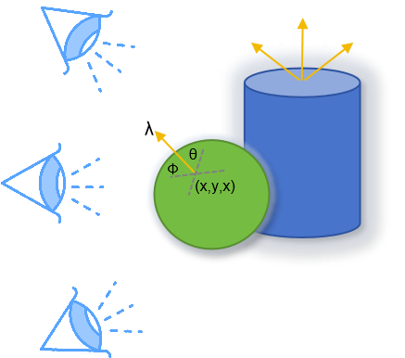

Figure 4.3.X.2, reflectance field
A light field can capture multiple-dimensional data, including spatial, angular, spectral, and temporal domains. Compared to traditional 2D video, the light field provides more 3D information, offering viewers an immersive visual experience. It also enables intelligent system to better understand the 3D environment or objects.Therefore, light field-related technologies are gradually being applied in fields such as industrial inspection, embodied intelligence, virtual/augmented reality, glasses-free 3D displays and so on, demonstrating vast application potential. For example, in the field of industrial inspection, data captured by light field cameras can be used to compute and render multi-view images, synthesize focus stacks, flexibly control depth of field, and achieve full volumetric reconstruction, thereby improving the accuracy of industrial inspection and quality control. Light field video can also be used in high-precision 3D reconstruction of people, objects, and environments, reducing the cost of digital content production, which can be applied in the metaverse and digital twin cities.
Table 4.3.X.1-1 provides an overview of existing lightfield technologies and their properties.
Table 4.3.X.1-1 Existing lightfield technologies and their properties
Properties | Google  Lightstage X4 [LF-3] | USC  Lightstage X6 [LF-4] | PlenOptic  Stage [LF-5]
Type | Color gradient, polarized light, directional light, OLAT | White gradient, OLAT | Gradient light, polarized light, directional light, color gradient, OLAT
Number of Lights | 331 | 1111 | 162~460
Number of Cameras | 90~100+ | 3 | 6~32
Acquisition speed | 60fps | 990fps | 5fps
Resolution | 4K | 2K | 6K/16K
Output frame rate | 30fps | 30fps | 5fps
Editor’s Note: other resolution may include 1536 * 2048, 3840 * 2160, 7680*4320 (45-100 views)

4.3.6.2.2 Production and Capturing Systems
Light fields are typically produced either by rendering a 3D model or by photographing a real scene. In either case, to produce a light field, views must be obtained for a large collection of viewpoints. Depending on the parameterization, this collection typically spans some portion of a line, circle, plane, sphere, or other shape, although unstructured collections are possible. Devices for capturing light fields photographically may include a moving handheld camera or a robotically controlled camera, an arc of cameras (as in the bullet time effect used in The Matrix), a dense array of cameras, or other optical systems. The number and arrangement of images in a light field, as well as the resolution of each image, are referred to as the "sampling" of the 4D light field.
Some capturing systems for light field videos can be captured using several techniques, including:
- Sequential Imaging: Sequential imaging involves capturing multiple images with a moving camera, recording light field information through a sequence of images. For example, a mechanical system can control the camera to move along a spherical trajectory, thus capturing static light field information inside the sphere. While the sequential imaging method can obtain light field with high spatial and angular resolution, the process is time-consuming due to the camera's mechanical movement, making it unsuitable for light field video capture of dynamic objects or scenes.

- Camera Array or camera modules: To improve the efficiency of light field acquisition, multiple cameras can be combined into a camera array, capturing the scene from different angles and positions to obtain light field video. Camera array-based light field video acquisition systems are highly time-efficient and can capture dynamic objects. However, due to the typically large size of the camera array and the high hardware costs, along with the challenges of synchronization and data transmission between multiple cameras, its practical application has certain limitations.

- Plenoptic Camera: To balance system cost and acquisition time, some researchers have proposed using a microlens array combined with a single camera for light field acquisition. A plenoptic camera places the microlens array between the main lens and the image sensor, offering the advantages of portability and low cost. This device can efficiently capture dynamic scenes, therefore they are increasingly being used in light field acquisition. PlenoptiCam is an open-source, cross-platform software tool that processes raw plenoptic camera images into light field data through 4D image alignment and calibration: https://github.com/hahnec/plenopticam.

4.3.6.2.3 Rendering and Display Systems
Light field video can be viewed on different rendering and display systems, including:
- AR glasses: CREALTM light-field AR glasses, https://creal.com/ar/

- VR HMD: Meta Quest, CREALTM light-field VR HMD, https://creal.com/vr/
- Light Field Display: Looking Glass (https://www.holoxica.com/looking-glass-4k), Leia

For rendering light-field video, it takes image rendering toward a “no-geometry-required” solution but use multiple image views. For example, there is an open-source interactive light field renderer using dynamically reparameterized light fields in GitHub: https://github.com/linusmossberg/light-field-renderer.

4.3.6.2.4 Supporting Information
The following is the end-to-end Light Field Video System proposed by Google [LF-6], including capturing, reconstructing, compressing, and rendering high quality immersive light field video. The immersive light fields are recorded using a custom array of 46 time-synchronized cameras distributed on the surface of a hemispherical, 92cm diameter dome. From this data it produces 6DOF volumetric videos with a wide 80-cm viewing baseline, 10 pixels per degree angular resolution, and a wide field of view (>220 degrees), at 30fps video frame rates. The resulting RGB, alpha, and depth channels in these layers are then compressed using conventional texture atlasing and video compression techniques. The final compressed representation is lightweight and can be rendered on mobile VR/AR platforms or in a web browser.

Multiple compression techniques have been proposed for the light field video, they are mainly categorized into three groups:
- Transform-based methods: these approaches typically involving using a transformer, such as the discrete cosine transform (DCT) or the discrete wavelet transform (DWT). For example, the MuLE [LF-7], which has been adopted by the JPEG pleno standardization committee.
- Prediction-based methods: some studies interpret light fields as multi-view sequences and use multi-view extension such as MV-HEVC for compression.
- Learning-based methods: these are recent development in light field compression. They leverage the power of machine learning techniques (e.g., GAN or CNN) to improve encoding efficiency,
MPEG is currently working on Lenslet Video Coding (LVC), which focuses on dense light field representations, use cases and requirements, and dedicated codecs .[LF-8].
The content can be delivered with a DASH-compliant framework, an open streaming media standard for field of light displays (SMFoLD) [LF-9] had also been developed for streaming dynamic scene. However, the work appears to have been discontinued, as there have been no updates since 2018.
Typical quality criteria for evaluating light field video includes:
- 3D IQA, PSNR and SSIM Quality Metrics
- FR light field metric [LF-10], which considers global spatial quality metrics based on viewing structure matching, local spatial quality based on near-edge MSE, and angular quality based on multiview quality analysis.
- JPEG is also preparing standardization activities [LF-11] in the domains of objective and subjective quality assessment for light fields, improved light field coding modes, and learning-based light field coding.

4.3.6.2.5 Benefits and Limitations

4.3.6.2.5.1 Benefits
The light field videos offer the following main benefit:
- Immersive visual experience, “cover all the different perspectives so the user can choose which one he wants to have and of course different users can choose different perspectives.” [LF-12]
Some advantages and benefits of lightfields are provided in [LF-13]:
- the light field content production approach has the benefit that it is a full representation of what is captured, is high resolution, one can observe in stereo and can move within this content, to a predefined degree.
- Content can be captured by a micro lens array or produced by computer graphics. Light fields allow the high fidelity of models, textures, lighting, and reflections.
- Lightfield captures are holographic, i.e. they contain all possible views within a preset range that can be defined.
- Light field captures have parallax, an overlap of object depth based on head movement. This increases immersion and presence, which is not available in 3DOF omnidirectional videos.
- Captures can have higher quality reflections, complex lighting, or realistic physics which would not be possible in real-time 3D graphics.
- Light fields focus or aperture can be adjusted on the fly based on depth versus a 2D video which needs to be in focus at the time of filming. This is because light fields can estimate depth based on the data acquired.
- Just like 3D models, multiple light field captures can be incorporated together and can be manipulated.
- Most of the captured data is not needed and can be removed. For example, thousands of high quality photos of small movements can be compressed to be a fraction of this size by removing this redundant visual info.

4.3.6.2.5.2 Limitations
The large number of views and captures in light field videos generate massive amounts of data, leading to significant storage and bandwidth demands. Even when content is delivered promptly, current handheld devices struggle to load these resources in real-time.
Some disadvantages and limitations of lightfields are provided in [LF-13]:
- Lightfields require a massive amount of high quality pixel based information, regardless whether it is from a real camera or from a virtual camera. In addition, the more movement in a scene means more individual captures of this information.
- Lightfields have restrictions in the volume they can capture, so they really only work for content where edges are not visible. Light fields are not useful for everything, but very targeted use cases.
- Lightfields are not truly volumetric (aka 3D), but fake 3D. If you try to go past the window of the capture area, the illusion disappears.
- Though light field technology had been on computer visionaries’ radar since the early 1990’s, even the biggest players struggled to launch a tangible version to market. Often light fields have been relegated to white papers, rarely finding their way into a commercial project.
[With the emergence of AI-based rendering technologies [LF-14], NeRFs are the successors of light fields, addressing some of the weaknesses of light fields. NeRFs are a scene methods in which a single neural network captures the entire scene. The neural network maps the viewing angle onto the color output, providing a continuous representation of the entire scene. The downside of scene-based approaches is that the whole set of weights is required to reconstruct even portions of the scene. This leads to the main disadvantages of whole-scene NeRF methods: encoding and decoding complexity and memory requirements. While NeRFs can be utilized as 3D assets in virtual productions, Gaussian splats can serve the same purpose just as effectively. Additionally, Gaussian splats offer the advantage of being loosely connected to the underlying geometry. This opens up possibilities for editing these 3D assets in various ways. Hence, more effective methods for distributing light field and radiance fields are anticipated.]
Editor’s note: The above paragraph could be relocated to a separate clause under 4.3.X as part of the conclusion.

4.3.6.3 3D Gaussian Splatting

4.3.6.3.1 Introduction
3D Gaussian Splatting (3DGS) is an emerging method that's gaining attention for its ability to render highly realistic scenes with impressive efficiency and speed. It shows potential in addressing many of the limitations associated with other representation formats. As 3D Gaussian Splatting is a rapidly evolving field, new developments and insights are emerging regularly. This documentation reflects the state of the art at the time of writing and may not capture the most recent advancements. However, a comprehensive, searchable database of 3D Gaussian Splatting papers is available through the following link, which will help you stay updated with the anticipated surge of research in the coming months:
- Awesome 3D Gaussian Splatting Paper List: https://mrnerf.github.io/awesome-3D-gaussian-splatting/

4.3.6.3.2 Overview
3D Gaussian Splatting (3DGS) [GS-1], also referred as Gaussian Splatting Radiance Field, is an explicit radiance field based 3D representation that represents 3D scene or objects using a large number of discrete 3D anisotropic balls or particles, each defined by its spatial mean μ and covariance matric ∑ [GS-2]:
$$G(p)= exp(−\frac{1}{2}{(p−μ)}^{T}∑^{−1}(p−μ))$$
The covariance matric ∑ is parameterized by using a scaling matrix S and a rotation matrix R, such that ∑=RSS^{T}R^{T}. Each 3D Gaussian is associated with a color c and an opacity α. During rendering, these Gaussians are projected (rasterized) onto the image plane, forming 2D Gaussian splats G′(x). The 2D Gaussian splats are sorted from front to back tile-wisely, and α-blending is performed for each pixel x to render its color as follows:
$$C(x)=\sum_{i∈N}{c_{i}}σ_{i}\prod_{j=1}^{i−1}{(1−σ_{j}), }σ_{j}=α_{i}G_{i}^{'}(x)$$
The color of each Gaussian, c, is represented by Spherical Harmonics (SH) as $k_{l}^{m}Y_{l}^{m}(ω_{view})$ to provide view-dependent effects, where (l,m) is the degree and order of the SH basis $Y_{l}^{m}$, $k_{l}^{m}$ is the corresponding SH coefficient, and $ω_{view}$ specifies the viewing direction.
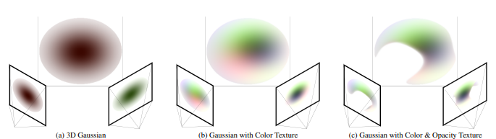
Figure 4.3.X.1-1 3D Gaussian Splatting (3DGS) representation [GS-13]
The data need to perform this 3DGS rendering process are, for each point, known as a Gaussian:
- 3 position values
- 4 rotation values
- 3 color values
- 3 scale values
- 1 transparency value
- 45 spherical harmonics values
Currently, the supported formats for 3D Gaussian Splatting data can be:
- A .PLY file, in which a detailed splat of an outdoor scene might exceed 250 MB (1888 bits by points for float 32 values).
- .splat format, a Javascript types serialized version of .PLY datas.
- The .SPZ format, shrinks the file size from a standard PLY file by using more compressed representation by reduce the different values that are associated with each Gaussian splat. This format reduces the size of the 3DGS files by quantizing the data, reducing the number of spherical harmonics used and compressing the quantized data, using lossless data compression process. This reduction in data in term of quantization and reduction disturbs the 3D object and is not lossless.
The Table 4.3.X.1-1 summarized the parameter types for .PLY and .SPZ format:
Table 4.3.X.1-1 Existing 3D Gaussian Splatting (3DGS) representation Formats
Element | SPZ Format | PLY Format
Positions | 24-bit fixed point integer with adjustable fractional bits | 32-bit or 64-bit floating-point
Rotation | 3 components of a quaternion stored as 8-bit signed integers | 4 components of quaternion as 32-bit floats
Color (RGB) | 8-bit unsigned integers per channel | Typically 8-bit or 32-bit floats per channel
Scales | 8-bit log-encoded integer | Typically 32-bit or 64-bit floating-point
Alphas | 8-bit unsigned integer | Typically 32-bit float
Spherical Harmonics | 8-bit signed integers for coefficients, with 4-5 bits of precision | Varies, but usually stored with higher precision (e.g., 32-bit floats)
Number of Spherical Harmonics | 0, 9, 24 or 45 values according to compression parameter | 45 values

The implementation of 3D Gaussian Splatting (3DGS) involves numerous elaborate steps, which may include:
- Pre-process: Estimate 6DOF poses corresponding to each view, and also obtain camera intrinsic parameters. These 6DOF poses (extrinsics), camera intrinsics, as well as RGBs are then processed in SfM block to obtain: (i) 3D point cloud - i.e., 3D projection of salient points observed in multiple images, as well as (ii) refined camera intrinsics and poses, optimized in a large nonlinear solver system.
- Structure from motion: This process starts by creating a point cloud from images e.g., using the SFM method [GS-3] with the COLMAP library
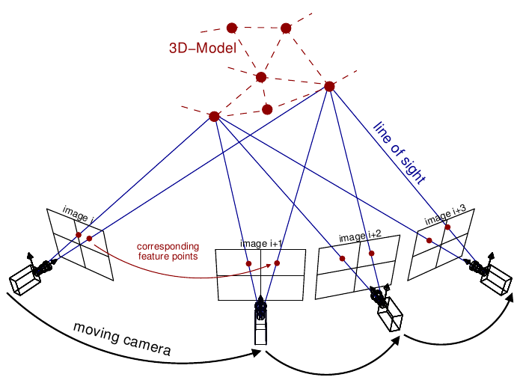
Figure 4.3.x.1-2 Structure from Motion (SfM) photogrammetric principle [GS-12]
- Convert to gaussian splats: Each point is then converted to a Gaussian splat, which is described by parameters such as position, covariance, color, and transparency.
- Differentiable Gaussian rasterization: Every 2D Gaussian requires differentiable Gaussian rasterization to be projected from the viewpoint of the camera, sorted according to depth, then repeated both backwards and forwards combined for every pixel.
- Adaptive Density Control: The method for dynamically adjusting the number, density, and parameters of Gaussians to accurately and efficiently represent the 3D scene. This involves two steps:
- Pruning: If the opacity of is too small or the gaussian is too large, then it’s being removed.
- Densification: this step handles two issues:
- Over-reconstruction: regions of a 3D scene are represented by excessively large or overlapping gaussians, leading to redundant and inefficient coverage of the geometry. To solve this the large gaussian is split in two parts (bottom row).
- Under-reconstruction: regions of a 3D scene lack sufficient Gaussian coverage, resulting in missing or poorly represented geometric details. This is solved by merging/cloning two or more gaussians associated with the area (top row).
- Training: iterative calculations on the content itself are used to determine additional details about how the point could be stretched/scaled (covariance) and its opacity using Stochastic Gradient Descent (SGD). Through this process, a model is created with millions of points containing data such as position, color, covariance, and opacity. The inputs to 3DGS training are: (1) Refined 6DoF poses (camera extrinsics), (2) Refined (or original) camera intrinsics - a.k.a., projection matrices, (3) Images/RGBs corresponding to these poses and intrinsics, and (4) 3D points cloud - obtained using SfM.

4.3.6.3.3 Production and Capturing Systems
The formats as defined in clause 4.3.X.1 may be captured by mobile devices with several mobile apps (both Android and iOS devices) or online services utilize 3DGS technology. However, smartphones often apply automatic enhancement to each captured images, aiming for the best result. These optimizations, such as sharpening edges, adjusting exposure, and optimizing colors, can introduce noise or errors that are not suitable for Gaussian Splatting training. To mitigate these challenges, a photogrammetry capture method with professional-grade cameras (e.g., Interchangeable Lens Camera), standardized settings, and a streamlined capture process can be utilized to meet the requirements.
The New York Times (NYT) development team explored the practical applications of 3D Gaussian Splatting (3DGS) for spatial journalism. They tested a range of capture and processing techniques using various hardware and software, evaluating solutions for both desktop and mobile devices, and give an overview of the practical takeaways they learned exploring exploring gaussian splatting for spatial journalism [GS-4].
- Quality: High resolution RAW stills when photographing a stationary object or space that requires lots of detail. More resolution generally equates to a more detailed splat — up to a point. They tested images up to 45 megapixels and video up to 8K and found little increase in quality above 20 megapixels or 6K video. If you opt for extreme resolutions, you may need to rescale your images or video before processing.
- Speed: Using a high frame rate during video capture (e.g., 120fps vs 24fps) can ensure less subject movement between frames, more overlap between adjacent frames, decrease motion blur, and help guarantee sufficient coverage. Using a burst mode or automated continuous capture mode when capturing still images similarly speeds up the process.

4.3.6.3.4 Rendering and Display Systems
During the rendering process, each Gaussian is rasterized onto the screen according to its parameters. Alpha blending technics are used to smoothly blend the transparenced splats to create a continuous surface appearance.
In the first step of the rendering process, the 3D points are sorted according to the viewer's position to be projected in the correct order on the screen and allow for proper color mixing. Rasterization of Gaussian splats works for each point by projecting the ellypsoid made based on the covariance matrix on the screen and for each pixel covered by the current splat, the color is calculated using the user's position and the values of the spherical harmonics. Alpha blending adds the colors of all the splats covering the current pixels to obtain the final color and achieve high-quality rendering.
Various implementations of the rendering process have been proposed in the literature. The standard implementation of the rasterization process can be made on CPU or on GPU using rendering shaders or compute shaders with various 3D graphics API: OpenGL, Vulkan, DirectX, CUDA, etc…
To facilitate high-frame-rate and high-resolution differentiable rendering, a tile-based rasterization process has been proposed in [GS-5]. For example, the rasterizer divides the image into a set number of tiles, assigning an index to each tile. For each Gaussian primitive, the rasterizer determines which tiles the primitive’s projection intersects and generates a key-value pair for each intersecting tile. By constructing these key-value pairs, the rasterizer only needs to perform a global sort on all pairs, eliminating the need for additional sorting of primitives for each pixel.
After sorting, the key-value pairs derived from each tile are stored in contiguous memory intervals. The rendering process for each tile is then managed by a CUDA thread block, with the number of threads within each block matching the number of pixels in the tile. Each thread is responsible for the alpha blending process for its corresponding pixel, completing the final rendering.
To improve the quality of the rendered sceen, [GS-10] proposes to render a 3D Gaussian splat scene with the ray tracing process. This method improves the quality of rendering by allowing for precise soft shadows, reflections, and transparency, surpassing the previously mentioned rasterization processes in terms of realism, but greatly increasing complexity.

4.3.6.3.5 Supporting Information
- Typical quality criteria for evaluating the format
- In the image domain: The Peak Signal-to-Noise Ratio (PSNR), Structural Similarity Index (SSIM),Learned Perceptual Image Patch Similarity (LPIPS), the resultant size in megabytes (MB), the training time, and required storage.
- In the 3D point domain: point to point/ point to plane, / point to surface for position. Attribute PSNR.
- Conversion from other formats (lossless, lossy)
- Point Clouds: There are tools, e.g., 3D Gaussian Splatting Converter (https://github.com/francescofugazzi/3dgsconverter), can seamlessly convert 3DGS .ply files to a Cloud Compare-friendly format and vice-versa. Converting point cloud representations to 3DGS can effectively fill in the point clouds’ holes, which is typically done after high-precision reconstruction of the point clouds. Conversely, 3DGS can also be converted into point clouds, followed by voxelizing the point cloud into 3D voxels and then projecting them onto 2D BEV grids [GS-6].
NOTE: filling holes in point cloud, can also be achieved by different techniques.
- Mesh: Research works have discussed how to convert 3DGS to Mesh. Once converted, the quality of mesh can be further optimized to achieve better geometric and appearance,
- Uncompressed data size
A Gaussian splat of a scene is a representation of 3D points. On average, a splat contains between 0.5 and 5 million of these 3D points. Each 3D point has unique parameters that represent the scene as accurately as possible.
- Known compression technologies:
Early research on 3DGS compression is ongoing. Vector quantization (VQ) [GS-7] had been applied in some research for 3DGS compression and encoding.Between 50:1 and 200:1 compression ratios are quite standard these days. MPEG has started an exploration that is looking at the most appropriate representation formats for 3DGS and various coding strategies.
- Extensibility of the format
The format is undergoing massive academic and industrial research, can be further expanded for more capabilities and is hence not stable. Example of use cases include: 3DGS can be further expanded for more capabilities, including dynamic 3DGS [GS-5, GS-8], surface representation from 3DGS [GS-5, GS-8], editable 3DGS [GS-5, GS-8], 3DGS with semantic understanding [GS-5, GS-8], and 3DGS-based physics simulation [GS-5, GS-8].

4.3.6.3.6 Benefits and Limitations

4.3.6.3.6.1 Benefits
- Real-time Rendering with GPU acceleration.
- Accurate Reconstruction, it can capture the geometry accurately
- Explicit representation
- Ability to render complex scenes in real-time
- Interpretability of the representation, an explanation of the mathematical mechanism, i.e., the working principle, of 3DGS can help researchers analyze the complex relationships in 3D scene reconstruction technology and reveal the performance characteristics of 3DGS in depth. [GS-11]
- Gaussian Splatting can deliver high-quality, real-time visualizations.[GS-9].
- Gaussian Splatting has evolved to handle dynamic and deformable objects [GS-9].
- Gaussian Splatting can be applicable to various application space, such as digital avatars and SLAM [GS-9].

4.3.6.3.6.2 Limitations
- There is a lack of industry agreement on the 3DGS format(s), due to no stable representation and compression format exists for static and dynamic 3DGS.
- Static and Dynamic 3DGS formats is evolving, multiple options are considered in current academic and industrial research. For dynamic, such research include modeling in 4 dimensions (i.e. temporal), time evolving 3DGS, and MLP predicted motion for 3DGS among others.
- High memory usage
- Not yet fully compatible with existing rendering pipelines
- Computation complexity [GS-9], the computational demands of handling large numbers of splats, especially for high-resolution rendering and complex scenes; it requires to process large datasets for training, which can also be time-consuming and resource-intensive.
- Edge artifacts [GS-9].

5 Overview of existing "Beyond 2D" Video Capabilities in 3GPP
Editor’s note: This clause summarized existing beyond 2D video capabilities in 3GPP from at least TS.26.119 and TS.26.118.

5.1 Introduction
This clause summarizes the existing beyond 2D video capabilities in relevant 3GPP-based services.
In Release 18, the beyond 2D video capabilities include support for 3GPP video codecs, H.264 (AVC) [clause5-1] and H.265 (HEVC) [clause5-2]. Both codecs are defined as part of AR Video capabilities in 3GPP TS 26.119 [26119], and VR Video Profiles in 3GPP TS 26.118 [26118].The highest defined profile/level combinations are:
- AVC-8K-Dec-8: The capability of supporting up to eight (N=8) concurrent decoder instances with the aggregate capabilities of H.264 (AVC) Progressive High Profile Level 6.1 [clause5-1].
- HEVC-8K-Dec-8: The capability of supporting up to eight (N=8) concurrent decoder instances with the aggregate capabilities of H.265 (HEVC) Main10 Profile, Main Tier, Level 6.1 [clause5-2].
Support for stereoscopic MV-HEVC for low delay stereoscopic 3D video applications was recommended by TR 26.966 [26966] and is being addressed in a Release 19 work TS 26.265 [26265]. More details on the beyond 2D video capabilities for different services are provided in the remainder of this clause.

5.2 AR Video Capabilities
3GPP TS 26.119 [26119] specifies the mandatory and optional media capabilities and profiles to be supported for each XR device type. These media capabilities include support for video codecs (AVC and HEVC), audio codecs (EVS, IVAS and AAC-ELDv2), scene description formats, and XR system capabilities. Table 5.2-1 summarized the Beyond 2D video capabilities defined in clause 7 of TS 26.119 [26119].
NOTE: The definition of concurrent video decoder instances can be found in clause 7.1.2.1 of TS 26.119 [26119].
Table 5.2-1: Summary of Operation Points
Operation Point Name | Max Concurrent Video Decoder Instances | Decoding Capabilities
AVC-FullHD-Dec-2 | 2 | Aggregate decoding capabilities of H.264/AVC HP@L4.0
AVC-UHD-Dec-4 | 4 | Aggregate decoding capabilities of H.264/AVC HP@L5.1
HEVC-UHD-Dec-4 | 4 | Aggregate decoding capabilities of H.265/HEVC MP10@L5.1
UHD-Dec-4 | 4 | Aggregate capabilities of AVC-UHD-Dec-4
UHD-Dec-4 | 4 | Aggregate capabilities of HEVC-UHD-Dec-4
UHD-Dec-4 | 4 | Decoding up to 4 bitstreams, each not exceeding the capabilities of H.264/AVC HP@L4.0 or H.265/HEVC MP10@L4.1.
AVC-8K-Dec-8 | 8 | Aggregate capabilities of H.264/AVC HP@L6.1
HEVC-8K-Dec-8 | 8 | Aggregate capabilities of H.265/HEVC MP10@L6.1
8K-Dec-8 | 8 | Aggregate capabilities of AVC-8K-Dec-8
8K-Dec-8 | 8 | Aggregate capabilities of HEVC-8K-Dec-8
8K-Dec-8 | 8 | Decoding up to 8 bitstreams, each not exceeding the capabilities of H.264/AVC HP@L4.0 or H.265/HEVC MP10@L4.1.
8K-Dec-8 | 8 | Decoding up to 4 bitstreams, each not exceeding the capabilities of H.264/AVC HP@L5.1 or H.265/HEVC MP10@L5.1.

5.3 VR Video Profiles
The VR profiles for streaming services are defined in TS 26.118 [26118], specifying the coded representation and media profile of 360 VR distribution signals. Table 5.3-1 provides an overview of the 360 VR relevant formats considered in the context of 3GPP VR Profiles.
For restrictions on source formats such as resolution and frame rates, content generation and encoding guidelines, refer to TS 26.118 [26118], Annex A.
Table 5.3-1: High-level Summary of Operation Points
Operation Point name | Decoder | Bit depth | Typical  Original  Spatial  Resolution | Frame  Rate | Colour space format | Transfer  Characteristics | Projection | Rotation | RWP | Stereo
Basic H.264/AVC | H.264/AVC HP@L5.1 | 8 | Up to 4k | Up to 60 Hz | BT.709 | BT.709 | ERP w/o padding | No | No | No
Main H.265/HEVC | H.265/HEVC MP10@L5.1 | 8, 10 | Up to 6k in mono and 3k in stereo | Up to 60 Hz | BT.709  BT.2020 | BT.709 | ERP w/o padding | No | Yes | Yes
Flexible H.265/HEVC | H.265/HEVC MP10@L5.1 | 8, 10 | Up to 8k in mono and 3k in stereo | Up to 120 Hz | BT.709  BT.2020 | BT.709,  BT.2100 PQ, BT.2100 HLG | ERP w/o padding  CMP | No | Yes | Yes
Main 8K H.265/HEVC | H.265/HEVC MP10@L6.1 | 10 | Up to 8k in mono and 6k in stereo | Up to 60 Hz for 8K and 120 Hz for 4k | BT.709  BT.2020 | BT.709,  BT.2100 PQ, BT.2100 HLG | ERP w/o padding | No | Yes, but restricted to coverage | Yes

Table 5.3-2 summarizes the video operation point, sample entry, and DASH integration associated with each video media profiles defined in clause 5.2 of TS 26.118 [26118].
Table 5.3-2 Video Media Profiles
Media Profile | Operation Point | Sample Entry | DASH Integration
Basic Video | Basic H.264/AVC | resv  avc1 | Single Adaptation Set  Single Representation streaming
Main Video | Main H.265/HEVC or Main 8K H.265/HEVC | resv  hvc1 | Single or Multiple independent Adaptation Sets offered  Single Representation streaming
Advanced Video | Flexible H.265/HEVC | resv  hvc1, hvc2 | Single or Multiple dependent Adaptation Sets offered  Single or Multiple representation streaming

5.4 Messaging Services
3GPP TS 26.143 [26143] specifies the media types, formats, codecs capabilities and profiles for the messaging applications used over the 5G System. The document extends to codecs for speech, audio, video, still images, bitmap graphics, 3D scenes and assets, and other media in general, as well as scene description.
Specifically, the 2D video capabilities defined in TS 26.143 [26143] clause 6.2 are fully aligned with 5G Media Streaming in 3GPP TS 26.511 [26511]:
- AVC with HD and Full-HD resolutions
- HEVC with HD, Full-HD and UHD resolutions
For Beyond 2D video capabilities, as HEVC simulcast and HEVC frame packing already been included in SA4 specifications and given the coding benefits MV-HEVC provides compared to these solutions, the support for stereoscopic MV-HEVC for low delay applications of stereoscopic 3D video was recommended by TR 26.966 [26966]. This aspect is being addressed in a Rel-19 work TS 26.265 [26265].

6 Evaluation and Characterization Framework

6.1 Overview
Generally, the test and characterization framework as documented in TR 26.955, clause 5 also applies to this document. This clause only documents differences and extensions that are needed for beyond 2D Evaluation and characterization framework.
The overview of the evaluation framework for the B2D messaging is presented in Figure 6.1-1. Representative reference sequences are collected and stored in a well-defined B2D format. For a video encoder, the configuration is provided that matches the application constraints. The resulting video streams are “pseudo”-packaged in order to determine the file size/bitrate. The data is then unpackaged, and a B2D video decoder is used to reconstruct data in the B2D format again. The data is stored. The original sequence and the recovered sequence are used determine metrics. The sequences may also be inspected subjectively.
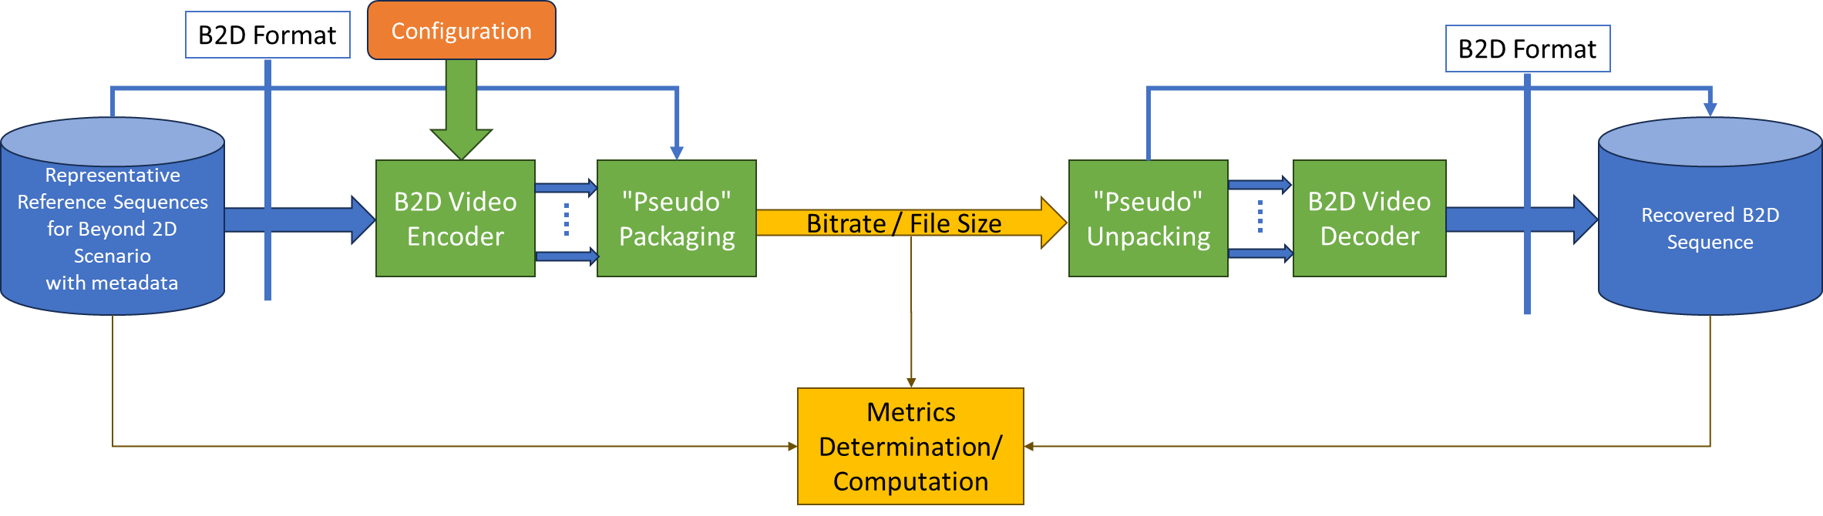
Figure 6.1-1 B2D Evaluation framework

6.2 Reference Sequences
This document provides reference sequences that are used to generate anchors and are also made available in order to generate test bitstreams for other codecs. Reference sequences are selected to be representative for a scenario.
Reference sequences are described in Annex C of this document along with their properties and their licenses. A format for raw reference sequences based on a JSON schema is defined in clause B.2.
Annex D describes how to upload new proposed reference sequences and how to download the reference sequences.

6.3 Reference Software Tools
Editor’s Note: For further study

6.4 Metrics
Editor’s Note: For further study
The metrics in clause 5.5 of TR 26.955 also apply for this report.
In addition, the following is defined
Editor’s Note: For further study
For metrics reporting, the following csv scheme is defined: tbd

6.5 Encoding Constraints
The encoding constraint definition in clause 5.6 of TR 26.955 also apply for this report.
In addition, the following is defined:
- Equal Quality Views: equal quality views refers to the encoding such that each view when decoded has the same quality target, typically applying the same QP.
Editor’s Note: More details are to be defined

7 Considered Scenarios

7.1 Introduction
This clause collects relevant scenarios and corresponding workflows for beyond 2D video services, based on the template defined in Annex A. For each scenario, the following information is provided:
- Motivation: This provides context for the scenario. What is the market relevance of the proposed scenario over the next few years, supported by key indicators?
- Description of the scenario: This provides a description of the corresponding beyond 2D end-to-end workflows, which includes identifying and defining beyond 2D formats being used in the context and representation technologies to delivery these formats.
- Source format properties: This defines a clear range of the considered and relevant source formats, including the signal properties, but also the characteristics of the content.
- Encoding and decoding constraints and settings: This provides details on encoding settings and constraints for the codecs mapped to the scenarios.
- Performance metrics and requirements: Documents the relevant performance metrics, and/or the main KPIs of the scenario.
- Interoperability Considerations: Documents relevant interoperability requirements.
- Referenced Sequences: Defines the reference sequences that are selected for this scenario in order to do the evaluation. A justification is provided, why this sequence is selected.
- Test Conditions: Provides detailed test condition, for example based on a reference software together with the sequences and configuration parameters.
- External Performance: Provides performance data available externally.
- Additional Information: Provides additional information, including industry activities, implementation constraints, and innovations.

7.2 Scenario 1: UE-to-UE Stereoscopic Video Live Streaming

7.2.1 Motivation
Live Streaming services can be deployed across various platforms, including social media platforms like YouTube Live™, Facebook Live™, and TikTokTM, as well as though e-commerce platforms such as eBayTM and TaobaoTM [LS-1]. It significantly impact marketing by providing a dynamic and interactive channel to directly connect markets and their target audiences in real time. To continue captivating users, it’s essential to explore a more immersive live streaming experience by incorporating beyond 2D video.
Most of the current Beyond 2D streaming services provided by network operators, services providers, and device manufacturers on the market are based on the stereoscopic video format, as defined in clause 4.3.2. In terms of distribution, existing stereoscopic 3D video formats, such as frame-compatible side-by-side and 2D video plus depth. Particular emphasis is given to the DVB systems [LS-3] and IP transport, focusing HTTP/TCP streaming, adaptive HTTP streaming, RTP/UDP streaming, P2P Networks, and Information-Centric Networking-ICN. Hybrid transport technologies, combining broadcast and broadband networks for video delivery are also addressed. The most important standards are MPEG-2 systems, which is used for digital broadcast and storage on Blu-ray discs, real-time transport protocol (RTP), which is used for real-time transmissions over the Internet, and the ISO base media file format, which can be used for progressive download in video-on-demand applications [LS-4].In cause 6.2 of TR 26.905 [LS-5], it provides a DASH-based streaming solution for streaming Stereoscopic 3D video.

7.2.2 Description of the Anticipated Application

7.2.2.1 Overall Description
3GPP until now has very restricted set of services but based on the considerations in clause 7.2.1, the following encoding benchmark capabilities are considered for decoding:
- The capability of supporting up to two (N=2) concurrent decoder instances with the aggregate capabilities of H.265 (HEVC) YUV 4:2:0, 10 bit, Max Resolution 4096 x 2048.
The considered scenarios is low-latency streaming. Important aspects that are expected to be considered when evaluating a codec in the context of this UE-to-UE Stereoscopic Video Live Streaming scenario are:
- Quality and Coding Efficiency:
- High and uninterrupted visual quality, taking into account the services constraints.
- The ability to compress 2 or more B2D streams in real-time to minimize latency requirements.
- Any savings can provide significant benefits due to the expected large volume of the traffic either in quality or network utilization.
- Considered settings for encoding:
- Low-latency settings
- Encoding in this scenario is typically done as:
- Live and On-Demand distribution and encoding
- Sever and Cloud-based Encoding

7.2.2.2 Capturing and processing
The existing and emerging capture methods include:
- Stereoscopic camera: a dual-lens camera which can directly capture stereo 3D video. For example, the SpatialLabs Eyes™, a stereoscopic camera cable of capturing at up to 8-MP (aka 4K) per eye at 30 fps or 2K per eye at 60 fps (https://www.tomshardware.com/cameras/3d-call-me-maybe-acers-new-spatiallabs-camera-live-streams-impressive-3d-video-in-8k-but-few-can-view-it). Another example is the ZTE Nubia Pad 3D II™, which can capture stereo 3D video at up to 13-MP per eye at 30 fps with the rear camera and 8-MP per eye at 30 fps with the selfie camera.
- 3D Camera Rig: The cameras setup is shown in the figure below, which consists of two identical HD camcorders (Canon HG-20™) and an adjustable stereo mount. The mount ensures that optical axes of the cameras are parallel and supports the continuous adjustment of the camera distance in the range 7-50 cm. To ensure matching of the focal length the wide angle end of the zoom lens with a focal length of 43 mm has been used. In order to match the cameras with each other the focal length, white balance and shutter speed have been set manually. The synchronized operation of the two camcorder is ensured through the use of a single remote control. The camcorders support the capture of images with a resolution of 1920×1080 pixels and store them as high quality JPEG files.
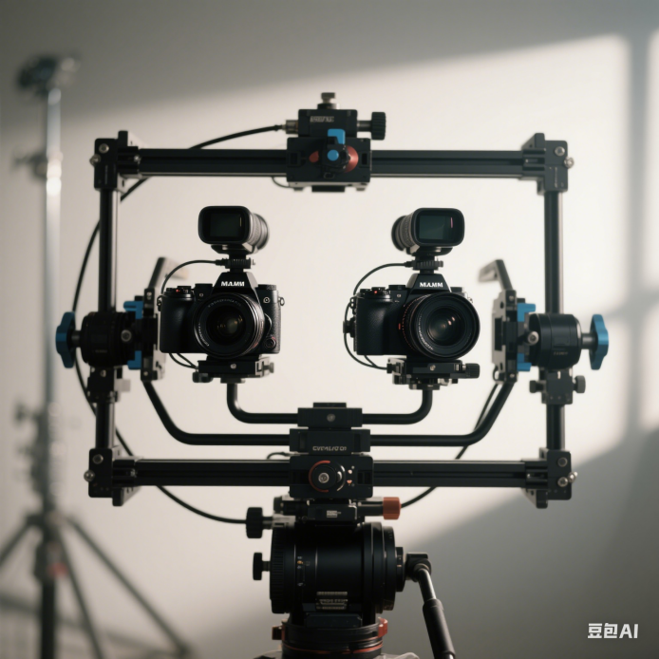
Figure 7.2.2.2-1 Camera Rig for stereoscopic video capture (AI generated Image)

- AI Based 2D-to-Stereo3D Conversion: The AI-based conversion leverages deep neural networks to perform real-time, end-to-end conversion of 2D videos and images into stereoscopic 3D format [LS-2]. This technology is proving commercially viable and meets the growing demand for high-quality stereoscopic images, as demonstrated by commercial services.
For UE capable of directly capturing stereoscopic video on the device, it pre-processes the captured video frames into a well-defined B2D format and sends them to the encoder as input. The encoded B2D video streams are then streamed to the streaming server within the network, where the server may transcode them into different bitrates and distribute them to various audiences. The receiving end decodes B2D video streams and perform post-processing to adapt to the rendering system.
For UE limited to capturing only 2D video (e.g., UE with a monocular camera), the UE initially encodes the regular 2D video and streams it to a cloud server capable of real-time 2D-to-beyond 2D transcoding (a generic pipeline for this transcoding process is described in Figure 7.2.2.2-2). The cloud server then encodes the transcoded B2D video and streams it to the streaming server.

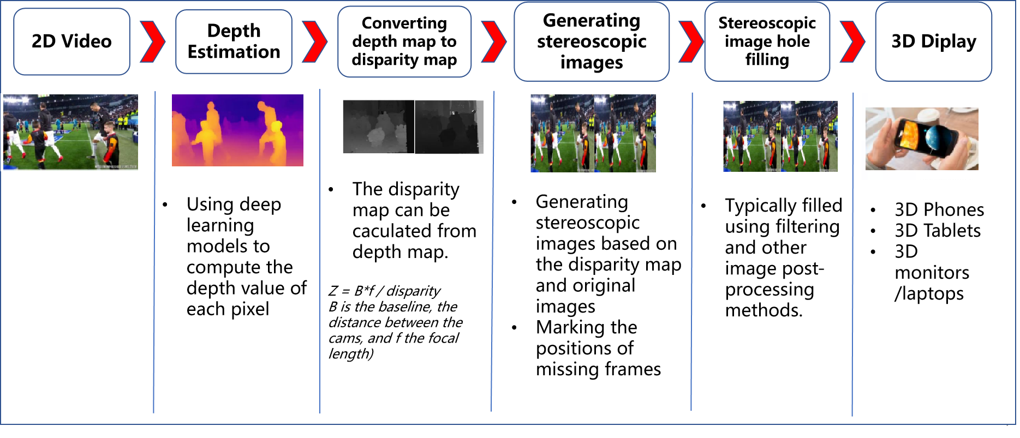
Figure 7.2.2.2-2 Pipeline for 2D-to-Stereo3D Conversion

7.2.2.3 Encoding
The following solutions can be used to realize this scenario:
- Concurrent H.265/HEVC
- MV-HEVC

7.2.2.4 Packing and Delivery
The content can be delivered using regular ISO BMFF based distribution, including streaming with DASH/HLS/CMAF.

7.2.2.5 Decoding
The following solutions can be used to realize this scenario:
- Concurrent H.265/HEVC decoding capabilities
- MV-HEVC

7.2.2.6 Rendering
Rendering can be on:
- Backward-compatible to 2D presentation, e.g., a mobile phone, but the stereoscopic effect is lost in this case.
- A device for 3D presentation, e.g., autostereoscopic displays, VR headset, and AR glasses, these devices can track the viewer's eye position and adjusts the 3D effect in real-time for single viewer applications (parallax adjustment) and rendering.

7.2.3 Source Format Properties
Table 7.2.3-1 provides an overview of the different source signal properties for UE-to-UE Stereoscopic Video Live Streaming. This information is used to select proper test sequences.
Table 7.2.3-1 UE-to-UE Stereoscopic Video Live Streaming Source Properties
Source format properties | B2D Live Streaming
Number of views | 2
Spatial resolution for each view | For each view:  1920 x 1080  2560 x 1600
Chroma format | Y’CbCr, RGB
Chroma subsampling | 4:2:0
Picture aspect ratio | 32:9  16:9  16:10
Frame rates | 25, 30, 60, 90,120 Hz
Bit depth | 8, 10

7.2.4 Encoding and Decoding Constraints
Table 7.2.4-1 provides an overview of encoding and decoding constraints for UE-to-UE Stereoscopic Video Live Streaming scenario using H.265/HEVC and MV-HEVC. This information supports the definition of detailed anchor conditions.
Table 7.2.4-1 Encoding and Decoding Constraints
Encoding and Decoding Constraints | H.265/HEVC |  | MV-HEVC
Relevant Codec and Codec Profile/Levels | H.265/HEVC Main 10 Profile  Level 4.1, 5.1 |  | Multiview Main or Multiview Main10 profile  Level 4, 5.1 and higher
Random access frequency | 1 second |  | 1 second
Bit rates and quality configuration | Fixed QP: [17~37]  CBR  Half Width/Height: 5-8Mbps  Full Width/Height: 8-16Mbps  Capped-VBR |  | Fixed QP: [17~ 37]
Bit rate parameters (CBR, VBR, CAE, HRD parameters) | Covering a range of relevant bitrates and qualities |  | Covering a range of relevant bitrates and qualities
Latency requirements and specific encoding settings | Low latency requirements |  | Low latency requirements
Encoding complexity context | Real-time encoding, Cloud-based encoding |  | Real-time encoding, Cloud-based encoding
Required decoding capabilities | H.265/HEVC Main 10 Profile  Level 4.1, 5.1 |  | Multiview Main or Multiview Main10 profile  Level 4, 5.1 and higher

7.2.5 Performance Metrics

7.2.5.1 Objective Metrics for Captured Stereoscopic Video
Objective evaluation of stereoscopic video can be conducted by applying 2D video quality metrics (e.g., PSNR, SSIM, SNR...) to each source view position and computing their average.
A full-referenced human visual-system-based quality metric for stereoscopic videos called HV3D had been proposed [LS-6，LS-7]. As shown in Figure 7.2.5.1-1, HV3D metric takes into account the quality of individual views, the quality of the cyclopean view (fusion of the right and left view, what the viewer perceives), as well as the quality of the depth information. The HV3D quality metric is taking values between 0 and 1 (because it is optimized to be correlated with MOS/10), and higher than 1 in case quality is improved.
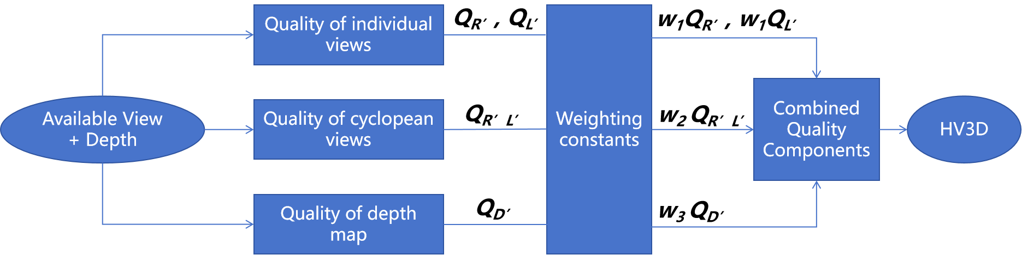
Figure 7.2.5.1-1 HV3D Flowchart

7.2.5.1.1 Quality of individual views
The metrics are computed for the quality of individual views that form the stereo pair. The quality of the distorted right view with respect to its matching reference view is calculated as followings. The quality of the left view is calculated in the same fashion.
$$w_{1}Q_{R'}= w_{1}VIF(Y_{R},Y_{R'})+w_{4}VIF(U_{R},U_{R'})+w_{4}VIF(V_{R},V_{R'})$$
Where Y_{R} and Y_{R’} are luma information of the reference and distorted right views respectively, U_{R} and V_{R} are the chroma information of the reference right-view, U_{R’} and V_{R’} are the chroma information of the distorted right-view, w₁ and w₄ are weighting constants.

7.2.5.1.2 Quality of cyclopean view
A 3D-DCT transform is then applied to each pair of matching blocks, generating two 1$6×16$ DCT-blocks containing the DCT coefficients of the fused blocks. Given the human visual system’s sensitivity to contrast, a 1$6×16$ Contrast Sensitivity Function (CSF) modeling mask is applied to the 1$6×16$ DCT block, assigning greater weights to frequencies that are more perceptually significant. This process is illustrated as follows:
$$XC=\sum_{i=1}^{16}{\sum_{j=1}^{16}{C_{i,j}}}X_{i,j}$$
Where XC is the cyclopean-view model for a pair of matching blocks in the right and left views, X_{i, j} are the low frequency 3D-DCT coefficients of the fused view, i and j are the horizontal and vertical indices of coefficients, and C_{i, j} is the CSF modeling mask.
Once the cyclopean-view model for all the blocks within the distorted and reference stereoscopic views is obtained, the quality of the cyclopean view is calculated as follows:
$$Q_{R'L'}=VIF(D,D')^{β}\sum_{i=1}^{N}{\frac{SSIM(IDCT (XC_{i}),IDCT (XC_{i}^{’}))}{N}}$$

7.2.5.1.3 Quality of depth maps
The quality of depth information plays an important role in the perceptual of the stereoscopic video content. In HV3D, the quality of depth map is chosen to be variance-dependent, and it is formulated as follows:
$$Q_{D'}=VIF(D,D')^{β}\sum_{i=1}^{N}{\frac{σ_{d_{i}}^{2}}{N.max(σ_{d_{i}}^{2} | i =1,2,..N)}}$$
Where $σ_{d_{i}}$is the variance of block i in the depth map of the 3D reference view, β is a constant = 0.7 and N is the total number of blocks. The local disparity variance, $σ_{d_{i}}^{2}$, is defined as follows:
$$σ_{d_{i}}^{2}=\frac{1}{64×64−1}\sum_{k, l=1}^{64}{{(M_{d}−R_{k,l})}^{2}}$$
Where $M_{d}$ is the mean of the depth value of each $64×64$ block in the normalized reference depth map. The reference depth map is normalized with respect to its maximum value per frame, ranging between 0 and 1. $R_{k,l}$ is the depth value of pixel (k, l) in the outer 64×64 block within the normalized reference depth map.

7.2.5.1.4 Weighting constants
Weighting constants are found using least mean square technique such that the difference between the HV3D metric values and the MOS values was minimized for the training video set.
$$\min_{w_{i, i=1,2,3,4}}\{{|| HV3D−MOS||}^{2}\}$$
In study [LS-6], and experiment has been conducted to to determine the best values for the weighting constants w₁, w₂, w₃ and w₄ which result in the minimum mean of square errors between HV3D index and the MOS. Table 7.2.5.1.4-1 shows the resulting values for these constants.
Table 7.2.5.1.4-1 Weighting Constants
w₁ | w₂ | w₃ | w₄
0.14 | 0.1208 | 0.05 | 0.1353

7.2.5.2 Objective Metrics for Generated Stereoscopic Video
Current AI-based stereoscopic video generation methods often experience artifacts such as edge sharpness mismatch, cardboarding effects and crosstalk. These artifacts are praticularly prominent along foreground objective edges [S7], as shown in Figure 7.2.5.2-1. Therefore the objective metric for generated stereoscopic video emphasize edge region evaluation.
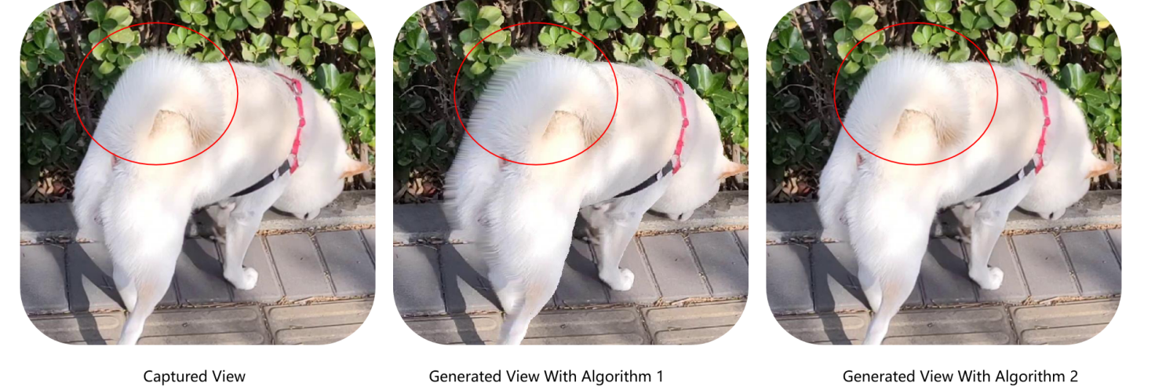
Figure 7.2.5.2-1 Example of AI-generated stereoscopic video
The objective evaluation of generated stereoscopic video sequences generally involves the following procedures:
Predicted Image and Depth Map Acquisition:
- It first takes a source monocular image as input into a stereo video generation model (e.g., AI-based algorithm) to generate the predicted image. For example, if the source image is a left-view image, the model generates the right-view image, and vice versa.
- After generation, a depth estimation algorithm to obtain the depth map of the predicted image.
Depth Map Processing and Edge Expansion:
- The depth values in the predicted image's depth map are divided into N ranges (where N is a positive integer)
- Edge detection and pre-processing such as filtering are the applied to extract vertical edge lines from the depth map (As shown in Figure 7.2.5.2-2).
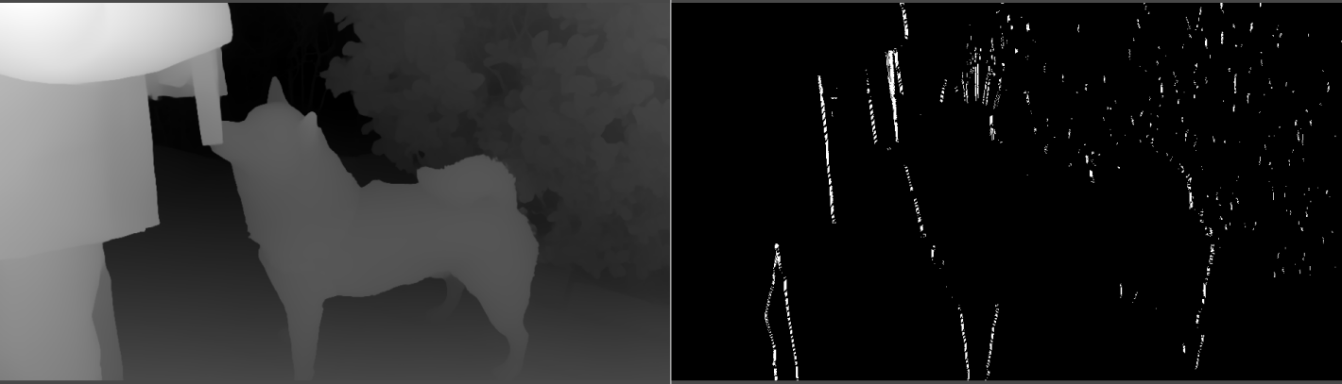
Figure 7.2.5.2-2 Example of Edge detection in depth maps
- The expansion ratio for each vertical edge line is determined based on the depth region it belongs to. Regions with greater depth values (i.e., farther from the viewer) are assigned smaller expansion ratios, while regions closer to the viewer has larger deformation, reflecting the greater disparity typically found in close objects.
- Expand the vertical edge lines horizontally according to their respective expansion ratios, and finally obtaining the segmentation mask (Figure 7.2.5.2-3) of the edge region in the predicted image’s depth map.
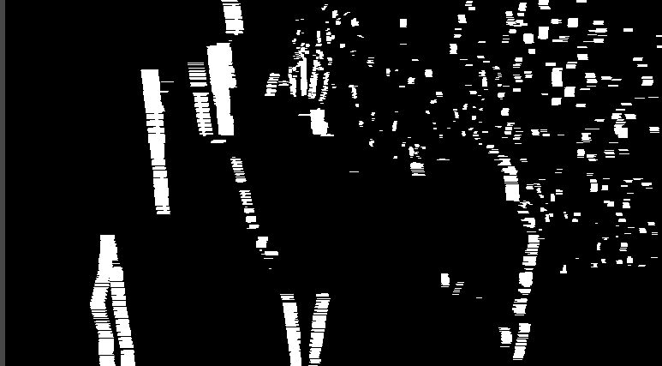
Figure 7.2.5.2-3 Example of segmentation mask
Evaluation Function Calculation
- Obtain the edge region in the predict image based on the segmentation mask.
- Calculate the first sub-evaluation function by comparing the edge region of the predicted image with the edge region of the Ground Truth Image.
- Calculate the second sub-evaluation function by comparing the non-edge regions of the predicted image (i.e., regions excluding the second edge region) with the non-edge regions of the Ground Truth Image.
The final evaluation function Q is calculated through the following weighted summation formula:
$$Q = α·subQ1 + β·subQ2$$
Here, α and β represent the weights assigned to the first and second sub-evaluation functions, respectively. Since artifacts are significantly more pronounced in edge regions compared to non-edge regions, α is significantly smaller than β. For example, α and β may be assigned values of 0.2 and 0.8, respectively.

7.2.5.3 Subjective Evaluation
According to [LS-7], the viewing conditions for subjective tests were set according to the ITU-R Recommendation BT.500-13 [LS-8]. The evaluation was performed using a 46” Full HD Hyundai 3D TV (Model: S465D) with passive glasses. The peak luminance of the screen was set at 120 cd/m2 and the color temperature was set at 6500K according to MPEG recommendations for the subjective evaluation of the proposals submitted in response to the 3D Video Coding Call for Proposals [LS-9]. The wall behind the monitor was illuminated with a uniform light source (not directly hitting the viewers) with the light level less than 5 % of the monitor peak luminance.
A total of 88 subjects participated in the subjective test sessions, ranging from 21 to 32 years old. All subjects had none to marginal 3D image and video viewing experience. They were all screened for color blindness (using Ishihara chart), visual acuity (using Snellen charts), and stereovision acuity (via Randot test– graded circle test 100 seconds of arc). Subjective evaluations were performed on both training and validation data sets.
Test session started after a short training session, where subjects became familiar with video distortions, the ranking scheme, and test procedure. Test sessions were set up using the single stimulus (SS) method where videos with different qualities were shown to the subjects in random order (and in a different random sequence for each observer). Each test video was 10 seconds long and a four-second gray interval was provided between test videos to allow the viewers to rate the perceptual quality of the content and relax their eyes before watching the next video. There were 11 discrete quality levels (0-10) for ranking the videos, where score 10 indicated the highest quality and 0 indicated the lowest quality. Here, the perceptual quality reflects whether the displayed scene looks pleasant in general. In particular, subjects were asked to rate a combination of “naturalness”, “depth impression” and “comfort” as suggested by [LS-10]. After collecting the experimental results, we removed the outliers from the experiments (there were seven outliers) and then the mean opinion scores (MOS) from the remaining viewers were calculated. Outlier detection was performed in accordance to ITU-R BT.500-13, Annex 2 [LS-10].

7.2.5.4 Correlation between the objective and subjective metrics
The performance of the objective metric, HV3D, described in section 7.2.5.1 is validated by subjective test described in section 7.2.5.2, using 88 subjects, following the ITU-R BT.500-13 recommendation. Performance evaluation results showed that HV3D quality metric quantifies quality degradation caused by several representative types of distortions very accurately, with Pearson correlation coefficient of 90.8 % [LS-9].

7.2.6 Interoperability Consideration
For UE-to-UE Stereoscopic Live Streaming, DASH-based solutions are expected.

7.2.7 Reference Sequences

7.2.7.1 Candidate Source Stereoscopic 3D Video Sequences
This section introduces candidate source stereoscopic 3D video sequences available for testing. Some sequences are freely available under a license agreement, while others are self-generated using AI-based 2D-to-3D conversion algorithms. Additionally, some sequences are self-captured using commercially available mobile devices.

7.2.7.1.1 Public Datasets
InStereo2K [LS-11], an indoor real scene stereo dataset. It contains 2000 pairs of images with high accuracy disparity maps. The author kindly grants the permission to use this dataset under the license in 3GPP.
Middlebury 2021 mobile datasets [LS-12], 24 datasets obtained with a mobile device on a robot arm, using the technique described in [LS-12]. The authors kindly grant permission to use and publish all images and disparity maps on their website. However, they request to cite the appropriate paper [LS-12] for using 2021 datasets.
Middlebury 2014 stereo datasets [LS-12], 33 datasets obtained using the technique described in [LS-12]. The authors kindly grant permission to use and publish all images and disparity maps on their website. However, they request to cite the appropriate paper [LS-12] for using 2014 datasets.
The table below summarizes the characteristics of the sequences in the public datasets.
Table 7.2.7.1.1-1 Test material datasets
Name | Generated  /Natural | Stereo | Depth | Resolution | Color Space | Download Link
InStereo2K | Natural | Y | Y | 1080 × 860 | BT.709  SDR | https://github.com/YuhuaXu/StereoDataset
Middlebury 2021 Mobile stereo datasets | Natural | Y | Y | 1920 × 1080 | BT.709  SDR | https://vision.middlebury.edu/stereo/data/scenes2021/
Middlebury 2014 stereo datasets | Natural | Y | Y | 2964 × 1988 | BT.709  SDR | https://vision.middlebury.edu/stereo/data/scenes2014/

7.2.7.1.2 Self-Converted Sequences
The AI-based conversion of existing 2D images and Video to stereo3D is proving commercially viable and fulfills the growing need for high quality stereoscopic images. This approach is particularly effective when creating content for the new generation of autostereoscopic displays that require multiple stereo images.Various open-source algorithms and platforms use deep neural networks to perform real-time end-to-end conversion of 2D videos and images to stereoscopic 3D video format.
As 2D-to-Stereo3D conversion algorithms usually take RGB video format, the Python scripts can be found in Annex D.2.2 to convert between YUV and RGB formats.
The test sequences use the left view of the stereoscopic videos collected in Section 7.2.7.1.3 as input, and generate the right view through AI algorithms to synthesize side-by-side stereoscopic videos. The sequences can be found in Annex C.3.5, C.3.6, and C.3.7.

7.2.7.1.3 Self-Captured Sequences
A dual-lens camera can be used to directly capture stereo 3D video. There are many mobile devices on the market with this capability. For example, SpatialLabs EyesTM provided by Acer is a stereoscopic camera capable of capturing up to 8-MP (4K) per eye at 30 fps or 2K per eye at 60 fps. Or the ZTE Nubia Pad 3D IITM can capture stereo 3D video with the specifications in Table 7.2.7.1.3-1:
The main camera setup is the dual-camera systems includes two identical 13 MP lenses. These cameras capture slightly different perspectives of the same scene, mimicking the way human eyes perceive depth. The AI then processes these images to produced a coherent 3D representation. The selfie camera setup features two lenses positioned near the center of the top bezel when the tablet is oriented horizontally (with the longer side on the top).
Table 7.2.7.1.3-1 Specification of Capturing Device
Rear Camera | Specification
Number of Cameras | 2 (Dual)
Resolution | 13 MP (wide); 13 MP (wide)
Autofocus | AF, AF
Video Recording | 1200 @ 30 fps
Others | LED Flash, panorama, HDR, Stereoscopic AI-powered 3D capture
Front Camera | Specification
Number of Cameras | 2 (Dual)
Resolution | 8 MP (ultra wide); 8 MP (ultra wide)
Aperture | f/2.2, f/2.2
Field of View | 105°, 105°
Video Recording | 1200 @ 30 fps

The captured videos (in mp4 file) need further processing (e.g., reading the right/left views and concatenate them into one video frame) the scripts can be found in Annex D.2.3. An FFmpeg command described in Annex D.2.4 can be used to save each frame into a proper test sequence,
The test sequences captured from ZTE Nubia Pad 3D IITM main camera and post-processed by the above tools can be found in Annex C.3.2, C.3.3, and C.3.4.

7.2.8 Test Condition

7.2.8.1 Test model and configuration files
The encoder configuration settings for both encodings are are outlined below:
- Inter-view coding structure
- 2 view case: left-right (in coding order)
- I-P inter-view prediction MV-HEVC
- Temporal prediction structure: GOP 8, intra every 24 frames (random access at ~1sec)
- Full resolution texture coding
- Codec software: HTM v16.3 for Simulcast HEVC and MV-HEVC
The following configuration files are provided in [LS-13]:
- /HTM-16.3-fixed/cfg/MV-HEVC/baseCfg_2view.cfg: Used to configure input/output filenames and encoder parameters (I-frame interval, number of B-frames, etc.)
- /HTM-16.3-fixed/cfg/MV-HEVC/qpCfg_QP25.cfg: : Used to configure the encoding QP
- /HTM-16.3-fixed/cfg/MV-HEVC/seqCfg_Shark.cfg: Contains the source sequence parameters (resolution, frame count, frame rate, etc.)
For each selected test sequence, configuration files containing information needed for HTM-16.3 configuration will be provided.

7.2.8.2 Rate points and test conditions
Fixed QP was used to evaluate and compare the performance of MV-HEVC and Simulcast HEVC is compared and evaluated in terms of PSNR (dB) and bitrate (kbps) over the set of QP values [17, 22, 27, 32, 37].

7.2.8.3 Profiles
MV-HEVC Main Profile is used.

7.2.8.4 Bitstream Generation
The HTM v16.3 is used to encode and decode test sequences as described in clause 7.2.8.1.
Below are examples of command lines for encoding and decoding test sequence:
- Before compilation, navigate to source/Lib/TLibCommon/TypeDef.h and modify the following parameter to configure the software as an MV-HEVC encoder:
/** \file TypeDef.h
\brief Define macros, basic types, new types and enumerations
*/
(…)
/* HEVC_EXT might be defined by compiler/makefile options.
Linux makefiles support the following settings:
make -> HEVC_EXT not defined
make HEVC_EXT=0 -> NH_MV=0 H_3D=0 --> plain HM
make HEVC_EXT=1 -> NH_MV=1 H_3D=0 --> MV only
make HEVC_EXT=2 -> NH_MV=1 H_3D=1 --> full 3D
*/
#ifndef HEVC_EXT
#define HEVC_EXT 1
#endif
(…)

- to encode a test sequence:
./TAppEncoder.exe -c baseCfg_2view.cfg -c seqCfg_Shark.cfg -c qpCfg_QP25.cfg

- to decode a test sequence:
./TAppDecoder.exe -b stream.bit -o shark_qp25.yuv -w 1

7.2.9 External Performance data
The verification test report for MV-HEVC can be downloaded from the JCT-3V website [LS-14]
The VQEG 3DTV Group conducted an evaluation of video quality models for stereoscopic 3D television content. In collaboration with the DVB, they further assessed the visual impact of Side-by-Side, Top-Bottom, and Tile formats on Quality of Experience (QoE) for Full-HD television transmissions across varying bitrates [LS-15]. The findings from this evaluation played a key role in the development of ITU-T Recommendations P.914 [LS-16], P.915 [LS-17], and P.916 [LS-18].
Two recent research papers [LS-19][LS-20] evaluated end-to-end stereoscopic 3D live streaming using the iPhone 15TM and the Apple Vision ProTM XR headset, the key observations are summarized below:
- Bandwidth Requirements
- Apple TV+TM’s immersive 180° stereoscopic video demands ~99.81 Mbps at peak quality (4320×4320, 90fps), challenging LTE/5G uplink.
- Vision ProTM’s spatial video requires 31 Mbps, while iPhone 15 ProTM uses 16.89 Mbps, comparable to YouTubeTM’s 4K (35-45 Mbps) and 2K (16 Mbps) streams.
- iPhone 15 ProTM’s spatial videos consume about twice the bitrate of conventional iPhone 11 ProTM videos.
- Impact of network artifacts on depth perception:
- According to [LS-19], lower bitrates degrade disparity map quality, with a 3.5 dB PSNR drop when reducing bitrates from 300 Mbps to 1 Mbps, along with noticeable object dislocation in the scene, creating unnatural depth conflicts under poor network conditions.
- Content-Related Impacts on User Experience
- Stereoscopic videos generally provided a better viewing experience than monoscopic videos at the same bitrate. However, some exceptions occurred: close-up scenes sometimes caused visual discomfort, and high-motion scenes were rated lower across both formats due to motion sickness. Scenes with strong depth cues and occlusions were particularly well-suited to stereoscopic presentation, receiving higher user ratings.

7.2.10 Additional information
The industry has increasingly embraced stereoscopic 3D video, as demonstrated by recent advancements in application support:
- Dolby VisionTM Profile 20 extends Dolby Vision’s quality enhancements to MV-HEVC and immersive content: https://professionalsupport.dolby.com/s/article/Dolby-Vision-Profile-20-FAQ?language=en_US
- Apple Vision ProTM Spatial Video Formats (a stereo MV-HEVC video track, plus spatial metadata): https://developer.apple.com/av-foundation/HEVC-Stereo-Video-Profile.pdf
- NVIDIATM’s Video Codec SDK 13.0 introduces an MV-HEVC encoder, further supporting stereoscopic 3D video: https://developer.nvidia.com/blog/enabling-stereoscopic-and-3d-views-using-mv-hevc-in-nvidia-video-codec-sdk-13-0/

7.3 Scenario 2: Streaming of professionally produced Volumetric Video with single asset containing people

7.3.1 Scenario name
Streaming of professionally produced Volumetric Video with single asset containing people.

7.3.2 Motivation for the scenario
The scenario addresses on-demand streaming of post-produced volumetric video with single asset containing people, providing experiences beyond what is achievable with 2D content. Particularly in AR application, the user can watch the volumetric video asset from all directions as if the asset were naturally present. In both AR and VR applications, the user can move smoothly around the asset, change its size or make the asset rotate.
The content is in the form of volumetric video, which is a frame-based immersive experience whereby each frame represents a volumetric region in 3D space in which any point is either non-occupied or has a colour that may depend on the viewing direction. Volumetric video has the potential to provide a more immersive and interactive experience than 2D content.
Several use cases for on-demand volumetric video streaming can be envisioned related to various domains including but not limited to entertainment, education and industrial monitoring. For example, in the entertainment domain users can stream a performance from their favorite singer or band to their living room and experience greater immersion potentially combined with spatial audio. Another example is the education/training domain, where a produced volumetric video of a fitness instructor shows how to perform an exercise that helps a student to better understand how the exercise is done and thus replicate it in a correct way. Yet another example in the education domain would be a mechanic giving a tutorial on how to assemble a mountain bike. A trainee can watch the movements of the mechanic from different angles and get an improved understanding of the different steps due to depth perception and different viewpoints.
For first implementations of relevant use cases the content can be quite simple without hindering the purpose, consisting of a camera captured 6 DoF person as asset and a 3D graphics background or an AR camera background coming from the rendering device. As an alternative a person could be captured with an object (e.g. a ball) or two persons together. Important is that everything is in a single asset.

- Technology evaluation on the market
KDDI experimented transmission of produced volumetric video over mobile networks including real time encoding and decoding [Vol-1].
Volucap, based in Potsdam Germany, developed several showcases and tested these on the market. The number of showcases is growing and the current list can be consulted here: https://volucap.com/showcases/.
The following showcases illustrate particularly the proposed scenario:
- Sports training: Volucap and Deutsche Telekom produced a clip to learn cool dribbles and precise throws from the former basketball star Josh Mayo: https://volucap.com/portfolio-items/meeting-josh/
- Music Group: Volucap and the music group “Boss Hoss” prototyped the your favorite band in your living room: https://volucap.com/portfolio-items/the-bosshoss-augmented-reality/
- Tagesschau: Volucap and the German news broadcaster Tagesschau collaborated to capture a volumetric representation of a news: https://volucap.com/portfolio-items/tagesschau-2025/
- Book enhanced with AR: Volucap enhanced a children song book with AR content on a smartphone: https://volucap.com/portfolio-items/rolf-zuckowski/
- XR Fashion show: Volucap and Lana Mueller, a Berlin based designer, produced a fashion presentation in XR: https://volucap.com/portfolio-items/lana-mueller-fashion/
- Charité medical VR training: This immersive simulation uses advanced volumetric video technology to bring users into the heart of a realistic surgical environment, ideal for virtual reality (VR) training scenarios: https://volucap.com/portfolio-items/charite-medical-vr-training/
- Industry activities
Several industry activities regarding on-demand volumetric video streaming have been experimented between various mobile network operators, volumetric capture studios and technology providers. Some of these industry activities are listed here:
- Volograms, based in Dublin, Ireland
- Provides professional volumetric content creation services to feed AR use cases such as augmented museum, training or fashion experiences: https://www.volograms.com/made-with-volograms
- The company has also developed an AI based solution to enable AR volumetric content from 2D single photo or video: https://www.volograms.com/
- 8i, Mantis Vision, Metastage, Volograms, XD Productions, etc. present volumetric capturing projects on their websites, similar to Volucap
- XD Productions and Volograms content (both professional and AI-based) has been showcased in public trade shows and conferences by InterDigital as part of MPEG-I V3C platform demonstration with the V-PCC player
- Zerospace and Canon are collaborating to open a volumetric video capturing studio. With over 100 Canon Cinema EOS cameras, it claims to offer unmatched capabilities. The website illustrates capture of sports content (e.g. basketball, Karate): https://www.zerospace.co/studios/canon-volumetric-capture
- Brazilian SBTVD Forum has adopted volumetric video for inclusion in their TV 3.0 standards (support is not be mandatory in all receivers; focus is on content distribution over the Internet and consumption on smartphones and HMDs). TV 3.0 services are planned to be launched in 2025 [Vol-2]
- The Volumetric Format Association has been formed to ensure interoperability of volumetric video capturing, processing, compression and playback [Vol-3]
- Production tools/companies
The following is a non-exhaustive list of companies providing tools, equipment or services to produce volumetric video content:
- 4D People: Renderpeople is a company that provides large libraries of different kinds of scanned people in 3D and 4D, where 4D includes the dimension of time and corresponds to Volumetric Video: https://4dpeople.com/
- 4D Views: 4D Views is a company that provides a volumetric capturing system named Holosys including HW, SW, support and editing software. A volumetric player is provided to review volumetric demo sequences: https://www.4dviews.com/
- 8i: Provides a volumetric capturing system including HW, SW and a solution to stream content to devices, browsers and HR/VR headsets: https://8i.com/
- Arcturus: Provides volumetric capturing services and commercializes a volumetric capturing system named HoloCapture and a volumetric video post-production and streaming solution named HoloSuite. A number of volumetric production studios are installed around the world such as Dimension in London, Metastage in Los Angeles, ifland Studio in Seoul (SK Telecom), Nikon Creates Corporation in Tokyo and at ETH in Zurich. See more information: https://arcturus.studio/
- CIVIT: https://civit.fi/volumetric-capture-studio/
- Dimension Studio: https://dimensionstudio.co/
- Evercoast : https://evercoast.com/
- Mantis Vision : https://mantis-vision.com/
- Metastage : https://metastage.com/
- Volucap: Volucap claims to have the world’s highest resolution for capturing volumetric video with 700 megapixels for each shot and a unique lighting system: https://volucap.com/
- XD Prod : https://www.xdprod.com/
Capturing systems typically integrate with 3D editing tools such as Maya, Blender for post producing content.
- Delivery solutions
Arcturus provides an on-demand adaptive streaming solution for volumetric video [Vol-4]
8i provides a solution to stream volumetric video produced with their capturing system [Vol-5]
An end-to-end implementation of a MPEG V3C standardized platform for packaging and delivery of volumetric video over content delivery network (CDN) is available [Vol-6]
- Content decoding and rendering
Arcturus provides a play-back solution with broad delivery capabilities including support for Unreal, Unity, iOS and Android [Vol-7].
8i provides a solution to decode and render volumetric video on a browser running on CE devices and AR/VR headsets [Vol-5].
5G-MAG hosts a V3C Immersive Platform [Vol-8]. It provides a Unity package to decode, render and play V3C content in Unity using the V3C Immersive Platform – Decoder Plugin.

7.3.3 Description of the scenario
This scenario covers Streaming of professionally produced Volumetric Video with single asset containing people.
[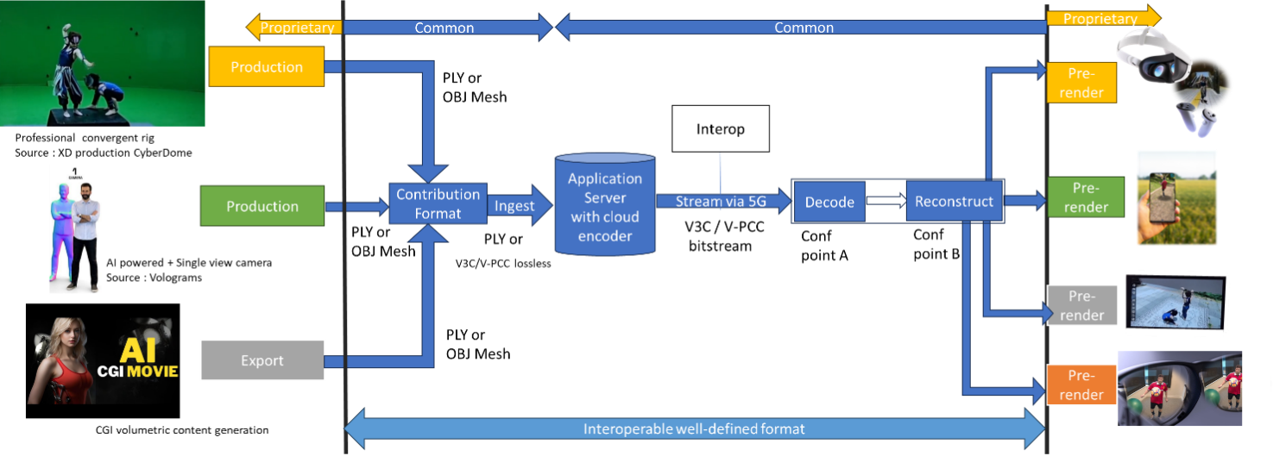]
Figure 7.3.3-1: Streaming of professionally produced Volumetric Video with single asset containing people (content courtesy XD Productions)
Editor’s Note: This Figure needs to be replaced to avoid copyright issues.
- Capturing and processing
Capturing of high-quality 6 DoF assets as a volumetric video is typically done with a rig of cameras aligned on a circle around the asset(s) to be captured. Depending on the rig, there can be one or more layers of cameras at different height positions. The number of cameras per layer depend again on the designer of the rig and in the year 2024 there are typically between 30 and 100 cameras per layer. Cameras can be equipped with depth sensors. Hardware such as cameras and depth sensors are mostly off the shelf equipment, but the assembly in the rig is vendor dependent and proprietary.
The various camera and depth sensor signals are fed into a production pipeline that produces the volumetric video. Production includes stitching the various signals, filling holes, correcting occlusions, etc. Persons or physical objects (e.g. a ball or an instrument) can be combined in an asset or separate assets can be used for each person or object. For simplification and not hindering the purpose, the use case described in this document is limited to a single asset. The representation format of a produced asset is typically a dense dynamic point cloud or a dynamic mesh.
As an example, in the following the production pipeline of the company XD Productions is illustrated.
The figures below show the XD Productions CYBERDOME capture rig and associated real time viewing to control acquisition.
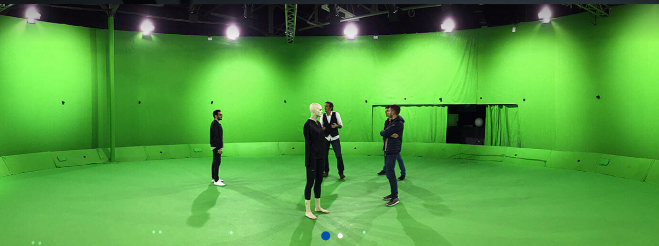
Figure 7.3.3-2: XD Productions capture rig (https://www.xdprod.com/services/studio/studio-virtuel/)
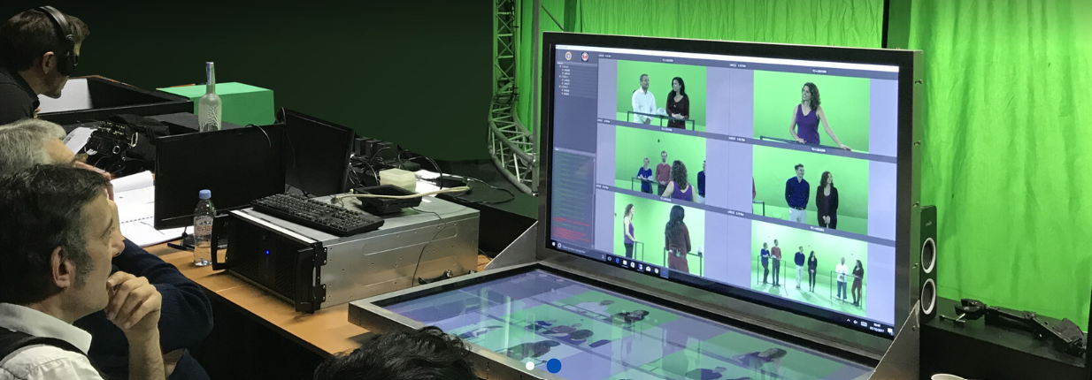
Figure 7.3.3-3: XD Production real time virtual production (https://www.xdprod.com/services/studio/studio-virtuel/)
The figures below show CYBERDOME acquisitions covering single or multiple characters in dynamic scenes.
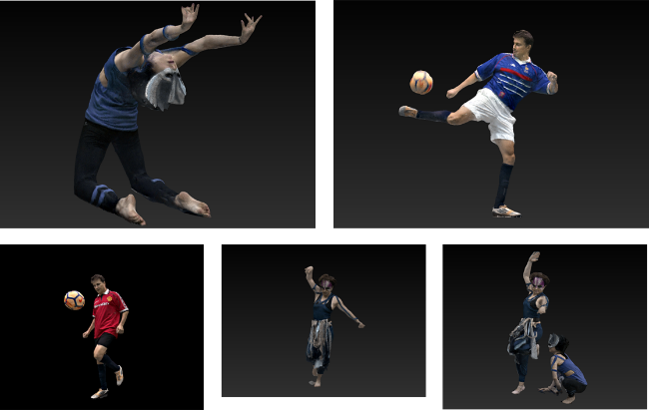
Figure 7.3.3-4: XD Productions contents screenshots, from top right to left: Acrobat01, Soccer Blue, Soccer Red, Dancer01 and Acrobat Duo
The acquisition processing pipeline includes a rig of about sixty 4K cameras, arranged in hemispheres around the scene to be captured. The set is 15-meter in diameter for a 7-meter diameter capture area. Two types of lenses are simultaneously used, with variable focal lengths, which allows to adapt the size of the capture area, and to mix wide shots and close-ups on the same captures to improve the quality of the textures. Each content item is then converted into point cloud frames. The processing output is provided in the PLY format.
Another example on how single asset volumetric video is produced is shown in a video (https://www.youtube.com/watch?v=xX4SJTE3hmQ) by Metastage.
There are several companies that provide volumetric video capturing technology or entire volumetric video capturing studios. More detailed information can be found in chapter 5.4.4 of the DVB Study Mission report S101 on Volumetric Video.[Vol-9]
The Volumetric Format Association [Vol-3] describes an end-to-end volumetric chain including capturing, processing, encoding, decoding and rendering. After capturing the processing generates a point cloud that can be encoded and delivered as dense dynamic point cloud and reconstructed either as a point cloud or as a mesh for rendering.
The Ultra Video Group of Tampere University describes the process of generating volumetric video content with the Mantis Vision system in their paper [Vol-10]. In a first step from the signals from multiple camera units on the rig a raw point cloud of the person or object is generated. In a second step a mesh is generated by using surface reconstruction algorithms. In a third step the mesh is sampled to generate a point cloud, which can then be voxelized on a regular 3D grid and normal can be calculated if needed.
It can be concluded that dense dynamic point clouds and dynamic meshes are used by industry to represent persons or objects as volumetric video.
In the following it is described how the scenario can be implemented with MPEG V-PCC [VOL-11] by using dense dynamic point clouds and with MPEG V-DMC [DM-20] by using dynamic meshes for representing the single asset.
The following figure shows the V-DMC workflow:
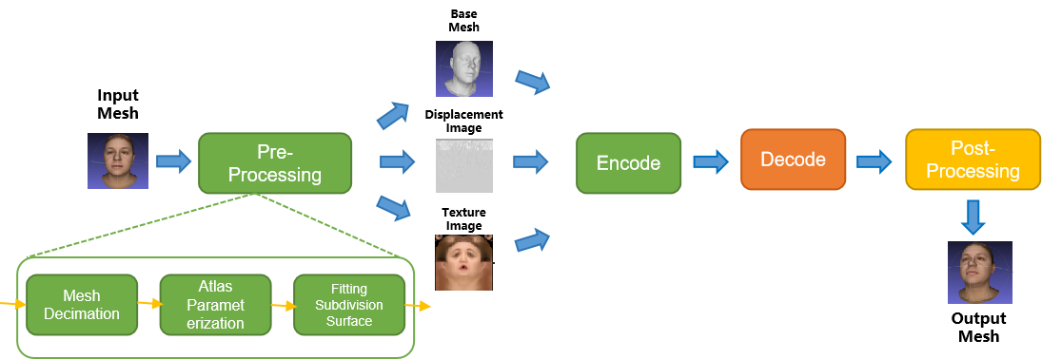
Figure 7.3.3-5 V-DMC Workflow
The pre-processing stage consists of three main processes: a decimation step, an atlas parameterization step, and a subdivision step.
- Encoding
Volumetric video can be represented in the representation format dense dynamic point clouds. MPEG has developed a specification named V-PCC for compressing and delivering the representation format dense dynamic point clouds at bitrates enabling consumer applications. V-PCC is standardized in ISO/IEC 23090-5 Visual Volumetric Video-based Coding (V3C) and Video-based Point Cloud Compression (V-PCC) – 2nd edition [Vol-11].
During its experimentation with V-PCC KDDI implemented a real time V-PCC encoder [Vol-1].
The following figure shows the V-PCC encoder main steps.
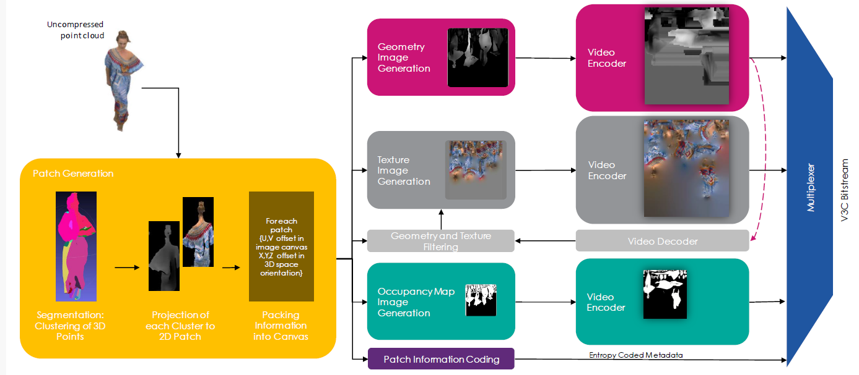
Figure 7.3.3-5 V-PCC encoder main steps (Content courtesy 8i)
For encoding of geometry, texture and occupancy map V-PCC relies on 2D video codecs. Due to its efficiency and market penetration HEVC aka H.265 is the choice of 2D video codec for the presented scenario.
Volumetric video can also be represented in the representation format dynamic mesh. MPEG has developed a specification named V-DMC for compressing and delivering the representation format dynamic at bitrates enabling consumer applications. V-DMC [DM-20] is standardized in ISO/IEC 23090-29 Video-based dynamic mesh coding (V-DMC). As V-PCC, V-DMC relies on (HW-accelerated) video codecs for the bulk of the data (attribute maps, …).
The following figure shows the V-DMC encoder main steps.
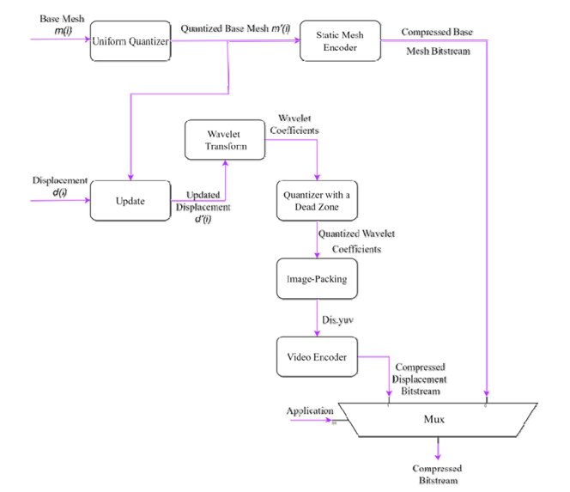
Figure 7.3.3-6 V-DMC encoder main steps [Vol-35]

- Packaging and delivery
MPEG has developed a specification addressing storage and delivery V-PCC coded data published as ISO/IEC 23090-10 Carriage of visual volumetric video-based coding data – 1st edition [Vol-12].
As of April 2025, MPEG is working on the second edition of ISO/IEC 23090-10 that will cover V-DMC storage in ISOBMFF format and delivery utilizing DASH.

- An overview of MPEG standards for storage and transport of V3C can be found in [Vol-33] Decoding
For the dense dynamic point cloud representation format, decoding can rely on the V-PCC specification and for dynamic mesh it can rely on the V-DMC specification. In both cases no dedicated hardware is required for V-PCC real-time decoding on consumer devices. If the encoder uses HEVC for the 2D video encodes, the decoder in the device can make use of integrated hardware HEVC video decoder capabilities for all pixel data, and a small number of metadata is decoded by a CPU.
As an example, the following figure shows the architecture of a V-PCC decoder.
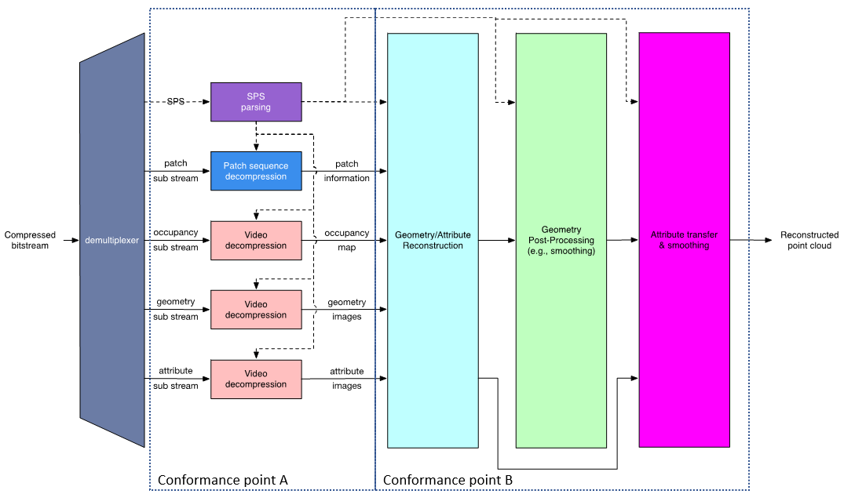
Figure 7.3.3-6 V-PCC decoder main steps
Decoding of the dense point cloud is terminated at the output of the video decoders, but these images are just intermediate results and do not represent a useable image for the human eye. Additional stages are needed to reconstruct the dense point cloud in 3D space and render it to the display of a consumer device. It can be rendered to 2D displays of e.g. smartphones and tablets, but also on head mounted devices or other 3D displays.
An example of point cloud data decoding processing has been described in [Vol-13].
During its experimentations with V-PCC and V-DMC, KDDI implemented a real time V-PCC encoder/decoder [Vol-1] and a V-DMC encoder/decoder [Vol-32].
Futuresource estimates that by the end of 2023 there are 4.1 billion Smartphones globally in the field with the capacity to decode HEVC video [Vol-14].
- *Post-processing
Post-processing is implementation dependent, but it is typically performed on a GPU without dedicated V-PCC/V-DMC hardware.
- Rendering
Rendering is implementation dependent, but it is typically performed on a GPU without dedicated V-PCC/V-DMC hardware. More information can be found in section 4.3.3.3 for dense dynamic point cloud and in section 4.3.5.3 for dynamic mesh.
- General constraints on latency, bandwidth, reliability and complexity
For delivery, the volumetric video frames are organized using a random-access reference frame structure.
All decoder and renderer processes are real-time and may have a latency in the order of a few frames.

7.3.4 Source format properties
As source format for the scenario the representation format dense dynamic point clouds and dynamic mesh are considered. Section 4.3.3 describes the dense dynamic point cloud format and section 4.3.5 describes the dynamic mesh format. The present section provides more detail in direct relation with the scenario.
The following table includes signal properties that are typically used in the near/mid term to represent people or objects.
Table 7.3.4-1 Signal properties for dense point cloud format
Source format properties | Volumetric Video with single asset
Number of points /Spatial Resolution | Up to 2 million points per frame
Chroma format | RGB
Chroma subsampling | Not Applicable
Picture aspect ratio | Not Applicable
Frame rates | 25, 30 Hz
Bit depth | 8 and 10
Colour space formats | RGB 444 nonlinear, BT.709
Transfer characteristics | BT.709
Viewpoints | All assets can be viewed from all directions and different distances
Table 7.3.4-2 Signal properties for dynamic mesh format
Source format properties | Volumetric Video with single asset
Number of vertices /Spatial Resolution | TBD
Chroma format | RGB
Chroma subsampling | Not Applicable
Picture aspect ratio | Not Applicable
Frame rates | 25, 30 Hz
Bit depth | 8 and 10
Colour space formats | RGB 444 nonlinear, BT.709
Transfer characteristics | BT.709
Viewpoints | All assets can be viewed from all directions and different distances
Editor’s note: Information TBD to be provided from CTC
For highly dynamic sports sequences higher frame rates such as 50 or 60 fps may be useful and this is left for the future.
In the following the quality of the dense point cloud representation format for representing people is further investigated.
Editor’s note: Depending on contributors, similar information could be provided in future for dynamic mesh

7.3.4.1 Conversion and quantization for dense dynamic point cloud format
If volumetric video source sequences are delivered in production quality, then bandwidth for consumer delivery may be too high and a conversion/quantization is necessary to reduce the number of points and use the fixed-point format. The result of that conversion is that the sequence is in a bounding box of 10, 11 or 12 bit which is named in the following as Vox10, Vox11 and Vox12.
- Vox 12 creates a quality that is close to the quality that comes out of the production system for most provided sequences. Emotional facial expressions are clearly visible and tissue structure of cloths is visible. See figures Y2 and Y5 below.
- Vox 11 creates a quality that allows viewing the sequence from a wider distance and it allows to zoom closer. Emotional facial expressions and patterns on cloths is visible. See figures Y3 and Y6 below.
- Vox 10 creates a quality allowing to view the sequence from a wider distance, but getting too close is less recommended. See figures Y4 and Y7 below.

7.3.4.2 Impact of rendering for dense dynamic point cloud format
It is referred to section 4.3.3.3 that covers rendering and display systems. Rendering is typically not covered by standards and allows manufacturers to differentiate. The referred section discusses hole filling, but also techniques such as local meshing could be applied.

7.3.4.3 Impact of the background
To avoid interference between the background and the test sequence, it is recommended to use a neutral background colour for codec evaluation. If a VR or AR background is used instead of a neutral background, potential artefacts in the sequence are less visible, as the human eye concentrates on the overall picture and not only on the sequence.
This means also that in a real service where a background is used, potential artefacts in a sequence are less visible.
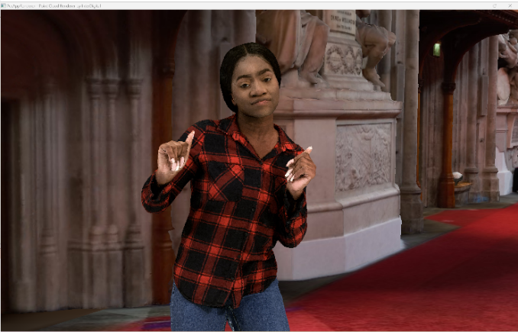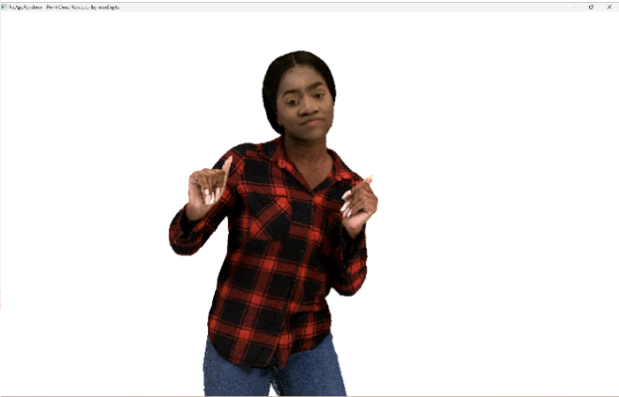
Figure 7.3.4.3-1 Impact of background on perceived quality (content courtesy RenderPeople [Vol-15])

7.3.4.5 Visual quality examples sequences in dense dynamic point cloud format
In the following the impact of number of points in a frame and type of renderer on the visual quality of the dense point cloud representation format is demonstrated. In this section still pictures are used to judge the preserved detail. In a volumetric video sequence some artefacts in the snapshots may not be visible.
It can be observed that sequences represented as dense point clouds of around 1M points/frame allow to watch a sequence with a person in AR from a wider distance (e.g. from 3m*) and point clouds of around 2M points/frame allow to get closer (e.g to around 1.5m distance) at good quality for the target scenario. In the latter emotional facial expressions and tissue structure of cloths is visible. More points per frame improve the details, but this may not be required for the target scenario. But if a scenario would require it, a high-end volumetric video production system is able to capture details from e.g. skin or finer details of tissue and it can be represented with the point cloud representation format.
*A typical demonstration scenario would be to use e.g. a smartphone or tablet running a volumetric video application showing a real person of e.g. 3m distance on the screen captured by the camera and rendering at the same time a second person rendered from a point cloud next to the first person.
In the following the sequence Volucap_T003_ThomasScenic-03 from Volucap [Vol-16] is used.

7.3.4.5.1 Thomas near with representative renderer (splat blend mode) and neutral background
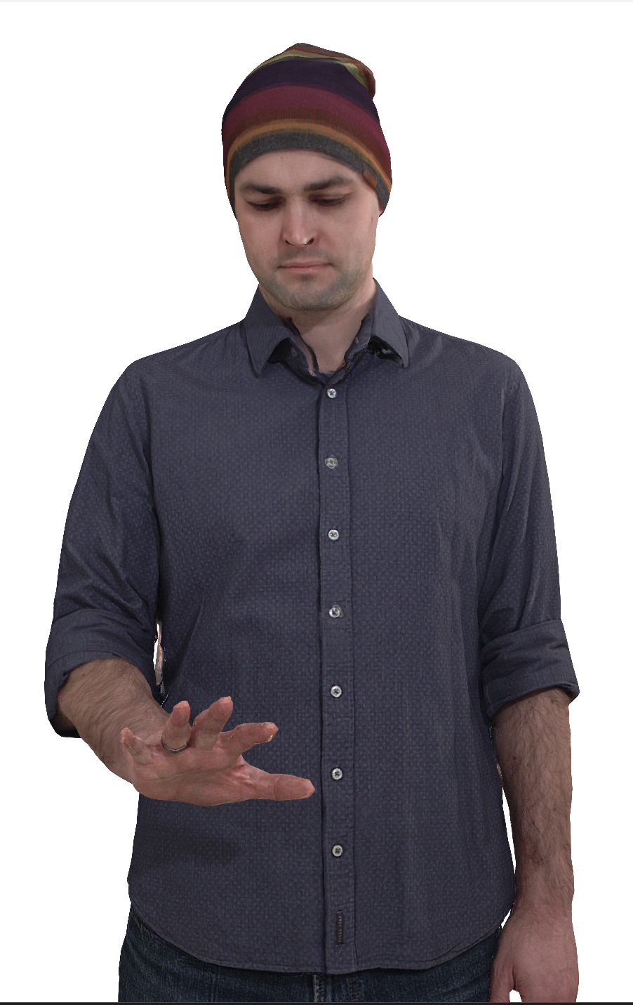
Figure 7.3.4.5.1-1 Vox 12 with 9.5M points per frame (content courtesy by Volucap [Vol-16])

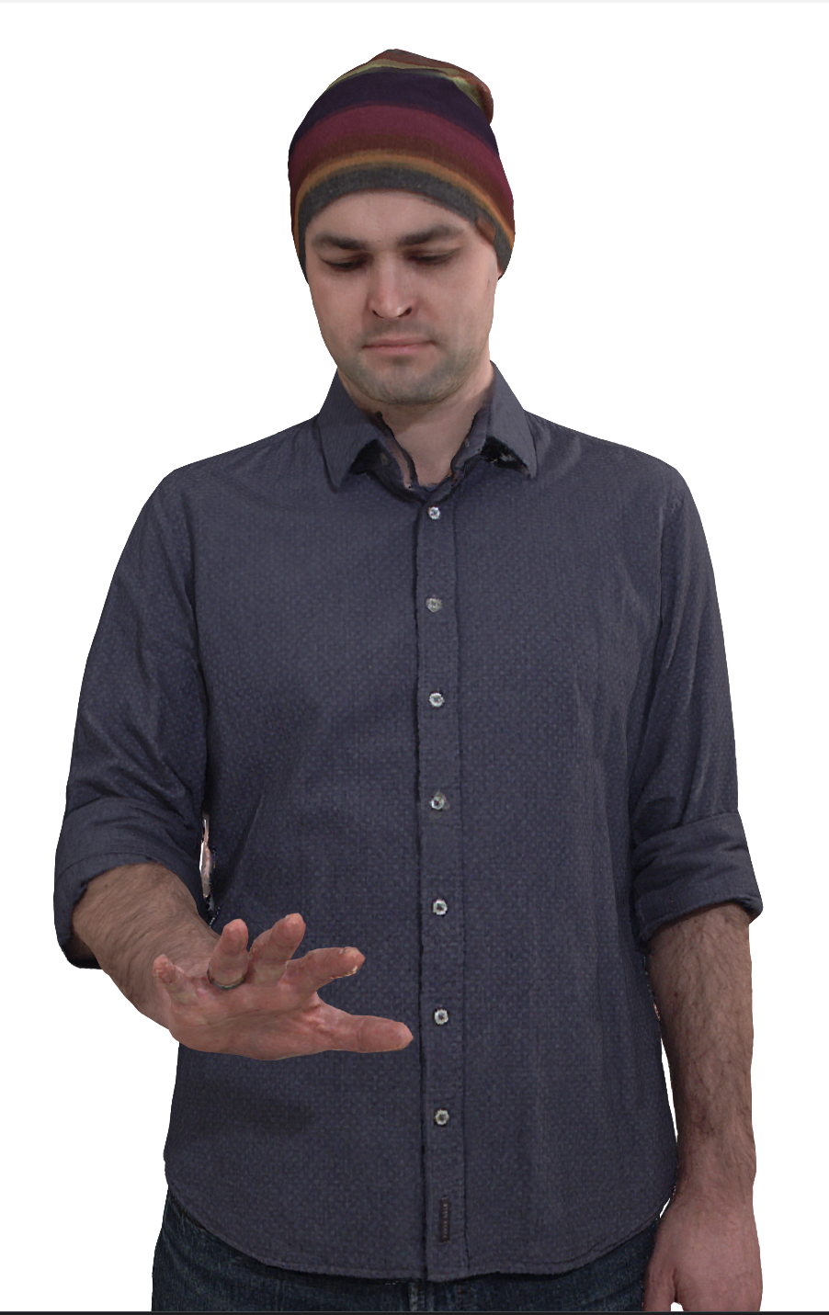
Figure 7.3.4.5.1-2 Vox 11 with 2.3M points per frame (content courtesy by Volucap [Vol-16])

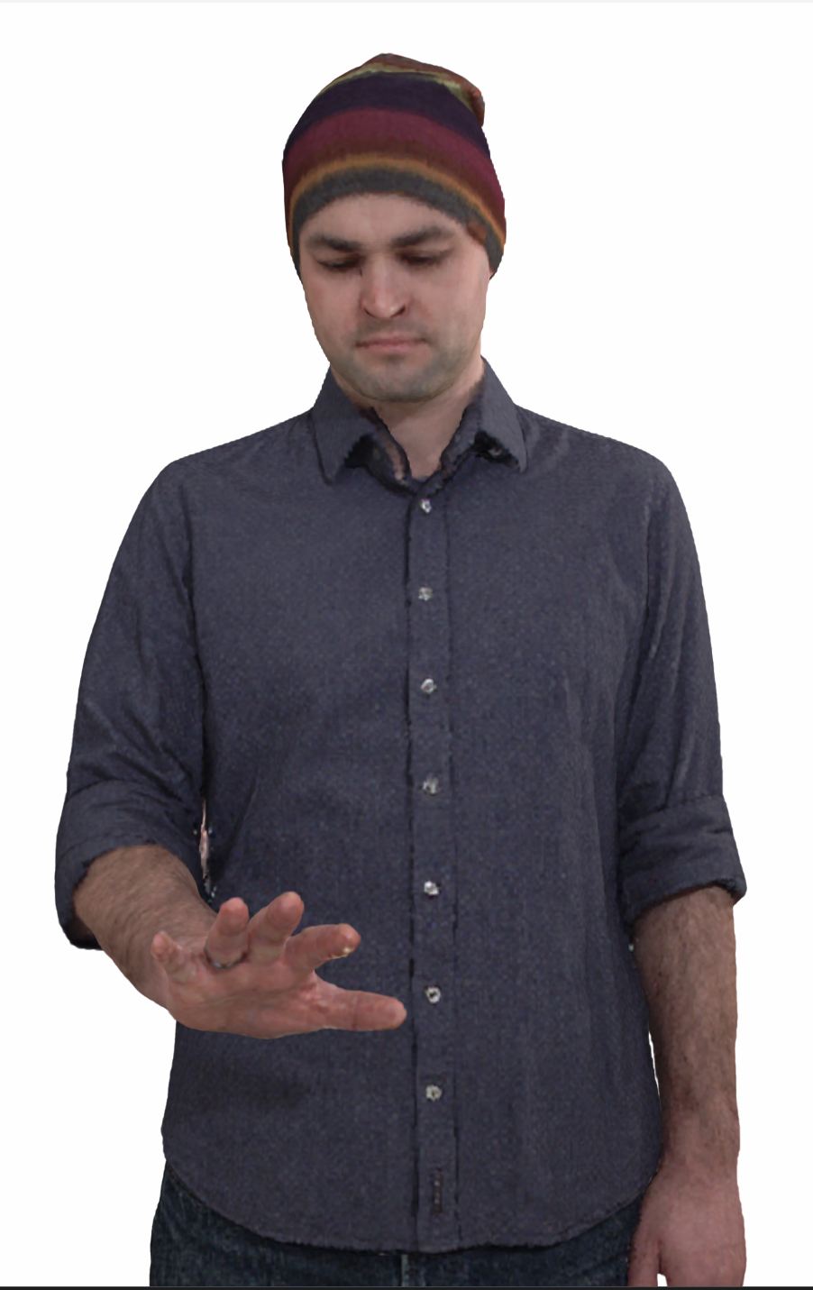
Figure 7.3.4.5.1-3 Vox 10 with 600K points per frame (content courtesy by Volucap [Vol-16])

7.3.4.5.2 Thomas near with representative renderer (cube mode) and neutral background
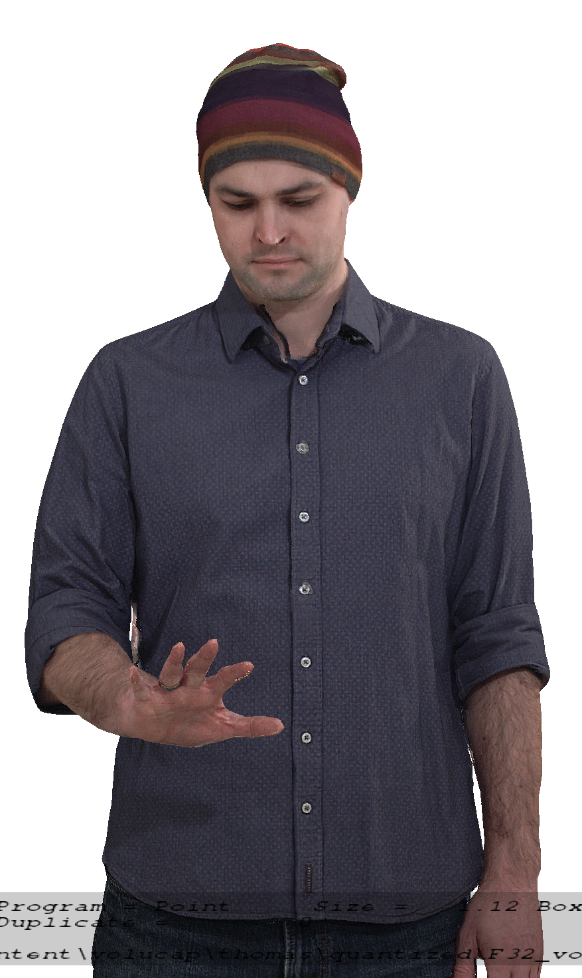
Figure 7.3.4.5.2-1 Vox 12 with 9.5M points per frame (content courtesy by Volucap [Vol-16])

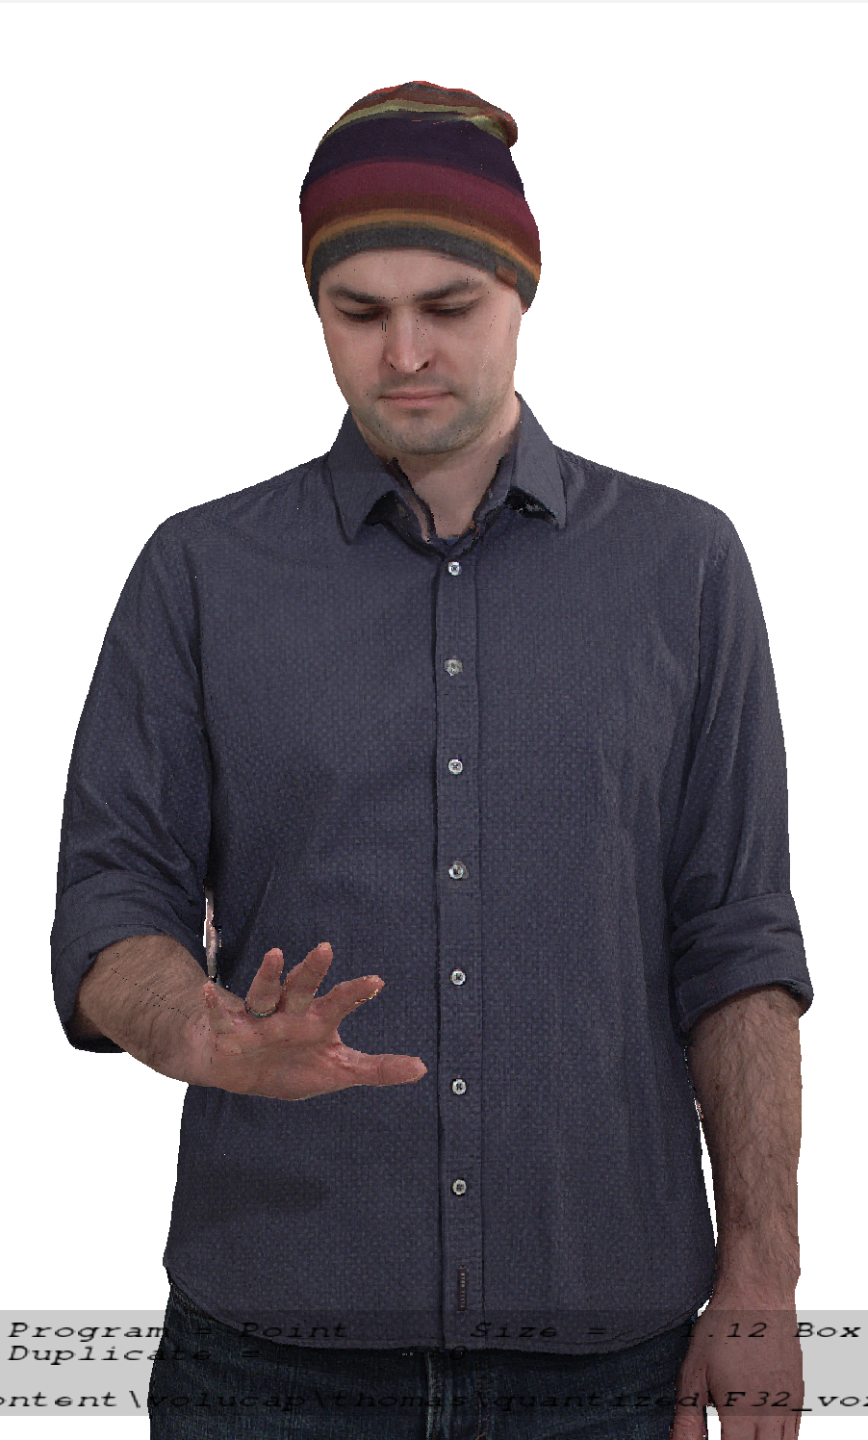
Figure 7.3.4.5.2-2 Vox 11 with 2.3M points per frame (content courtesy by Volucap [Vol-16])

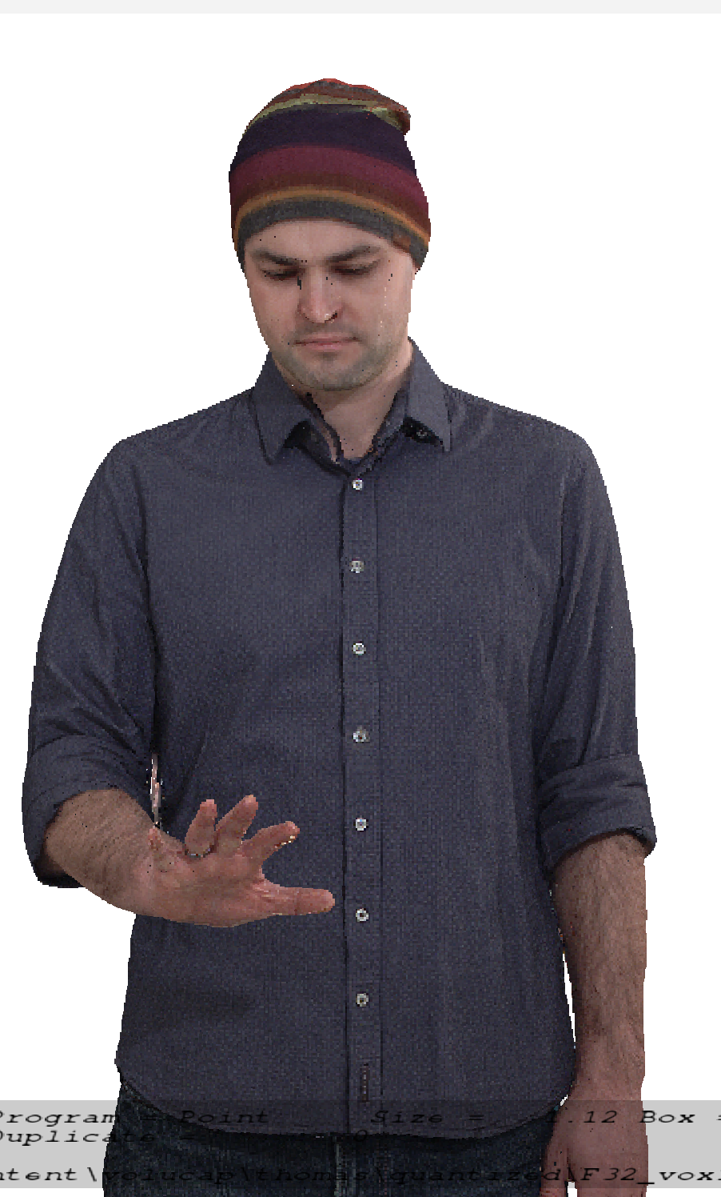
Figure 7.3.4.5.2-3 Vox 10 with 600K points per frame (content courtesy by Volucap [Vol-17])

7.3.5 Encoding and decoding constraints and settings
The following table provides an overview of encoding and decoding constraints for V-PCC with H.265/HEVC as codec for the Volumetric Video with single asset streaming scenario. Contribution aspects are not considered in this table.
Table 7.3.5 Encoding and decoding constraints
Encoding and Decoding Constraints | V-PCC with H.265/HEVC
Relevant Codec and Codec Profile/Levels | H.265/HEVC Main 10 Profile  Level 4.1, 5.1  Metadata stream parsing
Random access frequency | 1 seconds
Bit rates and quality configuration | Fixed QP Geometry: [32;28;24;20;16]  Fixed QP Texture: [42;37;32;27;22]  bitrates [1;50 Mbps]
Bit rate parameters (CBR, VBR, CAE, HRD parameters) | Covering a range of relevant bitrates and qualities
Latency requirements and specific encoding settings | No specific latency requirement
Encoding complexity context | Cloud-based encoding, offline encoding
Required decoding capabilities | 3 decoder instantiations of H.265/HEVC Main 10 Profile  Level 4.1, 5.1 for (occupancy, geometry and color)  One synchronized metadata bitstream (Atlas)

7.3.6 Performance Metrics and Requirements

7.3.6.1 Anchors
There is no specification in 3GPP that references a volumetric video anchor codec suitable for the streaming single asset scenario. MPEG V-PCC [Vol-11] is the first codec supporting the dense dynamic point cloud representation format with inter coding and therefore no anchor codec for the format can be selected. Similar to V-PCC, MPEG V-DMC [Vol-32] is the first codec supporting the dynamic mesh representation format and therefore no anchor codec for that format can be selected.

7.3.6.2 Objective tests
Objective tests for dense dynamic point cloud codecs and dynamic mesh codecs follow the principles as defined in TR 26.955, besides that there is no anchor:
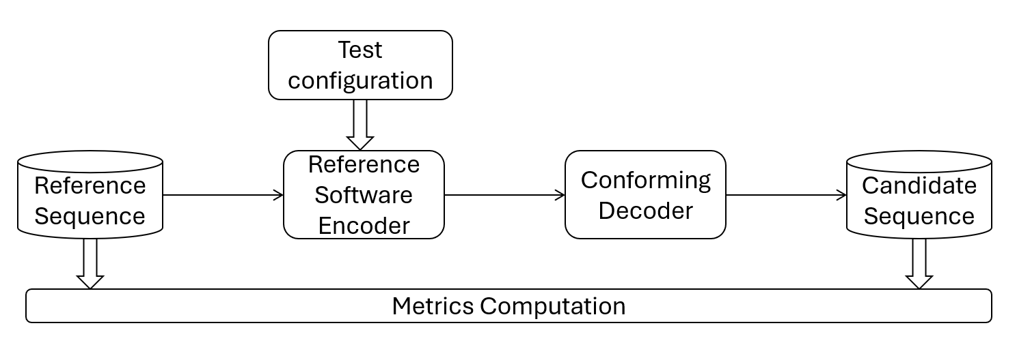
Figure 7.3.6.2-1 Test architecture for objective test
MPEG WG7 specified an objective metric that allows to characterize point cloud codecs. This objective metric is described in in annex B of the Call for Proposals for Point Cloud Compression [Vol-16]. MPEG WG7 used this “point-based” metric to develop codecs for point cloud compression. The “point-based” metric operates in 3D space and provides information on geometry and color distortion.
From 2D video objective testing it is known that a single objective metric is limiting, therefore “PCQM” [Vol-17] is added as a second objective metric in addition to the “point-based” metric.
Both objective metrics, the “point-based” metric and PCQM will be reported for all rate points and for all reference test sequences.
MPEG WG7 also specified objective metrics that allow to characterize dynamic mesh codecs. These objective metrics are described in in annex B of the Call for Proposals for Dynamic Mesh Coding [Vol-33]. It includes in annex B.1 the “point-based” metric as primary metric and in B.2 the “image-based metric” as informative metric.
To compute metrics, MPEG provides a public version of mpeg-pcc-mmetric [Vol-18]. The metric software implements the “point-based” metric, the “PCQM” metric and the “image-based” metric as referred in this section.
Five rate points that cover a range from low quality to high quality for codecs to be characterized will be selected.
A spreadsheet will be provided to 3GPP SA4 that can be used to visualize the objective results.
Note that objective results obtained with the selected metrics can only be used for comparison with codec for the same format. . There is no known objective metric that allows to compare different volumetric video codecs (e.g. dense point cloud against mesh) in a fair manner.

7.3.6.3 Subjective tests
Persons or objects in the “Streaming of professionally produced Volumetric Video with single asset containing people” scenario can be viewed from any angle and distances. To cope with this free viewpoint, MPEG WG7 developed a special procedure how to subjectively evaluate such volumetric sequences: The selected reference sequences are rendered with a point cloud renderer by following a pre-defined camera path into a 2D video. The procedure is done with the source reference sequence and with the codec/decoded reference sequence. Both 2D videos can then be evaluated with well-known 2D video evaluation methods.
The software tool that implements rendering of 2D videos from dense dynamic point clouds and dynamic meshes by following a camera path is provided by MPEG [Vol-19] and is named in the following representative renderer.
Due to specifics related point cloud rendering described in 4.3.3., this representative renderer supports two methods how to render voxels, one method is like cubes of a fixed size, the second method is splat blend. The latter draws a camera facing semitransparent splat of radius PointSize centered on the point position. The transparency (or alpha) varies with the distance from the center from fully opaque at the center to nearly transparent at the edge, to provide blending between points and reduce aliasing. In order to correctly use alpha blending, the points are sorted relative to the camera plane. Two blending modes are available, gaussian and linear, and the alpha falloff speed is customizable using the "pointFocus" setting.
For objective compression performance tests against the source reference, the cube method is recommended. For tests of the dense dynamic point cloud format against other volumetric representation formats such as mesh, the splat blend rendering is recommended as it fills holes between voxels. The representative renderer allows to activate a 3D background model or a neutral background. It also allows to activate a floor so that the test sequences look grounded.
A characteristic camera path for each volumetric test sequence is pre-defined to get a length of the output video as close as possible to 10s. A camera path that includes a full person view and a closer view at typical distance to the face is a good example.
The representative renderer produces uncompressed RGB 2D videos that can then be compressed with high bitrate HEVC. Resolution of the videos is 1080p, the frame rate and color space are aligned with the input point cloud.
The produced compressed 2D videos are made available to SA4 members so that the quality of a codec to be characterized can be judged.
There is no plan to engage an independent subjective test lab.

7.3.6.4 Correlation between the objective and subjective metrics
The objective metrics described in section 7.3.6.2 and the subjective comparison using the representative renderer in cube mode described in section 7.3.6.3 are used to evaluate coding distortions.
From MPEG there is no information available on the correlation between objective and subjective results and this may be investigated on a best effort basis.
A potential way of obtaining such correlation is described: the 4 licensed test sequences used in the MPEG subjective verification test report for V-PCC [Vol-20] can be obtained from the rights holders, the test sequences can be prepared as used in the verification test and objective metrics described in section 7.3.6.2 can be generated. The objective results can then be compared with the subjective results from the verification test and the correlation can be analyzed.
Note that for V-DMC the verification test is not available in the timeframe of this TR and no information will be provided.

7.3.6.5 Verification and crosscheck
All produced bitstreams, metric results and produced videos shall be crosschecked by at least one other 3GPP SA4 member to ensure that results are correct.

7.3.7 Interoperability Considerations for the application
MPEG-DASH is used with ISO/IEC 23090-10 Carriage of visual volumetric video-based coding data – 1st edition.[Vol-21]
As of April 2025, MPEG is working on the second edition of ISO/IEC 23090-10 that will cover V-DMC storage in ISOBMFF format and delivery utilizing DASH.
RTP is not proposed for this scenario.

7.3.8 Test Sequences
Editor’s Note: The content of this scenario relates to moving persons.

7.3.8.1 Candidate source dense point cloud sequences
Collected candidate raw dense point cloud sequences that are available for testing are presented in Annex C.2

7.3.8.2 Selected source dense point cloud sequences
This section lists 5 raw point cloud sequences that have been selected for objective and subjective testing. The following sequences have been selected for performing objective and subjective tests.
Test sequences have been selected based on visual quality and that these have not been used during codec development in MPEG. The following table lists the selected test sequences:
Table 7.3.8.2 Selected source point cloud sequences
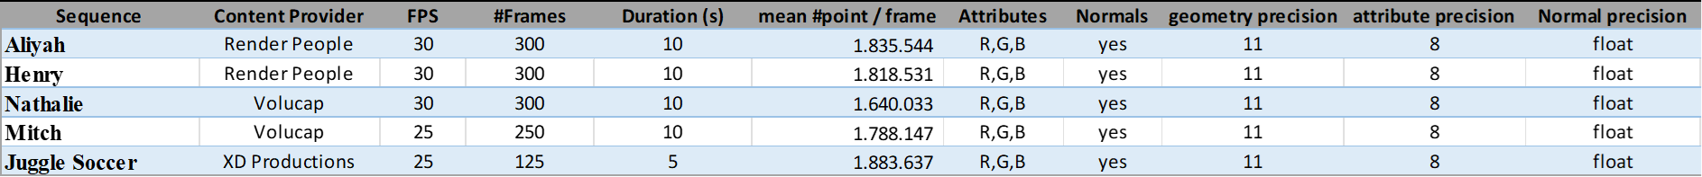
The following thumbnails illustrate the selected test sequences:
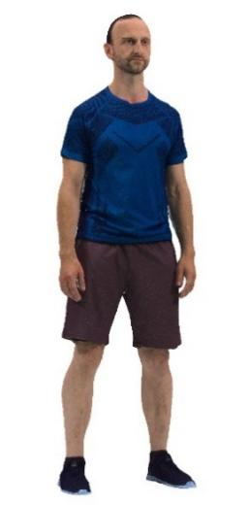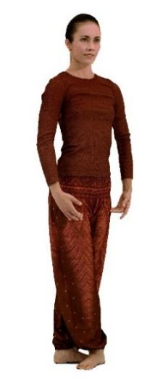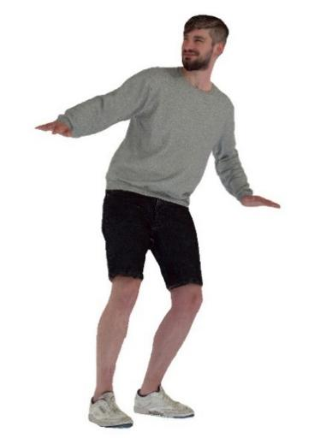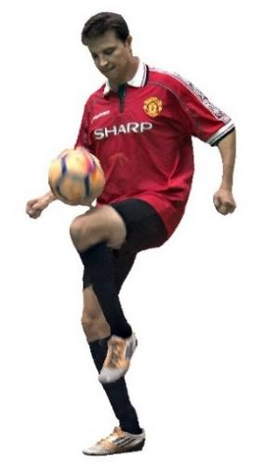
Figure 7.3.8.2-1 Aliya, Henry, Nathalie, Mitch and Joggle Soccer (content courtesy by Renderpeople, Volucap and XD Productions)
The selected licensed source point cloud sequences can be grouped as follows:
- Group 1 - Freely available to 3GPP members:Nathalie, Mitch and Joggle Soccer
- Group 2 - Publicly purchasable: Henry
- Group 3 - Publicly free available: Aliyah
Sequences of group 1 have already been converted to pointclouds of around 2 million points per frame and maximum 10s length and are provided on the server. Sequences of group 2 and group 3 need to be downloaded and converted by those doing the test.
Editor’s Note: Provide instructions and scripts on how to convert sequences of group 2 and group 3

7.3.8.3 Metadata for source dense point cloud sequences

7.3.8.3.1 Overview
For a raw dense point cloud sequence used in the context of this Technical Report, the following metadata is proposed:
- Name of the sequence
- Scenario
- Sequence key as provided in TR 26.956
- URI to zip file containing PLY files (URL to weblink where the original sequence is available)
- Name Format of files
- Frame count
- Start frame number
- Frame rate
- Geometry precision
- Color format
- Peak Value (bounding box resolution e.g. 1023, 2047)
- Copyright statement
- Contact Person
Optionally, the following metadata can be added:
- Background
- TR 26.956 reference
- Thumbnail preview
- Preview MP4
- Average point number per frame
- Duration
- MD5 of the zip file containing all point cloud frames
Size in bytes of the zip file containing all point cloud frames.
A JSON scheme is defined in clause 2.2 for this matter. An example is provided in clause 2.3

7.3.8.3.2 JSON Scheme
JSON schema for the raw format can be found in Annex B.2.3.

7.3.8.3.3 Example
An example is attached to the zip file:
{
"Sequence": {
"Name": "Exemple",
"Background": "This is a B2DV format example",
"Scenario": "Streaming of Beyond 2D Produced VoD Content",
"Key": "S01",
"TR26.956": "Annex X.Y.Z"
},
"Properties": {
"URI": "https://dash-large-files.akamaized.net/WAVE/3GPP/Beyond2D/ReferenceSequences/file.zip",
"thumbnail": "https://dash-large-files.akamaized.net/WAVE/3GPP/Beyond2D/ReferenceSequences/file.png",
"preview": "https://dash-large-files.akamaized.net/WAVE/3GPP/Beyond2D/ReferenceSequences/file.mp4",
"NameFormat": "exemple%04d.ply",
"frameCount": 320,
"startFrame": 0,
"frameRate": 30,
"pointsCountMean": 1000000,
"geometryPrecision": 10,
"colorformat": "rgb",
"peak": 2047,
"duration": 10.0,
"md5": "d055a94f35f7594776186fc5d09a9fa4",
"size": 11510343938
},
"CopyRight": "Conditions that are suitable for this study",
"Contact": {
"Name": "Celine Guede",
"Company": "InterDigital",
"e-mail": "celine.guede@interdigital.com",
"generation": "provided by contact"
}
}

7.3.9 Detailed test conditions

7.3.9.1 V-PCC test model and configuration files
The public version of the MPEG V-PCC test model named tmc2 in master branch is used to encode and decode dense dynamic point clouds [Vol-26].
Editor’s note: Configuration files to be validated
For using tmc2 in Random Access (RA) mode, MPEG provides a configuration file [Vol-27].
- cfg/common/ctc-common.cfg
- cfg/condition/ctc-random-access.cfg
- cfg/hdrconvert/yuv420toyuv444_16bit.cfg
For each selected test sequence, a configuration file containing information needed for tmc2 configuration will be provided.

7.3.9.2 Rate points and test conditions
In line with the V-PCC verification test [Vol-28], 5 rate points R1 to R5 for Random Access (RA) are used for each test sequence. Fixed rate points are used to enable an indicative subjective comparison of V-PCC with potential future other codecs for scenario 2, including codecs supporting another potential representation format (e.g. dynamic mesh with V-DMC).

For test sequences with 11-bit geometry precision (vox11) with approximately 2M points/frame the following target bitrates in kbps are used:
•R1: 5000
•R2: 10000
•R3: 20000
•R4: 30000
•R5: 50000
Target bitrates are obtained by selecting values for the V-PCC codec parameters Occupancy Precision, QP Geometry and QP Texture. The values are selected per test sequence and are included in a JSON file that is used in the scripts for encoding. More information on encoding can be found in Annex D.X. The values have been selected by doing encodes with varying value combinations and selecting those combinations which come close to the target bitrate and where a monotonic curve for objective metrics is obtained. There was no optimization in the sense of finding the closed bitrate match with the best objective and subjective performance.

In addition to the three codec parameters, a configuration file per test sequence is provided which is used by the encoding scripts.

7.3.9.3 Profiles
The V-PCC verification test [Vol-28] tested various V-PCC profiles such as HEVC Main10 V-PCC Basic Rec2, HEVC Main10 V-PCC Extended Rec2 and VVC Main10 V-PCC Extended Rec2 using test sequences with-10 bit geometry precision. To align with V-PCC prototype implementations at release time of this technical report, focus is on testing of the HEVC Main10 V-PCC Basic Rec0 profile using test sequences with 11-bit geometry precision.

7.3.9.4 Bitstream Generation, output
The MPEG V-PCC test model is used to encode and decode test sequences as described previously [Vol-26].
To compute metrics, the tool mpeg-pcc-mmetric [Vol-18] is used.
Scripts are provided to be able to:
- Encode each sequence for each condition, rate and profile
- Decode the corresponding sequence
- Compute the metrics
- Generate tables and graphs
Below are examples of command lines for the test profile for a vox11 sequence:
- to encode a test sequence:
mpeg-pcc-tmc2/release-v25.0/bin/PccAppEncoder \
--config=mpeg-pcc-tmc2/release-v25.0/cfg/common/ctc-common.cfg \
--config=mpeg-pcc-tmc2/release-v25.0/cfg/condition/ctc-random-access.cfg \
--config=mpeg-pcc-tmc2/release-v25.0/cfg/sequence/${test_sequence}.cfg \
--configurationFolder=mpeg-pcc-tmc2/release-v25.0/cfg/ \
--uncompressedDataFolder=${source_sequence}/ \
--compressedStreamPath=${test_sequence}.bin \
--normalDataPath=${source_sequence}/${source_sequence}_%04d.ply \
--frameCount=32 \
--resolution=2047 \
--geometryQP=11 \
--attributeQP=28 \
--occupancyPrecision=2 \
--profileToolsetIdc=0 \
--profileReconstructionIdc=0 \
--mapCountMinus1=0

- to decode a test sequence:
mpeg-pcc-tmc2/release-v25.0/bin/PccAppDecoder \
--startFrameNumber=0 \
--compressedStreamPath=${test_sequence}.bin \
--reconstructedDataPath=${test_sequence}_dec_%04d.ply \
--inverseColorSpaceConversionConfig=mpeg-pcc-tmc2/release-v25.0/cfg/hdrconvert/yuv420toyuv444_16bit.cfg

- to compute objective metrics of a test sequence:
mpeg-pcc-mmetric/1_1_7/build/Release/bin/mm \
--firstFrame 0 \
--lastFrame 31 END \
compare --mode pcc \
--inputModelA source_sequence_%04d.ply \
--inputModelB test_sequence_dec_%04d.ply END \
compare --mode pcqm \
--inputModelA source_sequence_%04d.ply \
--inputModelB test_sequence_dec_%04d.ply

For each test, outputs are:
- Bitstream file
- Log files containing metrics information
- Encoder log output
- Decoder log output
- Metric log output
A CSV file containing concatenated metrics information for each condition and selected profile is generated for all sequences and rates.
The following information is stored:
- SeqId: identifier of the sequence
- CondId: tested condition (RA)
- RateId: tested rate number [R1..R5]
- nbFrame: number of tested frames
- NbInputPoints: number of points in the source sequence
- NbOutputPoints: number of points in the candidate test sequence
- MeanOutputPoints: mean number of points in the candidate test sequence
- MeanDuplicatePoints: mean number of duplicated points (with same geometry) in the candidate test sequence
- TotalBitstreamBits: size of the bistream in bits
- geometryBits: size of the geometry stream in bits
- metadataBits: size of the metadata stream in bits
- attributeBits: size of the attribute stream in bits
- D1Mean: mseF,PSNR (p2point)
- D2Mean: mseF,PSNR (p2plane)
- LumaMean: c[0],PSNRF
- CbMean: c[1],PSNRF
- CrMean: c[2],PSNRF
- PCQM: PCQM PSNR
- SelfEncoderRuntime: encoder time for current process
- ChildEncoderRuntime: encoder time for child processes
- SelfDecoderRuntime: decoder time for current process
- ChildDecoderRuntime: decoder time for child processes
From this CSV file, an excel spreadsheet is generated to get tables and graphs for interpretation of the results.
Editor’s note: Text to be added on how a user can execute the objective tests based on scripts, including preparation of the content (new annex), installation of TMC2, installation of the metric SW, installation and execution of the scripts.
Editor’s note: Text needs to be added how a user can access the produced results in form of a spreadsheet

7.3.9.5 Videos Generation for subjective tests
The representative renderer [Vol-19] is used to generate videos for the subjective evaluation.
Videos are generated for the 5 selected test sequences and for the 5 rate points each. To evaluate the impact of rendering, each of the 25 videos is rendered in 3 modes as follows:
- Cube mode, neutral background with a color including a floor for the asset making the rendered scene more realistic
- Splat Blend mode, neutral background with a color including a floor for the asset making the rendered scene more realistic
- Splat Blend mode, 3D background model fitting with the test sequence
A camera path and blend parameter/render options adapted to each sequence are provided [Vol-30]. Backgrounds are presented in annex C.X and annex C.2 links the background with the selected test sequences.
A script is provided to generate the videos with the chosen camera path and blend parameter/render options adapted to each sequence and the output is stored as high-quality video sequence of a length as close as possible to 10s.
The generation is done into two steps: first the generation of the RBG raw file with the camera path and then the conversion into YUV or MP4 files.
The video sequences are generated with the following video parameters:
- Video resolution: progressive uncompressed full-range HD format (1920x1080). Note that upsampling by the TV set should be avoided
- Frame rate: The frame rate will be aligned with the frame rate of the test sequence
- Color space: ITU-R BT.709
- Sub-sampling: 4:2:0 YUV 10 bits or x265 fast preset lossless
Editor’s note: Text needs to be added how a user can launch the production of the videos, i.e. prepare the content (new annex E), install the TMC2, install the renderer, install the scripts, etc….
Editor’s note: Text needs to be added how a user can access the produced 75 videos

7.3.9.6 Verification / crosschecks
All produced bitstreams, metric results and produced videos will be crosschecked by at least one other SA member to ensure that results are correct.

7.3.10 External Performance data
The subjective verification test report for V-PCC can be downloaded from the public MPEG website [Vol-20]
The Brazilian SBTVD Forum performed objective tests with V-PCC. Full results are available in chapter 6.10 (Candidate Technology I), 6.10.3.2 and 6.10.4 of the following document [Vol-31]

7.3.11 Additional information
Sequences can be decoded and visualized in real time using a 3D background or in Augmented Reality on a smartphone, tablet, head-mounted display using DASH streaming mode or local file system.
Nokia’s real-time V-PCC decoder implementation that was released as open source: https://github.com/nokiatech/vpcc
A simple scene description could be added to enable the placement of the asset in the scene (position, orientation, scale…) but is outside the scope of this document, which is focused on the format and codec evaluation.

7.4 Scenario 3: Streaming of Multi-view plus depth Produced Content

7.4.1 Motivation for the scenario
This scenario handles the streaming of produced multi-view plus depth content that provides experiences beyond what is achievable with 2D content. The scenario allows for the evaluation of the streaming of high-quality, professionally captured and produced multi-view plus depth video content.
In this scenario, mult-view plus depth content is played back on phones and tablets for which one viewport is shown. UI elements and/or the tilt sensor can be used to change the virtual viewport. This experience is more immersive than 2D video because the (subtle) pose changes provide motion parallax which is a strong perceptual depth cue. This effect is already achieved using a small number of cameras (3-4) and a limited viewing space (the size of a person's head). More cameras (10-20) are needed for free-viewpoint functionality.
In this scenario, it is also considered, but not evaluated, that the same content can be played back on more advanced devices including head-mounted displays and eye-tracked autostereoscopic displays. For these classes of devices, two virtual viewports are rendered, thereby providing a stronger 3D effect due to the combination of motion parallax and stereopsis depth cues. While relevant, the expectation is that for the forseeable future the majority of the UE's will be 2D phones and tablets.
The main benefits of using the multi-view plus depth representation for on-demand streaming, is that 1) the difference in appearance of objects between cameras is preserved, making the experience more like video and less like graphics, 2) less processing steps are needed to construct the representation as compared to the derived representations, 3) transmission is possible by the combination of 2D video plus metadata.
As of start of 2025, no commercial deployment of multi-view plus depth delivery to mobile devices has been identified. Multi-view plus depth video can offer an experience on top of 2D video. First services can provide stills or short clips that enable a viewer to look around and observe some actions from different viewpoints. This can be a stepping stone towards live streaming of multi-view plus depth video.
[Ed.(BK): Review later and check if there is a consistent level of information for all scenarios.]
This scenario is based on the multi-view plus depth video representation format that is defined in clause 4.3.4. Capturing setups and production software are available as described in the related representation format definitions. Contribution, compression and storage formats for multi-view plus depth video are available, see clause 7.4.3. It is expected that segmented media delivery will be used based on DASH and ISOBMFF. Carriage of coded media using ISOBMFF has been specified for MIV [MD-10] in [MD-4] and MV-HEVC [MD-11] in [MD-9]. Other codecs may be considered. Hardware video decoder capabilities can be used for all pixel data. Rendering and display systems for multi-view plus depth video are described in clause 4.3.4.3.

7.4.2 Description of the scenario
This scenario considers on-demand streaming of multi-view plus depth produced content to a UE (Figure 7.4.2-1). All or the most relevant parts of the content are produced using a camera array that observes a scene. The array may include 2D cameras and/or range-sensing cameras. In some cases, part of a scene may be created or inpainted using AI or CGI to reduce the number of physical cameras. This scenario does not consider use of AI/CGI production without a physical camera array.
Figure 7.4.2-1: On-demand streaming of B2D produced content to a UE
Capture setup, production tools and workflows for multi-view plus depth video capture systems and production tools are described in clause 4.3.4.2. Contribution, compression and storage formats are linked to the multi-view video representation format. Well-defined contribution formats exist that carry the raw texture/depth images and camera parameters, e.g. as described in clause 4.3.4.2. Compression formats for multi-view plus depth video are described in clause 4.3.4.4. One codec that can be used to realize this scenario is MPEG Immersive Video (MIV) [MD-10]. Another option is the Multiview extension of high efficiency video coding (HEVC) standard [MD-11], commonly referred to as MV-HEVC, as well as the 3D extensions of HEVC (3D-HEVC). MV-HEVC enables the encoding of multiple views and depth data in HEVC by allowing the presence of additional layers in an HEVC bitstream, each corresponding to either a different view or depth information. Such support is enabled through only high level syntax modifications in the original design of the HEVC standard making it easy to repurpose multiple HEVC encoders or decoders that might be available in an existing implementation. 3D-HEVC, however, introduces additional low level coding tools intended for the improved compression of depth information and might not be available in most implementations. Other codecs may also be considered. Below one possible workflow with MIV is described.
The multiple camera views and depth maps are encoded to create a unified representation. An example could be MIV constrained to one or more atlases and packed video data. The single video sub-bitstream per atlas would be encoded with the HEVC Main10 profile. The bitstream contains all camera parameters that are necessary for 6DoF rendering. Each atlas is independently renderable. Another example can be MV-HEVC using auxiliary layers for depth maps and SEI messages for camera parameters.Figure 7.4.2-2 provides an example of an MIV encoder flow.

Figure 7.4.2-2: MIV encoder example
- Patch Extraction and Filtering: extraction of regions from the texture and depth map for the purpose of pixel-rate reduction and allowing object interactivity at the client.
- Background View Extraction: The ground surface and far-away background can be represented by a single background texture with depth. This greatly reduces the required pixel space.
- Atlas Generation: The patches and sprite are packed in an atlas such that both the pixel area is optimally used and the temporal correlation is retained to guarantee an acceptable bitrate.
An example of multi-view plus depth video encoding has been described in the paper [MD-5].
The encoded bitstream is encapsulated to ISOBMFF according to the rules of the used codec.
For example, an MIV bitstream may be packaged in one track, or multiple tracks where the packed video data is one track, common atlas data is one track, and atlas data is another track. ISO/IEC 23090-10 [MD-4] specifies how to map MIV (V3C) onto ISOBMFF, file format and DASH.
When a scene is represented by multiple atlases, only one of them may be decoded based on the viewing position. This is called atlas-level sub-bitstream access. In the case of DASH, switching atlas would amount to changing tracks.
The decoder(s) will make use of hardware video decoder capabilities for all pixel data, and metadata describing information needed for rendering is decoded/parsed by a CPU.
Rendering and display systems for multi-view plus depth video are described in clause 4.3.4.3.

7.4.3 Source format properties
The source format that is commonly used and recognized is a set of video sources in combination with a format for camera parameters. Texture is typically available in 8 or 10 bit unsigned integer formats and geometry is typically available in 16 bit unsigned integer or 32-bit float formats. The Colmap format [MD-2] is most commonly used in the literature. There is also a JSON format that is used within multiple MPEG activities, and a converter between the two camera parameter formats exists [MD-8].
For this scenario, the multi-view plus depth video source format has 3 to 20 views. It is expected that most or all test data will have perspective projection (PSP), but test data with equirectangular projection (ERP) may be included.
Each view has the following components:
- Texture (color)
- Depth coded as normalized disparity
Depth information can be used in rendering e.g. by shaders for surface normal estimation.
Editor’s note: Further details on depth processing is FFS.
All views have view parameters: camera ID, camera intrinsics, camera extrinsics (pose) and depth quantization parameters (optional).
Views may be undistorted, otherwise distortion parameters have to be provided.
The signal properties defined in clause 4.3.4.1 apply with no further constraints.

7.4.4 Encoding and decoding constraints and settings
Some constraints and settings below are given for MIV:
Codec profiles/levels:
- HEVC Main 10 MIV Main
- MIV level 2.0 or 2.5.
- HEVC Main 10 MIV Extended
- MIV level 2.0, 2.5 or 3.0 whereby the level 3.0 is only allowed if there is a single video sub-bitstream.
Support for multi-plane image (MPI) through the MIV Extended Restricted Geometry sub-profile may be relevant for this scenario, but it is not considered for this study for practical reasons: it requires an additional conversion from multi-view plus depth to multi-plane image.

Some constraints and settings below are given for MV-HEVC:

For content with N views plus depth, there will be the following layers:
- First (reference) texture layer: Main or Main 10 profile, level 4.1 or 5
- N - 1 dependent texture layers: Multiview Extended or Multiview Extended 10 profile, level 4.1 or 5
- First (reference) depth layer (AuxId = AUX_DEPTH): Multiview Monochrome or Multiview Monochrome 10 profile, level 4.1 or 5
- N - 1 dependent depth layers: Multview Monochrome or Multiview Monochrome 10 profile, level 4.1 or 5
The presence of the following two SEI messages is required for virtual view synthesis:
- Depth representation info SEI
- Multiview acquisition info SEI
Note that the coding of the depth layers could be independent of the coding of the texture layers.
In general, a random-access frequency of 32 frames can be considered. It is up to the service provider to define the exact random access frequency.
Transmission systems need to be prepared to resend data in case of data loss. If data loss still occurs or retransmitted data does not reach the receiver device in time for rendering, previous immersive frames may be re-rendered with updated viewing poses. In case one or more of the sub-bitstreams is lost, it is up to the application to determine an optimal method for hiding the missing information.
Typically, bitrates between 5 and 50 Mbit/s may be considered.
Bitrate parameters related to video sub-bitstreams need to be configured by the streaming service provider. Transfer characteristics are signalled in the video sub-bitstreams.
There are no special requirements regarding ABR. Configuration is left for the service provider to determine.
Latencies between 500ms to several seconds are considered. Random access interval or segment duration are configured according to the latency requirements.
Encoding is performed by a content provider. This scenario assumes professional setting for recording and processing the content, so no real-time or encoder hardware or architecture requirements are provided.
It is expected that devices support HW accelerated video decoding.
Decoding requirements for MIV:
- HEVC Main 10
- HEVC levels are determined according to the maximum HEVC Level that is needed for a video sub-bitstream decoder to fulfill the MIV level.
- HEVC level 5.1 for MIV level 2.0
- HEVC level 5.2 for MIV level 2.5
- HEVC level 6.1 for MIV level 3.0
- Video sub-bitstreams need to be independently decodable. This helps implementations on various platforms that may have only high-level APIs. For instance, geometry needs to be full range.
Samples in the sub-bitstreams should be temporally aligned.
Decoding requirements for MV-HEVC:
While decoding and rendering all views may result in a higher quality, this is not a requirement. At a minimum, a client needs to be able to select the two nearest views for decoding and rendering. This requires the decoding of the following six sub-bitstreams:
- Reference texture: Main or Main 10, level 4.1 or 5
- Reference depth: Multiview Monochrome or Multiview Monochrome 10, level 4.1 or 5
- Two dependent textures: Multiview Extended or Multiview Extended 10, level 4.1 or 5
- Two dependent depths: Multiview Monochrome or Multiview Monochrome 10, level 4.1 or 5
The view selection can change each intra period.

7.4.5 Performance Metrics and Requirements
The tests are run for a chosen level as described in clause 7.4.6. Bitstreams are provided. Camera calibration, depth estimation, and encoding are not evaluated.
The test will have four rate points and QP values are selected for each sequence to approximately match the 5 to 50 Mbps range. When saturation occurs before 50 Mbps a lower value may be chosen in consultation. When there are multiple video components or packed regions then the other QP values need to be directly derived from the texture QP using an equation or a look-up table. (They cannot depend on the sequence.)
[Ed.(BK): To be aligned with the agreed evaluation framework.]
The IV-PSNR tool, available at https://gitlab.com/mpeg-i-visual/ivpsnr, is available to compute full-reference objective metrics:
- Weighted sphere PSNR (WS-PSNR)
- Immersive video PSNR (IV-PSNR)
All source views that were used for encoding are provided. Each source view is reconstructed by decoding and rendering (view synthesis). The IV-PSNR tool is then run on all source views and the score is averaged over all views.
Depending on bit rate, quality of depth maps and rendering, either the video codec or view synthesis is the limiting factor. BD-PSNR is calculated for both metrics because the metric behaves more predictably than BD-rate.
[Ed.(BK): To be aligned with the agreed evaluation framework. The discussion here on correlation of objective and subjective metrics may need to be moved to that framework after more deliberation.]
There is experience in testing of multi-view plus depth video in MPEG context. The test conditions as described are a simplification and evolution of the common test conditions for MIV defined in [MD-6].
The main challenge with testing of multi-view plus depth video is that codecs are asymmetric. The input is a number of source views (with depth maps), and the output of the decoder + renderer can be any viewport within a spatial region around those source views. In the mentioned CTC two tests are used:
- Objective evaluation at source view positions
- Subjective evaluation of pose trace videos (dynamic viewports)
This has resulted in a lack of correlation between objective and subjective results, but despite that it is the best-known approach. Alternatives that have been tried and dismissed (for now):
- Objective evaluation at dynamic viewports: It includes view synthesis in the reference condition and this skews the results towards a specific renderer. It prevents an A/B comparison of different renderers.
- Subjective evaluation at source view positions: This is not how the end-user will interact with the content, and it does not evaluate artifacts due to viewport dynamics.
For this test, because the aim is to prove feasibility of a scenario, objective evaluation may be sufficient, especially when supplemented with (informal) real-time demonstration of the same bitstreams that were used for objective evaluation.

7.4.6 Interoperability Considerations for the application
The multi-view plus depth video bitstream needs to be carried over DASH for this scenario. It is not necessary to prove this as part of the feasibility test, if written evidence can be provided.
In the example of using MIV as a codec, there are implementations for DASH [5G-MAG] and RTP + SDP [uvgRTP]. It is possible to subset MIV to always transmit all pixel data in a single packed video track plus a timed metadata track.

7.4.7 Test Sequences
Test sequences that were used during the development of a codec are discouraged because they may create a bias towards that specific codec. Sequences that were used in a verification test are permissible.
Preferably test sequences match with the intended use case both in terms of technical requirements and content semantics.
For MIV a list of available sequences is provided in [MD-6].

7.4.8 Detailed test conditions
[Ed.(BK): To be aligned with the agreed evaluation framework.]
For each candidate codec, a suitable decoder + renderer needs to be made available for testing purposes.
For MIV and MV-HEVC a reporting template or script will be provided to compute BD-PSNR based on IV-PNSR log files of all rates and sequences.
For MIV and MV-HEVC the common test conditions defined in [MD-6] are followed. The anchor is based on multiple individual HEVC streams, one for each texture and each depth frame.

7.4.9 External Performance data
For MIV the performance data is available from the verification test report [MD-7].
NOTE: This performance data was based on different source view properties and the results may not translate to this study.

7.4.10 Additional Information
The Metaverse Standards Forum (MSF) has established a Volumetric Media Interoperability working group which aims to build a better understanding of volumetric media, including multi-view plus depth video, to identify relevant areas of applications and compatibility requirements, and to establish common requirements for different systems. See here the WG description: https://metaverse-standards.org/domain-groups/volumetric-media-interoperability/
The technology is expected to be highly scalable since it uses well-established transport technologies like DASH and 2D video coding techniques.
Regarding complexity, rendering and decoding frame rates for MIV content were measured for Windows and Android platforms in [MD-5]. The results show that the developed platform can decode V3C content in real time on both Windows and Android. Evaluation of battery consumption (power levels) is FFS.
Streaming of multi-view plus depth content has the potential to disrupt several markets including entertainment/media, education/training, retail/shopping.
Several use cases can be envisioned related to these domains. For example, in an education/training scenario, a pre-recorded video of a fitness instructor showing how to perform an exercise can help the student to better understand how the exercise is done and thus replicate in a correct way. Another example in education domain would be a mechanic giving a tutorial on how to assemble a mountain bike. The viewer can watch the movements of the mechanic from different angles and get an improved understanding of the different steps due to depth perception and different viewpoints. In the entertainment domain, users can stream a performance from their favorite band to their living room and experience greater immersion potentially together with spatial audio.

7.x Scenario x: <tbd>

8 Common Evaluation Features
Editor’s note: Documents common metrics, software, etc..

9 Evaluation of Selected Scenarios
Editor’s note: This clause defines test conditions and parameters, KPIs, Metrics, test sequences, agreed reference signals per scenario.

9.1 Introduction
Editor’s note: Identifies the preferred scenarios

9.2 Scenario 1: <tbd>

9.2.1 Evaluation Overview
Editor’s note: Based on scenario in clause 6, summarizes the source formats parameters used for evaluation, the encoding and decoding constraints, interoperability considerations and the general idea of the performance metrics.

9.2.2 Reference Sequences

9.2.3 Performance Metrics

9.2.4 Candidate Solutions

9.2.4.1 Solution 1: <Name>

9.2.4.1.1 Introduction

9.2.4.1.2 Reference Software

9.2.4.1.3 Parameter Settings

9.2.4.1.4 Distribution

9.2.4.1.5 Evaluation Results

9.2.4.1.6 Network Requirements
Editor’s note: Documents required bitrates as well as possibly other aspects.

9.2.4.2 Solution 2: <Name>

9.2.4.2.1 Introduction

9.2.4.2.2 Reference Software

9.2.4.2.3 Parameter Settings

8.2.4.2.4 Distribution

9.2.4.2.5 Evaluation Results

9.2.4.2.6 Network Requirements

9.2.5 Summary of Evaluation

9.3 Scenario 2: <tbd>

9.4 Scenario x: <tbd>

10 Gaps and Optimization Potential

10.1 Identified Gaps and Deficiencies with Video Capabilities

10.2 Potential Requirements for New Video Capabilities

10.3 Potential Network Optimizations

11 Conclusions and Proposed Next Steps
Editor’s note: This clause provides conclusion and potential areas for normative work as the next phase.

Annex A: Scenario Template

A.1 Introduction
This annex provides a proposed template to introduce a Scenario for Beyond 2D Video. This template has been used to collect the scenarios in this report. The text in blue corresponds to guidelines on the information to be provided with a scenario proposal.

A.2 Template
The following aspects are considered for a scenario:
- Scenario name
- Motivation for the scenario
What is the market relevance of the proposed scenario within the next few years? Are there any commercially available or pre-released products or prototypes?
Market relevance key indicators:
- Technology evaluation on the market
Are there indications of pre-evaluation by service providers, device manufacturers, and/or network operators?

- Industry activities
Is there relevant work in 3GPP MRPs, industry collaborations or among market stakeholders?
- Production tools/companies
What is the availability of capturing setups, and production software? Are there endorsed formats for representation, contribution, compression, and storage? Is there an ecosystem of content creators?

- Delivery solutions
Which delivery type is expected to be used? What are the expected transport formats? Is there SW or HW support and providers?

- Content decoding and rendering
Is there decoding SW/HW support, and providers? Are there rendering devices and displays available yet?

- Description of the scenario
This provides a description of beyond 2D video end-to-end workflows, which includes identifying and defining beyond 2D formats being used in the context and representation technologies to delivery these formats. The following aspects may be considered for each workflow:
- Capturing and processing
- Encoding
- Packaging and delivery
- Decoding
- *Post-processing
- Rendering
- General constraints on latency, bandwidth, reliability and complexity
- Supporting companies and 3GPP members
- This documents the 3GPP members that support this scenario in terms of providing the information, test material, test requirements and the characterization for the tests. For each of the identified necessities, a tick box is created in the template.
- Preferably several 3GPP members are included in the support, and in addition a video service provider may be included (not necessarily a 3GPP member).
- Cross-verification is preferably done by the supporters of the scenario.
- Source format properties
This defines a clear range of the considered and relevant source formats, including the signal properties, but also the characteristics of the content. As an example, the texture and depth format properties of the source may be used which include:
- Spatial resolutions
- Chroma Format
- Chroma Subsampling
- Aspect ratios
- Frame rates
- Colour space formats
- Transfer Characteristics
- Bit depth
- Viewpoints
- Other signal properties
- Encoding and decoding constraints and settings
Typical encoding constraints and settings such as:
  - Relevant Codec and Codec Profile/Levels according to 3GPP TS (e.g., TS 26.119),
  - Random access frequency
  - Error resiliency requirements
  - Bitrates and quality requirements
  - Bitrate parameters (CBR, VBR, CAE, HRD parameters)
  - ABR encoding requirements (switching frequency, etc.)
  - Latency requirements and specific encoding settings
  - Encoding context: real-time encoding, on device encoding, cloud-based encoding, offline encoding, etc.
  - Required decoding capabilities
  - Synchronization requirements
- Performance Metrics and Requirements
- A clear definition on how the performance needs to be evaluated including metrics, etc addressing the main KPIs of the scenario.
- Objective measures such as PSNR, VMAF, etc, may be used
- Justification on whether objective metrics are sufficient and representative of the subjective performance.
- Interoperability Considerations for the application
- Streaming with DASH/HLS/CMAF/QUIC
- RTP based delivery
- Test Sequences
A set of selected test sequences that are provided by the proponents in order to do the evaluation. They should cover a set of source format properties
- Detailed test conditions
Provides a proposal for detailed test conditions, for example based on a reference software together with the sequences and configuration parameters.
- External Performance data
References to external performance data that can be added, for example other SDOs, public documents and so on.
- Additional Information
- Industry activities
Is there Relevant work in industry forums?
- Implementation constraints
Are there any indications about scalability of the technology with regards to network and devices?
- Innovation
Does the technology address a current or a future need on the market? Can it potentially disrupt existing markets?

Annex B: Data Formats and Metrics

B.1 Introduction
<TBD>

B.2 Raw Video Sequences

B.2.1 Overview
<TBD>

B.2.2 JSON Schema
JSON schema for the raw format is here
< https://dash-large-files.akamaized.net/WAVE/3GPP/Beyond2D/ReferenceSequence/raw-schema.json>
- {
- "Sequence": {
- "Name": "Example",
- "Background": "This is a B2DV format example",
- "Scenario": "On-demand",
- "Key": "Identifier",
- "TR26.956": "Annex X.Y.Z"
- },
- "Views": [
- {
- "ViewId": "v0",
- "Extrinsics": {
- "orientation": {
- "qw": 0.9999915361,
- "qx": 0.0024327517,
- "qy": 0.0024349121,
- "qz": -0.0022688841
- },
- "position": [
- -0.0006123598,
- 0.3035059273,
- 0.0012498678
- ]
- },
- "Intrinsics": {
- "focalLength": 1002.349976,
- "principalPoint": {
- "horizontalNorm": 960.0,
- "vertical": 540.0
- }
- },
- "ProjectionPlaneSize": {
- "columnCount": 1920,
- "rowCount": 1080
- },
- "Quantization": {
- "highNormDisp": 2.000000,
- "lowNormDisp": 0.200000
- },
- "Components": [
- {
- "ComponentId": "texture",
- "Data": {
- "URI": "https://dash-large-files.akamaized.net/WAVE/3GPP/some/url/file.yuv",
- "md5": "e537665c18e32bbaf8e5e9d63e18dd2c",
- "thumbnail": "https://dash-large-files.akamaized.net/WAVE/3GPP/some/url/file.png",
- "preview": "https://dash-large-files.akamaized.net/WAVE/3GPP/some/url/file.mp4",
- "size": 7962624000,
- "md5-10": "1c3550197120f95502c4add38d7ebd33"
- },
- "Properties": {
- "width": 1920,
- "height": 1080,
- "format": "yuv",
- "packing": "planar",
- "scan": "progressive",
- "subsampling": "420",
- "bitDepth": 8,
- "frameRate": 30,
- "colourPrimaries": "1",
- "transferCharacteristics": "1",
- "matrixCoefficients": "1",
- "sampleAspectRatio": "1",
- "duration": 10,
- "frameCount": 600,
- "startFrame": 1,
- "videoFullRangeFlag": "0",
- "chromaSampleLocType": "0"
- }
- },
- {
- "ComponentId": "depth",
- "Data": {
- "URI": "https://dash-large-files.akamaized.net/WAVE/3GPP/some/url/file.yuv",
- "md5": "e537665c18e32bbaf8e5e9d63e18dd2c",
- "thumbnail": "https://dash-large-files.akamaized.net/WAVE/3GPP/some/url/file.png",
- "preview": "https://dash-large-files.akamaized.net/WAVE/3GPP/some/url/file.mp4",
- "size": 7962624000,
- "md5-10": "1c3550197120f95502c4add38d7ebd33"
- },
- "Properties": {
- "width": 1920,
- "height": 1080,
- "format": "yuv",
- "packing": "planar",
- "scan": "progressive",
- "subsampling": "420",
- "bitDepth": 16,
- "frameRate": 30,
- "colourPrimaries": "2",
- "transferCharacteristics": "8",
- "matrixCoefficients": "0",
- "sampleAspectRatio": "1",
- "duration": 10,
- "frameCount": 600,
- "startFrame": 1,
- "videoFullRangeFlag": "1",
- "chromaSampleLocType": "0"
- }
- }
- ]
- }
- ],
- "copyRight": "Conditions that are suitable for this study",
- "Contact": {
- "Name": "Bart Kroon",
- "Company": "Philips",
- "e-mail": "bart.kroon@philips.com",
- "generation": "provided by contact"
- }
- }

B.2.3 JSON Scheme for Dense Dynamic Point Cloud
JSON schema for the raw dense dynamic point cloud format is here:
<https://dash-large-files.akamaized.net/WAVE/3GPP/Beyond2D/ReferenceSequences/raw-schema-ddpc.json >
- {
- "$schema": "http://json-schema.org/draft-07/schema",
- "$id": "https://dash-large-files.akamaized.net/WAVE/3GPP/Beyond2D/ReferenceSequences/B2DPC-schema.json",
- "type": "object",
- "title": "The root schema",
- "description": "Schema for beyond 2D point cloud sequences.",
- "default": {},
- "required": [
- "Sequence",
- "Properties",
- "CopyRight",
- "Contact"
- ],
- "properties": {
- "Sequence": {
- "$id": "#/properties/Sequence",
- "type": "object",
- "title": "Schema for the Sequence",
- "description": "Includes all information about the sequence",
- "default": {},
- "required": [
- "Name",
- "Scenario",
- "Key"
- ],
- "properties": {
- "Name": {
- "$id": "#/properties/Sequence/properties/Name",
- "type": "string",
- "title": "The Name schema",
- "description": "Provides a unique name of the sequence."
- },
- "Background": {
- "$id": "#/properties/Sequence/properties/Background",
- "type": "string",
- "title": "The Background schema",
- "description": "Provides a background information on the sequence."
- },
- "Scenario": {
- "$id": "#/properties/Sequence/properties/Scenario",
- "type": "string",
- "title": "The Scenario schema",
- "description": "Provides information to which Scenario this sequence relates."
- },
- "Key": {
- "$id": "#/properties/Sequence/properties/Key",
- "type": "string",
- "title": "The Key schema",
- "description": "Provides the key used in TR 26.956.",
- "examples": [
- "S41"
- ]
- },
- "TR26.956": {
- "$id": "#/properties/Sequence/properties/TR26.956",
- "type": "string",
- "title": "The TR26.956 schema",
- "description": "Provides the reference to TR26.956 used.",
- "examples": [
- "S41"
- ]
- }
- },
- "additionalProperties": true
- },
- "Properties": {
- "$id": "#/properties/Properties",
- "type": "object",
- "title": "The Properties schema",
- "description": "the properties of the raw video.",
- "required": [
- "URI",
- "NameFormat",
- "frameCount",
- "startFrame",
- "frameRate",
- "geometryPrecision",
- "colorformat",
- "peak"
- ],
- "properties": {
- "URI": {
- "$id": "#/properties/Properties/properties/URI",
- "type": "string",
- "title": "The URI schema",
- "description": "Provides a reference/URL to the sequence point cloud data."
- },
- "thumbnail": {
- "$id": "#/properties/Properties/properties/thumbnail",
- "type": "string",
- "title": "The thumbnail schema",
- "description": "Provides a reference/URL to a typical frame of the video."
- },
- "preview": {
- "$id": "#/properties/Properties/properties/preview",
- "type": "string",
- "title": "The preview schema",
- "description": "Provides a reference/URL to an mp4 encoded video."
- },
- "NameFormat": {
- "$id": "#/properties/Properties/properties/NameFormat",
- "type": "string",
- "title": "The NameFormat schema",
- "description": "Provides a name of the sequence to which a frame index is added.",
- "examples": [
- "exemple%04d.ply"
- ]
- },
- "frameCount": {
- "$id": "#/properties/Properties/properties/frameCount",
- "type": "integer",
- "title": "The frameCount schema",
- "description": "The number of point cloud frames in the sequence.",
- "examples": [
- 327
- ]
- },
- "startFrame": {
- "$id": "#/properties/Properties/properties/startFrame",
- "type": "integer",
- "title": "The startFrame schema",
- "description": "The first frame in the sequence that is to be used starting from 1.",
- "default": 1,
- "examples": [
- 1
- ]
- },
- "frameRate": {
- "$id": "#/properties/Properties/properties/frameRate",
- "type": "integer",
- "title": "The frameRate schema",
- "description": "Framerate of the video.",
- "examples": [
- 30
- ]
- },
- "pointsCountMean": {
- "$id": "#/properties/Properties/properties/pointsCountMean",
- "type": "integer",
- "title": "The average of points number per frame schema",
- "description": "The average point number per frame.",
- "examples": [
- 857241
- ]
- },
- "geometryPrecision": {
- "$id": "#/properties/Properties/properties/geometryPrecision",
- "type": "integer",
- "title": "The geometry procision schema",
- "description": "geometry precision in bits of the point cloud sequence.",
- "default": "10",
- "examples": [
- 10
- ]
- },
- "colorformat": {
- "$id": "#/properties/Properties/properties/colorformat",
- "type": "string",
- "title": "The colorformat schema",
- "description": "Format of texture attribute",
- "default": "rgb",
- "enum": [
- "rgb",
- "yuv"
- ],
- "examples": [
- "rgb"
- ]
- },
- "peak": {
- "$id": "#/properties/Properties/properties/peak",
- "type": "integer",
- "title": "The peak schema",
- "description": "peak of the point cloud sequence.",
- "default": "1023",
- "enum": [
- 1023,
- 2047
- ],
- "examples": [
- 1023
- ]
- },
- "duration": {
- "$id": "#/properties/Properties/properties/duration",
- "type": "number",
- "title": "The duration schema",
- "description": "Duration of the sequence in seconds.",
- "examples": [
- 5.46
- ]
- },
- "md5": {
- "$id": "#/properties/Properties/properties/md5",
- "type": "string",
- "title": "The md5 string",
- "items": {
- "description": "md5 of the zip files containing all point cloud frames.",
- "type": "string",
- "examples": [
- "d055a94f35f7594776186fc5d09a9fa4"
- ]
- }
- },
- "size": {
- "$id": "#/properties/Properties/properties/size",
- "type": "integer",
- "title": "The size integer",
- "items": {
- "description": "Size in bytes of the zip file containing all point cloud frames.",
- "type": "integer",
- "examples": [
- 149190147
- ]
- }
- }
- },
- "additionalProperties": true
- },
- "CopyRight": {
- "$id": "#/properties/CopyRight",
- "type": "string",
- "title": "The CopyRight schema",
- "description": "Copyright statement."
- },
- "Contact": {
- "$id": "#/properties/Contact",
- "type": "object",
- "title": "The Contact schema",
- "description": "A contact for the sequence.",
- "required": [
- "Name"
- ],
- "properties": {
- "Name": {
- "$id": "#/properties/Contact/properties/Name",
- "type": "string",
- "title": "The Name schema",
- "description": "The name of a person."
- },
- "Company": {
- "$id": "#/properties/Contact/properties/Company",
- "type": "string",
- "title": "The Company schema",
- "description": "Company."
- },
- "e-mail": {
- "$id": "#/properties/Contact/properties/e-mail",
- "type": "string",
- "title": "The e-mail schema",
- "description": "e-mail or web page link."
- },
- "generation": {
- "$id": "#/properties/Contact/properties/generation",
- "type": "string",
- "title": "The generation schema",
- "description": "Information on how the data was generated"
- }
- },
- "additionalProperties": true
- }
- },
- "additionalProperties": true
- }

Annex C: Reference Sequences

C.1 Introduction
This annex provides a summary of candidate reference sequences that where discussed to be potentially suitable for one or multiple of the scenarios introduced in clause 6 of this Technical Report. For each candidate reference sequence, at least the following information is provided.
- A summary of the sequence characteristics
- A screenshot of the sequence
- Source sequence properties
- Information where the source sequence is hosted
- Copyright and license information
The content is provided in JSON files here: https://dash-large-files.akamaized.net/WAVE/3GPP/Beyond2D/ReferenceSequence. The format of the reference sequences follows the proposed format in Annex B.2.
The sequences are summarized here: https://dash-large-files.akamaized.net/WAVE/3GPP/Beyond2D/ReferenceSequences/sequences.csv.

C.2 Test Sequences for Volumetric Video with single asset containing people

C.2.1 Overview
This annex presents candidate test sequences that are available for testing. Some sequences have been made freely available to 3GPP under license agreement but cannot be made publicly available. Some sequences are not free but can be publicly purchased by those who need to work with the source sequences. Yet other sequences are free and publicly available for download by respecting the license.
NOTE: Sequences from Volucap and XD Productions that are freely available to 3GPP members have been converted to the dense dynamic point cloud representation format with around 2 million points per frame.

C.2.2 Juggle Soccer test sequence

C.2.2.1 Description
Soccer player with red shirt is showing soccer tricks with a ball. Particularity with the sequence is that a moving person and a ball are captured in one asset.
Figure X1 Joggle Soccer - content courtesy XD Productions

C.2.2.2 Sequence properties
The tables Y1 and Y2 summarize the properties of the Joggle Soccer sequence
Parameter | Value
Frame rate | 25
#frames | 125
Mean #point / frame | 1.883.637
Attributes | RGB
Normals | Yes
Geometry Precision | 11
Attribute Precision | 8
Normal Precision | Float
Table Y1 Joggle Soccer sequence properties dense dynamic point cloud

Parameter | Value
Frame rate | 25
#triangles per frame | 80K
Texture resolution | 4K
#frames | 125
Table Y2 Joggle Soccer sequence properties dynamic mesh
The sequence can be accessed: https://aspera.pub/I4tSQ8k
3GPP members can request the password by contacting XYZ.

C.2.2.3 Copyright and license information
XD Productions[Vol-22] kindly made this sequence freely available for 3GPP internal usage under license. License XD_Productions_-_InterDigital_Content_license_3GPP is provided in the directory with the sequence.

C.2.3 Mitch test sequence

C.2.3.1 Description
Mitch is slacklining with slow movements allowing to check preserved details in tissue of the shirt and in the face.
Figure X2 Mitch - content courtesy Volucap

2.3.2 Sequence properties
The tables Y3 and Y4 summarize the properties of the Mitch sequence
Parameter | Value
Frame rate | 25
#frames | 250
Mean #point / frame | 1.788.147
Attributes | RGB
Normals | Yes
Geometry Precision | 11
Attribute Precision | 8
Normal Precision | Float
Table Y3 Mitch sequence properties dense dynamic point cloud

Parameter | Value
Frame rate | 25
#triangles per frame | 30K
Texture resolution | 4K
#frames | 475
Table Y4 Mitch sequence properties dynamic mesh

The sequence can be accessed: https://aspera.pub/I4tSQ8k
3GPP members can request the password by contacting XYZ

C.2.3.3 Copyright and license information
Volucap [Vol-16] kindly made this sequence freely available for 3GPP internal usage under license. License “License_Volucap_T097_Mitch2.1-05” is provided in the directory with the sequence.

C.2.4 Thomas test sequence

C.2.4.1 Description
Thomas is waiting and performing slow body and hands/arms movements allowing to check for preserved details in tissue of the shirt and in the face.
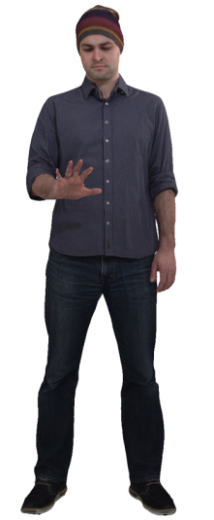
Figure X3 Thomas - content courtesy Volucap

C.2.4.2 Sequence properties
Parameter | Value
Frame rate | 25
#triangles per frame | 30K
Texture resolution | 4K
#frames | 748
Table Y5 Thomas sequence properties dynamic mesh

The sequence can be accessed: https://aspera.pub/I4tSQ8k
3GPP members can request the password by contacting XYZ

C.2.4.3 Copyright and license information
Volucap [Vol-16] kindly made this sequence freely available for 3GPP internal usage under license. License “License_Volucap_T003_ThomasScenic-03” is provided in the directory with the sequence.

C.2.5 Nathalie test sequence

C.2.5.1 Description
Nathalie is performing a classic dance, as such the sequence is dynamic.
Figure X4 Nathalie - content courtesy Volucap

C.2.5.2 Sequence properties
The tables Y6 and Y7 summarize the properties of the Mitch sequence

Parameter | Value
Frame rate | 30
#frames | 300
Mean #point / frame | 1.640.033
Attributes | RGB
Normals | Yes
Geometry Precision | 11
Attribute Precision | 8
Normal Precision | Float
Table Y6 Nathalie sequence properties dense dynamic point cloud

Parameter | Value
Frame rate | 30
#triangles per frame | 30K
Texture resolution | 4K
#frames | 925
Table Y7 Nathalie sequence properties dynamic mesh

The sequence can be accessed: https://aspera.pub/I4tSQ8k
3GPP members can request the password by contacting XYZ

C.2.5.3 Copyright and license information
Volucap [Vol-16] kindly made this sequence freely available for 3GPP internal usage under license. License “AOM_License Volucap_rp_nathalie_4d_001_dancing-20211214_Gsplats” is provided in the directory with the sequence.

C.2.6 Steam Roller test sequence

C.2.6.1 Description
Steam Roller is a performance on a BMX bike. Particularity with the sequence is that a moving person and an object (bicycle) are captured in one asset and that there are fast movements.
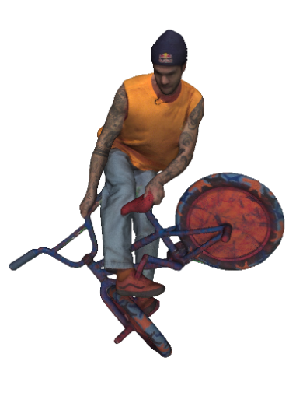
Figure X5 Steam Roller - content courtesy Volucap

C.2.6.2 Sequence properties
The table Y8 summarizes the properties of the Steam Roller sequence

Parameter | Value
Frame rate | 30
#triangles per frame | 70K
Texture resolution | 8K
#frames | 493
Table Y8 Steam Roller sequence properties dynamic mesh

The sequence can be accessed: https://aspera.pub/I4tSQ8k
3GPP members can request the password by contacting XYZ

C.2.6.3 Copyright and license information
Volucap [Vol-16] kindly made this sequence freely available for 3GPP internal usage under license. License “AOM_License Volucap_Rec030_Steam_Roller_no_hands_Gsplats” is provided in the directory with the sequence.

C.2.7 Aliyah test sequence

C.2.7.1 Description
Aliyah is performing a modern dance, as such the sequence is pretty dynamic.
Figure X6 DancingAliyah - content courtesy Renderpeople

C.2.7.2 Sequence properties
The tables Y9 and Y10 summarize the properties of the Aliyah sequence

Parameter | Value
Frame rate | 30
#frames | 300
Mean #point / frame | 1.835.544
Attributes | RGB
Normals | Yes
Geometry Precision | 11
Attribute Precision | 8
Normal Precision | Float
Table Y9 Aliyah sequence dense dynamic point cloud

Parameter | Value
Frame rate | 30
#triangles per frame | 30K
Texture resolution | 4K
#frames | 1112
Table Y10 Aliyah sequence properties dynamic mesh
Renderpeople [Vol-23] provides a free and publicly downloadable “4D People” source sequence under license. This source sequence is provided in file formats for 3ds Max, Maya, Blender, Cinema 4D and Alembic and can be stored or converted to mesh or dense point cloud format.
The sequence can be accessed: https://renderpeople.com/free-3d-people/
Select then the free sequence under 4D People

C.2.7.3 Copyright and license information
General terms and conditions can be found here: https://renderpeople.com/general-terms-and-conditions/

C.2.8 Henry test sequence

C.2.8.1 Description
Henry is performing a stretching exercise, as such the sequence is dynamic.
Figure X7 Henry - content courtesy Renderpeople

C.2.8.2 Sequence properties
The tables Y11 and Y12 summarizes the properties of the Henry sequence

Parameter | Value
Frame rate | 30
#frames | 300
Mean #point / frame | 1.818.531
Attributes | RGB
Normals | Yes
Geometry Precision | 11
Attribute Precision | 8
Normal Precision | Float
Table Y11 Henry sequence properties dense dynamic point cloud

Parameter | Value
Frame rate | 30
#triangles per frame | 30K
Texture resolution | 4K
#frames | 733
Table Y12 Henry sequence properties dynamic mesh
Renderpeople[Vol-24] provides a catalogue of currently 130 “4D People” under license and the catalog is growing. These source sequences are provided in file formats for 3ds Max, Maya, Blender, Cinema 4D and Alembic and can be stored or converted to mesh or dense point cloud format. Sequences from the 4D catalog are not free and need to be purchased. Henry is one of the sequences in the catalog that has been picked up as it is dynamic and different from the other presented sequences.
The “4D People” shop is accessible here: https://renderpeople.com/3d-people/?_product=4d-people

C.2.8.3 Copyright and license information
General terms and conditions can be found here: https://renderpeople.com/general-terms-and-conditions/

C.2.9 Ultra Video Group of Tampere University test sequences

C.2.9.1 Description
Ultra Video Group of Tampere University [Vol-25] kindly provides 12 downloadable sequences @25 fps under license.
Detailed descriptions and thumbnails are directly available on the website and are not reproduced here.

C.2.9.2 Sequence properties
All sequences can be downloaded as dense dynamic point cloud or as dynamic mesh. Different quality levels are proposed when downloading.
The table Y13 summarizes the properties of the UVG sequences

Parameter | Value
Frame rate | 25
#frames | 250
Mean #point / frame | Depends per sequence and on geometry precision
Attributes | RGB
Normals | Yes
Geometry Precision | 9, 10, 11 and 12 bit
Attribute Precision | 8
Normal Precision | 9, 10, 11 or 12 bit integer
Table Y13 UWG sequences properties dynamic point cloud

C.2.9.3 Copyright and license information
The license agreement can be found here: https://ultravideo.fi/UVG-VM/UVG-VM_LICENSE_AGREEMENT.pdf

C.2.10 Owlii Inc test sequences

C.2.10.1 Description
Owlii Inc [DM-9]. makes available 2 dynamic human mesh sequences basketball_player and dancer.
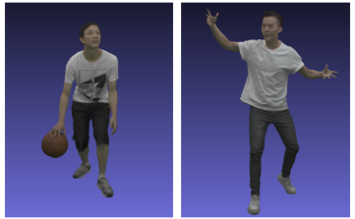
Figure X8 basketball_player and dancer - Owlii Inc

C.2.10.2 Sequence properties
All sequences can be downloaded as dynamic mesh. The Table Y14 summarizes the properties of the Owlii Inc sequences.
Table Y14 Owlii Inc sequences properties dynamic mesh
Test material dataset filename | #Frames | #Vertices | #Faces | Geometry Precision | Texture Coord. Precision | Texture Map Size
basketball_player [DM-9] | 600 | 20k | 40k | 12 bits | 12 bits | 2k x 2k
dancer [DM-9]. | 600 | 20k | 40k | 12 bits | 12 bits | 2k x 2k

The sequence can be accessed:
- Owlii Dynamic Human Textured Mesh Sequence Dataset: https://mpeg-pcc.org/index.php/pcc-content-database/owlii-dynamic-human-textured-mesh-sequence-dataset/

C.2.10.3 Copyright and license information
The sequences are used as potential test material for MPEG standardization efforts, as well as non-commercial use subject to the accompanying license agreement by the wider research community.
Editor’s Note: The licences for using these datasets in 3GPP need to be checked.

C.2.11 Vologram Ltd test sequences

C.2.11.1 Description
Vologram Ltd [DM-10] makes 2 available dynamic human mesh sequences levi and Rafa.
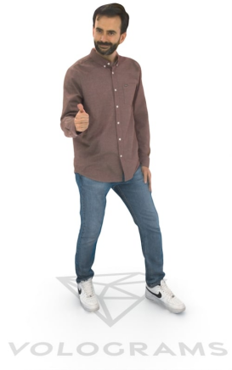
Figure X9 levi and Rafa - Vologram Ltd

C.2.11.2 Sequence properties
All sequences can be downloaded as dynamic mesh. The Table Y15 summarizes the properties of the Vologram Ltd sequences.
Table Y15 Vologram Ltd sequences properties dynamic mesh
Test material dataset filename | #Frames | #Vertices | #Faces | Geometry Precision | Texture Coord. Precision | Texture Map Size
levi [DM-10] | 150 | 20k | 40k | 12 bits | 13 bits | 4k x 4k
Rafa [DM-10] | 150 | 20k | 40k | 12 bits | 13 bits | 4k x 4k

The sequence can be accessed:
- Vologram research dataset: https://www.volograms.com/research-datasets

C.2.11.3 Copyright and license information
The sequences are used as potential test material for MPEG standardization efforts, as well as non-commercial use subject to the accompanying license agreement by the wider research community.
Editor’s Note: The licences for using these datasets in 3GPP need to be checked.

C.2.12 Exercise test sequences

C.2.12.1 Description
The sequence is captured by a lightweight capture system, equipped with 4 Azure KinectTM depth cameras and proprietary 3D reconstruction algorithms, is capable of capturing and reconstructing dynamic mesh sequences. It can reconstruct 29.9695 frames per second, with each dynamic human mesh containing more than 50K triangles. The texture maps have resolutions ranging from 1K to 8K (depends on the settings).
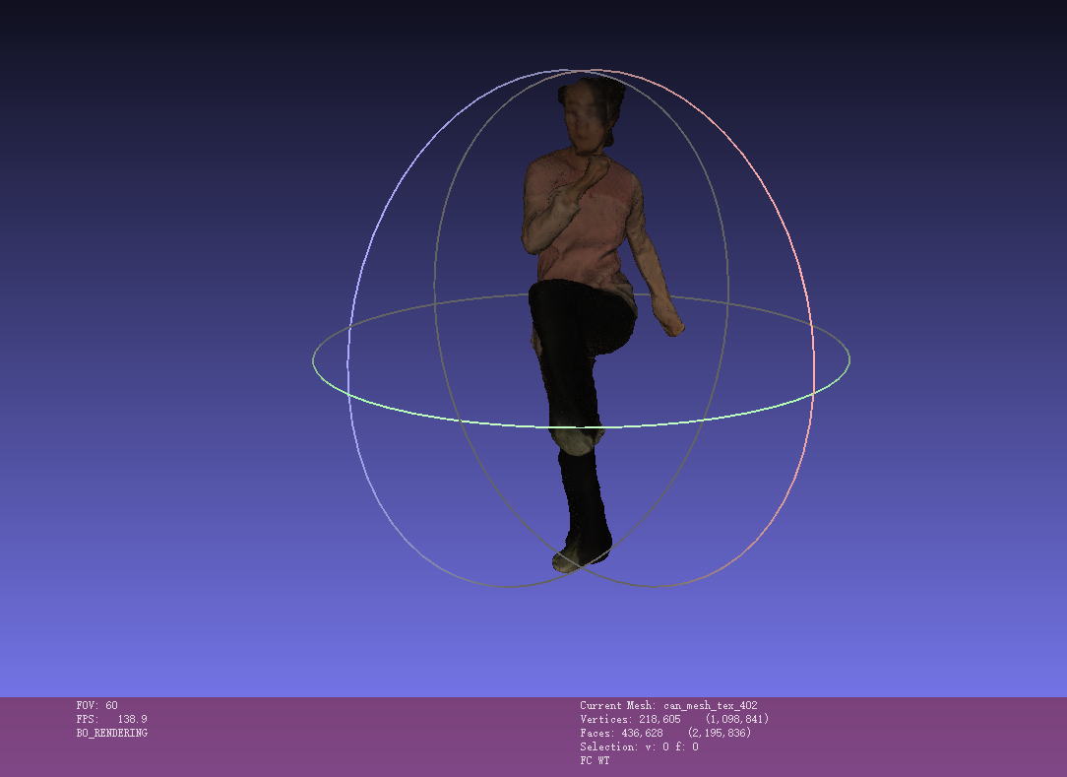
Figure X9 Exercise’s Sequence

C.2.12.2 Sequence properties
The sequence can be downloaded as dynamic mesh. The dynamic human mesh containing more than 50K triangles. The texture maps have resolution of 8K (depends on the settings).
Table Y16 Exercise sequence properties dynamic mesh
Test material dataset filename | #Frames | #Vertices | #Faces | Geometry Precision | Texture Coord. Precision | Texture Map Size
live_model_guangboticao_8192 | 200 | 40k | 80k | 12 bits | 13 bits | 8192*8192

The dataset contain one PNG file representing texture, one MTL representing material, and one OBJ file representing geometry for each mesh frame.
The sequence can be accessed: https://www.dropbox.com/scl/fi/rkbw1sb2i8nbcm69po00m/live_model_guangboticao_8192.zip?rlkey=qza774eses1p1jfiybe50c1j2&st=gabk43hw&dl=0
3GPP members can request the password by contacting xujiayi@chinamobile.com.

C.2.12.3 Copyright and license information
Exercise © 2025 by XU is licensed under CC BY-ND 4.0. To view a copy of this license, visit https://creativecommons.org/licenses/by-nd/4.0/

C.3 Test Sequences for UE-to-UE Stereoscopic Video Live Streaming

C.3.1 Overview
This annex presents candidate test sequences that are available for testing. Some sequences have been made freely available to 3GPP under license agreement but cannot be made publicly available. Some sequences are free and publicly available for download by respecting the license.

C.3.2 Street View - captured test sequence

C.3.2.1 Description
Real-time street view capture using stereoscopic cameras, combining moving pedestrians, vehicles, and static background elements in a single 3D scene.
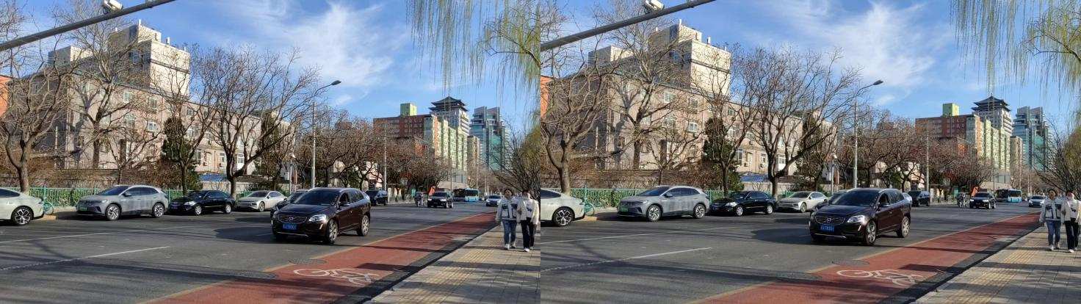
Figure C.3.2.1-1 StreetView - captured

C.3.2.2 Sequence properties
The tables Y1 summarizes the properties of the StreetView captured sequence
Parameter | Value
Resolution | 1920 ×1080 (Per Eye)
Frame Rate | 30
Bit Depth | 8
Length | 344
YUV format | 4:2:0
Color Component | ITU-R.BT2020
Color Space | HDR PQ
Table Y1 StreetView - captured sequence properties
The sequence can be accessed: https://pan.baidu.com/s/18ZQXrdm3LTTvV4JDE0sr2A?
3GPP members can request the password by contacting xujiayi@chinamobile.com.

C.3.2.3 Copyright and license information
sbs_streatView_data © 2025 by Jie Li is licensed under CC BY-ND 4.0. To view a copy of this license, visit https://creativecommons.org/licenses/by-nd/4.0/

C.3.3 Cute Dog - Captured test sequence

C.3.3.1 Description
A cute dog plays in the road. The scene is dynamic, with lively movements and detailed fur textures.

Figure C.3.3.1-1 Cute Dog - Captured

C.3.3.2 Sequence properties
The tables Y2 summarizes the properties of the Cute Dog - Captured sequence
Parameter | Value
Resolution | 1920 ×1080 (Per Eye)
Frame Rate | 30
Bit Depth | 8
Length | 505
YUV format | 4:2:0
Color Component | ITU-R.BT2020
Color Space | HDR PQ
Table Y2 Cute Dog - Captured sequence properties
The sequence can be accessed: https://pan.baidu.com/s/1DgjHpQJ8I-jay75PjCj3NQ?
3GPP members can request the password by contacting xujiayi@chinamobile.com.

C.3.3.3 Copyright and license information
sbs_Cute_Dog © 2025 by Jie Li is licensed under CC BY-ND 4.0. To view a copy of this license, visit https://creativecommons.org/licenses/by-nd/4.0/

C.3.4 Moving Girl - Captured test sequence

C.3.4.1 Description
The girl presents a doll and a signboard to the audience, with particularly strong 3D depth effects visible especially when she extends the objects toward the camera.
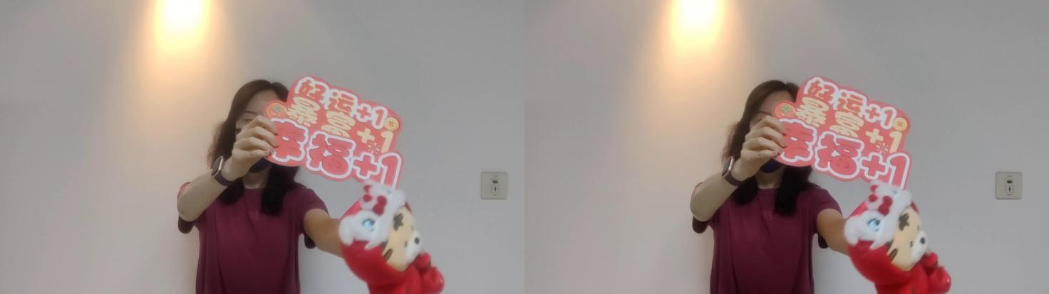
Figure C.3.4.1-1 MovingGirl-Captured

C.3.4.2 Sequence properties
The tables Y3 summarizes the properties of the MovingGirl-Captured sequence
Parameter | Value
Resolution | 1920 ×1080 (Per Eye)
Frame Rate | 30
Bit Depth | 8
Length | 312
YUV format | 4:2:0
Color Component | ITU-R.BT2020
Color Space | HDR PQ

Table Y3 MovingGirl-Capture properties
The sequence can be accessed: https://pan.baidu.com/s/1rpdbtxs7TrLGla8sYAvC8w?
3GPP members can request the password by contacting xujiayi@chinamobile.com.

C.3.4.3 Copyright and license information
TestSequence_JuneXie_2 © 2025-03-26 by June Xie is licensed under CC BY-ND 4.0. To view a copy of this license, visit https://creativecommons.org/licenses/by-nd/4.0/

C.3.5 Street View - Generated test sequence

C.3.5.1 Description
The sequence uses the left view of the stereoscopic videos collected in Annex C.3.2 as input, and generate the right view through AI algorithms to synthesize side-by-side stereoscopic videos.
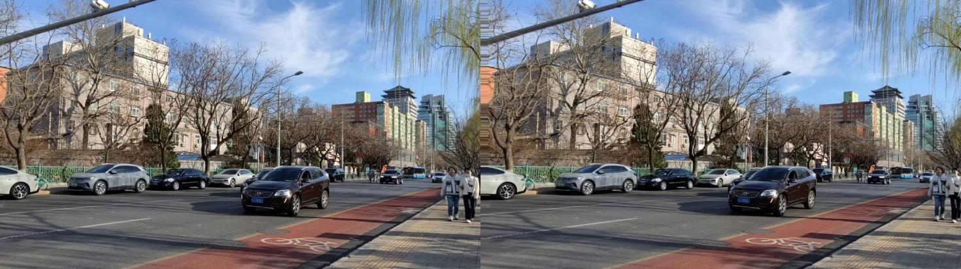
Figure C.3.5.1-1 StreetView - Generated

C.3.5.2 Sequence properties
The StreetView - generated sequence has same properties as defined in C 3.2.2, it can be accessed: https://pan.baidu.com/s/16tKuVdLWMfyrtm8JbA4QVw
3GPP members can request the password by contacting xujiayi@chinamobile.com.

C.3.5.3 Copyright and license information
Streetview_lina_generated © 2025 by Lina is licensed under CC BY-ND 4.0. To view a copy of this license, visit https://creativecommons.org/licenses/by-nd/4.0/

C.3.6 Cute Dog - Generated test sequence

C.3.6.1 Description
The sequence uses the left view of the stereoscopic videos collected in Annex C.3.3 as input, and generate the right view through AI algorithms to synthesize side-by-side stereoscopic videos.

Figure C.3.6.1-1 Cute Dog - Generated

C.3.6.2 Sequence properties
The Cute Dog - generated sequence has same properties as defined in C 3.3.2, it can be accessed: https://pan.baidu.com/s/1TVTtsHriJMeXflrd3CweFQ
3GPP members can request the password by contacting xujiayi@chinamobile.com.

C.3.6.3 Copyright and license information
Dog_lina_generated © 2025 by Lina is licensed under CC BY-ND 4.0. To view a copy of this license, visit https://creativecommons.org/licenses/by-nd/4.0/

C.3.7 Moving Girl - Generated test sequence

C.3.7.1 Description
The sequence uses the left view of the stereoscopic videos collected in Annex C.3.4 as input, and generate the right view through AI algorithms to synthesize side-by-side stereoscopic videos.
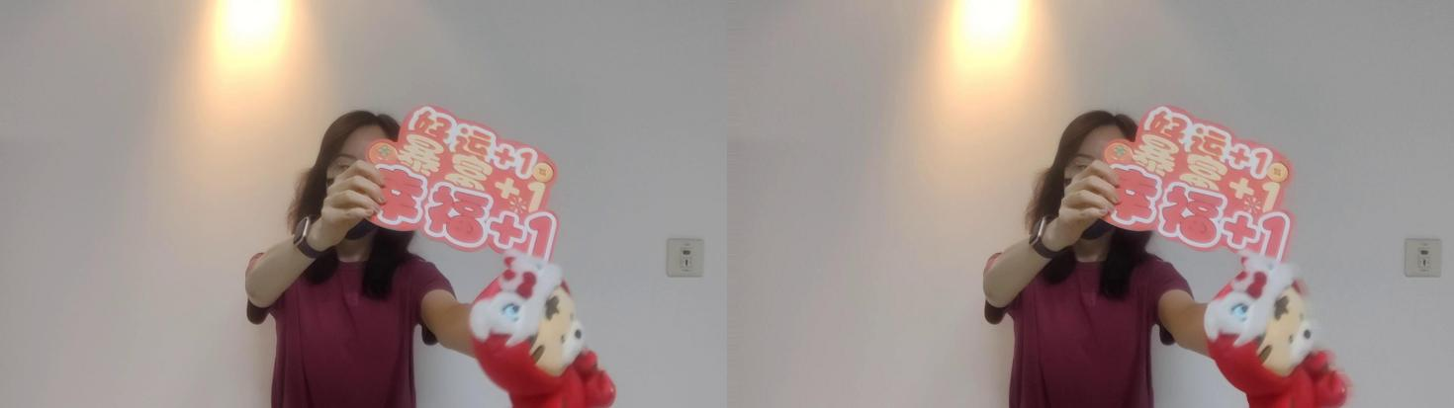
Figure C.3.7.1-1 Moving Girl - Generated

C.3.7.2 Sequence properties
The Moving Girl - generated sequence has same properties as defined in C 3.4.2, it can be accessed: https://pan.baidu.com/s/1aduJg1C_6j3tq3_-3p7aIw?
3GPP members can request the password by contacting xujiayi@chinamobile.com.

C.3.7.3 Copyright and license information
TestSequence_JuneXie_1 © 2025-03-26 by June Xie is licensed under CC BY-ND 4.0. To view a copy of this license, visit https://creativecommons.org/licenses/by-nd/4.0/

Annex D: Software Package

D.1 Introduction
<TBD>

D.2 Video Processing

D.2.1 Overview
<TBD>

D.2.2 Common Color Conversion
A Python script for converting YUV to RGB format can be found blow:
- import cv2
- import subprocess

- def videoInfo(filename):
- proc = subprocess.run([
- *"ffprobe -v quiet -print_format json -show_format -show_streams".split(),
- filename
- ], capture_output=True)
- proc.check_returncode()
- return json.loads(proc.stdout)

- def readVideo(filename):
- cmd = ["ffmpeg", "-i", filename]
- streams = 0
- for stream in videoInfo(filename)["streams"]:
- index = stream["index"]
- if stream["codec_type"] == "video":
- width = stream["width"]
- height = stream["height"]
- cmd += "-map", f"0:{index}"
- streams = streams + 1
- cmd += "-f", "rawvideo", "-pix_fmt", "rgb24", "-"
- shape = np.array([streams, height, width, 3])
- with subprocess.Popen(cmd, stdout=subprocess.PIPE) as proc:
- while True:
- # One byte per each element
- data = proc.stdout.read(shape.prod())
- if not data:
- return
- yield np.frombuffer(data, dtype=np.uint8).reshape(shape)

- if __name__ == '__main__':
- import matplotlib.pyplot as plt
- from PIL import Image
- idx = 1
- for left, right in readVideo("./StereoCaptured.mp4"):
- # concatenate left and right
- img = np.concatenate((left[0:1080,:], right[0:1080,:]), axis=1)
- img = Image.fromarray(img)
- img.save(f"imgs/{idx}.jpg")
- idx += 1

D.2.3 Video Composition
A Python script for reading the right/left views and concatenating them into one video frame can be found below:
- import numpy as np
- import json
- import subprocess

- def videoInfo(filename):
- proc = subprocess.run([
- *"ffprobe -v quiet -print_format json -show_format -show_streams".split(),
- filename
- ], capture_output=True)
- proc.check_returncode()
- return json.loads(proc.stdout)

- def readVideo(filename):
- cmd = ["ffmpeg", "-i", filename]
- streams = 0
- for stream in videoInfo(filename)["streams"]:
- index = stream["index"]
- if stream["codec_type"] == "video":
- width = stream["width"]
- height = stream["height"]
- cmd += "-map", f"0:{index}"
- streams = streams + 1
- cmd += "-f", "rawvideo", "-pix_fmt", "rgb24", "-"
- shape = np.array([streams, height, width, 3])
- with subprocess.Popen(cmd, stdout=subprocess.PIPE) as proc:
- while True:
- # One byte per each element
- data = proc.stdout.read(shape.prod())
- if not data:
- return
- yield np.frombuffer(data, dtype=np.uint8).reshape(shape)

- if __name__ == '__main__':
- import matplotlib.pyplot as plt
- from PIL import Image
- idx = 1
- for left, right in readVideo("./StereoCaptured.mp4"):
- # concatenate left and right
- img = np.concatenate((left[0:1080,:], right[0:1080,:]), axis=1)
- img = Image.fromarray(img)
- img.save(f"imgs/{idx}.jpg")
- idx += 1

D.2.4 FFmpeg Tools
FFmpeg is a universal media converter. It can read a wide variety of inputs - including live grabbing/recording devices - filter, and transcode them into a plethora of output formats.
- An FFmpeg 7.0 command for storage each frame into .yuv:
- ffmpeg -start_number 1 -r 30 -i %d.jpg -pix_fmt yuv420p -s 1920x1200 out.yuv

D.3 Scenario 2 Processing

D.3.1 Overview
The generation of objective metrics and 2D videos for subjective viewing for scenario 2 is supported by a software package provided in this repository: https://github.com/XXX/Beyond2D-pointcloud
The software package permits the following functionalities:
- Test sequence preparation
- Bitstream generation and objective metric generation
- 2D video generation using a camera path for subjective viewing

D.3.2 Installation

D.3.2.1 Cloning
git clone https://github.com/XXX/Beyond2D
cd Beyond2D
Please use a python virtual environment to install dependencies and run the scripts. A requirements.txt file is provided such that a suitable virtual environment can be set-up as follows:
python3 -m venv venv
venv\Scripts\activate # on Windows
. venv/bin/activate # on Linux
python -m pip install –upgrade pip
pip install -r requirements.txt

D.3.2.2 Working Directory
The scripts assume that the current directory is a local working directory, at the root of the repository.

D.3.3 Test sequence preparation

D.3.3.1 Dense dynamic point cloud
This clause describes how reference sequences provided in dynamic mesh format are converted to the dense dynamic point cloud format with the target quality (vox11, approximately 2M points/frame). Please follow instructions in annex C.2 for downloading the sequences Mitch, Joggle Soccer, Nathalie, Aliyah and Henry in dense dynamic mesh format. The sequences Aliyah and Henry are provided as Blender project and generation of dense dynamic mesh is described in the complementary document doc/readme_ply_generation.docx in the repository.

D.3.3.1.1 Generation of target dense dynamic point clouds
To proceed with the generation, the user needs to navigate to the /ply_generation/ directory, which contains:
- *.py: Python scripts for generating PLY (point cloud) files.
- output_info/: Directory containing all expected md5sum result files for meshes (*_mesh_md5.txt) and PLY files (*_output.log) for each sequence.
- jsons/: Directory with an example of input configuration files.-
A JSON file named 3gpp_selection.json is provided as input and is located in the jsons/ directory. It contains all information listed in Table D1. This JSON file needs to be updated for each sequence with the correct paths to the meshes for your environment (MeshObjPath and MeshTxtPath).
Table D1 conversion parameters
Sequence | Geo Quantization Bitdepth | Ratio | 1st Frame Index | Frame Number
Mitch | 11 | 0.70 | 1 | 475
JuggleSoccer | 11 | 1 | 0 | 125
Henry | 11 | 0.75 | 1 | 733
Nathalie | 11 | 1 | 1 | 925
Aliyah | 11 | 0.88 | 1 | 1112

Once the JSON file is updated with the correct mesh paths, the PLY generation can be launched using the script exec_ply_generation.py which goes through the following steps:
- The MPEG mmetric software [DM-18] is automatically downloaded to the output directory within the dependencies directory.
- A sampling pass gathers information on the sequence for quantifying the number of expected points. A ratio is provided via the JSON file to ensure each sequence generates point clouds with approximately 2M points/frame.
- Quantization pass.
- Cleaning pass: This step removes all duplicate points using PyntCloud in Python.
The script is launched from the python environment with the following command:
python3 ply_generation/exec_ply_generation.py -i ply_generation/jsons/3gpp_selection.json -o $YOUR_OUTPUT_PATH
For help on the script see complementary document doc/readme_ply_generation.docx in the doc folder installed by Git.
In the output directory, you will find the generated PLY files and corresponding log files for each sequence.
To ensure the PLY generation proceeded as expected, md5 checksums for meshes, the number of points and the md5 checksums for point clouds are provided for each frame of each sequence. These details are compiled into a single file per sequence and stored in ply_generation/output_info.

D.3.4 Bitstream and objective metric generation

D.3.4.1 Dense dynamic point cloud
This clause assumes that all test sequences are available in the dense point cloud representation format as described in clause D.3.3.1. This clause describes how to execute the text environment using the provided scripts. Deeper information on the functioning of the scripts is given the documentation installed via Git. Interested users are referred to the document doc/readme_ply_to_bin.docx in the repository.

D.3.4.1.1 Executing tests
Python scripts are provided to:
- Build the test environment under the output “dependencies” directory. The MPEG V-PCC test model [VOL-26] will be used to encode and decode test sequences. The MPEG mmetric software [DM-18] will be used to compute metrics. These tools are automatically downloaded and built by the script.
- Perform tests, including:
- Encode each sequence for each condition, rate point and profile.
- Decode the corresponding sequence.
- Compute the objective metrics.
- Generate CSV tables and graph worksheets.
To execute the tests, the user should navigate to the “ply_to_bin/” directory, which contains:
- *.py: Python scripts to encode, decode, compute metrics and generate CSV and XLSM workbooks.
- templates/: Directory with template XLSM sheet used for graph generation.
- jsons/: Directory with configurations
- sequences.json: Describes the list of input sequences to test. It contains information on the location of point cloud sequences and has to be set by the user to point to the right location. It also has information on the name of the configuration file used for the encoding step (${test_sequence}.cfg).
- 3gpp_test_configuration.json: Describes the test lists to perform. For each profile, it defines the encoding parameters ("—profileToolsetIdc, --profileReconstructionIdc, --mapCountMinus1), the number of frames to test (typically 300) and the list of sequences to be tested. This list includes:
- The “id” corresponding to the one set in the sequences.json file.
- The condition to test, here, random access.
- A list of 5 rate points as defined in Table D2.
Table D2 with QP selection for obtaining the fixed target bitrates
Rate | Target Bitrate (mbps) | S01 Mitch |  |  | S02 Juggle Soccer |  |  | S03 Henry |  |  | S04 Nathalie |  |  | S05 Aliyah
 |  | QP  Geo | QP  Att | Occ  Prec | QP  Geo | QP  Att | Occ  Prec | QP  Geo | QP  Att | Occ  Prec | QP  Geo | QP  Att | Occ  Prec | QP  Geo | QP  Att | Occ  Prec
R01 | 5 | 29 | 33 | 4 | 30 | 39 | 4 | 23 | 34 | 4
R02 | 10 | 23 | 29 | 2 | 19 | 35 | 2 | 15 | 30 | 2
R03 | 20 | 19 | 25 | 2 | 11 | 28 | 2 | 8 | 26 | 2
R04 | 30 | 15 | 23 | 2 | 9 | 24 | 2 | 7 | 23 | 2
R05 | 50 | 11 | 21 | 2 | 5 | 21 | 2 | 6 | 20 | 2

Editor’s note: Table to be completed for Nathalie and Aliyah
A script “exec_binGenerator.py” is provided to automate all steps including encoding, decoding, objective metrics computation and output generation. It can be launched from your Python environment with the following command:
python exec_binGenerator.py -o $YOUR_OUTPUT_DIR -i jsons/sequences.json -t jsons/test_configuration.json
For help on the script see the complementary document readme_ply_to_bin in the doc folder installed by Git.
The output directory structure is:
- cmd: Directory with job command and logs.
- dependencies: Compilation of TMC2 and mmetric software used to perform the test.
- A list “Fyy_ProfileName” directories with Fyy corresponds to the number of tested frames, ProfileName corresponds to the tested profile and includes generated bitstreams.
- A list of CSV files with extracted metric information per profile for a given number of frames.
- Excel worksheets with graphs per profile for a given number of frames.

D.3.4.1.2 Objective results
CSV and workbook files are automatically generated by the scripts. The output log containing all metrics information is used to extract metrics and a build CSV files. Each CSV file concatenates metrics information for each condition and selected profile and is generated for all sequences and rate points.
The following information is stored in a CSV file:
- SeqId: identifier of the sequence
- CondId: tested condition (RA)
- RateId: tested rate number [R1..R5]
- nbFrame: number of tested frames
- NbInputPoints: number of points in the source sequence
- NbOutputPoints: number of points in the candidate test sequence
- MeanOutputPoints: mean number of points in the candidate test sequence
- MeanDuplicatePoints: mean number of duplicated points (with same geometry) in the candidate test sequence
- TotalBitstreamBits: size of the bistream in bits
- geometryBits: size of the geometry stream in bits
- metadataBits: size of the metadata stream in bits
- attributeBits: size of the attribute stream in bits
- D1Mean: mseF,PSNR (p2point)
- D2Mean: mseF,PSNR (p2plane)
- LumaMean: c[0],PSNRF
- CbMean: c[1],PSNRF
- CrMean: c[2],PSNRF
- PCQM: PCQM PSNR
- SelfEncoderRuntime: encoder time for current process
- ChildEncoderRuntime: encoder time for child processes
- SelfDecoderRuntime: decoder time for current process
- ChildDecoderRuntime: decoder time for child processes
From the CSV file, an excel spreadsheet is generated from the template xlsm sheet (in the “templates” directory) to get tables and graphs for interpretation of the results.

D.3.5 Video generation

D.3.5.1 Dense dynamic point cloud
This clause describes how to generate 2D videos with a predefined camera path. It is assumed that test sequences are available either in raw dense point cloud format or as bitstream encoded with V-PCC. Please check clauses D.3.3 and D.3.4 on how to generate these inputs.
The provided scripts use the MPEG V-PCC test model [VOL-26] for decoding V-PCC bitstreams and the MPEG Representative Renderer [VOL-19] to generate videos from PLY files. Both are automatically cloned and built when running the scripts for the first time.
Detailed information on the functioning of the scripts is given in the document doc/readme_bin_to_video.docx in the repository.

Annex E: Testing support material

E.1 3D background models for scenario 2 tests

E.1.1 Introduction
Volumetric Video test sequences presented in annex C.2 contain single assets without background. For subjective tests of scenario 2 representation formats, videos using a camera path are generated on top of a neutral background and of a 3D background model. The purpose of the 3D background model is to enable the evaluation of interference between a test sequence and a background. For example, artefacts of the borderline of a test sequence may be less visible in front of a background model than on a neutral background, see clause 7.3.4.3 where the impact of a background is explained and illustrated. The focus of the subjective evaluation should be on the test sequence itself and not the background, the background is only a support.
This chapter presents three 3D background models that are free of charge and publicly available under license.

E.2 Crouch End Station 3D background model

E.2.1 Description
This model presents the remains of the Crouch End Station in London.
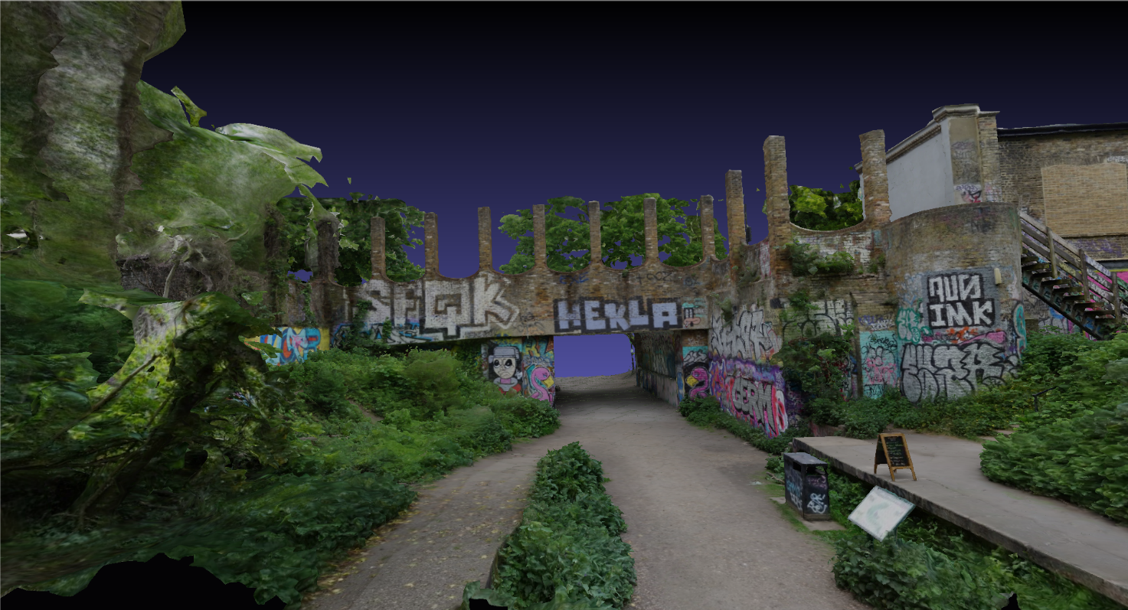
Figure E2.1 Remains Crouch End Station – content courtesy artfletch / Sketchfab

E.2.2 Copyright and license information
The Remains Crouch End Station 3D background model is available under the Creative Commons license: https://creativecommons.org/licenses/by/4.0/
This model is free of charge and publicly available.

E.3 Great Drawing Room 3D background model

E.3.1 Description
This model represents the Great Drawing Room of the Hallwyl Museum in Stockholm/Schweden. The room is inspired by the baroque style of the 17th century.
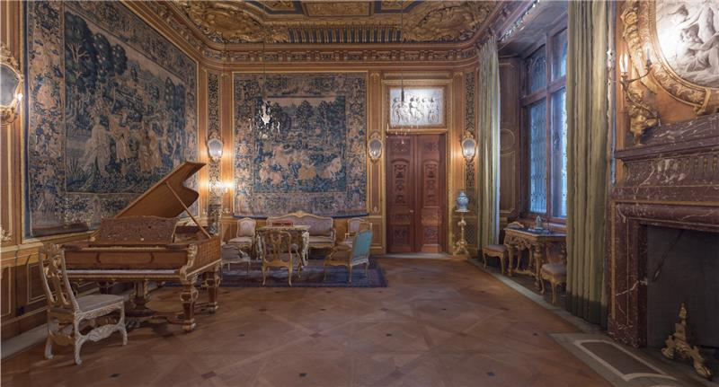
Figure Z2 Great Drawing Room – content courtesy The Hallwyl Museum / Sketchfab
This background model can be publicly accessed: https://sketchfab.com/3d-models/the-great-drawing-room-feb9ad17e042418c8e759b81e3b2e5d7

E.3.2 Copyright and license information
The Great Drawing Room 3D background model is available under the Creative Commons license: https://creativecommons.org/licenses/by/4.0/
This model is free of charge and publicly available.

E.4 Southbank Undercroft Skatepark 3D background model

E.4.1 Description
This model represents a skate park in the Underscoft neneath Queen Elizabeth Hall on the Southbank, London.
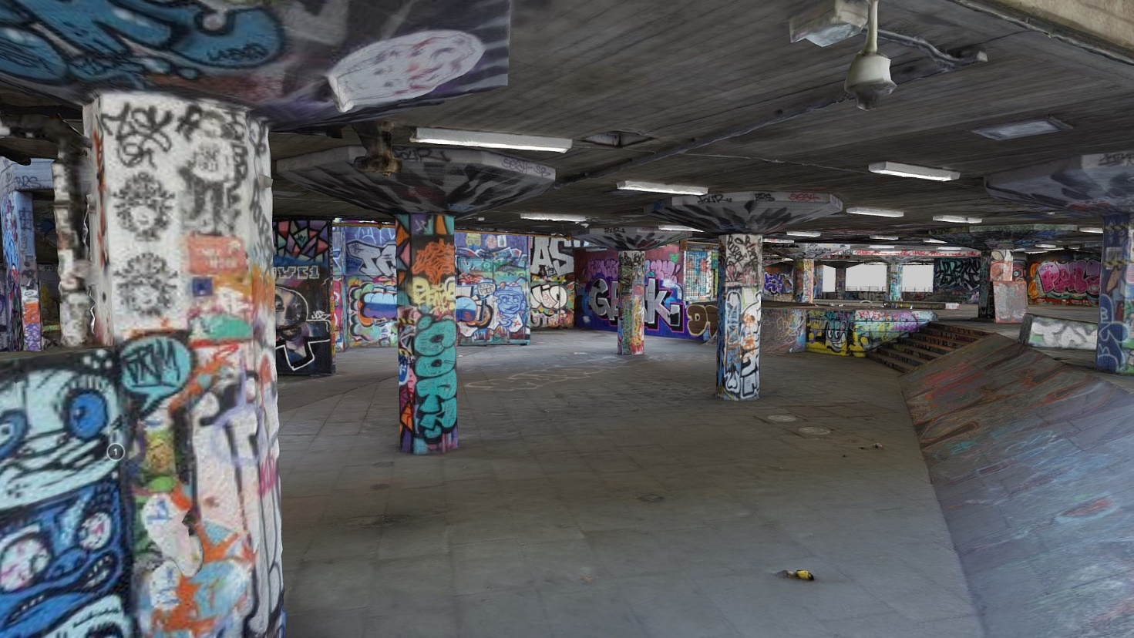
Figure Z3 Southbank Undercroft Skatepark – content courtesy artfletch / Sketchfab
The background model can be publicly accessed: https://sketchfab.com/3d-models/southbank-undercroft-skatepark-add37d5dc6a2456eb0d7607c6fbd884d

E.4.2 Copyright and license information
The Southbank Undercroft Skatepark background model is available under the Creative Commons license: https://creativecommons.org/licenses/by/4.0/
This model is free of charge and publicly available.

Annex F: Data Management and Hosting

F.1 Reference Sequences

F.1.1 Hosting
Data for reference sequences are hosted at the public server:
https://dash-large-files.akamaized.net/WAVE/3GPP/Beyond2D/ReferenceSequences/
Below this folder, for each reference sequence a dedicated folder with the name of the sequence is created. The folder includes at least the following information:
- JSON file for raw content according to schema in clause B.2, depending on the representation format.
In addition, the folder may include the following information:
- the raw sequence, if hosted on the public server,
- a preview file,
- a thumbnail image.
For some reference sequences the license may not allow storage on the indicated public server and in this case additional servers including information how to obtain the credentials are listed below.

F.1.1.1 Scenario 2
Freely available reference sequences to 3GPP members coming from the content providers Volucap and XD Productions are hosted at:
https://aspera.pub/I4tSQ8k
3GPP members can request credentials by sending a request per email to: 3GPP_B2D_Datasets@interdigital.com
The folder hierarchy follows the same structure as on the public server and information provided here is complementary to the public server.

F.1.2 Uploading
For uploading a new reference sequence to the public server, please create a new issue here:
- https://github.com/haudiobe/Beyond2D-Content/issues/new?assignees=&labels=request&template=reference_sequence.md&title=
Please specify all information that needs to be added to the JSON file for raw video sequences as defined in clause B.2.

F.1.3 Downloading
Sequences can be downloaded from the above servers and folders. Licensing terms must be obeyed. Downloaded files should be MD5 verified.
On Windows
Open Command Prompt
Open your downloads folder by typing cd Downloads. ...
Type certutil -hashfile followed by the file name and then MD5
Check that the value returned matches the value the MD5 file you downloaded from the json
On Mac
Open Terminal
Type md5 and hit the SPACE button
Drag the file you have downloaded into the Terminal Window. ...
Hit Enter
You should now see the MD5 Checksum so you can compare it to the string you have been given in json
On Linux
Open Terminal
Type md5 and add file name – hit enter
Verify the json provided MD5

F.2 Anchors and Tests

F.2.1 Hosting
Test results are hosted at the public server:
https://dash-large-files.akamaized.net/WAVE/3GPP/Beyond2D/Bitstreams/.
Below this folder, a hierarchy is created:
- Scenario
- Codec
- Metrics (contains all metrics)
- Videos (contains all videos for subjective viewing)
- Characterization (contains all characterization results)
- CFG (contains all cfgs)
- streams.csv (Documents the streams and generation)
- videos.csv (Documents the videos)
- crosscheck.csv (documents all cross-check results)
- verification.csv (documents all verification results)
The folder includes at least the following information:
- JSON file for binary video according to schema in clause B.2.2.
- Potentially log files
A basis example hierarchy is as follows:
/Bitstreams
/Scenario-2
/V-PCC
/Metrics
/Videos
/Aliya
For some reference sequences the license may not allow storage of information on the indicated public server and in this case additional servers including information how to obtain the credentials are listed below.

F.2.1.1 Scenario 2
Results for freely available reference sequences to 3GPP members coming from the content providers Volucap and XD Productions are hosted at:
https://aspera.pub/I4tSQ8k
3GPP members can request credentials by sending a request per email to: 3GPP_B2D_Datasets@interdigital.com
The folder hierarchy follows the same structure as on the public server and information provided here is complementary to the public server.
A basis example hierarchy is as follows:
/Bitstreams
/Scenario-2
/V-PCC
/Mitch
/Soccer
/Nathalie

F.2.2 Uploading
For uploading data on the public server, please create a new issue here
- https://github.com/haudiobe/Beyond2D-Content/issues/new?assignees=&labels=request&template=anchor_tuple.md&title=
Please specify all required information that needs to be added to the JSON file for encoded video sequences as defined in clause B.3.

F.2.3 Downloading
Data can be downloaded for free from the above folders. Licensing terms must be obeyed. Downloaded files should be MD5 verified.

Annex <X> (informative):
Change history

Change history
Date | Meeting | TDoc | CR | Rev | Cat | Subject/Comment | New version
2024-04 | SA4#127-bis | S4-240825 |  |  |  | Initial Version | 0.0.1
2024-05 | SA4#128 | S4-240947 |  |  |  | Updated version based on SA4-post 127-bis, 24,May,2024 | 0.0.2
2024-05 | SA4#128 | S4-241319 |  |  |  | Update style and include agreed content in S4-241266, S4-241336 and S4-241318 | 0.0.3
2024-08 | SA4#129-e | S4-241491 |  |  |  | Updated version based on agreed Tdoc S4aV240023, S4aV240040  In SA4-post 128 meeting. | 0.0.4
2024-08 | SA4#129-e | S4-241721 |  |  |  | Updated version based on agreed Tdoc S4-241708, S4-241709 and S4-241710 during SA4#129-e meeting. | 0.1.0
2024-11 | SA4#130 | S4-241867 |  |  |  | Updated version based on agreed Tdoc S4aV240062 during SA4-post 129-e meeting. | 0.1.1
2024-11 | SA4#130 | S4-242196 |  |  |  | Updated version based on agreed Tdoc S4-241997, S4-242000, S4-241871,S4-242098, S4-242199, S4-242226, S4-242227, S4-242193 during SA4 130 meeting. | 0.2.0
2025-02 | SA4#131 | S4-250076 |  |  |  | Updated version based on 1). the agreed Tdoc S4aV250012 from the SA4 post-130 meeting. 2). Editorial updates: Duplicate references within the Draft TR have been resolved, and typos have been corrected. | 0.2.1
2025-02 | SA4#131 | S4-250372 |  |  |  | Updated version based on agreed Tdoc S4-250379, S4-250378, S4-250365, S4-250345, S4-250344, S4-250273, S4-250272, S4-250070, S4-250071, S4-250072, S4-250073 | 0.3.0
2025-04 | SA4#131-bis-e | S4-250680 |  |  |  | Updated version based on agreed Tdoc S4-250727, S4-250729, S4-250731, S4-250732, S4-250717, S4-250718, S4-250677, S4-250678 | 0.4.0

