3GPP TSG-SA WG4 Meeting #132 S4-250985
Japan, Fukuoka, 19 – 23 May 2025 revision of S4-250533

Source: InterDigital Canada
Title: [FS_ARSpatial] Pseudo-CR on IMS Mapping
Spec: 3GPP TR 26.819 v0.4.0
Agenda item: 9.8
Document for: Agreement

1. Introduction
The Study on Spatial Computing for AR Services (FS_ARSpatial) was approved during SA#104 meeting. The objectives of the study include identifying where spatial computing functions run and which media, metadata, and description formats are used for exchange between these elements based on the architecture defined in the TS 26.506, notably in split processing scenarios.
This document provides a mapping of spatial computing functions to the generalized IMS DC architecture to support AR communication described in TS 26.264.
2. Reason for Change
The mapping of network functions related to spatial computing into the general IMS DC architecture to support spatial computing functions in AR communication services.
3. Proposal
It is proposed to agree the following changes to 3GPP TR 26.819 v0.4.0.

* * * First Change * * * *

7.5.3 Potential mapping to Generalized IMS DC Architecture

7.5.3.1 General
A potential mapping of the spatial computing function into the IMS architecture is shown in Figure 7.5.3.1-1.
Figure 7.5.3.1-1: Generalized IMS DC Architecture to support Spatial Computing.
Spatial Computing AR MTSI Client (SR-ARMTSI Client): An AR-MTSI Client, that is responsible for acquiring the UE media capabilities and interacting with the MF during the spatial computing process.
The following reference points from Figure 7.5.3.1-1 are used to enable spatial computing over IMS:
- Mb: Reference point to enable spatial computing between UE and MF.
- Gm: Reference point to support communication between UE and IMS, as specified in TS 23.228 [50].
- MDC1: Reference point for transport of data channel media between data channel media function and DCSF. MF terminates the bootstrap data channel from the UE and forward HTTP traffic between UE and DCSF via MDC1, as specified in TS 23.228 [50].
- MDC2: Reference point for transport of data channel media between data channel media function and AR Application Server, for spatial computing functions between application server to MF. MF relay traffic on A2P/P2A application data channels between the UE and the AR Application Server via MDC2, as specified in TS 23.228 [50].
The following reference points are also used to support spatial computing related procedures:
- DC1: Reference point between the DCSF and the IMS AS, as specified in TS 23.228 [50].
- DC2: Reference point between the IMS AS and MF, for spatial computing related data channel media resource management, as specified in TS 23.228 [50].
- DC3: Reference point between the DCSF and NEF, as specified in TS 23.228 [50].
- DC4: Reference point between the DCSF and AR Application Server, as specified in TS 23.228 [50].
- N33: Reference point between NEF and AR Application server, network exposure to enable spatial computing related applications, as specified in TS 23.501 [51].
NOTE: DC5, ISC, and N5 are out of scope.

7.5.3.2 Call flow for session set up and operation
The general procedure for spatial computing session establishment and operation is shown in the call flow in Figure 7.5.3.2-1.
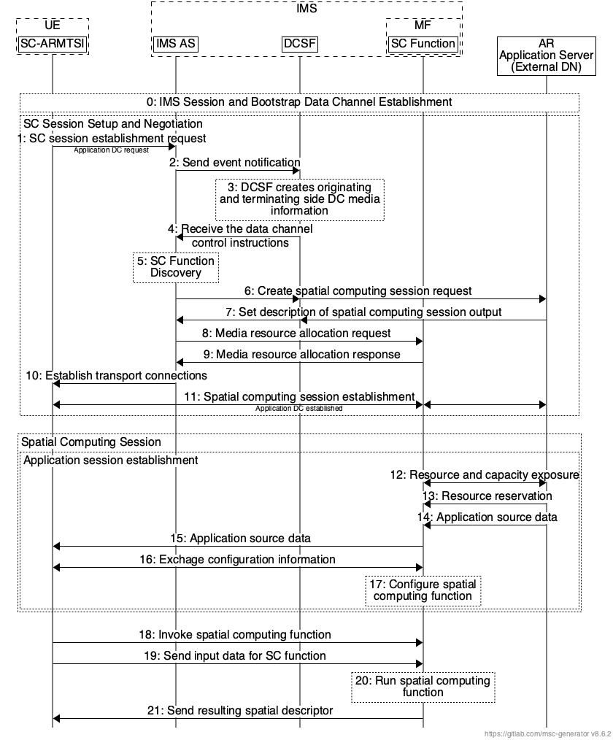
Figure 7.5.3.2-1: General procedure for session establishment and operation in IMS DC architecture.
The steps are as follows:
0: The UE initiates an IMS session, including bootstrap data channel establishment, with the originating Media Function.
1: UE sends a request to IMS AS to establish an application data channel for a spatial computing session. The UE can initiate a request for spatial computing session establishment if its spatial computing capabilities cannot meet the related compute and rendering requirements. The UE calculates which operations and spatial computing functions it can perform based on its status and decides which functions to be performed in the UE and which be run in the IMS network.
2: The IMS AS sends DCSF the event notifications including spatial computing related information.
3: The DCSF receives event notifications from the IMS AS and processes the session establishment request based on the information in the notification (i.e. associated spatial computing related information). The DCSF manages (if applicable) application data channel resources at the MF which meet the spatial computing request, to instruct IMS AS to terminate the media flow of the UE to the SC Function.
4 and 5: The IMS AS receives the data channel control instructions from the DCSF and accordingly interacts with the MF via DC2.
6: The IMS AS sends a spatial computing session establishment request to the AR AS via the DCSF. The request may include the spatial computing functions to be run in the IMS network.
7: The AR AS sends a description of the spatial computing output to the IMS AS via the DCSF.
8: The IMS AS sends the media resource allocation request to the Media Function, to reserve spatial computing resources for the UE.
9: When the resources are allocated successfully, the MF returns a successful response to the IMS AS.
10: The IMS AS returns a successful response to the UE.
11: Successful spatial computing session is established between the UE and MF through the application data channel.
12: The MF exposes its current capabilities and resources to the DC-AS. The information exposed may be the hardware and software stack and the resources currently available at the MF, including the supported spatial computing functions.
13: AR AS selects resources at the MF and asks MF to reserve these resources.
14: AR AS transfers application source data, for example scripts and scene graph, and graphical assets to the MF.
15: UE relevant application source data is sent to the UE.
16: UE and MF negotiate the spatial computing session configuration.
17: MF configures which spatial computing functions are to be used in the session.
18: UE sends a request to invoke a spatial computing function.
19: UE may also upload any data required as input to the desired spatial computing function. This data could be for example sensor data collected by the UE.
20: The MF runs the spatial computing function and return the resulting spatial descriptor to the UE.

* * * Next Change * * * *

2 References
The following documents contain provisions which, through reference in this text, constitute provisions of the present document.
- References are either specific (identified by date of publication, edition number, version number, etc.) or non-specific.
- For a specific reference, subsequent revisions do not apply.
- For a non-specific reference, the latest version applies. In the case of a reference to a 3GPP document (including a GSM document), a non-specific reference implicitly refers to the latest version of that document in the same Release as the present document.
[1] 3GPP TR 21.905: "Vocabulary for 3GPP Specifications".
[2] 3GPP TR 26.928: "Extended Reality (XR) in 5G".
[3] 3GPP TR 26.998: "Support of 5G glass-type Augmented Reality / Mixed Reality (AR/MR) devices".
[4] ARCore SLAM, https://developers.google.com/ar/develop/fundamentals
[5] ARKit VIO, https://developer.apple.com/documentation/arkit/arkit_in_ios/configuration_objects/understanding_world_tracking
[6] ARCore Cloud Anchor, https://codelabs.developers.google.com/codelabs/arcore-cloud-anchors#0
[7] ARKit World Map, https://developer.apple.com/documentation/arkit/arworldmap
[8] Meta Quest Spatial Anchor, https://developer.oculus.com/documentation/unity/unity-spatial-anchors-overview/
[9] HoloLens, https://learn.microsoft.com/en-us/windows/mixed-reality/design/spatial-mapping
[10] Meta Space Setup, https://www.uploadvr.com/quest-v64-undocumented-features-furniture-recognition-multimodal/
[11] Apple RoomPlan, https://developer.apple.com/augmented-reality/roomplan/
[12] Google Scene Semantics, https://developers.google.com/ar/develop/scene-semantics
[13] Unity Documentation - Collision, https://docs.unity3d.com/2023.1/Documentation/Manual/collision-section.html
[14] Blender Documentation – Collisions, https://docs.blender.org/manual/en/latest/physics/rigid_body/properties/collisions.html
[15] Unity Documentation - Compound Colliders, https://docs.unity3d.com/Manual/compound-colliders-introduction.html
[16] Unity Documentation - Mesh Colliders, https://docs.unity.cn/Manual/mesh-colliders-introduction.html.
[17] ARCore Ligthing Estimation, https://developers.google.com/ar/develop/lighting-estimation
[18] Cast Shadow https://ieeexplore.ieee.org/document/9018202
[19] Macario Barros, A., Michel, M., Moline, Y., Corre, G., & Carrel, F. (2022). A comprehensive survey of visual slam algorithms. Robotics, 11(1), 24.
[20] Khronos OpenXR
[21] ETSI Industry Specification Group AR Framework (ISG ARF), https://www.etsi.org/committee/1420-arf
[22] ETSI GS ARF 004-2: “Augmented Reality Framework (ARF); Interoperability Requirements for AR components, systems and services - Part 2: World Storage and AR Authoring functions”.
[23] ETSI GS ARF 005: “Augmented Reality Framework (ARF); Open APIs for the Creation and Management of the World Representation”.
[24] ISO/IEC 23090-14, Text of ISO/IEC FDIS 23090-14 2nd edition Scene description, April 2024.
[25] 3GPP TS 26.119: “Media Capabilities for Augmented Reality”
[26] 3GPP TS 26.143: “Messaging Media Profiles”
[27] 3GPP TS 26.264: “IMS-based AR Real-Time Communication”
[28] 3GPP TR 26.812: “QoE metrics for AR/MR services”
[29] 3GPP TR 23.700-21: Study on Application architecture for enabling mobile metaverse applications.
[30] Open Geospatial Consortium: https://www.ogc.org/
[31] Open AR Cloud: https://www.openarcloud.org/
[32] ETSI GS ARF 004-4: “Augmented Reality Framework (ARF); Interoperability Requirements for AR components, systems and services - Part 4: World Analysis, World Storage and Scene Management functions”.
[33] OGC GeoPose 1.0 Data Exchange Draft Standard, https://docs.ogc.org/dis/21-056r10/21-056r10.html.
[34] OGC Points of Interest Conceptual Model Standard (draft document), https://docs.ogc.org/DRAFTS/21-049.html
[35] 3GPP TR 22.856: "Feasibility Study on Localized Mobile Metaverse Services".
[36] SIFT, https://www.vlfeat.org/api/sift.html
[37] E. Rublee, V. Rabaud, K. Konolige and G. Bradski, "ORB: An efficient alternative to SIFT or SURF," 2011 International Conference on Computer Vision, Barcelona, Spain, 2011, pp. 2564-2571.
[38] A. Alahi, R. Ortiz and P. Vandergheynst, "FREAK: Fast Retina Keypoint," 2012 IEEE Conference on Computer Vision and Pattern Recognition, Providence, RI, USA, 2012, pp. 510-517.
[39] M. Calonder, V. Lepetit, M. Ozuysal, T. Trzcinski, C. Strecha and P. Fua, "BRIEF: Computing a Local Binary Descriptor Very Fast," in IEEE Transactions on Pattern Analysis and Machine Intelligence, vol. 34, no. 7, pp. 1281-1298, July 2012.
[40] OBJ, https://en.wikipedia.org/wiki/Wavefront_.obj_file
[41] PLY, http://gamma.cs.unc.edu/POWERPLANT/papers/ply.pdf
[42] FBX, https://www.autodesk.com/products/fbx/overview
[43] STL, https://docs.fileformat.com/cad/stl/
[44] glTF, https://registry.khronos.org/glTF/specs/2.0/glTF-2.0.pdf
[45] USD, https://openusd.org/dev/api/class_usd_object.html
[46] Unity, https://docs.unity3d.com/Manual/mesh-colliders-introduction.html
[47] ISO/IEC 23090-14, Text of ISO/IEC FDIS 23090-14 2nd edition Scene description, April 2024.
[48] FAST, http://www.edwardrosten.com/work/rosten_2006_machine.pdf
[49] Herbert Bay, Andreas Ess, Tinne Tuytelaars, Luc Van Gool, Speeded-Up Robust Features (SURF), Computer Vision and Image Understanding, Vol. 110, Issue 3, 2008, pp. 346-359.
[50] 3GPP TS 23.228: “IP Multimedia Subsystem (IMS); Stage 2”.
[51] 3GPP TS 23.501: “System architecture for the 5G System (5GS)”.
[x] <doctype> <#>[ ([up to and including]{yyyy[-mm]|V<a[.b[.c]]>}[onwards])]: "<Title>".

* * * End of Changes * * * *

