3GPP TSG-SA4 Meeting #131 S4-250103r01

Geneva, , 17th Feb 2025 - 21st Feb 2025
CR-Form-v12.3
CHANGE REQUEST
 | 26.501 | CR | 0103 | rev | 5 | Current version: | 18.8.0
For HELP on using this form: comprehensive instructions can be found at
http://www.3gpp.org/Change-Requests.

Proposed change affects: | UICC apps |  | ME |  | Radio Access Network |  | Core Network | X

Title: | [AMD-ARCH-MED] Media delivery from multiple service endpoints/locations
Source to WG: | Dolby Laboratories Inc.
Source to TSG:
Work item code: | AMD-ARCH-MED |  |  |  |  |  | Date: |  |  | 2025-02-10
Category: | B |  |  |  |  |  | Release: |  |  | Rel-19
 | Use one of the following categories:  F (correction)  A (mirror corresponding to a change in an earlier release)  B (addition of feature),  C (functional modification of feature)  D (editorial modification)  Detailed explanations of the above categories can  be found in 3GPP TR 21.900. |  |  |  |  |  |  |  | Use one of the following releases:  Rel-8 (Release 8)  Rel-9 (Release 9)  Rel-10 (Release 10)  Rel-11 (Release 11)  …  Rel-17 (Release 17)  Rel-18 (Release 18)  Rel-19 (Release 19)  Rel-20 (Release 20)
Reason for change: |  | Media delivery from multiple service endpoints/locations: Content distributors often use multiple Content Delivery Networks (CDNs) to distribute their content to end-users. As an example, they may upload a copy of their catalogue to each CDN, or more commonly have all CDNs pull the content from a common origin. In advanced deployments, technologies such as Coded Multisource Media Format (CMMF) use Application Layer FEC techniques to stripe different subsets of content across multiple CDNs. Different client implementations may then beneficially use the content on multiple CDNs, potentially guided by the service or network provider. Integration of these different technologies into the Media Delivery System is of relevance to address content provisioning, content hosting, impacts on reference points, as well as potential benefits in terms of quality and resource usage.
Summary of change: |  | Media delivery from multiple service endpoints/locations as introduced in clause 5.19 and based on the conclusions in clause 6.19 of TR 26.804:  i. Multi-source media streaming collaboration scenarios and associated call flows are documented (item 1 in clause 5.19.7).  ii. Reference point M10 is brought into scope of 5GMS for the purposes of content preparation chaining and media delivery between provisioned content distributions (item 4 in clause 5.19.7).  iii. Update the description of the Content Hosting Configuration to describe the ability of the 5GMSd AF to provision Content Distributions in hierarchical or peer-to-peer configurations (item 4 of clause 5.19.7).  iv. Document the capability to signal information to the 5GMSd Client that is required to deliver media from multiple content sources/endpoints using the Media Entry Point (item 6 in clause 5.19.7).  v. Define the requirements and functions necessary for a Media Player and the equivalent network functions in the AS to be interoperable within the 5GMS System (item 7 in clause 5.19.7).  vi. Clarify that the Media Player used for the purposes of multi-source/service location media delivery natively supports the multi-source/service location delivery approach in use (item 8 in clause 5.19.7).  vii. Define a new reference point between a new External Access Client function located with the Media Player and a non-3GPP third-party provider content hosting function or 5GMSd Application Provider for the purposes of communicating user plane information between the two functions (item 10 in clause 5.19.7).
Consequences if not approved: |  | Feature not supported
Clauses affected: |  | 3.1, 4.01, 4.0.2, 4.1.1, 4.1.2.2, 4.1.2.4, 4.1.2.5, 4.1.2.5.1, 4.1.2.5.2, 4.1.2.5.3, 4.2.1, 4.2.2, 4.2.3, 4.3.1, 4.3.2, 4.3.3, 5.2.6, 5.4.4, 7.2, A.16
 |  | Y | N
Other specs |  | X |  | Other core specifications |  |  |  | TS 26.506 CR 0009
affected: |  |  | X | Test specifications |  |  |  | TS/TR ... CR ...
(show related CRs) |  |  | X | O&M Specifications |  |  |  | TS/TR ... CR ...
Other comments:
This CR's revision history: |  | S4al250034: BBC modifications and updates to address outstanding comments.  S4al250041: Updates to address changes and comments from BBC and Qualcomm.  S4al250052: Clean up, updates to address comments from Qualcomm and BBC, and addition of media ingest collaboration scenarios in A.16.  S4al250067: Clean up and updates to address comments from BBC.  S4-250103: Clean up and updates to address comments.

===== CHANGE =====

3.1 Terms
…
affinity group: A set of service locations that are intended to be deployed with each other and not with members of other affinity groups
…
Media Entry Point: A Media Player Entry for downlink media streaming or a Media Streamer Entry for uplink media streaming intended to be consumed by a 5GMS Media Stream Handler.
Media Player Entry: A document or a pointer to a document that defines a downlink media streaming presentation (e.g. MPD for DASH content or URL to a video clip file) and, optionally, a downlink media streaming configuration (e.g. service location and configuration information for the purposes of accessing content from one or more service locations whether internal or external to the 5GMS System) intended to be consumed by a 5GMSd Media Player.
…
Media Streamer Entry: A pointer (e.g. in the form of a URL) that defines an entry point of an uplink media streaming session intended to be consumed by a 5GMSu Media Streamer.
service location: A collection of content hosting resources that can be referred to by a common label and which may be deployed alongside those of another service location with which share an affinity.
…

===== CHANGE =====

4.0.1 Introduction
…
In the context of the present document, streaming is defined as the delivery of time-continuous media as the predominant application traffic. Streaming points to the fact that the media is predominantly sent only in a single direction and is consumed as it is received. Additionally, the media content may be streamed as it is produced, referred to as live streaming. If content is streamed that is already produced, it is referred to as on-demand streaming. Streaming content may also be delivered in non-real time and stored for later consumption on demand.
References to Dynamic Adaptive Streaming over HTTP (MPEG-DASH) [29] in the present document apply equally to HTTP Live Streaming (HLS) [28] except where noted otherwise. The term Media Entry Point is used to refer generically to an MPEG-DASH Media Presentation Description (MPD) but, unless noted otherwise, it may be taken to apply equally to alternative media presentation description formats such as an HLS master playlist or to a document that supplements a media presentation description by providing additional information necessary to access and stream media.
Table 4.0.1-1 lists the principal features of the 5GMS architecture along with cross-references to relevant clauses defining its functions and procedures.
Table 4.0.1-1: 5G Media Streaming feature index
Feature | Feature description clause | Procedure definition clause(s)
Feature | Feature description clause | Downlink media streaming | Uplink media streaming
Content hosting | 4.0.2 | 5.4 | Not applicable
Content publishing | 4.0.3 | Not applicable | 6.2.3
Content preparation | 4.0.4 | Not defined | Not defined
Network assistance | 4.0.5 | 5.9 | 6.5, 6.7
Dynamic policies | 4.0.6 | 5.8, 5.7.6 | 6.9
Remote control | 4.0.7 | Not applicable | 6.6
Consumption reporting | 4.0.8 | 5.6 | Not applicable
QoE metrics reporting | 4.0.9 | 5.5 | Not applicable
Edge processing | 4.0.10 | 8
eMBMS delivery | 4.0.11 | 5.10 | Not applicable
Data collection, reporting and exposure | 4.0.12 | 5.11 | 6.8
Service URL handling | 4.0.13 | 9, 5.10.7 | 9

The following clauses introduce these features in terms of network-side components ("5GMS network services") and a UE-side client component referred to variously as the 5GMSd Client (for downlink media streaming), 5GMSu Client (for uplink media streaming), or simply 5GMS Client (in the case of features applicable to either downlink media streaming or uplink media streaming).
…

===== CHANGE =====

4.0.2 Content hosting
The content hosting feature is applicable to downlink media streaming only. It provides a service equivalent to a Content Delivery Network (CDN) deployed inside or outside the Trusted DN. High-level procedures for this feature are defined in clause 5.4.
Figure 4.0.2-1: High-level arrangement for content hosting feature
When a 5GMSd Application Provider has provisioned the content hosting feature for downlink media streaming:
1. Media content is either retrieved by a network-side component of the 5GMS System from a media origin at the 5GMSd Application Provider (pull-based content ingest) or else it is published to a network-side component of the 5GMS System by the 5GMSd Application Provider (push-based content ingest).
2. Network-side components of the 5GMS System may cache this content for a configurable period of time across one or more service locations.
3. Network-side components of the 5GMS System may manipulate the content according to rules provisioned in Content Preparation Templates (see clause 4.0.4).
4. The 5GMSd Client in the UE subsequently retrieves the (possibly manipulated) media content as part of a downlink media streaming session. The security of the content served to the 5GMSd Client by network-side components of the 5GMS System may be guaranteed by a provisioned Server Certificate.
In addition, the use of content hosting by 5GMSd Clients is logged by the 5GMS System and, if suitably provisioned, is exposed by it to subscribing 5GMSd Application Providers in the form of events. This information is equivalent to that contained in CDN access logs (see also clause 4.0.12).
…

===== CHANGE =====

4.1.1 Definition of 5G Media Streaming architecture
…

NOTE: The 5GMS Client in the UE is depicted in the form of Media Session Handler and Media Stream Handler constituent functions which expose APIs to one another in the same way that those APIs are exposed to 5GMS-Aware Applications. This UE architecture is not applicable generally; it is just as valid to implement a 5GMS Client that does not expose APIs at reference point M11 within the 5GMS Client. It is also valid for a 5GMS Client inside a UE to be completely self-contained, such that all functionality typically implemented in the 5GMS-Aware Application is embedded in the UE and thus interfaces at reference points M6, M7, and M11 are not exposed at all.
Figure 4.1.1-2: 5G Media Streaming general architecture
…

===== CHANGE =====

4.1.2.2 Reference architecture for Media Delivery
A functional description with additional details as well as reference points is provided below, as illustrated in figure 4.1.2.2-1.

NOTE 1: Exposed APIs are named in italics.
NOTE 2: If the Media Client is deployed as a monolithic functional block, it may choose not to expose interfaces externally at reference point M11.
Figure 4.1.2.2-1: Generalized Media Delivery architecture
…

===== CHANGE =====

4.1.2.4 Reference points
The following reference points are defined for Media Delivery:
M1: Reference point between the Media Application Provider and the Media AF for the provisioning of Media Delivery.
M2: Reference point between the Media Application Provider and the Media AS for the purposes of ingesting media into the Media AS or egesting media from the Media AS.
M3: Reference point between the Media AF and the Media AS for the purposes of Media AS configuration and/or for media session handling in relation to Media Delivery.
M4: Reference point between the Media AS and the Media Access Function in the UE for the purpose of downlink transport of media from the Media AS to the Media Access Function ("content distribution") or uplink transport of media from the Media Access Function to the Media AS ("content contribution").
M5: Reference point between the Media AF and the Media Session Handler in the Media Client for the purpose of media session handling in relation to Media Delivery.
M6: Reference point between the Media-aware Application and the Media Session Handler for the purpose of configuring the Media Session Handler.
M7: Reference point between the Media-aware Application and the Media Access Function for the purpose of media access control.
M8: Reference point between the Media-aware Application and the Media Application Provider.
NOTE 1: Reference point M8 is private and therefore beyond the scope of standardisation.
M9: Reference point between one instance of the Media AF and another for the purpose of Media AF instance chaining.
NOTE 2: Reference point M9 is not defined by the 5GMS architecture.
M10: Reference point between one instance of the Media AS and another for the purpose of distributed service chaining of Media AS instances.
NOTE 3: Void.
M11: Reference point between the Media Session Handler and the Media Access Function (both in the Media Client) for the purpose of configuring the Media Session Handler and/or media access control.
M12: Reference point between one Media Access Function and another for the purpose of peer-to-peer media transport between different Media Clients when this is permitted by the 5G System.
NOTE 4: Reference point M12 is not defined by the 5GMS architecture.
M13: Reference point between the Media Access Function and Media Application Provider for the purpose of accessing media functions and/or resources in the Media Application Provider domain.
NOTE 5: Reference point M13 is private and therefore beyond the scope of standardisation.
Table 4.1.2.4-1 Mapping of 5GMS reference points to generalized Media Delivery architecture
Generalized Media Delivery architecture reference point | 5GMSd reference point | 5GMSu reference point
M1 | M1d | M1u
M2 | M2d | M2u
M3 | M3d | M3u
M4 | M4d | M4u
M5 | M5d | M5u
M6 | M6d | M6u
M7 | M7d | M7u
M8 | M8d | M8u
M9 | Not defined | Not defined
M10 | M10d | Not defined
M11 | M11d | M11u
M12 | Not defined | Not defined
M13 | M13d | M13u

4.1.2.5 Interfaces and APIs

4.1.2.5.1 Interfaces and APIs supporting media session handling
The Media AF exposes the following network service interfaces for media session handling:
- Provisioning API (Maf_Provisioning): External API, exposed to the Media Application Provider by the Media AF at reference point M1 to provision the usage of the Media Delivery and to obtain feedback.
- Media Session Handling API (Maf_SessionHandling) exposed by a Media AF to the Media Session Handler at reference point M5 and/or to the Media AS at reference point M3 for media session handling, control, reporting and assistance that also include appropriate security mechanisms, e.g. authorization and authentication.
The Media Session Handler exposes the following UE APIs for media session handling:
- Media Session Handling Client API: exposed by the Media Session Handler to the Media-aware Application at reference point M6 and to the Media Access Function at reference point M11, for configuring media session handling, including service launch.

4.1.2.5.2 Interfaces and APIs supporting media transport
The Media AS exposes the following network service interfaces to support media transport:
- Media Application Server Configuration API (Mas_Configuration) used by the Media AF at reference point M3 to configure the Media AS.
The Media AS exposes the following media transport interfaces:
- Application Provider media transport interface between the Media AS and the Media Application Provider, used to exchange media data using a media transport protocol at reference point M2.
- Client-facing media transport interface between the Media Access Function and the Media AS, used to exchange media data using a media transport protocol at reference point M4.
- Media AS-facing transport interface between one instance of the Media AS and another, used to exchange media data using a media transport protocol at reference point M10.
The Media Access Client exposes the following UE APIs for media access control:
- Media Access Control API exposed by the Media Access Function to the Media-aware Application at reference point M7 and to the Media Session Handler at reference point M11, in order to configure and communicate with the Media Access Function.
The Media Application Provider exposes the following media transport interfaces:
- Media Application Provider media interface between the Media Access Function and the Media Application Provider, used to exchange media and other information at reference point M13.

4.1.2.5.3 Interfaces and APIs supporting application functionality
The Media Application Provider exposes the following network service interfaces to support application functionality:
- Application-private API used for information exchange between the Media-aware Application and the Media Application Provider at reference point M8.

===== CHANGE =====

4.2.1 Standalone – Non-Roaming
…
The architecture in Figure 4.2.1-2 below represents the media architecture connecting UE internal functions and related network functions.

Figure 4.2.1-2: Media architecture for unicast downlink media streaming
NOTE 3: As described in the NOTE of Figure 4.1-2, the functions indicated by the yellow filled boxes are in scope of stage 3 for 5GMSd. The functions indicated by the grey boxes are defined in 5GS. The interfaces indicated by solid lines are in scope of stage 3 for 5GMSd. The interfaces indicated by dashed lines are defined in 5GS. The interfaces indicated by dotted lines are neither in scope of 5GS nor 5GMSd, but are considered as part of informative call flows.
NOTE 4: Red ovals indicate API provider functions.
NOTE 5: The 5GMSd AF may also interact with the NEF for NEF-enabled API access. However, within Release 16, the NEF is only used by the 5GMSd AF to interact with the Policy and Charging Function (PCF) in 5GMS specifications.
NOTE 6: Some information might also be exchanged between 5GMSd entities and the OAM, although the OAM is not explicitly shown in the architecture.
The following functions are defined:
- 5G Media Streaming Client for downlink (5GMSd Client) on the UE: Receiver of 5GMS downlink media streaming service that may be accessed through well-defined interfaces/APIs. Alternatively, the UE may be implemented in a self-contained manner such that interfaces M6d and M7d are not exposed at all.
- The 5GMSd Client contains two subfunctions:
- Media Session Handler: A function on the UE that communicates with the 5GMSd AF in order to establish, control and support the delivery of a media session, and may perform additional functions such as consumption and QoE metrics collection and reporting. The Media Session Handler may expose APIs that can be used by the 5GMSd-Aware Application. The Media Session Handler may be launched by a 3GPP-defined Service URL (see clause 4.10).
- Media Player: A function on the UE that communicates with the 5GMSd AS in order to stream media content in real time or download media content in non-real time (e.g., for later consumption) and that may provide APIs to the 5GMSd-Aware Application for media playback and to the Media Session Handler for media session control.
The Media Player supports the following features:
- Handling of Media Player Entries (and relevant auxiliary documents referenced by Media Player Entries) describing a media streaming presentation (e.g. MPD for DASH content, URL to a video clip file, etc.); and, if necessary, supplementary information describing a downlink media streaming configuration that should be used to access content (i.e., information needed by the Media Player to access content referenced by the media streaming presentation, but auxiliary to the media streaming presentation itself).
- Functionality to access media using the downlink streaming configuration indicated by a Media Player Entry (and any relevant auxiliary documents referenced by that Media Player Entry). This may include the functionality to decrypt DRM encrypted media, switch between service locations, utilize a network-side function for the purposes of guiding or steering access to different service locations, use of multiple service locations in parallel, etc.
- 5GMSd-Aware Application: The 5GMSd Client is typically controlled by an external media application, e.g. an App, which implements external application or content service provider specific logic and enables a media session to be established. The 5GMSd-Aware Application is not defined within the 5G Media Streaming specifications, but the function makes use of 5GMSd Client and network functions using 5GMSd interfaces and APIs.
- 5GMSd AS: An Application Server which hosts 5G media functions. Note that there may be different realizations of the 5GMSd AS, including the distribution of 5GMSd AS functionality between different physical hosts, for example in a Content Delivery Network (CDN).
The 5GMSd AS in this release supports the following features:
i. Content Hosting, including:
- Ingesting media content from a 5GMSd Application Provider at reference point M2d.
- Redistributing media content at reference point M10d to support exposure of M4d service locations from different client-facing instances of the logical 5GMSd AS in a deployed 5MGS System, reducing the need to ingest the same content repeatedly at reference point M2d.
- Caching media content to reduce the need to ingest the same content repeatedly at reference point M2d.
- A generic framework for content preparation, including the capability to (re-)encode media objects that have been ingested at reference point M2d.
- Geographic restrictions on content access by the Media Player at reference point M4d ("geofencing").
- Domain Name aliasing at reference point M4d.
- Support for server certificates at reference point M4d.
- URL path rewriting at reference point M4d.
- URL signing at reference point M4d.
NOTE 6a: The features of the 5GMSd AS cater primarily for media streaming content. However, many of these features may also be used to support the delivery of other types of content, for example web content.
- 5GMSd Application Provider: External application or content-specific media functionality, e.g., media creation, encoding and formatting that uses 5GMSd interfaces to stream media to 5GMSd-Aware Applications. The 5GMSd Application Provider may also host media streaming content (e.g. content hosting, DRM server, etc.) for the purpose of streaming to the Media Player outside the scope of the 5GMS System via reference point M13d.
- 5GMSd AF: An Application Function that provides various control functions to the Media Session Handler on the UE and/or to the 5GMSd Application Provider. It may relay or initiate a request for different Policy or Charging Function (PCF) treatment or interact with other network functions via the NEF.
NOTE 7: There may be multiple 5GMSd AFs present in a deployment and residing within the Data Network, each exposing one or more APIs.
The following interfaces are defined for 5G Downlink Media Streaming:
- M1d (5GMSd Provisioning API): External API, exposed by the 5GMSd AF which enables the 5GMSd Application Provider to provision the usage of the 5G Media Streaming System for downlink media streaming and to obtain feedback.
- M2d (5GMSd Ingest API): Optional External API exposed by the 5GMSd AS used when the 5GMSd AS in the trusted DN is selected to host content for the streaming service.
- M3d: Internal API used by a 5GMSd AF to configure and manage a 5GMSd AS instance.
- M4d (Media Streaming APIs): APIs exposed by a 5GMSd AS to the Media Player to stream media content in real time or download media content in non-real time.
- M5d (Media Session Handling API): APIs exposed by a 5GMSd AF to the Media Session Handler for media session handling, control, reporting and assistance that also include appropriate security mechanisms, e.g. authorization and authentication.
- M6d (UE Media Session Handling APIs): APIs exposed by a Media Session Handler to the Media Player for client-internal communication, and exposed to the 5GMSd-Aware Application enabling it to make use of 5GMS functions. This API may be supported by a 3GPP-defined Service URL (see clause 4.10).
- M7d (UE Media Player APIs): APIs exposed by a Media Player to the 5GMSd-Aware Application and Media Session Handler to make use of the Media Player.
- M8d (Application API): application interface used for information exchange between the 5GMSd-Aware Application and the 5GMSd Application Provider, for example to provide Service Access Information to the 5GMSd-Aware Application. This API is external to the 5G System and not specified by 5GMS.
NOTE 8: Non-Standalone, Roaming, Non-3GPP Access and EPC-5GC interworking aspects are FFS.
- M10d (Service Chaining interface): Interface between one instance of the 5GMSd AS and another for the purpose of distributed service chaining.
- M11d (UE Media Session Handling and Media Player APIs): APIs exposed by the Media Session Handler and Media Player to each other for the purpose of client-internal communication.
- M13d (External downlink Media Streaming interface): Interface exposed by the 5GMSd Application Provider to the Media Player offering access to media content and/or related resources. This reference point is not further defined by the present document.
The following subfunctions are identified as a part of a more detailed breakdown of the 5GMSd AS for stage 3 specifications:
- Adaptive Bit Rate (ABR) Encoder, Encryption and Encapsulator.
- Manifest (e.g. MPD) Generator and Segment (e.g. DASH) Packager.
- Origin Server hosting content at one or more service locations, each of which may be assigned to an affinity group.
- CDN Server (e.g. Edge Servers).
- DRM Server (e.g. DRM License Server).
- Service Directory.
- Content Guide Server.
- Replacement content server (e.g. Ad content server).
- Manifest Proxy, i.e. MPD modification server.
- App Server.
- Session Management Server.
- Media object encoding and/or packaging.
A breakdown of 5GMSd functions in the UE is provided in clause 4.2.2 below.

4.2.2 5GMSd UE functions
The UE may include many detailed subfunctions that can be used individually or controlled individually by the 5GMSd-Aware Application. This clause breaks down several relevant identified subfunctions for which stage 3 specification is available.
NOTE: This UE architecture is logical; the realization of reference points M6, M7 and M11 inside the logical 5GMS Client is subject to implementation choice.
The 5GMSd-Aware Application itself may include many functions that are not provided by the 5GMSd Client or by the 5G UE. Examples include service and content discovery, notifications and social network integration. The 5GMSd-Aware Application may also include functions that are equivalent to ones provided by the 5GMSd Client and may only use a subset of the 5GMSd client functions. The 5GMSd-Aware Application may act based on user input or may for example also receive remote control commands from the 5GMSd Application Provider through M8d.
With respect to Media Player functions, Figure 4.2.2-1 below shows more detailed functional components of a UE for media player functions to access the 5GMSd AS.

Figure 4.2.2-1: Downlink 5G Media Streaming UE functions (Media Player centric)
The following subfunctions are identified as part of a more detailed breakdown of the Media Player function:
- Media Access Client: Accesses media content, such as DASH-formatted media segments, for immediate or delayed consumption.
- Application Provider Access Client (optional): When present, accesses resources and data, possibly including media content, such as DASH-formatted media segments, for immediate or delayed consumption from the 5GMSd Application Provider. This function is not defined within the present document.
- Media Decapsulation: Extracts the elementary media streams for decoding and provides media system related functions such as time synchronization, capability signalling, accessibility signalling, etc.
- Consumption Measurement and Logging Client: Performs the measurement and logging of content consumption-related information in accordance with the Consumption Reporting Configuration part of provisioning data, supplied by the 5GMSd Application Provider to the 5GMSd AF, and forwarded by the 5GMSd AF to the Media Player via the Media Session Handler.
- Metrics Measurement and Logging Client: Performs the measurement and logging of QoE metrics in accordance with the Metrics Reporting Configuration part of provisioning data, supplied by the 5GMSd Application Provider to the 5GMSd AF, and forwarded by the 5GMSd AF to the Media Player via the Media Session Handler.
- DRM Client (optional): When present, the DRM client might or might not be a part of the Media Player. It provides a content protection mechanism with its unique key management and key delivery system, authentication/‌authorization, policy enforcement and entitlement check. The DRM Client is not defined within 5G Media Streaming specifications.
- Media Decryption (optional): When present, media decryption is responsible to decrypt the media samples using the keys provided in the DRM license, and further passing to the Media Decoder to enable playback of encrypted media. The media decryption and media decoding could be implemented on a general-purpose processor in software or hardware or, for a more secure and robust architecture, the decryption, decoding and rendering could be implemented on the hardware of secure processors.
- Media Decoder: Decodes the media, such as audio or video.
- Media Presentation and Rendering: Presents the media using an appropriate output device and enables possible interaction with the media.
With respect to the Media Session Handler, Figure 4.2.2-2 below shows more detailed functional components of a UE to access the 5GMSd AF.

Figure 4.2.2-2: Downlink 5G Media Streaming UE functions (control-centric)
NOTE 1: The yellow colour indicates here that the 3GPP has created specifications for the function.
NOTE 2: A UE is a logical device which may correspond to the tethering of multiple physical devices or other types of realizations.
The following subfunctions are identified as part of a more detailed breakdown of Media Session Handler:
- Core Functions: Realization of a "session" concept for media communications, optionally spanning multiple stateless sessions. May optionally interact with network-based 5GMSd AFs.
- Metrics Collection and Reporting: executes the collection of QoE metrics measurement logs from the Media Player and sending of metrics reports to the 5GMSd AF for the purpose of metrics analysis or to enable potential transport optimizations by the network.
- Consumption Collection and Reporting: executes the collection of content consumption measurement logs from the Media Player and sending of consumption reports to a 5GMSd AF about the currently consumed media within the available presentation, about the UE capabilities and about the environment of the media session for potential transport optimizations by the network or consumption report analysis.
- Dynamic Policy: involves interacting with the 5GMSd AF to instantiate Policy Templates that change the network Quality of Service for a media streaming session. Policy Templates may be selected based on interactions with the Media Player.
- Network Assistance: downlink streaming delivery assisting functions provided by the network to the 5GMSd Client and Media Player in the form of bit rate recommendation (or throughput estimation) and/or delivery boost. Network Assistance functionality may be supported by 5GMSd AF or ANBR-based RAN signalling mechanisms. This function also includes the logging of ANBR-based Network Assistance invocations and their reporting via reference point R2, as defined in clause 4.7.1.
- Service URL Handling: a UE function that handles 3GPP Service URLs (see clause 4.10) to support the launch of 5GMSd services and associated functions in the UE and in the network.
NOTE 2a: While this function may not be exclusive to 5GMS, this specification only defines Service URL handling for 5GMS.
NOTE 3: Based on such a decomposition, additional interfaces and APIs may exist in inside the UE:
- Media control interface(s) to configure and interact with the different UE media functions.
- Media control interface for media session management.
- Control interface for collection of logged QoE metrics measurements.
- Control interface for collection of logged content consumption measurements.
- Decoded media samples are handed over to the media renderer.
- Decrypted, compressed media samples are handed over to a trusted media decoder.
- In the case of encryption, the encrypted, compressed media samples are handed over to the DRM Client.
NOTE 4: Non-Standalone, Roaming, Non-3GPP Access and EPC-5GC interworking aspects are FFS.

4.2.3 Service Access Information for downlink media streaming
The Service Access Information is the set of parameters and addresses which are needed by the 5GMSd Client to activate and control the reception of a downlink streaming session, and to report service/content consumption and/or QoE metrics.
The Service Access Information may be provided together with other service announcement information using M8d. Alternatively, the 5GMSd Client fetches the Service Access Information from the 5GMSd AF. The Service Access Information may be provided as, or may be accessed via, a 3GPP-defined Service URL that provides a unique resolvable identifier to the 5GMSd Provisioning Session and that may also include a reference to the Media Player Entry. Regardless of how it is provided, the Service Access Information contains different information, depending on the collaboration model between the 5GMS System and the 5GMSd Application Provider, and also depending on offered features. Baseline parameters are listed in Table 4.2.3-1 below:
Table 4.2.3-1: Parameters of baseline Service Access Information
Parameters | Description
Provisioning Session identifier | Unique identification of the M1d Provisioning Session.

When the content hosting feature is activated for a downlink streaming session, the parameters from Table 4.2.3-1a below can additionally be present.
Table 4.2.3-1a: Streaming Access parameters
Parameters | Description
Media Entry Points  (Media Player Entries) | A set of pointers to documents that provide additional details for different downlink streaming session configurations and/or define equivalent media presentations (see NOTE), e.g. MPD for DASH content or URL to a video clip file.  Each member of the set may specify additional details to aid selection by the 5GMS Client, including content type, profile indicators and precedence.  A Media Player Entry document may additionally include:  - Service Descriptions, each one identified by an External reference that enables it to be matched with a Policy Template, and each describing the set of media streaming parameters (e.g., bit rate, target latency) that realise a Service Operation Point.  - Service configuration information (e.g. location and configuration information for the purposes of accessing content from multiple service locations either internal or external to the 5GMS System).  A Media Player Entry URL may be embedded in a 3GPP Service URL.
NOTE: An equivalent media presentation is one which has the same content but may result in a different Quality of Experience.

When the consumption reporting feature is activated for a downlink streaming session, the parameters from Table 4.2.3-2 below are additionally present.
…

===== CHANGE =====

4.3.1 Media architecture
…

Figure 4.3.1-2: Media architecture for unicast uplink media streaming
…
- M8u (Application API): application interface used for information exchange between the 5GMSu-Aware Application and the 5GMSu Application Provider, for example to provide Service Access Information to the 5GMSu-Aware Application. This API is external and not specified in the 5GMS architecture.
- M11u (UE Media Session Handling and Media Streamer APIs): APIs exposed by the Media Session Handler and Media Streamer to each other for the purpose of client-internal communication.
- M13u (External uplink Media Streaming interface): Interface exposed by the 5GMSu Application Provider to the Media Streamer to stream media. This reference point is not further defined by the present document.
NOTE 7: Non-Standalone, Roaming, Non-3GPP Access and EPC-5GC interworking aspects are FFS.

===== CHANGE =====

4.3.2 UE 5GMSu functions
The UE may include many detailed subfunctions that can be used individually or controlled individually by the 5GMSu-Aware Application. This clause breaks down several relevant identified subfunctions for which stage 3 specification is available.
The 5GMSu-Aware Application itself may include many functions that are not provided by the 5GMSu Client or to the 5G UE. Examples include peripheral discovery, notifications and social network integration. The 5GMSu-Aware Application may also include functions that are equivalent to ones provided by the 5GMSu Client and may only use a subset of the 5GMSu Client functions.
With respect to the Media Streamer and Media Handler functions, Figure 4.3.2-1 shows more detailed functional components of a 5GMSu Client.

Figure 4.3.2-1: Uplink 5G Media Streaming UE functions
NOTE 1: A UE is a logical device which may correspond to the tethering of multiple physical devices or other types of realizations.
The following subfunctions are identified as part of a more detailed breakdown of the UE 5G Uplink Media Streaming functions:
- 5GMSu-Aware Application: application which is out of scope of the present specification, and which uses the UE uplink Media Streaming functions and APIs.
- Media Capturing: Devices such as video cameras or microphones that transform an analogue media signal into digital media data.
- Media Encoder(s): Compresses the media data.
- Media Upstream Client: encapsulates encoded media data and pushes it upstream to the 5GMSu AS in real time or non-real time.
- Network Assistance: uplink streaming delivery assisting functions provided by the network to the 5GMSu Client and Media Streamer in the form of bit rate recommendation (or throughput estimation) and/or delivery boost. Network Assistance functionality may be supported by 5GMSu AF or ANBR-based RAN signalling mechanisms.
- Dynamic Policy: involves interacting with the 5GMSu AF to instantiate Policy Templates that change the network Quality of Service for an uplink media streaming session. Policy Templates may be selected based on interactions with the Media Streamer.
- Core Functions: configures the 5GMSu AS for uplink streaming reception.
- Service URL Handling: a UE function that handles 3GPP Service URLs (see clause 4.10) to support the launch of 5GMSu services and associated functions in the UE and in the network.
NOTE 2: While this function may not be exclusive to 5GMS, the present document only defines Service URL handling for 5GMS.
Here are the roles of the different client APIs of the UE uplink Media Streaming functions:
- Media session handling client API used by the 5GMSu-Aware Application (at reference point M6u) and by the Media Streamer (at reference point M11d) to control the Core Functions via the Media Session Handler.
- Media stream handling client API used by the 5GMSu-Aware Application (at reference point M7d) and by the Media Session Handler (at reference point M11d) to configure, activate and stop the Media Capturing, Media Encoding(s) and Media Upstream Client functions, and also to support metrics configuration and collection functionality.

4.3.3 Service Access Information for uplink media streaming
…
Table 4.3.3-2: Streaming Access parameters
Parameters | Description
Media Entry Points  (Media Streamer Entries) | A set of entry points. Each entry point consists of one of the following:  a. A URL endpoint on the 5GMSu AS to which media can be streamed directly at M4u and its associated data, or  b. The URL of a document that can be downloaded from the 5GMSu AS which contains the parameters for uplink media streaming at M4u.  A Media Streamer Entry document may additionally include Service Descriptions, each one identified by an External reference that enables it to be matched with a Policy Template, and each describing the set of media streaming parameters (e.g., bit rate, target latency) that realise a Service Operation Point.  A Media Streamer Entry URL may be embedded in a 3GPP Service URL.

…

===== CHANGE =====

5.2.6 Procedures for downlink streaming from multiple service locations
Figure 5.2.6-1 illustrates a variant of the high-level procedure for DASH streaming defined in clause 5.2.3 that permits downlink streaming from multiple service locations. Differences from the baseline procedure in clause 5.2.3 are highlighted in boldface.
The procedure makes the following assumptions:
- The Media Player has the necessary functionality to stream media content from multiple service locations. This may include the functionality needed to switch between service locations, for example by client decision, or based on steering information from the network, or the use of multiple service locations concurrently, etc.
- Multiple service location configuration information required to access content across multiple service locations is available within the Media Player Entry (or available within a document referenced by the Media Player Entry). This configuration information may be:
- Embedded in a Media Player Entry document (e.g., MPD),
- Provided in a separate document referenced by a Media Player Entry document (e.g., MPD) by URL, or
- Provided as the Media Player Entry document with a reference to a document containing the media streaming presentation information (e.g., MPD).
- Content is hosted at two or more service locations. These service locations may be located inside (i.e., hosted within the 5GMSd AS) or outside (i.e., hosted by the 5GMSd Application Provider) the 5GMS System.
NOTE: It is the responsibility of the 5GMSd Application Provider to configure and provision service locations hosted outside of the 5GMS System. In such cases, the 5GMSd Application Provider is also responsible for updating the Media Player Entry to include the necessary multiple service location configuration information to access content from these service locations.
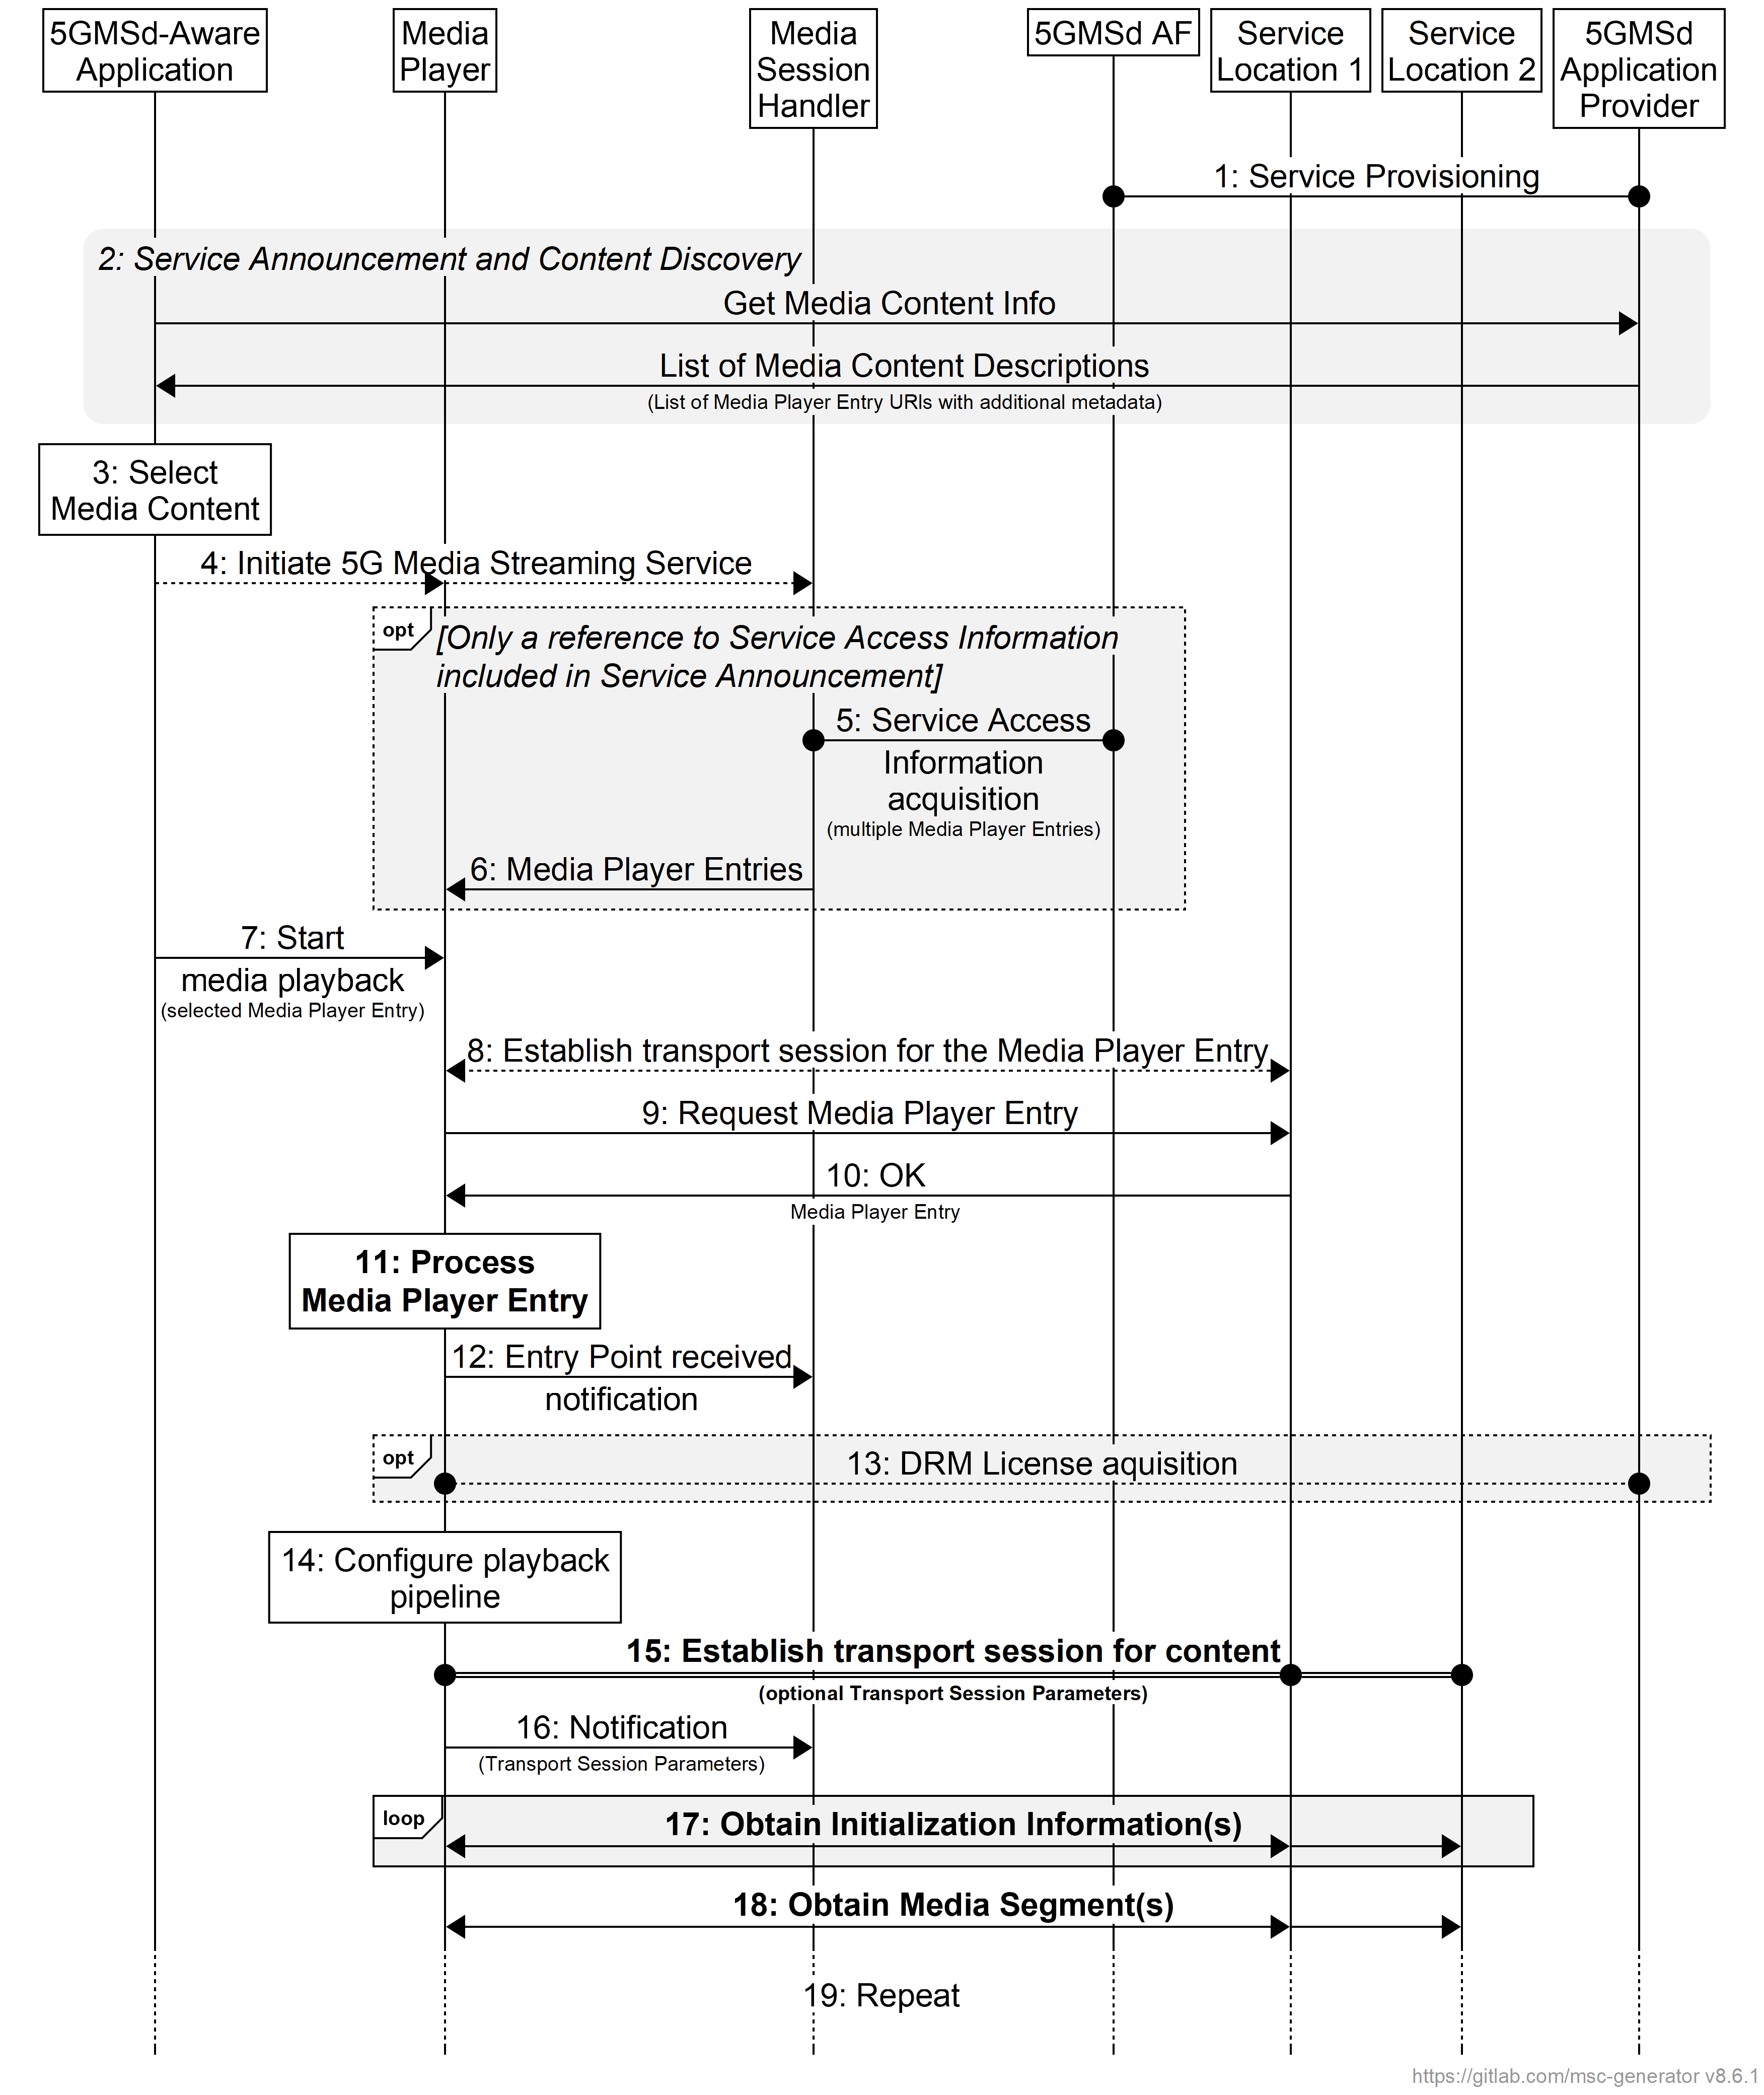
Figure 5.2.6-1: High-level procedure for downlink streaming from multiple service locations
within the 5GMS System
Steps:
1. The 5GMSd Application Provider provisions the 5G Media Streaming System, including content hosting and ingest, such that content is available from two or more service locations (labelled Service Location 1 and Service Location 2). Upon successful provisioning and content ingest (see clause 5.4.4), either the 5GMSd Application Provider or the 5GMSd AS may create or update Media Player Entry documents (or documents pointed to by each Media Player Entry document) to include any necessary multiple service location configuration information required by the 5GMSd Client to access media content from multiple service locations.
2. The 5GMSd-Aware Application triggers the Service Announcement and Service and Content Discovery procedure. The Service and Content Discovery procedure only involves the 5GMSd-Aware Application and the 5GMSd Application Provider. The Service Announcement includes either the whole Service Access Information (i.e. details for Media Session Handling at reference point M5d and for Media Streaming access at reference point M4d) or a reference to the whole Service Access Information.
3. A media content item is selected.
4. The 5GMSd-Aware Application triggers the 5GMSd Client to initiate the 5G Media Streaming Service.
When the 5GMS-Aware Application has received only a reference to the Service Access Information (see step 1):
5. The Media Session Handler interacts with the 5GMSd AF to acquire the whole Service Access Information. The Service Access Information may include Media Player Entry URLs.
6. The Media Session Handler provides the Media Player Entries to the 5GMS-Aware Application. The information may indicate a precedence order for these Media Player Entries.
Then:
7. The Media Player is invoked with the selected Media Player Entry to start media access and playback.
8. The Media Player establishes the transport session for acquiring the Media Player Entry.
9. The Media Player requests the Media Player Entry.
10. The Media Player receives the Media Player Entry.
11. The Media Player processes the Media Player Entry. From the Media Player Entry, the Media Player determines the multiple service location configuration, including the locations of the available service locations where content can be accessed and the method in which it should access this content (e.g., switch between service locations, use of a content steering to guide access to service locations, simultaneous use of service locations, etc.). It further determines, for example, the number of needed transport sessions for media acquisition to each service location. The Media Player should be able to use the Media Player Entry information to initialize the media pipelines for each media stream. The Media Player Entry should also contain information to initialize the DRM client, when DRM is used.
12. The Media Player notifies the Media Session Handler about the Media Player Entry.
13. Optional: the Media Player acquires the necessary DRM information, for example a DRM License.
14. The Media Player configures the media playback pipeline.
15. The Media Player establishes the necessary transport sessions for the content according to the multiple service location strategy and configuration information indicated by the Media Player Entry. These transport sessions may be established between the Media Player and any one or more of the available service locations. For example, the Media Player may establish one transport session for each media component (audio, video, etc) and possibly additional transport sessions for other media representations to each service location.
16. The Media Player notifies the Media Session Handler that it is ready to commence playback and optionally provides transport session parameters for those transport sessions terminating at the 5GMSd AS.
17. The Media Player requests and obtains the initialization information according to the multiple service location strategy in use. This initialization information may be obtained from any one service location or a combination of service locations. The Media Player repeats this step for each required initialization segment.
18. The Media Player requests and obtains the media segments according to the multiple service location strategy in use. These media segments may be obtained from any one service location or a combination of service locations. The received information is put into the appropriate media rendering pipeline.
19. Previous steps are repeated according to the Media Player Entry information.

===== CHANGE =====

5.4.4 Media ingest and distribution procedure with multiple service locations
Figure 5.4.4-1 shows a variant of the high-level call flow for downlink media ingest, processing, and distribution in clauses 5.2.2, 5.4.2, and 7.2 where the 5GMSd AS is configured to host multiple service locations. Differences from the baseline procedure in clauses 5.4.2 and 7.2 are highlighted in boldface.
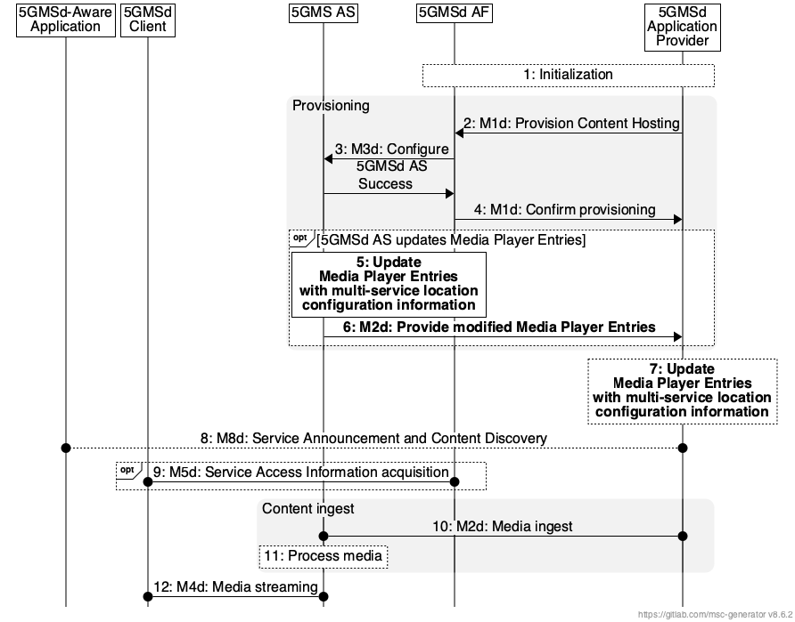
Figure 5.4.4-1: Media ingest and distribution procedure with multiple service locations
The steps are as follows:
1: Initialization: The 5GMSd Application Provider discovers the M1d endpoint address and authenticates itself with the 5GMSd AF.
2: Provision Content Hosting: The 5GMSd Application Provider creates a new Content Hosting Configuration for all media formats of its content through the 5GMSd AF at reference point M1d. The configuration specifies a domain name, supplies a certificate for HTTPS access to the content, sets the caching rules per media type, describes the number of 5GMSd AS service locations to expose at reference point M4d, indicates the distribution area (e.g. through geofencing), distribution protocol, the desired content preparation (e.g., manifest manipulation, media object encoding, etc.), URL signing, etc. The configuration may also specify affinity groups that guide deployment of 5GMSd AS service locations within the 5GMS System. Upon successful configuration, the 5GMSd AF responds with a Content Hosting Configuration identifier, the base URL of each configured 5GMSd AS service location that will be used to deliver content, and the location of the 5GMSd AS service location(s) where to send content (if using the push mode).
NOTE 1: Service locations may also be hosted outside the 5GMS System by the 5GMSd Application Provider. This process for provisioning and hosting these is outside the scope of the present document.
3: Configure 5GMSd AS instance(s): The 5GMSd AF configures the related 5GMSd AS instance(s) via reference point M3d to prepare for media ingest for that particular Content Hosting Configuration. As well as configuring any necessary Server Certificates and/or Content Preparation Templates, this step may involve instructing the 5GMSd AS instance(s) to set appropriate caching rules, to perform URL signature validation, limit access through geofencing, expose service locations from 5GMSd AS instances according to the defined affinity group(s), and configure media ingest at reference point M2d or M10d. The 5GMSd AS instance(s) respond(s) indicating whether the configuration was successful or not.
In case of partial failure, the configuration shall be removed from all 5GMSd AS instance(s) that succeeded.
4: Confirm provisioning: The 5GMSd AF communicates the Content Hosting Configuration of the 5GMSd AS back to the 5GMSd Application Provider for further media push or pull.
In the case where not all requested media formats could be accommodated during the previous step, the 5GMSd AF shall indicate these in the failure response.
5. Update Media Player Entries: The 5GMSd AS may be configured by the 5GMSd AF to modify Media Player Entry documents with the necessary multiple service location configuration information needed to access content from service locations hosted within the 5GMS System. Configuration information may include the base URL for each provisioned service location, content steering configuration information, multiple service location strategy-specific configuration information, etc.
6. Provide 5GMSd AS configured Media Player Entry documents: The 5GMSd AS communicates generated or modified Media Player Entry documents containing multiple service location configuration information to the 5GMSd Application Provider.
7: Update Media Player Entry documents: Based on the information provided in the previous step, the 5GMSd Application Provider may update the Media Player Entry documents, at a minimum, with the necessary multiple service location configuration information needed to access content from service locations hosted outside the 5GMS System (e.g., by the 5GMSd Application Provider). The 5GMSd Application Provider may also update the Media Player Entry documents for those service locations hosted by the 5GMSd AS using configuration information obtained from the 5GMSd AF upon confirmation of successful 5GMSd AS provisioning. Configuration information may include the base URL for each provisioned service location, content steering configuration information, multiple service location strategy-specific configuration information, etc.
8. Service Announcement and Content Discovery: The 5GMSd Aware Application triggers the Service Announcement and Service and Content Discovery procedure. The Service and Content Discovery procedure only involves the 5GMS-Aware Application and the 5GMSd Application Provider. The Service Announcement includes either the whole Service Access Information (i.e. details for Media Session Handling (M5d) and for Media Streaming access (M4d)) or a reference to the Service Access Information.
9: Service Access Information acquisition: When the 5GMS-Aware Application has received only a reference to the Service Access Information (see step 8), the Media Session Handler interacts with the 5GMSd AF to acquire the whole Service Access Information.
10: Media ingest and distribution: Content for the configured service locations is ingested by the 5GMSd AS from the 5GMSd Application Provider at reference point M2d. Depending on the Content Hosting Configuration, this may involve 5GMSd AS service chaining via reference point M10d.
11. Media processing: The 5GMSd AS may perform any configured content preparation required for each exposed service location prior to providing access to the content at reference point M4d. This may include manifest manipulation, providing further updates to the Media Player Entry documents, media object encoding, etc.
NOTE 2: Pull of media content from the 5GMSd Application Provider or an external 5GMSd AS may be triggered by a request from the 5MGSd Client.
12. Media Streaming: The media is streamed to a 5GMSd Client via reference point M4d.
The 5GMSd Application Provider may update a Content Hosting Configuration subsequently to modify some of its parameters. The subset of parameters that can be updated may be limited by the 5GMSd AF.

===== CHANGE =====

7.2 Media processing procedures for downlink media streaming
As part of setting up a Content Hosting Configuration for downlink media streaming, a 5GMSd Application Provider may request content preparation to be performed.
The following content preparation operations may be available:
- Adaptive Bit Rate (ABR) encoding, encryption and encapsulation.
- Presentation manifest (e.g., MPD) generation and media segment (e.g., DASH) packaging.
- Content replacement (e.g., advertising insertion, blackouts, regional content):
- Presentation manifest (e.g., MPD) modification.
- Content enrichment, such as Closed Caption insertion, object detection, content filtering, etc.
- Media object encoding and/or packaging.
…

===== CHANGE =====

A.16 Media ingest for downlink media streaming using multiple service locations

A.16.1 Introduction
These collaboration scenarios supplement the downlink media streaming scenarios provided in clauses A.1 through A.9 where media content is available and/or streamed to the 5GMSd Client from multiple service locations via reference points M4d and M13d. These collaboration scenarios focus on different methods media content may be ingested into the 5GMSd AS via reference point M2d, distributed within the 5GMSd AS via reference point M10d, and made available via M4d at different service locations. The 5GMSd AF (not shown) may or may not be used to configure the 5GMSd AS via reference point M3d, and it may or may not be used to provide Service Access Information to the Media Session Handler (not shown) via reference point M5d.
Three distinct methods are described in the following clauses.
- In the first method (clause A.16.2), the 5GMSd Application Provider performs any necessary operations to prepare media content for multiple service location delivery. The 5GMSd Application Provider prepares all media content intended to be served at each service location and provides it to the 5GMSd AS.
- In the second method (clause A.16.3), media content is ingested into the 5GMSd AS via reference point M2d where the 5GMSd AS performs any necessary operations at the point of ingest to prepare media for multiple service location delivery. This media content is then exposed at each provisioned M4d service location via reference point M10d.
- In the third method (clause A.16.4), media content is ingested into the 5GMSd AS via reference point M2d. This media content is exposed at each provisioned M4d service location via reference point M10d. Any operations to prepare media content for multiple service location delivery are performed independently immediately prior to exposure at each provisioned M4d service location.
These three methods are not mutually exclusive. For example, media content made available via reference point M4d at one service location may use the first method, while media content made available via reference point M4d at a second service location may use the second or third methods. Furthermore, the collaboration scenarios below show service locations exposed at different physical network locations within the 5GMS System. This is accomplished by placing each service location into different affinity groups within the Contest Hosting Configuration.

A.16.2 5GMSd Application Provider content preparation and ingest
In the first variant of this collaboration scenario, the 5GMSd Application Provider performs any necessary operations to prepare media content for multiple service location delivery prior to ingest into the 5GMSd AS. This content preparation may include manifest manipulation, media object encoding, etc. Furthermore, this media content is ingested independently by each 5GMSd AS via reference point M2d. The 5GMSd Client may stream media content from any of the available service locations by either switching among them or using each in parallel. This is illustrated in figure A.16.2-1.
NOTE: A service location accessible by a 5GMSd Client at reference point M13d is depicted. Content preparation and provisioning of this service location is the responsibility of the 5GMSd Application Provider and is outside the scope of the present document.

Figure A.16.2-1: 5GMSd Application Provider content preparation and ingest
for downlink media streaming from multiple service locations
Figure A.16.2-2 shows the call flow for this scenario describing the process followed by the 5GMSd AS at each service location it exposes to the 5GMSd Client at reference point M4d. To simplify the call flow, only the processes for content ingest and preparation are shown. These procedures reflect the process followed in the execution of steps 17 and 18 of figure 5.2.6-1.
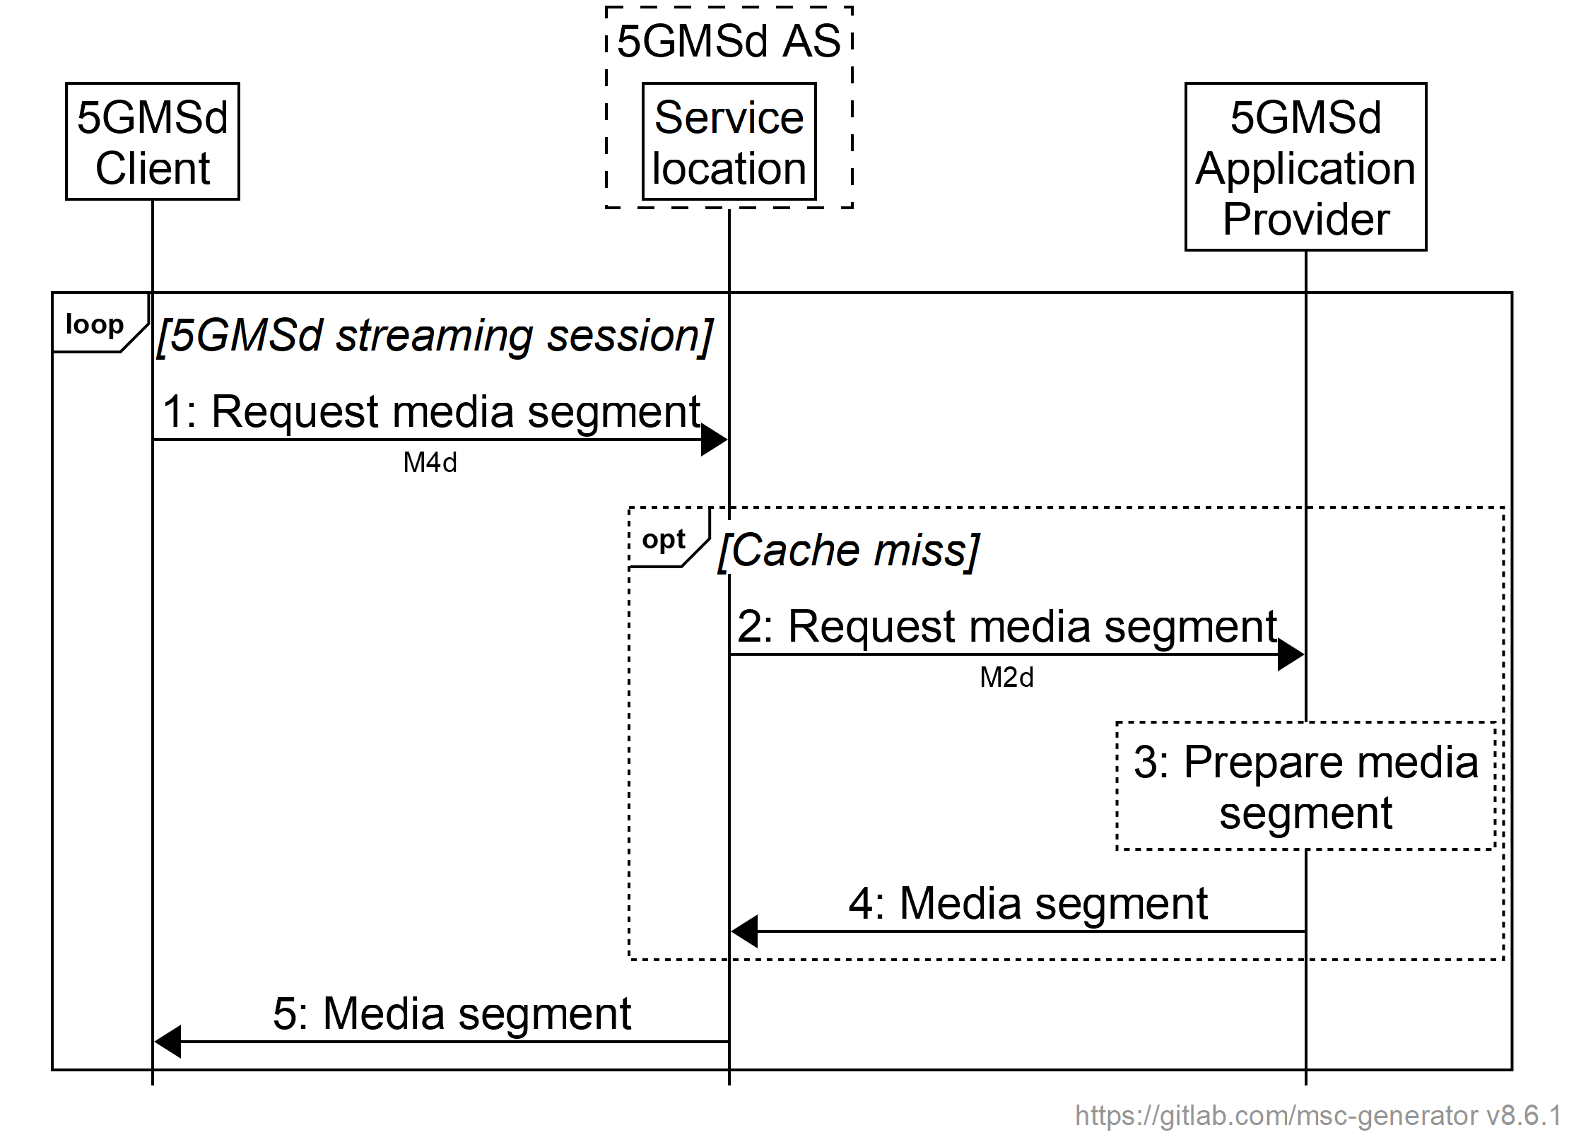
Figure A.16.2-2: Procedure for 5GMSd Application Provider content preparation and ingest
for downlink media streaming from multiple service locations
The steps are as follows:
1. The 5GMSd Client sends a request for media content to one or more service locations via reference point M4d.
2. If the requested media content is not cached at the target service location, the 5GMSd AS propagates the request to the 5GMSd Application Provider via reference point M2d.
3. The 5GMSd Application Provider may prepare the requested media content for delivery via the requested service location. Depending on the type of media segment requested, this may include manifest manipulation, media object encoding, etc.
4. The 5GMSd Application Provider responds with the requested media content via reference point M2d. Upon receipt, the media content may also be cached by the 5GMSd AS at the service location for future delivery to another 5GMSd Client.
5. The 5GMSd AS responds from the target service location via reference point M4d with the requested media content.

A.16.3 Centralized 5GMSd AS content preparation and ingest
In the second variant of this collaboration scenario, media is ingested into the 5GMSd AS via reference point M2d where the 5GMSd AS performs any necessary operations to prepare media for multiple service location delivery. This media content is then exposed at each provisioned M4d service location via reference point M10d. The 5GMSd Client may request media content from any of the available service locations by either switching among them or using each in parallel. This is illustrated in figure A.16.3-1.
NOTE: A service location accessible by a 5GMSd Client at reference point M13d is depicted. Content preparation and provisioning of this service location is the responsibility of the 5GMSd Application Provider and is outside the scope of the present document.

Figure A.16.3-1: Centralized 5GMSd AS content preparation and ingest
for downlink media streaming from multiple service locations
Figure A.16.3-2 shows the call flow for this scenario that describes the process followed by the 5GMSd AS at each service location it exposes to the 5GMSd Client at reference point M4d. To simplify the call flow, only the processes for content ingest and preparation are shown. These procedures reflect the process followed in the execution of steps 17 and 18 of figure 5.2.6-1.
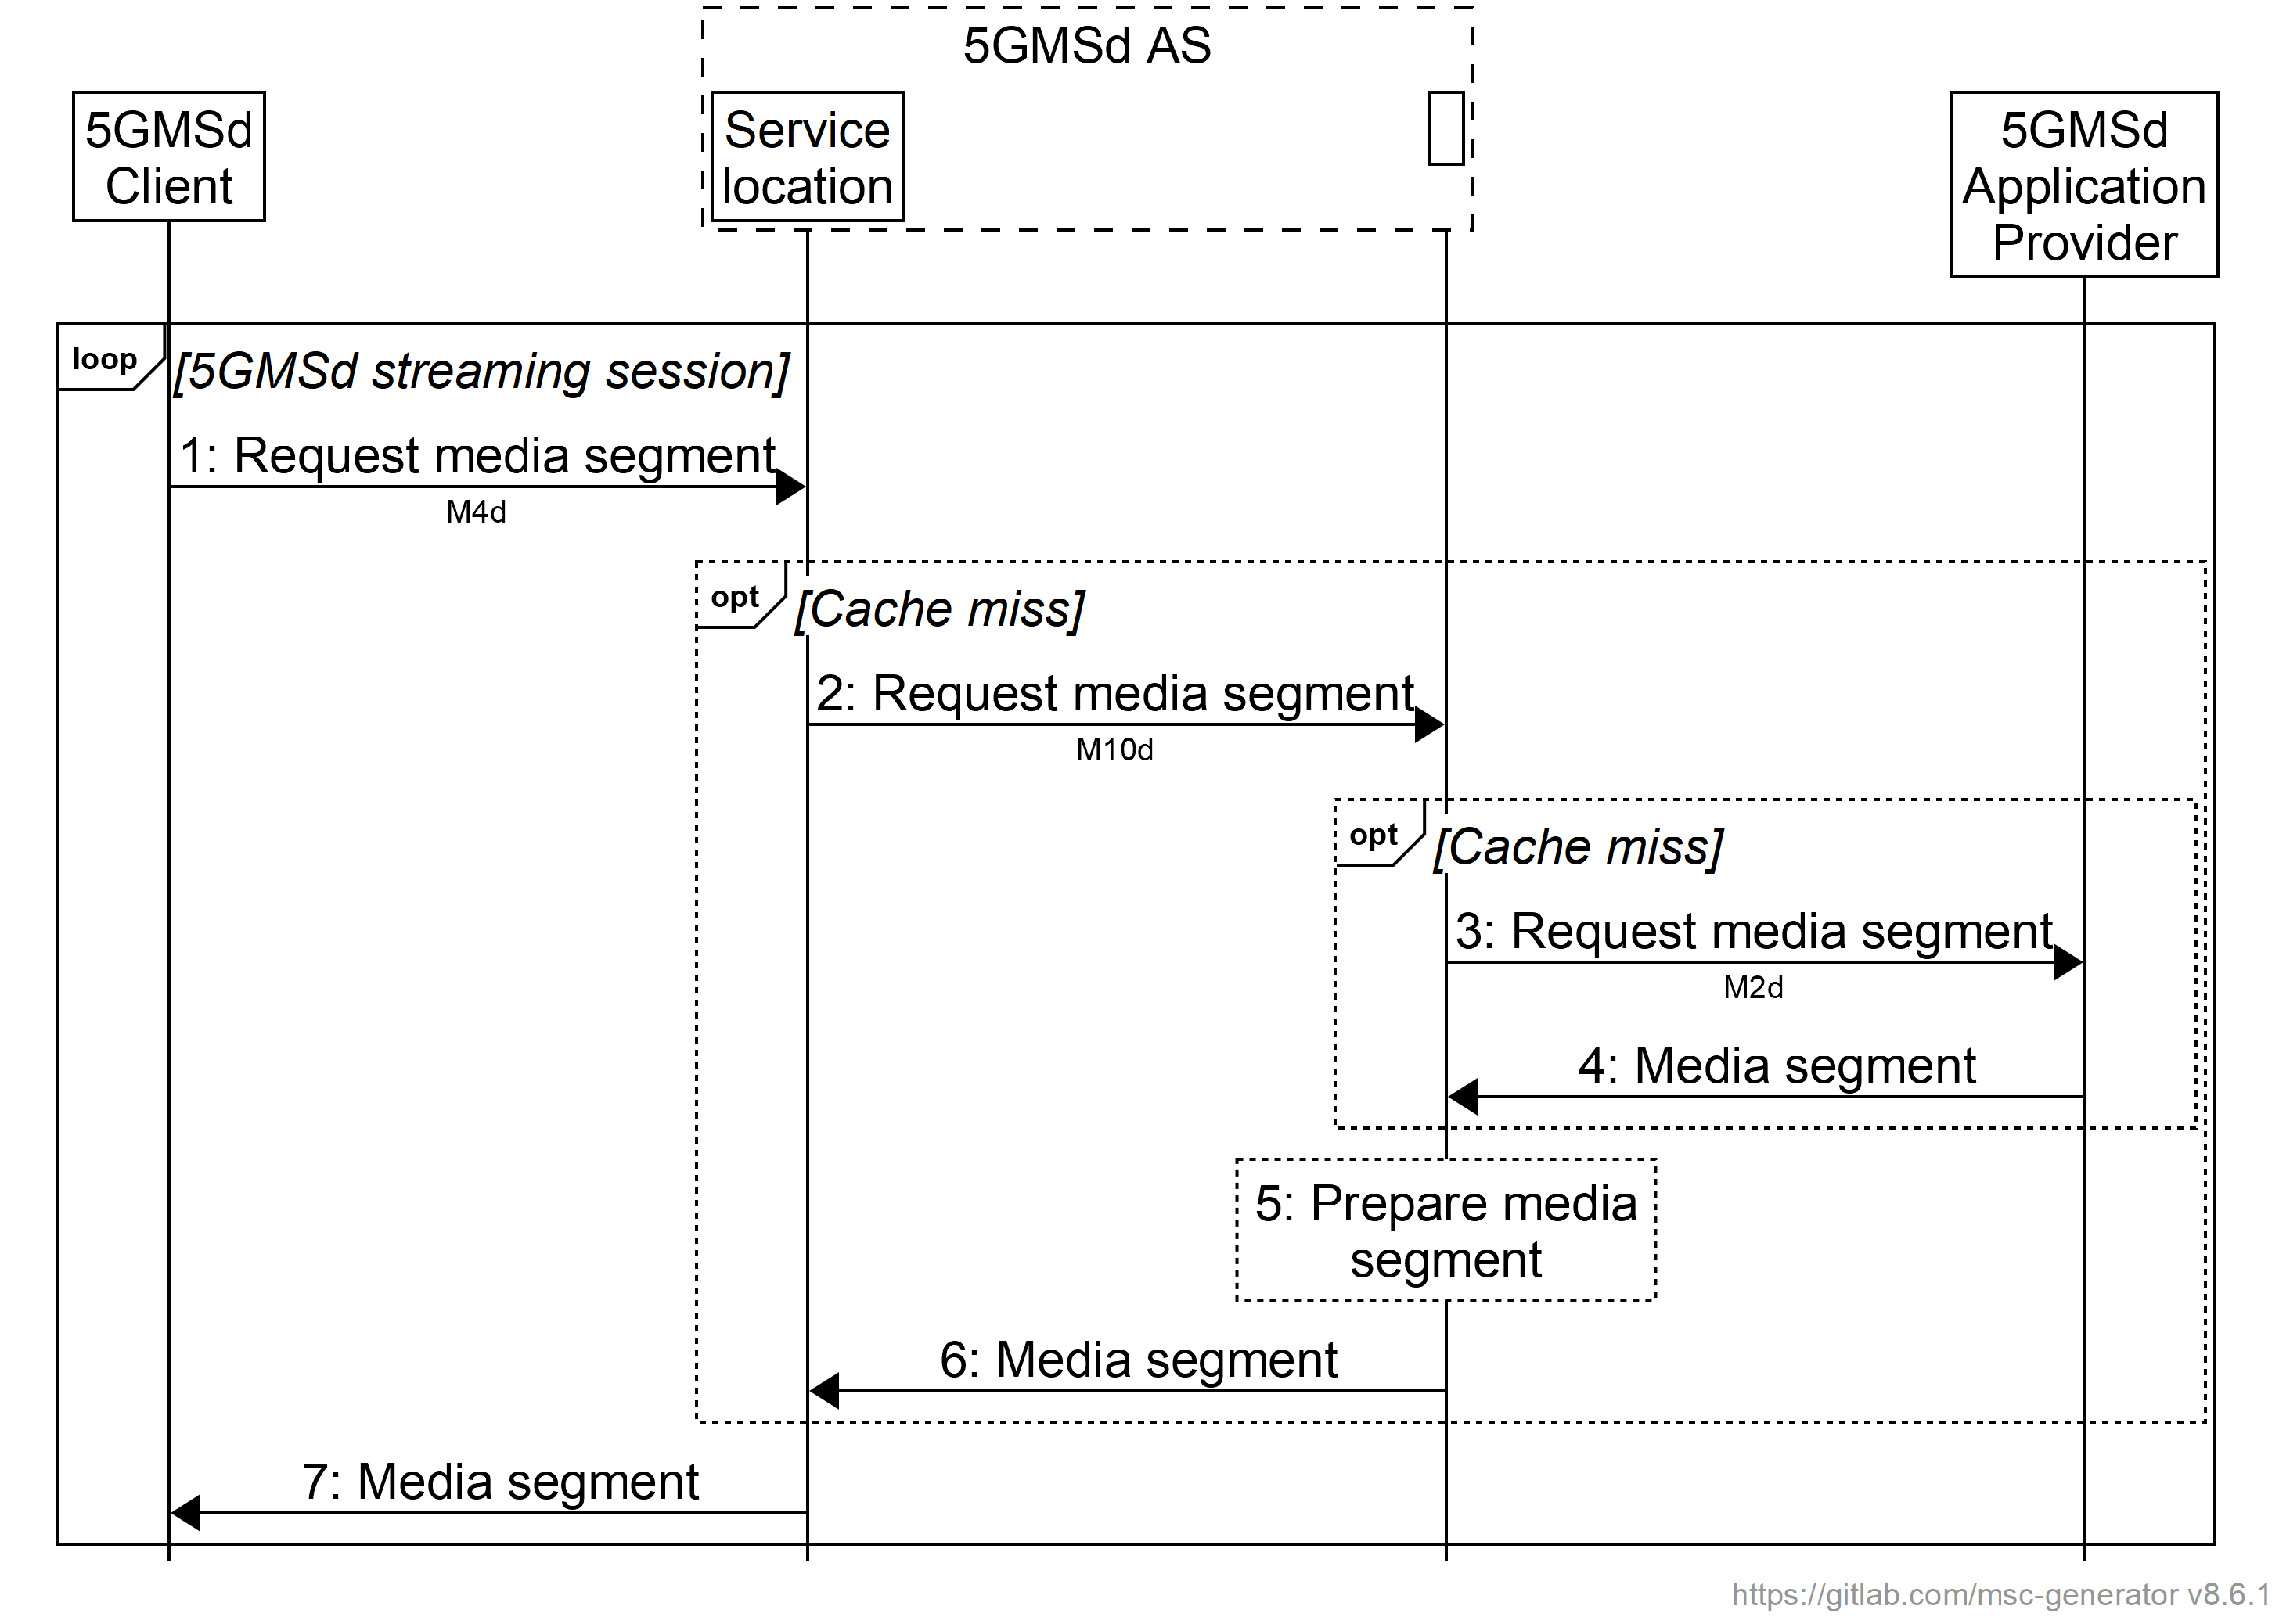
Figure A.16.3-2: Procedure for centralized 5GMSd AS content preparation and ingest
for downlink media streaming from multiple service locations
The steps are as follows:
1. The 5GMSd Client sends a request for media content to one or more service locations via reference point M4d.
2. If the requested media content is not cached at the target service location, the request is propagated via reference point M10d to ingest and prepare the requested media content.
3. If the requested media content is not cached, the request is propagated to the 5GMSd Application Provider via reference point M2d.
4. The 5GMSd Application Provider responds with the requested media content via reference point M2d.
5. The 5GMSd AS may prepare the requested media content for delivery from the requesting service location. Depending on the type of media segment requested, this may include manifest manipulation, media object encoding, etc. The media content may also be cached for future delivery from another service location.
6. The 5GMSd AS makes the requested media content available at the service location via reference point M10d. Upon receipt, this media content may be cached at this location for future delivery to another 5GMSd Client.
7. The 5GMSd AS responds from the target service location via reference point M4d with the requested media content.

A.16.4 Decentralized 5GMSd AS content preparation and ingest
In the third variant of this collaboration scenario, media content is ingested by the 5GMSd AS via reference point M2d; and this media content is made available at each provisioned M4d service location via reference point M10d. The former may be considered a primary service location, and the latter peer service locations. The 5GMSd AS may also independently prepare the ingested media content at each service location for exposure via reference point M4d. The 5GMSd Client may stream media content from any of the available service locations by either switching among them or using each in parallel. This is illustrated in figure A.16.4-1.
NOTE: A service location accessible by a 5GMSd Client at reference point M13d is depicted. Content preparation and provisioning of this service location is the responsibility of the 5GMSd Application Provider and is outside the scope of the present document.

Figure A.16.4-1: Decentralized 5GMSd AS content preparation and ingest
for downlink media streaming from multiple service locations
Figure A.16.4-2 shows the call flow for this scenario that describes the process followed by the 5GMSd AS at each service location it exposes to the 5GMSd Client at reference point M4d. Within the figure, the 5GMSd AS ingests media content from the 5GMSd Application Provider via reference point M2d and exposes it at a primary service location. Those service locations that only obtain media content via reference point M10d are labelled as "peer". To simplify the call flow, only the processes for content ingest and preparation are shown. These procedures reflect the process followed in the execution of steps 17 and 18 of figure 5.2.6-1.
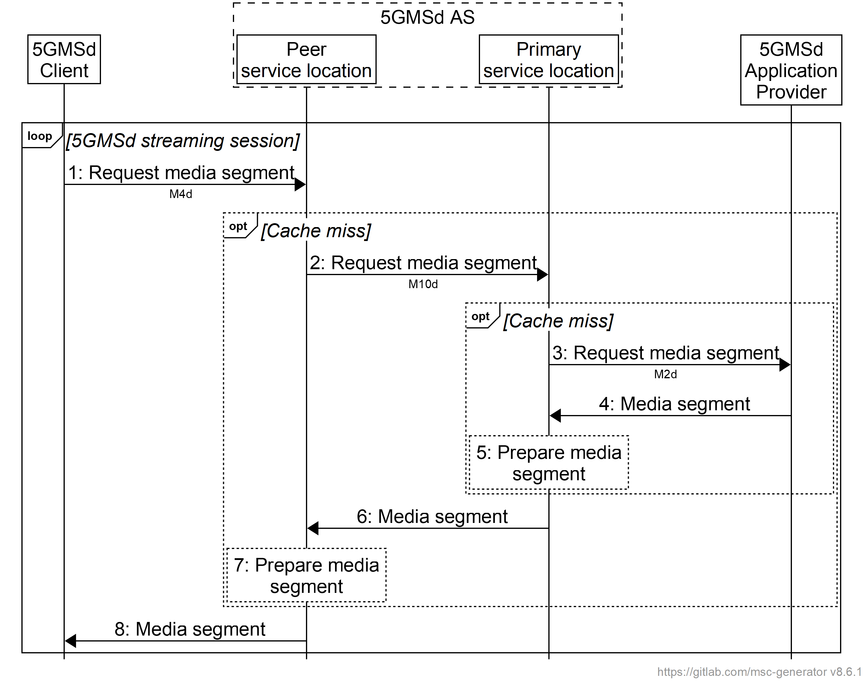
Figure A.16.4-2: Procedure for decentralized 5GMSd AS content preparation and ingest
for downlink media streaming from multiple service locations
The steps are as follows:
1. The 5GMSd Client sends a request for media content to one or more service locations via reference point M4d.
2. If the requested media content is not cached at the target service location, the request is propagated to the primary service location via reference point M10d.
NOTE 1: The procedure shows a request from the 5GMSd Client to a peer service location. If the request is received by a primary service location, the request may be propagated upward to the 5GMSd Application Provider via reference point M2d instead of to a peer service location via reference point M10d.
3. If the requested media content is not cached at the primary service location, the request is propagated to the 5GMSd Application Provider via reference point M2d.
NOTE 2: The procedure shows a request from a peer service location to a primary service location where media content is also ingested from the 5GMSd Application Provider via reference point M2d. Alternatively, the service location receiving the request from a peer service location may not be co-located with the service location from which media content is ingested via reference point M2d. In this case, a sub-procedure starting at step 2 is initiated by the 5GMSd AS to obtain the requested content at the service location.
4. The 5GMSd Application Provider responds with the requested media content via reference point M2d.
5. The 5GMSd AS may prepare the requested media content at the service location for delivery either through another service location (reference point M10d) or to a 5GMSd Client (reference point M4d). Depending on the type of media segment requested, this may include manifest manipulation, media object encoding, etc. The 5GMSd AS may also cache this media content at the service location for future exposure from another M4d service location.
6. The 5GMSd AS responds with the requested media content from the primary service location to the peer service location via reference point M10d.
7. The 5GMSd AS may prepare the requested media content at the peer service location for delivery either to another service location via reference point M10d (not depicted) or for exposure to a 5GMSd Client at reference point M4d. Depending on the type of media segment requested, this may include manifest manipulation, media object encoding, etc. The 5GMSd AS may also cache this media content at the service location for future delivery to another service location or 5GMSd Client.
8. The 5GMSd AS responds from the target service location via reference point M4d with the requested media content.

