3GPP TSG-SA WG4 Meeting #130 S4-242066
USA, Orlando, 18 – 22 November 2024

Source: Rapporteur ATIAS_Ph2
Title: Permanent Document ATIAS_Ph2-1 v0.1
Agenda item: 7.8
Document for: Agreement

Introduction
The present document collects candidate changes to 3GPP TS 26.260 [2] on test methods for immersive UEs that were proposed during the work item ATIAS_Ph2 [1]. If applicable, associated requirements for 3GPP TS 26.261 [3] are included as well.
The following clauses and subclauses are structured according to the objectives that are in scope of the ATIAS_Ph2 WID:
- Consider additional requirements corresponding to the test methods in TS 26.260 and/or update requirements marked as TBD for sending and receiving characteristics of terminals in TS 26.261.
- Define new test methods and performance requirements/objectives, for the assessment of capture and playback of complex sound scenes, i.e., sound scenes with more than one source and from more than one defined direction.
- Define new test methods and performance requirements/objectives for the assessment of acoustic echo control. Test methods may be either completely new or be based on existing ones for mono telephony (from e.g., TS 26.132). In the latter case, it has to be investigated if and how such methods can be adapted for UEs providing immersive audio playback and/or capture capabilities.
- Define test methods and performance requirements/objectives for the assessment of binaural rendering in receive direction, including headtracking and motion-to-sound latency. Electrical as well as acoustical interfaces should be considered.
- Consideration of aspects, that are based on other ongoing work items, such as complexity level definitions in IVAS_Codec_Ph2.
NOTE: Updates to TS 26.259, in support of the development of the objective tests, are out of scope of this permanent document.
Each candidate change (i.e., updates to existing text or new clauses) is described in a separate subclause and contains:
- a brief summary and status of the proposed change
- a list of TDocs that initially proposed and further supported the change, as well as other related inputs
- all necessary changes to 3GPP TS 26.260 [2] and/or 3GPP TS 26.261 [3]. To reduce overhead and workload during drafting, the changes are prepared for a direct transfer into formal CRs.
This working procedure was preferred by the SA4 Audio SWG over continuously developed CRs, as it allows to add and track complementary information, avoiding also "changes over changes" in the history of the permanent document.

References
The following references are used in the present document, but not in the change candidates.
[1] 3GPP SP-241314, "WID on Terminal Audio quality performance and Test methods for Immersive Audio Services, Phase 2," HEAD acoustics GmbH, Qualcomm Incorporated, Nokia Corporation, Dolby Sweden AB, Orange, Xiaomi, Melbourne, 2024.
[2] 3GPP TS 26.260: "Objective test methodologies for the evaluation of immersive audio systems", V18.1
[3] 3GPP TS 26.261: "Terminal audio quality performance requirements for immersive audio services", V18.0
The following references are not yet included in TS 26.260/261 but used by the change candidates in the present document.
[99] Recommendation ITU-T G.122 (03/1993): "Influence of national systems on stability and talker echo in international connections".

Changes on test setup

UE types

Summary
Summary: Specify test setups for UEs that are composed of multiple UE types (e.g. headset and handheld).
Status: Initial discussion

Related documents
TDoc | Title / Source | Notes
S4-242015 | "On acoustic echo control testing and on UE type combinations", Nokia. | Adapted test method for PDoc

Changes
TBD

Changes on test methods and requirements

Acoustic echo control

Summary
Summary: Introducing test method for evaluating performance of acoustic echo control (AEC), which is adapted from existing specifications for IVAS-based UEs.
Status (after SA4#130): Initial proposal

Related documents
TDoc | Title / Source | Notes
S4-242015 | "On acoustic echo control testing and on UE type combinations", Nokia. | Adapted test method for PDoc
S4-241840 | "Test methods for UE acoustic echo control", HEAD acoustics GmbH. | Provided useful information on AEC test methods

Changes
Change for TS 26.260:
Start change [
5.5.6 Acoustic Echo Control
One of the most relevant aspects for traditional as well as for immersive speech communication is that the generation and insertion of echo signals in send direction should be avoided wherever possible.
[The compressed British-English single talk sequence described in clause 7.3.3 of Recommendation ITU-T P.501 [14]] is used to simulate a conversation at the far-end. To evaluate echo cancellation performance with immersive audio playback/capture, the different talkers are virtually positioned to alternating source directions according to Table T1 and as visualized in Figure F1.
Table T1: Source direction of each sentence in test signal
Direction | Talker | Source direction [°]
1 | M1, M4 | 0
2 | M2, M5 | 45
3 | M3, M6 | -45
4 | F1, F4 | 90
5 | F2, F5 | -90
6 | F3, F6 | 180

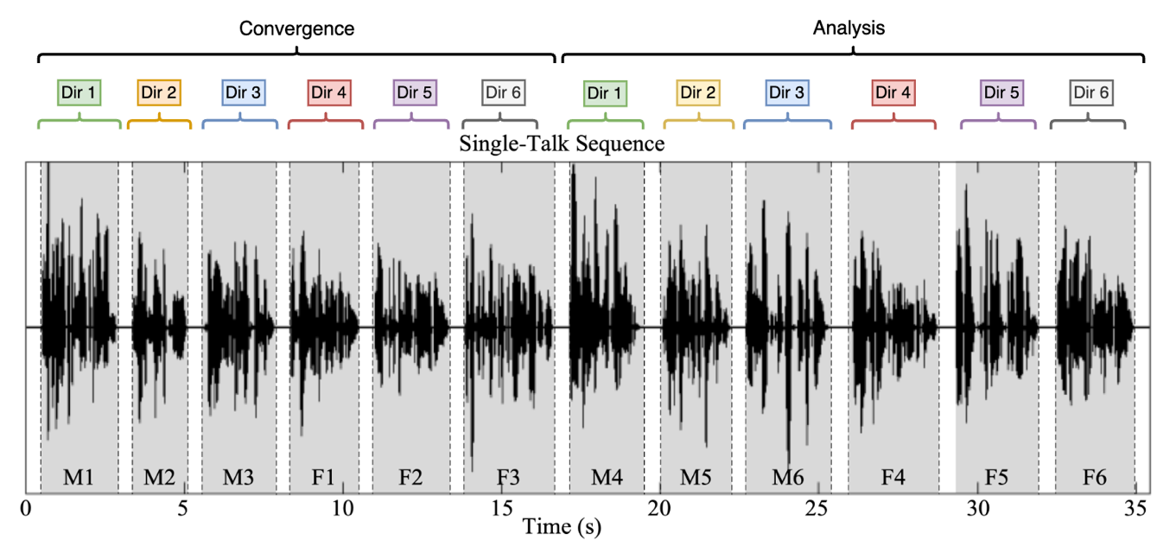
Figure F1: Sentence directions in the test signal

Test method
The calculation of terminal coupling loss (TCL) is based on the attenuation between the rendered input signal and rendered output signal versus frequency bands. For the rendering step, the IVAS renderer [30] shall be used. The following common measurement steps are applicable for all types of UE modes:
1) The source signal to be used for the measurements shall be [the compressed British-English single talk sequence described in clause 7.3.3 of Recommendation ITU-T P.501 [14].]
2) The test signal sentences shall be [virtually positioned according to clause 5.5.2. The source directions of each sentence shall be according to Table T1.]
3) The input signal shall be calibrated to [-20 LFKS]
4) The first 17.0 s of the test signal (6 sentences) are discarded from the analysis to allow for convergence of the acoustic echo canceller. The analysis is performed over the remaining length of the test sequence (last 6 sentences).
5) The external renderer in the reference client shall be configured to [mono/stereo] output.
6) The analysis shall be conducted in 1/3-octave band intervals as given by the R.10 series of preferred numbers in ISO 3 [54] for each stereo audio channel. For the calculation, the averaged measured echo level at each frequency band is referred to the averaged, rendered test signal level measured in each frequency band, denoted as echo loss in the following.
7) TCL is calculated according to Annex B.4 of Recommendation ITU-T G.122 [99], which utilizes tabulated data for any frequency range between $f_{0}$ and $f_{N}$. a s unweighted echo loss from [100/300] Hz to [8/6.7] kHz by the following equations:
$L_{e}=C-10\log_{10}{\sum_{i=1}^{N}{(A_{i}+A_{i-1})(\log_{10}{f_{i}-\log_{10}{f_{i-1})}}}}$
$C=10\log_{10}{(2⋅{(log}_{10}{f_{N}-\log_{10}{f_{0}}})}$
Where:
$A_{0}$ is the output/input power ratio at frequency $f_{0}=[100 / 300]$ Hz,
$A_{i}$ the ratio at frequency $f_{i}$,
$A_{N}$ the ratio at frequency $f_{N}=[8 / 6.7]$ Hz.

Editor's Note / further considerations:
- Step 7) adapted from ITU-T P.381 (reference to " trapezoidal rule" is actually wrong)
- dynamic movement within the test signal sentences, or static directions per measurement
- ambience or reverberation could be additionally simulated on the test signal

] End change

Headtracking & rendering
TBD

