3GPP TSG-SA4 Meeting #129-e S4-241614
Electronic Meeting, 19th Aug – 23rd Aug 2024 Revision of S4-241252
CR-Form-v12.0
CHANGE REQUEST
 | 26.804 | CR | 0013 | rev | 4 | Current version: | 18.1.0
For HELP on using this form: comprehensive instructions can be found at
http://www.3gpp.org/Change-Requests.

Proposed change affects: | UICC apps |  | ME |  | Radio Access Network |  | Core Network | X

Title: | [FS_AMD] Expanding on the collaboration scenario for multi-access with ATSSS
Source to WG: | Samsung Electronics Co. Ltd., Dolby France SAS, BBC
Source to TSG: | S4
Work item code: | FS_AMD |  |  |  |  |  | Date: |  |  | 2024-08-10
Category: | B |  |  |  |  |  | Release: |  |  | Rel-19
 | Use one of the following categories:  F (correction)  A (mirror corresponding to a change in an earlier release)  B (addition of feature),  C (functional modification of feature)  D (editorial modification)  Detailed explanations of the above categories can  be found in 3GPP TR 21.900. |  |  |  |  |  |  |  | Use one of the following releases:  Rel-10 (Release 10)  Rel-11 (Release 11)  Rel-12 (Release 12)  Rel-13 (Release 13)  Rel-14 (Release 14)  Rel-15 (Release 15)  Rel-16 (Release 16)  Rel-17 (Release 17)  Rel-18 (Release 18)
Reason for change: |  | Document S4-241252 was endorsed during SA4#128 meeting with initial draft on multi-access media delivery study. That document presented a basic collaboration scenario for 5G Media Streaming with multi-access media delivery based on ATSSS architecture specification in TS 23.501. This contribution expands on this collaboration scenario with more details.
Summary of change: |  | Addition of details on collaboration scenario for multi-access media delivery using ATSSS
Consequences if not approved: |  | One of the study topics will be incomplete
Clauses affected: |  | 5.15
 |  | Y | N
Other specs |  |  |  | Other core specifications |  |  |  | TS/TR ... CR ...
affected: |  |  |  | Test specifications |  |  |  | TS/TR ... CR ...
(show related CRs) |  |  |  | O&M Specifications |  |  |  | TS/TR ... CR ...
Other comments: |  | For discussion, steering functionalities UE model (TS 23501). To be removed before uploading final revision  Figure 5.32.6.1-1: Steering functionalities in an example UE model
This CR's revision history: |  | S4-241252: Endorsed CR on initial draft for multi-access media delivery

* * * * First change (all new text)* * * *

5.15 Multi-access media delivery

5.15.1 Description

5.15.1.0 Introduction
Media streaming applications traditionally obtain content from a single source over a single path within a network. This imposes several limitations:
1. Performance is constrained to that of the source and path chosen. Any limits on network bandwidth and latency between the client and that source are directly translated to the client’s achievable Quality of Service (QoS) and Quality of Experience (QoE).
2 Disruptions or degraded performance caused by the source in use or on any of the network links between the client and source can lead to poor user experience, often in the form of lower playback quality, rebuffering, or complete playback failure.
This Key Issue considers integration of different technologies into the 5G Media Streaming System that addresses these, and similar, issues by allowing media streaming applications to efficiently access content across multiple access networks. Different client implementations may then beneficially use the content on these multiple access networks either serially or concurrently, potentially guided by the service or network provider. Study of integration of different technologies into the 5G Media Streaming System is of relevance to address content provisioning, content hosting, impacts on user plane reference points M2 and M4, and on media session handling at reference point M5 as well as potential benefits in terms of quality and resource usage.
Challenges that multi-access architectures aim to address may include:
1. Disruptions to QoS and QoE resulting from degraded performance or loss of availability of one or more network interfaces/access networks. An example is disruption such as significant delays and loss of throughput caused during the process of switching from one access network to another as transport layer connections are migrated to new endpoint addresses on a different access network, or are destroyed and need to be re-established.
2. Inability to efficiently utilise multiple network interfaces/access networks concurrently to achieve a target QoS or QoE. An example is the inability of a UE to effectively utilise its connection with a secondary, reliable but high-cost, 5G access network in support of the primary, unreliable but inexpensive, access network using Wi-Fi.

5.15.1.1 Multi-access using more than one USIM
A UE contains at most one USIM. Multiple UEs may be combined in a single device to form a composite terminal that is able to access more than one access network concurrently.
Editor's Note: Common scenario in media production where 5G modem units provide multiple SIM card slots intended for concurrent use. (Smartphone UEs with multiple slots aren't typically able to use more than one at the same time.) This Key Issue should also study what (if any) changes to the 5GMS System are needed to take advantage of this. Unlikely to be transparent to the 5GMS Client, requiring the use of multipath transport protocols, or applications specifically written to work with multiple paths.

5.15.1.2 Non-ATSSS multi-access
UEs connected to multiple access networks (whether they be a 3GPP and non-3GPP network, multiple disjoint 3GPP networks, etc.) inherently have the capability to deploy and utilize multi-access techniques without the need of ATSSS assuming support for the techniques and/or protocols are available at the Application Server. In these cases, the UE may establish multiple connections with the application server over different access networks such that media delivered by the application server is routed back over the appropriate access network.

5.15.1.3 Multi-access using ATSSS
Clause 5.32 of TS 23.501 [23501] describes ATSSS (Access Traffic Steering, Switching, and Splitting) an optional feature supported by the UE and 5G Core network for multi-access. Some of the key principles this feature defines that are relevant for our study are:
1. The ATSSS feature enables a Multi-Access PDU Connectivity Service allowing for the exchange of PDUs between the UE and a Data Network by simultaneously using one 3GPP access network and one non-3GPP access network via two independent N3/N9 tunnels between a PDU Session Anchor UPF (PSA UPF) and the RAN/AN.
NOTE 1: The limits on the number and type of access network refer to Release 18 and may differ in subsequent releases.
2. The Multi-Access PDU Connectivity Service is facilitated by a Multi-Access PDU (MA PDU) Session that may have User Plane resources on two access networks. In the context of the generalised media delivery architecture specified in TS 26.501 [15]:
- If conveyed over an MA PDU Session, the application flow between the Media Session Handler and the Media AF (e.g., 5GMS AF) at reference point M5 may use two different access networks.
- If conveyed over an MA PDU Session, the application flow between the Media Access Client (e.g., Media Player or Media Streamer) and the Media AS (e.g., 5GMS AS) at reference point M4 may use two different access networks.
3. The UE is supplied with policy rules ("ATSSS rules") by the network for deciding how to distribute uplink traffic across multiple access networks. Similarly, the UPF anchor is supplied with policy rules ("N4 rules") by the network for deciding how to distribute downlink traffic across the two N3/N9 tunnels and the two access networks. The network entity configuring ATSSS rules and N4 rules is the SMF. The SMF may map PCC rules from the PCF to create these ATSSS and N4 rules.
4. The UE indicates its support for ATSSS (steering functionalities and steering modes) in the PDU Session Establishment Request that is sent to request a new MA PDU Session.
5. If the UE requests a network slice instance, the same S-NSSAI is allowed to span both access networks.
NOTE 2: Support for QoS when PDUs are conveyed over a PDU Session belonging to a network slice that spans non-3GPP access network is unknown.
6. For QoS support, the same 5G QoS model used for conventional PDU Sessions also applies to MA PDU Sessions, i.e. QoS Flow is the finest granularity of QoS differentiation. However, QoS Flow is access-agnostic: the same network QoS applies to each of the different access network comprising the MA PDU Session, i.e. the same QoS is available across two different paths in different access networks. The network (SMF) may provide QoS rules to the UE via one access network that are used for both the 3GPP access network and non-3GPP access network.
- In the context of the generalised media delivery architecture, application flows at reference point M5 and/or M4 using a MA PDU Session may have similar network QoS as when they are transmitted via the 3GPP access network alone.
NOTE 3: Support for PDU Session QoS when PDUs are conveyed over a non-3GPP access network is unknown.
7. The network may provide Measurement Assistance Information to the UE and/or UPF to assist them in determining which measurements (packet round-trip time measurements, packet loss rate measurements) are to be performed before deciding how to distribute traffic across the two access networks.
8. The ATSSS rules provided to the UE by the network contain information about the type of steering to be used to distribute traffic across multiple access networks. This allows traffic to be steered, switched and split across multiple access networks. From clause 5.32.8 of TS 23.501 [23501], the supported steering mechanism defined in this release are:
- Higher-layer MPTCP (Multipath TCP) functionality – The UPF provides MPTCP proxy functionality. Corresponding MPTCP functionality in the UE may communicate with the MPTCP proxy in the UPF to distribute and aggregate traffic across multiple access networks.
- Higher-layer MPQUIC (Multipath-enabled QUIC) functionality – The UPF provides MPQUIC proxy functionality. The corresponding MPQUIC functionality in the UE may communicate with the MPQUIC proxy in the UPF to distribute and aggregate traffic across multiple access networks.
- ATSSS-LL (ATSSS Low-Layer) functionality – The UPF allows steering, switching, and splitting of traffic across two access networks based on information from the IP layer and below.
9. The ATSSS rules provided to the UE by the network indicate which steering mode is to be applied to matching traffic for each Service Data Flow (SDF). The steering mode determines how the matching traffic is to be distributed across 3GPP and non-3GPP access networks. Supported steering modes in Release 18 include:
- Active-Standby: Used to steer matching SDF packets onto one access network (the "Active access") when this is available, and onto another (the "Standby access") when the Active access is unavailable.
- Smallest Delay: Matching SDF packets are steered to the access network with smallest packet round-trip time.
- Load-Balancing: Used to split the delivery of SDF packets between both the access networks if both of them are available.
- Priority-based: Used to steer SDF packets onto an access network with a higher priority.
- Redundant: Used to duplicate SDF packets on both access networks if both of them are available.
To support the operation of media delivery services specified in TS 26.501 [26501], TS 26.506 [26506], and TS 26.502 [26502] with multi-access, there is a need to first document clear potential issues to split, steer, and switch the M4 application flows of the above media delivery services based on methods specified in ATSSS architecture.

5.15.2 Collaboration scenarios

5.15.2.0 Introduction
The following collaboration scenarios correspond to clauses A.x, A.y and A.z in TS 26.501 [26501] in which a 5GMS Client is connection to one more 5GMS AS instances via multiple access networks (e.g., a 3GPP Access and a non-3GPP Access, such as Wi-Fi). The 5GMS AS instances may be deployed in the Trusted DN or in an external DN. Where a 5GMS AS instance is deployed in a Trusted DN, connectivity between it and the 5GMS Client via the non-3GPP Access is still achieved via the UPF.

5.15.2.1 Multi-access media delivery without using ATSSS
In this scenario, based on the description in clause 5.15.1.2, the Media Stream Handler in the 5GMS Client is connected (either directly or via functions within the UE) to multiple data, or access, networks (e.g., an unmanaged Wi-Fi network and the 5G network). The client requests media streaming content from one or more 5GMS Application Servers. The 5GMS Client may choose to switch between access networks or use multiple simultaneously. This allows the client to distribute network load across access networks, optimise costs, as well as improve QoS.
The client’s Media Session Handler discovers the URL of each Application Server from Media Entry Points provided in Service Access Information, acquired either from the 5GMS Application Function (AF) at reference point M5, or else obtained from the 5GMS Application Provider via reference point M8.
Figure 5.15.2.1-1 shows the client communicating with a single Application Server through different data networks. Neither data network has direct communication with its peers. The 5GMS AS communicates (minimally) with the Application Provider at reference point M2 and with the 5GMS AF (not depicted) via reference point M3. In some scenarios, the 5GMS Client and 5GMS AS may use lower-layer functionality and/or functions to manage multi-access media delivery. In these cases, a single reference point M4 may be split among multiple access networks such that the 5GMS Client and 5GMS AS are unaware of the use of multi-access delivery.

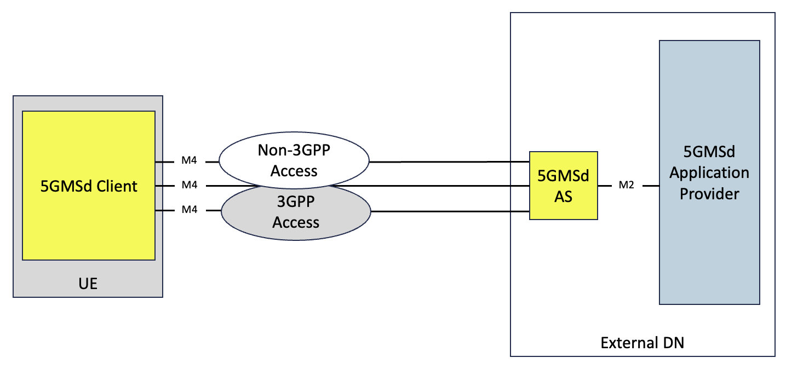
Figure 5.15.2.1-1: Multi-access media delivery without using ATSSS

5.15.2.2 Multi-Access media delivery using ATSSS
Figure 5.15.2.2-1 shows the collaboration scenario for multi-access media delivery using ATSSS. In this scenario, the multi-access delivery is supported by ATSSS functionalities deployed in both the UE and the UPF, as described in clause 5.15.1.3 of the present document. These are responsible for steering, switching, and splitting of M4 application flows. Depending on the ATSSS mechanism selected, the 5GMS Client and the 5GMS AS may be unaware of multi-access media delivery.
Figure 5.15.2.2-1: Multi-access media delivery using ATSSS

5.15.3 Architecture mapping
Editor’s Note: Based on existing architectures, develop one or more deployment architectures that address the key topics and the collaboration models.

5.15.3.1 ATSSS mapping into 5GMS architecture
Figure 5.15.3.1-1 shows the detailed collaboration scenario for multi-access media delivery using different ATSSS steering functionalities described in clause 5.15.1.3 of the present document.
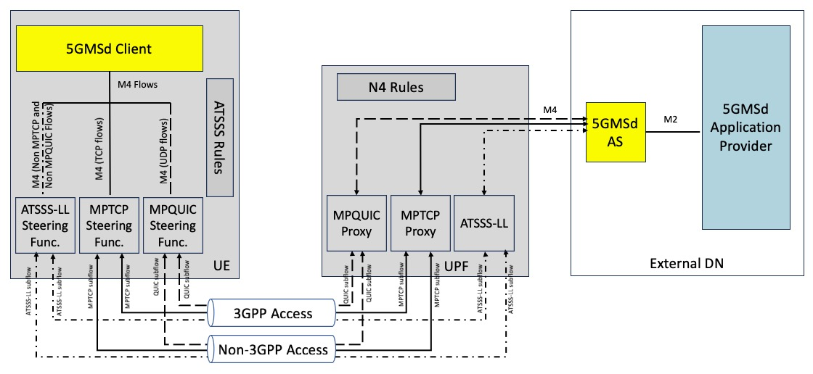
Figure 5.15.3.1-2: Multi-access media delivery using different ATSSS steering mechanisms
In figure 5.15.3.1-2, the UE and the network may negotiate the use of one or more ATSSS steering mechanisms:
1. If the UE and the network agree on using the low-layer steering mecanism (ATSSS-LL) as specified in clause 5.32 of TS 23.501 [23501]:
a. The 5GMS Client and the 5GMS AS are unaware of multi-access media delivery.
b. Traffic steering, switching, and splitting decisions at the UE and UPF are based on information at IP the layer and below.
c. A data switching function in the UE decides how to steer, switch, and split M4 flows across the 3GPP and non-3GPP accesses based on provisioned ATSSS rules and local conditions (e.g., signal loss conditions).
d. Any type of traffic, including the TCP traffic, UDP traffic, Ethernet traffic, etc. from the 5GMS Client may be steered, switched, or split.
2. If the UE and the network agree on using the high-layer MPTCP Steering mechanism as specified in clause 5.32.6.2.1 of TS 23.501 [23501]:
a. The 5GMS Client and the 5GMS AS may be unaware of multi-access media delivery.
b. Traffic steering, switching, and splitting decisions at the UE and UPF are based on information at the IP layer and above.
c. The network enables an MPTCP proxy in the UPF for the multi-access PDU Session.
d. The network allocates three IP addresses/prefixes to the UE – one for the multi-access PDU Session and two additional IP addresses/prefixes called “MPTCP link-specific multipath” addresses associated with each of the 3GPP and non-3GPP Accesses. The “MPTCP link-specific multipath” addresses may not be routable via N6.
e. TCP application flows at reference point M4 from the Media Stream Handler of the 5GMS Client in a UE allowed to use MPTCP functionality are sent to the MPTCP proxy over the two access networks using the two link-specific multipath addresses, and the MPTCP proxy functionality in the UPF uses the multi-access PDU Session IP address/prefix to communicate with the 5GMS AS in the External DN.
f. Any non-MPTCP traffic from the 5GMS Client is routed over either the 3GPP Access or the non-3GPP Access based on a received ATSSS rule for non-MPTCP traffic as specified in clause 5.32.2 of TS 23.501 [23501].
3. If the UE and the network agree on using the high-layer MPQUIC Steering mechanism as specified in clause 5.32.6.2.2 of TS 23.501 [23501].
a. The 5GMS Client and the 5GMS AS may be unaware of multi-access media delivery.
b. Traffic steering, switching, and splitting decisions at the UE and UPF are based on information at the IP layer and above.
c. The network enables an MPQUIC proxy in the UPF for the multi-access PDU Session.
d. The network allocates three IP addresses/prefixes to the UE – one IP for the multi-access PDU Session and two additional IP addresses/prefixes called “MPQUIC link-specific multipath” addresses associated with each of the 3GPP and non-3GPP Accesses. The “MPQUIC link-specific multipath” addresses may not be routable via N6.
e. A QoS Flow selection and steering mode selection component in the Media Stream Handler of the 5GMS Client determines the number of multipath QUIC connections to be set up for the application flows at reference point M4. Each QUIC connection carries one QoS flow (based on QoS rules) i.e. each multipath QUIC connection carries the UDP traffic mapped to a single QoS flow
f. QUIC-based UDP application flows at reference point M4 from the Media Stream Handler of a 5GMS Client are sent over the two access networks to the MPQUIC proxy using the two link-specific multipath addresses with multiple QUIC paths, and the MPQUIC proxy functionality in the UPF uses the multi-access PDU Session IP address/prefix to communicate with the 5GMS AS in the External DN.

5.15.4 High-level call flow
Editor’s Note: Map the key topics to basic functions and develop high-level call flows.

5.15.5 Gap analysis and requirements
The following potential open issues are identified:
1. Document potential open issues to split, switch, and steer M4 application flows based on methods specified in ATSSS architecture.

5.15.6 Candidate solutions
Editor’s Note: Candidate solutions for identified key issue.

5.15.7 Summary and conclusions

* * * * End of changes * * * *

