CR-Form-v12.0
Pseudo CHANGE REQUEST
 | 26.956 | CR | <CR#> | rev | - | Current version: | 0.0.1
For HELP on using this form: comprehensive instructions can be found at
http://www.3gpp.org/Change-Requests.

Proposed change affects: | UICC apps |  | ME | X | Radio Access Network |  | Core Network | X

Title: | [FS_Beyond2D] Description of B2D formats
Source to WG: | China Mobile Com. Corporation
Source to TSG: | SA4
Work item code: | FS_ Beyond2D |  |  |  |  |  | Date: |  |  | 2024-05-14
Category: | B |  |  |  |  |  | Release: |  |  | Rel-19
 | Use one of the following categories:  F (correction)  A (mirror corresponding to a change in an earlier release)  B (addition of feature),  C (functional modification of feature)  D (editorial modification)  Detailed explanations of the above categories can  be found in 3GPP TR 21.900. |  |  |  |  |  |  |  | Use one of the following releases:  Rel-8 (Release 8)  Rel-9 (Release 9)  Rel-10 (Release 10)  Rel-11 (Release 11)  Rel-12 (Release 12)  Rel-13 (Release 13)  Rel-14 (Release 14)  Rel-15 (Release 15)  Rel-16 (Release 16)
Reason for change: |  | The study item asks for formalized description of the B2D formats in clause 4
Summary of change: |  | For the B2D spatial experience, it provides an introduction and consistent description of the format, mainly including stereo views and multi views.
Consequences if not approved: |  | Relevant B2D formats description is missed.
Clauses affected: |  | Annex A
 |  | Y | N
Other specs |  |  | X | Other core specifications |  |  |  | TS/TR ... CR ...
affected: |  |  | X | Test specifications |  |  |  | TS/TR ... CR ...
(show related CRs) |  |  | X | O&M Specifications |  |  |  | TS/TR ... CR ...
Other comments: |  | This pCR is based on TR26.956v0.0.1
This CR's revision history:

Introduction
Controversy around B2D formats may become one of the reasons why it is difficult to determine the scenarios and solutions. This proposal will be based on B2D experience and try to give a formalized description of the B2D formats to help determine the end-to-end scenarios.
For spatial experience, the two types of market relevant experiences are as follows. The common point is the collection of texture and depth information based on different viewpoints for B2D experience. Correspondingly, the basic B2D format can be summarized.
1) Experience with stereo view. An immersive view makes it feel like you're facing a 3D space. The depth information makes everything feel in its place.
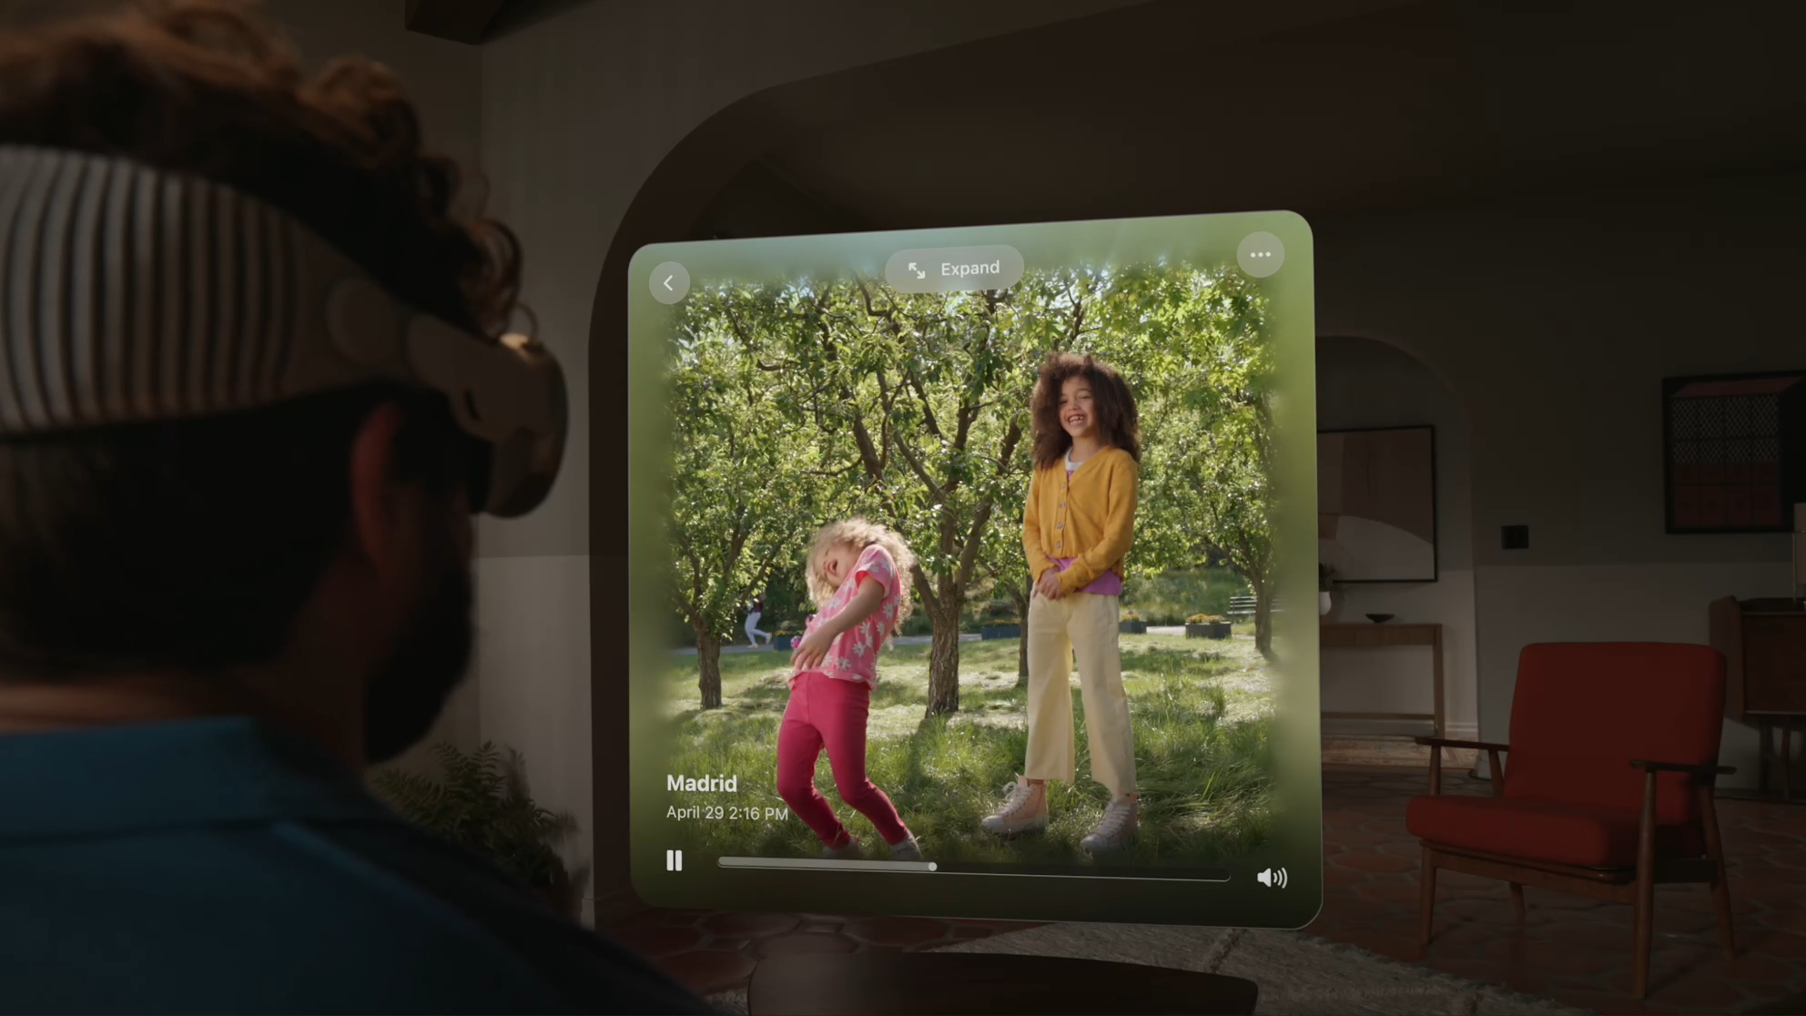
2) Experience with multi-views. A freely selected viewpoint makes it feel like you can move and watch within a 3D space, including looking up and down, back and forth, left and right.
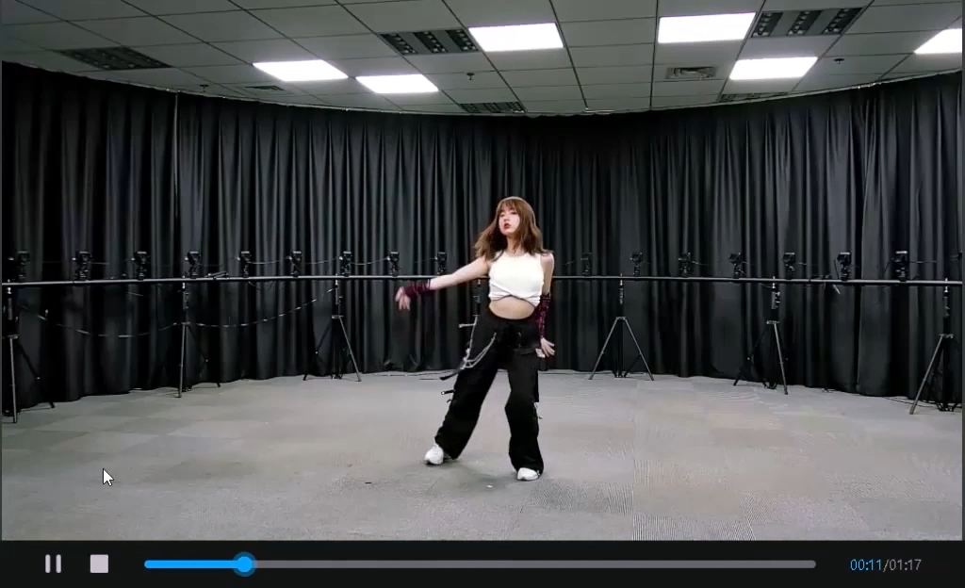

Proposal
1st Change

4.x.4 Formats Description

4.x.4.1 Source Formats
Market relevant source formats include texture and depth information, or point clouds enabling a variety of viewpoints. The following formats for texture and depth can be considered:
Source formats (texture and depth map)
viewpoints | Stereo views or multi views
Resolution per view | 1080x1080, 1440x1440, 2048x2048, 1920*1080
Frame rates | 30, 50, 60 fps
Bit depth | 10
Chroma format | Y’CbCr ,RGB
Chroma subsampling | 4:2:0, 4:0:0
Colour space formats | BT.709, BT.2020
Transfer characteristics | BT.709, BT.2100 (HDR)
the following information may be available:
- Static metadata:
  - Camera extrinsic: Relative position between cameras, Rotation Matrix, Translation Vector
  - Camera intrinsics: Focal Length, Principal Point, Distortion Coefficients

For point cloud, the following formats can be considered:
TBD add corresponding table based on “single asset” use case.
Editor notes: TBD add other formats as needed from various scenarios.

4.x.4.3 Compression and Storage Formats

Codecs for Stereo views, multi views and point clouds includes:
- H.265/HEVC Main 10 Profile
- Multiview Main profile: MV-HEVC with depth/alpha channels .
- MIV Main Profile: Multi-View Video with Depth.
- V-PCC

Editor’s note: TBD add other codec as needed from various scenarios and usecases.

Storage format for Stereo views, multi views and point clouds includes:

- TBD

-TBD

<tbd>

Change End

