3GPP TS 26.260 V18.0.0 (2022-12)
Technical Specification
3rd Generation Partnership Project;
Technical Specification Group Services and System Aspects;
Objective test methodologies for the evaluation of immersive audio systems
(Release 18)

The present document has been developed within the 3rd Generation Partnership Project (3GPP TM) and may be further elaborated for the purposes of 3GPP.
The present document has not been subject to any approval process by the 3GPP Organizational Partners and shall not be implemented.
This Specification is provided for future development work within 3GPP only. The Organizational Partners accept no liability for any use of this Specification.
Specifications and Reports for implementation of the 3GPP TM system should be obtained via the 3GPP Organizational Partners' Publications Offices.

3GPP
Postal address

3GPP support office address
650 Route des Lucioles - Sophia Antipolis
Valbonne - FRANCE
Tel.: +33 4 92 94 42 00 Fax: +33 4 93 65 47 16
Internet
http://www.3gpp.org

Copyright Notification
No part may be reproduced except as authorized by written permission.
The copyright and the foregoing restriction extend to reproduction in all media.

© 2022, 3GPP Organizational Partners (ARIB, ATIS, CCSA, ETSI, TSDSI, TTA, TTC).
All rights reserved.

UMTS™ is a Trade Mark of ETSI registered for the benefit of its members
3GPP™ is a Trade Mark of ETSI registered for the benefit of its Members and of the 3GPP Organizational Partners
LTE™ is a Trade Mark of ETSI registered for the benefit of its Members and of the 3GPP Organizational Partners
GSM® and the GSM logo are registered and owned by the GSM Association

Contents
Foreword 4
Introduction 4
1 Scope 5
2 References 5
3 Definitions, symbols and abbreviations 5
3.1 Definitions 5
3.2 Symbols 6
3.3 Abbreviations 6
4 Objective Test Methodologies for Immersive Audio Systems 6
4.1 Objective Test Methodologies for Assessment of Immersive Audio Systems in the Sending Direction 6
4.1.1 Diffuse-field Send Frequency Response for Scene-based Audio 6
4.1.1.1 Introduction 6
4.1.1.2 Definition 7
4.1.1.3 Test method with periphonic array 8
4.1.1.3.1 Test Conditions 8
4.1.1.3.2 Measurement 8
4.1.1.4 Test method with loudspeaker array and turn table 9
4.1.1.4.1 Test Conditions 9
4.1.1.4.2 Measurement 9
4.1.2 Directional response measurement for scene-based audio 10
4.1.2.1 Definition 10
4.1.2.2 Test conditions 10
4.1.2.3 Measurement 11
4.2 Objective Test Methodologies for Assessment of Immersive Audio Systems in the Receiving Direction 11
4.2.1 Headset Binaural Diffuse-field Receive frequency response for Scene-based audio 11
4.2.1.1 Introduction 11
4.2.1.2 Definition 11
4.2.1.3 Test Conditions 11
4.2.1.4 Measurement 11
4.2.2 Nominal System Sensitivity in Receive Direction for Channel-based audio 12
4.2.2.1 Introduction 12
4.2.2.2 Definition 12
4.2.2.3 Test Conditions 12
4.2.2.4 Measurement 12
4.2.3 Motion to Sound Latency in Dynamic Binaural Rendering Systems 13
4.2.3.1 Introduction 13
4.2.3.2 Requirements 13
4.2.3.3 Calibration 14
4.2.3.4 Evaluation Environment 14
4.2.3.5 Data acquisition 15
4.2.3.6 Data Analysis 15
Annex A (normative): Order dependent directions 18
Annex B (normative): Directions in Gaussian spherical grid 22
B.1 Definition 22
B.2 Example loudspeaker array 22
Annex C (informative): Change history 23

Foreword
This Technical Specification has been produced by the 3rd Generation Partnership Project (3GPP).
The contents of the present document are subject to continuing work within the TSG and may change following formal TSG approval. Should the TSG modify the contents of the present document, it will be re-released by the TSG with an identifying change of release date and an increase in version number as follows:
Version x.y.z
where:
x the first digit:
1 presented to TSG for information;
2 presented to TSG for approval;
3 or greater indicates TSG approved document under change control.
y the second digit is incremented for all changes of substance, i.e. technical enhancements, corrections, updates, etc.
z the third digit is incremented when editorial only changes have been incorporated in the document.

Introduction
Audio is a key component of an immersive multimedia experience and 3GPP systems are expected to deliver immersive audio with a high Quality of Experience. However, industry agreed methods to assess the Quality of Experience for immersive audio are relatively few and the present document seeks to address this gap by providing objective test methods for the assessment of immersive audio.

1 Scope
The present document specifies objective test methodologies for 3GPP immersive audio systems including channel based, object based, scene-based, parametric and hybrids of these formats. The objective evaluation methods described in the present document are applicable to audio capture, coding, transmission and rendering as indicated in their corresponding clauses. They include testing of IVAS-based UEs [26.250].

2 References
The following documents contain provisions which, through reference in this text, constitute provisions of the present document.
- References are either specific (identified by date of publication, edition number, version number, etc.) or non-specific.
- For a specific reference, subsequent revisions do not apply.
- For a non-specific reference, the latest version applies. In the case of a reference to a 3GPP document (including a GSM document), a non-specific reference implicitly refers to the latest version of that document in the same Release as the present document.
[1] 3GPP TR 21.905: "Vocabulary for 3GPP Specifications".
[2] J. Fliege und U. Maier: "A two-stage approach for computing cubature formulae for the sphere," Dortmund University, 1999.
[3] ISO 3745 - Annex A: "Acoustics - Determination of sound power levels and sound energy levels of noise sources using sound pressure -- Precision methods for anechoic rooms and hemi-anechoic rooms - Annex A: General procedures for qualification of anechoic and hemi-anechoic rooms".
[4] ISO 1996 Acoustics: "Description, measurement and assessment of environmental noise".
[5] ANSI S1.4: "Specifications for Sound Level Meters".
[6] ISO 3: "Preferred numbers – Series of preferred numbers".
[7] B. Rafaely, “Analysis and design of spherical microphone arrays,” IEEE Transactions on Speech and Audio Processing, no. 13, 2005, pp. 135 – 143
[8] M. Poletti, “Unified Description of Ambisonics Using Real and Complex Spherical Harmonics,” Ambisonics Symposium 2009, June 25-27, 2009, Graz, Austria.
[9] Recommendation ITU-T G.100.1 (06/2015): "The use of the decibel and of relative levels in speechband telecommunications".
[9] Recommendation ITU-T P.56 (12/2011): "Objective measurement of active speech level".
[10] Recommendation ITU-T P.57 (06/2021): "Artificial ears".
[11] Recommendation ITU-T P.58 (03/2023): "Head and torso simulator for telephonometry".
[12] Recommendation ITU-T P.501 (05/2020): "Test signals for use in telephonometry".
[13] Recommendation ITU-T P.581 (07/2022): "Use of head and torso simulator for hands-free and handset terminal testing".
[14] Recommendation ITU-T P.340 (05/2000): "Transmission characteristics and speech quality parameters of hands-free terminals".
[15] Recommendation ITU-T P.341 (03/2011): "Transmission characteristics for wideband digital loudspeaking and hands-free telephony terminals".
[16] Recommendation ITU-T P.380 (07/2022): "Electro-acoustic measurements on headsets".
[17] Recommendation ITU-T P.381 (03/2023): "Technical requirements and test methods for analogue wired headsets or headphones and corresponding universal interface of terminals".
[18] Recommendation ITU-T P.382 (03/2023): "Technical requirements and test methods for analogue wired multi-microphone headsets or headphones and corresponding universal interface of terminals".
[19] Recommendation ITU-T P.383 (03/2023): "Technical requirements and test methods for digital headsets or headphones and corresponding interfaces of terminals".
[20] Recommendation ITU-T P.700 (06/2021): "Calculation of loudness for speech communication".
[21] Recommendation ITU-R BS.1770-5 (11/2023): "Algorithms to measure audio programme loudness and true-peak audio level".
[22] IEC 60268-1:1985: "Sound system equipment. Part 1: General".
[23] 3GPP TS 26.131: "Speech and video telephony terminal acoustic test specification".
[24] 3GPP TS 26.132: "Speech and video telephony terminal acoustic test specification".
[25] 3GPP TS 26.250: "Codec for Immersive Voice and Audio Services - General overview".
[26] 3GPP TS 26.254: "Codec for Immersive Voice and Audio Services - Rendering".
[27] 3GPP TS 26.258: "Codec for Immersive Voice and Audio Services; C code (floating-point)".
[28] ETSI TS 103 224: "A sound field reproduction method for terminal testing including a background noise database".
[29] USB Implementors' Forum: "HID Usage Tables for USB", Version 1.5.

3 Definitions, symbols and abbreviations

3.1 Definitions
For the purposes of the present document, the terms and definitions given in 3GPP TR 21.905 [1] and the following apply. A term defined in the present document takes precedence over the definition of the same term, if any, in 3GPP TR 21.905 [1].
spherical coordinates: The coordinate system used in this document is defined such that the x-axis points to the front, the y-axis to the left and the z-axis to the top (see Figure 0). Spherical coordinates are the distance rθθrr from the origin, the azimuth ϕ in mathematical positive orientation (counter-clockwise) and the elevation angle θ relative to the z-axis (with 0 degrees pointing to the equator and +90 degrees pointing to the North pole).

Figure 0: Spherical coordinate system
dBFS: dB full-scale, where 0 dBFS refers to the RMS level of a DC-free sinusoidal signal exercising the full scale of the digital interface/file.
Coded Formats: See payload format in 3GPP TS 26.253 Annex A.
User Capture: The user's voice is considered as the primary target intended to be captured by the UE.

3.2 Symbols
For the purposes of the present document, the following symbols apply:

ϕϕ
θ(A) A-weighting
dB Decibel
dBPa Sound pressure level in dB, referenced to 1 Pa
dBSPL Sound pressure level in dB, referenced to 2E-5 Pa
f Frequency (in Hertz)
Hz Unit of frequency (Hertz)
Gf Frequency response of measured versus reference signal
LA_{eq} the sound level in decibels equivalent to the total A-weighted sound energy measured over a stated period of time.
Pf Spectral magnitude of measured signal
Pref(f) Spectral magnitude of reference signal
Pkf Spectral magnitude of measured signal (k-th channel)

Pa Unit of pressure (Pascal)
ϕ azimuth angle (phi)
r distance from a point in space to the origin of the spherical coordinate system (radius of sphere)
RCV Receiving (direction)
SND Sending (direction)
θ elevation angle (theta)
T_{R} UE delay in receiving direction
T_{TER} Test equipment delay in receiving direction
T_{S} UE delay in sending direction
T_{TES} Test equipment delay in sending direction

3.3 Abbreviations
For the purposes of the present document, the abbreviations given in 3GPP TR 21.905 [1] and the following apply. An abbreviation defined in the present document takes precedence over the definition of the same abbreviation, if any, in 3GPP TR 21.905 [1].
EXT External output
FOA First-Order Ambisonics
HATS Head-And-Torso Simulator
HFRP Hands-free Reference Point
HID Human Interface Device
HOA2 Higher-Order Ambisonics (2nd order)
HOA3 Higher-Order Ambisonics (3rd order)
HRP HATS Reference Point
ISM Independent Stream with Metadata
IVAS Immersive Voice and Audio Services
MASA Metadata-Assisted Spatial Audio
MRP Mouth Reference Point
N3D full three-dimensional normalization (of an Ambisonics signal)
OMASA Metadata-assisted spatial audio with ISM
OSBA Scene-based audio with ISM
SBA Scene-Based Audio (Ambisonics)
SN3D Schmidt semi-normalization (of an Ambisonics signal)
SS System Simulator
TC Transport Channel (for MASA)
THD Total Harmonic Distortion
USB Universal Serial Bus

4 Objective Test Methodologies for Immersive Audio Systems

4.0 General

4.0.1 Applicability
This clause describes general objective test methodologies for immersive audio systems. For testing IVAS-based devices, refer to clause 5.

4.0.2 Test equipment
[clause 3.3 from PDoc + further specifications]
Unless specified otherwise, the accuracy of electric and acoustic measurements made by test equipment shall meet the requirements defined in clause 5.3 of 3GPP TS 26.132 [24].
For tests with head tracking, HATS rotation around the vertical axis should be realized using a motorized turntable or a HATS with motorized head rotation. For motorized or manual rotations of HATS and/or UE, error in orientation (elevation and azimuth) shall not exceed [±2°]
NOTE: Some UE may not have a natural reference orientation (which, for instance, may be defined by the direction of a screen). In this case, the UE may reset the reference direction automatically, e.g., to the primary device orientation over a previous span of time. This has to be taken care of during the measurement. The measurement with the rotated HATS has to be performed quickly enough to prevent the reference direction from being spuriously readjusted. To avoid unreasonable results, a motorized rotation of HATS and UE is highly recommended.
Head-and-torso simulators (HATS) used for acoustic testing are specified in ITU-T Recommendation P.58 [11], corresponding artificial ears for testing in receiving direction are specified in ITU-T Recommendation P.57 [10] (Type 3.3 or Type 4).

[
In sending direction, HATS equipped with mouth simulators (or equivalent stand-alone mouth simulator) used as a single sound source for spatial or user capture (see clause 5.4.1) in the test arrangement shall comply with ITU-T P.58 [11] and ITU-T P.581 [13].
Loudspeakers used as a single sound source in the test arrangement for spatial capture (see clause 5.4.1) shall meet the following requirements:
- The spectrum of the acoustic signal produced by the loudspeaker shall be equalized under free field conditions with a measurement microphone positioned on the main loudspeaker axis at a distance of 50 cm from the loudspeaker membrane. The achieved free field equalized spectrum in 1/3rd octave bands shall be within ±1 dB from 100 Hz to 200 Hz and shall be within ±0.5 dB from 200 Hz to 20 kHz.
- THD ≤ [1]% when measured at 1 m on axis with an [80] dBSPL sinusoidal signal for frequencies ≥ 125 Hz.
- Maximum long term level ≥ [86] dBSPL when measured at 1 m on axis with the simulated programme signal defined in clause 7 of IEC 60268-1 [22].
]

4.1 Objective Test Methodologies for Assessment of Immersive Audio Systems in the Sending Direction

4.1.1 Diffuse-field Send Frequency Response for Scene-based Audio

4.1.1.1 Introduction
This test is applicable to UEs capturing scene-based audio (e.g. First and Higher Order Ambisonics).
NOTE: Currently, the test method uses a periphonic loudspeaker array for generation of a diffuse-field. Additional loudspeaker setups for the derivation of the diffuse sound field are under consideration.
General test conditions
Free-field propagation conditions
- The test environment shall contain a free-field volume, wherein free-field sound propagation conditions shall be observed.
- The free-field sound propagation conditions shall be observed down to a frequency of 200 Hz or less.
- Qualification of the free-field volume shall be performed using the method and limits for deviation from ideal free-field conditions described in [3].
Test environment noise floor
Within the free-field volume, the equivalent continuous sound level of the test environment in each 1/3rd octave band, L_{eq}(f), shall be less than the limits of the NR10 curve, following the noise rating determination procedures in [4].

4.1.1.2 Definition
The Diffuse-field Send Frequency Response for Scene-based Audio is defined as the transfer function, $G\left(f\right)$, between:
$\hat{P}\left(f\right)$, the estimated sound pressure magnitude spectrum obtained from a diffuse-field scene-based audio capture and reference synthesis at the geometric center of a free-field volume; and
Pf, the sound pressure magnitude spectrum obtained from a diffuse-field microphone recording the same diffuse field at the origin of a spherical coordinate system.
Figure 1 describes a typical block diagram for the scene-based audio sending direction with measurement points when using a periphonic loudspeaker array.
Figure 1: Scene-based audio capture block diagram for sending direction measurements
Definition of Equivalent Spatial Domain
The equivalent spatial domain representation, w(t), of a N^{th} order Ambisonics soundfield representation c(t) is obtained by rendering c(t) to K virtual loudspeaker signals w_{j} (t), 1 ≤ j ≤ K$1≤j≤K$Error! Digit expected., with K = (N+1)². The respective virtual loudspeaker positions are expressed by means of a spherical coordinate system, where each position lies on the unit sphere, i.e., a radius of 1. Hence, the positions can be equivalently expressed by order-dependent directions Ω_{j}^{(N)}=(θ_{j}^{(N)}, φ _{j}^{(N)}), 1 ≤ j ≤ K, where θ_{j}^{(N)} and φ _{j}^{(N)} $θ_{j}^{(N)}$θj(N)$ϕ_{j}^{(N)}$ϕj(N)denote the inclinations and azimuths, respectively. These directions are defined according to [2] and reproduced in Annex A for convenience.
The rendering of $c\left(t\right)$into the equivalent spatial domain can be formulated as a matrix multiplication:
w(t) = (Ψ^{(N,N)})⁻¹ ⋅c(t),
where (⋅)⁻¹ denotes the inversion.
The matrix Ψ^{(N,N)} of order N with respect to the order-dependent directions Ω_{j}^{(N)} is defined by:
Ψ^{(N,N)} := [S₁^{(N)} S₂^{(N)} … S_{K}^{(N)}],
with:
$S$_{j}^{(N)} := [S₀⁰(Ω_{j}^{(N)}) S₋₁⁻¹(Ω_{j}^{(N)}) S₋₁⁰(Ω_{j}^{(N)}) S₋₁¹(Ω_{j}^{(N)}) S₋₁¹(Ω_{j}^{(N)}) … S_{N}^{N}(Ω_{j}^{(N)})]^{T} ,
where S_{n}^{m}(⋅) represents the real valued spherical harmonics of the order n and degree m as defined in [8].
The matrix Ψ^{(N,N)} is invertible so that the HOA representation c(t) can be converted back from the equivalent spatial domain by:
c(t) = Ψ^{(N,N)}·w(t)

4.1.1.3 Test method with periphonic array

4.1.1.3.1 Test Conditions
Periphonic loudspeaker array
a) A periphonic loudspeaker array shall be placed within the free-field volume with the geometric center of the periphonic loudspeaker array coinciding with the geometric center of the free-field volume.
b) The periphonic loudspeaker array shall have a radius greater or equal than 1 meter.
c) The periphonic loudspeaker array shall be composed of (N+1)² coaxial loudspeaker elements. Each of the (N+1)² coaxial loudspeaker elements shall be equalized (if necessary) and level compensated to conform with the operational room response curve limits given in [5] Section 8.3.4.1. N shall be equal to 4.
d) The (N+1)² coaxial loudspeaker elements shall be positioned according to the azimuth and elevation coordinates given in Annex B.
e) All coaxial loudspeaker elements shall be oriented such that their acoustic axis intersects at the geometric center of the free field volume.
f) The radius of each coaxial loudspeaker element shall be such that, at the geometric center of the free-field volume, the far field approximation for the coaxial loudspeaker axial pressure amplitude decay holds true.

4.1.1.3.2 Measurement
Reference Spectrum measurement for periphonic loudspeaker array method
a) A diffuse-field / random incidence, or multi-field microphone is mounted in the free-field volume such that the tip of the microphone corresponds to the geometric center of the free-field volume and the geometric center of the periphonic loudspeaker array.
NOTE 1: Diffuse-field / random incidence microphones, are described in [5].
b) (N+1)² decorrelated pink noise signals are played simultaneously over each of the (N+1)² coaxial loudspeakers of the periphonic loudspeaker array.
c) The playback level is adjusted such that the LAeq, measured over a 30s time window at the geometric center of the periphonic loudspeaker array, is equal to 78dBSPL(A) ± 0.5dB.
d) The reference sound pressure at the geometric center of the free-field volume, p(t), is captured with the diffuse-field or multi-field microphone.
e) The magnitude spectrum of the reference sound pressure, P(f), is calculated for the 1/12th octave intervals as given by the R40 series of preferred numbers in [6].
NOTE 2: For ideal (calibrated) loudspeakers, the P(f) spectra should have equal energy in each 1/12th octave intervals.
Estimated Spectrum measurement
a) The scene-based audio capture device under test is mounted in the free-field volume such that its geometric center coincides with the geometric center of free-field volume and the geometric center of the periphonic loudspeaker array.
b) (N+1)² decorrelated pink noise signals are played simultaneously over each of the (N+1)² coaxial loudspeakers of the periphonic loudspeaker array. The pink noise signals shall be identical to the signals used for the reference spectrum measurement.
c) The B-format scene-based audio format representation (compressed or uncompressed, depending on the use case being tested) is stored for offline analysis.
d) The B-format scene-based audio format representation is uncompressed (if necessary) and converted to an equivalent spatial domain representation of order N_{DUT} (B-Format to ESD conversion in Figure 1), where N_{DUT} corresponds to the Ambisonics order of the device under test.
e) $\hat{p}\left(t\right)$, the estimate of the sound field at the geometric center of the free-field volume and periphonic loudspeaker array, is synthesized using the equivalent spatial domain representation of order N_{DUT}.
NOTE 3: $\hat{p}\left(t\right)$ can be taken from the W component of the B-Format signal, as an alternative to implementing the B-Format to ESD conversion in step d).
f) The magnitude spectrum of the estimated sound pressure, $\hat{P}\left(f\right)$, is calculated for the 1/12th octave intervals as given by the R40 series of preferred numbers in [6].
Calculation of send frequency response for scene-based audio
The send frequency response for scene-based audio, G(f), is calculated as $G\left(f\right)=\frac{\hat{P}\left(f\right)}{P\left(f\right)}$.

4.1.1.4 Test method with loudspeaker array and turn table

4.1.1.4.1 Test Conditions
Loudspeaker array
a) A calibrated loudspeaker array shall be placed within the free-field volume.
b) The loudspeaker array shall comprise one or several semi-arcs having a radius greater or equal than 1 meter. The radius shall be reported.
c) The loudspeaker array shall be composed of N+1 loudspeaker elements. The ambisonic order N shall be reported.
d) Each loudspeaker in the array shall be calibrated with a frequency response of [at least 100 Hz-20,000 Hz] and minimum phase response.
e) The coordinates of the loudspeaker elements are defined according to a Gaussian spherical grid [7] of order N. Directions shall comply with Annex B.1 and the N+1 elevations of the spherical grid shall be reported.
Turn table
a) A turn table with a resolution of 0.5 degrees shall be used. The rotation axis of the turn table and the vertical axis of the semi-arcs shall be aligned The turn table shall be adjusted in height so that the device under test is positioned at the geometric center of the loudspeaker array.
b) For measurement, an azimuth step of 180/(N+1) degrees shall be used.

4.1.1.4.2 Measurement
Reference Spectrum measurement
a) A diffuse-field / random incidence, or multi-field microphone is mounted in the free-field volume such that the tip of the microphone corresponds to the geometric center of the free-field volume and the geometric center of the loudspeaker array.
NOTE 1: Diffuse-field / random incidence microphones, are described in [5].
Repeat steps b-c) with an azimuth angular resolution of 180/(N+1) degrees:
b) An exponential sweep sine signal is played over each of the N+1 loudspeakers of the loudspeaker array.
c) The impulse response at the geometric center of the loudspeaker array ptpt is measured for each loudspeaker position.
d) The magnitude spectrum of the reference sound pressure, P(f), is calculated for the 1/12th octave intervals as given by the R40 series of preferred numbers in [6].
NOTE 2: For ideal (calibrated) loudspeakers, the P(f) spectra should have equal energy in each 1/12th octave intervals.
Estimated Spectrum measurement
a) The scene-based audio capture device under test is mounted in the free-field volume such that its geometric center coincides with the geometric center of free-field volume and the geometric center of the loudspeaker array.
b) Repeat steps b-c) with an azimuth angular resolution of 180/(N+1) degrees::
c) An exponential sweep sine signal is played over each of the N+1 loudspeakers of the loudspeaker array. The sweep signals shall be identical to the signals used for the reference spectrum measurement.
d) The impulse response at the geometric center of the loudspeaker array ptpt is measured for each loudspeaker position.
e) The magnitude spectrum of the estimated sound pressure, $\hat{P}\left(f\right)$, is calculated for the 1/12th octave intervals as given by the R40 series of preferred numbers in [6].
Calculation of send frequency response for scene-based audio
The send frequency response for scene-based audio, G(f), is calculated as Gf=PfPf.
Due to practical constraints (e.g. reflections on turn table), measurements for specific elevations (e.g. < - degrees) may be unreliable and discarded. In this case, the above measurement procedure may be conducted in two phases by measuring only directions for one hemisphere (e.g. top hemisphere, with elevations >0) in each phase. The device under test shall be flipped upside down between the two phases, and this two-phase approach shall be reported.

4.1.2 Directional response measurement for scene-based audio

4.1.2.1 Definition
The directional response for scene-based audio is defined as the transfer function, represented as an impulse response, h(θ_{i}, φ_{i}), $G\left(f\right)$Gfbetween a device under test and a loudspeaker located at an equal distance r and L predefined directions, (θ_{i}, φ_{i}), i=1,...,L.

4.1.2.2 Test conditions
Free-field propagation conditions
- The test environment shall contain a free-field volume, wherein free-field sound propagation conditions shall be observed.
- The free-field sound propagation conditions shall be observed down to a frequency of 200Hz.
Test environment noise floor
The equivalent continuous sound level of the test environment in each 1/3rd octave band, L_{eq}(f)$L_{eq}(f)$Leq(f), shall be less than the limits of the NR10 curve, following the noise rating determination procedures in [4].
Loudspeaker array
A real or simulated loudspeaker array comprising L loudspeakers located be a set of predefined directions (θ_{i}, φ_{i}), i=1,...,L, from the geometric center of the loudspeaker array shall be used.

4.1.2.3 Measurement
For each loudspeaker position (θ_{i}, φ_{i}), i=1,...,L , the following procedure shall be used:
a) An exponential sweep sine test signal is played over the loudspeaker.
NOTE: The impact of codec on the exponential sweep sine test signal needs to be verified before performing the measurements. An activation signal may be needed.
b) The impulse response h(θ_{i}, φ_{i}) at the geometric center of the loudspeaker array$p\left(t\right)$pt is measured.

4.2 Objective Test Methodologies for Assessment of Immersive Audio Systems in the Receiving Direction

4.2.1 Headset Binaural Diffuse-field Receive frequency response for Scene-based audio

4.2.1.1 Introduction
This test is applicable to UEs rendering scene-based audio (e.g. First and Higher Order Ambisonics) over a binaural headset.

4.2.1.2 Definition
The Headset Binaural Diffuse-field Receive Frequency Response for Scene-based Audio (for left and right ears) is defined as the transfer function, G_{L,R} (f)$G\left(f\right)$Gf, between:
a) P_{L,R}(f), the binaurally recorded sound pressure magnitude spectra, obtained when a diffuse field signal in the equivalent spatial domain representation, w(t), is played on the DUT; and
b) P_{ref L,R}(f)$\hat{P}\left(f\right)$Pf, the reference sound pressure magnitude spectra, obtained by direct convolution of the diffuse field signal in the equivalent spatial domain representation, w(t) with its corresponding set of HRTFs.

4.2.1.3 Test Conditions
Test environment noise floor
The equivalent continuous sound level of the test environment in each 1/3rd octave band, L_{eq}(f)$L_{eq}(f)$Leq(f), shall be less than the limits of the NR10 curve, following the noise rating determination procedures in [4].
The set of HRTFs used by the UE shall be documented and available to the test lab.

4.2.1.4 Measurement
Reference sound pressure magnitude spectra
The reference sound pressure magnitude spectra are derived offline. The reference sound pressure magnitude spectra for the left and right ears, P_{ref L,R} (f) is the frequency domain representation of the convolution between the set of equivalent spatial domain signals, w(t), with its corresponding set head related transfer functions h _{L,R}(t), for each direction j in an equivalent spatial domain of order N_{DUT ,} i.e.:
$$P_{ref L,R}\left(f\right)=F(\sum_{j=1}^{{(N_{DUT}+1)}^{2}}{w_{j}\left(t\right)*h_{j L,R}(t))}$$
The signals w_{j}(t), for 1 ≤ j ≤ (N_{DUT} +1)², are uncorrelated pink noise signals of 30s length.
Binaurally recorded sound pressure magnitude spectra
The binaurally recorded sound pressure magnitude spectra is obtained as follows:
a) The binaural headset is placed on a HATS.
b) The DUT shall be configured such that the set of HRTFs used for binaural rendering correspond to the HATS used for testing.
c) The DUT volume control (if any) is adjusted for its nominal setting.
d) The binaural time-domain signals are recorded with HATS.
e) The binaurally recorded sound pressure magnitude spectra, P_{L,R}(f) is obtained by taking the Fourier transform of the binaurally recorded time-domain signals.
Calculation of headset binaural diffuse-field receive frequency response for scene-based audio
The headset binaural diffuse-field frequency response for scene-based audio, G(f)$G\left(f\right)$Gf, is calculated for each supported Ambisonics order N_{DUT} as:
$$G\left(f\right)=\frac{P_{L,R} (f)}{P_{ref L,R} (f)}$$

4.2.2 Nominal System Sensitivity in Receive Direction for Channel-based audio

4.2.2.1 Introduction
This test is applicable to UEs rendering channel-based audio (e.g. 7.1.4) over a binaural headset.

4.2.2.2 Definition
The nominal system sensitivity in receive direction for channel-based audio is defined as the difference between the sound pressure level (in dBSPL(A)) produced by the DUT on HATS and the root mean square of the digital test signal (in dBFS).

4.2.2.3 Test Conditions
Test environment noise floor
The equivalent continuous sound level of the test environment in each 1/3rd octave band, L_{eq}(f)$L_{eq}(f)$Leq(f), shall be less than the limits of the NR10 curve, following the noise rating determination procedures in [4].
The specific HATS used for the recording shall be described in the test report. The set of HRTFs used by the UE shall be documented and available to the test lab.

4.2.2.4 Measurement
For each audio channel supported by the DUT, a pink noise signal with -18 dBFS RMS level is played, with the signals played only one channel at a time.
The LAeq (in dBSPL(A)) is measured continuously for a period of 30 s for each of the left and right ears.
The sensitivity G_{i L,R} is expressed as the difference of the recorded sound pressure levels at the left and right ears and the root mean square digital level of the pink noise test signal, i.e. -18 dBFS.
$$G_{i L,R}={LA}_{eq}-18$$

4.2.3 Motion to Sound Latency in Dynamic Binaural Rendering Systems

4.2.3.1 Introduction
Motion to Sound latency is the time difference between the event of a change in head rotation and when the immersive audio signal is finally compensated for the head motion. The method in this specification is intended to verify that the overall motion-to-sound latency that a user experiences upon rotating their head is within acceptable limits.
The method allows full measurement of motion to sound, i.e. including both the latency of the head tracking sensor as well as the audio playback. This includes all components of a real setup and therefore contains all possible causes of additional latency that a user may experience.
The method also provides a latency value for the isolated audio processing of the binaural renderer without the aforementioned external hardware, assuming that the binaural renderer can process audio data as an audio processing plugin that can be evaluated in isolation.
NOTE: This method requires synchronized playback of two renderer instances and may not be suitable for the measurements of UEs where such synchronization is not possible.

4.2.3.2 Requirements
The following will be required:
Software:
- Audio processing software to run and record output of two renderers simultaneously
- Head tracker software
Hardware:
- Host machine for audio processing
- Head tracker hardware
- Stereo audio recording interface
- Stereo audio playback interface
- Mechanical setup to rotate the head tracking sensor in a precise and reproducible way
An exemplary hardware setup can be seen below in Figure 2, the method however can also be implemented using different systems under test and accompanying equipment:
Figure 2: Hardware Overview (Setup in Position 1 on the left, Position 2 on the right)
The audio processing environment uses two parallel signal chains, each containing its own instance of the same binaural renderer being tested. The test is concerned only with yaw angles, so values of pitch and roll should be set to zero at the beginning of the test and can be ignored thereafter.
Figure 3: Generic Audio Processing Environment
The initial conditions are that Rendering Chain 1 (RC1) has a static yaw head rotation angle of 0 degrees and RC2 uses the physical rotation of the head tracker to get its yaw value. A white noise signal is virtually placed directly in front of the listener (0 degrees azimuth, elevation), meaning that rotation of the arm directly affects how the white noise source is rendered.

4.2.3.3 Calibration
The first step is to calibrate the final position of the rotating arm (Position 2 / P2). The rotating arm is moved manually and requires only a limited range of motion - from some small rotation away from the table (Position 1 / P1), 20 to 30 degrees will be ample, through until contact with the table (P2). The arm should be placed at P2 and set up so that this position also corresponds to 0 degrees yaw.

4.2.3.4 Evaluation Environment
An object within the evaluation environment, e.g. using Max/MSP, should be created to set the value of yaw to exactly 0 degrees once the real value of yaw (received from the head tracker) is <0.2 degrees.
NOTE: This tolerance value was chosen to be as small as possible while ensuring that it does not bounce (dependent on the accuracy of the tracking system)
This object should be designed to latch to zero once the actual value is under the tolerance threshold, so that any small accidental rebound of the rotating arm does not affect the yaw angle fed to the renderer - it artificially remains at exactly 0, which is important to ensure that both rendering chains have exactly the same head rotation when the arm is in its final position (P2). The output from the evaluation environment is captured by the recording audio interface, which therefore includes any latency introduced by playback.

4.2.3.5 Data acquisition
A test run begins by starting to record on the recording audio interface. The rotating arm is set to Position 1, then the audio processing set running and starts feeding the input source to both renderer instances. A microphone is positioned near the contact point at the table. This mono room microphone will be recorded synchronously with the output from the evaluation environment, with its purpose being to log the point of contact of the arm with the table, which should be done with a good amount speed and vigour so that the microphone picks up a loud knock at the table. Shortly after this (one or two seconds for example), with the test run now complete, playback and recording can be stopped.
Some milliseconds after the collision, the latest yaw value detected by the tracking system will have been passed into the evaluation environment (t_{Tracking}). With the target yaw value now reached (latched to zero in Max), both rendering chains will have the identical values of head rotation and therefore, after some further short delay, the output of both renderer instances will be identical.

4.2.3.6 Data Analysis
The overall motion-to-sound latency (tM2S) is taken as the time from the moment of collision until the point at which the two output signals are identical.
To easily visually inspect when this point occurs, one output channel of one signal chain (e.g. RC1-left) is subtracted from the same output channel of the complementary signal chain (RC2-left).
NOTE 1: This could be done manually in audio editor software after processing, but this would require recording at least three channels synchronously (one from each renderer chain, and one of the room microphone). Instead, the subtraction of signals can be done within Max/MSP, meaning only the output of this operation (one channel) and the room microphone can conveniently be recorded with a stereo audio interface. In addition to the stereo WAVE file recorded by a separate audio application, the Max/MSP application also writes to a separate mono WAVE file once it detects that it is in the final tolerated yaw position (latched on). This mono WAVE contains only the subtracted signals as described above, from which the tMspProc time can also be measured.
Evaluation is performed offline in audio editor software. The tMspProc time is measured from the start of the file until the point at which consecutive zero samples begin. This value encompasses any motion-to-sound latency caused by the tested renderer chain as well as any other latency caused by Virtual Studio Technology (VST) plugin framework buffering. The tMspProc time shall be measured from the audio frame boundary at which the latched-on yaw value is activated and applied within that audio frame.
NOTE 2: Since the yaw rotation update rate of the tracker is typically in the range of a few milliseconds, there is a framing mismatch when compared to the audio framing, but this mismatch will not be incorporated in the tMspProc value but rather only in the tM2S measurement.
An example measurement of the tMspProc is displayed in Figure 4. For tM2S this is measured by selecting the duration between the visible collision peak in the microphone channel and the point at which the other channel reduces to silence. Figure 5 shows an example measurement for the motion-to-sound latency.
Figure 4: tMspProc latency measurement
Figure 5: Motion-to-sound (tM2S) latency measurement
In Figure 5 the room recording is on the top, subtracted renderer output is on the bottom. Marked region is the time passed since the arm hits the table (recorded knock) and when the subtracted binaural renderer output reaches silence.
NOTE 3: Unlike the tMspProc measurement, the tM2S measurement is taken from signals recorded from hardware audio interfaces, hence it is not possible to look for continuous silence since the resulting file will always contain some noise added by the digital-to-analog and analog-to-digital converters. For this reason, it is important to ensure a high signal-to-noise ratio in the signal provided to audio interfaces, to make it easier to inspect where the cancellation occurs.

5 Objective Test Methodologies for IVAS-based UEs

5.1 Overview
This clause adds objective test methodologies that are specific to IVAS-based UEs. The following clauses allow testing of UEs on either an acoustical or an electrical interface. In case of acoustical interface testing, a HATS (head and torso simulator) is used for a realistic simulation of an average user. A motorized turntable or an HATS with motorized head rotation is used to test head-tracking behavior of the UE under test. Moreover, in contrast to conventional telephony, which aims to capture/present the subscriber's voice isolated from any acoustical background scene, IVAS-based UEs aim to capture and/or reproduce spatial information of the acoustic scene.
NOTE: The tests in this clause are limited to single sound source tests and are not intended to evaluate UE performance in more complex sound fields. Test methods with more complex sound fields are for further study.

5.2 Interface Definitions
UE testing is realized by connecting a terminal to a test system composed of a system simulator and a reference client. The system simulator simulates the access network, provides core network functionalities and a point of interconnection (POI). The reference client serves as the far-end communication endpoint at the POI and provides IVAS encoder, decoder and rendering functionalities. Test sequences are both captured and fed into the reference client for sending and receiving direction tests, as illustrated in Figure 6. Immersive audio encoding, decoding, and rendering can be part of the system simulator or the reference client. No further transcoding beyond linear PCM shall take place.
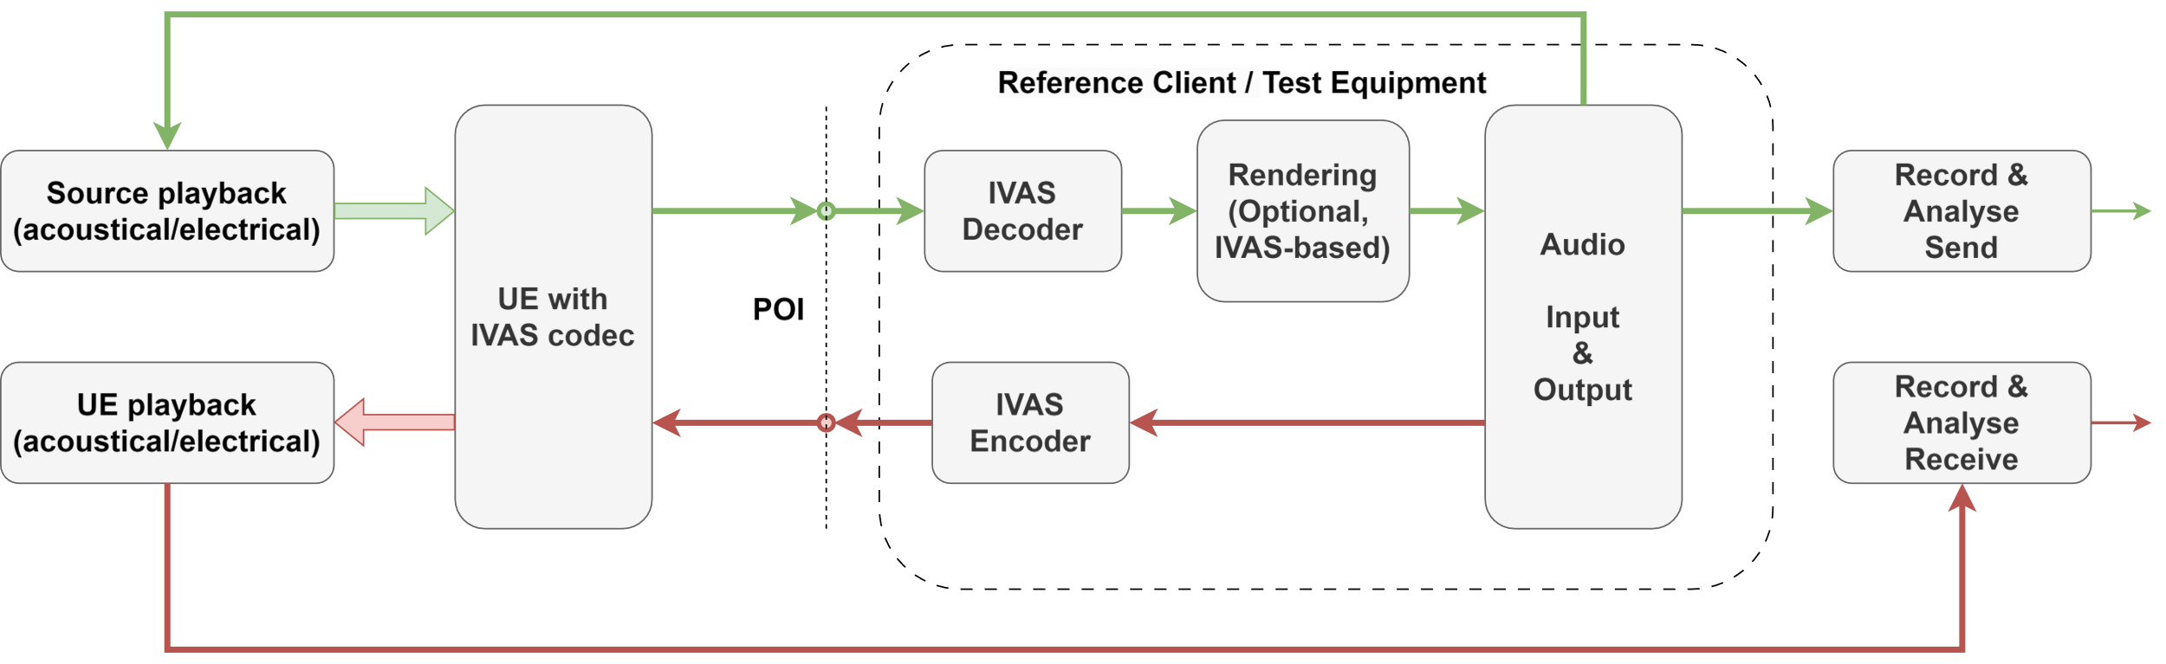
Figure 6: General test setup with UE and reference client
The digital overload point in dBm0 (corresponds to 0 dBr according to ITU-T G.100.1 [9]) for testing IVAS-based UEs is the same as in 3GPP TS 26.132 [24] and applies equally for all possible encoded or decoded signal channels:
D/A converter - a Digital Test Sequence representing the codec equivalent of an analogue sinusoidal signal with an RMS value of 3.14 dB below the maximum full-load capacity of the codec shall generate 0 dBm across a 600 Ω load;
A/D converter - a 0 dBm signal generated from a 600 Ω source shall give the digital test sequence representing the codec equivalent of an analogue sinusoidal signal with an RMS value of 3.14 dB below the maximum full-load capacity of the codec.
With the given definitions, a sinusoidal signal at 3.14 dBm0 corresponds to:
- A full scale digital signal at -3.01 dBov / 0 dBFS.
- An analogue voltage signal at +0.92 dBV (= -2.21 dBV + 3.14 dBm0), since 0.775 V_{RMS} = -2.21 dBV results in 1 mW / 0 dBm across a load of 600 Ω.

The details of the acoustical and electrical test setup as well as IVAS session parameters are UE-type-dependent and are given in the following clauses.

5.3 Test conditions

5.3.1 Environmental conditions
The test environment (anechoic chamber) shall contain a free-field volume, wherein free-field sound propagation conditions shall be observed. The free-field sound propagation conditions shall be observed down to a frequency of 200 Hz. Qualification or verification of this requirement can be conducted using the methods and limits for deviation from ideal free-field conditions as specified in ISO 3745 [3] or ITU-T P.340 [14].
For testing headset UE in receiving direction, the test environment according to clause 6.1 of ETSI TS 103 224 [28] may be used.
NOTE: The usage of the test environment according to ETSI TS 103 224 for other UE types and use cases is for further study.
The ambient noise level shall be less than [15] dBSPL(A).

5.3.2 System simulator
[clause 3.2 of PDoc (bitrates!)]
The system simulator configuration and radio conditions on the air interface shall be as specified in clause 4.2 of 3GPP TS 26.132 [24]. Unless otherwise specified for the respective test, the system simulator shall provide an error-free radio connection to the UE under test.
The UE shall be connected to a system simulator and test equipment supporting the IVAS codec [25]. Unless specified otherwise, 48 kHz sampling rate and fullband mode shall be used.
Since UEs may provide different capabilities for sending (capture) and receiving (rendering) direction, a bidirectional communication may not be symmetric regarding IVAS Coded Formats and corresponding bitrates.
[
During negotiating and exchange of session parameters via Session Description Protocol (SDP), the UE advertises its available and preferred Coded Formats in sending and receiving direction, as well as corresponding bitrate ranges.
- The reference client shall advertise via SDP that all IVAS audio formats and corresponding bitrates as specified in Table 1 are supported in sending and receiving direction.
- For sending direction, the decoder in the reference client shall be configured for the EXT decoder output format.
- For receiving direction, the encoder in the reference client shall be configured for the coded audio format as preferably indicated by the UE via SDP, i.e., assuming that it is the same as in the UE decoder.

Table 1: Bitrates per audio format used for testing
Coded Format | Subformat | Default Bitrate for testing… | Max. bitrate  [kbit/s]
Stereo |  | TBD | 256
ISM | 1 | TBD | 128
ISM | 2 | TBD | 256
ISM | 3 | TBD | 384
ISM | 4 | TBD | 512
SBA | FOA | TBD | 512
SBA | HOA2 | TBD | 512
SBA | HOA3 | TBD | 512
MASA | 1 TC | TBD | 512
MASA | 2 TC | TBD | 512
OSBA |  | TBD | 512
OMASA |  | TBD | 512
Multichannel | 5.1 | TBD | 512
Multichannel | 7.1 | TBD | 512
Multichannel | 5.1.2 | TBD | 512
Multichannel | 5.1.4 | TBD | 512
Multichannel | 7.1.4 | TBD | 512
NOTE: The maximum bitrates are provided for information.

NOTE 1: Default bitrate configurations for testing are for further study.
NOTE 2: The maximum bitrates listed in Table X may not be supported by all UEs.
The bitrate shall be provided by the network operator configuration. If the bitrate is not available from the operator, the maximum bitrate supported by the UE shall be used. The test operator shall report the bitrate used for testing.
]

5.3.3 Test equipment
The same requirements as specified in clause 4.0.2 apply for IVAS-based testing.

5.4 Test arrangement

5.4.1 Capture modes
[
To simulate a single sound source, either loudspeaker or a HATS equipped with an artificial mouth (or equivalent stand-alone mouth simulator) positioned relative to the UE at a certain anlge/distance. In general, the default source direction (independent of UE type or capture mode) is located at ϕ = 0° and θ = 0°. Two different types of sound sources are distinguished:
1) User capture: The user's voice is considered as the primary target intended to be captured by the UE. The distance between these source and UE is typically small (<0.5 m). The sound source is always a HATS equipped with an artificial mouth and typically only speech (or speech-like) test signals are used.
2) Spatial capture: Acoustic scenes that include directional or diffuse sound sources, are considered as the primary target intended to be captured by the UE. Distances of such sources are typically larger (> 1 m). In general, arbitrary test signals can be used.
The general principle of both capture modes is illustrated in Figure 7.
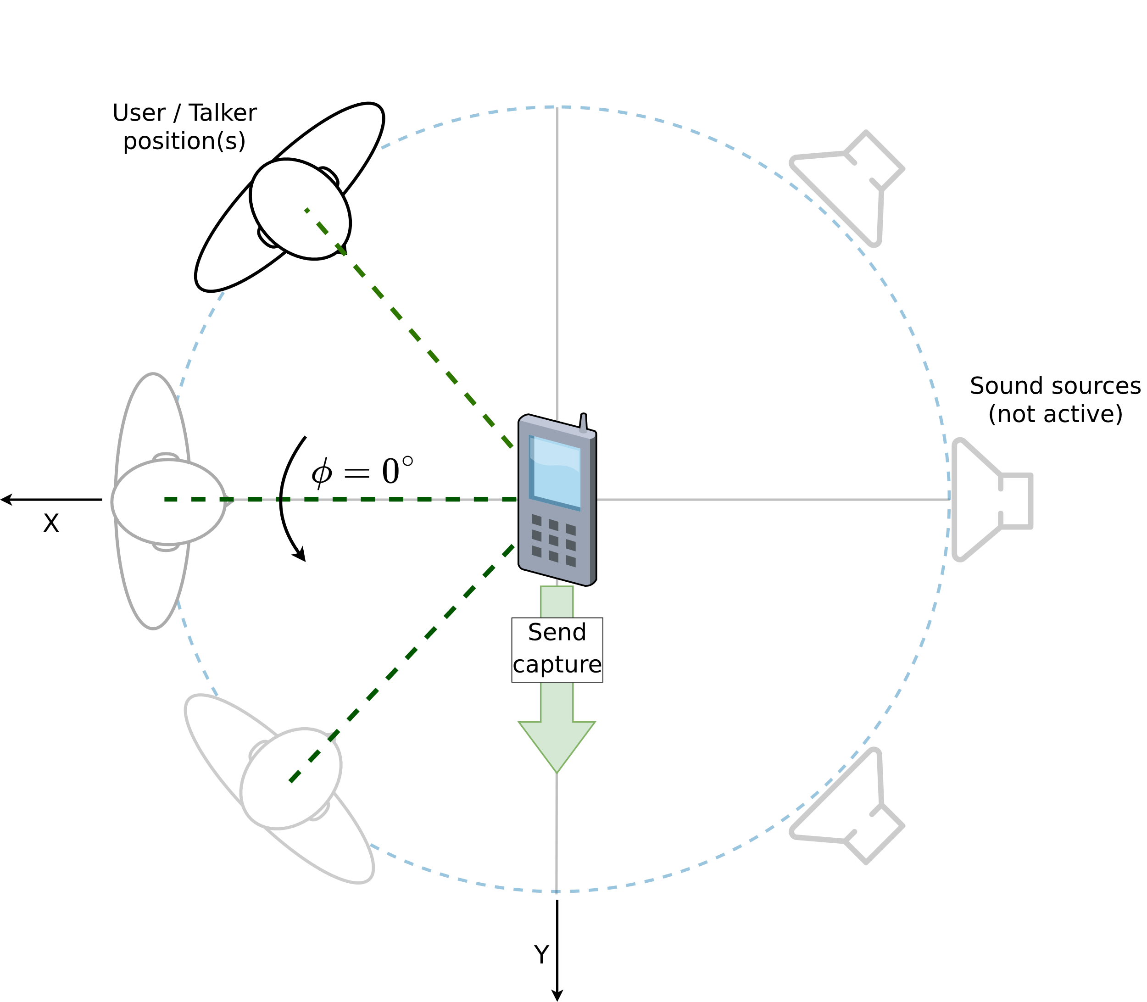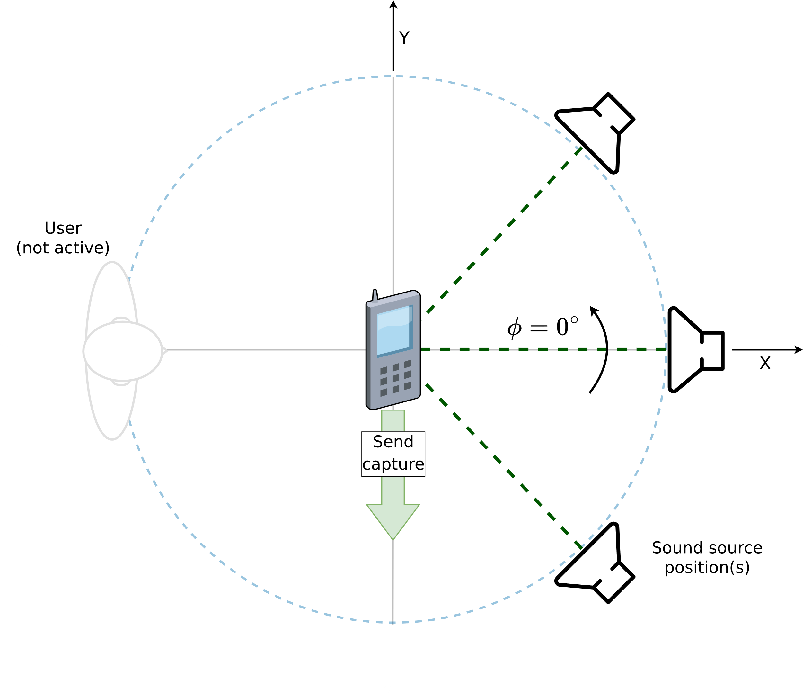
Figure 7: Device orientation and sound sources for User Capture (left) and Spatial Capture (right)
]

5.4.2 UE types and positioning

5.4.2.1 Overview
The definition of IVAS-enabled UE types is more complex than in 3GPP TS 26.132 [24]. Due to the variety of new applications that are enabled by the IVAS codec, the capture and playback audio format may not necessarily be the same in sending and receiving direction. Thus, the classification of an UE type is defined as follows:
- An UE type is composed of SND-UE-type and RCV-UE-type.
- The SND-UE-type is defined as the combination of a certain audio capturing mode (acoustic or electric) and a negotiated coded format (see clause 5.3.2).
- The RCV-UE-type is defined as the combination of a negotiated coded format (see clause 5.3.2) and a certain audio playback mode (acoustic or electric).
- Each audio capturing/playback mode corresponds to a specific physical test arrangement.
UEs may support multiple IVAS formats in sending and receiving direction, which are negotiated during call setup. At least one supported IVAS format shall be tested in all directions supported by the UE, which is selected according to the following priority:
1) Format specified by the manufacturer (if applicable).
2) Preference of the UE, as indicated during negotiation in SDP.
3) Test operator selects format based on form factor and envisioned use case of the UE.
The IVAS format for each tested direction shall be documented in the test report. Other available supported formats may be tested as well to ensure best-possible compatibility with other UE types.
Complementary to the well-defined IVAS formats, capturing/playback modes and corresponding interfaces are given in the following clauses along with several UE type definitions, which may be applicable in SND and/or RCV. All UE type definitions with acoustical interfaces assume that microphones and loudspeakers/headset of the UE are either integrated into the device or that necessary additional off-the-shelf equipment (like e.g., headset, microphone array, loudspeaker array) is either bundled with the device or explicitly recommended by the manufacturer.
If no acoustical interface is available, the electrical interface shall be tested and the test setup according to clause 5.4.2.7 applies.
NOTE: If testing at the electrical interface is not possible for important technical reasons (e.g., due to a non-standardized electrical interface), an acoustic test may be carried out with suitable third-party equipment, which is, e.g., recommended by the manufacturer. This allows to perform tests at an acoustic interface in order to informally assess the performance of the UE (without applying requirements).
The physical test arrangement used for UE testing in sending and receiving direction is in general specified by the manufacturer by:
- Referencing one of the following clauses (recommended),
- Referencing a test arrangement from other standards (e.g., ITU-T P.340 [14] or P.341 [15]),
- Specifying an individual test arrangement.
In case no instructions on the test arrangement are provided by the manufacturer, the test operator shall select one based on the envisioned use case, form factor, etc. from either one of the following clauses or from other standards. If no suitable test arrangement can be identified for certain UEs with acoustical interface, the test operator may set up an individual arrangement or modify an existing one. In any case, the arrangement used for testing shall be documented in the test report.

5.4.2.2 Handset Mode
The EVS-compatible mono mode of IVAS shall be tested according to clause 9 of TS 26.132 [10]. Requirements according to clause 7 of 3GPP TS 26.131 [23] apply.
Immersive testing for handset UE is not considered in the present document due to the following reasons:

- RCV: Monaural listening cannot provide any spatial/immersive audio.
- SND: The device is typically located close to the user's head, which can limit the capture of spatial information.

NOTE: There might be some applications also in handset mode for some immersive audio formats, for example to capture ambient sound at the near end. Such scenarios are a kind of extension to the traditional mono telephony and are not excluded in general. However, so far, test methods are not specified for handset mode and are for further study.

5.4.2.3 Headset Mode
The test setup for headset UE for sending and receiving directions is shown in Figure 8. It applies to all devices that provide a head-worn acoustical frontend. The acoustical frontend may either be internal or external to the UE device. In the latter case, it may be connected via wired or wireless link (e.g., analogue jack, Bluetooth, or USB).

The device may provide head tracking data that can be used for rendering binaural audio in receiving direction.
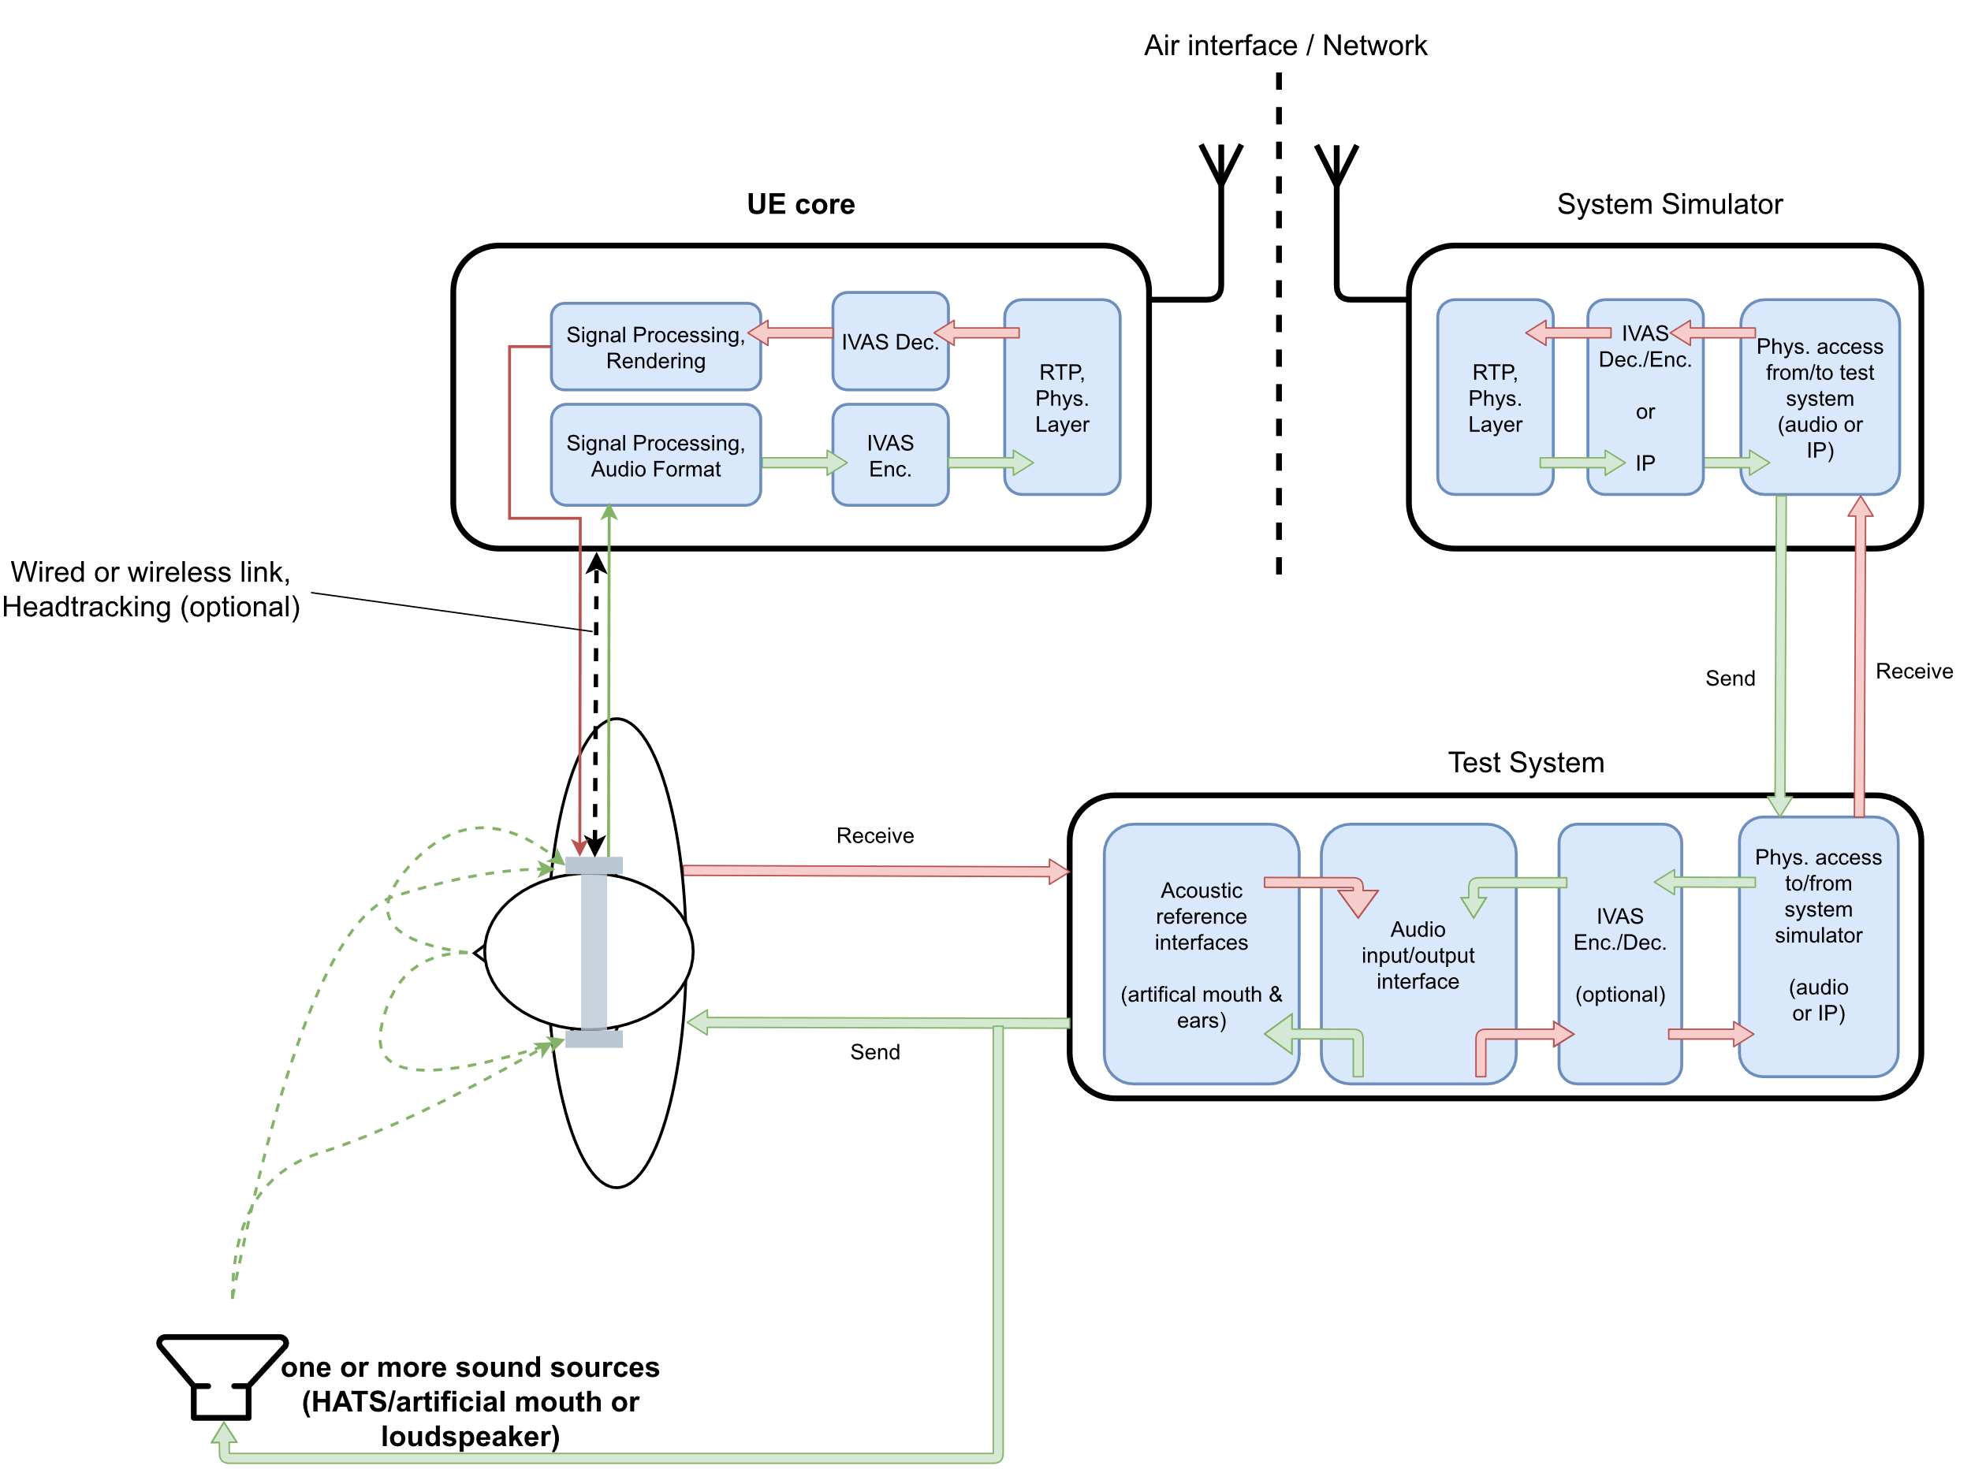
Figure 8: Headset UE and test equipment
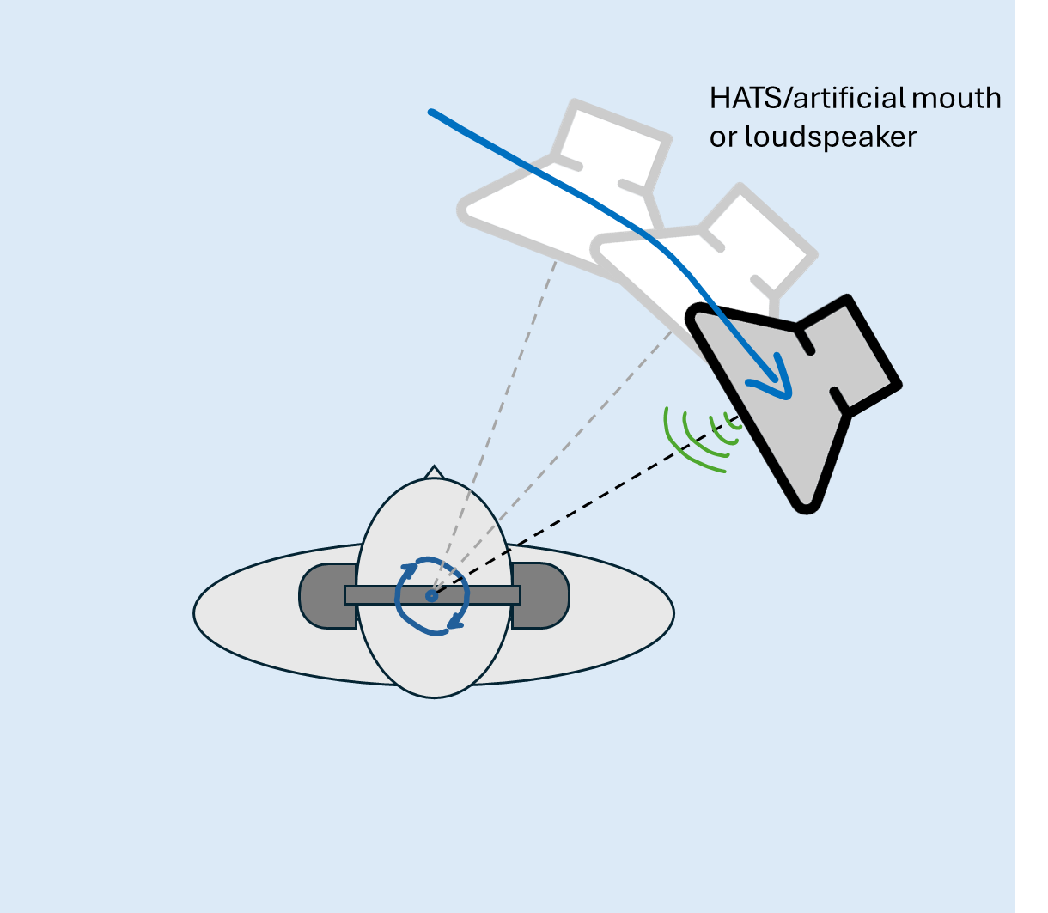
Figure 9: Sound source positioning for Headset UE tests

User capture
If not specified otherwise, the arrangement for a single sound source is a HATS wearing the headset. The playback level at MRP shall be calibrated to -4.7 dB Pa.
Spatial capture
If not specified otherwise, the arrangement for a single sound source is a loudspeaker positioned at 0° azimuth and elevation and at a distance of 1 m relative to HRP of the HATS wearing the headset device, which is assumed to be the geometric center for all headset UEs. Sound source positioning for sending tests is illustrated in Figure 9. The playback levels at HRP (in the absence of HATS) shall be calibrated to [75 dBSPL].

5.4.2.4 Handheld hands-free Mode
The test setup for handheld hands-free UE for sending and receiving directions is shown in Figure 10. It applies to all devices that can be held in front of the user.
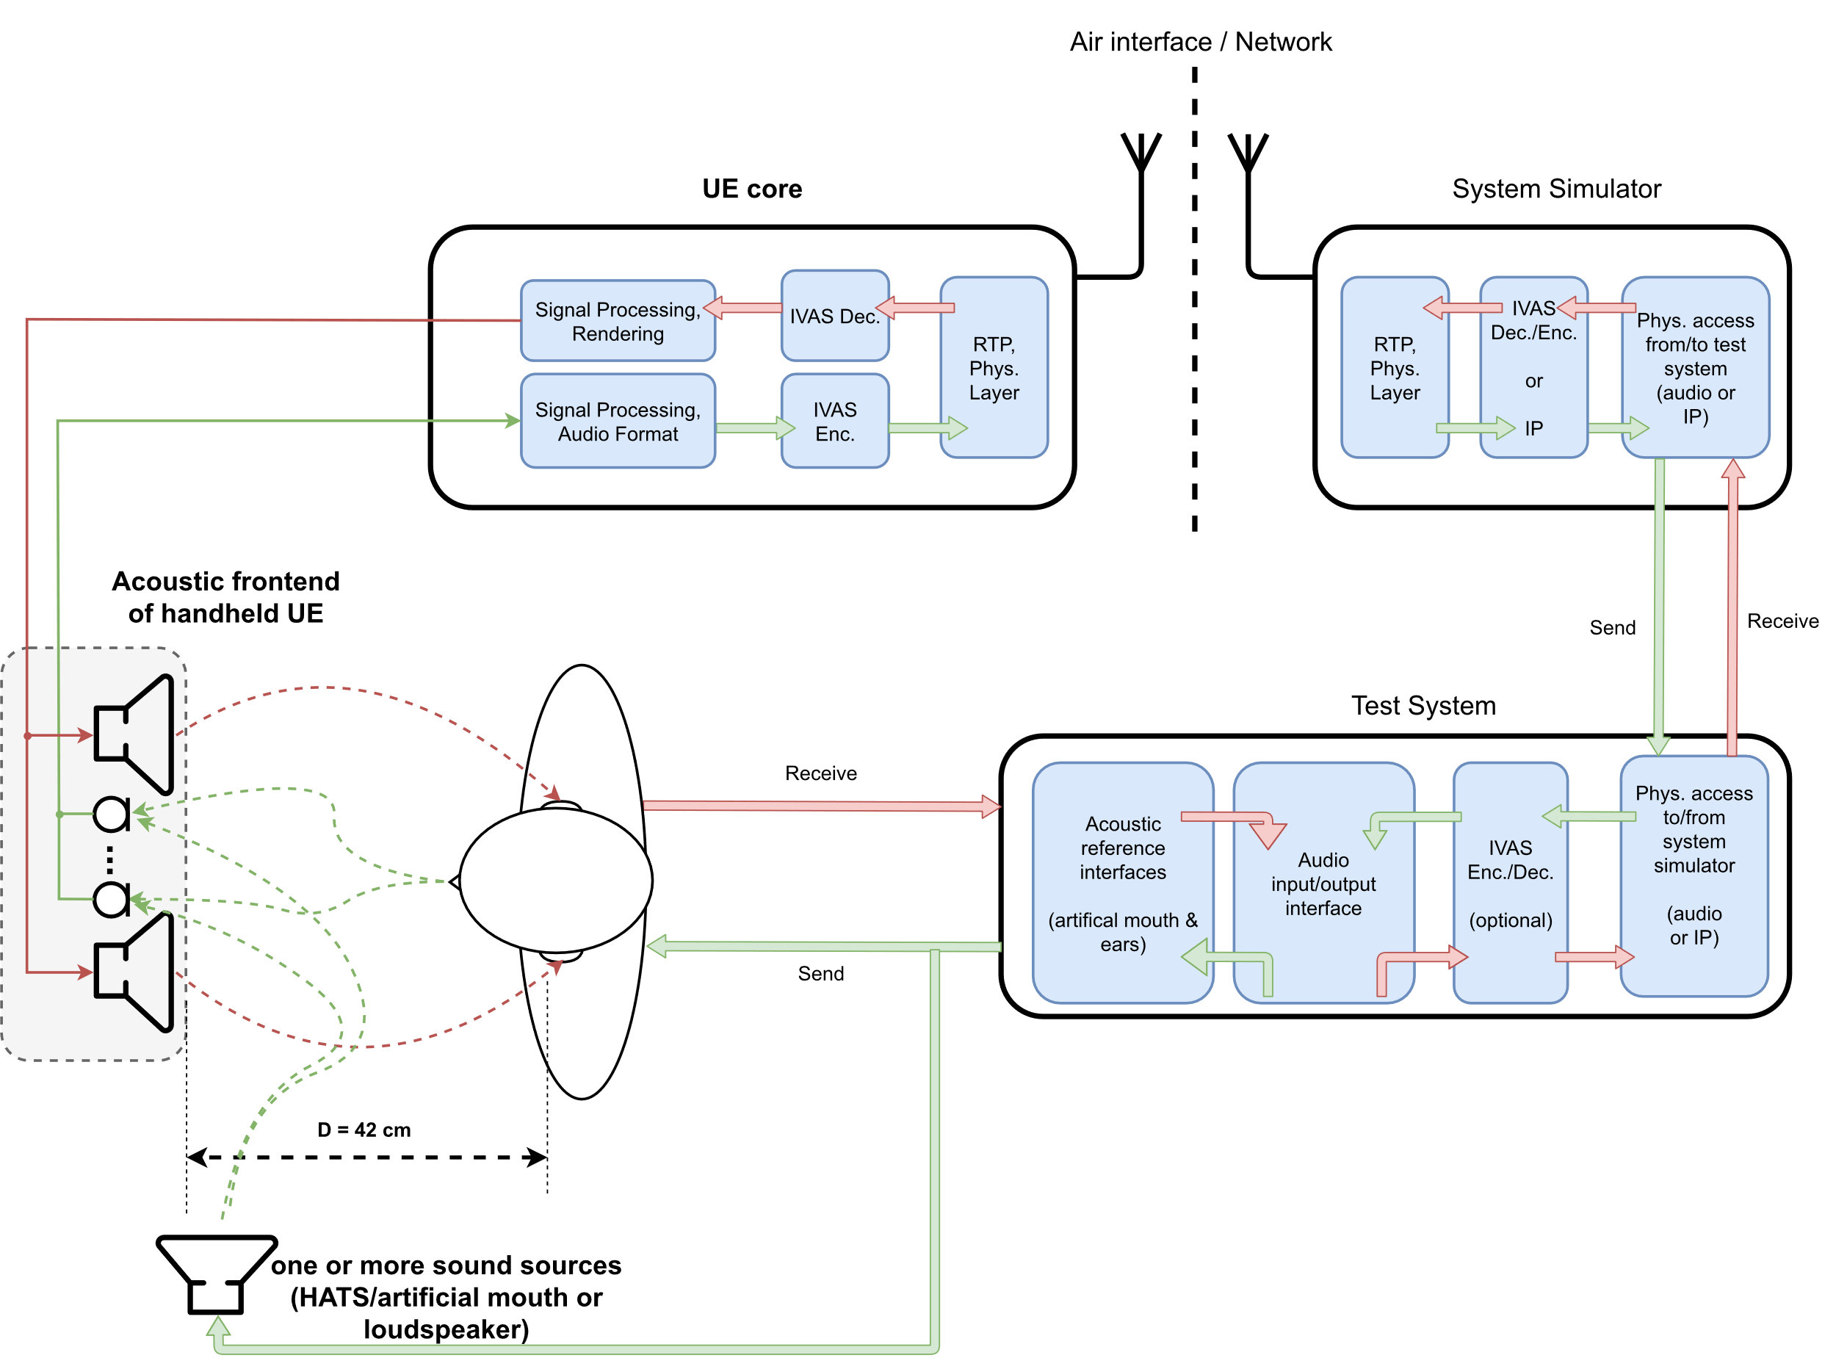
Figure 10: Handheld hands-free UE and test equipment
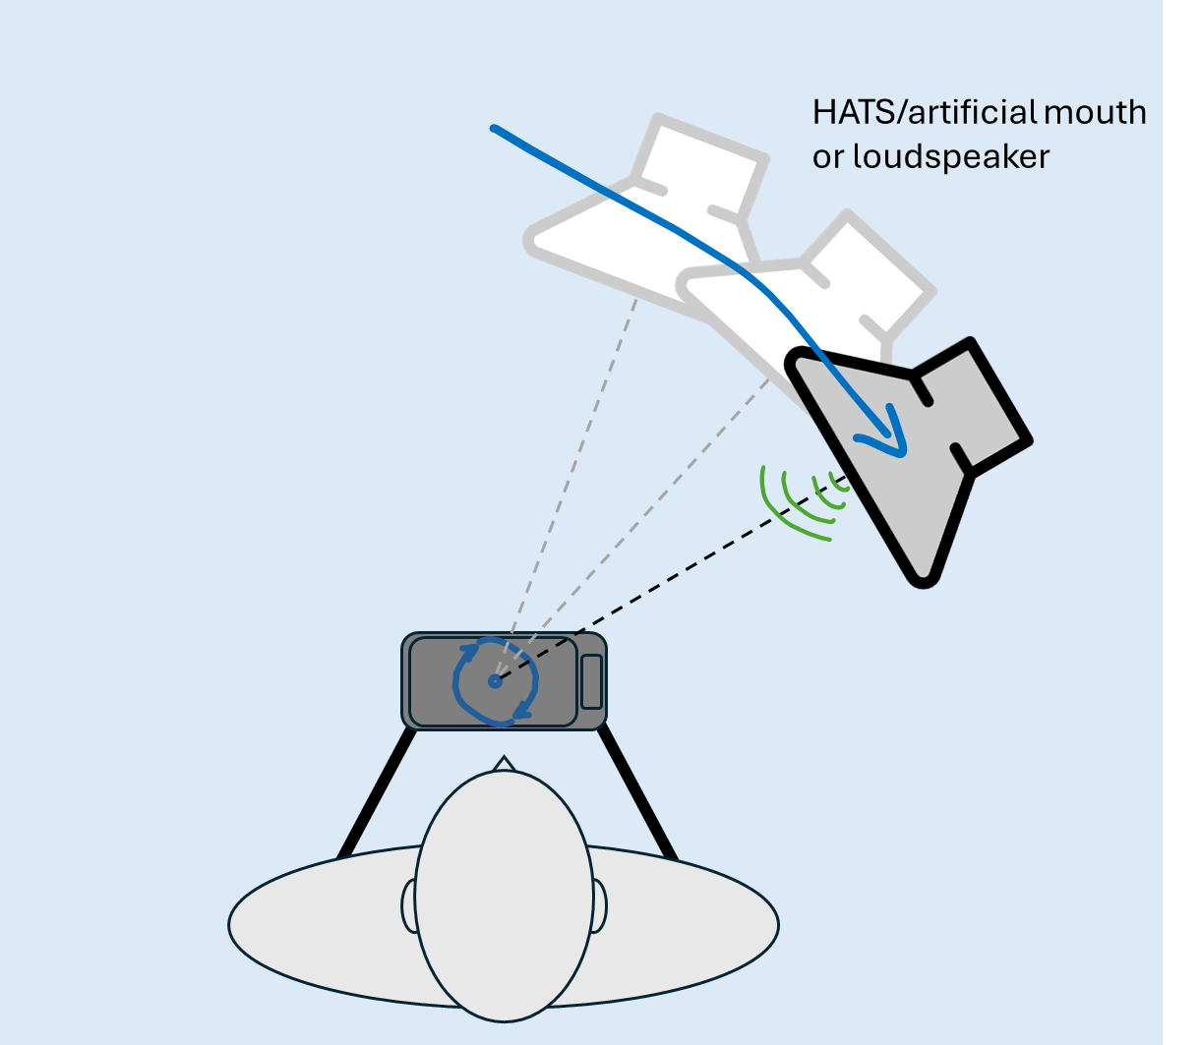
Figure 11: Sound source positioning for Handheld UE tests

The UE orientation (landscape/portrait and top/bottom position, front/back side facing the user) used for testing is specified by the manufacturer. If such information not available, the orientation depends on the capture mode.
User capture
If not specified otherwise, the arrangement for a single sound source is a HATS positioned at a distance of 42 cm from the center point of the visual display of the UE (same setup as in TS 26.132 [24] for handheld hands-free). If applicable, different geometries of this setup are considered in corresponding test methods (for e.g., multi-talker scenarios or speech from certain angles). The playback levels at MRP shall be calibrated to -1.7 dB Pa.
If no manufacturer-defined orientations are defined, the UE shall be positioned in portrait mode, whereas the front side is facing the user.
Spatial capture
Sound source positioning for sending tests with spatial capture is shown in Figure 11. If not specified otherwise, the arrangement for a single sound source is a loudspeaker positioned at 0° azimuth and 0° elevation and at a distance of 1 m relative to the geometric center of the handheld hands-free UE. The playback levels at the UE shall be calibrated to [75 dBSPL]. If applicable, different geometries of this setup are considered in corresponding test methods (for e.g., multiple sources from different angles).
If no manufacturer-defined orientations are defined, the UE shall be positioned in landscape mode (top of the device pointing to the left), whereas the front side is facing the user.
NOTE: Spatial capture typically targets at acoustic scenes opposite to the user of the device. The acoustic impact of the simulated user/HATS in such a setup is for further study.

5.4.2.5 Table-mounted Mode
The test setup for table-mounted hands-free UE for sending and receiving direction is shown in Figure 12. It applies to all hands-free devices that are intended for usage on tables (like e.g., conference devices). In contrast to handheld hands-free UE, the reflections of the table are explicitly included in the test setup.
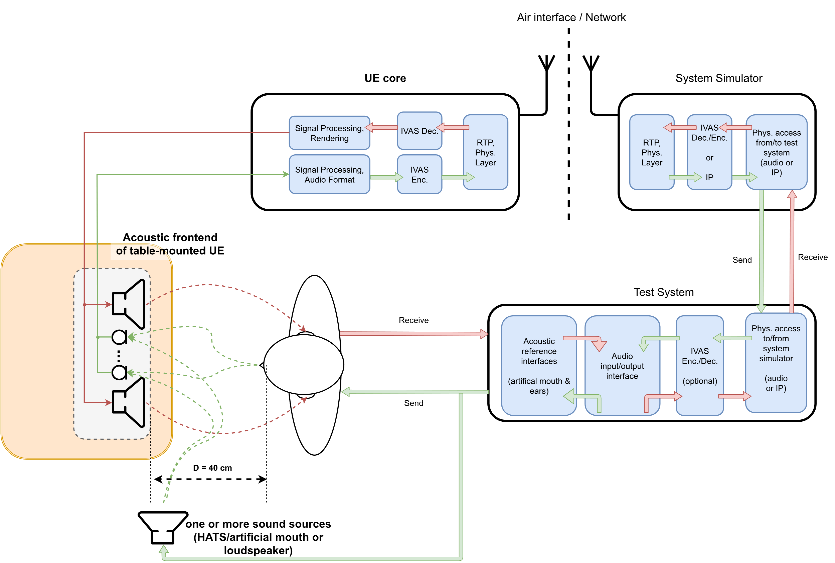
Figure 12: Table-mounted hands-free UE and test equipment
Figure 12 shows an example with a distance of D = 40 cm between front of the UE and lip reference plane of the user, which corresponds to the desktop hands-free setup as specified in Recommendation ITU-T P.341 [15], which is also referenced in 3GPP TS 26.132 (width W = 40 cm, height H = 30 cm). In general, multiple sub-setups may be considered for this UE type, like e.g., the "group audio terminal" position (see clause 4.2.4 of P.341 [15]) or the softphone/laptop-based setups 3GPP TS 26.132 [24].
NOTE: The term "table-mounted hands-free" is suggested here instead of "desktop hands-free", as used in e.g., 3GPP TS 26.132. The intention for this is to explicitly address also different/larger setups like e.g., conferencing scenarios with multiple microphones and loudspeaker arrays.

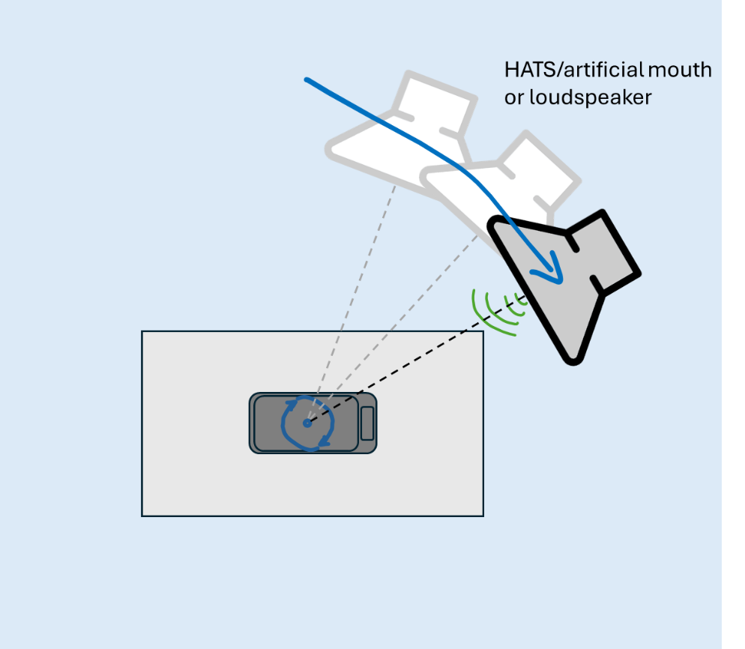
Figure 13: Sound source positioning for Table-mounted UE tests
User capture
If not specified otherwise, the arrangement for a single sound source is a HATS positioned at a distance of 40 cm between UE and lip reference plane and a height of 40 cm. The playback levels at MRP shall be calibrated to -1.7 dB Pa.
Spatial capture
Sound source positioning for sending tests is shown in Figure 13. If not specified otherwise, the arrangement for a single sound source is a HATS or loudspeaker positioned at a height H = 40 cm above the table and at a width of 80 cm in front of the geometric center of the table-mounted UE. In spherical coordinate system, this corresponds to 0° azimuth, 26.6° elevation and a distance of 89.4 cm. The playback levels at the HFRP shall be calibrated to -24.7 dBPa.

5.4.2.6 Loudspeaker Mode
The test setup for loudspeaker hands-free UE for receiving direction is shown in Figure 14. It applies to multichannel loudspeaker systems and speaker arrays, e.g., soundbars or automotive infotainment systems.
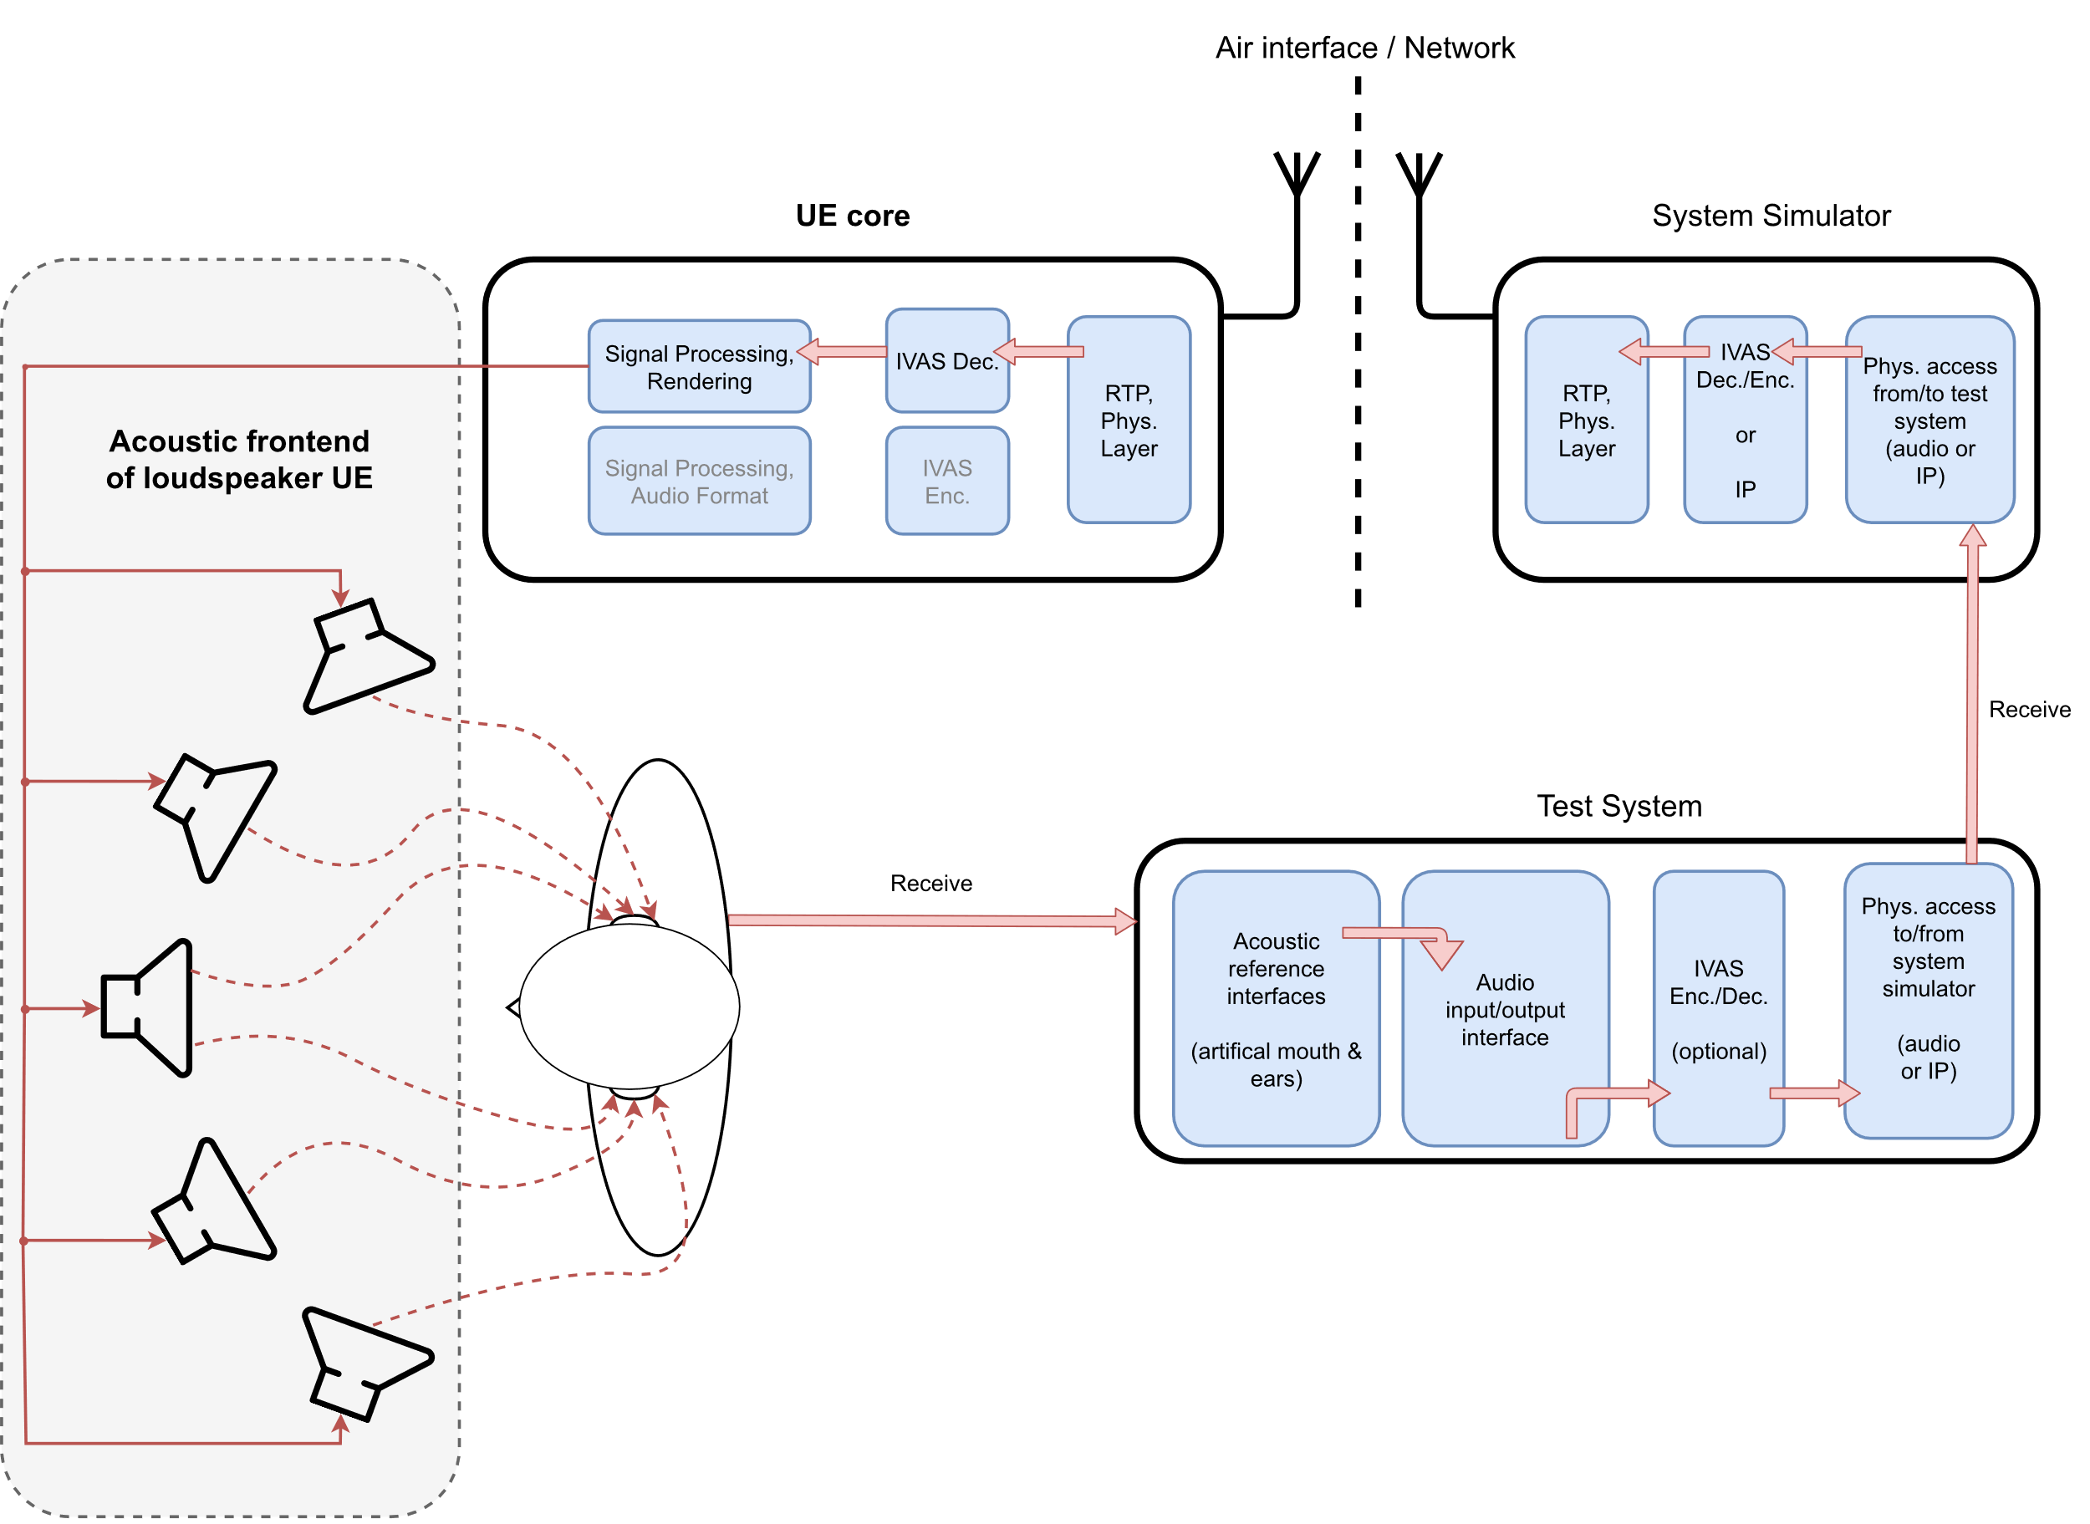
Figure 14: Loudspeaker hands-free UE and test equipment

5.4.2.7 Electrical interface Mode
The test setup for electrical interface UE for sending and receiving directions is shown in Figure 14. It applies to all devices that do not provide integrated or associated equipment for capturing and/or reproduction of immersive audio. Wired or wireless digital audio interfaces according to Recommendation ITU-T P.383 [19] (e.g., Bluetooth or USB) are commonly used. Note that the interface may also be realized via an analogue jack plug, which provides up to two channels in receiving and sending direction (see Recommendations ITU-T P.381 [17] and ITU-T P.382 [18]).
The device may provide an additional input for head tracking data that can be used for rendering the receiving direction (e.g., Bluetooth or USB with HID profile [29]).
Different equipment may be connected to the electrical interface UE such that the combination of UE and additional equipment will behave like one of previous UE types (e.g., headset or loudspeaker). Test methods apply according to the envisioned use-case. The default test signal for electrical insertion of a single sound source shall correspond to the envisioned use-case.
EXAMPLE: If the electrical interface of an UE is envisioned to connect a third-party immersive headset (e.g., with headtracking functionalities), the default test signal contains a virtual single sound source at the default source position specified for headset UE (see clause 5.4.2.3). Only test methods for headset UE are applicable in this case.
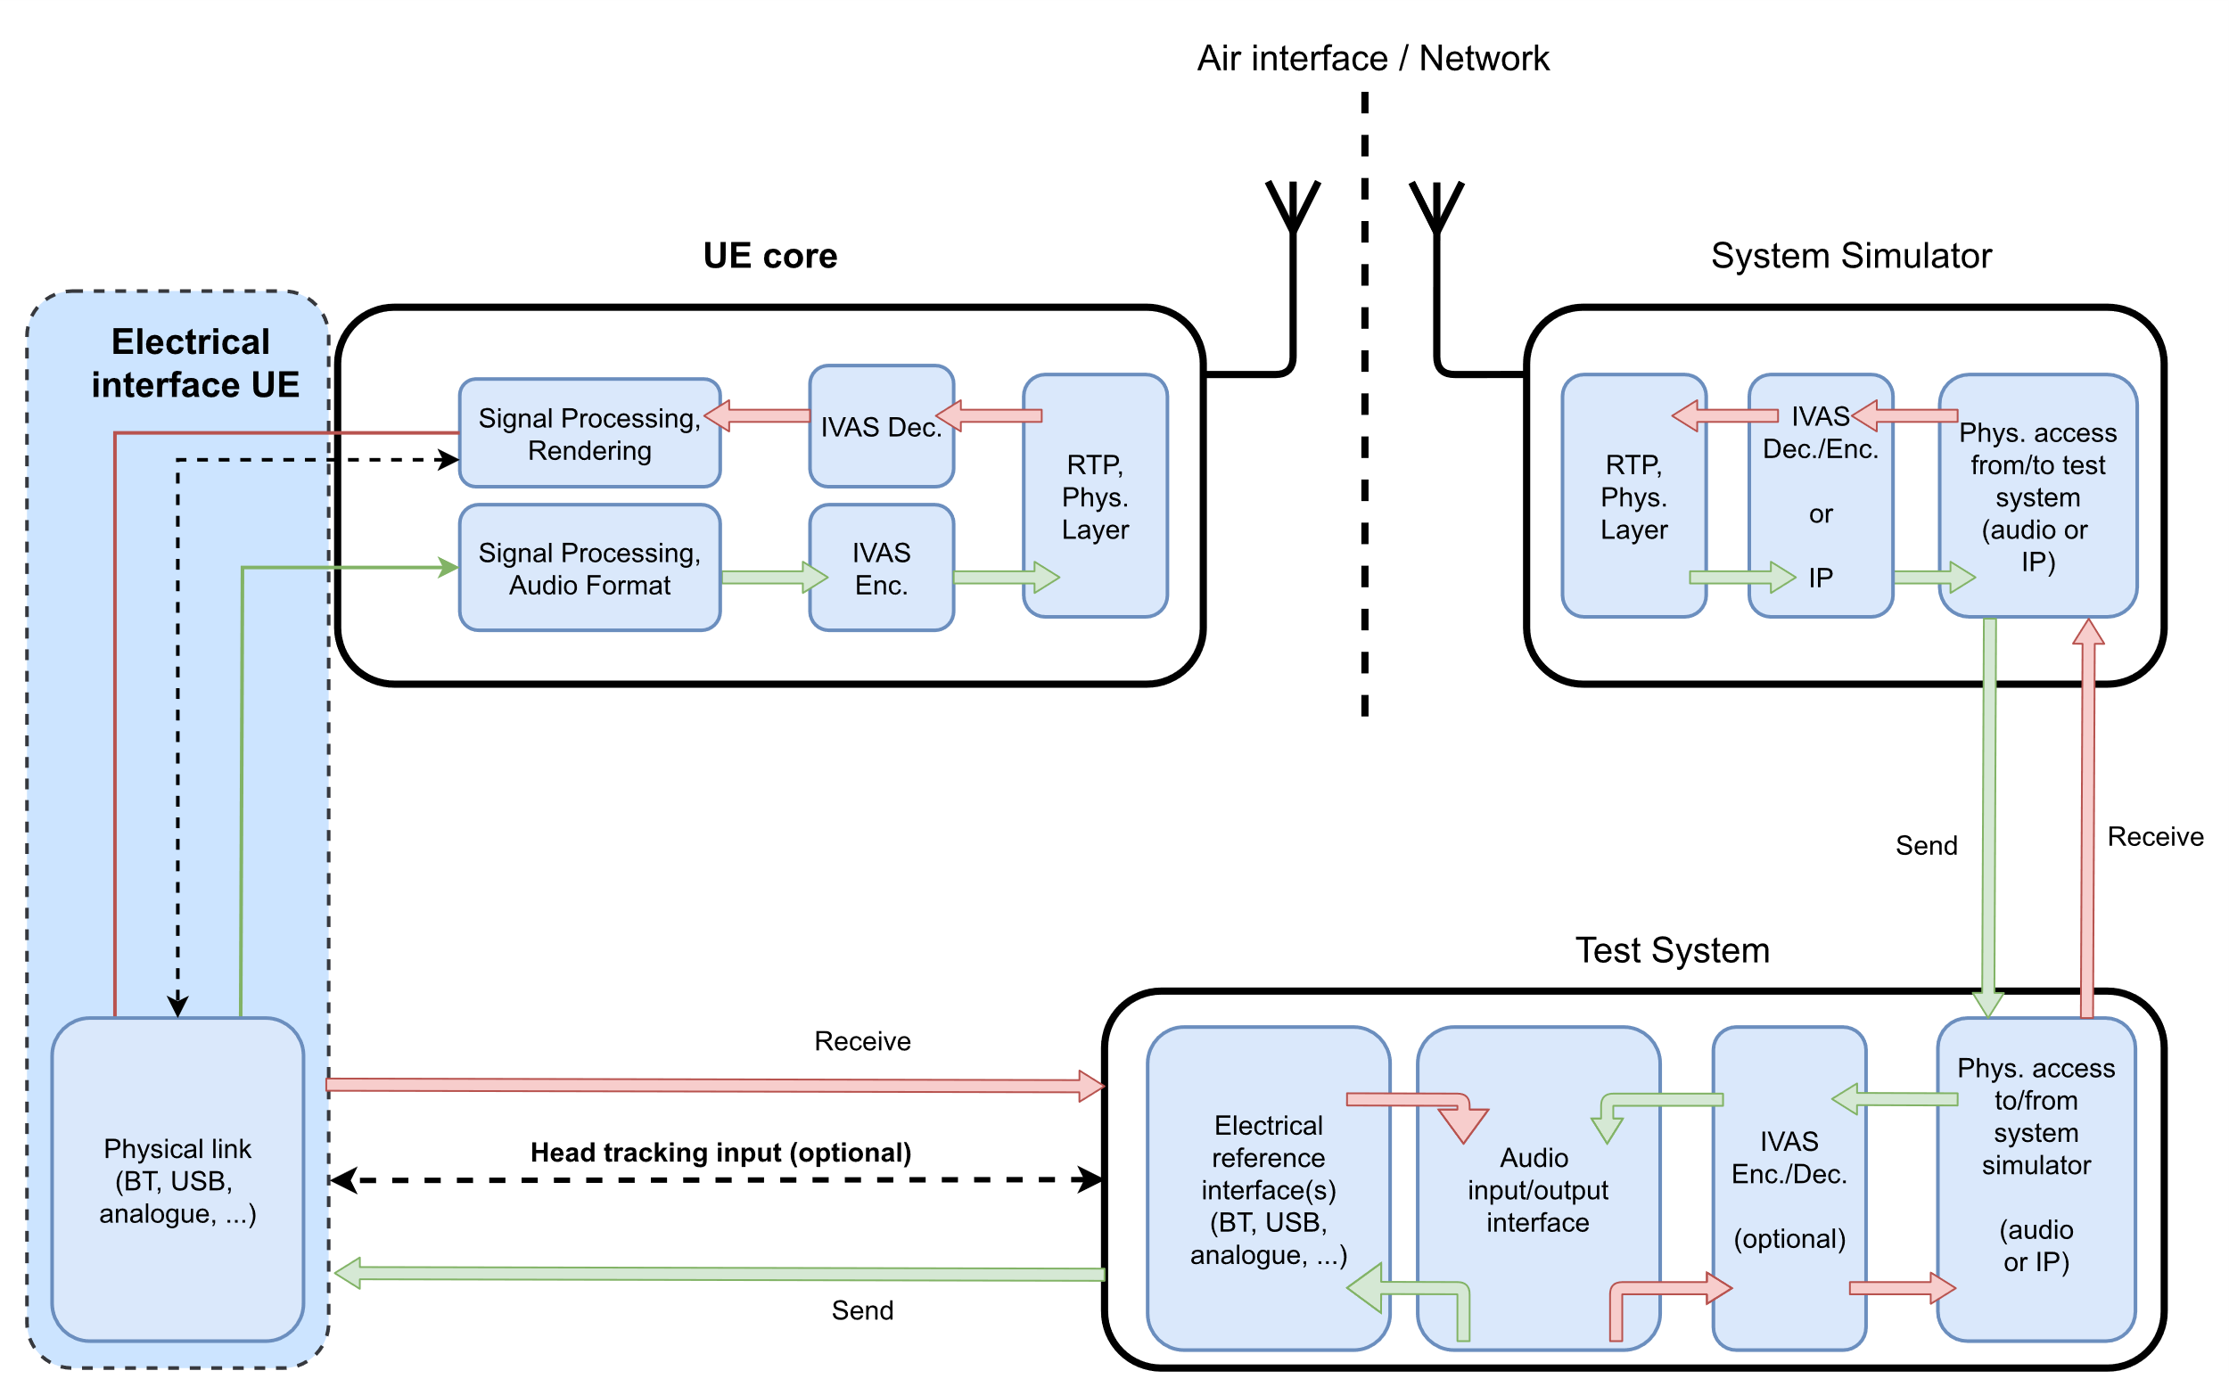
Figure 14: Electrical interface UE and test equipment

5.4.2 UE configuration
For testing, the UE shall be configured for the relevant and/or envisioned use cases as described in clause 5.4.2.
UEs shall be tested as is, even if they have signal enhancement features, like e.g., noise suppression, which may cause that performance requirements are not met. During the tests, any possible internal development modes of the UE bypassing these features shall be disabled. However, if such issues are encountered and the UE allows to disable certain of these features, the tests should be repeated with these features disabled to document the possible root cause of the problem.
Unless stated otherwise, if a volume control is provided in receiving direction, the setting is chosen such that the nominal receiving loudness is met as closely as possible.

5.5 Test signals

5.5.1 Test signal calibration
The input signal levels for testing receiving direction or testing with an electrical interface in sending direction shall be calibrated by means of a calibration factor, which is determined according to the iterative procedure illustrated in Figure Figure 14. The rendering of the input signal to the target format shall be done via external IVAS reference renderer, which is defined in clause 6 of 3GPP TS 26.254 [26]. The rendered output format shall be set to 7.1+4 output, except if the format of the input signal is already multichannel or stereo. The level is then calculated according to ITU-R BS.1770 [21] for these intermediate signals. If the difference between measured and target level exceeds [0.5] LKFS the procedure is repeated for up to ten iterations.

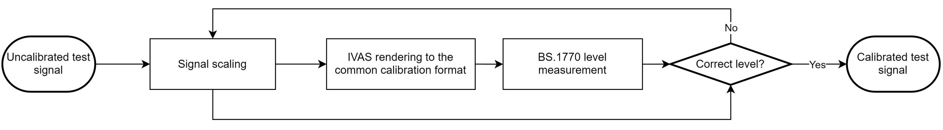
Figure 14: Test signal input level adjustment procedure for receiving tests
For mono real speech signals, acoustical and electrical calibration of test signals shall be carried out with active speech level according to ITU-T P.56 [9], calculated over the complete test sequence.

5.5.2 Virtual positioning
For testing of a single, directional sound source in receiving direction and sending direction with an electrical interface, the test signal shall be positioned virtually to represent the tested source direction.
Object-based audio
Unless specified otherwise, the source position of the test signal shall be set by format specific metadata as defined in Table 2. No further metadata fields shall be set.
Table 2: Object-based audio format specific metadata
Azimuth | Elevation | Spread | Gain
According to the tested azimuth | According to the tested elevation | 0 | 1

Scene-based audio
Unless specified otherwise, the source position of the test signal shall be set by a multi-component Ambisonics (ACN/SN3D) signal that represents a source from the particular incidence angle. To generate the test signal, first the virtually positioned object-based format is created. Then the IVAS external renderer according to 3GPP TS 26.254 [26] is used to obtain the desired signal in scene-based audio output format from the object-based input.

Metadata-assisted spatial audio
Unless specified otherwise, the source position of the test signal shall be set by the format specific metadata. The applied descriptive metadata for every frame and the applied spatial metadata for every time-frequency tile shall be set as defined in Table 3 and Table 4. The fields of the MASA metadata format is specified in Annex A of 3GPP TS 26.258 [27]. Unless specified otherwise, the source signal shall be applied on each transport channel used for testing.
Table 3: Applied descriptive metadata
MASA format descriptive common metadata parameters | Assigned values for every metadata frame
Format descriptor | Default
Number of directions | 1 (bit value 0)
Number of channels | 1 or 2 (bit value 0 or 1), depending on the number of applied transport channels
Source format | Bit values 00 (Default/unknown)
Variable description | 12 bit zero-padding (Default/unknown)

Table 4: Applied spatial metadata
MASA format spatial metadata parameters | Assigned values for every time-frequency tile in all MASA metadata sub-frames
Direction Index | According to the tested azimuth and elevation
Direct-to-total energy ratio | 1.0
Spread coherence | 0.0
Diffuse-to-total energy ratio | 0.0
Surround coherence | 0.0
Remainder-to-total energy ratio | 0.0

Multichannel audio
To generate the test signal, first the virtually positioned object-based format is created. Then the IVAS external renderer according to 3GPP TS 26.254 [26] is used to obtain the desired signal in multichannel audio output format from the object-based input.

5.6 Test methods for sending direction

5.6.1 Delay
[clause 4.1/4.1.2 of PDoc]
The assessment of sending UE loudness is illustrated in Figure 14. The default arrangement for a single sound source is used, as defined in clause 5.4.2 for each UE type. The IVAS audio format used by the UE is first decoded in the reference client and then rendered to a common analysis-dependent format. For this rendering step, the IVAS renderer shall be used.
NOTE: The default arrangement for a single sound source only depends on the UE type but is independent of the used IVAS audio format.
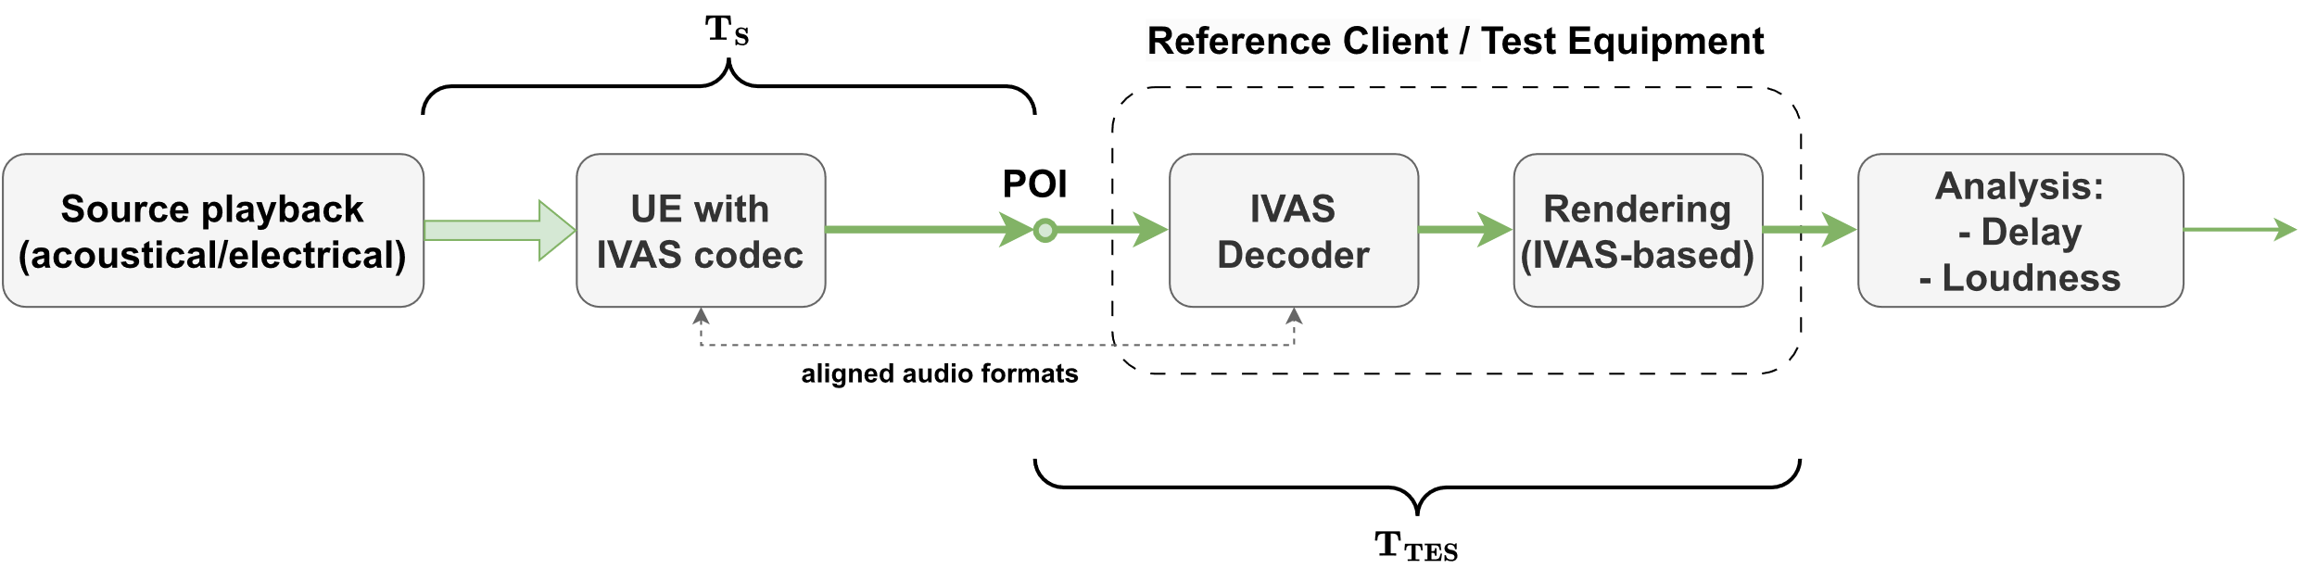
Figure 14: Test setup for sending loudness and delay
Test method
- The default arrangement for a single sound source as defined in clause 5.4.2 is set up according to the UE type.
- The test signal to be used for the measurements shall be the British-English single talk sequence described in clause 7.3.2 of Recommendation ITU-T P.501 [xx] and is calibrated to an active speech level according to Recommendation ITU-T P.56 [9] as defined in clause 5.4.2 for the corresponding UE type.
- The UE under test and the reference client are connected and configured as described in the claus, except the renderer configuration shall be set to the mono.
- The UE delay in sending direction T_{S} is obtained between the acoustical sound source and the electrical POI of the test equipment. The source signal is used as a reference for the cross-correlation analysis described in Annex C, which is used to determine T_{S}.
- The measured delay shall be compensated by the delay T_{TES} introduced by the test equipment (including possible contributions of the rendering to mono).

5.6.2 Loudness
[clause 4.1/4.1.3 of PDoc]
The assessment of sending UE delay is illustrated in Figure 14. The default arrangement for a single sound source is used, as defined in clause 5.4.2 for each UE type. The IVAS audio format used by the UE is first decoded in the reference client and then rendered to a common analysis-dependent format. For this rendering step, the IVAS renderer shall be used.
Test method
- The default arrangement for a single sound source as defined in clause Error! Reference source not found. is set up according to the UE type.
- The test signal to be used for the measurements shall be the British-English single talk sequence described in clause 7.3.2 of Recommendation ITU-T P.501 [xx] and is calibrated to an active speech level according to Recommendation ITU-T P.56 [9] as defined in clause 5.4.2 for the corresponding UE type.
- The UE under test and the reference client are connected and configured as described in the clause [Error! Reference source not found.], except the renderer configuration shall be set to the mono.
- The UE loudness in sending direction is obtained by [Analysis method TBD: BS.1770, P.700, P.79 SLR, P.56 ASL, etc.]

5.6.3 Frequency response (single source)
[clause 4.2 of PDoc]

5.6.3.1 Test method
The default [spatial capture] arrangement for a single sound source is used, as defined in clause 5.4.2 for each UE type. The decoded and rendered output format shall be the same as the IVAS audio format used by the UE.

For each source direction under test, the following procedure shall be used:
- The test signal to be used for the measurements shall be [the British-English single talk sequence described in clause 7.3.2 of Recommendation ITU-T P.501 [9], calibrated to an active speech level according to Error! Reference source not found..]
- The UE under test and the reference client are connected and configured as described in the clause Error! Reference source not found..
- Acoustical Interface: The UE is mounted as described in the clause [Error! Reference source not found.] and the acoustic source is positioned such that the source direction under test is met. The test signal is played via the acoustic source.

Electrical Interface: The test signal is generated by virtually placing the acoustic source such that the source direction under test is met as described in clause [Error! Reference source not found.].

- The frequency spectrum of the decoded output is calculated for the 1/12th octave intervals as given by the R40 series of preferred numbers in [ISO 3] for frequencies from [100 Hz] to [12 kHz] inclusive. The output format dependent frequency spectrum calculation shall be done as defined in [4.1.3].

5.6.3.2 IVAS format specific definitions
Stereo
[
Frequency spectrum of the stereo audio signal is defined as a ratio of the sound pressure magnitude spectrum of the audio channels (k): Pkf and a reference magnitude spectrum Pref(f). Letter k denotes audio channel number. Thus, for each stereo audio signal channel a frequency response is determined by:
Gkf=PkfPref(f)
]
Object-based audio
[
Frequency spectrum of the Object-based audio signal is defined as a ratio of the sound pressure magnitude spectrum of the object audio signal Pf and a reference magnitude spectrum Pref(f). For a single object audio signal, a frequency response is determined by:
Gf=PfPref(f)
]
Scene-based audio
The magnitude spectrum of the scene-based audio signal is determined by evaluating the root mean square of the magnitude response of [the N+12 Ambisonics coefficients Plmf, i.e.,
Pf=1N+12l=0Nm=-nn(2l+1)Plmf2.
]
Letters l and m respectively denote Ambisonics degree and index. The factor 2l+1 renormalizes the SN3D-normalized coefficients to N3D. The N3D-normalized root-mean-square of the coefficient-domain magnitude spectrum is equivalent of determining the root-mean-square in the spatial domain evaluated on a uniform sampling grid (Parseval’s theorem).
The UE frequency response is determined by dividing the magnitude spectrum by a reference measurement in order to compensate for the impact of the test signal and the measurement system. The frequency response is determined by
Gf=PfPref(f)
Metadata-assisted spatial audio
Frequency spectrum of the metadata-assisted spatial audio signal is defined as a ratio of the sound pressure magnitude spectrum of the transport channels (k): Pkf and a reference magnitude spectrum Pref(f). Letter k denotes transport channel number. Thus, for each MASA transport channel a frequency response is determined by:
Gkf=PkfPref(f)

5.6.4 Directional information (single source)
[clause 4.5 + 4.6 (merged) of PDoc]

5.6.4.1 Test method
The default arrangement for a single sound source is used, as defined in clause [Error! Reference source not found.] for each UE type. The decoded and rendered output format shall be the same as the IVAS audio format used by the UE. In addition to the default sound source direction, L=[N] directions shall be evaluated, as indicated in Table X. In case the setup is realized with a turntable, the device shall be rotated around the vertical center of the UE.
Table X: Additional source positions
  φ_{i} [deg] | θ_{i} [deg]
  -90° | 0°
  -45° | 0°
  0° | 0°
  45° | 0°
  90° | 0°
  φ_{i} [deg] | θ_{i} [deg]
  -90° | 0°
  -60° | 0°
  -30 | 0°
  0 | 0°
  30° | 0°
  60° | 0°
  90° | 0°
or
For each sound source position (θ_{i}, φ_{i}), i=1,...,L , the following procedure shall be used:
- The test signal to be used for the measurements shall be [the British-English single talk sequence described in clause 7.3.2 of Recommendation ITU-T P.501 [xx], calibrated to an active speech level according to Error! Reference source not found..]
- The UE under test and the reference client are connected and configured as described in the clause [Error! Reference source not found.].
- Acoustical Interface: The UE is mounted as described in clause [Error! Reference source not found.] and the acoustic source is positioned such that the source direction under test is met. The test signal is played via the acoustic source.
Electrical Interface: The test signal is generated by virtually placing the acoustic source such that the source direction under test is met as described in clause [Error! Reference source not found.].
- The output format dependent directional metric calculations shall be done as defined in [4.4.4] for the tested format.

5.6.4.2 IVAS format specific definitions
Stereo
- The left and right channel signals (sLk, sR(k)) are recorded by the test equipment.
- The inter-channel time difference (ICTD(ϕ0)=Δτ) is determined as described in Annex X between the signals sLk and sR(k).
- The inter-channel level difference (ICLD) is determined as follows:
    - The active speech level according to Recommendation P.56 [xx] is calculated separately for slk and sr(k), resulting in LL and LR.
    - ICLD for source position ϕi is calculated as:
          - ICLD(ϕ0)=LL-LR
- The equivalent level difference Δ(ϕi) for source position ϕi is calculated as:
      - Δ(ϕi)=ICLD(ϕi)+ICTD(ϕi)⋅17.3 dBms [dB]
- The estimated source position Pαi in the stereo panorama is calculated as:
Pϕi=100⋅Δ(ϕi)13.5 forΔ≤6.75 dB-32Δ(ϕi)dB3+288Δ(ϕi)dB2+20736Δ(ϕi)dB-6561⋅signΔ(ϕi)273375for6.75 dB<Δ<18 dBsignΔ(ϕi)forΔ≥18 dB [%]

Scene-based audio

Direction of arrival analysis with scene-based audio shall be done as follows:

- The B-format scene-based audio format representation is captured by the test equipment.

- The intensity parameter is calculated from the B-format capture b=bwbxbybz using the equation:
i=Rbwbxbybz*.

NOTE: The intensity is calculated in frequency domain and per subframe. Further steps are thus performed with subframe accuracy.

- The direction of arrival estimation (θest,ϕest) is calculated based on the intensity parameter using the equations:
ϕest=arctaniyixπ⋅180°,
θest=arctanizix2+iy2π⋅180°,
Where the arctan function is assumed to be the computational variant “atan2” that solves the correct quadrant automatically

- The estimated direction of arrival (θ_{est}, φ_{est}) is compared to the ground truth angle (θ_{i}, φ_{i}).
[Editor’s note: Potentially in several frequency bands and potentially time averaged. Weighting could be done similarly as in MASA case by estimating subframe energies and energy ratios.]
If the sending UE is properly implemented in terms of directionality, phase and scaling of Ambisonics components, the DOA metric is expected to correspond to the ground truth angle. The DOA angle calculated from the Ambisonics components from the UE capture system shall be within some tolerances w.r.t. the ground truth angle to the incident sound.

Metadata-assisted spatial audio

Direction of arrival analysis with metadata-assisted spatial audio shall be done as follows:

- The MASA format representation is captured by the test equipment. The MASA representation includes estimated source angles and direct-to-total energy ratio quantities per time-frequency tiles. Total energy per time-frequency tile is estimated from the transport signals.

- The direct-to-total ratio times energy weighted azimuth and elevation angles (in radians) are mapped into Cartesian coordinate vectors X, Y and Z over all subframes and [N] frequency bands:

X=nNkK(cosϕnk⋅cosθnk⋅direct-to-total energy rationk⋅energynk)
Y=nNkK(sinϕnk⋅cosθnk⋅direct-to-total energy rationk⋅energynk),
Z=nNkK(sinθnk⋅direct-to-total energy rationk⋅energynk),

where n is the index of the frequency bands and k is the index of the subframes.

- The direction of arrival estimation (θ_{est}, φ_{est}) in degrees is calculated based on the mapped Cartesian coordinate vectors using the equations:
ϕest=arctan(YX)π⋅180°,
θest=arctanZX2+Y2π⋅180°,

Where the arctan function is assumed to be the computational variant “atan2” that solves the correct quadrant automatically

- The estimated direction of arrival (θest,φest) is compared to the ground truth angle (θ_{i}, φ_{i}).
[Editor’s note: Potentially in several frequency bands and potentially time averaged.]
If the sending UE is properly implemented in terms of directionality and the energy ratio analysis for the MASA metadata, the DOA metric is expected to correspond to the ground truth angle. The DOA angle calculated from the MASA metadata from the UE capture system shall be within some tolerances w.r.t. the ground truth angle to the incident sound.

5.7 Test methods for receiving direction

5.7.1 Delay
[clause 5.6 of PDoc]
Test method
The assessment of receiving UE delay is illustrated in Figure 4. The default arrangement (acoustical or electrical interface) in receiving direction as defined in clause Error! Reference source not found. for each UE type is used.
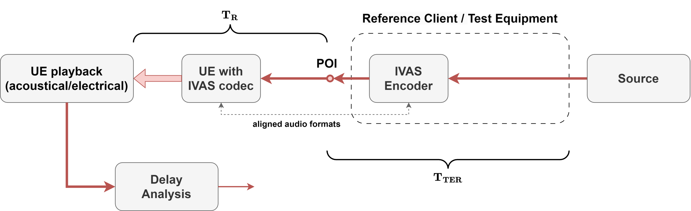
Figure 4: Test setup for receiving delay

- The test signal to be used for the measurements shall be the British-English single talk sequence described in clause 7.3.2 of Recommendation ITU-T P.501 [xx].
- For the delay measurement in receiving, virtual positioning at azimuth 0° and elevation 0° according to clause [3.4.2] is used for the generated test signal.
- The source signal is calibrated to a [level/loudness] of [-26 LKFS] as defined in sub-clause [Error! Reference source not found.].
- The UE is setup according to the clause [2.2]. The UE and the reference client connection is setup according to clause(s) [3.2], the source signal is encoded by the reference client, and inserted at the POI to the UE.
- The capture of the UE output is carried out via …
  - acoustical interface (headphones or loudspeakers): recording via diffuse-field equalized HATS.
  - electrical interface: recording via corresponding reference interface. If the captured audio format is not stereo or binaural, the default IVAS binaural renderer is used to generate a binaural signal. To calibrate the digital signal into the (pseudo-)acoustical domain, it is assumed that a level of -26 dBov corresponds to an acoustical level of 73 dBSPL (-21 dBPa).
6) The UE delay in receiving direction is obtained between the electrical POI of the test equipment and the recorded signals at both ears. The cross-correlation analysis described in Annex X is carried out for both ear signals, using the mono source signal as reference. To obtain the overall delay T_{R}, the results for left and right ears are averaged.
7) The measured delay shall be compensated by the delay T_{TER} introduced by the test equipment. If applicable, also the binaural renderer for the electrical interface is compensated.

5.7.2 Loudness
[clause 5.1 of PDoc]

5.7.2.1 Test method
- The test signal to be used for the measurements shall be the British-English single talk sequence described in clause 7.3.2 of Recommendation ITU-T P.501 [xx]
- The source signal is calibrated to a [level/loudness] of [-26 LKFS] as defined in sub-clause [Error! Reference source not found.].
- The UE is setup according to the clause [2.2]. The UE and the reference client connection is setup according to clause(s) [3.2], the source signal is encoded by the reference client, and inserted at the POI to the UE.
- The capture of the UE output is carried out via …
  - acoustical interface (headphones or loudspeakers): recording via diffuse-field equalized HATS.
  - electrical interface: recording via corresponding reference interface. [If the captured audio format is not stereo,] the default IVAS binaural renderer [xx] is used to generate a binaural signal.’Editor’s Note 1: Assume that stereo == binaural and directly analyse it – or can/should it also be rendered to binaural?’Editor’s Note 2: Add better description / reference to IVAS default renderer. We might need an additional factor to scale the renderer output to the acoustic domain (like e.g., 73 dB SPL == -21 dB Pa == -26 dBov à apply +5 dB)?
- The LLR in phon is calculated according to clause 8.3.3 of Recommendation ITU-T P.700 with the captured or rendered binaural signal.
- The same binaural signal should be used to calculate Receiving Loudness Rating (RLR) according to Recommendation ITU-T P.79 [xx] for comparison to 3GPP TSs 26.131 [9]/26.132 [10].
  - The inverse diffuse-field correction according to Recommendation ITU-T P.58 is applied on left and right channel of the recording to obtain the signal at DRP. Then DRP-to-ERP correction is applied.
  - The reference signal used for the RLR calculation is the original test signal specified in step 1), calibrated to -16 dBm0.
  - The RLR is calculated according to clause 8.2.3.2 of 3GPP TS 26.132.
- Editor’s Note: RLR may be calculated optionally from the same recording?
- Steps 2-7 should be repeated for additional source positions as described in Error! Reference source not found..

5.7.2.2 IVAS format specific definitions
Stereo
[
The test signal shall be the same test signal as defined in the 5.1.3 for both stereo channels.
]
Object-based audio
The virtual positioning of the source signal is done as defined in clause [3.4.2].
[Editor’s note: Test cases with rotated HATS TBD]

Scene-based audio
The virtual positioning of the source signal is done as defined in clause [3.4.2]. For the test cases with rotated HATS, the signal is rotated by multiplication with 10000 cos(φ0)0-sin(φ0)00100sin(φ0)0cos(φ0).

Metadata-assisted spatial audio
The virtual positioning of the source signal is done as defined in clause [3.4.2]. The test signal shall be the same signal as defined in clause 5.1.3 for each transport channel.
[Editor’s note: Test cases with rotated HATS TBD]

Multichannel
[
The test signal shall be… / The source position is set by… / TBD
]

5.7.3 Frequency response (single source)
[clause 5.2 of PDoc]

5.7.3.1 Test method
Table X: Source positions for sensitivity/frequency characteristics
Source azimuth [deg] | Source elevation [deg]
0 | 0
180 | 0
0 | 90
90 | 0
-90 (270) | 0

The sensitivity/frequency characteristics may in addition be measured and reported for other positions.
[Editor’s note: Where it is possible to assign a certain distance to the object, a large value should be specified, to avoid corner cases with close distances]
The following procedure shall be used:
- The test signal to be used for the measurements shall be as described in TS 26.132 clause [9.4.2 (SWB)].
- The source signal is calibrated to a [level/loudness] of [-26 LKFS] as defined in sub-clause [3.4].
- The UE and the reference client are setup according to clause(s) [3.2], the source signal is encoded by the reference client, and inserted at the POI to the UE.
- The sensitivity/frequency characteristics are measured as described in TS 26.132 and are reported for the left and the right sides.

5.7.3.2 IVAS format specific definitions
Stereo
[
The test signal shall be the same test signal as defined in the 5.2.4 for both stereo channels.
]
Object-based audio
The virtual positioning of the source signal is done as defined in clause [3.4.2].
[Editor’s note: Test cases with rotated HATS TBD]
Scene-based audio
The source position of the test signal is set by presenting the encoder with a multi-component Ambisonics signal that represents a source from the particular incidence angle (see sub-clause 5.1.4).
Metadata-assisted spatial audio
The virtual positioning of the source signal is done as defined in clause [3.4.2]. The test signal shall be the same signal as defined in clause 5.2.4 for each transport channel.
[Editor’s note: Test cases with rotated HATS TBD]
Multichannel
[
The test signal shall be… / The source position is set by… / TBD
]

5.7.4 Inter-aural differences for binaural rendering
[clause 5.3 of PDoc. Suggest to use inter-aural (referring to binaural) instead of inter-channel (which would rather refer to stereo, multichannel, etc.?)]
[clause 5.4 of PDoc – could maybe be merged with ITD?]

5.7.4.1 Test method
If the UE supports head tracking, the test is performed for the reference direction with no HATS rotation and additionally for rotated HATS orientations. For the electrical interface test, the orientation information shall be passed to the electrical interface. For the acoustical test, HATS rotation shall be realized as described in clause [Error! Reference source not found.]. The source directions from Table X are rotated in the same way as the HATS is rotated, so that for all UE rotations the binaural signal generated by the UE shall only differ within the required tolerance.
Table X: Source positions for inter-channel time difference measurement
Source azimuth [deg] | Source elevation [deg]
0 | 0
180 | 0
0 | 90
90 | 0
-90 (270) | 0

The following procedure shall be used:
- The UE and the reference client are setup according to clause(s) [3.2], the source signal is encoded by the reference client, and inserted at the POI to the UE. The audio input format and bitrate shall be reported.
- The left and right headphone/headset audio outputs from the UE are connected to the test system electrically, or acoustically using headphones and an ITU-T P.58 compliant head and torso simulator with associated left and right artificial ears as described in [2.2]. [Editor’s note: headtracking shall also be considered. Text TBD]
- The volume control is set to nominal [Editor’s note: it is expected that the generic clauses of this specification will state that the volume control, unless otherwise stated, is set to meet the nominal RLR=8 +-3dB for each ear. The sentence “The volume control is set to nominal” may then be superfluous.].
- The test signal is a CS-signal complying with ITU-T Recommendation P.501 using a PN-sequence with a length, T, of 4 096 points (for a 48 kHz sample rate test system). The duration of the complete test signal is as specified in ITU-T Recommendation P.501. [Editor’s note: this is the same signal as in TS 26.132 clause 7.5.4] The source signal is calibrated to a [level/loudness] of [-26 LKFS] as defined in sub-clause [3.4].
Editor’s note: The impact of codec on the test signal needs to be verified before performing the measurements.
- If the UE supports head-tracking, the following horizontal plane HATS orientations φ₀ are to be tested: φ₀=0°,-30°, +30°.
- For each simulated source position (θ_{i}, φ_{i}), i=1,...,L and each HATS orientation under test, the following procedure is repeated:
  - The HATS is oriented according to the current orientation under test.
  - The test signal is rotated just like the HATS orientation and is played to audio input of the refence client [the signal is proposed to be identical to TS 26.132 clause 8.5.4]. For each sub-test, the source position is set as defined in [5.4.5].
  - The left and right headphone audio signals from the UE are captured electrically or acoustically, the capture method shall be reported. The analysis window shall include the PN-sequence part of the CSS signal. The correct positioning of the analysis window is accomplished by correcting for the delay of the test system and the particular UE, which is measured priorly.
  - The left and right levels for the frequency bands of interest is noted.
  - The transfer function between the left and the right channel is estimated [Editor’s note: details to be defined] and the inter-channel group delay is calculated from the phase response, as τg(ω)=-dΦ(ω)dω, where Φ is the phase and ω is the angular frequency. The group delays for the different frequency bins are averaged from 200 to 2000Hz to obtain a single-figure inter-channel time difference.

- The measurement is repeated for all source angles as listed in Table X.

5.7.4.2 IVAS format specific definitions
Stereo
Void.
Object-based audio
The virtual positioning of the source signal is done as defined in clause [3.4.2].
[Editor’s note: Test cases with rotated HATS TBD]
Scene-based audio
The virtual positioning of the source signal is done as defined in clause [3.4.2]. For the test cases with rotated HATS, the signal is rotated as defined in 5.1.4.
Metadata-assisted spatial audio
The virtual positioning of the source signal is done as defined in clause [3.4.2]. The test signal shall be the same signal as defined in 5.4.4 for each transport channel.
[Editor’s note: Test cases with rotated HATS TBD]
Multichannel
[
The test signal shall be… / The source position is set by… / TBD
]

Annex A (normative):
Order dependent directions
The following tables order-dependent directions $Ω_{j}^{(N)}=({ϕ_{j}^{\left(N\right)},θ}_{j}^{\left(N\right)}), 1≤j≤K$, where $θ_{j}^{(N)}$ and $ϕ_{j}^{(N)}$ denote the elevations and azimuths in radians, respectively.

Index $j$ | $$θ_{j}^{(N=1)}$$ | $$ϕ_{j}^{(N=1)}$$
1 | 1.570796 | 0
2 | -0.339837 | 0
3 | -0.339837 | 2.094395
4 | -0.339837 | -2.0944

Index $j$ | $$θ_{j}^{(N=2)}$$ | $$ϕ_{j}^{(N=2)}$$
1 | 1.570796 | 0
2 | -0.790277 | 0
3 | 0.363207 | -1.95668
4 | 0.363207 | 1.956682
5 | -0.844382 | -1.95668
6 | 0.009757 | -3.14159
7 | -0.844382 | 1.956681
8 | 0.245128 | 0.687124
9 | 0.245129 | -0.68712

Index $j$ | $$θ_{j}^{(N=3)}$$ | $$ϕ_{j}^{(N=3)}$$
1 | 1.570796 | 0
2 | 0.716698 | 0
3 | -0.461173 | 1.119907
4 | -1.034310 | -0.25283
5 | 0.492174 | 1.155586
6 | -0.165812 | 2.040481
7 | -0.461172 | -1.38118
8 | -0.165813 | 0.270692
9 | 0.001916 | -2.20417
10 | 0.653709 | 2.297267
11 | 0.653709 | -2.80293
12 | -0.192680 | 3.010956
13 | -1.079056 | 2.154919
14 | 0.001915 | -0.63529
15 | 0.616834 | -1.41973
16 | -0.887326 | -2.46809

Index $j$ | $$θ_{j}^{(N=4)}$$ | $$ϕ_{j}^{(N=4)}$$
1 | 1.570796 | 0
2 | 0.747578 | 0
3 | -0.168324 | -2.00759
4 | 0.846499 | 1.927637
5 | 0.234515 | -1.41208
6 | 0.699165 | -2.10001
7 | 0.307091 | 2.512927
8 | 0.130649 | 1.667633
9 | -0.677517 | 1.442383
10 | 0.136843 | -0.60062
11 | -1.317269 | 0.329968
12 | -0.433118 | -1.18621
13 | -0.231864 | 2.983332
14 | 0.174242 | -2.69222
15 | -0.599985 | 0.507602
16 | -0.382009 | 2.208977
17 | -0.009394 | 0.952319
18 | -1.013813 | -1.71565
19 | 0.696199 | 0.934402
20 | -0.602139 | -0.38654
21 | -1.041921 | 2.675958
22 | -0.623111 | -2.62842
23 | 0.054056 | 0.165012
24 | 0.855489 | -1.02504
25 | 0.808243 | -3.13121

Index $j$ | $$θ_{j}^{(N=5)}$$ | $$ϕ_{j}^{(N=5)}$$
1 | 1.570796 | 0
2 | -0.454100 | 0
3 | 0.323739 | -1.19666
4 | -1.175381 | 0.184066
5 | 0.947221 | 0.124282
6 | -0.193698 | -2.84022
7 | 0.500281 | -1.84701
8 | -0.663529 | 0.698758
9 | -0.613332 | 2.280239
10 | -0.588043 | -2.28482
11 | 0.946645 | -2.37569
12 | 0.333311 | 2.883411
13 | 0.967374 | -1.18504
14 | 0.436854 | -2.76846
15 | 0.510141 | 0.763488
16 | -0.063811 | -0.46491
17 | 0.048266 | -2.27504
18 | -0.148392 | 1.762138
19 | 0.945735 | 2.804486
20 | -0.125777 | -1.69175
21 | -0.241518 | -1.0321
22 | -0.063824 | 0.509415
23 | -1.240392 | -1.95737
24 | 0.542172 | -0.567
25 | 0.043647 | 2.319619
26 | -0.291045 | 2.853233
27 | -0.841101 | -3.07101
28 | -1.213891 | 2.113132
29 | -0.706626 | -1.50877
30 | -0.774625 | -0.65404
31 | -0.707445 | 1.464227
32 | 0.990842 | 1.373127
33 | -0.122664 | 1.112751
34 | 0.598614 | 2.113949
35 | 0.306690 | 0.057137
36 | 0.381934 | 1.457925

Index $j$ | $θ_{j}^{(N=6)}$ | $$ϕ_{j}^{(N=6)}$$
1 | 1.570796 | 0
2 | 0.720144 | 0
3 | -0.308365 | 3.024454
4 | 0.068431 | 2.080642
5 | -0.495677 | -2.21373
6 | -0.018779 | -2.03598
7 | 0.426043 | 1.678014
8 | -0.259742 | 0.964363
9 | 0.179320 | -3.03552
10 | -0.249618 | -2.70206
11 | 1.074183 | 0.581055
12 | -0.781172 | -2.80103
13 | 0.457849 | 0.550136
14 | 0.523951 | -1.98436
15 | -0.006246 | -0.51212
16 | -0.788507 | -1.1411
17 | 0.228181 | -2.48765
18 | -0.418110 | -1.62282
19 | -0.512688 | -0.57506
20 | 0.572140 | 2.286204
21 | -0.867576 | -0.08741
22 | -0.624799 | 0.547028
23 | -0.446687 | 1.878965
24 | -0.789667 | 2.746717
25 | 1.047763 | -0.76025
26 | 0.247192 | -1.01978
27 | 0.720143 | 1.162107
28 | -0.081819 | 1.507148
29 | 0.226040 | 1.062706
30 | 0.709088 | -2.68135
31 | -0.249096 | -1.08377
32 | 0.573959 | 2.91352
33 | 1.069121 | 2.939099
34 | 0.135381 | -1.53966
35 | -0.057504 | 0.473238
36 | -0.975369 | -1.95522
37 | -0.666036 | 1.294994
38 | -1.146922 | 0.887936
39 | -0.357070 | 2.427548
40 | 0.200642 | -0.01608
41 | -0.965084 | 1.97199
42 | 0.681666 | -1.35341
43 | 0.112434 | 2.651183
44 | 0.528475 | -0.57647
45 | 1.003627 | 1.857517
46 | -1.275974 | -0.77916
47 | 1.051102 | -2.01121
48 | -1.315079 | 3.087768
49 | -0.326694 | -0.00446

Annex B (normative):
Directions in Gaussian spherical grid

B.1 Definition
A Gaussian grid of order N consists of 2(N+1)² points associated to directions Ωi,j(N)=θi(N),ϕj(N), 0≤i≤N Ωi,j(N)=θi(N),ϕj(N)Ωi,j(N)=θi(N),ϕj(N)and 0≤j<2(N+1), where θi(N) and ϕj(N) denote the elevation and azimuth, respectively. These directions are defined as follows [7]: The elevations θi(N)θi(N)θi(N) are computed as the zeros of the (N+1)-th degree Legendre polynomial
PN+1cos⁡(θi(N))=0, while the azimuths are given by PLcosθj(N)=0PLcosθj(N)=0PNcosθj(N)=0PNcosθj(N)=0ϕj(N)=2πj2(N+1) (in radians) or j.180/(N+1) (in degrees), 0≤j<2(N+1)0≤j≤2N+1Error! Digit expected..
Directions in test setup shall comply with the theoretical values Ωi,j(N) with an accuracy of +/-0.5 degree for all azimuths and +/-0.5 degree for elevations in the range [-80,+80] degrees. For elevation >80 degrees and <-80 degrees, the accuracy shall be respectively +4/-0.5 degrees and +0.5/-4 degrees.

B.2 Example loudspeaker array
An example implementation with an ambisonic order N = 29 is described below:
- A turn table with constant step size of 6 degrees and starting at 0 degree (to obtain 60 positions in azimuth).
- Two fixed semi-arcs of radius 2.5 meters separated in azimuth by 90 degrees with 15 loudspeakers on each semi-arc; the elevations of loudspeakers are given (in degrees) by -85, -80, -74, -68, -62, -56, -50, -44, -38, -32, -27, -21, -15, -9, -3, 3, 9, 15, 21, 27, 32, 38, 44, 50, 56, 62, 68, 74, 80, 85, where succesive values are alternatively allocated to each semi-arc.
NOTE: In practice, the elevation of -85 degrees may be replaced by a nearby value (e.g. -82 degrees) to leave room for the mounting structure at the bottom of the loudspeaker array.

Annex C (normative):
Cross-correlation analysis
The following analysis method is used to determine the time difference (delay) between two time-discrete signals xk and y(k) by applying segmental cross-correlation with period T (in samples) and overlap L (in percent).
If not specified otherwise, a sampling rate of 48 kHz is assumed.
The envelope E(i,τ) of the segmental cross-correlation function Φxy(i, τ) between xk and y(k) is calculated by means of the Hilbert transformation:
E(i,τ)=Φxy(i,τ)2+HΦxy(i,τ)2
HΦxy(i,τ)=u=-T2+T2Φxy(i,u)π(τ-u)
Φxy(i,τ)=1Tk=-T2T2x(i,k)⋅y(i,k+τ)
Each segment i has a duration of T samples, using an overlap of L percent. The time difference Δτ is then determined by the time lag τ that provides the maximum value.
E(τ)=1Ni=1NE(i,τ)
Δτ=argmaxτE(τ)
For expected shorter time differences (up to ~85 ms), T = 8192 and L = 50% are recommended.
For expected longer time differences (up to ~1.4 s), T = 131072 and L = 50% are recommended.

Annex Z (informative):
Change history

Change history
Date | Meeting | TDoc | CR | Rev | Cat | Subject/Comment | New version
2018-09 | SA-81 | SP-180644 |  |  |  | Presented to TSG SA#81 for approval | 1.0.0
2018-09 | SA-81 |  |  |  |  | Approved at TSG SA#81 | 15.0.0
2018-12 | SA-82 | SP-180969 | 0001 | 2 |  | Corrections to test method with loudspeaker array and turn table | 15.1.0
2020-03 | SA-87-e | SP-200105 | 002 | 1 | F | Correction of sensitivity calculation for immersive audio playback | 15.2.0
2020-07 | - | - | - | - | - | Update to Rel-16 version (MCC) | 16.0.0
2022-04 | - | - | - | - | - | Update to Rel-17 version (MCC) | 17.0.0
2022-12 | SA-98-e | SP-221058 | 0004 | 2 | D | Corrections to TS 26.260 Clause 4 | 18.0.0

