Source: Xiaomi (Rapporteur)
Title: MeCAR Permanent Document v7.0
Version: 7.0.0
Agenda Item: 14.4
Document for: Agreement
Work Item information:
Work Item Name | Media Capabilities for Augmented Reality
Acronym | MeCAR
Unique ID | 950015
Target release | 18

Source details:
Rapporteur | Name | Emmanuel THOMAS
Rapporteur | Company | Xiaomi
Rapporteur | Email | thomase@xiaomi.com
Editor | Name | Gilles TENIOU
Editor | Company | Tencent
Editor | Email | teniou@tencent.com

Revision history:
Version | Date | Meeting | Subject/Comment
1.0.0 | 2022-04-14 | SA4#118e | - Added  - Working assumptions  - Example media capabilities
2.0.0 | 2022-05-20 | SA4#119e | - Added  - Clause 2 on definitions, including Optical see-through device and Video see-through device  - Clause 4 on device categories, including draft EDGAR-1 architecture (4.2)  - Clause 5.3 on media capability validation framework, including Khronos 3D Commerce conformance example (5.3.1), a possible media capability evaluation framework (5.3.2) and its MeCAR scope (5.3.3)  - Clause 6 on sensor and user environment data types including the view-related information (6.2)  - Clause 7 on activities in external organizations, including the AVTCORE WG in IETF (7.1)
3.0.0 | 2022-08-26 | SA4#120e | - Added:  - Clause 5.4 Examples of media capabilities based on existing specifications, based on TS 26.511.  - Clause 3.6 Transparency information.  - Clause 3.7 Media Type Categories and Characteristics  - Clause 6.3 User surroundings information  - Clause 5.3 Display capability
3.1.0 | 2022-11-03 | SA4 Video SWG Telco (November 2, 2022) | - Added:  - Clause 5.5 Examples of display capabilities and possible impact on media capabilities
4.0.0 | 2022-11-18 | SA4#121 | - Added:  - Clause 3.7.3 AR/MR Data Type characteristics  - Clause 3.7.4 Real-time metadata transport  - Clause 4.2 Thin Augmented Reality User Equipment (Thin AR UE)  - Clause 6.7 Minimum Media Capabilities  - Clause 6.8 Media capability for RTC  - Clause 3.8.2 Media-related conformance aspects of OpenXR  - Clause 4.1 Candidate XR Baseline Client  - Modified:  - Clause 4.3 Augmented Reality User Equipment (AR UE) with new architecture diagram and added text on the relationship with the Thin AR UE (4.2) and added descriptive text
5.0.0 | 2023-02-24 | SA4#122 | - Removed:  - 6.9 Media capability for RTC since follow-up in iRTCW and SmartTAR  - Moved:  - Moved 6.4 Examples of media capabilities based on existing specifications under 6.2 Examples of media capabilities  - Moved 6.5 Examples of display capabilities and possible impact on media capabilities under 6.3 Display capability  - Modified:  - Environment blend mode in 3.6.1 Interest of transparency information  - Added:  - 10.1 Volumetric video support in MPEG-I V3C  - 4.4 XR User Equipment (XR UE)  - 5.2 Metrics Observation Points and KPIs  - 7 Metadata formats (pose prediction and action format)  - 8.3 Pose information  - Eye gaze as interaction type in Table 2  - 3.9 MPEG-I Scene Description  - 4.3.2.2 Video decoding interface, code point like decoding and encoding for concurrent decoding instance support
5.1.0 | 2023-03-27 | SA4 post #122 | - Added:  - 4.1.3 Example Technologies  - 10.3 MPEG-I Video Decoding Interface
6.0.0 | 2023-04-11 | SA4#123-e | - Modified:  - Added content to 5.1 Interoperability Points for Visual and Audio  - Removed:  - 9 AR data transport analysis
7.0.0 | 2023-04-20 | SA4#123-e | - Added:  - 3.10 Working assumption on operation points for MeCAR  - 9.1.4 3D media capabilities considerations  - 8.5 Available visualization space  - 8.6 User interaction  - 6.7 System capabilities  - 6.7 Audio function and capabilities  - 6.8 XR Runtime capabilities  - Modified:  - 5.2.3 Typical Latencies in networked AR Services and their Measurements  - 8.3 Pose information  - 9.1.2 Systems aspect of V3C  - Eye gaze in Table 2 in 3.7.2 Media types definition  - 6.6.3 Video decoding interface

Contents
Contents 4
1 Introduction 8
2 Definitions, symbols and abbreviations 8
2.1 Definitions 8
2.2 Abbreviations 9
3 Working assumptions 9
3.1 Prioritization of AR optical see-through 9
3.2 Device design types 9
3.2.1 General 9
3.2.2 Device design type 1 10
3.2.2 Device design type 2 11
3.2.3 Device design type 3 12
3.2.4 Device design type 4 12
3.3 General functional architecture 13
3.4 5G_STAR EDGAR-type device architecture 13
3.5 Media Access Function for AR 14
3.6 Transparency information 15
3.6.1 Interest of Transparency information 15
3.6.2 Processing transparency information 16
3.6.3 Carrying transparency information 17
3.7 Media Type Categories and Characteristics 18
3.7.1 General 18
3.7.2 Media types definition 18
3.7.3 AR/MR Data Type characteristics 21
3.7.4 Traffic characteristics 22
3.8 Background on OpenXR 23
3.8.1 Visual rendering in OpenXR 23
3.8.2 Media-related conformance aspects 25
3.9 MPEG-I Scene Description 28
3.9.1 Overview 28
3.9.2 MPEG glTF extensions 28
3.10 Working assumption on operation points for MeCAR 29
4 Device categories 30
4.1 Candidate XR Baseline Client 30
4.1.1 General 30
4.1.2 Architecture 32
4.1.3 Example Technologies 32
4.2 Thin Augmented Reality User Equipment (Thin AR UE) 34
4.2.1 Device architecture 34
4.2.2 XR Runtime and Source processing 35
4.2.3 XR Visual Processing 35
4.2.4 XR Audio Processing 36
4.3 Augmented Reality User Equipment (AR UE) 38
4.3.1 Device architecture 38
4.3.2 Visual capabilities 40
4.4 eXtended Reality User Equipment (XR UE) 40
4.4.1 Device architecture 40
4.3.2 Visual capabilities 41
5 Interoperability points and metrics 42
5.1 Interoperability Points for Visual and Audio 42
5.2 Metrics Observation Points and KPIs 46
5.2.1 Metrics Observation Points 46
5.2.2 Relevant KPIs for XR and AR according to TR 26.998 47
5.2.3 Typical Latencies in networked AR Services and their Measurements 50
6 Media capabilities 53
6.1 Categories of media capabilities 53
6.2 Examples of media capabilities 54
6.2.1 Examples of media capabilities based media capabilities categorisation 54
6.2.2 Examples of media capabilities based on existing specifications 55
6.3 Display capability 57
6.3.1 General 57
6.3.2 Examples of display capabilities and possible impact on media capabilities 58
6.4 Media capability validation framework 60
6.4.1 Example framework by Khronos on 3D Commerce conformance (glTF viewer) 60
6.4.2 Possible capability evaluation framework 62
6.4.3 Possible scope of media capability 63
6.5 Minimum Media Capabilities 64
6.6 Visual functions and capabilities 64
6.6.1 Video Decoding 64
6.6.2 Video Encoding 64
6.6.3 Video decoding interface 65
6.7 Audio function and capabilities 65
6.7.1 Audio Decoding 65
6.7.2 Audio Encoding 65
6.8 System capabilities 65
6.8.1 Support of RGBD content 65
6.9 XR Runtime capabilities 68
7 Metadata formats 68
7.1 General 68
7.2 Pose Prediction Format 68
7.3 Action Format 70
7.4 JSON Schema 71
8 Sensor and user environment data types 74
8.1 General 74
8.2 View-related information 74
8.3 Pose information 75
8.3.1 QoE timing information 75
8.3.2 Pose information delays and QoE 77
8.4 User surroundings information 77
8.5 Available visualization space 77
8.5.1 General 77
8.5.2 Possible solution 78
8.5.3 Potential implementation 78
8.6 User interaction 80
8.6.1 General 80
8.6.2 QoE timing information 80
8.6.3 QoE measurement 81
8.6.4 Interactivity delays and QoE 82
9 Relevant activities in external organizations 83
9.1 Volumetric video support in MPEG-I V3C 83
9.1.1 Coding aspect of V3C 83
9.1.2 Systems aspect of V3C 83
9.1.3 Implementations 85
9.1.4 Capabilities considerations 85
9.1.4 3D media capabilities considerations 87
9.2 IETF AVTCORE WG 90
9.3 MPEG-I Video Decoding Interface [37] 90
9.3.1 Introduction 90
9.3.2 Use Cases 91
9.3.3 Background 92
9.3.4 ISO/IEC 23090-13 (MPEG-I VDI) [37] 95
9.3.5 Relevancy for MECAR 96
10 Technical status 97
10.1 List of elements open for work 97
10.2 List of completed elements 97
10.4 List of open issues requiring specific attention 97
11 References 98

Introduction
During SA4#117-e the New Work Item on “Media Capabilities for Augmented Reality” (MeCAR) in S4-220332 was agreed and afterwards approved in by SA#95e in SP-220242.
The media capabilities of AR devices typically contribute to three main functionalities: 1) simple media rendering, 2) split-rendering, for which a pre/scene-rendering of the scene and views is carried out in the cloud/edge and 3) uplink streaming of sensor and device data to the network in order to support network-based processing of device sensor information.
To support basic interoperability for AR applications in the context of 5G System based delivery, a set of well-defined media capabilities are essential to create the conditions of a successful ecosystem. Therefore, the MeCAR work item defines those media capabilities for AR devices in a service-independent manner. In particular, the following objectives are considered:
- Define at least one AR device category that addresses the constraints of an EDGAR-type AR glass
  - Note: Additional device categories may be defined, but with lower priority.
- For each AR device category
  - Define a reference terminal architecture regarding media capability aspects for this AR device category
  - Define media types and formats produced and consumed by the AR device, including basic scene descriptions, audio, graphics and video as well as sensor information and metadata about user and environment.
  - Define the integration of the relevant existing 3GPP codecs into the reference terminal architecture
  - Define decoding capabilities, including support for multiple parallel decoders
  - Define encoding capabilities
  - Define security aspects related to the media capabilities
  - Define the required, recommended and optional media capabilities for this AR device category
- Integrate IVAS into suitable AR device categories, once IVAS is available
- Define capability exchange mechanisms based on complexity of AR media and capability of device to support EAS KPIs for provisioning of edge/cloud resources
  - Note: Identify a suitable existing capability framework, or if it does not exist, we need to work with the broader industry (e.g., IETF, KHRONOS, W3C, etc.) to get this done.
- Identify which QoE metrics from VR QoE metrics can be reused or enhanced for AR media (e.g., resolution per eye, Field of view (FOV), round-trip interaction delay, etc.) and define relevant KPIs that are dedicated to AR/MR
- Specify additional relevant KPIs and simple QoE Metrics for AR media
- Specify encapsulations into RTP, ISOBMFF and CMAF
- Specify the relevant codec-level parameters for session setup and negotiation of the media delivery and provide instantiations for SDP and DASH MPD
- Enable AR media in 5G Media Streaming by defining suitable 5GMS profiles based on AR media capabilities
- Define typical traffic characteristics for AR media

2 Definitions, symbols and abbreviations

2.1 Definitions
Optical see-through device: Device providing a view of the surrounding world by letting the light from the real world directly reaches the user’s eyes through an optical system.
Video see-through device: Device providing a view of the surrounding world by capturing the light from the real world and then presenting it through a display system to the user.

2.2 Abbreviations
PLR Point Local Reconstruction
EOM Enhanced Occupancy Mode
VUI Volumetric Usability Information (when used in reference to V3C)

3 Working assumptions

3.1 Prioritization of AR optical see-through
Optical see-through devices have the advantage of not requiring any additional video streams for rendering the surrounding environment. The natural light passing through the lenses of the device provides the user with a clear and natural view of the surrounding environment and does not add additional rendering latencies since the only media data that needs to be streamed by the device is the AR data. Therefore, even display systems with limited capabilities can offer the user a high level of experience.
Prioritizing optical see-through devices will allow us to focus on the overlaid AR data that is displayed on the glasses and synchronized (time and space) with the real word. It will make possible to offer a good level of user experience relying on relatively lower KPIs, in terms of FoV, resolutions, etc., and leads to lighter constraints on the design of the glasses, making easier the emergence of near to mid-term solutions.

3.2 Device design types

3.2.1 General
The MeCAR Work Item aims at being in line with device manufacturing constraints so that the specifications as output of MeCAR when published can be as relevant as possible for the AR ecosystem. As a result, the following clause lists typical device designs that are considered to be the illustrative of the current or future manufactured AR devices. Those device types are not meant to constitute interoperability points in the MeCAR specifications but rather serve as reality check during the development of MeCAR work to verify this desired alignment. If and when gaps are identified in terms of media capabilities between those device types and the current draft specification, it would be expected to update the draft specification for a better alignment with those current and future AR devices.
The current list of device design types are :
- Device type 1: Standalone physically-constrained AR glasses
- Device type 2: 5GUE-tethered physically-constrained AR glasses
- Device type 3: 5GUE-powered lightweight AR glasses
- Device type 4: 5GUE XR device
At present, the device design types are numbered in increasing order of media capability performances. However, this is not a fixed rule and more device design types in the future may be listed which would differ based on other criteria as long as they represent a realisation of AR Glasses with a different design.

3.2.2 Device design type 1
Looking at existing AR Glasses, based on the study in TR 26.998 [1] and based on information from chipset manufacturers on existing and emerging devices, an AR Glass designed for AR experiences does integrate complex functionalities and many of those relate to capabilities. Figure 1 is a picture providing an overview of an AR glass.
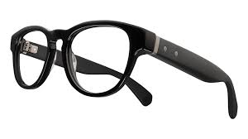
Hinge
SoC Media
Connectivity
Eye Tracking + Camera/Sensor Aggregator
Figure 1 – Overview of AR glasses of device design type 1
Typical functions of such a AR glass consists of:
- Peripheries including
  - Displays
  - Cameras
  - Microphones
  - Sensors
  - Camera/Sensor Aggregators
  - Perception functionality: Eye Tracking, Face Tracking, etc.
- SoC Media
  - Display Processing
  - GPU functionalities: Composition/Reprojection
  - Decoding
  - Decryption
  - Camera Front ends
  - Perception functionality: 6DoF, etc.
  - Encoding
- Connectivity
  - Wi-Fi, Bluetooth, 5G, etc.
An interesting aspect to consider from the above is that the device consists of different thermal islands, hence division in multiple chips in the headset is highly desirable. This means that both minimizing the power consumption per thermal island as well as minimizing the overall power consumption is an essential design constraint for the device battery life.
In addition, such type of devices require to partition workloads to remote devices or the cloud to some extent to balance the power load. Based on this, media capabilities are also possibly required on UE that acts as a hub for a tethered glass. Architectures and processing for this will be discussion SmartAR. The main target device in the MeCAR work item remains glasses as shown above.
It should be noted that such AR glasses are predominantly served with media that can directly be rendered by the peripheries, or produce media captured on the device and sent to remote processing.
It is considered that for media capabilities related to this primary AR category, only capabilities of the SoC media are to be part of the media capability definitions. We also note that the XR experience observed by the user depends on more aspects than the media capabilities, such as the display, the optics, the quality of the sensors, the stability of the connection and so on. However, such aspects are not considered to be part of the media capabilities for AR.
Initial System-on-Chip (SoC) media will likely rely on existing hardware, for example from lower end mobile chipsets. Some people consider XR even a hack that uses existing components in a smart manner. However, a core aspect of XR experiences different from traditional mobile devices is the concurrent operation of multiple encoders and/or decoders to address different sensors, eye buffers, layers and so on, as well as the rendering to GPU instead of directly going to the display.
Only over time, such hardware will get added specific functionalities, but not in the near and mid-term. Expected in the future are higher render and display resolutions, multi-layer composition, etc.
Given that many functionalities are defined through Khronos OpenXR, defining capabilities for example by mandating or recommending support of certain APIs or parameter settings on API may be relevant. In some cases it may not even be possible to define capabilities, but for example rely on test signals and benchmarking requirements that estimate the performance of a device.
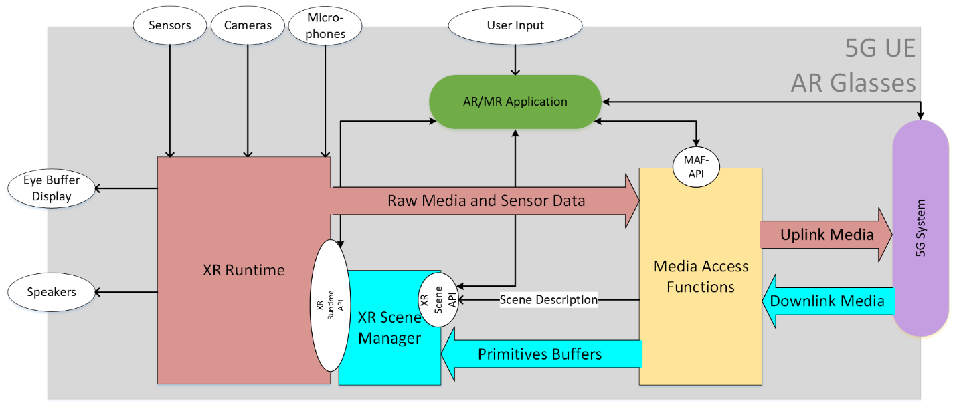
Figure 2 – Example architecture of AR glasses based on device design type 1
Based on these observations, an initial main objective of a standard is to create near to mid-term interoperability for media capabilities based existing and emerging media SoCs.

3.2.2 Device design type 2
Similar as in the case for the device design type 1 introduced in 3.2.1, the AR Glasses runs an AR/MR application that uses the capabilities of the glass to create a service.
However, the AR glasses does not provide a 5G connection, but is tethered to a 5G device. The AR glasses may only use the 5G connectivity of the phone, or it may use capabilities on the phone for additional processing support. As a result, this device type is expected to have higher media capabilities compared to the device type 1 which is the most constrained one.
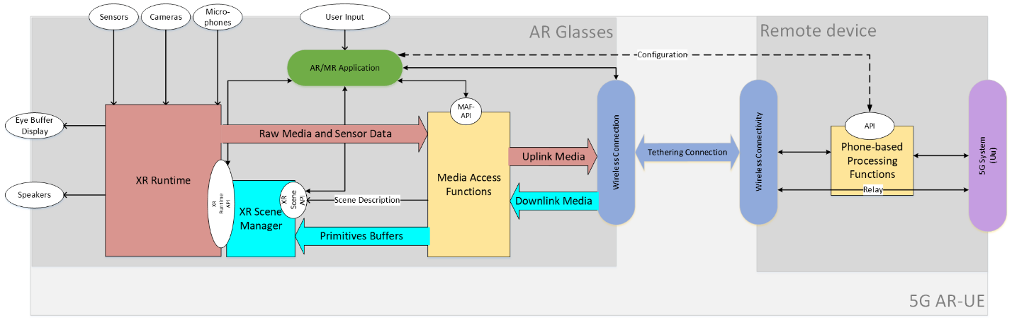
Figure 3 – Example architecture of AR glasses based on device design type 2

3.2.3 Device design type 3
The AR Glasses is tethered to a 5G device that includes the application and the XR functions. The tethering may be wireless or wired, but it is proprietary.
The 5G device runs the application that uses the Media access and rendering capabilities of the 5G device to run an AR/MR experience. The AR glass is connected to the 5G Device, but the XR runtime API is exposed to the 5G device/phone.
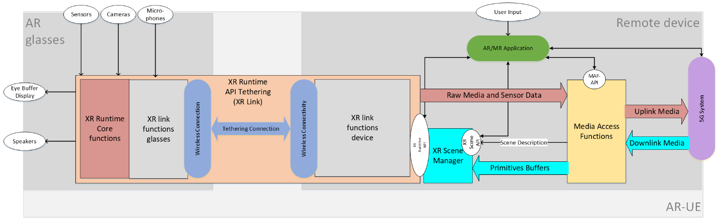
Figure 4 – Example architecture of AR glasses based on device design type 3
In this case, the connection between the phone and glass is handled by a proprietary system that tethers the XR Runtime API running on the 5G device to the XR Runtime core functions on the glass. The overall function is referred to as XR Link.
In order to determine the media capabilities of such a device, it is assumed that the media access and rendering functions of a high-end smart phone can be used.

3.2.4 Device design type 4
The considered device is not referring to optical see-through glasses, but may for example be a regular 5G phone with extended AR/XR capabilities. The capabilities include 6DOF rendering, pose tracking and other type of rendering functionalities.
The 5G device runs the XR application that uses the Media access and rendering capabilities of the 5G device to run an XR experience. All XR functionalities are included in a single device.
The device is possibly not head-mounted, i.e. tracking information may not be the head pose, but relate to the location and orientation of the XR device.
Figure 5 – Example architecture of an XR device based on device design type 4
In order to determine the media capabilities of such a device, it is assumed that the media access and rendering functions of a high-end smart phone can be used.

3.3 General functional architecture
For any type of AR devices targeted by MeCAR, the functional architecture depicted in Figure 6 is applicable.
Figure 6 – General functional architecture of AR device

3.4 5G_STAR EDGAR-type device architecture
From TR 26.998 [1], the architecture of the EDGAR device type was defined as illustrated in Figure 7. Note that EDGAR in TR 26.998 stands for EDGe-dependent AR (EDGAR) UE.
Figure 7 – Architecture of 5G_STAR EDGAR-type device

3.5 Media Access Function for AR
The Media Access Function defined in TR 26.998 [1] supports the AR UE to access and stream media. Figure 8 depicts its different functions and buffer elements.
Figure 8 – Media Access function for AR as defined in TR 26.998 [1]

3.6 Transparency information

3.6.1 Interest of Transparency information
It is desirable to support the transmission of transparency information (alpha_channel) in addition to the colour (e.g., RGB) information. Augmented reality services may overlay of virtual objects on the real world which are accessed directly through the “optical see-through” glasses. The overlay is not a full picture but only part of it, the other pixels of the picture being transparent or partially transparent, in case of a shadow effect for instance.
Figure 9 below depicts the overlay of a virtual dragon on the table of a real living room. If the whole video is overlayed, the dragon may appear in the middle of a rectangle corresponding to the video size. This is illustrated on the left picture. With additional transparency information, only the part of the video corresponding to the dragon is overlayed, as illustrated on the right picture.
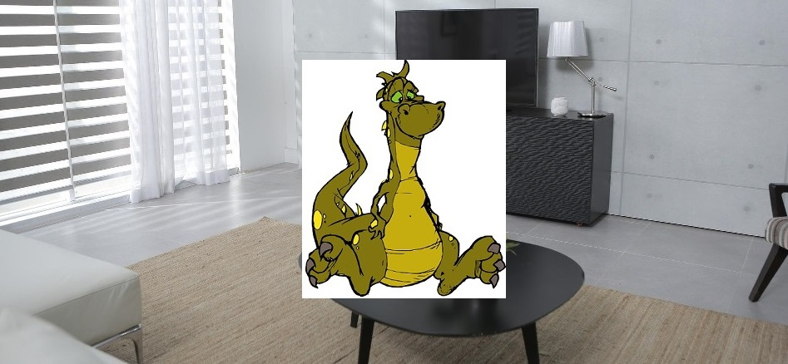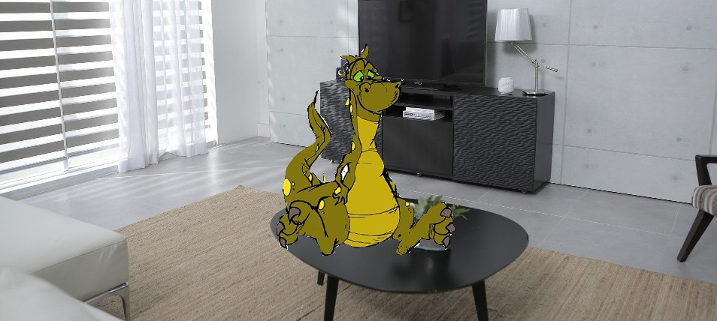
Figure 9 – Video overlay without (left) and with (right) transparency information
The following text is extracted from the OpenXR specification [11] as illustrative purposes. It specifies how the XR Runtime has to render the views:
- blended with a captured view of the real world,
- presented on top of the real world based on optical see-through display, or
- not related to a real-world scene (e.g. VR).
Start of quote
After the compositor has blended and flattened all layers (including any layers added by the runtime itself), it will then present this image to the system’s display. The composited image will then blend with the user’s view of the physical world behind the displays in one of three modes, based on the application’s chosen environment blend mode.
VR applications will generally choose the XR_ENVIRONMENT_BLEND_MODE_OPAQUE blend mode, while AR applications will generally choose either the XR_ENVIRONMENT_BLEND_MODE_ADDITIVE or XR_ENVIRONMENT_BLEND_MODE_ALPHA_BLEND mode.
The possible blend modes are specified by the XrEnvironmentBlendMode enumeration:
typedef enum XrEnvironmentBlendMode {
XR_ENVIRONMENT_BLEND_MODE_OPAQUE = 1,
XR_ENVIRONMENT_BLEND_MODE_ADDITIVE = 2,
XR_ENVIRONMENT_BLEND_MODE_ALPHA_BLEND = 3,
XR_ENVIRONMENT_BLEND_MODE_MAX_ENUM = 0x7FFFFFFF
} XrEnvironmentBlendMode;
Enumerant Descriptions
- XR_ENVIRONMENT_BLEND_MODE_OPAQUE. The composition layers will be displayed with no view of the physical world behind them. The composited image will be interpreted as an RGB image, ignoring the composited alpha channel. This is the typical mode for VR experiences, although this mode can also be supported on devices that support video passthrough.
- XR_ENVIRONMENT_BLEND_MODE_ADDITIVE. The composition layers will be additively blended with the real world behind the display. The composited image will be interpreted as an RGB image, ignoring the composited alpha channel during the additive blending. This will cause black composited pixels to appear transparent. This is the typical mode for an AR experience on a see-through headset with an additive display, although this mode can also be supported on devices that support video passthrough.
- XR_ENVIRONMENT_BLEND_MODE_ALPHA_BLEND. The composition layers will be alpha-blended with the real world behind the display. The composited image will be interpreted as an RGBA image, with the composited alpha channel determining each pixel’s level of blending with the real world behind the display. This is the typical mode for an AR experience on a phone or headset that supports video passthrough.

End of quote
As can be seen on the specification, OpenXR indicates that the AR glasses as discussed in MeCAR are supposed to operate in the XR_ENVIRONMENT_BLEND_MODE_ADDITIVE mode. In this mode, the alpha channel if present is ignored. Instead, the transparency effect is achieved by “black composited pixels to appear transparent”. Therefore, transparency information does not seem to be relevant for the current AR MeCAR devices when it comes to display virtual objects as overlay on the real scene as depicted in section 3.6.1 of this document.
Therefore, transparency information in the transmitted data seems to be relevant for AR devices which are able to occlude the real-world (e.g. smartphone, VR headset, video-see through device) but are not relevant for AR devices such as current optical-see through AR Glasses which are not capable of occluding the real-world.

3.6.2 Processing transparency information
[Editor’s note] This chapter is a preliminary draft. Further study is required on this topic.
Depending on how the transparency information is carried, it may be processed at different functional blocs.
For example, transparency information may be processed in the Media Access Function. This may be the case if the transparency information is carried in media tracks. This also includes the decoder if transparency information is carried as auxiliary pictures. Transparency information may also be processed by an AR scene manager, when the transparency information is carried in the scene description.
Wherever the processing is located, transparency information is forwarded to the display so that only the appropriate parts of the picture are displayed.

3.6.3 Carrying transparency information

3.6.3.1 Carriage as auxiliary pictures in the video stream
The carriage of transparency information may be achieved by using the concept of auxiliary pictures defined by both the AVC and HEVC codecs.

3.6.3.1.1 AVC
The AVC (H.264) specification provides guidelines for carrying transparency information.
It defines the concept of alpha-blending in clause 3.5 : “A process not specified by this Recommendation | International Standard, in which an auxiliary coded picture is used in combination with a primary coded picture (…) the samples of an auxiliary coded picture are interpreted as indications of the degree of opacity (or, equivalently, the degrees of transparency) associated with the corresponding luma samples of the primary coded picture.” AVC specification precises in clause 3.7 that “An auxiliary coded picture must contain the same number of macroblocks as the primary coded picture. Auxiliary coded pictures have no normative effect on the decoding process.” It also mentions (clause 3.1) that “In addition to the primary coded picture, an access unit may also contain (…) one auxiliary coded picture”.

Clause 7.3.2.1.2 (Sequence parameter set extension RBSP syntax) of the AVC specification defines fields related to alpha blending (alpha_incr_flag, alpha_opaque_value and alpha_transparent _value) and the semantics are detailed in clause 7.4.2.1.2 (Sequence parameter set extension RBSP semantics). The same clause also explains that “aux_format_idc equal to 1 indicates that exactly one auxiliary coded picture is present in each access unit of the coded video sequence, and that for alpha blending purposes the decoded samples of the associated primary coded picture in each access unit should be multiplied by the interpretation sample values of the auxiliary coded picture in the access unit in the display process after output from the decoding process.”

3.6.3.1.2 HEVC
HEVC also defines how to carry an alpha channel in the same video bitstream as the base video.In this case, each frame contains two parts: a base layer containing the video, and an alpha layer containing the alpha channel information. Both layers are compressed using the HEVC codec. The two layers are signalled by a specific HEVC syntax element, namely a specific alpha channel information SEI message has to be added, so that the decoder knows how to interpret the auxiliary pictures. A decoder incapable of handling this SEI message only decodes the base layer.
The concept of auxiliary picture is defined in Annex F of the HEVC (H.265) specification:
F.3.5 auxiliary picture: A picture that has no normative effect on the decoding process of primary pictures, and with a nuh_layer_id value such that AuxId[ nuh_layer_id ] is greater than 0.

In the same Annex, Table F.2 details the different types of auxiliary pictures:
Table F.1 – Mapping of AuxId to the type of auxiliary pictures
AuxId | Name of AuxId | Type of auxiliary pictures | SEI message describing interpretation of auxiliary pictures
1 | AUX_ALPHA | Alpha plane | Alpha channel information
2 | AUX_DEPTH | Depth picture | Depth representation information
3..127 |  | Reserved
128..159 |  | Unspecified
160..255 |  | Reserved

3.6.3.2 Carriage in ISOBMFF-based formats
ISO/IEC 14496-12 (ISO Base Media File Format) defines a general format which is used as a basis for defining other carriage formats such as MP4, CMAF, HEIF, AVIF, etc. It defines general concepts for the transport and carriage of data in an ISOBMFF-based container format and therefore nothing specific for the transport of auxiliary pictures is mentioned. Among many other things, ISOBMFF specifies the concept of non-timed items that can be used to store static images, and the concept of tracks that can be used to define the carriage of timed video. The format is flexible enough to allow carriage of auxiliary picture information, such as transparency, in the same structure (e.g., using a single item or a single video track) as well as using multiple tracks or items, with dependencies signaled by the item or track reference concept. For example, in the latter case an auxiliary video track needs to be used together with the ‘auxl’ track reference type as defined in clause 8.3.3.
HEIF (High Efficiency Image File format, ISO/IEC 23008-12) builds on top of ISOBMFF and defines a format for carriage of images and image sequences. Because the format is derived from ISOBMFF, transparency information can be carried in a single item or using multiple items, although the latter requires an ‘auxl’ item reference type similar to the video example above.
MIAF (Multi Image Application Format, ISO/IEC 23000-22), which defines additional constraints for HEIF, describes in its clause 7.3.5 how MIAF auxiliary image items can be used to carry alpha planes. In particular, it mentions that “MIAF renderers shall interpret alpha planes and should support alpha blending using alpha-plane auxiliary images. This is especially important for image overlays”. It also details in its clause 6.7 (MAIF renderer processing model) the interpretation of alpha planes.

3.6.3.3 Carriage in Scene Descriptions
Possible carriage of transparency information or associated transparency information via the scene description has also to be considered. In particular, this may be a solution when an auxiliary picture carrying transparency information is available and not to rely on the SEI messages which not be decoded by all decoders (see HEVC chapter).
As an example for carrying transparency information in scene descriptions, clause 3.9 on Materials in the glTF 2.0 specification has a subclause “additional-texture” and a subclause “alpha-coverage” which describe how to use the fourth (alpha) component, if present, of a texture.

3.7 Media Type Categories and Characteristics

3.7.1 General
AR/MR applications are expected to deal with various media types that have different characteristics and levels of dependency on real-time transport. This clause introduces how and where some of the AR/MR media types are defined and provides an assessment on their levels of dependency on real-time transport and size/bitrate characteristics.

3.7.2 Media types definition
Based on the metadata definition and the description, the AR/MR data can be classified into three categories:
- Device capability: the metadata specifying the device capabilities and features such as camera information and projection information. The information is usually available at the beginning of an AR/MR session and may not change within an AR/MR session.
- Media description: the metadata describing the space or object media content such as scene description, spatial description, and 3D visual mode to be consumed by the UEs. The data size may be large (>10MB) and the information usually does not change frequently and may be event driven.
- Interaction: the metadata representing the user inputs or haptics such as user pose, viewport, gesture, body action, facial expression, FOV and AR anchor point. The interaction may trigger the event at the receiver side and the sender may expect low-latency response (50~1000ms). The interaction data size may be small, but the frequency could be high (>1KHz). The data transport may be continuously or may require burst transport. Depending on the applications, the interactive metadata may be synchronized to each other, or synchronized to other media streams, and the reliability may be strict or not strict.
Table 2 – AR/MR Data type definitions
AR/MR Data category | AR/MR  Data type | Definition | Media type description (Examples)
Media Description | Scene Description | Clause 4.4.2 of 3GPP TR 26.998[1]  Scene description is used to describe the composition of a 3D scene, referencing and positioning the different 2D and 3D assets in the scene typically using a tree or a graph structure. | Type: glTF2.0, JSON format  Organization: MPEG-I and Khronos
Media Description | Spatial Description | Clause 4.4.7.3 of 3GPP TR 26.998[1]  Visual features, keyframes, and spatial maps are used for mapping the real world, typically as part of the SLAM process. | Type: For example:  https://www.khronos.org/registry/OpenXR/specs/1.0/html/xrspec.html#XR_FB_spatial_entity  Organization: OpenXR
Media Description | 3D Visual Model | Clause 4.6.3.5.2 of 3GPP TR 26.928[2]  3D visual object description as a list of vertices, faces and other elements, along with associated attributes. | Type: PoLYgon  Organization: None
Media Description | Split rendered 2D projection video | 2D video containing projected and rendered AR/MR media with the projection information. | Type: 2D video with projection information metadata.  Organization: MPEG
 | Split rendered 2D depth map video | Monochrome 2D auxiliary video containing depth map in the same perspective view with primary picture. | Type: 2D auxiliary video with depth type defined in I.13.2.3 of ISO/IEC 14496-10 [X] and G.14.3.3 of ISO/IEC 23008-2 [Y].  Organization: MPEG
 | Split rendered 2D alpha channel video | 2D auxiliary video containing alpha channel information in the same perspective view with primary picture. | Type: 2D auxiliary video with alpha channel information defined in 7.3.2.1.2 of ISO/IEC 14496-10 [X] and F.14.3.8 of ISO/IEC 23008-2 [Y].  Organization: MPEG
Interaction | AR Anchor | The AR anchor is meant to identify a point in the user space to be used to anchoring a visual object (2D or 3D) | Type: Metadata allowing accurate overlaying/rendering of text, graphics or video contents to support Use Case 8 of TR 26.928.  Organization: None
Interaction | User Pose | Clause 4.4.3.1 of 3GPP TR 26.998[1]  Representation of the user position and orientation | Type: It consists of a quaternion for orientation and a 3D vector for position. Timestamp is represented by a 64 bit monotonically increasing nano-second-based integer.  Organization: Khronos OpenXR
Interaction | FOV | Y.6.2.3 of 3GPP TS 26.114[3]  The Field of View (FOV) is the extent of observable world at any given moment | Type: It consists of vertical fov and horizontal fov.  Organization: None
Interaction | Viewport | Y.7.2 of 3GPP TS 26.114[3]  The viewport corresponds to the projection of the user View onto a target display | Type: It shall contain all of the parameters Viewport_azimuth, Viewport_elevation, Viewport_tilt, Viewport_azimuth_range and Viewport_elevation_range  Organization: None
Interaction | Gesture | TBD | Type: A array of finger joint position.  For example: https://www.khronos.org/registry/OpenXR/specs/1.0/html/xrspec.html#XR_EXT_hand_tracking  Organization: OpenXR
Interaction | Body action | TBD | Type: bvh format.  Frequency: at least 1kHz  Organization: BioVision company
Interaction | Facial expression | TBD | Type: An array of key point position.  For example: https://www.khronos.org/registry/OpenXR/specs/1.0/html/xrspec.html#XrSystemFacialTrackingPropertiesHTC  Organization: None
Interaction | Sensor information | TBD | Type: a new interaction profile path  For example, OpenXR EXT format offers the possibility to developers to integrate and benefit from new controllers and sensor subsystems, (e.g., https://registry.khronos.org/OpenXR/specs/1.0/html/xrspec.html#XR_EXT_hp_mixed_reality_controller, etc.).  Organization: OpenXR
Interaction | Eye gaze  (see note below table) | Eye gaze typically consists of a gaze origin (a point positioned between the user’s eyes) and a gaze direction, a ray pointing towards where the user is looking at, and gaze point, a three-dimensional position where the user is looking at. | Type: 3D vector for gaze origin and gaze point, a quaternion for gaze direction.  For example, OpenXR defines a new interaction profile path for eye gaze input:  https://registry.khronos.org/OpenXR/specs/1.0/html/xrspec.html#XR_EXT_eye_gaze_interaction, , and Unity defines methods to get the gaze information: https://docs.unity3d.com/ScriptReference/XR.Eyes.html  Organization: OpenXR
Device capability | Camera information | TBD | Type: The camera parameters such as focal length, principal points, calibration parameters and the pose of the camera all contribute in understanding the relevance between points in the volumetric scene and pixels in the captured image.  Organization: None
Device capability | Projection information | Parameters associated to the projection to the 3D scene. Perspective, orthogonal and omnidirectional are the projection types to be used. | Type: In the case of omnidirectional projection, the signaling of projection type such as Equirectangular and Cubemap are defined in sub clauses of clause D.2.35 1 Equirectangular projection SEI message semantics of ISO/IEC 14496-10 [X] and clause D.3.41 Semantics of omnidirectional video specific SEI messages of ISO/IEC 23008-2 [Y], or as ISOBMFF box in clause 7.6.2 of ISO/IEC 23090-2 [Z].  Organization: MPEG

NOTE The way of measuring the gaze point is out of scope of this specification. Device may have eye tracking cameras, sensors, and may perform calibration procedures to accommodate different disparity and different screen to eye distance by different face shapes.

[Editor’s note]: The list of Media Type is a starting point and other types of AR media will be added.

3.7.3 AR/MR Data Type characteristics
The AR media can be classified to three categories according to its real time characteristics:
- Non timed: Scene Description/3D Model/FOV/Sensor information.
- Sparsely timed (event based): Spatial Description/AR Anchor/Camera information/Projection information.
- Continuous: User Pose/Viewport/Gesture/Body action/Facial expression.
Therefore, the AR media transporting solution should support unreliable, partial reliable and reliable for each categories.
NOTE: the mapping of the reliability with the real time characteristics is TBD.
Table 3 illustrates the characteristics of each AR/MR metadata category.
Table 3 – AR/MR Data characteristics
AR/MR data characteristics | Device capability | Media description | Interaction
metadata | camera information, projection information | Scene description, spatial description, 3D visual mode | FOV, AR anchor, user pose, viewport, gesture, body action, facial expression
Data size | Small | Large (>10MB) | Small
Frequency | Beginning of the session | Low (event based) | High (>1KHz)
Real-time | Sparsely timed (event based)/Non timed | Sparsely timed (event based)/Non timed | Timed
Latency |  |  | 50~1000ms
Reliability | reliable | reliable | reliable/unreliable
Uplink/downlink |  | DL | UL
Synchronization | N | Y | Y
Table 4 – Real Time Characteristics of AR/MR Media Types
AR/MR Metadata  Media Type | Real Time Characteristics
Scene Description | Non timed
Spatial Description | Sparsely timed (event based)
3D Model | Non timed
AR Anchor | Sparsely timed (event based)
User Pose | Continuous
FOV | Non timed
Viewport | Continuous
Gesture | Continuous
Body action | Continuous
Facial expression | Continuous
Sensor information | Non timed
Camera information | Sparsely timed (event based)
Projection information | Sparsely timed (event based)
Split rendered 2D projection video | Continuous
Split rendered 2D depth map video | Continuous
Split rendered 2D alpha channel video | Continuous

3.7.4 Traffic characteristics
Table 5 – Typical size and bitrate of AR/MR Media Types
AR/MR Metadata  Media Type | Typical size or bitrate
Scene Description | TBD
Spatial Description | TBD
3D Model | TBD
AR Anchor | TBD
User Pose | TBD
FOV | TBD
Viewport | TBD
Gesture | TBD
Body action | TBD
Facial expression | TBD
Sensor information | TBD
Camera information | TBD
Projection information | TBD
Split rendered 2D projection video | TBD
Split rendered 2D depth map video | TBD
Split rendered 2D alpha channel video | TBD

3.8 Background on OpenXR

3.8.1 Visual rendering in OpenXR
As described in the OpenXR Reference Guide [7], an OpenXR application is composed of different cycles as depicted in Figure 18Figure 10.
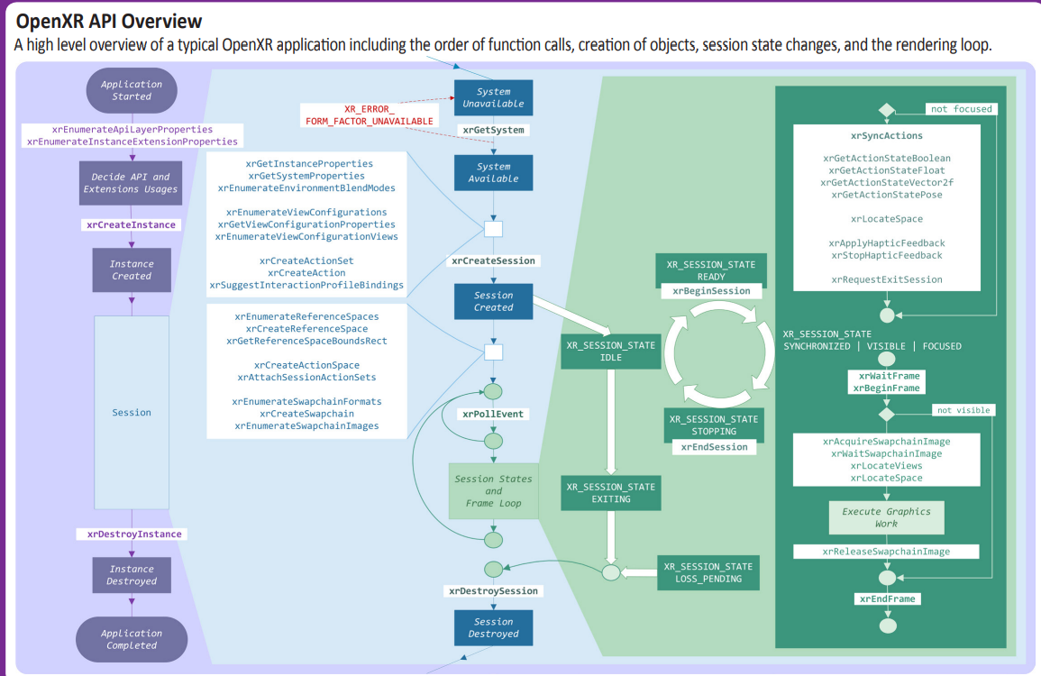
Figure 10 – OpenXR application lifecycle [7]
After creating an OpenXR session, the application starts a frame loop. The frame loop is executed for every frame. The frame loop consists of the following steps:
- Synchronize actions: this step consists of retrieving the action state, e.g. the status of the controller buttons and the associated pose. During this step, the application also establishes the location of different trackables. The application may also send haptics feedback.
- Start a new frame: this step starts with waiting for a frame to be provided by the XR runtime. This step is necessary to synchronize the application frame submission with the display. The xrWaitFrame function returns a frame state for the requested frame that includes a predictedDisplayTime, which is a prediction of when the corresponding composited frame will be displayed. This information is used by the application to request the predicted pose at display. Once the xrWaitFrame function completes, the application calls xrBeginFrame to signal the start of the rendering process.
- Retrieve rendering resources: the application starts by locating the views in space and time by calling the xrLocateViews function, provided with the predicted display time and the XR space. It then acquires the swap chain image associated with every view of the composition layer. It waits for the swap chain image to be made available so it can write into it.
- Rendering: the application then performs its rendering work. This is for instance what the scene manager is tasked with. It iterates over the scene graph nodes and renders each object to the view. This step usually uses a Graphics Framework such Vulkan, OpenGL, or Direct3D to perform the actual graphics operations.
- Release resources: once the rendering is done for a view, the application releases the corresponding swap chain image. Once all views are rendered, it sends them for display by calling the xrEndFrame function.
In terms of rendering operation, the relevant part is located between the call to xrBeginFrame and the call to xrEndFrame on the bottom right part of the diagram.
When the application calls the xrEndFrame function, the application provides the structure XrFrameEndInfo which contains all necessary information to render the frame that is:
- The time at which this frame should be displayed.
- The mode to be used for blending the user’s envriromnent with the submitted frame
One or more layers which composes the submitted frame

As documented in the OpenXR specification:
“XrFrameEndInfo may reference swapchains into which the application has rendered for this frame. From each XrSwapchain only one image index is implicitly referenced per frame, the one corresponding to the last call to xrReleaseSwapchainImage.”
This describes how the XR runtime and the application can exchange visual data, i.e. via the use of swapchains.
A key feature of the XR runtime is its ability to perform layer composition. A Compositor in the runtime is responsible for taking all the received layers from xrEndFrame calls, performing any necessary corrections such as pose correction and lens distortion, compositing them, and then sending the final frame to the display. An application may use multiple composition layers for its rendering. The number of supported composition layers may be queried by the application.
OpenXR supports different types of layers, with the main ones being:
- Projection Composition Layer: represents planar projected images, one rendered for each eye using a perspective projection.
- Quad Composition Layer: is useful for rendering user interface elements or 2D content on a planar area in the world.
- Cube Composition Layer: consists of a cube map with 6 views to be rendered by the application.
- Equirectangular Composition Layer: consists of an equirectangular image that is mapped onto the inside of a sphere in the world.
- Depth Composition Layer: provides an extra composition layer to allow applications to submit depth maps to assist with the pose correction of projected images of a project layer.
Figure 11 depicts an example of a projection composition layer and the resulting composited distorted image (image courtesy of Khronos).
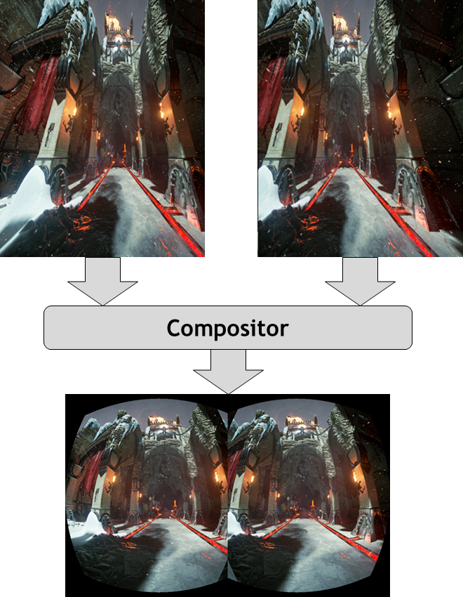
Figure 11 – Example illustrating composition of a stereoscopic image submitted to the Compositor
Another relevant configuration when setting up the XR session is the choice of the view configuration, which depends on the target device and its capabilities. Mono and Stereo are natively supported by all XR runtimes. Some advanced types like the primary quad, defined as a vendor extension provide support for foveated rendering.

3.8.2 Media-related conformance aspects

3.8.2.1 General
This analysis of media related conformance aspects was performed on the specification Version 1.0.25: from git ref release-1.0.25 [11].

3.8.2.2 Composition layer

3.8.2.2.1 Specification quote
The XrSystemGraphicsProperties structure is defined as:

typedef struct XrSystemGraphicsProperties {
uint32_t maxSwapchainImageHeight;
uint32_t maxSwapchainImageWidth;
uint32_t maxLayerCount;
} XrSystemGraphicsProperties;

Member Descriptions
• maxSwapchainImageHeight is the maximum swapchain image pixel height supported by this
system.
• maxSwapchainImageWidth is the maximum swapchain image pixel width supported by this
system.
• maxLayerCount is the maximum number of composition layers supported by this system. The
runtime must support at least XR_MIN_COMPOSITION_LAYERS_SUPPORTED layers.

// Provided by XR_VERSION_1_0
#define XR_MIN_COMPOSITION_LAYERS_SUPPORTED 16

XR_MIN_COMPOSITION_LAYERS_SUPPORTED defines the minimum number of composition layers that a conformant runtime must support. A runtime must return the XrSystemGraphicsProperties::maxLayerCount at least the value of XR_MIN_COMPOSITION_LAYERS_SUPPORTED.

…

(10.4. Frame Submission)

XR_ERROR_LAYER_LIMIT_EXCEEDED must be returned if XrFrameEndInfo::layerCount exceeds XrSystemGraphicsProperties::maxLayerCount or if the runtime is unable to composite the specified layers due to resource constraints.
…

(10.4.5. Composition Layer Types)

The core specification defines XrCompositionLayerProjection and XrCompositionLayerQuad layer types.

The projection layer type represents planar projected images rendered from the eye point of each eye using a perspective projection. This layer type is typically used to render the virtual world from the user’s perspective.

The quad layer type describes a posable planar rectangle in the virtual world for displaying two-dimensional content. Quad layers can subtend a smaller portion of the display’s field of view, allowing a better match between the resolutions of the XrSwapchain image and footprint of that image in the final composition. This improves legibility for user interface elements or heads-up displays and allows optimal sampling during any composition distortion corrections the runtime might employ.

3.8.2.2.2 Media capabilities
Regarding composition layers, the study of OpenXR shows the following mandatory support:
- The Runtime must at least accepts 16 layers per submitted frame. However, note that at runtime, the system may reject the composition of those layers if resource are not available for it.
- The Runtime must support at least the projection layer and quad layer from the core specification.

3.8.2.3 Tracking

3.8.2.3.1 Specification quote
The XrSystemTrackingProperties structure is defined as:
typedef struct XrSystemTrackingProperties {
XrBool32 orientationTracking;
XrBool32 positionTracking;
} XrSystemTrackingProperties;

Member Descriptions
• orientationTracking is set to XR_TRUE to indicate the system supports orientational tracking of
the view pose(s), XR_FALSE otherwise.
• positionTracking is set to XR_TRUE to indicate the system supports positional tracking of the
view pose(s), XR_FALSE otherwise.

3.8.2.3.2 Tracking capabilities
Regarding tracking, the core specification does not seem to mandate the presence of tracking capabilities.

3.8.2.4 Swapchains

3.8.2.4.1 Specification quote
(10.1. Swapchain Image Management)
The runtime must allow applications to create multiple swapchains.

Swapchain image format support by the runtime is specified by the xrEnumerateSwapchainFormats function. Runtimes should support R8G8B8A8 and R8G8B8A8 sRGB formats if possible.

3.8.2.4.2 Swapchain format capabilities
Regarding swapchains, the study of OpenXR shows the following mandatory support:
- The Runtime must allow multiple swapchains (i.e. more than one)
- The Runtime should support at least support R8G8B8A8 and R8G8B8A8 sRGB.

There seems thus to be little constraints in terms of swapchain image format to be mandatory supported.

3.9 MPEG-I Scene Description
NOTE: As part of the working assumptions MPEG-I SD functionalities will be evaluated, as a candidate solution, against the device capabilities and requirements of MeCAR.

3.9.1 Overview
As described in section 4.6.5 of TR 26.998 [1], a key technology in enabling immersive 3D user experiences is scene description. Scene description is used to describe the composition of a 3D scene, referencing and positioning the different 2D and 3D assets in the scene. The information provided in the scene description is then used by an application to render the 3D scene properly, using techniques such as Physically-Based Rendering (PBR) that produce realistic views
To address the needs of immersive applications, MPEG Scene Description (SD) specified a collection of extensions to glTF to support scene description. glTF 2.0 [35] provides a solid and efficient baseline for exchangeable and interoperable scene descriptions.
A white paper providing an overview of MPEG Scene Description is available [36].

Khronos glTF 2.0 specification was released in 2017. Khronos allows to extend the glTF specifications through an extension mechanism. The process of registering MPEG extensions as Khronos Vendor extensions is now in its final stage.

MPEG SD defines the following extensions:
- the First Edition of MPEG-I Scene Description (ISO/IEC 23090-part14) is a set of extensions providing support for audio, timed media, and scene update.
- Amendment 1 provides support for immersive media (MIV and V-PCC, V3C standards).
- Amendment 2 provides support for immersive audio, anchoring, interactivity, lighting, avatar, haptics.

In the MPEG SD Technologies under Consideration (TuC) document, support for advanced interactivity and for real environment are under study for an Amendment 3.

3.9.2 MPEG glTF extensions

3.9.2.1 The anchoring extension
The anchoring extension enables the sharing of a common spatial reference among multiple users by specifying trackables and anchors.

Trackable is an element of the real world which features can be extracted. This element can then be detected and tracked over time.
An anchor is a virtual object defining a local reference space for the virtual scene.
The anchor is attached to this trackable. The anchor position is then relative to the trackable it is attached to.

The MPEG Scene Description anchoring extension is defined in Amd2 clause 8.1. It includes all the necessary syntax to define the trackable, the anchor, the relative position of the anchor in relation to the trackable.

3.9.2.2 The interactivity extension
MPEG-I Scene Description Amd2 defines an interactivity framework for the description of allowed runtime interactions between a user with the virtual scene objects and between the virtual objects themselves. The framework relies on the definition of behavior, composed of a logical combination of generic triggers and of the related actions to be launched sequentially or in parallel.

The trigger types are :
- Visibility trigger, allowing to detect if a 3D object in a virtual scene is visible from the user viewpoint,
- Proximity trigger, allowing to detect the proximity of the user to a 3D object of a virtual scene,
- Collision trigger, allowing to determine a collision between 3D objects,
- User-input trigger, allowing to detect a specific user input.

The physical parameters to animate the 3D objects according to physical laws are provided through interactivity extension.

The interactivity extension is defined in Amd2, clause 8.2.

3.9.2.3 Additional extensions
Several other MPEG SD extensions increase the quality of the AR user experience, notably:
- Avatar extension: Annex H of Amd2 provides a description of a reference topology for the representation of humanoid avatars.
- Lighting extension (clause 8.4 of Amd2): this extension enables a support of timed lighting.
- Haptic extension (Annex G3 of Amd2): this extension defines a support for haptic signals. An example may be to add vibrations to scene objects.
- Support for Volumetric Video (V3C) codecs (Annex G1 of Amd1): this extension allows to support V3C compressed objects in MPEG-I Scene Description.

3.9.2.4 MPEG SD extensions in the TuC
Extensions described in the TuC document include, but are not limited to:
- Advanced interactivity: this extension addresses the need to support scene updates generated at runtime from the activation of triggers. The advanced interactivity extension is typically required in the case of a common virtual scene, shared between multiple users, each of them interacting and modifying the scene at runtime.

Real environment: this extension aims at providing scene understanding by supporting a real-world representation in scene description to achieve a seamless integration of the virtual into the real world (an example may be the interaction of virtual objects falling on a real surface).

3.10 Working assumption on operation points for MeCAR
Before starting the work on defining the required media capabilities related to 3D video, Operations Points are to be considered, where Operation Point is aligned with the definition in TS26.118 as "a collection of discrete combinations of different content formats including spatial and temporal resolutions, colour mapping, transfer functions, rendering metadata or the encoding format."
The MeCAR specification would define operation points for immersive video in IF-4, i.e. the interface between the Media Access Function and the 5G System for user plane data as defined in section 4.1.
However, in contrast to TS26.118, where the bitstreams conforming to Operation Points were defined to be self-contained omnidirectional experiences, in TS26.119, the bitstreams may be added to a scene that renders and composes data contained in multiple bitstreams.
Hence, carrying forward the definition from TS 26.118 into TS 26.119 may not be straightforward. We may need to differentiate three cases:
- The operation point is such that no action or pose-based rendering is needed, i.e. that operation point is directly consumable by the XR Runtime as the media is already projected (left/right eye), equirectangular, etc., possibly with some simple colour conversion. Note that this may require some amount of metadata processing.
- The operation point describes an asset and includes asset metadata that requires a GPU-based rendering taking into account the viewer pose, but can be projected into a composition layer to be consumed by the run-time
- The operation point is a scene that requires a GPU-based rendering taking into account the viewer pose and also address local input an actions, but then is projected into a composition layer to be consumed by the run-time.
The above operation points may require different capabilities on the device:
  - Video decoding capabilities: needed by all three cases
  - Rendering capabilities: needed by 2 and 3
  - Scene composition capabilities: needed by 3
Hence, the MeCAR specification would define at least three capabilities:
- video decoding capability
- rendering capabilities based on asset metadata information, describing the mapping from 3D space to the 2D video frame (texture, depth, etc).
- rendering and scene composition capabilities to render scenes and included assets
Video decoding capability would be defined by the requirements as per clause 6.6 in this document.
Rendering capabilities for asset metadata information may require the ability to render information provided by the video decoder output combined with asset metadata this could include. Asset metadata may for example be:
- Certain SEI messages,
- Atlas metadata as defined in V3C profiles, or
Finally, scene rendering includes the ability to interpret a scene and render the scene and the referenced objects. There may be for example:
- A gltf scene
- A gltf scene with MPEG-I Scene Description extensions.
For the asset metadata information, MeCAR may evaluate, for example,
- Relevant rendering metadata in SEI messages
- MIV and V-PCC profiles of V3C,.
NOTE Further clarifications need to be added on 3D video and asset metadata. The terminology ‘operation points’ can be further refined to match the terminology agreed in MeCAR. Rendering capabilities for devices need to be further studied.

4 Device categories

4.1 Candidate XR Baseline Client

4.1.1 General
The XR Baseline Client represents the functionalities, the peripherals, and the interfaces that are present on a generic XR UE. The actual device may be realized by a single device, or a combination of devices linked together. The details on how to instantiate an XR Baseline Client in the context of a service or deployment scenario is left for the respective Work Items and Study Items to define.
In terms of functionalities, an XR Baseline Client is composed of:
- An XR application: a software application that integrates audio-visual content into the user’s real-world environment
- An XR Runtime: a set of functions that interface with a platform to perform commonly required operations, such as accessing the controller/peripheral state, getting current and/or predicted tracking positions, performing spatial computing, as well as submitting rendered frames to the display processing unit and rendered audio to the speakers with a late stage re-projection to the latest pose.
- An XR Source Management: management of data sources provided through the XR runtime such as microphones, cameras, trackers, etc, for instance, making the information available to the XR application or providing it to the MAF for sending in the uplink.
- A Media Access Function: A set of functions that enables access to media and other XR-related data that is needed in the Scene manager or XR Runtime to provide an XR experience as well to create delivery formats for information provided by the XR Source Management.
- A Scene Manager: a set of functions that supports the application in arranging the logical and spatial representation of a multisensorial scene based on support from the XR Runtime.
- A Presentation Engine: a set of composite renderers, rendering the component of the scenes, based on the input from the Scene Manager.
- A Media Session Handler: a set of functions responsible for handling all 5G control plane operations, such as requesting network assistance, discovering and allocating edge resources, etc. This may be realized as a 5G-RTC MSH, 5GMS Media Session Handler, or any other function
In addition, those functional blocks are integrated together via interfaces. Interfaces may be made of APIs and/or data formats and collectively act as a contract between the two sides of the interface.
The XR Baseline Client contains the following interfaces:
Editor’s Note: The renumbering was done to align IF-4, IF-5, IF-6, IF-7 and IF-8 with 5GMS interfaces
- IF-1 lies between the XR Runtime on one side and the XR Source Management and the Presentation Engine. IF-1 is implemented as an API-1 that exposes functions provided by the XR Runtime. An example of this API is the Khronos OpenXR API.
- IF-2 describes the functions exposed by the XR Source Management that can be accessed and controlled by the XR application, or possibly other functions in the device. IF-2 is typically implemented as an API.
- IF-3 lies between the XR Source Management and the Media Access Function and provides serialized information accessible on XR Runtime to the MAF.
- IF-4 lies between the Media Access Function and the 5G System for user plane data.
- IF-5 lies between the UE and the 5G System, implementing control sessions (such as 5G Media Streaming, IMS). This interface provides for instance the functionality of the RTC-5 interface as defined by TS26.506.
- IF-6 lies between the Media Session Handler and the Application/MAF. It offers the tools for them to activate 5G media functionality such as network assistance and edge resource discovery. The IF-8 is realized through an API.
- IF-7 lies between the XR Application and the Media Access function to configure Media Access. This is typically implemented as an API that exposes functions of the MAF.
- IF-8 is an interface that allows the XR application to make use of 5G System connectivity.
- IF-9 lies between the Scene Manager and the Media Access Function.
- IF-10 lies between the Scene Manager and the XR Application.

4.1.2 Architecture
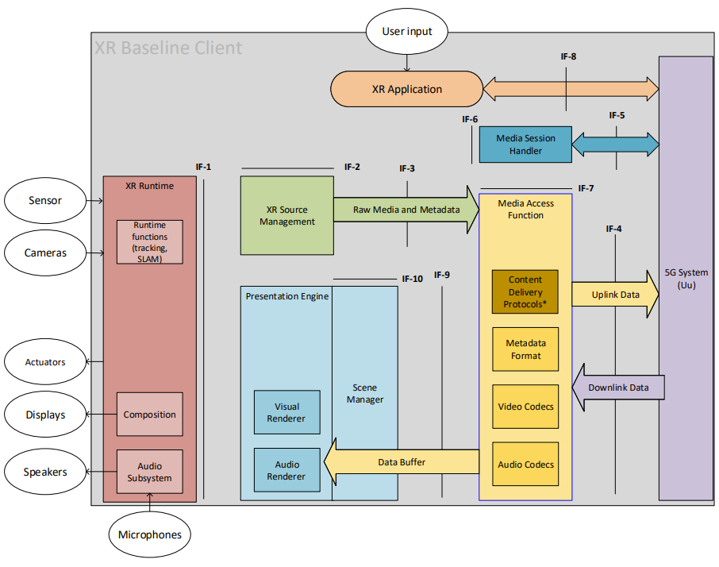
Figure 12 - XR Baseline Client architecture

4.1.3 Example Technologies
The current clause is purely informative and intend to give some ideas about the different technology blocks and specifications that could be relevant for realizing a concrete instance of a XR baseline client. The interfaces could be enabled as follows:
- IF-1 as an example is OpenXR API.
- IF-2 source management is for example provided by Snapdragon Spaces, Unity or Unreal.
- IF-3 is expected to be defined in TS 26.119 as a reference.
- IF-4 is expected to build on protocols including webRTC, IETF user plane protocols and 3GPP or MPEG codecs.
- IF-5 lies between the UE and the 5G System, implementing control sessions (such as 5G Media Streaming, IMS). This interface provides for instance the functionality of the RTC-5 interface as defined by TS26.506.
- IF-6 provides a communication between the app and the 3GPP session handling.
- IF-7 provides an API to be defined in TR 26.119.
- IF-8 is a regular application connection to a server OTT delivery, for example using HTTP.
- IF-9 is for example described as part of a glTF2.0 presentation.
- IF-10 is for example exposed by Unity or Unreal such that an application can use the underlying rendering.
Figure 13 provides an illustration of those example technologies mapped onto the XR baseline client architecture.
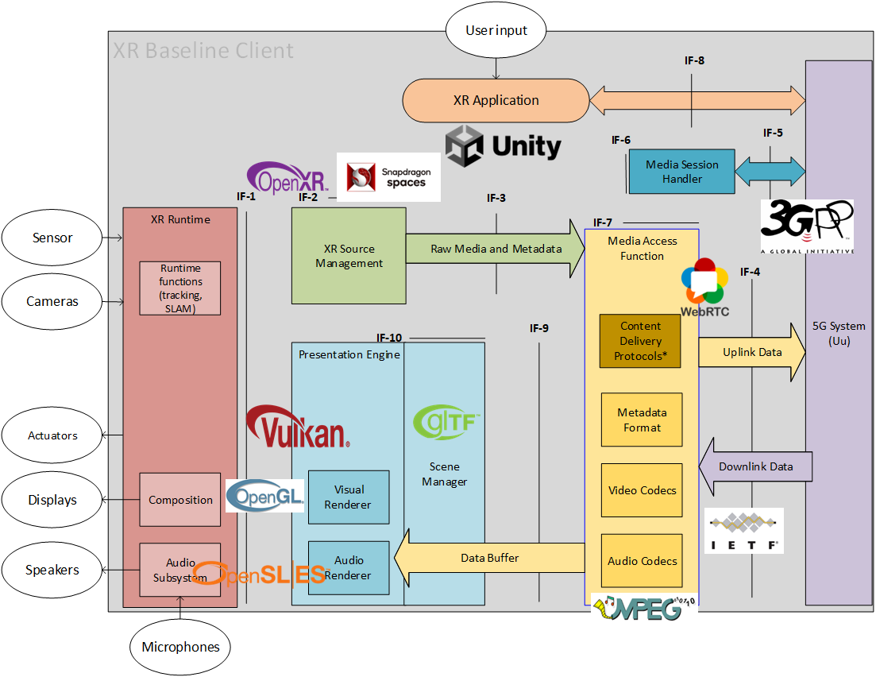
Figure 13 - Example Technologies in an XR Baseline Client

4.2 Thin Augmented Reality User Equipment (Thin AR UE)

4.2.1 Device architecture
The simplified version of an AR device follows the principles of a 5G_STAR EDGAR-type device architecture with a standalone 5G System integrated. It is referred to as "Thin AR UE". In this case it is taken into account that the device is not capable of rendering complex 3D scenes or objects, but basically only makes use of the composition capabilities of the XR runtime.
In a typical use case, the media is pre-rendered for a specific point in time in the future and a specific render pose by an entity outside of the device, for example in the 3GPP network, and the Scene Manager only converts the data to be compatible with the XR Runtime formats in the swap chain. Pre-rendering for video may be done to 2D video projections, possibly augmented with additional depth information (indicated as 2.5D in Figure 14). For audio, equivalent pre-rendering formats may be considered. In the uplink, a coded representation of the 6DoF pose sampled from the XR Runtime needs to be made available such that it can be used remotely for prerendering to the latest pose. As a result, such a UE may be used in a split rendering application.
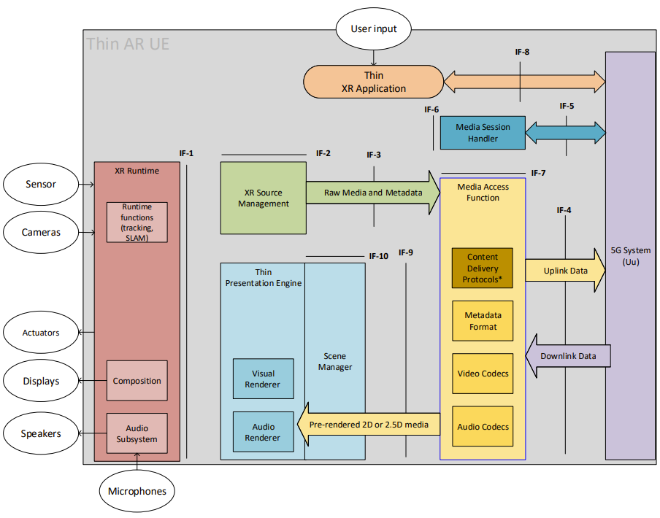
Figure 14 – Thin AR UE device architecture
In the following, initial assumptions and potential requirements for the XR Runtime for visual and audio processing are provided taking into account existing systems, in particular OpenXR, OpenGL ES and OpenSL ES. In all cases, the focus is on the functional methods of these specifications. Reference to specifics in these specifications does not imply that we mandate any of these specifications, but they serve as a reference.
Implementations may be done differently.

4.2.2 XR Runtime and Source processing
For XR source processing, the following is assumed
- The application (including the Scene Manager) has access to the viewer pose and projection parameters that are needed to render the different views. The XR Runtime provides the viewer pose and projection parameters needed to render using a function equivalent to the OpenXR xrLocateViews function to render each view for use in a composition projection layer. The xrLocateViews function returns the view and projection info for a particular display time. This time is typically the target display time for a given frame. Repeatedly calling xrLocateViews with the same time may not necessarily return the same result. Instead the prediction gets increasingly accurate as the function is called closer to the given time for which a prediction is made. This allows an application to get the predicted views as late as possible in its pipeline to get the least amount of latency and prediction error. The viewer pose and projection parameters may need to be provided to the MAF.
- The specification does not define any requirements on input actions or haptics. However, input actions may be provided to the XR Source Management to be delivered to the network. In summary
  - A 6DoF predicted pose for a target display time can be sampled from XR Runtime at a frequency of at least 1kHz
  - This information may be provided to a pose compressor that may send a compressed and quantized version to the network
- Other audio or video sources may be provided to the XR source manager.

4.2.3 XR Visual Processing
For visual processing, OpenXR and OpenGL ES aligned terminology is used as a reference, but this does not imply that we mandate any of these specifications. The following is assumed:
- To present images to the user, the runtime provides images organized in swapchains for the application to render into. The XR Runtime is expected to allow applications to create multiple swapchains (at least 4).
- The XR Runtime may support different swapchain image formats and the supported image formats may be provided to the application through the runtime API. The XR Runtime is expected to at least support R8G8B8A8 and R8G8B8A8 sRGB formats. Details may depend on the graphics API specified in xrCreateSession. Options include DirectX or OpenGL.
- Support for OpenGL ES as a reference is assumed, i.e. an extension equivalent to the functionalities provided in XR_KHR_opengl_es_enable. OpenGL ES is platform independent and suited for embedded systems. The version and a subset of functionalities is still to be determined, likely 3.2. Again note that this is assumed as a reference.
- Swapchain images can be 2D or 2D Array. Arrays allow to extract a subset of the 2D images for rendering.
- The application or Scene Manager can offload the composition of the final image to a XR Runtime-supplied compositor. By this, the rendering complexity is significantly lower since details such as frame-rate interpolation and distortion correction are performed by the XR Runtime. It is assumed that the XR Runtime provides these functionalities.
- A XR Runtime is expected to support at least the equivalent functionalities of OpenXR composition, namely
  - XrCompositionLayerProjection: The projection layer type represents planar projected images rendered from the eye point of each eye using a perspective projection. This layer type is typically used to render the virtual world from the user’s perspective.
  - XrCompositionLayerQuad: The quad layer type describes a posable planar rectangle in the virtual world for displaying two-dimensional content. Quad layers can subtend a smaller portion of the display’s field of view, allowing a better match between the resolutions of the XrSwapchain image and footprint of that image in the final composition. This improves legibility for user interface elements or heads-up displays and allows optimal sampling during any composition distortion corrections the runtime might employ.
- A XR Runtime may support additional OpenXR composition functionalities, namely
  - XR_TYPE_COMPOSITION_LAYER_CUBE_KHR: This extension adds an additional layer type that enables direct sampling from cubemaps. The cube layer is the natural layer type for hardware accelerated environment maps. Without updating the image source, the user can look all around, and the compositor can display what they are looking at without intervention from the application.
  - XR_TYPE_COMPOSITION_LAYER_CYLINDER_KHR: This extension adds an additional layer type where the XR runtime must map a texture stemming from a swapchain onto the inside of a cylinder section. It can be imagined much the same way a curved television display looks to a viewer. This is not a projection type of layer but rather an object-in-world type of layer, similar to XrCompositionLayerQuad. Only the interior of the cylinder surface must be visible; the exterior of the cylinder is not visible and must not be drawn by the runtime.
  - XR_TYPE_COMPOSITION_LAYER_EQUIRECT_KHR and XR_TYPE_COMPOSITION_LAYER_EQUIRECT2_KHR: This extension adds an additional layer type where the XR Runtime must map an equirectangular coded image stemming from a swapchain onto the inside of a sphere. The equirect layer type provides most of the same benefits as a cubemap, but from an equirect 2D image source. This image source is appealing mostly because equirect environment maps are very common, and the highest quality you can get from them is by sampling them directly in the compositor.
  - XR_KHR_composition_layer_depth: This extension defines an extra layer type which allows applications to submit depth images along with color images in projection layers, i.e. XrCompositionLayerProjection. The XR Runtime may use this information to perform more accurate reprojections taking depth into account. Use of this extension does not affect the order of layer composition as described in Compositing.
- Each image that is provided to the runtime for rendering has assigned a reference pose defining the position and orientation of the projection in the reference frame of the associated space.
- The runtime provides information about a predicted display time for the next time that the runtime predicts a composited frame will be displayed, i.e. using xrFrameState if in context to OpenXR
- The composition may refer to a sub-image as for example defined in XrSwapchainSubImage, i.e. representing the valid portion of the image to use, in pixels. It also implicitly defines the transform from normalized image coordinates into pixel coordinates.

4.2.4 XR Audio Processing
Editor’s Note: From SA4#121, The current clause is work-in-progress and will be further discussed and worked on during the upcoming telcos.
[
For audio processing, OpenXR and OpenSL ES aligned terminology is used as a reference, but this does not imply that we mandate any of these specifications. The following is assumed to reflect a typically possible decomposition of steps for immersive audio rendering:
- An interface to the XR runtime is available hand over raw audio buffers to determine how the XR application and scene manager would access a device’s audio capabilities. In order address a concrete implementation example, the model of OpenSL ES is used as a reference for. OpenSL ES supports both file-based and in-memory data sources, as well as buffer queues, for efficient streaming of audio data from memory to the audio system. Buffer queues in OpenSL may be viewed as equivalent to visual swap chains. OpenSL ES may be viewed as companion to 3D graphic APIs such as OpenGL ES. The 3D graphics engine will render the 3D graphics scene to a two-dimension display device, and the OpenSL ES implementation will render the 3D audio scene to the audio output device.
- In addition to the functionalities from such buffer queues, different types of audio signals may be provided, and additional/alternative processing steps may be carried out. Audio signals (i.e. the combination of metadata and buffer queues) may be
  - non-immersive or also known as non-diegitic, i.e. they are not rendered according to the pose.
  - Immersive and describe a full 6DoF experience in the reference space of the XR session. In this case, the XR runtime will create a rendered signal according to the latest pose.
  - Immersive and pre-rendered for a specific render pose. In this case, the signals have been prepared such that the runtime can use the audio signal and the associated render pose and supplementary data for a pose correction to the latest pose.
  - a mixture of such signals that are jointly presented.
  - the signals may originate from different source, for example some may be generated locally, others may be part of a pre-rendering or a full scene created in the network.
- Of particular interest is a simple use case, for example prominent for split rendering is a combination of signals a) non-diegetic, c) pre-rendered with assigned render pose, d) mixture of those. At least a), b), d) and e) from above follows the principle of what is defined in TS 26.118, figure 4.5-1 providing a Block diagram of Common Informative Binaural Renderer. Pre-processing of content to HOA may for example be done based on TS 26.118, Annex B.3. The displacement of the scene to adjust to the latest head pose if done for example based on what is described in TS 26.118, Annex B.4. The headphone output signal computation may follow TS 26.118, Annex B.5. As a starting point, the renderer in Annex B of TS 26.118 may be considered as a reference renderer. However, note that this renderer may have certain limitations and, for example, not be fully usable for translational movements as well as to address signal types c from above. Detailed analysis from audio experts is needed if Annex B renderer is sufficient as reference.
The renderer according to these principles may be applicable in a use case for split rendering which is a combination of signals a) non-diegetic, c) pre-rendered with assigned render pose, d) mixture of those. Suitable formats for this purpose may be
  - Mono signal (non-diegetic signals) that is not adapted to the latest viewer pose and position
  - Stereo signal (non-diegetic signals) that is not adapted to the latest viewer pose and position
  - Stereo signal (diegetic signal) with pre-render pose that is not adapted to the latest viewer pose and position
  - HOA signal with pre-render pose (for example the position) which then is only rotated to the latest pose (pre-dominantly orientation).

From audio experts, it would be excellent to get a list of formats and a reference renderer that can address the above use case in a manner that realization using similar interfaces as provided in OpenSL ES can be provided.

Addressing full 6DoF audio scenes with rendering on the device may be subject of future work.
]

4.3 Augmented Reality User Equipment (AR UE)

4.3.1 Device architecture
A render centric-UE would support additional rendering capabilities in the device such as more complex 3D rendering (meshes and point clouds), uplink media capturing and so on. The basic principle of what is described in clause 4.2.2 remains. The additional capabilities may be expressed initially as optional extensions to the minimum capabilities in clause 4.2.2. No additional device classes are needed for now.
However, such extensions then would need to be done by identifying and adding the relevant capability checks.
Figure 14 provides the technical architecture of the AR UE.
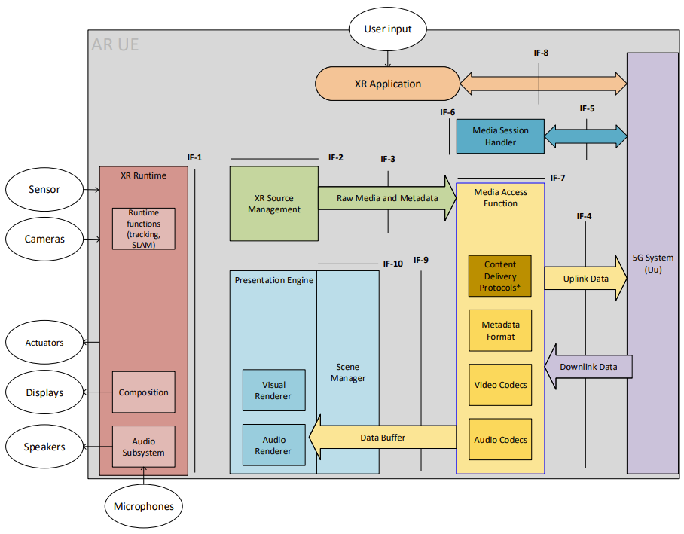
Figure 15 – AR UE device architecture
The AR UE is regular 5G UE with 5G connectivity provided through an embedded 5G modem and 5G system components. The AR UE also features several sensors and user controllers relevant for AR experiences that are cameras, microphones, speakers, display and generic user input. The AR/MR Application is responsible for orchestrating the various device resources to offer the AR experience to the user. In particular, the AR/MR Application can leverage the main internal components on the device which are:
- The Media Access Functions (MAF)
- The XR Runtime
- The Presentation Engine
- The Scene Manager together with the Presentation Engine that includes functions such as scene composition and possible complex audio or visual rendering
- The XR Source Management address the management or sources provided through the XR Runtime such as microphones, cameras, trackers, etc. The XR Source Management may expose information to the application or may provide a subset to the media access function to be sent remote.

The AR/MR Application can communicate with those three components via dedicated APIs. Exposed in are:
- the XR Runtime API which provides access to the core functionalities of an XR device.
- the MAF-API, which is essential to allow the application to make use of dedicated media functions available on the XR device

In addition, it is expected that an application can communicate with the Scene Manager and the Presentation Engine to establish the presented scene. It can also communicate with the XR Source Management in order to coordinate which data is made available for uplink streaming.
Among other functionalities, those APIs also enables the AR/MR Application to discover and query the media capabilities in terms of support as well as available resources at runtime.

Regarding rendering, it is expected that the XR Scene Manager has access to the latest pose and tracking information from the XR Runtime which is then provided. Based on this information, the Scene Manager may for example determine the objects visible to the user at a given point in time or more generally the objects that may be needed to be rendered in the next rendering cycles. The Scene Manager is responsible together with the Presentation Engine to submit the rendered views to the XR Runtime as frames written to the images of the Swapchains. Swapchains are established during the configuration phase of the XR Session using the information provided by the XR Runtime API. From those images in the Swapchains, the XR Runtime then generates the left and right eye buffers possibly based on late adjustment techniques using updated head pose information, if available, commonly known as late stage reprojection (LSR).

Once the XR application is running, the downlink media flows from the 5G System to the MAF in compressed form and then from the MAF to the Scene Manager in the form of primitive buffers. Note that for real-time media, the primitive buffers are provided with a rendering time and an associated pose. The Scene Manager may be guided by a static or dynamically updated scene description.
In parallel, the AR UE is capable of establishing an uplink data flow from the XR Runtime to the MAF wherein the data may be in an uncompressed form and then from the MAF to the 5G System wherein the MAF may have compressed the data in order to facilitate the expected transmission over the network.
A typical call flow for establishing an XR Presentation is as follows:
- The AR/MR Application is launched
- The AR/MR application launches and XR Session in the runtime
- The AR/MR application communicates with the scene manager to provide a scene description either through an application interface or through a well-defined scene description document, possibly retrieved over the network
- Based on the scene requirements, the capabilities of the XR Runtime, as well as the capabilities of the media access function, a set of media pipelines in the uplink and downlink are established.
- The media access function accesses the network resources or sends data to the network using the established media pipelines.
- The XR Runtime captures and renders the relevant data to match the device capabilities and the user interaction.

4.3.2 Visual capabilities

4.3.2.1 Video decoding
The AR UE shall support video decoding AVC-FullHD-Dec as defined in clause 6.6.1.
The AR UE should support video decoding HEVC-FullHD-Dec as defined in clause 6.6.1.

4.3.2.2 Video decoding interface
The AR UE shall support the video decoding interface AVC-HEVC-2-Dec defined in clause 6.6.3.

4.3.2.3 Video encoding
The AR UE shall support video decoding AVC-FullHD-Enc as defined in clause 6.6.2.
The AR UE should support video decoding HEVC-FullHD-Enc as defined in clause 6.6.2.

4.4 eXtended Reality User Equipment (XR UE)

4.4.1 Device architecture
The XR UE would typically be running the application on a phone form factor without any specific peripheries. The basic principles of the UE as described in clause 4.2.2 as well as the extensions in 4.3.2 remain. The additional capabilities may be expressed initially as optional extensions to the minimum capabilities in clause 4.2.2.
However, such extensions then would need to be done by identifying and adding the relevant capability checks.
Figure 15 provides the technical architecture of the XR UE.
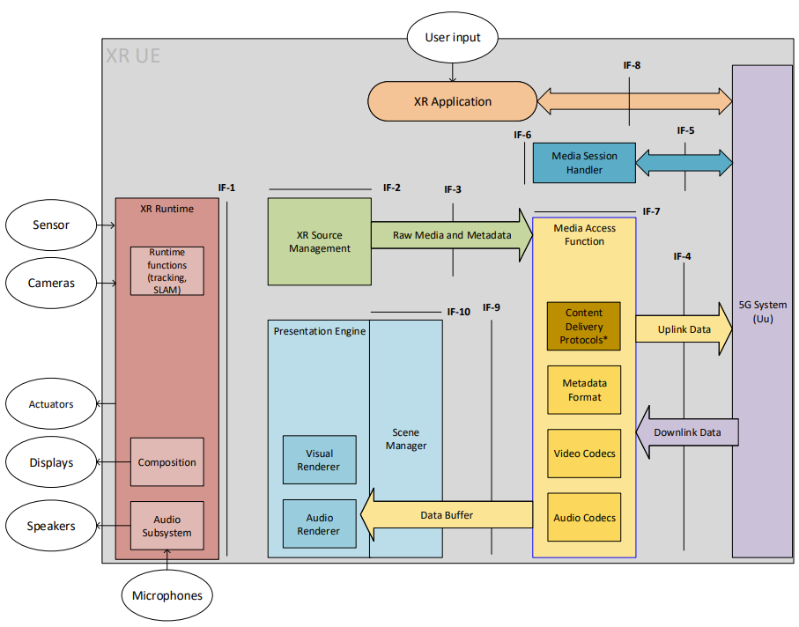
Figure 16 – XR UE device architecture
The same principles as in clause 4.3.1 apply.
The capabilities shall be aligned with high-end smartphone and is aligned with the capabilities defined in TS 26.511.

4.3.2 Visual capabilities

4.3.2.1 Video decoding
The video decoding capabilities shall be aligned with TS 26.511 and the following shall be supported:
- HEVC-UHD-Dec as defined in clause 4.2.2.1 of TS 26.511
The video decoding capabilities shall be aligned with TS 26.511 and the following should be supported:
- HEVC-8k-Dec as defined in clause 4.2.2.1 of TS 26.511

4.3.2.2 Video decoding interface
The XR UE shall support the video decoding interface AVC-HEVC-4-Dec defined in clause 6.6.3.

4.3.2.3 Video encoding
The XR UE shall support video encoding HEVC-4k-Enc as defined in TS 26.511.

4.3.2.4 Visual Rendering
tbd

5 Interoperability points and metrics

5.1 Interoperability Points for Visual and Audio
Figure 17 provides multiple interoperability points and interfaces that may or may not be relevant for the MeCAR specification.
Figure 17 – Interoperability points and Interfaces of interest for TS 26.119
Note that the interfaces align with operation points in TS 26.118.
Discussion for each interface is provided in the following in terms of functionalities as well relevancy for the specification in Table 6.
Table 6 – Interfaces of relevance
IF | Name | Summary of functionalities | Specification (normative, reference)
1 | XR Runtime API | The functionalities of the API include what is documented in clause 4.2.2 predominantly, namely  - Creation of a XR Session  - Providing controller and pose information to support immersive and 6DoF based rendering.  - Visual composition through swap chains including associated timing and predicted pose information and adapted to the latest pose and the output peripheries.  - Audio composition to through buffers including associated timing and predicted pose information and adapted to the pose and the output peripheries.  - Synchronization of audio-visual output  - Collection of audio and video sources provided to the XR source management.  - Query of optional processing and rendering capabilities, for example projection formats  Uncompressed data formats | The specification will assume that an XR Session is established and that the device provides access to the device peripheries and XR capabilities using an XR Runtime API.  - During the development of MeCAR work, OpenXR will be used, where applicable, as a reference instantiation of the API for the XR runtime.  It is assumed that an equivalent functionality of all mandatory functionalities of OpenXR are available through a run-time.  For Visual rendering, it is assumed that at least all functionalities of OpenGL ES are available.  For Audio rendering, it is assumed that at least all functionalities of OpenSL ES and TS 26.118 are available.  This API is similar and an extension to the combination of the VR-API and the 3GPP VR Viewport test point in TS 26.118. See Figure XX, the blue interface.
2 | XR Source media and metadata formats | The functionalities of this API include the configuration on how to access the data from the XR run-time and pre-process in order to serialize the data for delivery and assign the sampling and action tiem of the data. | The configuration is conceptually relevant in order to select the sources of the device to deliver upstream and to define an appropriate format for the metadata, using typical XR Runtime API semantics.  However, the detailed API is not specified in TS26.119.
3 | Scene Information and buffers formats | Uncompressed buffer format  The functionalities of this interface include to collect information from the XR Runtime that then may be serialized, time-stamped, and compressed, including:  - Viewer pose and projection parameters needed to render using the xrLocateViews function to render each view for use in a composition projection layer.  - Camera output  - Microphone output  Other sensor and haptics data | For XR metadata to be possibly delivered over a network interface, the raw formats including information on timing needs to be defined in order to permit serialization of the data in metadata delivery. Information includes viewer pose, triggers and actions, etc.  For this specification the following needs to be defined:  Input [compressor] binary [decompressor] output  - The input is sampled from the XR runtime API. After compression and decompression, the output needs to be represented as if it would be provided from the XR runtime.  - Compressor and binary formats are defined in MAF.  Input/output formats need to be determined and are conceptually assigned to this function
4 | MAF-API | These are the core network interfaces to support media delivery in the downlink and uplink.  The functionality includes:  - Scene Description delivery and updates  - Audio and video formats for parallel decoding of multiple buffers  - Audio and video encoding for multiple buffers  - Coding and delivery of pose information  - Metadata delivery  - 5GMS based Content Delivery protocol based on DASH/CMAF  - RTP-based delivery  - Encryption and security  Rate control | Core of the specification for TS 26.119  This API is equivalent to the 3GPP VR OP as defined in TS 26.118.  The DASH API is not defined as the entry point is the Scene Description.
5 | MeCAR media formats | This API and function allows to support integration into the 5G System to support 5G Network functionalities such as session establishment, QoS, QoE reporting, discovery and establishment of edge capabilities, etc. | This aspect is outside of MeCAR, but is included in 3GPP system specs that adds MeCAR capabilities to the system.  Example for such systems are IMS, 5G Media Streaming, etc.
6 | Internal Interprocess communication | The application may have access to control the runtime and the sources in order to configure the work flow | This is outside of the scope of the specification
7 | Application network communication | A functionality to configure and control the media access and delivery by the scene manager, the XR source manager and/or the application in order to set up media delivery pipelines. The API is rich enough to support configuration of  - Downlink access for media  - Downlink access of scene description  - Uplink delivery for media  - Uplink delivery for metadata  The information may include for example dynamic information such as updated pose information, etc. | A reference API should be specified for the MAF in order to configure the pipelines. While this API may not be mandatory, it is a reference to support the functionalities of media pipelines.  This part is included in the VR-API as defined in TS 26.118.
8 | Application network communication | The application may connect to the network to identify entry points or deal with XR Runtime specific data. | Basic entry point assumptions may be documented, but do not have to be specified in TS26.119.
9 | Scene Information and buffers formats | Uncompressed buffer format  The functionality of this interface is to define a set of primitive buffers for different media types that can be rendered by the Visual and Audio renderer. In combination with the Scene description, the information can be used to render 3D and immersive scenes by the Scene manager and the presentation engine.  The combination of the scene description information, possibly generated from the application or in a scene description delivery document, as well as the primitive buffers provide sufficient information to the presentation engine in order create an immersive audio-visual experience | A reference scene description format based on glTF2.0 as a reference.  The scene description is specified as one way to support it, but equivalent application functions may be defined. A proper subset of glTF2.0 with possible extensions need to be defined.  This information is similar to what was defined as VR Scheme in the context of TS 26.118
10 | Scene Manager API | This interface allows to configure the scene manager | The configuration is conceptually relevant in order to establish the rendering pipelines.  However, the detailed API is not specified in TS26.119.

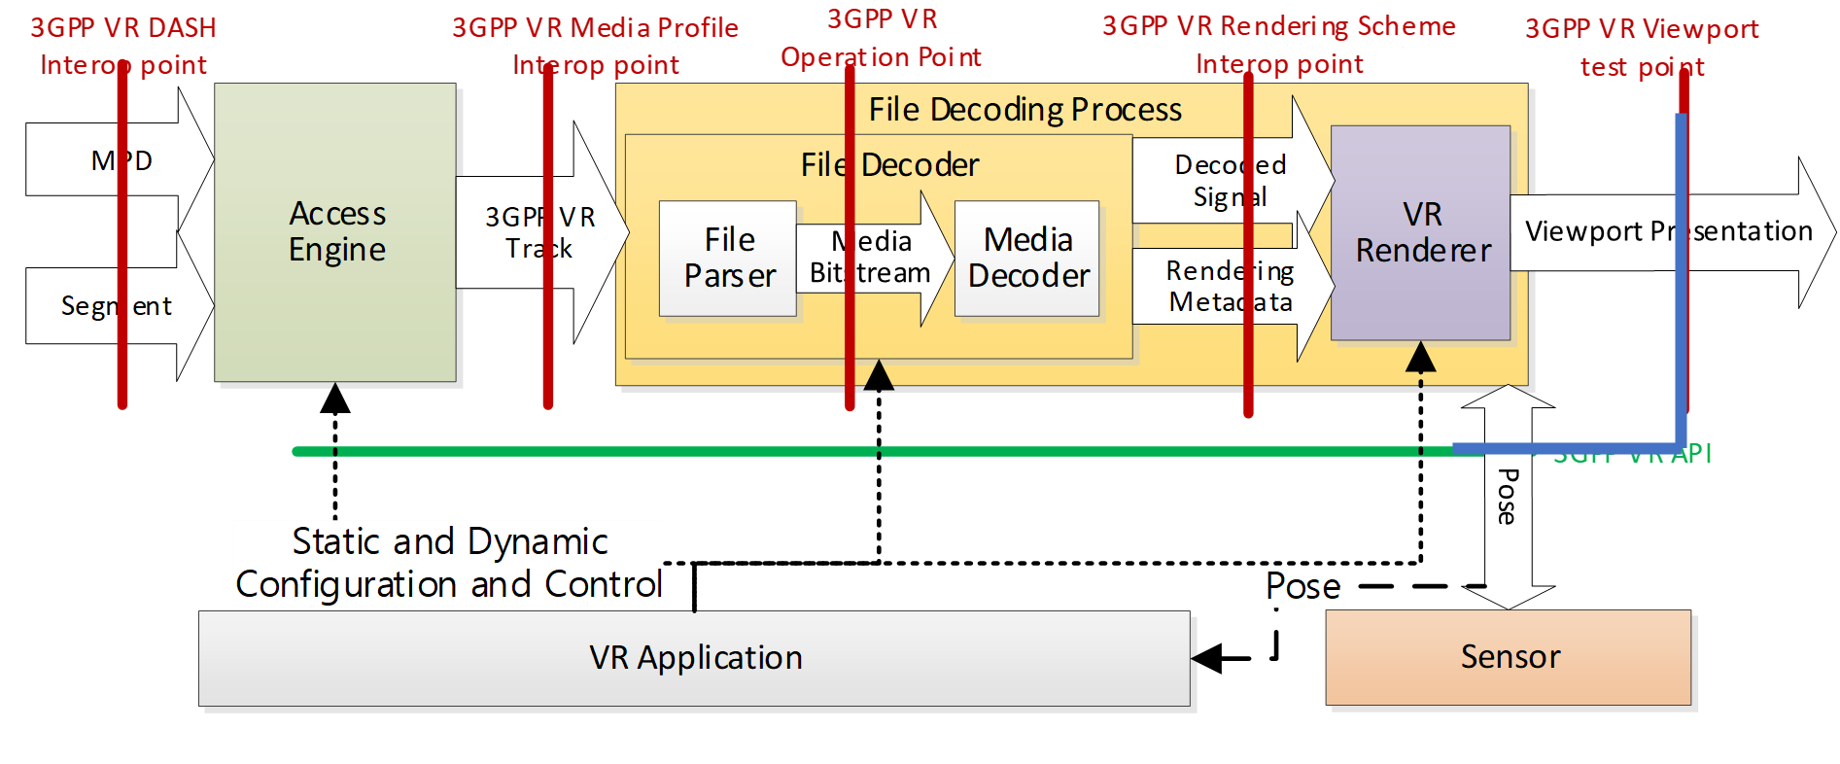

5.2 Metrics Observation Points and KPIs

5.2.1 Metrics Observation Points
In a similar fashion as for operation points and interface, metrics observation points may be defined to specify basic metrics as shown in Figure 17.
Editor’s Note: the above diagram is expected to be further updated and refined based on the agreements of the XR baseline client.
Figure 18 – Metrics Observation Points of interest for TS 26.119
In the following potential KPIs as documented in TR 26.998, clause 4.5.2 are summarized. Specifically, the latencies as introduced in TR 26.998 are rediscussed in the context of the MeCAR work item.

5.2.2 Relevant KPIs for XR and AR according to TR 26.998
In TR 26.928, some high-level statements on experience KPIs for AR are provided. To achieve Presence in Extended and Augmented Reality, seamless integration of virtual content and physical environment is required. Like in VR, the virtual content has to align with user's expectations. For truly immersive AR and in particular MR, it is expected that users cannot discern virtual objects from real objects.
Also relevant for VR and AR, but in particular AR, is not only the awareness for the user for the environment. This includes, safe zone discovery, dynamic obstacle warning, geometric and semantic environment parsing, environmental lighting and world mapping.
Table 5.2.2-1 provides the KPIs from TR 26.998, Table 4.5.2-1 with focus on AR and in particular glasses. For some background and additional details refer for example to [10], [11], [49], [50], and [51].
[10] Daniel Wagner, Louahab Noui, Adrian Stannard, "Why is making good AR displays so hard?", LinkedIn Blog, August 7, 2019, https://www.linkedin.com/pulse/why-making-good-ar-displays-so-hard-daniel-wagner/
[11] Daniel Wagner, "MOTION TO PHOTON LATENCY IN MOBILE AR AND VR", Medium Blog, August 20, 2018, https://medium.com/@DAQRI/motion-to-photon-latency-in-mobile-ar-and-vr-99f82c480926
[49] Oscar Falmer: “AR Headsets Landscape”, 10th September 2021, https://docs.google.com/spreadsheets/d/1aUO8nuXWCnL1xYnpe9tvSgCphifhMRLrFj1enayv0X8/edit#gid=0
[50] Oscar Falmer: “Mobile AR Features Landscape”, 20th September 2021, https://docs.google.com/spreadsheets/d/1S1qEyDRCqH_UkcSS4xVQLgcMSEpIu_mPtfHjsN02GNw/edit#gid=0
[51] Microsoft, Coordinate Systems, https://docs.microsoft.com/en-us/windows/mixed-reality/design/coordinate-systems
Table 4.5.2-1 AR KPIs from TR 26.998 with relevance for MeCAR
Feature | KPIs for AR glasses | Relevance for MeCAR
Tracking
Freedom Tracking | 6DoF | It is a device feature and an assumption/requirement for the device, but not a metric to be computed.
Translational Tracking Accuracy | Sub-centimeter accuracy - tracking accuracy of less than a centimeter | It is a device feature and an assumption/requirement for the device, but not a metric to be computed.
Rotational Tracking Accuracy | Quarter-degree-accurate rotation tracking is desired | It is a device feature and an assumption/requirement for the device, but not a metric to be computed.
AR tracking space | In AR, the tracking space is theoretically unlimited. However, when moving, tracking accuracy may not be assured beyond a certain level of space or trajectory distance. SLAM based methods quickly introduce a large drift in large scale mapping. To correct the scaling issues, a loop closure technique [12] needs to be applied in order to continuously harmonize the local coordinate systems with global ones. | It is a device feature and an assumption/requirement for the device, but not a metric to be computed.
World-scale experience | World-scale experiences that let users wander beyond  - orientation-only or seated-scale experiences  - standing-scale or room-scale experiences  To build a world-scale experience, techniques beyond those used for room-scale experiences, namely creating an absolute room-scale coordinate system that is continuously registered with the world coordinate system, typically requiring dynamic sensor-driven understanding of the world, continuously adjusting its knowledge over time of the user's surroundings. | It is a device feature and an assumption/requirement for the device, but not a metric to be computed.
Tracking frequency | At least 1000 Hz | It is a device feature and an assumption/requirement for the device, but not a metric to be computed.
Latency (for more details refer to clause 4.5.3)
motion-to-photon latency | Less than 20 ms, and preferably even sub 10ms for AR as you may observe movement against the real world. | This latency is run-time internal.  It is a device feature and an assumption/requirement for the device, but not a metric to be computed.
pose-to-render-to-photon latency | 50-60ms for render to photon is desired in order to avoid wrongly rendered content with late warping applied. | This is a relevant metric and measuring this should be in scope of MeCAR.  For details refer to clause 5.2.3.
Video Rendering and Display
Persistence – Duty time | Turn pixels on and off every 2 - 4 ms to avoid smearing / motion blur | It is a device feature and an assumption/requirement for the device, but not a metric to be computed.
Display refresh rate | 60 Hz minimum  90 Hz acceptable  120 Hz and beyond desired  240 Hz would allow always on display at 4ms | It is a device feature and an assumption/requirement for the device, but not a metric to be computed.
Colour | RGB colours  Accurate colours independent of viewpoint. | It is a device feature and an assumption/requirement for the device, but not a metric to be computed.
Spatial Resolution per eye | for 30 x 20 degrees  - 1.5K by 1K per eye is required  - 1.8K by 1.2K per eye is desired  for 40 x 40 degrees  - 2K by 2K required  - 2.5 K by 2.5 K desired  ultimate goal for display resolution is reaching or going slightly beyond the human vision limit of roughly one arcmin (1/60°) | It is a device feature and an assumption/requirement for the device, but not a metric to be computed.  However, the resolution of the content is relevant and is a metric that should be computed.
Content frame rates | Preferably matching the display refresh rate for lowest latency  Lower frame rates for example 60 fps or 90 fps may be used but add to overall end to end delay. | This is a feature that can be handled together with latency. For more details refer to clause 5.2.3.
Brightness | 200-500 nits for indoor  Up to 2K for state-of-the-art devices in 2021 [49]  10K to 100K nits for full outdoor experiences | It is a device feature and an assumption/requirement for the device, but not a metric to be computed.
Optics
Field of View | Augmentable FoV  - typically, 30 by 20 degrees FoV acceptable  - 40 by 40 degrees desired  maximize the non-obscured field of view | It is a device feature and an assumption/requirement for the device, but not a metric to be computed.
Eye Relief | the minimum and maximum eye-lens distance wherein a comfortable image can be viewed through the lenses.  at least 10mm, ideally rather 20mm | It is a device feature and an assumption/requirement for the device, but not a metric to be computed.
Calibration | correction for distortion and chromatic aberration that exactly matches the lens characteristics | It is a device feature and an assumption/requirement for the device, but not a metric to be computed.
Depth Perception | Avoid vergence and accommodation conflict (VAC) for accommodation being different for the real and virtual object | It is a device feature and an assumption/requirement for the device, but not a metric to be computed.  However, it relates also to the content and may be checked for metrics.
Physics
Maximum Available Power | AR Glass: below 1 W, typically 500mW  For less design-oriented devices, additional power may be available. | It is a device feature and an assumption/requirement for the device, but not a metric to be computed.
Maximum Weight | AR Glass: around 70g. However, if the weight is well distributed, several hundred grams may be acceptable. | It is a device feature and an assumption/requirement for the device, but not a metric to be computed.
Audio Related metrics
Tbd | Tbd | tbd

5.2.3 Typical Latencies in networked AR Services and their Measurements
Building on top of the architectures introduced in TR 26.998, in this document as well as the latency considerations in TR 26.928, Figure 4.5.3-1 provides a summary of different latencies involved networked AR services. Based on TR 26.928 as well as Table 5.2.3-1, two relevant latency requirements for adequate user experience matter:
- motion-to-photon latency being less 20ms, but preferably even single digit latency below 10ms.
- pose-to-render-to-photon latency: as small as 50-60ms
It is important to note that the motion-to-photon latency is primarily a function of the device implementation as it is basically covered within the AR runtime. What matters and is relevant is the time used to provide the pose information from the AR runtime to the renderer and the renderer using this pose to generate the displayed media. Final pose correction to the latest pose may always be done in the AR runtime.
Figure 5.2.3-1 (based on Figure 4.5.3-1 from TR 26.998) provides different latency critical uplink and downlink operations, depending on where the rendering is done, locally, in the edge or in the cloud. If done in the edge or cloud, rendered data needs to be delivered in low-latency and high-quality over the network. The typical operations in this case include:
- pose detection in the UE
- sending the pose through a 5G uplink network to the edge of cloud.
- rendering the scene in the edge or cloud
- compressing and encrypting the rendered scene and delivering to the UE
- decrypting and decompressing the rendered scene
- composition of the scene
- applying the latest pose in the pose correction and display the immersive media.
Note that Figure 5.2.3-1 also adds buffers that are typically handled by the AR Run time, namely eye and depth as well as sound buffers.
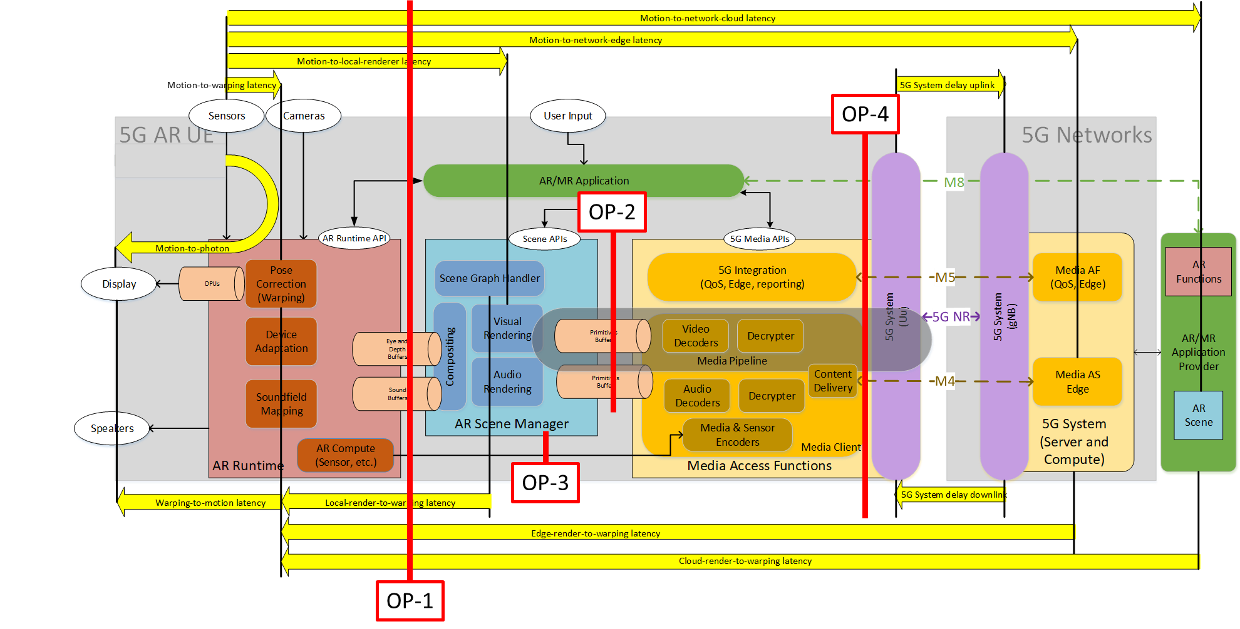
Figure 5.2.3-1: Typical Latencies in networked AR services with OPs
It is ultimately relevant that in case of networking the rendering loop, the processes in the loop are executed such that the end-to-end latency requirements for the pose-to-render-to-photon latency are ensured. Clearly the “closer” the rendering happens at the AR UE, the easier it is to meet latency requirements. However, with proper support of 5G system and media functionalities, these networked AR challenges are solved. This is subject of the remaining discussion of this report.
With reference to TR 26.928 , other types of latencies impact the user experience, for example when used for cloud gaming, interactive scenes or in case of real-time network-based processing of sensor data. These aspects are not specific to AR but are also relevant.
Figure 5.2.3-1 also adds the OPs.
Editor’s Note: the above diagram is expected to be further updated and refined based on the agreements of the XR baseline client.
Based on the OPs, a subset of the latencies can be measured.
In order to collect the information related to latencies, the rendering loop of an XR Runtime needs to be understood.
Once a session is running and is in focused state, the rendering loop as shown in Figure 19 can be used:
1) Before an application can begin writing to a swapchain image, it first waits on the image to avoid writing to it before the Compositor has finished reading from it. Then an XR application synchronizes its rendering loop to the runtime. In the common case that an XR application has pipelined frame submissions, the application is expected to compute the appropriate target display time using both the predicted display time and predicted display interval.
2) Once the wait time completes, the application initiates the rendering process. In order to support the application in rendering different views the XR Runtime provides access to the viewer pose and projection parameters that are needed to render the different views. The view and projection info is provided for a particular display time within a specified XR space. Typically, the target/predicted display time for a given frame.
3) the application then performs its rendering work. Rendering work may be very simple, for example just directly copying data from the application into the swap chain or may be complex, for example iterating over the scene graph nodes and rendering complex objects. Once all views/layers are rendered, the application sends them to the XR Runtime for final compositing including the expected display time as well as the associated render pose.
4) The XR application offloads the composition of the final image to an XR Runtime-supplied compositor. After the compositor has blended and flattened all layers, it then presents this image to the system’s display at a specific display time.
Core aspect in metrics computation are:
- The time difference when the view and projection info is sampled from the run time and the time when the corresponding rendered information is provided to the run time for display with the associated render pose.
- The difference of the associated render pose and the actual pose at the time when the data is rendered.
Figure 19 - Rendering loop for visual data
Detailed algorithms are ffs.

6 Media capabilities

6.1 Categories of media capabilities
Media capabilities may be defined for those categories:
- Audio
  - Capture
  - Playback
  - Codec
  - Formats
  - Framework (multiple codecs, etc.)
- Camera
  - RGB
  - Depth
- Display
  - Processing
  - Number of Displays
  - Bit depth
  - Color format
- GPU
  - Functionalities/APIs
  - Performance
- Security
  - Content Protection
  - Cryptography
  - Key Management
- Non-media sensors
  - Types: Accelerometer, Magnetometer, Gyroscope, ambient light
  - Access for example through OpenXR APIs
- Video
  - Playback/Decoding
  - Processing
  - Recording/Encoding
  - Formats (bit depth, color components, chroma subsampling, etc.)
  - Framework (multiple codecs, etc.)
- Runtime
  - APIs
  - Performance

6.2 Examples of media capabilities

6.2.1 Examples of media capabilities based media capabilities categorisation
Given the categories listed in clause 3.1, the following are examples of media capabilities for those categories:
- Video
  - Playback/Decoding
    - H.264 High, Main and Baseline profile
    - H.265 Main and Main 10 Profile
    - Maximum processing: Up to 8,294,400 Macroblocks per second (corresponding to 8192x4320 @ 60fps)
    - HEIF
  - Processing
  - Recording/Encoding
    - H.264 High, Main and Baseline profile
    - H.265 Main and Main 10 Profile
    - Maximum processing: Up to 3,888,000 Macroblocks per second (corresponding to 3840x2160 @ 120fps)
    - Low-latency encoding
    - Error-robustness, slicing, intra refresh, long term prediction
  - Formats
    - 8-Bit: NV12, UBWC, YV12, RGBA888
    - 10-Bit: UBWC TP10, P010
  - Framework (multiple codecs, etc.)
    - Maximum number of combined encoding and decoding instances: 16
- GPU
  - Functionalities
    - tbd
  - Performance
    - Examples
      - 3D Triangle Rate
      - 3D Pixel Draw Rate
      - Texture Fetch Rate
      - Z reject rate (pixels/sec)
    - The issue is that GPU capabilities are more defined through benchmarks. A way to address is to define a set of test signals that a GPU needs to be able to handle in real-time.
- Audio
  - Capture
  - Playback
  - Codec
  - Formats
  - Framework (multiple codecs, spatial audio support etc.)
    - Low-Latency: input, output, roundtrip
    - Game Audio Playback up to 8/16/32 simultaneous streams

6.2.2 Examples of media capabilities based on existing specifications
In the next chapter, different video profiles are listed which may be considered as relevant for consideration in MeCAR. These candidates do not reflect the final recommendations which MeCAR will produce. Additionally the lists may be refined and updated as the work in MeCAR progresses.

6.2.2.1 Possible 2D video profiles candidates
2D video encoding and decoding capabilities have of course to be considered. First, a basic scenario for AR is the virtual TV-set, where a 2D video stream is displayed as an overlay to the real world (for instance on the wall of the living room). Then, 2D video encoding/decoding capabilities may be used to display 3D objects on AR glasses, using the stereoscopic effect, by feeding the two eyes buffers of the AR glasses with the appropriate 2D videos.
It is referred here to video capabilities which have been referenced in clause 4.2 of TS 26.511 (“5G Media Streaming, Profiles, Codecs and Formats”) [5]. No video profiles published in TS 26.118 (“Virtual Reality (VR) profiles for streaming applications”) [6] are here listed. They indeed refer to a 360° immersive context, which may not be relevant for the optical see-through device types.

Lastly, the here listed candidates do not preclude of the result of the work which shall be carried on within MeCAR. Especially, if both encoding and decoding profiles are listed as they are referenced in clause 4.2 of TS 26.511 [5], requirements for encoding and decoding capabilities may differ.

6.2.2.1.1 AVC

6.2.2.1.1.1 Decoding
TS 26.511 [5] has defined the following decoding capabilities for H.264 (AVC4) in its clause 4.2.1.1:
- AVC-HD-Dec: the capability to decode H.264 (AVC) Progressive High Profile Level 3.1 [2] bitstreams, for which the maximum VCL Bit Rate is constrained to be 14 Mbps with cpbBrVclFactor and cpbBrNalFactor being fixed to be 1,000 and 1,200, respectively.
- AVC-FullHD-Dec: the capability to decode H.264 (AVC) Progressive High Profile Level 4.0 [2] bitstreams.
- AVC-UHD-Dec: the capability to decode H.264/AVC Progressive High Profile Level 5.1 [2] bitstreams for H.264/AVC with the following additional restrictions and requirements:
- the maximum VCL Bit Rate is constrained to be 120 Mbps with cpbBrVclFactor and cpbBrNalFactor being fixed to be 1250 and 1500, respectively.
- the bitstream does not contain more than 10 slices per picture.
NOTE: High Profile for H.264/AVC excludes Flexible macro-block order, Arbitrary slice ordering, Redundant slices, Data partition.

6.2.2.1.1.2 Encoding
The corresponding encoding capabilities (in the sense that their bitstream are decodable by the decoder with the same name) have been defined:
- AVC-HD-Enc:
- up to 108,000 macroblocks per second;
- up to a frame size of 3,600 macroblocks;
- up to 120 frames per second;
- the chroma format being 4:2:0; and
- the bit depth being 8 bits;
- AVC-FullHD-Enc:
- up to 245,760 macroblocks per second;
- up to a frame size of 8,192 macroblocks;
- up to 240 frames per second;
- the chroma format being 4:2:0; and
- the bit depth being 8 bits;
- AVC-UHD-Enc:
- up to 983,040 macroblocks per second;
- up to a frame size of 36,864 macroblocks;
- up to 480 frames per second;
- the chroma format being 4:2:0; and
- the bit depth being 8 bits.

6.2.2.1.2 HEVC

6.2.2.1.2.1 Decoding
TS26.511 [5] has defined the following decoding capabilities for H.265 (HEVC) in its clause 4.2.2.1:
- HEVC-HD-Dec: the capability to decode H.265 (HEVC) Main Profile, Main Tier, Level 3.1[3] bitstreams that have general_progressive_source_flag equal to 1, general interlaced_source_flag equal to 0, general_non_packed_constraint_flag equal to 1, and general_frame_only_constraint_flag equal to 1.
- HEVC-FullHD-Dec: the capability to decode H.265 (HEVC) Main10 Profile, Main Tier, Level 4.1[3] bitstreams that have general_progressive_source_flag equal to 1, general interlaced_source_flag equal to 0, general_non_packed_constraint_flag equal to 1, and general_frame_only_constraint_flag equal to 1.
- HEVC-UHD-Dec: the capability to decode H.265 (HEVC) Main10 Profile, Main Tier, Level 5.1[3] bitstreams that have general_progressive_source_flag equal to 1, general interlaced_source_flag equal to 0, general_non_packed_constraint_flag equal to 1, and general_frame_only_constraint_flag equal to 1.
- HEVC-8K-Dec: the capability to decode H.265 (HEVC) Main10 Profile, Main Tier, Level 6.1[3] bitstreams that have general_progressive_source_flag equal to 1, general interlaced_source_flag equal to 0, general_non_packed_constraint_flag equal to 1, and general_frame_only_constraint_flag equal to 1 with the following further limitations:
- the bitstream does not exceed the maximum luma picture size in samples of 33,554,432,
- the maximum VCL Bit Rate is constrained to be 80 Mbps with CpbVclFactor and CpbNalFactor being fixed to be 1000 and 1100, respectively.
Note that HEVC_8K-Dec is mentioned as a reminder of TS 26.511 references. It may not be relevant in the context of AR glasses. As said in introduction to this chapter, this discussion is left for further study.

6.2.2.1.2.2 Encoding
The corresponding encoding capabilities (in the sense that their bitstream are decodable by the decoder with the same name) have been defined:
- HEVC-HD-Enc:
- up to 33,177,600 luma samples per second;
- up to a luma picture size of 983,040 samples;
- up to 120 frames per second;
- the Chroma format being 4:2:0; and
- the bit depth being 8 bits;
- HEVC-FullHD-Enc:
- up to 133,693,440 luma samples per second;
- up to a luma picture size of 2,228,224 samples;
- up to 240 frames per second;
- the Chroma format being 4:2:0; and
- the bit depth being either 8 or 10 bits;
- HEVC-UHD-Enc:
- up to 534,773,760 luma samples per second;
- up to a luma picture size of 8,912,896 samples;
- up to 480 frames per second;
- the Chroma format being 4:2:0; and
- the bit depth being either 8 or 10 bits.

6.3 Display capability

6.3.1 General
The capability of a display for AR glasses may be characterised by its ability to reproduce colour and the ability to change its opacity comprised in to a given opacity range.
The followings are the relevant information to describe the capability of such display.
- display
  - Reference colour space (For example, https://registry.khronos.org/OpenXR/specs/1.0/html/xrspec.html#XR_FB_color_space)
  - Perceptible colours (For example, https://registry.khronos.org/OpenXR/specs/1.0/html/xrspec.html#XR_KHR_composition_layer_color_scale_bias)
  - Coordinate of primary colours in the reference colour space (For example, https://registry.khronos.org/OpenXR/specs/1.0/html/xrspec.html#XR_FB_color_space)
  - Colour map (For example, https://registry.khronos.org/OpenXR/specs/1.0/html/xrspec.html#XrPassthroughColorMapMonoToRgbaFB)
  - Opacity range (For example, https://registry.khronos.org/OpenXR/specs/1.0/html/xrspec.html#XrPassthroughStyleFB)
- sensor
  - Ambient light intensity (For example, https://www.w3.org/TR/ambient-light)
  - Ambient light intensity range
NOTE: The ambient light parameters from W3C have been primarily defined for regular displays. It is still to be checked if they are applicable to AR glasses.
The reference colour space is the colour space in which the display is compatible.
The perceptible colours is a list of the colours perceptible or reproducible. Primary colours such as R, G, B and their coordinates in the reference colour space are listed. The display may provide the colour space coordinate according to dedicated reference condition, or according to measured ambient light.
The colour map is the array of colours that remapped by the device. It is a list of colours and their target RGBA values in the reference colour space. The application may provide the colours map according to dedicated display capability of a device.
The opacity range is the range of supported opaque/transparency level of the display. From fully opaque as 1.0 to fully transparent as 0.0, the display may provide its capability on blocking light rays from outside.
The ambient light intensity is the intensity of the ambient light measured at a given point in time.
The ambient light intensity range is the minimum and maximum level of light in the unit of lux that the sensor can measure and provide.

6.3.2 Examples of display capabilities and possible impact on media capabilities
TR 26.998 [1] in clause 4.5.2 has gathered a collection of features and KPIs focusing on AR glasses. These features detail, among others, display capabilities which are listed as KPIs, as a capability level in order to provide the required user experience of a good sense of presence in immersive scenes. The display capabilities and their associated KPIs, as defined in clause 4.5.2 of TR 26.998 [1], are listed in the first and second columns of Table 7.

The third column details which category of media capabilities among the list given in the clause 5.1 of the permanent document may be impacted by each the display capability. This last column may be further updated with additional categories and the listed categories may be further expanded by detailing for each of them which individual media capabilities are concerned.

Table 7 is intended to be used as a helping and guidance tool through the selection of media capabilities.

Table 7 – Examples of display capabilities and impact on media capabilities
Display capability | KPIs for AR glasses  (Table 4.5.2-1 from TR 26.998 [1], clause 5.4.2) | Possibly impacted Category of Media Capability (as listed in clause 5.1)
Persistence – Duty time | Turn pixels on and off every 2 - 4 ms to avoid smearing / motion blur | - Display  - Processing  - GPU  - Performance (refresh rate)
Display refresh rate | - 60 Hz minimum  - 90 Hz acceptable  - 120 Hz and beyond desired  - 240 Hz would allow always on display at 4ms | - Video  - Playback/Decoding (codecs profile)  - Framework (multiple codecs, etc.)  - GPU  - Performance (refresh rate)
Colour | - RGB colours  - Accurate colours independent of viewpoint. | - Display  - Bit depth  - Color format  - Video  - Formats (bit depth, color components)
Spatial Resolution Per Eye | For 30 x 20 degrees:  - 1.5K by 1K per eye is required  - 1.8K by 1.2K per eye is desired  For 40 x 40 degrees:  - 2K by 2K required  - 2.5 K by 2.5 K desired  Ultimate goal for display resolution is reaching or going slightly beyond the human vision limit of roughly one arcmin (1/60°) | - Display  - Number of Displays (at least two, one per eye)  - Video  - Playback/Decoding (codec profile)  - Formats (Image resolution)
Brightness | - 200-500 nits for indoor  - Up to 2K for state-of-the-art devices in 2021 [49]  - 10K to 100K nits for full outdoor experiences | - Video  - Formats (high dynamic range)
Field of View | Augmentable FoV  - typically, 30 by 20 degrees FoV acceptable  - 40 by 40 degrees desired maximize the non-obscured field-of-view | - Display  - Number of Displays (at least two, one per eye)  - Video  - Playback/Decoding (codecs profiles)  - Formats (image resolution)

In addition, commercial optical see-through devices are starting to emerge in the market. The Nreal Light AR glasses, which may be considered as one of the most advanced implementation of optical see-through AR glasses currently available in the market. As can be found in [8], the technical specifications of the Nreal Light AR glasses are:

- Persistence – Duty time
  - No data
- Display refresh rate
  - 60Hz
- Colour
  - RGB, 106% color gamut
  - Color depth 8 bits for 16.773 million colors
  - OLED display
- Spatial Resolution Per Eye
  - 52° FoV
  - 42 pixels per degree
  - 1920x1080 per eye
- Brightness
  - Up to 280 nits perceived brightness.
- Field of View
  - 52°

6.4 Media capability validation framework

6.4.1 Example framework by Khronos on 3D Commerce conformance (glTF viewer)

6.4.1.1 General
The Khronos group defines many specifications that rely on hardware capabilities and, in particular, its specifications are largely powered by Graphics Processing Units (GPU). As a result, the deployment of Khronos specification depends significantly on the ability for a vendor to evaluate whether its products meets the requirement of those specifications.
To this end, Khronos offers the Khronos 3D Commerce Viewer Certification Program which “enables any company to demonstrate that their viewer is capable of accurately displaying 3D Products that have been created using the 3D Commerce asset creation guidelines”.
The relevant part in the context of MeCAR is the certification process described in [2].

Figure 20 - Khronos' 3D commerce certification process

6.4.1.2 Relevant steps in the MeCAR context
From this certification process only a subset of those steps are relevant for us which are:
- Viewer Test Package
  - What does it contain? What are the file formats?
- Run Certifications Test
  - How are those test described? Are the test objective or subjective? On which criteria and/or metrics do they rely on?
- Generates Results packages
  - How are expressed, in format, the performance of a 3D viewer against the tests? Is the result binary, i.e. passed/not passed? Or a score on a given scale with a minimum threshold?

To answer, those questions more documentation is available at the Khronos Group 3DC Certification repository [3]. The following was found based on the available documentation.
- Viewer Test Package
  - The package contains a list of glTF models [4]:
    - AnalyticalCubes
    - AnalyticalGrayscale
    - AnalyticalSpheres
    - GreenChair
    - Mixer
    - Shoe
    - TennisRacquet
    - WickerChair
- Run Certifications Test
  - The test plan defines how the tested viewer must operate to render the test models:
    - “The Certification Program Test Plan document defines the detailed requirements for generating the certification images.”
  - Some test are verified by mathematical functions some by humans.
    - “Certification renders will be evaluated programmatically and through human checks”
    - Example of subjective test:
      - “Strings should appear translucent outside of the blue star area”
    - Example of objective test:
      - “When scored by the evaluation tool included in the repository an SSIM or PSNR lower than their respective thresholds will automatically flag the image for review.”
- Generates Results packages
  - To evaluate whether a glTF viewer is conformant, the tested renders must generate images from the glTF model and those images are programmatically verified against reference renders.
    - “All certification images must be 1024x1024 and displayed according to the embedded cameras. The five retail models have three cameras each. One of the analytical models (spheres) is displayed in four different IBLs. All certification images need to be created according to the rules specified in the Test Plan document.”
  - How are expressed, in format, the performance of a 3D viewer against the tests? Is the result binary, i.e. passed/not passed? Or a score on a given scale with a minimum threshold?

6.4.3.3 Takeaways from the certification process
Here are some takeaways from the certification test:
- A set of test models is essential for defining the test and the evaluation criteria.
- Objective tests are a minimum to pass but subjective tests via human verification are here to confirm for hard cases, e.g. transparency, reflection, etc.
- For objective tests, PSNR or SSIM is used to evaluated the rendered images from the test models.
- The tests are limited to static images and not rendering of the models over time.

6.4.2 Possible capability evaluation framework
In the context of MeCAR, the goal is not to certify a device but to define the media capabilities that are required at minimum for a given device category. The figure below depicts a possible workflow for implementing the evaluation of graphics capabilities in rendering glTF models and scenes.

Figure 21 - Possible framework for defining media and graphics capabilities
The first type of requirements is the playback of the test vectors. The test vectors are composed of a set of glTF tests models and scenes as well as pose traces. The MeCAR UE is supposed to render views of those glTF test models under the given poses coded in the test pose traces). The second type of requirements is whether the playback of the test vectors is correct. To this end, the generated views could be considered as a rendered videos (similar to the rendered image in the Khronos example). Such videos could be then checked against a reference video for the given test vector. The video validator could verify for the entire video:
- correct number of frames
- correct frame rate
- correct coded resolution of frames
- correct chroma sampling
- correct bit depth
- correct disparity between left and right views
- correct timing with respect to real-time rendering constraints

For each frame, the video validator could verify that each rendered image does not deviate too much from the reference image in the reference video. To validate the real-time nature of the rendering, the test run environment should also limit the time allowed to run the test scene.

6.4.3 Possible scope of media capability
In contrast to the Khronos example, the goal in MeCAR is not to establish a certification process. As a result, we would define the scope of the MeCAR graphics capability that does not fully cover the framework described in clause 3.1. The possible scope would cover he following elements:
- The glTF test models (possibly included media assets).
- The test pose traces associated with the glTF test models. The pose traces could be specific to each glTF test model.
- The test plan that defines the criteria to evaluate the rendered video (resolution, number of frames, etc…)
- Optionally, the generation of the reference rendered videos could be included to facilitate the reuse of this framework. However, since MeCAR may not define the reference scene render, providing these reference rendered video may actually go beyond MeCAR scope. This should be further discussed.

6.5 Minimum Media Capabilities
A MeCAR device can query the capabilities of the XR Runtime, the Scene Manager and the Presentation Engine for audio and visual media, and the MAF.
A MeCAR device at the minimum shall support:
- A set of XR Runtime functionalities
  - allowing to establish a XR Session
  - enabling 6DoF and AR video rendering based on swapchain APIs (as defined for example in OpenXR) with pose correction
  - enabling rendering of audio signals with pose correction
  - providing a 6DoF pose of the user to the application
- A subset of 2D video codecs to support display characteristics as defined in 6.4.1.2.1
- A subset of audio codecs (to be defined)
- Basic delivery formats
- A media playback entry point (e.g. a scene description)
- A security framework

A MeCAR device may in addition support:
- Additional functionalities of XR Runtime or other APIs beyond the minimum set supported
- 3D rendering capabilities that, for example, allow to render point clouds, meshes, depth, etc. present in the scenes
- Additional audio and video encoding and decoding capabilities
- Decoding of streaming formats encapsulated in CMAF
- Delivery of data with RTP and SRTP
- Capabilities to be exchanged with the network in order to support cloud/edge rendering

6.6 Visual functions and capabilities

6.6.1 Video Decoding
AVC-FullHD-Dec: the capability to decode H.264 (AVC) Progressive High Profile Level 4.0 [6] bitstreams, with the chroma format being 4:2:0; and the bit depth being 8 bit.
HEVC-FullHD-Dec: the capability to decode H.265 (HEVC) Main10 Profile, Main Tier, Level 4.1[7] bitstreams that have general_progressive_source_flag equal to 1, general interlaced_source_flag equal to 0, with the chroma format being 4:2:0; and the bit depth being 8 bit.

6.6.2 Video Encoding
AVC-FullHD-Enc: the capability to encode H.264 (AVC) Progressive High Profile Level 4.2 [6] bitstreams, with the chroma format being 4:2:0; and the bit depth being 8 bit.
HEVC-FullHD-Enc: the capability to encode a video signal to a bitstream that is decodable by a decoder that is HEVC-FullHD-Dec capable as defined in clause 6.1

6.6.3 Video decoding interface
AVC-HEVC-2-Dec: the capability to support two concurrent video decoding instances from any of the following profiles that are AVC-FullHD-Dec and HEVC-FullHD-Dec.
AVC-HEVC-4-Dec: the aggregate simultaneous processing of four video decoding instances of HEVC-UHD-Dec and HEVC-8k-Dec.
HEVC-Dec-1: a compliant entity shall support the decoding of H.265 (HEVC) Main Profile level 4 bitstreams. a compliant entity should support the decoding of H.265 (HEVC) Main 10 Profile level 5 bitstreams.
HEVC-DEC-2: a compliant entity shall support the simultaneous decoding of two bitstreams that comply with media capability HEVC-DEC-1. The UE should support the simultaneous decoding of three bitstreams that comply with media capability HEVC-DEC-1.
HEVC-ENC-1: a compliant entity shall support the simultaneous encoding of 2 H.265 (HEVC) Main Profile level 4 bitstreams.
HEVC-ENC-2: a complaint entity shall support the encoding of monochrome video for alpha and depth information using H.265 (HEVC) Main Profile level 4.

Editor’s note: Further study needed on the way to define the video decoding interface section, i.e. number of instances vs aggregated capabilities as

6.7 Audio function and capabilities

6.7.1 Audio Decoding

AUDIO-DEC-1: a compliant entity shall be able to decode at least one MPEG-4 Enhanced Low Delay AAC (AAC-ELD) with SBR disabled at 64kbps (ELD-64-S) compressed audio streams.
AUDIO-DEC-2: a compliant entity should be able to decode an EVS stream with input sampling rate of up to 48kHz, operating on full band audio bandwidth at bitrates up to 128kbps.

6.7.2 Audio Encoding
AUDIO-ENC-1: a compliant entity shall support the encoding of an audio stream using MPEG-4 Enhanced Low Delay AAC (AAC-ELD) with SB disabled at 64kbps (ELD-64-S) with a total algorithmic latency no higher than 20 milliseconds.
AUDIO-ENC-2: a compliant entity shall support the encoding of an audio stream using EVS with a total algorithmic latency no higher than 32 milliseconds.

6.8 System capabilities

6.8.1 Support of RGBD content

6.8.1.1 General
RGBD content refers to a data sequence composed of a video sequence and a depth map sequence that share a known temporal and spatial relation. A depth map may be represented as a video frame of a video sequence in which case each pixel of this depth map sequence may represent a measure of the distance between the surface of an AR object, point (A) and the camera centre (C). Conventionally, the distance is represented by the coordinate of the point on the z-axis obtained by the orthogonal projection of the point (A) on this axis, here denoted as the point (A’). The measured distance is thus the length of the segment (CA’) as depicted in Figure 22.
Figure 22 - Pixel representation of depth images
A depth map thus contains pixels with the distance attribute (e.g., depth). Distance is one-dimensional information and may be represented in an absolute/relative or linear/non-linear manner. Metadata to interpret the pixels of a depth map image may be provided as well as to determine the spatial and temporal relationship between pixels of the depth video sequence and pixels of the texture video sequence.

6.8.1.2 Metadata describing RGBD content

6.8.1.2.1 OpenXR extension XR_KHR_composition_layer_depth

As described in the OpenXR specification, the multi-vendor XR_KHR_composition_layer_depth extension defines “an extra layer type which allows applications to submit depth images along with color images in projection layers. The XR runtime may use this information to perform more accurate reprojections taking depth into account. Use of this extension does not affect the order of layer composition as described in Compositing”.

The depth information provided as an extra layer is thus described with the data structure and is defined as follows:
// Provided by XR_KHR_composition_layer_depth
typedef struct XrCompositionLayerDepthInfoKHR {
XrStructureType type;
const void* next;
XrSwapchainSubImage subImage;
float minDepth;
float maxDepth;
float nearZ;
float farZ;
} XrCompositionLayerDepthInfoKHR;
Member Descriptions
- type is the XrStructureType of this structure.
- next is NULL or a pointer to the next structure in a structure chain. No such structures are defined in core OpenXR or this extension.
- subImage identifies the depth image XrSwapchainSubImage to be associated with the color swapchain. The swapchain must have been created with a faceCount of 1.
- minDepth and maxDepth are the window space depths that correspond to the near and far frustum planes, respectively. minDepth must be less than maxDepth. minDepth and maxDepth must be in the range [0, 1].
- nearZ and farZ are the positive distances in meters to the near and far frustum planes, respectively. nearZ and farZ must not be equal. nearZ and farZ must be in the range (0, +infinity].

6.8.1.3 Compression of RGBD information

6.8.1.3.1 Video-based depth compression
As described in clause 6.6.1.1, RGBD is essentially composed of a texture video sequence along with a depth sequence. This depth sequence is represented as a sequence of depth frame which constitute a video sequence as well.
Since texture and depth video sequence are by nature different, their spatial resolution, frequency sampling, bit depth may differ. In addition, a texture video sequence is composed of three colour channels while a depth video sequence is essentially a monochrome video sequence.
For those reasons, it is desirable to carry RGBD content as the combination of two independent sequences as opposed to artificially stitching them into one.
In terms of compression, the video coding standard HEVC/H.265 has provisions to carry in a compressed form depth video sequence as auxiliary picture of type AUX_DEPTH.
Since a depth video sequence is essentially a monochrome video sequence, monochrome profiles defined in HEVC (Monochrome, Monochrome 12, Monochrome 16) are also thus relevant for coding the depth sequence.

6.8.1.4 Processing of RGBD content
tbd

6.8.1.5 Carriage of RGBD content over RTP

6.8.1.5.1 Option 1: Single RTP stream
A first option is to carry the RGBD sequence in a single RTP stream which means that both sequences can be part of the same elementary stream. In order to do so, a possible option is to use the concept of independent layers when present in video codec. For instance with the HEVC codec, both the texture and the depth sequences may constitute different layers of the same elementary stream.

6.8.1.5.2 Option 2: Two RTP streams
In this second option, the RGBD sequence is transmitted over two concurrent RTP streams. Both video streams may be encoded with different encoding characteristics and even different codecs. The temporal relation between both sequence will be given by the timestamps.

6.8.1.6 Storage of RGBD content in ISOBMFF

6.8.1.6.1 Current State
Currently ISO Base Media File Format (ISOBMFF) supports accompanying video with depth via auxiliary tracks – with reference_type as ’auxl’ or ‘vdep’ (or both). This allows to signal a texture video track along with a depth map video track. However, further metadata is needed to be able to interpret the depth map pixels. To this end, ISO/IEC 23002-3 “Representation of auxiliary video and supplemental information” defines such metadata, e.g. stride, near/far plane, to be carried as item of type ‘auvd’ in the auxiliary video metadata of ISOBMFF spec. These two specifications combined merely provide a partial solution for a RGBD storage and would require further specification in order to ensure interoperability for the applications targeted in MeCAR, e.g. split rendering.

6.8.1.6.2 Possible encapsulation analysis
Even though there are already some tools in ISOBMFF for RGBD storage, there is lack of a single RGBD storage format that is a content-centric, but application and codec agnostic which would enable the encapsulation of RGBD content.
Some example depth information that must be available prior to accessing the data for immersive real time communication scenarios would be:
- Depth range
- Depth projection properties
- Depth coding properties
- Projection format of depth image
- Disparity between texture and depth image

6.9 XR Runtime capabilities
XR-Pose-Cap 1: the UE shall be able to retrieve one or more pose predictions for each view and for every frame to be rendered as defined in clause 7.
XR-Pose-Cap 2: the UE shall be able to retrieve and collect the user actions that occurred during an identified time interval.

7 Metadata formats

7.1 General
In the “3gpp-sr” data channel sub-protocol, the message content depends on the type of the message. Message types shall be unique identifiers in the URN format. This clause defines a set of message types and their formats. The messages are derived from the OpenXR API to ensure smooth operation with AR devices that support OpenXR. In case other XR APIs are used, mapping the message payload to the appropriate XR API structures shall be performed by the split rendering client.

7.2 Pose Prediction Format
The split rendering client on the XR device periodically transmits a set of pose predictions to the split rendering server. The type of the message shall be set to “urn:3gpp:split-rendering:v1:pose”.
Each predicted pose shall contain the associated predicted display time and an identifier of the XR space that was used for that pose.
Depending on the view configuration of the XR session, there could be different pose information for each view.
The payload of the message shall be as follows:
Table 8 - Pose Prediction Format
Name | Type | Cardinality | Description
poseInfo | Object | 1..n | An array of pose information objects, each corresponding to a target display time and XR space.
displayTime | number | 1..1 | The time for which the current view poses are predicted.
xrSpace | number | 0..1 | An identifier for the XR space in which the view poses are expressed. The set of XR spaces are agreed on between the split rendering client and the split rendering server at the setup of the split rendering session.
viewPoses | Object | 0..n | An array that provides a list of the poses associated with every view. The number of views is determined during the split rendering session setup between the split rendering client and server, depending on the view configuration of the XR session.
pose | Object | 1..1 | An object that carries the pose information for a particular view.
orientation | Object | 1..1 | Represents the orientation of the view pose as a quaternion based on the reference XR space.
x | number | 1..1 | Provides the x coordinate of the quaternion.
y | number | 1..1 | Provides the y coordinate of the quaternion.
z | number | 1..1 | Provides the z coordinate of the quaternion.
w | number | 1..1 | Provides the w coordinate of the quaternion.
position | Object | 1..1 | Represents the location in 3D space of the pose based on the reference XR space.
x | number | 1..1 | Provides the x coordinate of the position vector.
y | number | 1..1 | Provides the y coordinate of the position vector.
z | number | 1..1 | Provides the z coordinate of the position vector.
fov | Object | 1..1 | Indicates the four sides of the field of view used for the projection of the corresponding XR view.
angleLeft | number | 1..1 | The angle of the left side of the field of view. For a symmetric field of view this value is negative.
angleRight | number | 1..1 | The angle of the right side of the field of view.
angleUp | number | 1..1 | The angle of the top part of the field of view.
angleDown | number | 1..1 | The angle of the bottom part of the field of view. For a symmetric field of view this value is negative.

7.3 Action Format
Actions are grouped into action sets, which may be activated and deactivated during the lifetime of an XR session. The action sets and actions are negotiated at the start of the split rendering session.
The split rendering client reports any changes to action state as soon as it occurs by sending a message of the type “urn:3gpp:split-rendering:v1:action”.
The content of the action message type shall follow the following format:
Table 9 - Action Format
Name | Type | Cardinality | Description
actionSets | Object | 1..n | An array of active action sets, for which there is at least an action that has a state change.
actions | Object | 1..n | An array of objects that conveys information about the actions of the parent action set.
identifier | string | 1..1 | A unique identifier of the action that was agreed upon during split rendering session setup.
subactionPath | string | 1..1 | The sub-action path for which the state has changed. It abstracts a binding between an action and the hardware input associated to it by the XR runtime.
state | object | 1..1 | The state of the action that had a change in state.
lastChangeTime | number | 1..1 | The timestamp of the last change to the state of this action.
currentStateBool | Bool | 0..1 | The current Boolean state of the action
currentStateNum | number | 0..1 | The current numerical state of the action.
currentStateVec2 | Array | 0..1 | An array of numerical state values for the action.

7.4 JSON Schema
The JSON schema for the message and the defined message types is provided in the following table:
{
"$schema" : "http://json-schema.org/draft-07/schema",
"title" : "Split Rendering Metadata Format",
"type" : "object",
"description": "Defines the split rendering timed metadata message format.",
"properties" : {
"version": {
"type": "number",
"default": 1
},
"type": {
"oneOf": [
{"type": "string",},
{"enum": ["sr-pose", "sr-action"]}
]
},
"timestamp": {
"type": "string"
},
"content": {
"oneOf": [
{"$ref": "#/$message/poseInfo"},
{"$ref": "#/$message/actionSet"},
{"type": "object"}
]
},
"$message": {
"poseInfo": {
"type": "object",
"properties": {
"displayTime": {
"type": "number"
},
"xrSpace": {
"type": "number"
},
"viewPoses": {
"type": "array",
"items": {
"$ref": "#/$components/viewPose"
}
}
}
},
"actionSets": {
"type": "object",
"properties": {
"type": "array",
"items": {
"$ref": "#/$components/action"
}
}
}
},
"$components": {
"ViewPose": {
"type": "object",
"properties": {
"pose": {
"type": "#/$components/pose"
},
"fov": {
"type": "#/$components/fov"
}
}
},
"pose": {
"type": "object",
"properties": {
"orientation": {
"type": "#/$components/position"
},
"position": {
"type": "#/$components/orientation"
}
}
},
"position": {
"type": "object",
"properties": {
"x": {
"type": "number"
},
"y": {
"type": "number"
},
"z": {
"type": "number"
}
}
},
"orientation": {
"type": "object",
"properties": {
"x": {
"type": "number"
},
"y": {
"type": "number"
},
"z": {
"type": "number"
},
"w": {
"type": "number"
}
}
},
"fov": {
"type": "object",
"properties": {
"angleLeft": {
"type": "number"
},
"angleRight": {
"type": "number"
},
"angleUp": {
"type": "number"
},
"angleDown": {
"type": "number"
}
}
},
"action": {
"type": "object",
"properties": {
"identifier": {
"type": "string"
},
"subactionPath": {
"type": "string"
},
"state": {
"$ref": "#/$components/state"
}
}
},
"state": {
"type": "object",
"properties": {
"lastChange": "number",
"oneOf": [
{
"currentStateBool": {
"type": "boolean"
}
},
{
"currentStateNum": {
"type": "number"
}
},
{
"currentStateVec2": {
"type": "object",
"properties": {
"v1": {"type": "number"},
"v2": {"type": "number"}
}
}
}
]
}
}
}
},
"required": [ "version", "type", "timestamp" ]
}

8 Sensor and user environment data types

8.1 General
This clause collects data types that can be consumed or produced by a MeCAR device and relates to Sensor and user environment data types.

8.2 View-related information
The device may generate static or dynamic data streams related to view information. The different types of data are listed as follows.
- Device pose information
  - Position in user’s volumetric space (maybe relative coordinate to user’s space origin)
  - Position in global space (maybe absolute coordinate)
  - Viewing direction in user’s volumetric space (maybe relative direction to user’s space origin)
  - Viewing direction in global space
  - Device pose timestamp
- Device frustum information
  - Field of view
  - Aspect ratio
  - Z-near
  - Z-far
  - Resolution of display
  - Screen to eye distance
  - Eye gaze point (on display or space)
The device may also receive media content representing pre-rendered views of a scene along with descriptive information. The different types of data are listed as follows.
- Pre-rendered media
- Codec, resolution, and profile of the pre-rendered media
- Estimated pose used to generate the pre-rendered media
- Estimated presentation time used to generate the pre-rendered media
- Frustum information of the pre-rendered media (in case device does not provide its frustum information)

8.3 Pose information

8.3.1 QoE timing information

The MeCAR device sends a group of pose information to the server's split render function to generate rendered media frames based on the poses. Each pose is associated with time metadata, such as the time when the pose estimation was made (T1), the estimated target display time of the content (T2.estimated), and the time the group of poses was sent (T1').
The gap between the actual-target-display-time (T2.actual) and the pose estimate time (T1) is the pose-to-render-to-photon delay, which allows the MeCAR device to know the amount of processing time as well as the connection delay required for a loop of split rendering. The next round of pose estimation should refer to the pose-to-render-to-photon delay for the estimation of a new T2.estimated.
The split render function in the server may refer to T1', which is the time when the group of poses is sent from device, if multiple pairs of pose and metadata for the same target display time are received from the device. The T1’ information may be used to manage poses by the server, such as allowing the MeCAR device to update former estimations by resubmitting a new pose with the same estimated-target-display-time.
The split render function in the server sends rendered media frames and associated metadata. The metadata shall include the pose used for the rendered frame, as well as corresponding time information, such as T1, T2.estimated, and may include the time when the rendering started (T3), all sent to the MeCAR device in order to measure the render-to-photon delay.
The (T5) is the time information at the output of the Split Rendering Server (SRS).
The (T5) timestamp can be used to:
- measure the server processing delay, (T3 – T5)
- the overall application delay excluding the server processing delay,
Note: the downlink delay can be measured with T5 and inferred timing from the MAF, and the uplink delay can be measured with (T1’ - T3).

In the case where there are poses stacked in the server’s pose buffer, for example with a granularity finer than the device's supported frame rate, the split render function should select the pose closest to the display time, according to the previous-render-to-photon delay. The previous-render-to-photon delay from the most recent frame information may help the server to make this selection.
Procedure
- The raw pose is acquired by the XR Source Management from the XR Runtime.
- The XR Source Management estimates the target display time (T2.estimated

- ). To estimate that time, it uses the previous timestamps and delays measurements of the pose-to-render-to-photon which is the gap between the (T2.actual) and the pose estimate time (T1) for the most recent frame.

- The XR Source Management predicts the pose at the estimated target (T2.estimated) of the content. The pose prediction is made at (T1).
- The UE MAF gets the predicted poses or group of poses with the associated times metadata (T2.estimated, T1, previous-render-to-photon).
- The UE MAF sends the predicted pose or group of poses and the associated time metadata. The MAF appends to the time metadata the (T1’) which is the time when the group of poses is sent from device.
- The Scene Manager in the Split Rendering Server renders the scene based on the received predicted pose. It records the time when the rendering started (T3) and appends it to the time metadata.
The predicted pose used for rendering with its associated time metadata is stored with the output rendered media frame.
In the case where there are poses stacked in the server’s pose buffer, the Scene Manager in the Split Rendering Server should select one of the (predicted pose, T2.estimated ) pair following a local estimation of the display time by using the previous-render-to-photon received in the time metadata.
- The rendered media frame is sent to the video encoder with the associated time metadata.
- The Split Rendering Server encodes the rendered media frame together with the associated time metadata. The (T5) timestamp is recorded at the output of the Split Rendering Server. The encoded media frame is sent from the Split Rendering Server to the UE MAF with the associated time metadata.
- The UE MAF decodes the media data. The rendered frame is then shared to the Presentation Engine and the XR runtime.
- The XR runtime performs further processing such pose correction using the latest pose. The UE records the time (T4) of the latest pose.
- The frame is displayed at the actual display time (T2.actual).

8.3.2 Pose information delays and QoE
The timing metadata are used to measure the following delays:
- pose-to-render-to-photon delay = T2.actual – T1
- render-to-photon delay = T2.actual – T3
- pose-to-render delay = T3 – T1
By using all the history of delay measurements, the Application can estimate the delays for the next poses and rendered frames.
- Pose and timestamp information from the device:

  - Predicted pose: it includes location and direction information
  - (T1): the time when the pose estimation was made
  - (T2.estimated): the estimated target display time for the media frame which will be rendered, using to this pose.
  - (T1’): the actual time when a pose or a group of poses is sent from the device to the Split Rendering Server
  - previous-render-to-photon: the render-to-photon delay for the most recent frame (T2.actual – T3).
- Pose and timestamp information associated with rendered media frame from the Split Rendering Server:
  - Pose used for rendering
  - (T1): the time when the pose estimation was made
  - (T2.estimated): the estimated target display time for the media frame which is rendered.

  - (T3): is the actual time when the renderer in the Split Rendering Server starts to render the associated media frame

  - T5 : is the time when the rendered media frame is output from the Split Rendering Server

8.4 User surroundings information
User surroundings is a structural and geometric representation of user's environment based on primitives. Examples of primitives are for instance mesh, plane and 3D object. The information on the user surrounding is listed as follows:
- User surroundings information
  - Primitive (including mesh, plane, and other shape of objects. For example, XR_FB_triangle_mesh https://registry.khronos.org/OpenXR/specs/1.0/html/xrspec.html#XR_FB_triangle_mesh and XR_MSFT_scene_understanding https://registry.khronos.org/OpenXR/specs/1.0/html/xrspec.html#XR_MSFT_scene_understanding)
  - Level of detail (for example, https://registry.khronos.org/OpenXR/specs/1.0/html/xrspec.html#XrMeshComputeLodMSFT)

8.5 Available visualization space

8.5.1 General
A visual 3D scene may be required to be rendered within a specific visualization area to ensure that visual objects will fit into the available space surrounding the user. Primarily addressing a need for AR games, the proposed approach is meant to be applicable for any type of service such as AR streaming, AR conversational and other applications.
An AR experience is achieved by the integration of visual objects into the user environment. Depending on the available space around the user, the AR experience may be unreal by the perceived collision between the virtual 3D objects and the real environment.

8.5.2 Possible solution
In order to appropriately render an AR scene into the real environment, the system needs to know the available space in which visual objects can be rendered. The visual area capability defines the available volume in size and coordinates in space inside which the 3D objects can be easily rendered.
Such a rendering space may be defined with a simple shape (e.g., cylinder, cube, sphere) for which the size and coordinates can be easily signaled.
A more complex and precise space may also be defined thanks to the device capabilities to capture accurately the shape of objects (e.g., with LiDAR sensors). In this case, the available rendering space may either be calculated in the device itself of by the server if the LiDAR scene is uploaded to the server. But this second case may cause some privacy issues. For many applications, defining the free space with a simple shape is adequate.

8.5.3 Potential implementation
Assuming the visualization space is represented by a simple shape, the UE needs to signal the type and dimensions of the shape.
In the example of a cylinder as illustrated below the radius, the height (if not infinite) and the angle (if only part of the cylinder is covered, as shown in green below) is signaled.
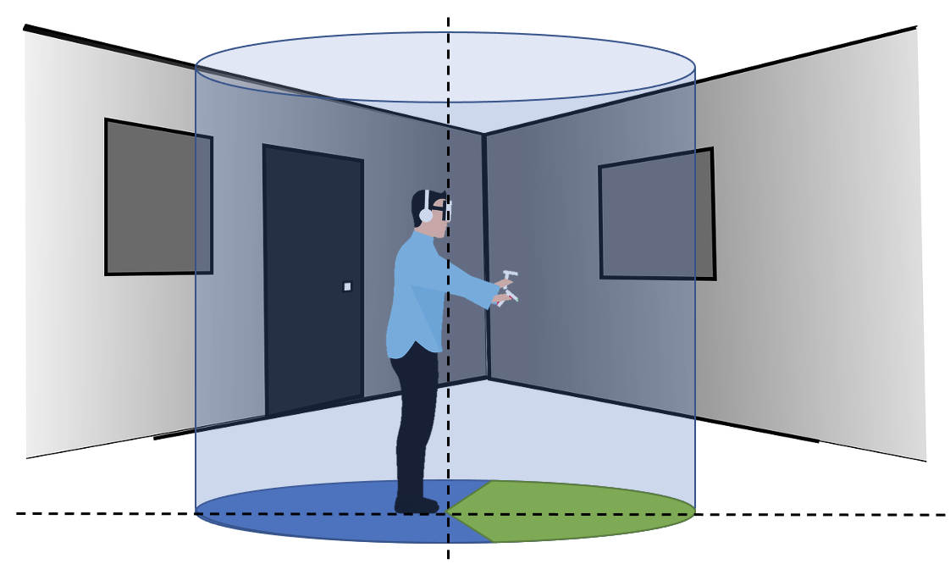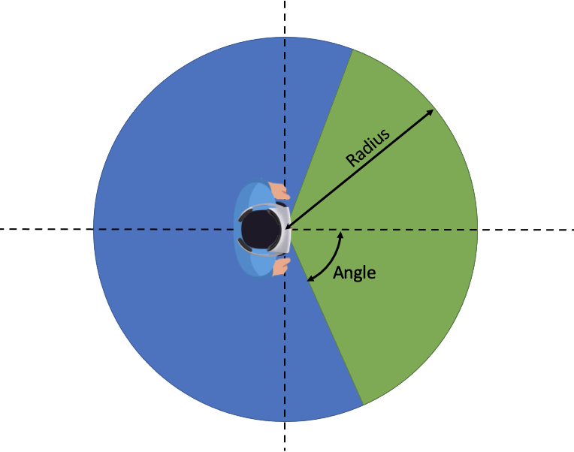
Figure 23 - Example of cylinder-shape visualization space
In the example of a cube, only the distance from the center of the cube to any face of it (half the distance of an edge) is signaled, assuming that the cube is centered on the viewer’s viewpoint. An extension of cube signaling is when the 3 sizes of a cubic space (depth, width and height) are signaled.
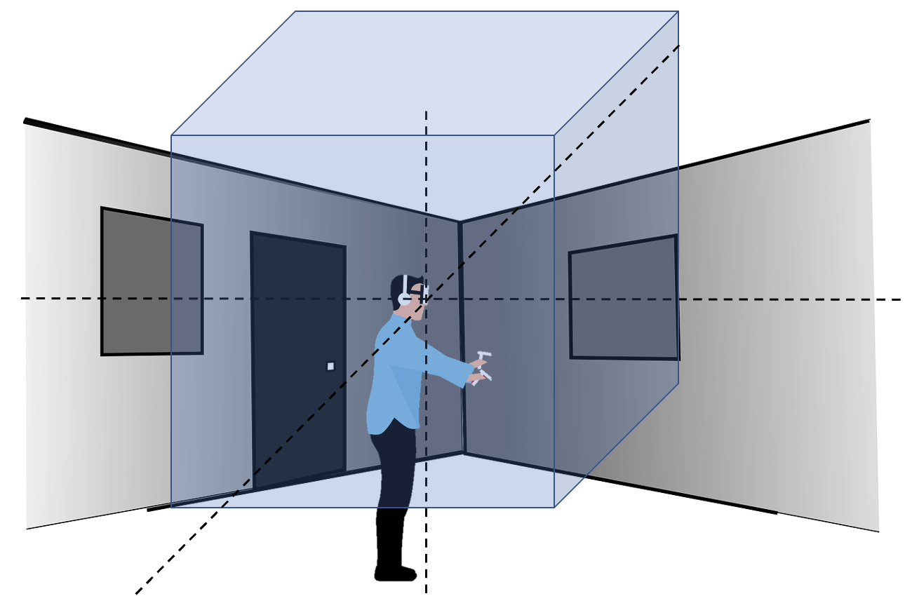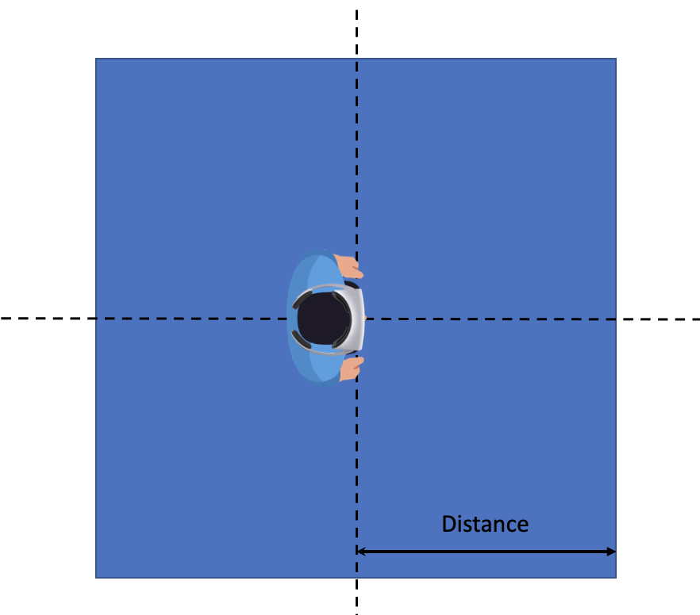
Figure 24 - Example of cube-shape visualization space
In the case of a sphere, only its radius is signaled, also assuming that the center if the sphere is the user’s viewpoint.

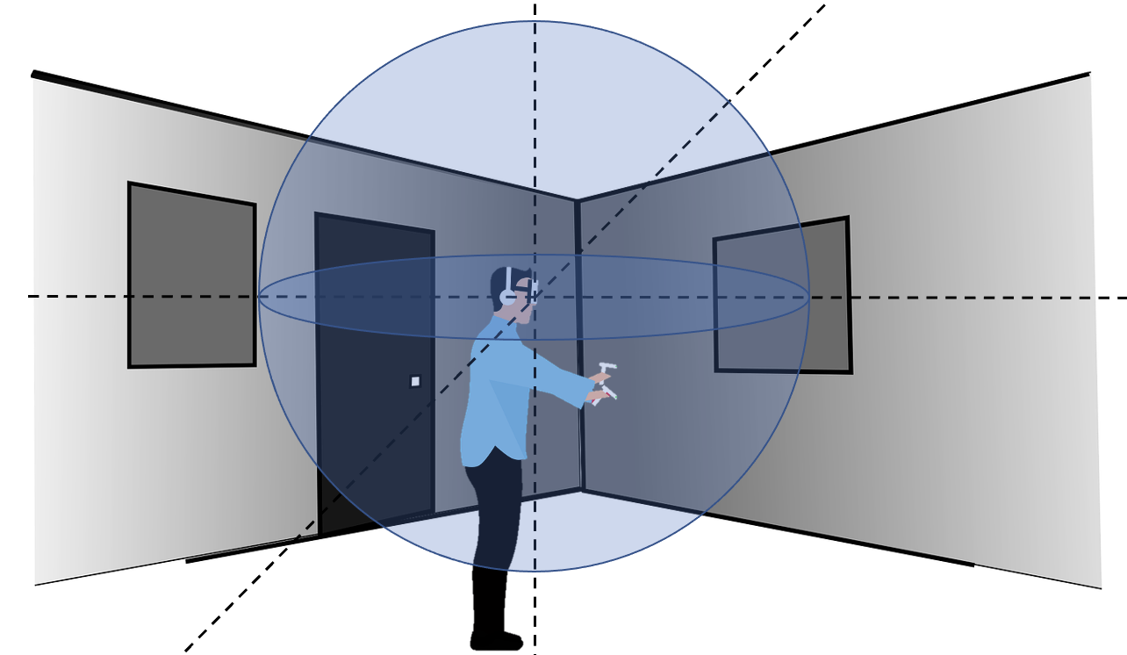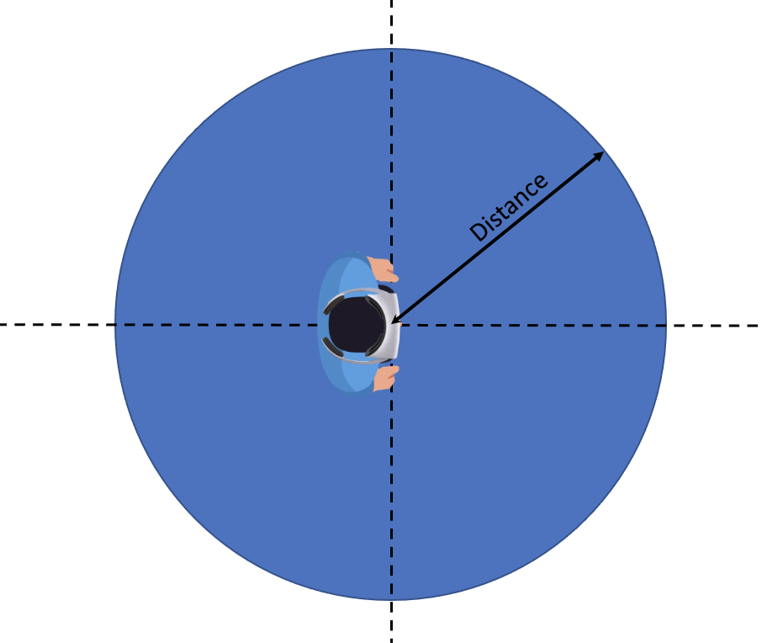
Figure 25 - Example of sphere-shape visualization space
For the above examples here is the required signaling:
Table 10 - Visualization space shape properties
Shape | Cylinder | Partial cylinder | Cube | Sphere
Measures | - Height (if not infinite)  - Radius | - Height (if not infinite)  - Radius  - Angle | - Side | - Radius

NOTE: It is expected to analyze for further study:
- the implement ability of the potential solutions together with the OpenXR runtime for the acquisition of the available space. OpenXR as an example provides this in an extension https://registry.khronos.org/OpenXR/specs/1.0/html/xrspec.html#XR_FB_scene, using xrGetSpaceBoundary2DFB or xrGetSpaceBoundingBox3DFB
- the persistence of the available space (static vs dynamic including how frequent the information is refreshed and used)
- the accuracy of the space, i.e., units used and the mapping of 3D scene and objects to these units.
With the knowledge of the available rendering space, a server can ensure that the virtual objects fit into it. What the server decides to do remains out of scope of 3GPP and is the responsibility of the service provider. The following is just an illustration of the possible content adaptations at the server side:
- The server may decide to downscale the 3D scene so that all objects fit into the rendering volume.
- The server may decide to clip the scene and only send the virtual objects fully present in the rendering volume.
- The server may decide to deny the service due to incompatibility between the immersive experience and the available space around the user.
- In case of multiple users in different spaces, the server may decide to downscale the 3D scene for some or upscale for others to create a symmetric experience for all users.
As an example in Figure 23, the following scene with 3 objects has one object (orange cylinder) within the rectangle visualization space one object partially inside the cube (yellow rectangle) and one object out of the rendering volume (green cylinder).
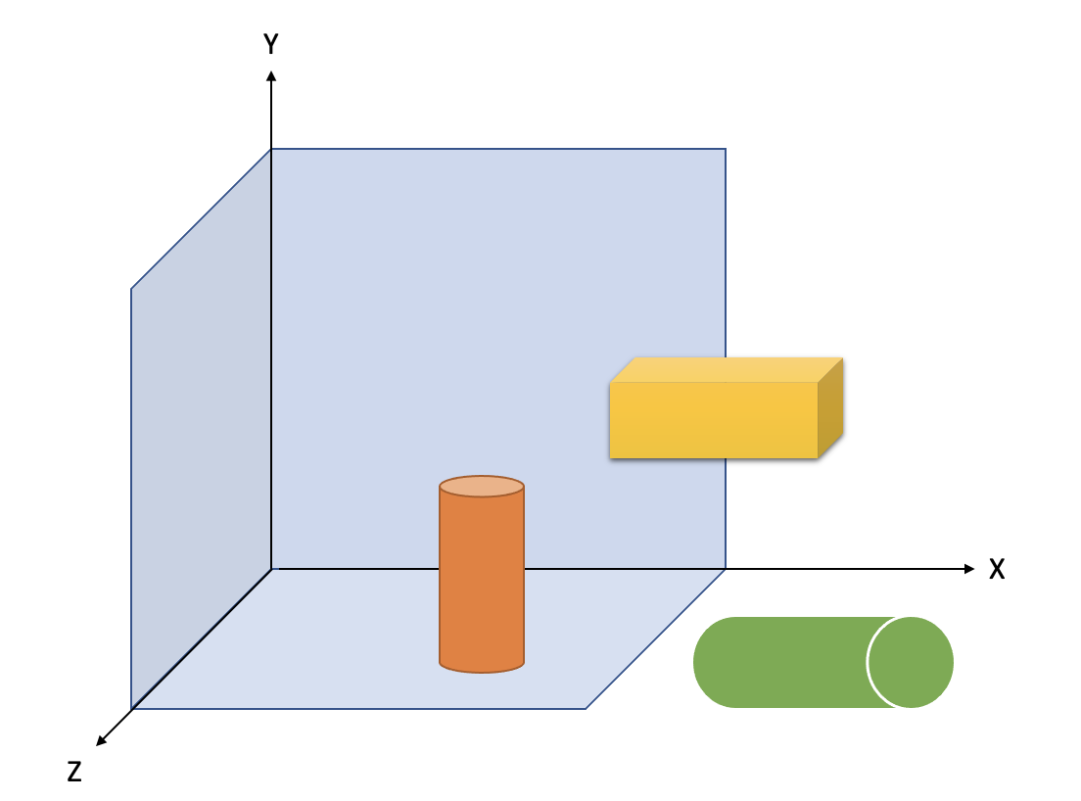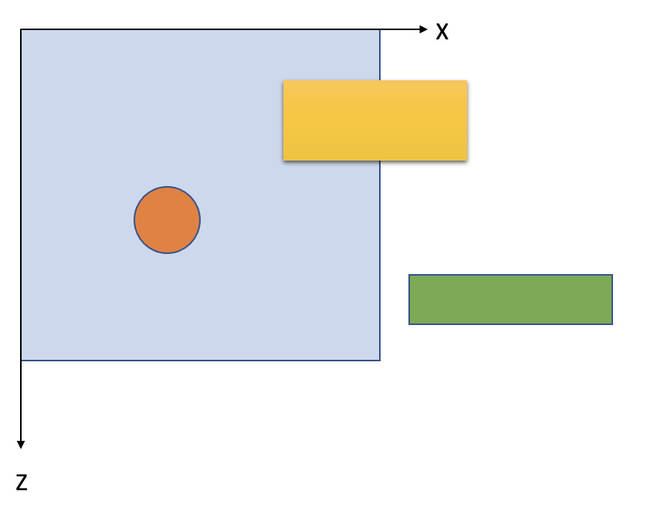
Figure 26 - Example scene before adaptation

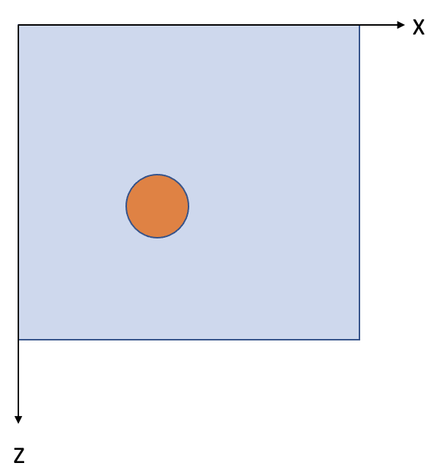  Figure 27 - Example scene after clipping | 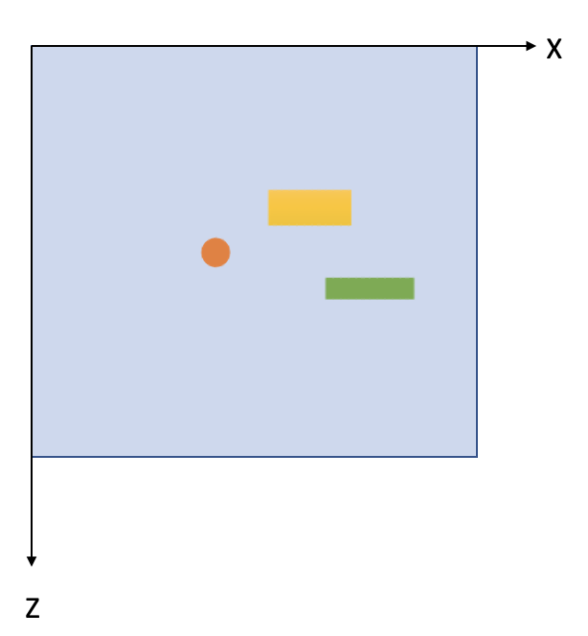  Figure 28 - Example scene after downscaling

8.6 User interaction

8.6.1 General
In use cases such as shared interactive immersive services, the user interaction is sent from a UE to a server. The server handles the user’s request to the immersive media scene (e.g., changing the context such as translation, rotation, and scaling or adding a new object in the scene). With the edge assisted UE type, the UE offloads the scene rendering to the Split Rendering Server, the server rasterizes the XR viewport and does pre-rendering to generate a XR media which is encoded and delivered to the UE.

8.6.2 QoE timing information
In the context of interactive immersive services, one important parameter to estimate the user quality of experience is the roundtrip interaction delay which is defined in the TR 26.928 [38] section 4.2.2. “Interaction Delays and Age of Content”.
The roundtrip interaction delay is defined as the sum of the Age of Content and the User Interaction Delay.
The User interaction delay is defined as the time duration between the moment at which a user action is initiated and the time such an action is taken into account by the content creation engine. It is impacted by the uplink latency of the wireless network.
The Age of content is defined as the time duration between the moment the content is created and the time it is presented to the user. It is impacted by the downlink latency of the wireless network.
The interactivity Quality of Experience (QoE) is highly dependent on the roundtrip interaction delay. Furthermore, the acceptable delay may differ according to the use case and the type of interaction. Several type of interactions with different roundtrip interaction delay thresholds may coexist in one application.
The Table X lists four categories of interaction/application defined in the TR 26.928 [38] with respect to roundtrip interaction delay:
Table 11 - Roundtrip interaction delay threshold
Interaction/application Categories | Roundtrip interaction delay threshold
Ultra-Low-Latency | ≤ 50 ms
Low-Latency | ≤ 100 ms
Moderate latency | ≤ 200 ms
Non-critical latency | > 200 ms

The user interaction may be a single event which is utterly asynchronous from other data flows or may occur at different frequency.

8.6.3 QoE measurement
For the Edge dependent MeCAR XR device type, the server’s split render function is in charge to pre-render the scene for the UE using the latest user pose, encodes the rendered frame and sends it back to the UE. The UE decodes the rendered frame, performs further post-processing like pose correction before presenting the frame to the user.
The procedures of the interactivity pipeline are detailed in Figure 28.
Figure 29 - User action call flow
Procedure:
- The raw user action is acquired from the XR runtime by the XR source management, including the lastChangeState timestamp of the last change to the state of this action.
- The XR source management formats and gathers the raw user action into an action message. The action message is shared with the Media access Function (MAF).
- The MAF sends the action message to the Scene Manager in the Split Rendering Server.
- The action message is received by the Split Rendering Server and buffered before being handled during the next iteration of the update loop of the Scene manger. The Scene manager in the server processes the interaction task according to the actions in the action message from the UE and updates the scene. The Scene Manager records in the timeInfo metadata the sceneUpdateTime timestamp when it starts to process the action.
The scene manager may ignore the action according to the application policy: too many actions, actions too late or lower priority.
- The Scene manager shares the updated scene with the renderer.
- The scene is rendered using the predicted user pose.
- The rendered media frame is shared with the Media Delivery Function.
- The Split Rendering Server encodes the rendered media frame together with the associated time metadata. The encoded media frame is sent from the Split Rendering Server to the UE MAF with the associated time metadata.
- The UE MAF decodes the media data. The rendered frame is then shared to the Presentation Engine and the XR runtime.
- The XR runtime performs further processing such pose correction using the latest pose.
- The rendered frame with the interaction response is displayed to the user at the actual display time (T2.actual).

8.6.4 Interactivity delays and QoE
Using all the timestamps from the Split Rendering Server and the UE, the application can calculate the interaction delays:
- User-interaction-delay = sceneUpdateTime - lastChangeState
- Age-of-content = T2.actual - sceneUpdateTime
- Roundtrip-interaction-delay = T2.actual - lastChangeState

Those delays allow to estimate the interactivity QoE taking into account the category of interaction defined in the TR 26.928 [38] and listed in the Table X.
By using all the history of delay measurement, the Application can estimate the delays between the next user action and rendered frames.
- Action and timestamp information from the device:
  - Action information: the user action information which are grouped into action sets. Each action has a unique identifier of the action
  - lastChangeTime: the time when the user action is made. It corresponds to the lastChangeTime field in the action information defined as the timestamp of the last change to the state of the action.
- Action and timestamp information associated with rendered media frame from the Split Rendering Server:
  - Action identifiers: The identifiers of the actions which are handled by the scene manager and rendered in the associated media frame
  - sceneUpdateTime: the time when the Scene manager processes the interaction task according to the actions in the action message from the UE and updates the scene.

9 Relevant activities in external organizations

9.1 Volumetric video support in MPEG-I V3C

9.1.1 Coding aspect of V3C
V3C encoding of a volumetric frame is achieved through a conversion of a volumetric frame from its 3D representation to multiple 2D representations and a generation of associated data, also known as the atlas data.
2D representations, known as V3C video components, of a volumetric frame are encoded using traditional 2D video codecs (such as AVC or HEVC). The V3C video component may, for example, include occupancy, geometry, attribute data, or packed data. The occupancy data informs a V3C decoder which pixels in other V3C video components contribute to the reconstructed 3D representation. The geometry data describes information on the position of the reconstructed voxels, while attribute data provides properties of that voxel, e.g. color or material information. The packed data component, introduced in 2nd edition of the standard, allows to limit the number of the video components required and pack all types of video component data (i.e. occupancy, geometry, and attributes) into one video frame.
Atlas data, known as V3C atlas component, provides information to interpret the V3C video components and enables the reconstruction from a 2D representation back into a 3D representation of a volumetric frame. The atlas data is composed of a collection of patches. Each patch identifies a region in all V3C video components and provides the necessary information to perform the appropriate inverse projection of the indicated region back into 3D space. The shape of the patch region is determined by a 2D bounding box associated with each patch as well as their coding order. The 2D shape of these patches is further refined based on occupancy data.
Figure 20 visualizes the reconstruction from patches and different video components of V3C content.
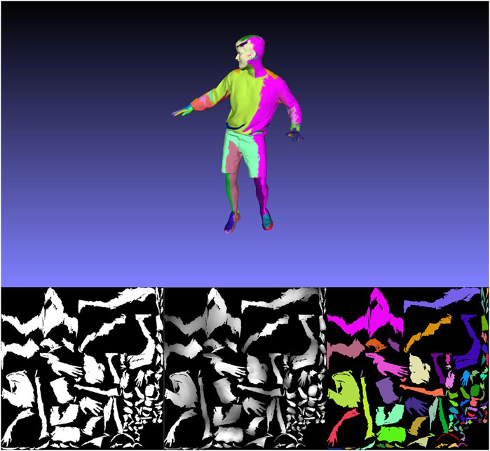
Figure 30 - Example of reconstructed point 3D frame with one color per patch (Top), occupancy video frame (bottom-left), geometry video frame (bottom-middle) and one color per patch texture frame (bottom-right).
To enable parallelization, random access, as well as a variety of other functionalities, an atlas frame can be divided into one or more rectangular partitions referred to as tiles. Tiles are not allowed to overlap and are independently decodable. The functionality of tiles, closely resembles similar mechanisms in video codecs, such as motion constraint tiles in HEVC or sub-pictures in VVC.
The binary form of V3C video components, i.e. video bitstream, and V3C atlas components, i.e. V3C atlas bitstream, can be collected and represented by a single V3C bitstream. The V3C bitstream is composed of a set of V3C units. Each V3C unit has a V3C unit header and a V3C unit payload. The V3C unit header describes the V3C unit type for the payload and the V3C unit payload contains the data for V3C video components, V3C atlas components or V3C parameter set. V3C video component, i.e. occupancy, geometry, attribute, or packed corresponds to video data units (e.g. NAL units defined in (ISO/IEC 23008-2)) that could be decoded by an appropriate video decoder. The V3C atlas component contains V3C NAL units as defined in (ISO/IEC 23090-5 and ISO/IEC 23090-12). The same standards also define how to decode said V3C NAL units.

9.1.2 Systems aspect of V3C

9.1.2.1 General
The ISO/IEC JTC1/SC29 MPEG Systems workgroup (WG3) has developed a standard to support efficient and interoperable storage and transport of compressed visual volumetric media content with 6 degrees of freedom. The standard defines how to carry V3C bitstreams in an ISOBMFF container and is based on and derived from the ISO/IEC 14496-12 standard [3] and extends the Dynamic Adaptive Streaming over Hypertext Transfer Protocol (HTTP) (DASH) and MPEG Media Transport (MMT) frameworks by adding additional signaling to enable delivery of V3C-coded content over a network. A comprehensive overview of the generic V3C carriage concepts and related functionalities defined by the specification is presented in [15]. A V3C streaming demo based on the technologies defined in this standard was presented during the SA4#122 meeting and described in S4-230217.

9.1.2.2 Encapsulation File Format
The ISO/IEC 23090-10 specification is derived from ISO/IEC 14496-12 and specifies how boxes defined in ISO/IEC 14496-12 should be used for storing V3C-coded content. It also defines new boxes required to store a V3C bitstream in an ISOBMFF container and to support various functionalities, such as recommended viewports and spatial partial access. The specification introduces three methods for storing V3C-coded content in ISOBMFF, where each mode defines a number of sample entries that impose certain constraints on the track(s) supported by that mode and a specific sample format for these tracks in addition to other mode-specific tools. The supported storage modes are: single-track storage, multi-track storage, and non-timed storage.
A single-track encapsulation mode represents the V3C bitstream in ISOBMFF as one track, V3C bitstream track. V3C bitstream track is identified by a sample entry with type ‘v3e1’ or ‘v3eg’. This encapsulation mode is intended for direct ISOBMFF encapsulation without any additional pre-processing or de-multiplexing of the ingested V3C bitstream. While simple, this encapsulation mode does not support partial access and a client is not able to select only a subset of the V3C components for playback.
The multi-track encapsulation mode stores the V3C bitstream in the ISOBMFF file as several tracks, where each track represents either part of or a complete V3C component. This is the preferred mode for streaming applications since a number of independent encoders can run in parallel and the resulting bitstreams can be stored into an ISOBMFF-compliant file or set of files as separate tracks. This provides a flexibility where the extraction and direct processing of each V3C component by their respective decoder becomes much easier without the need to reconstruct the V3C bitstream.
Finally, the non-timed encapsulation mode represents the V3C bitstream in ISOBMFF as items, as defined in [3], where each item represents part of or a complete V3C component. This mode is well suited, for example, to store a V3C bitstream encoded with a still picture profile that has less strict decoding requirements and limited coding tool support.
To signal to a parser which storage mode is used and what type of functionality needs to be supported to play the file, a number of ISOBMFF brands are defined by ISO/IEC 23090-10. A brand might indicate the type of encoding used, how the data of each encoding is stored, constraints and extensions that are applied to the file, the compatibility, or the intended usage of the file.
The single-track encapsulation mode is identified by the brand ‘v3st’. Multi-track encapsulation is identified by the ‘v3mt’ and ‘v3mp’ brands. The ‘v3mt’ brand informs the parser that the file contains V3C content stored using a basic multi-track storage mode, while the brand ‘v3mp’ indicates a multi-track storage mode with additional features present, such as spatial partial access or recommended viewports. The non-timed encapsulation mode is identified by the brand ‘v3nt’.

9.1.2.3 Streaming Support
The ISO/IEC 23090-10 specification supports delivering V3C content using MPEG-DASH as well as MMT. In the case of MPEG-DASH, the standard defines how to signal V3C content in the Media Presentation Description (MPD) for both the single-track and multi-track encapsulation modes, including defining V3C-specific DASH descriptors, and defines restrictions on the DASH segments generated for the content.

9.1.2.3.1 DASH Single Track Mode
In this mode, the V3C content is represented with a single Adaptation Set in the MPD with one or more Representations. The only constraint on the Representations of this Adaptation Set is that the codec used for encoding a given V3C video component must be identical across all Representations. There is no requirement, however, that all the V3C video components in one Representation must be encoded using the same codec.

9.1.2.3.2 DASH Multi-track Mode
As with encapsulation, the multi-track mode provides more flexibility over the single-track mode by enabling adaptation across several dimensions as each V3C component is represented by its own Adaptation Set. By separating the V3C video component bitstreams into multiple Adaptation Sets, a streaming client can prioritize or completely drop some components or maps when making adaptation decisions. Moreover, V3C video component representations can be encoded using different video codecs or different bitrates to allow for efficient adaptive bitrate streaming. In addition, the multi-track mode defines number of constrains on the segments of the Adaptation Sets describing V3C components.

9.1.2.2 RTP
In order to transport V3C compressed content over RTP, an appropriate payload format is needed for both 1) video, and 2) data components (atlas).
The RTP payload format for V3C video component is defined by appropriate Internet Standards for the applicable video codecs. For example, RFC 7798 defines the payload format for HEVC, and RFC 6184 defines the payload format for H.264.
The RTP payload format for V3C atlas component is under development in the IETF AVTCORE WG and reached working group draft status in December 2022 (IETF – avtcore 2023). As the atlas bitstream uses the high-level syntax NAL unit concept known from existing video codecs, the proposed payload format tries to re-use as much as possible from RTP payload formats for existing modern video codecs. Additionally, the internet draft [16] provides information on how the association between the V3C atlas component and the V3C video components can be signalled on SDP level, e.g., by defining groups of RTP streams to contain V3C encoded data (RFC 5888), or by defining a way to bundle multiple RTP streams in a single transport (RFC 8843).
The following figure shows the end-to-end overview of a V3C communication system in a uni-directional conversational scenario.
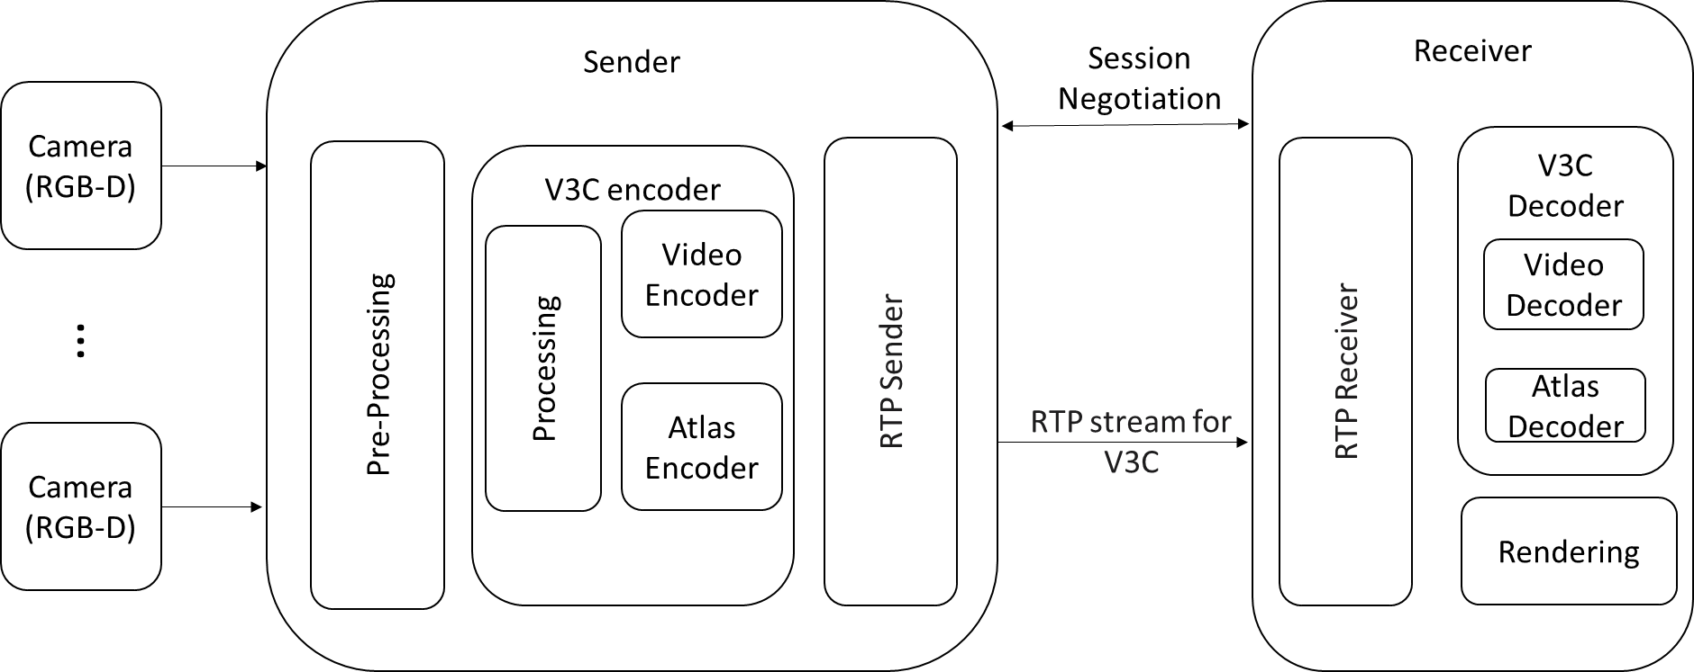

Figure 31 - High level overview of a V3C system for one way conversational communication.

9.1.2.3 V3C Applications
The V3C standard defines a generic mechanism for coding volumetric video and can be used by applications targeting different flavors of volumetric content, such as point clouds, immersive video with depth, or even mesh representations of visual volumetric frames. Compression of mesh representations is currently ongoing in MPEG under Video-based Dynamic Mesh Compression (V-DMC) [17].

9.1.2.3.1 Video-based Point Cloud Compression (V-PCC)
V-PCC addresses lossless and lossy coding of 3D point clouds with associated attributes such as colors and reflectance. Point clouds are typically represented by extremely large amounts of data, which is a significant barrier for mass market applications. However, the relative ease of capturing and rendering 3D information as point clouds compared to other volumetric video representations makes point clouds increasingly popular to present immersive volumetric data. With the current V-PCC encoder implementation providing a compression in the range of 100:1 to 300:1, a dynamic point cloud of one million points could be encoded at 8 Mbit/s with good perceptual quality. Real-time decoding and rendering of V-PCC bitstreams has also been demonstrated on current mobile hardware. The overview of coding aspects of V-PCC is provided in [12][13].

9.1.2.3.2 MPEG-I Immersive Video (MIV)
MIV enables the compression of multi-view content, multi-view plus depth and multi-plane image source data. MIV was developed to support compression of immersive video content, in which a real or virtual 3D scene is captured by multiple real or virtual cameras. The standard builds on capabilities defined in 23090-5, by adding more flexible video component packing strategies, depth encoding formats and camera models. The new camera models support arbitrary orientation and translation properties as well as equirectangular, perspective, or orthographic projections. Observed in demos, by pruning and packing views, MIV can achieve typical bit rates around 5 to 30 Mb/s using HEVC and a pixel rate up to HEVC Level 5.2. The overview of coding aspects of MIV is provided in [14][31].

9.1.2.4 V3C Performance

9.1.2.4.1 V-PCC Results
Subjective verification results for V3C V-PCC conclude that the MPEG developed test model significantly outperforms the reference anchor (point cloud library). More detailed information is available in the full test report [30].

9.1.2.4.2 MIV Results
V3C MIV is currently conducting its own verification tests. The results of the dry-run of the subjective experiments organized in this context show that MIV significantly outperforms its reference anchor, which consists in the combination of the Multiview extension of HEVC (MV-HEVC) and the MPEG Reference View Synthesizer (RVS) [32][33][34].

9.1.3 Implementations
In order to support generation of content for V3C encoder, it is recommended that a device be capable of capturing depth + texture video, also sometimes referred to as RGBD. However, as indicated by the geometry absent profile as defined in ISO/IEC 23090-12, depth capture is not sometimes even needed to generate volumetric video. Even a device with a single depth + texture camera sensor can generate point cloud sequences. Currently, in the mobile industry we see an increased number of handheld devices which support depth sensing, like the iPhone 12 or 13. There are also dedicated cameras like Microsoft Kinect Azure or Intel Realsense, which support depth sensing. Over the last 4 years there were number of implementations in the industry showing how V3C encoded can be consumed by different types of devices.
In January 2019 Nokia shared a demo based on an open-sourced implementation [18] using standard mobile device hardware to decode and render V3C encoded content [19].
In January 2020 Futurewei also contributed to describing a mechanism for GPU friendly rendering on mobile platforms using geometry shaders and presented V3C rendering capabilities on a mobile device [20].
In January 2021 Intel demonstrated MIV video playback on the Intel Max GPU using its media and graphics hardware engines [21]. The proof of concept “Freeport Player” uses a modified open source VLC player, DirectX11 implementation of TMIV decoder and renderer, and a face tracking system. The demo was interactive, using a normal web camera to track viewer motion, and a normal PC display to show rendered viewports.
In August 2022 Interdigital and Philips showcased real-time decoding of V3C bitstreams using three simultaneous HEVC hardware decoders [22][23]. The demo showed that V3C standard is ready for deployment for public application as it relies on 2D conventional video codecs and is codec agnostic. So, it does not require specialized hardware.
In October 2022 Interdigital showcased streaming of V3C compressed content to Nreal AR glasses [24][25] over DASH as described in 23090-10.
In February 2023 Nokia provided description of the V3C-based real-time delivery demo [26] that showcase the V3C capabilities for conversational scenarios, where data is delivered over RTP streams. The demo utilized commercially available RGB-D cameras [27], standard PC desktop as a sender and Meta Quest 2 as a receiver.
All the demonstrations indicate that both generating V3C content as well as decoding and displaying it using existing commercially available hardware is both possible as well as practical. Different types of implementations also display the flexibility of the V3C family of standards. More consideration about the performance requirements can be found in [28]. Some practical examples of the recommended minimum GPU requirements are provided below:
- Functionalities at least one of the following
  - Minimum OpenGL 3.0
  - Minimum OpeGLES 2.0
  - Minimum Vulkan 1.0
  - Minimum DirectX 9.0
  - Minimum Metal 1.0
- Performance
  - Minimum Adreno 540 or Apple A11 equivalent mobile GPU.

9.1.4 Capabilities considerations
Until now, V3C defines two applications: video-based point cloud compression (V-PCC) specified in ISO/IEC 23090-5 and MPEG immersive video (MIV) specified in ISO/IEC 23090-12. V3C specifications provide restrictions on the bitstreams and hence limits on the capabilities needed to decode the bitstreams utilizing profiles, tiers, and levels. Profiles are also used to indicate the application of V3C bitstream, i.e. V-PCC or MIV, in other words indicate the algorithmic features and limits that must be supported by decoders conforming to given profile.
ISO/IEC 23090-5 describes several codec group profiles for its applications, V-PCC and MIV, in Annex A, extracted from Annex A, is copied below for convenience. There are currently five codec groups defined: AVC Progressive high, HEVC Main 10, HEVC 444, VVC Main 10 and MP4RA. The details for the profiles defined in TS 26.118 for the subset of codecs can be reviewed from the table below.
For any given profile, a level (ptl_level_idc) of a tier (ptl_tier_flag) generally corresponds to a particular decoder processing load and memory capability. While defining the levels in V3C specification MPEG took into account the video codec requirements for 3GPP devices specified in TS 26.118 based on [29]. For advanced use cases, the HEVC Main10 profile, Main tier, at level 5.1 is mandated in TS 26.118, which corresponds to level 2.0 in V3C specification with 534 773 760 maximum aggregated luma sample rate per second (roughly corresponds to two 4k decoders running at 30 fps).
Table 11 - CodecGroup profile component supported functionality in ISO/IEC 23090-5.
 |  | AVC Progressive High |  |  | HEVC Main10 |  |  | HEVC444 |  |  | VVC Main 10 |  |  | MP4RA
 | Capability | Occupancy | Geometry | Attributes, Packed video | Occupancy | Geometry | Attributes, Packed video | Occupancy | Geometry | Attributes, Packed video | Occupancy | Geometry | Attributes, Packed video | Occupancy | Geometry | Attributes, Packed video
Chroma format | Mono |  |  |  |  |  |  | ✓ | ✓ | ✓ | ✓ | ✓ | ✓ | ‒ | ‒ | ‒
Chroma format | 4:2:0 | ✓ | ✓ | ✓ | ✓ | ✓ | ✓ | ✓ | ✓ | ✓ | ✓ | ✓ | ✓ | ‒ | ‒ | ‒
Chroma format | 4:4:4 |  |  |  |  |  |  |  |  | ✓ |  |  |  | ‒ | ‒ | ‒
Bit depth | 8 bit | ✓ | ✓ | ✓ | ✓ | ✓ | ✓ | ✓ | ✓ | ✓ | ✓ | ✓ | ✓ | ‒ | ‒ | ‒
Bit depth | 10 bit |  |  |  | ✓ | ✓ | ✓ | ✓ | ✓ | ✓ | ✓ | ✓ | ✓ | ‒ | ‒ | ‒
Video coding specification | name | ISO/IEC  14496-10 |  |  | ISO/IEC 23008-2 |  |  |  |  |  | ISO/IEC DIS 23090-3 |  |  | As defined by a component codec mapping SEI (F.2.11)
Video coding specification | profile | Progressive High as specified in ISO/IEC 14496-10 |  |  | Main 10 as specified in ISO/IEC 23008-2 |  |  | Main 4:4:4 10 as specified in ISO/IEC 23008-2 |  |  | VVC Main 10 as specified in ISO/IEC DIS 23090-3 |  |  | ‒
To fully define decoding capability V3C uses a combination of syntax elements ptl_profile_codec_group_idc and ptl_profile_toolset_idc. The toolsets are used to describe the required V3C atlas codec features and are copied for convenience in Table 2. V3C specifies two toolset profiles for V-PCC applications and four toolset profiles for MIV applications. Additionally, V-PCC toolsets can be differentiated for static and dynamic volumetric content using ptc_one_v3c_frame_only_flag.
For V-PCC applications, the V-PCC Extended toolset profile allows for more than one map of geometry and attribute and enables the usage of tools for increased performance, such as Extended Occupancy Map patches (EOM patches, which transmits occupancy information between two maps), Point Local Reconstruction (PLR, which creates new points using interpolation parameters), among others, and also allows for more flexibility in patch placement (including patch rotations) and in patch projection directions (including directions rotated by 45-degrees). Furthermore, the V-PCC Extended profile also does not restrict the number of channels in V3C video component.
MIV applications allow only I_INTRA patch type compared to V-PCC that is provided per GOP of video frames. Additionally, the MIV toolsets are more flexible with regard to the amount and types of V3C video components. For example it allows a packed version of V3C video components that enables one video encoder/decoder V3C use case. MIV toolsets profile also clearly limits the number of attribute V3C video components.
Table 12 - Available toolset profile components in ISO/IEC 23090-5.
Ptl_profile_toolset_idc | ptc_one_v3c_frame_only_flag | Toolset profile component | Type
0 | 0 | V-PCC Basic  /* Specified in Annex H * / | Dynamic
0 | 1 | V-PCC Basic Still  /* Specified in Annex H */ | Static
1 | 0 | V-PCC Extended  /* Specified in Annex H */ | Dynamic
1 | 1 | V-PCC Extended Still  /* Specified in Annex H */ | Static
64 | 0 | MIV Main  /* Specified in ISO/IEC 23090-12 */ | Dynamic
65 | 0 | MIV Extended  /* Specified in ISO/IEC 23090-12 */ | Dynamic
66 | 0 | MIV Geometry Absent  /* Specified in ISO/IEC 23090-12 */ | Dynamic
2..63, 67..255 | - | Reserved | -

It should be pointed out that the V3C coding standards do not specify how the content should be displayed to the user / rendered. Similarly to 2D video codecs, the display should be application specific; thus, individual applications can decide on the optimal reconstruction and rendering techniques. This allows the V3C standard to remain relevant, when novel rendering and reconstruction techniques and hardware acceleration features become available.

9.1.4 3D media capabilities considerations

9.1.4.1 General
ISO/IEC 23090-5 specifies a generic mechanism for volumetric video coding, i.e., visual volumetric video-based coding (V3C), that may be used by applications targeting volumetric content, such as point clouds or immersive video with depth. The applications of V3C target point cloud representations of volumetric frames in Annex H of ISO/IEC 23090-5 (V-PCC). ISO/IEC 23090-12 specifies the applications of V3C targeting Immersive Video (MIV).
Unlike two dimensional image or video coding standards, the V3C standard specifies profiles as a combination of three components, namely CodecGroup, Toolset, and Reconstruction components.
The CodecGroup component indicates video decoding specifications and their profiles, e.g., Main 10 as specified in ISO/IEC 23008-2, that is used for encoding V3C video components. The CodeGroup profile component affects only V3C video components and does not have impact on V3C atlas component. The Toolset profile component indicates the coding tools that could be used to generate the conformant bitstream and shall be supported by a decoder. The Toolset profile component affects only the V3C atlas components and does not have impact on the V3C video component. The CodecGroup and Toolset components specify conformance point A in ISO/IEC 23090-5.
The Reconstruction profile component describes conformance point B in ISO/IEC 23090-5 and it specifies the pre-reconstruction, reconstruction, post-reconstruction, and adaptation tools supported or recommended to achieve conformance in terms of 3D reconstruction. A decoder may support and may be able to conform to multiple reconstruction profiles specified in ISO/IEC 23090-5. However, the Reconstruction profile that a decoder selects to operate in, is outside the scope of ISO/IEC 23090-5. When a decoder claims to be operating at a particular conformance point B, it shall be capable of reconstructing a volumetric frame according to the reconstruction recommendations specified by that profile.
The following subsections further summarize profile, tier and level structure for V3C codecs.

9.1.4.2 V3C decoder conformance points
V3C profiles follow a structured and flexible definition to allow for clearly identifying two distinct conformance points, Conformance Point A and Conformance Point B. These conformance points are illustrated in the decoding block diagram shown in Figure 24.
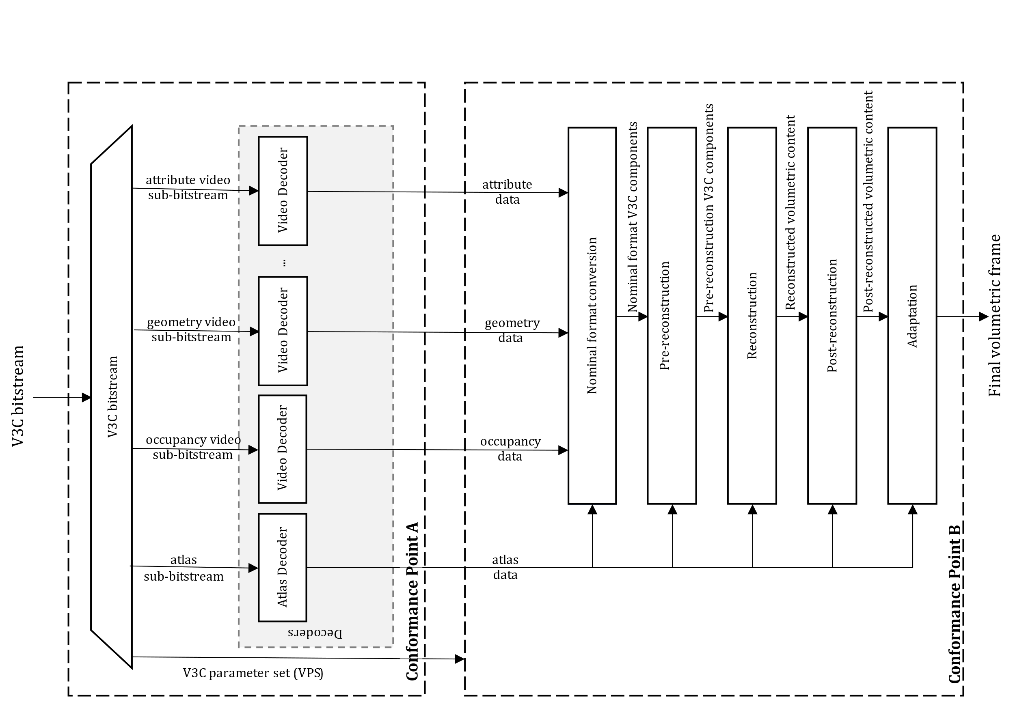
Figure 32 - V3C decoding block diagram with decoding conformance points A and B
The first conformance point, point A, covers the decoded video sub-bitstreams and atlas sub-bitstream. It also covers the derived block to patch map information. The second conformance point, point B, covers the reconstruction process.
In order to signal the required decoding capability at a given conformance point V3C utilizes a combination of syntax elements ptl_tier_flag, ptl_level_idc, ptl_profile_codec_group_idc, ptl_profile_toolset_idc, and ptl_profile_reconstruction_idc that are present in the V3C bitstream. A mapping of the syntax elements to a given conformance point is shown in Figure 25.
Figure 33 - V3C profile, level, and tier structure
V3C bitstreams conforming to a specified tier and level obey the following constraints for each atlas bitstream, where tiers, main (MT) and high (HT) relate directly to the video bitstream level limits.
- V3C bitstream level
  - Maximum of PROJECTED, EOM, and RAW points per second
  - Maximum of PROJECTED, EOM, and RAW points per atlas frame
  - Maximum number of maps
  - Maximum number of attributes
  - Maximum number of attribute dimensions (channels)
- Atlas bitstream level
  - Maximum of PROJECTED, EOM, and RAW patches per atlas frame
  - Maximum of PROJECTED, EOM, and RAW patches per second
  - Maximum number of tiles per atlas
  - Maximum atlas size
  - Maximum atlas bitrate
- Video bitstream level
  - Maximum luma picture size
  - Maximum aggregated luma sample rate
  - Maximum bitrate per video stream
  - Maximum aggregated video stream bitrate
The CodecGroup and Toolset profile components describe conformance point A. More specifically, CodecGroup describes video decoding specifications and their profiles, and Toolset specifics tools (e.g., use of EOM and PLR etc) allowed, i.e., define constrains on the atlas bitstream syntax structures.
- CodecGroup
  - AVC Progressive High
  - HEVC Main10
  - HEVC444
  - VVC Main 10
  - HEVC Main
  - MP4RA (codec specified by a fourcc registered at mp4ra.org)
- Toolset
  - V-PCC Basic (specified Annex H of ISO/IEC 23090-5)
  - V-PCC Basic Still (specified Annex H of ISO/IEC 23090-5)
  - V-PCC Extended (specified Annex H of ISO/IEC 23090-5)
  - V-PCC Extended Still (specified Annex H of ISO/IEC 23090-5)
  - MIV Main (specified Annex A of ISO/IEC 23090-12)
  - MIV Extended (specified Annex A of ISO/IEC 23090-12)
  - MIV Geometry Absent (specified Annex A of ISO/IEC 23090-12)
The V3C bitstream profile, level and tier syntax further indicates the number of maximum required video decoder instantiations, from 0 to a maximum of 32 video decoder instances.
To indicate profile conformance of a bitstream or decoder at conformance point A, it is only needed to consider the CodecGroup and Toolset profile components. Decoders conforming to a V3C profile at conformance point A at a specific level of a specific tier shall be capable of decoding all V3C bitstreams or collection of V3C sub-bitstreams, for which all of the following conditions apply:
- The V3C bitstream or the collection of V3C sub-bitstreams are indicated to conform to the supported CodecGroup and Toolset profile components.
- The V3C bitstream or the collection of V3C sub-bitstreams are indicated to conform to a level that is lower than or equal to the specified level.
- The V3C bitstream or the collection of V3C sub-bitstreams are indicated to conform to a tier that is lower than or equal to the specified tier.
The Reconstruction profile component describes conformance point B, specifying the pre-reconstruction, reconstruction, post-reconstruction, and adaptation tools supported or recommended to achieve conformance in terms of 3D reconstruction.
A decoder may support and may be able to conform to multiple reconstruction profiles as specified. When a decoder claims to be operating at a particular conformance point B, it shall be capable of reconstructing a volumetric frame according to the reconstruction recommendations specified by that profile.

9.2 IETF AVTCORE WG
MPEG has published a group of standards, under the umbrella of Visual Volumetric Video-based Coding (V3C). The V3C family of standards covers the aspects of encoding, storage, and transport of volumetric video and consists of three documents:
- ISO/IEC 23090-5 Visual volumetric video-based coding (V3C) and video-based point cloud compression (V-PCC)
- ISO/IEC 23090-12 MPEG Immersive video, which specifies the compression of volumetric video content captured by multiple cameras; and
- ISO/IEC 23090-10 Carriage of visual volumetric video-based coding (V3C) data.
A V3C encoder converts volumetric video frames, i.e., 3D volumetric information, into a collection of 2D images, and associated data, known as atlas data. The converted 2D images are subsequently encoded using existing video or image/video codecs, while the atlas data is encoded with mechanisms specified in ISO/IEC 23090-5.
The RTP payload format for V3C atlas component is under development in the IETF AVTCORE WG (see Internet draft https://datatracker.ietf.org/doc/draft-ilola-avtcore-rtp-v3c/). The draft provides information on how the association between the V3C atlas component and the V3C video components can be done on SDP level, e.g., by defining groups of RTP streams to contain V3C encoded data (RFC 5888), or by defining a way to bundle multiple RTP streams in a single transport (RFC 8843).
The authors of the RTP payload format for V3C keep a public repository of the project where the latest status of the work can be followed: https://github.com/laurilo/draft-ilola-avtcore-rtp-v3c.

9.3 MPEG-I Video Decoding Interface [37]

9.3.1 Introduction
One of the most distinctive features of immersive media compared to 2D media is that only a portion of the content created by the author is presented to the user. Such a portion is interactively selected at the time of consumption. For example, a user can typically not see a point cloud object’s front and back sides simultaneously. Thus, for efficiency reasons and depending on the users’ viewpoint, only the front or back sides may be delivered, decoded, and presented. Similarly, parts of the scene behind the observer may not need to be accessed.
At the 140th MPEG meeting, MPEG Systems (WG 3) reached the final milestone of the Video Decoding Interface for Immersive Media (VDI) standard (ISO/IEC 23090-13) by promoting the text to Final Draft International Standard (FDIS). At the time of writing (March 2023), the publication of the International Standard which is the the final published version is still pending. The standard defines the basic framework and specific implementation of this framework for various video coding standards, including support for application programming interface (API) standards that are widely used in practice, e.g., OpenMax and Vulkan by Khronos.
The VDI standard allows for dynamic adaptation of video bitstreams to provide the decoded output pictures in such a way that the number of actual video decoders can be smaller than the number of the elementary video streams to be decoded. In other cases, virtual instances of video decoders can be associated with the portions of elementary streams required to be decoded. With this standard, the resource requirements of a platform running multiple virtual video decoder instances can be further optimized by considering the specific decoded video regions to be presented to the users rather than considering only the number of video elementary streams in use. The first edition of the VDI standard includes support for the following video coding standards: High Efficiency Video Coding (HEVC), Versatile Video Coding (VVC) and Essential Video Coding (EVC).

9.3.2 Use Cases
While built under the MPEG-I umbrella, VDI addresses several relevant use cases as shown in Figure 23. It includes XR experiences, 360 VR as well as multi object AR scenes, but also video calls with multiple video streams or TV multi-stream functionalities.
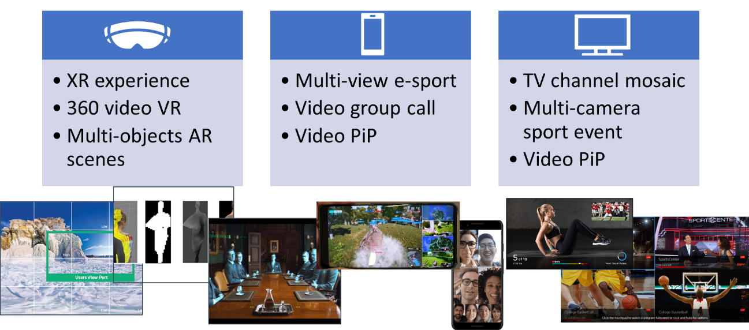
Figure 34 - Example use cases for Video Decoding Interface
An example for a dynamic mesh decoding is shown in Figure 24.
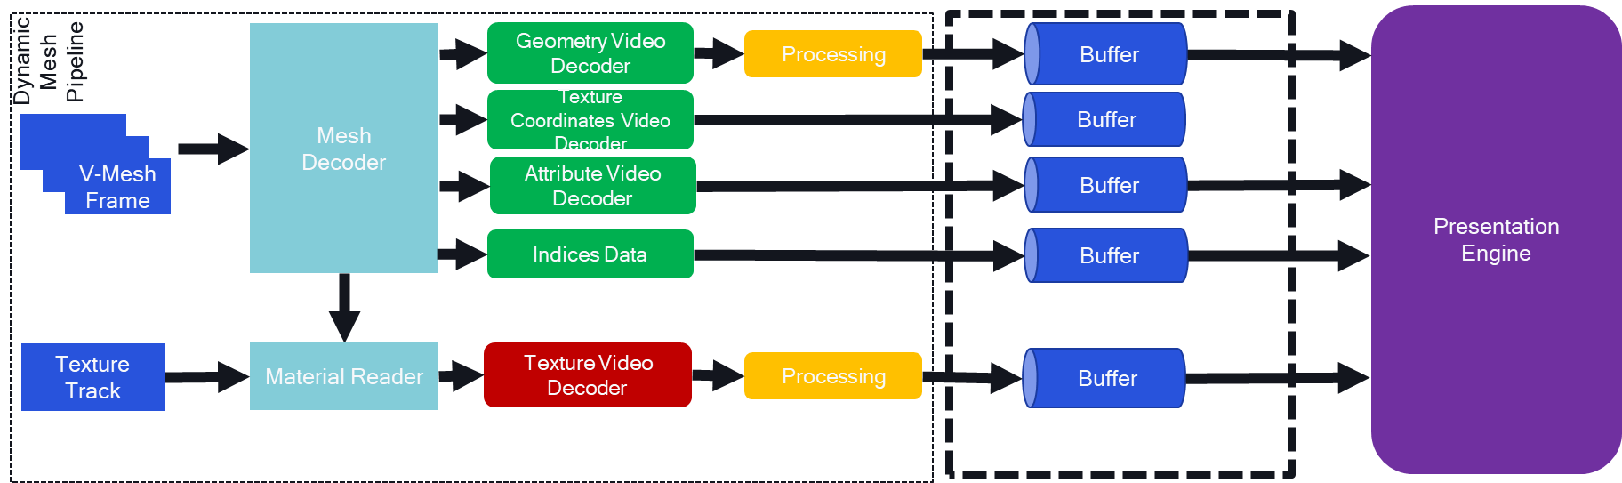
Figure 35 - Example use cases for Video Decoding Interface
Multiple video decoders need to operate in parallel, including a geometry, texture, and attribute decoder. Another decoding instance may be provided for the texture track. In order to operate a decoding platform, there is a need for synchronizing the various video decoder instances.

9.3.3 Background
Typical video decoding stacks for mobile devices are provided in Figure 25.
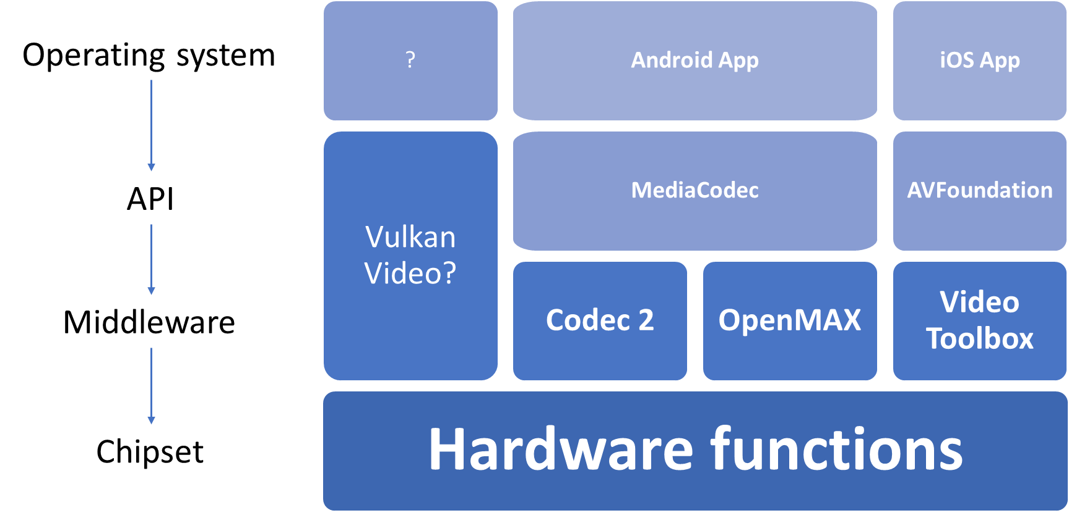
Figure 36 - Video decoding stacks for mobile devices
In this case, applications access codecs through OS APIs, which in itself rely on underlying hardware abstractions such as Khronos OpenMAX, to abstract the chipset and hardware functionalities. Vulkan Video is a new API from Khronos offering such functionalities, however there is no evidence yet of support of Vulkan Video on mobile platforms as opposed to computer desktops, even though the core Vulkan API is supported on Android for instance.
A specific example need to support use cases shown in clause 9.3.2 is provided in Figure 26. An application may instruct a decoder to decode multiple video bitstreams concurrently and provides those for joint GPU processing to generate a viewport.
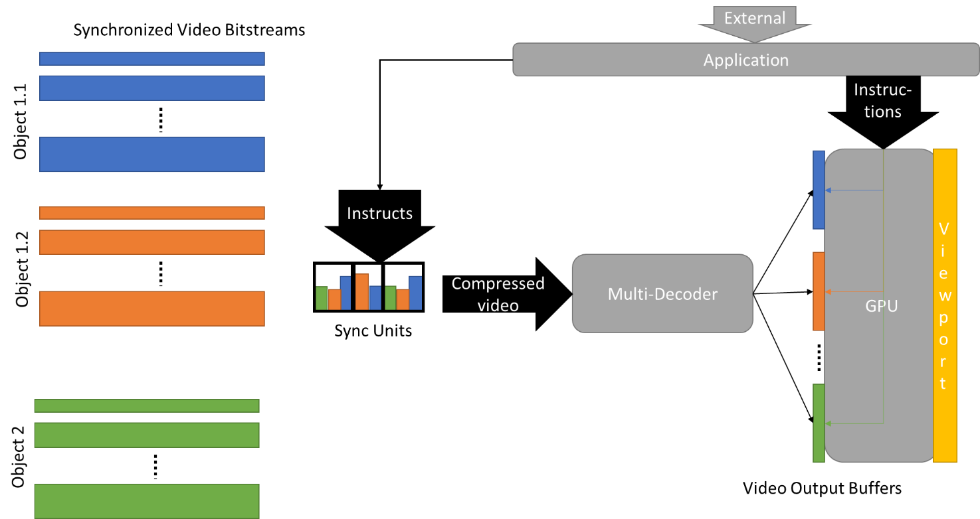
Figure 37 - Multi-decoder support
Preferably, such a configuration of a multi-decoder instance is simple enough for an application to create such workflows.
Current APIs exposing video decoding functions may have the following shortcomings:
- API cannot allocate a group of decoder instances on a SoC for a single application.
- API cannot indicate the maximum number of HW video decoders available for a certain profile and level constraint.
- SoC are underused to guarantee that an app will be able to run based on a minimal requirement, e.g. 1 HW and 1 CPU decoders.
- Higher user experience or lower consumption could be achieved, if no CPU decoders are used.
- Secure rendering pipelines for multi-decoder combination in GPU.
These shortcomings result in challenges for app developers such as lack of interoperability for the processing of concurrent video streams, unavailability of sufficient amount of instances, or synchronized decoder output into swap-chain buffers for concurrent rendering.
ISO/IEC 23090-13 address this issue by extending existing APIs to support multiple video decoders as shown in Figure 27.
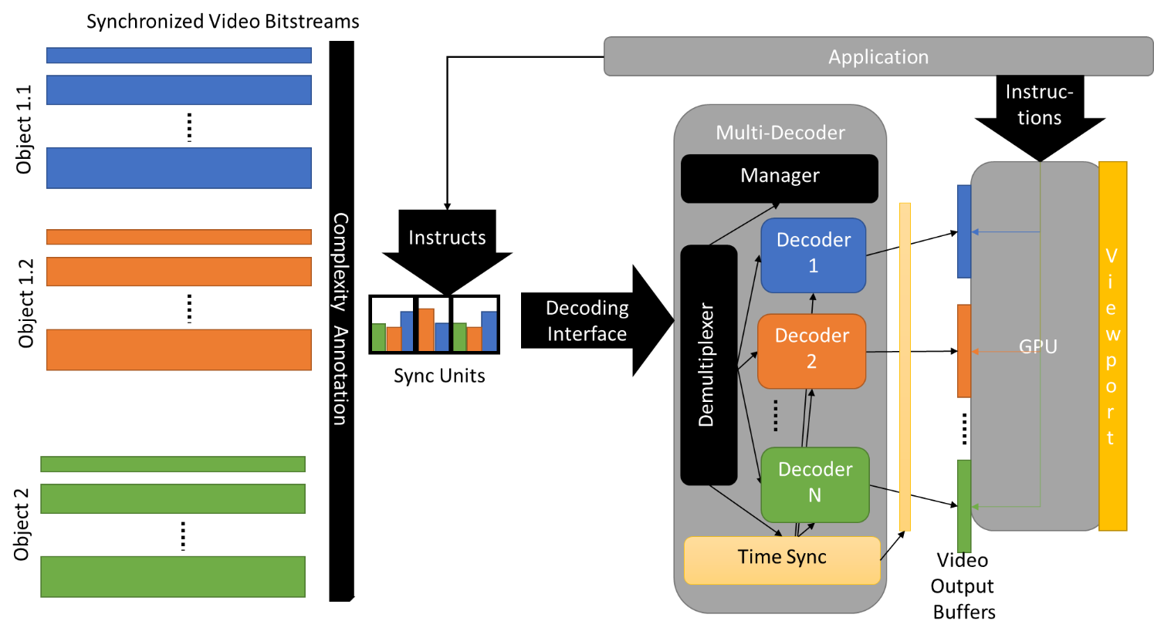
Figure 38 - Multiple decoder management
The manager in the multi-decoder manages the resources to provide time synchronized output buffers to the GPU. In a variant of this, all instructions and decoding are done in a secure hardware pipeline as shown in Figure 28.
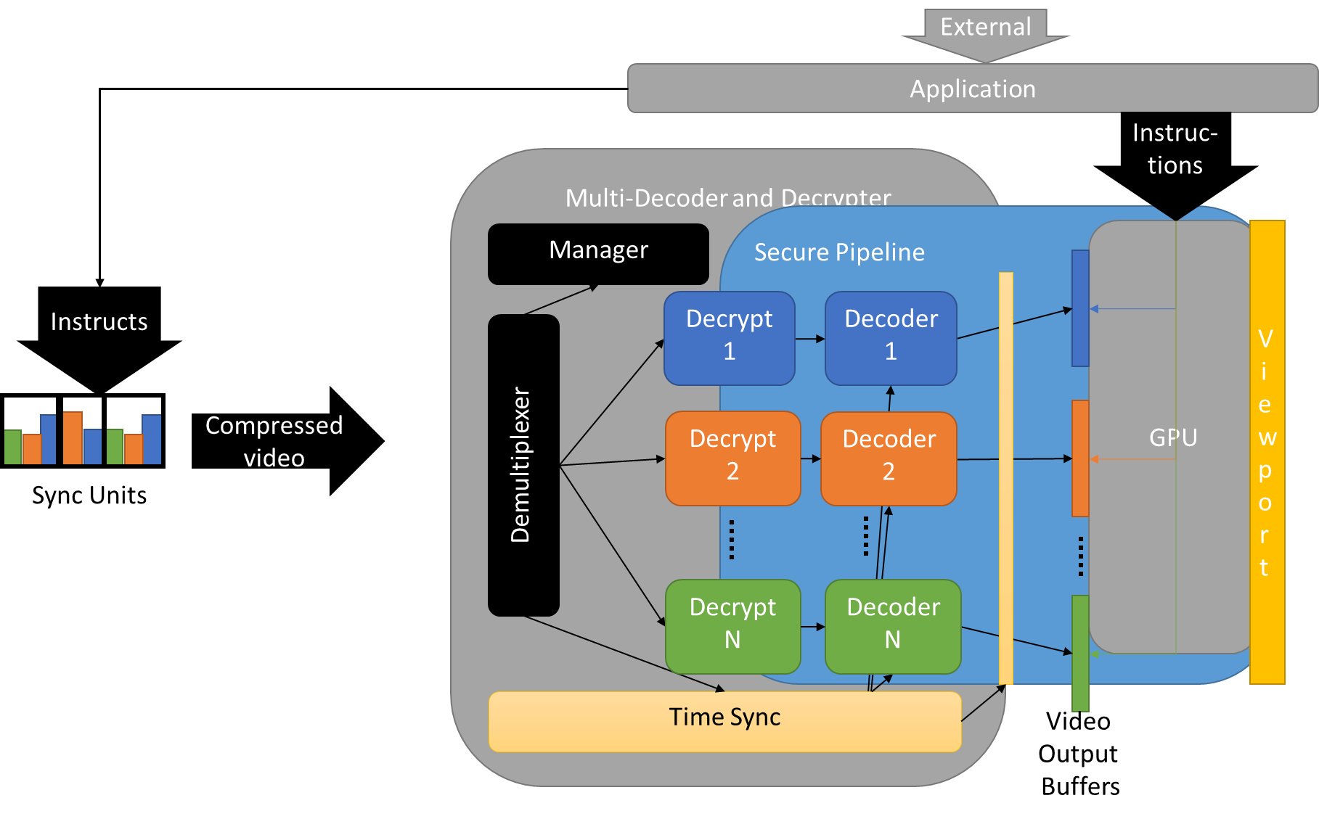
Figure 39 - Multiple decoder management with secure HW pipeline

9.3.4 ISO/IEC 23090-13 (MPEG-I VDI) [37]
MPEG-I Video decoding interface as specified in ISO/IEC 23090-13 addresses the challenges and requirements of XR applications, namely:
- 3D object => several components => 2D decoder instance per component
- Decoders for same object need to be synced and paced
- Synchronization at frame accuracy (different from A/V sync)
It provides the following functionalities:
- Manage decoding resources efficiently and with certainty
- Enhance control interface for decoder platform
- Specify pre- and post-processing instructions for input and output
- Abstract API with mappings to
  - OpenMAX
  - WebCodecs
  - Vulkan Video API
The principle architecture is shown in Figure 29.
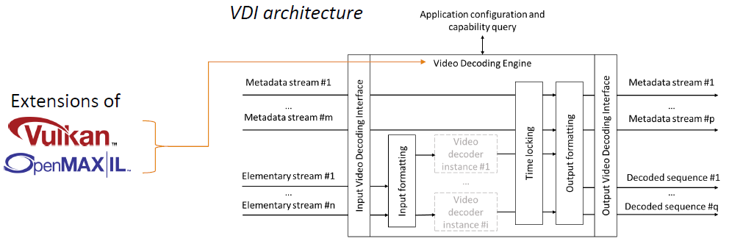
Figure 40 - MPEG-I VDI Architecture
The VDI specification provides abstract API definition using IDL for the following functionalities:
- function to query the instantaneous aggregate capabilities of a decoder platform for a specific codec component
- setting up decoder instances belonging to a same group means that the VDE treats those instances collectively such that the decoding statuses of those instances progress in synchrony and not in competition against each other
- setting up a configuration for the output buffer
- extended parameter settings and query such as subframe output, cropping, or timing.
Extensions of current video decoding API are provided for:
- Mapping on OpenMAX™ Integration Layer (OpenMAX IL)
- Mapping on Vulkan® Video

9.3.5 Relevancy for MECAR
MPEG-I VDI is clearly of relevance of MeCAR functionalities to address several use cases:
- decoding and processing multiple eye buffers, possibly also a depth buffer
- decoding and processing multiple layers
- decoding and processing multiple video streams associated to 3 D objects
- decoding and processing the streams of multiple objects (possibly each with multiple streams)
Hence, beyond the capabilities of video decoding as defined in clauses 4.3.2.2 and 6.6.3, the capabilities should refer to the capabilities as defined in ISO/IEC 23090-13 using terminology and the capability descriptions according to clause 5.4.1.1
The IDL declarations of the queryCurrentAggregateCapabilities() function along with the AggregateCapabilities and PerformancePoint structures and the capabilities flags are defined as follows:
const unsigned long CAP_INSTANCES_FLAG = 0x1;
const unsigned long CAP_BUFFER_MEMORY_FLAG = 0x2;
const unsigned long CAP_BITRATE_FLAG = 0x4;
const unsigned long CAP_MAX_SAMPLES_SECOND_FLAG = 0x8;
const unsigned long CAP_MAX_PERFORMANCE_POINT_FLAG = 0xA;

struct PerformancePoint {
float picture_rate;
unsigned long width;
unsigned long height;
unsigned long bit_depth;
};

struct AggregateCapabilities {
unsigned long flags;
unsigned long max_instances;
unsigned long buffer_memory;
unsigned long bitrate;
unsigned long max_samples_second;
PerformancePoint max_performance_point;
};

AggregateCapabilities queryCurrentAggregateCapabilities (
in string component_name,
in unsigned long flags
);

In addition, the MAF should support
- setting up decoder instances belonging to a same group
- setting up a configuration for the output buffer
- extended parameter settings and query such as subframe output, cropping, or timing.

10 Technical status

10.1 List of elements open for work
The work-in-progress elements are:
- Integration of 3GPP codecs in the EDGAR-type architecture
- Security aspects related to the media capabilities of the EDGAR-type
- Encapsulations into RTP, ISOBMFF and CMAF
- Codec-level parameter for SDP and DASH
- Capability exchange mechanisms to support edge provisioning
- Addition of AR Media Capabilities for 5G Media Streaming
- AR Audio Capabilities

10.2 List of completed elements
The completed elements thus far are:
- None

10.4 List of open issues requiring specific attention
The current open issues that are identified are:
- None

11 References
- 3GPP TR 26.998, “Support of 5G Glass-type Augmented Reality / Mixed Reality (AR/MR) devices”
- 3D Commerce Viewer Certification Program, https://www.khronos.org/3dcommerce/certification/
- Khronos Group 3DC Certification documents, https://github.com/KhronosGroup/3DC-Certification/
- Khronos Group 3DC Certification models, https://github.com/KhronosGroup/3DC-Certification/tree/main/models
- 3GPP TS 26.511, “5G Media Streaming (5GMS); Profiles, codecs and formats”
- 3GPP TS 26.118, “Virtual Reality (VR) profiles for streaming applications”
- OpenXR 1.0 Reference Guide, https://www.khronos.org/files/openxr-10-reference-guide.pdf
- Nreal Glasses Technical Specifications, Online: https://www.nreal.ai/specs/.
- IETF RFC3550, "RTP: A Transport Protocol for Real-Time Applications", July 2003
- IETF RFC8831, "WebRTC Data Channels", January 2021
- The OpenXR Specification, Copyright (c) 2017-2022, The Khronos Group Inc., Version 1.0.25: from git ref release-1.0.25
- Graziosi, D., Nakagami, O., Kuma, S., Zaghetto, A., Suzuki, T., and Tabatabai, A. (2020). An Overview of Ongoing point Cloud Compression Standardization Activities: Video-Based (V-PCC) and Geometry-Based (G-PCC). APSIPA Trans. Signal Inf. Process. 9 (13).
- Schwarz, S., Preda, M., Baroncini, V., Budagavi, M., Cesar, P., Chou, P. A., et al. (2019). Emerging MPEG Standards for Point Cloud Compression. IEEE J. Emerg. Sel. Top. Circuits Syst. 9 (1), 133–148.
- Boyce, J. M., Dore, R., Dziembowski, A., Fleureau, J., Jung, J., Kroon, B., et al. (2021). MPEG Immersive Video Coding Standard. Proc. IEEE 109 (9), 1521–1536.
- Ilola L, Kondrad L, Schwarz S and Hamza A (2022) An Overview of the MPEG Standard for Storage and Transport of Visual Volumetric Video-Based Coding. Front. Sig. Proc. 2:883943. doi: 10.3389/frsip.2022.883943.
- IETF – avtcore, RTP Payload Format for Visual Volumetric Video-based Coding (V3C), https://datatracker.ietf.org/doc/draft-ietf-avtcore-rtp-v3c/, [accessed: 01.02.2023].
- ISO/IEC 23090-29 Information Technology — Coded Representation of Immersive media — Part 29: Video-based dynamic mesh coding (V-DMC).
- Nokia, Video Point Cloud Coding (V-PCC) AR Demo, https://github.com/nokiatech/vpcc, [accessed 01.02.2023].
- S. Schwarz, M. Pesonen, “Real-time Decoding and AR playback of the Merging MPEG Video-based Point Cloud Compression Standard”, International Broadcasting Convention 2019.
- [V-PCC] GPU efficient rendering for mobile platforms, input contribution m52641, MPEG meeting, January 2020.
- Immersive video playback of HEVC bitstream on Intel GPU, input contribution m55800, MPEG meeting, January 2021.
- Promotion of V3C during Set Expo, input contribution m60663, MPEG meeting, September 2022.
- https://s3.amazonaws.com/files.interdigital.com/55bd0288af0b0930ba599bd0c4b7ca38/resources/uploads/resources/Philips_and_InterDigital_Showcasing_SBTVD_TV_30_technologies_at_SET_expo_2022.pdf.
- BOG Report on Scene Description for MPEG-I, input contribution m61243, MPEG meeting, October 2022.
- https://www.nreal.ai.
- S4-230073, [iRTCW] An implementation of real-time V3C streaming for conversational scenario, Nokia Corporation, 3GPP TSG SA WG 4 meeting # 122, February 2023.
- https://azure.microsoft.com/en-us/products/kinect-dk/.
- [PCC] On V-PCC decoder output conformance, input contribution m44728, MPEG meeting, October 2018.
- V-PCC level considerations, input contribution m50998, MPEG meeting, October 2019.
- Subjective verification test report for V-PCC, ISO/IEC JTC1/SC29/WG7, MDS 20992, Output document, October 2021.
- V. K. M. Vadakital, A. Dziembowski, G. Lafruit, F. Thudor, G. Lee, P. Rondao Alface, “The MPEG immersive video standard—current status and future outlook”, IEEE multimedia 29(3), 2022, pp. 101-111.
- Reference View Synthesizer (RVS) manual, ISO/IEC JTC1/SC29/WG11 MPEG/N18068, October 2018, Macau SAR, CN.
- M. Wien, J. Jung, Results of dryrun for MIV verification test, m62279, MPEG meeting, January 2023, Online.
- “Verification test preparations of MPEG immersive video,” ISO/IEC JCT 1/SC 29/WG 4, Document N235, July 2022.
- glTF 2.0 specification https://registry.khronos.org/glTF/specs/2.0/glTF-2.0.html
- MPEG-I Scene Description, White Paper https://www.mpeg.org/wp-content/uploads/mpeg_meetings/140_Mainz/w22138.zip
- ISO - ISO/IEC DIS 23090-13 - Information technology — Coded representation of immersive media — Part 13: Video decoding interface for immersive media, https://www.iso.org/standard/80899.html
- 3GPP TR 26.928, “Extended Reality (XR) in 5G”

