3GPP TSG SA4 123-e Meeting S4-230565
Online, 17th – 21th April 2023
Source: Fraunhofer Heinrich Hertz Institute (HHI)
Title: [FS_AI4Media] Scenario for transmission of AI/ML model data
Agenda item: 9.7
Document for: Discussion and Agreement

- Introduction

At the 122th SA4 meeting in Athens, it was agreed to define an AI/ML evaluation framework, including a set of anchor models and corresponding data sets. Then, at the SA4 Video SWG Teleconference on March 28th, it was decided to first define scenarios and then to derive the test framework from these scenarios. This document suggests such a scenario.

The scenario covers the transmission of AI/ML model data, which is required in several use cases defined in clause 4 of the permanent document [1] and has been identified as one of key operations for AI/ML related services in TR 22.874 [2]. As staring point, we suggest a test case for this scenario considering a state-of-the-art model (wav2vec) for automatic speech recognition (ASR). Further test cases might be added in future meetings.

R2 of the document includes changes triggered by the e-mail discussion on April 18th and minor typo fixes.

R3 of the document is restructured to match the scenario template defined in S4-230509.
- Proposed scenario for clause 7 (AI/ML evaluation framework)

Scenario name
Transmission of compressed AI/ML model data for automatic speech recognition

Motivation
AI/ML model data distribution and sharing over 5G system has been identified in TR 22.874 [2] as one of the three key operations for AI/ML related services. Reason for this is that UEs might need a great variety of AI/ML models to respond to different tasks and environments, while not being able to store all needed AI/ML models due to memory storage constraints, so that a frequent context adaptive down-loading of AI/ML model data is necessary.
To tackle this problem, methods for model compression have been proposed (see clause 6), which provide the benefits that they 1) lower bandwidth requirements or latencies for model data distribution, and 2) reduce the memory footprint of the AI/ML models on the UEs. However, besides the reduction of the model size, compression method can also lead to a decrease of the AI/ML model performance. Which performance/compression trade-offs can be reached by different AI/ML model compression methods is thus an important question when defining AI/ML related services and is thus investigated in this scenario.

From the media-based AI/ML use cases defined in clause 4, the following require the transmission of AI/ML model data and thus could benefit from model compression:

- Full or partial transfer of models for object recognition in image and video (clause 4.1)
- Transfer of models for post-filtering for video coding (clause 4.2.1.2)
- Transfer of models for crowd-sourcing media capture (clause 4.3.1)
- Transfer of models for NLP on speech (clause 4.4)

This scenario evaluates the transmission of the wav2vec AI/ML model [3] for automatic speech recognition (ASR), which derives a transcript of a given speech sequence.

The transmission of compressed AI/ML models for ASR is relevant in the following use cases defined in clause 4:

- Crowd-Sourcing Media Capture (clause 4.3.1): To adapt to background noise or for lyrics recognition, specialized AI/ML models for ASR need to be transferred to a huge number of UEs for device inference.
- NLP on Speech (clause 4.4.): An initial ASR model needs to be down-loaded to the UE; then updated model data needs to be shared frequently with other UEs for distributed/federated learning.

Description of the scenario
In this scenario, an AI/ML model for ASR, called wav2vec [3], is transmitted to an UE. To reduce bandwidth requirements or latencies the model is compressed before transmission. The compression method might be implemented as sender-only compression/optimization technique or might comprise an encoder at the sender-side and a decoder at the receiver-side.

How the wav2vec AI/ML model can be employed by an UE to derive a transcript of a speech sequence is shown in Figure 2.3-1, which comprises the following entities:

- A speech sequence stored as uncompressed audio file sampled with 16kHz.
- The wav2vec AI/ML model inferring a classification for the speech sequence.
- A vector sequence representing the classification. Each vector comprises 29 elements specifying the probability (represented as logits) of the 29 labels: '-', ' ', 'E', 'T', 'A', 'O', 'N', 'I', 'H', 'S', 'R', 'D', 'L', 'U', 'M', 'W', 'C', 'F', 'G', 'Y', 'P', 'B', 'V', 'K', ''', 'X', 'J', 'Q', and 'Z'.
- A label selector selecting the most probable labels from the vector sequence.
- The predicted transcript, i.e. the sequence of selected labels.

Figure 2.3-1: Prediction of a transcript with the wav2vec AI/ML model

Supporting companies and 3GPP members
- Fraunhofer HHI

Reference trained AI/ML model for the scenario
Several pre-trained wav2vec AI/ML models are provided by the TorchAudio library [4] under MIT License. For evaluation, the BASE LS-960 wav2vec model, as defined in [3], should be used. It is trained on 960 hours of audio data from the Librispeech data set [6][7] and is called WAV2VEC2_ASR_BASE_960H [5] in the TorchAudio library.

The BASE LS-960 wav2vec has 94.4 million parameters with a size of about 377.6 MB.

AI/ML model split configuration factors, constraints and settings:
Not applicable.

Compression or optimization constraints and settings
None.

Feasibility/performance metrics and requirements
The derivation of test metrics is shown in Figure 2.8-1.

It comprises of the following entities:

- A test encoder, which can also be a sender-only optimization/compression technique, and (optionally) a test decoder implementing the method under test.
- A test configuration for the test encoder.
- A reference model that is compressed by the test encoder.
- A test bitstream representing the compressed reference model.
- A reconstructed model that is either a) reconstructed by the test decoder from the test bitstream or b) equal to the test bitstream for encoder-only compression methods.
- Metrics computation based on the reference model, the test bitstream and the reconstructed model.
- The derived test metrics for the method under test with respect to the reference model and the test configuration.

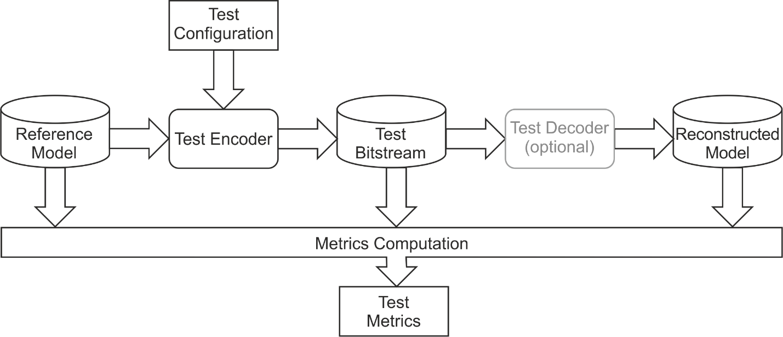

Figure 2.8-1: Derivation of test metrics

The reference model and test bitstream are provided as files containing the model parameters. The file size (size) combined with the word error rate (wer) achieved by the wav2vec model after inference are employed to determine the efficiency of a compression method.

File Size

The reference model and test bitstream can be stored as follows:

- The reference model is provided as data file containing numParam uncompressed model parameters individually represented as N-byte floating-point values.
- For encoder-only compression methods, the test bitstream is provided as data file containing numParam quantized and/or reduced model parameters individually represented as N-byte values.
- For methods requiring a decoder, the test bitstream is a coded representation encoding the parameters jointly.

For all cases, size can be determined by measuring the file size. For cases a) and b), size can also be determined as numParam * 8 * N.

Word Error Rate

To quantify the performance of the reference and the reconstructed model, the word error rate (wer) is used, which has also been applied in the original publication of the wav2vec model [3]. The word error rate is determined on a set of data pairs. Each pair comprises

- a speech sequence stored as uncompressed audio file, and
- a reference transcript of the audio sequence stored as text file.
Using the data set, the wer value is determined in two steps:

- A word error rate ${wer}_{i}$ is derived for each pair $i$ of the test set as follows:
- The AI/ML model is applied as shown in Figure 2.3-1 using the speech sequence as input and obtaining a predicted transcript as output.
- The predicted and reference transcripts are split into a predicted and a reference list of words, respectively.
- The word error rate ${wer}_{i}$ of the predicted word list with respect to the reference word list is derived as follows
$${wer}_{i}=\frac{S_{i}+D_{i}+I_{i}}{N_{i}}$$

with $S_{i}$, $D_{i}$, and $I_{i}$ denoting the number of word substitutions, word deletions, and word insertions in the predicted word list and $N_{i}$ denoting the number of words in the reference list.

- The total word error rate wer is derived as follows:
$$wer= \frac{\sum_{i}{{wer}_{i}}N_{i}}{\sum_{i}{N_{i}}}$$

Interoperability considerations for the scenario
Not applicable.

Reference data set(s)
To quantify the performance of the reference and the test model, the word error rate (wer) is determined based on the Librispeech test-clean data set [6][7], which contains about 2620 data pairs. The Librispeech test-clean data set is available under Creative Commons Attribution 4.0 International License.

Detailed test conditions

To characterize a compression method under test, it is evaluated using different test configurations T, which might be produced by varying encoder parameters as e.g. quantization parameters or sparsification ratios. The characterization is performed in comparison to the model size sizeRef and the word error rate werRef of the reference model, which are given in Table 2.11-1.

numParam [M] | sizeRef [Mbit] | werRef [%]
94.4 | 3021 | 3.397

Table 2.11-1: Number of parameters, size and word error rate of the wav2vec reference model
To fully characterize a compression method under test, a data pair (cSize, wer) is derived for each test configuration T from a set of test configurations with

- cSize denoting the size of the test bitstream size divided by the size of reference model sizeRef and
- wer denoting the word error rate of the reconstructed model.

The set of test configurations should at least contain 5 test configurations T that produce word error rates in the range of werRef (3.397%) to werRef + 0.05 (8.397%). [Note: This threshold might be discussed and changed.]

For comparison, (cSize, wer) pairs, as well as werRef, might be reported graphically, as shown in Figure 7.1.2.1.3-1.

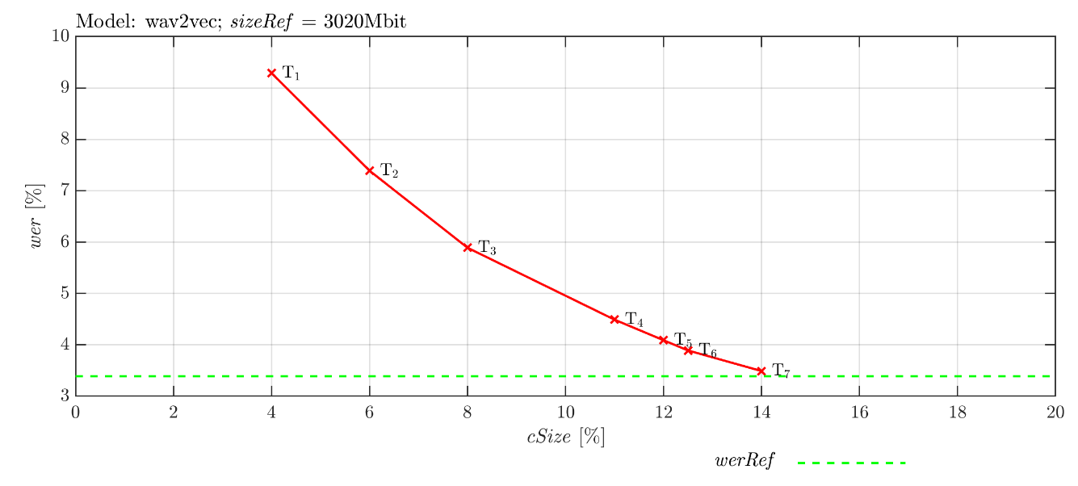
Figure 2.11-1: Example for the characterization of a method M for different test configurations T

External performance data
None.

Additional information

An exemplary python-script to derive word error rate and file size of the wav2vec model is given in Figure 2.13-1.

import torchaudio
import torch
import torchaudio.datasets as datasets
from torcheval.metrics import WordErrorRate
test_dir = "D:\\data" # This directory should exist.
device = "cuda"
def main():
####### Get Model ##############################
bundle = torchaudio.pipelines.WAV2VEC2_ASR_BASE_960H
model = bundle.get_model()
sample_rate = bundle.sample_rate
labels = bundle.get_labels()
####### Get Data Loader Model ##################
val_loader = torch.utils.data.DataLoader(
datasets.LIBRISPEECH(test_dir, "test-clean", "LibriSpeech", True ),
batch_size=1, shuffle=False,
num_workers=1, pin_memory=True)
####### Evaluate Model #########################
model.eval()
model.to( device )
metric = WordErrorRate()
blank = 0
with torch.inference_mode():
for speech_sequence, cur_sample_rate, reference_transcript, *dump in val_loader:
# Resample speech sequence if necessary
if cur_sample_rate != sample_rate:
speech_sequence = torchaudio.functional.resample(speech_sequence, cur_sample_rate, sample_rate)
speech_sequence = speech_sequence.reshape( (1,-1) )
speech_sequence = speech_sequence.to(device)
# Apply wav2vec
vetor_sequence, _ = model(speech_sequence)
# Select labels
idcs = torch.argmax(vetor_sequence[0], dim=-1)
idcs = torch.unique_consecutive(idcs, dim=-1)
idcs = [i for i in idcs if i != blank]
predicted_transcript = "".join([labels[i] for i in idcs])
predicted_transcript = predicted_transcript.replace("|"," ")
# Update error
metric.update( predicted_transcript, reference_transcript[0] )
wer_Ref = metric.compute()
print('wer_Ref: {wer_Ref:.3f} %'.format(wer_Ref=wer_Ref*100))
####### Get Model Size #########################
num_parameters = 0
for param in model.parameters():
num_parameters += param.numel()
size_Ref = num_parameters * 4 * 8 # Each parameter is stored as 32 bit float
print('size_Ref: {size_Ref:.3f} Mbit'.format(size_Ref=size_Ref/1000/1000))
if __name__ == '__main__':
main( )
Figure 2.13-1: Exemplary python script for determining sizeRef and werRef

- References
- S4-230305 [FS_AI4Media] Permanent Document v0.6, February 2022.
- 3GPP TR 22.874, Study on traffic characteristics and performance requirements for AI/ML model transfer in 5GS
- A. Baevski, H. Zhou, A. Mohamed and M. Auli, “wav2vec 2.0: A Framework for Self-Supervised Learning of Speech Representations”, arXiv, 2006.11477, 2020
- TorchAudio: An audio library for Pytorch [Computer software], https://github.com/pytorch/audio, V0.13.1
- TorchAudio: WAV2VEC2_ASR_BASE_960H, [Computer software] https://pytorch.org/audio/stable/generated/torchaudio.pipelines.WAV2VEC2_ASR_BASE_960H.html
- OpenSLR, LibriSpeech ASR corpus [Online], https://www.openslr.org/12
- V. Panayotov, G. Chen, D. Povey and S. Khudanpur, "Librispeech: An ASR corpus based on public domain audio books," 2015 IEEE International Conference on Acoustics, Speech and Signal Processing (ICASSP), Australia, 2015

