3GPP TSG-SA4 Meeting #122 S4-230087

Athens, Greece, 20th Feb 2023 - 24th Feb 2023 revision of S4aI230016
CR-Form-v12.2
CHANGE REQUEST
 | 26.804 | CR | 0003 | rev | 3 | Current version: | 17.1.0
For HELP on using this form: comprehensive instructions can be found at
http://www.3gpp.org/Change-Requests.

Proposed change affects: | UICC apps |  | ME |  | Radio Access Network |  | Core Network

Title: | 3GPP Service and URL Handler
Source to WG: | Qualcomm incorporated
Source to TSG: | S4
Work item code: | FS_5GMS_EXT, TEI18 |  |  |  |  |  | Date: |  |  | 2023-02-14
Category: | B |  |  |  |  |  | Release: |  |  | Rel-18
 | Use one of the following categories:  F (correction)  A (mirror corresponding to a change in an earlier release)  B (addition of feature),  C (functional modification of feature)  D (editorial modification)  Detailed explanations of the above categories can  be found in 3GPP TR 21.900. |  |  |  |  |  |  |  | Use one of the following releases:  Rel-8 (Release 8)  Rel-9 (Release 9)  Rel-10 (Release 10)  Rel-11 (Release 11)  …  Rel-16 (Release 16)  Rel-17 (Release 17)  Rel-18 (Release 18)  Rel-19 (Release 19)
Reason for change: |  | Until now, 3GPP specifications for 5G Media Streaming have been avoiding addressing the detailed question on how to bootstrap 3GPP defined UE and network functions such as the Media Session Handler or the MBMS/MBS client. This was deferred to implementation, device pre-configuration, and so on. However, the lack of having a specification around this topic.
Summary of change: |  | A new key issue is added that addresses the problem and discusses different options. Based on the discussion a concrete proposal for next steps are provided.
Consequences if not approved: |  | 5G Media Streaming will stay undeployed.
Clauses affected:
 |  | Y | N
Other specs |  |  | X | Other core specifications |  |  |  | TS/TR ... CR ...
affected: |  |  | X | Test specifications |  |  |  | TS/TR ... CR ...
(show related CRs) |  |  | X | O&M Specifications |  |  |  | TS/TR ... CR ...
Other comments:
This CR's revision history: |  | Presenter: Thomas Stockhammer (Qualcomm)  Online Discussion:  - Richard: It is very interesting. We have quite the same thing in DVB-MABR with the Rendez-vous service.  - Frederic: This would add key issue 12 and the candidate solution. Is the recommendation also ok?  - Richard: We probably need a meeting time to think about this.  - Frederic: Can we include it in 5GMS_Phase2?  - Thorsten: I would support letting it run as TEI18 in the next meeting.  Decision:  - In principle we agree to work on this under TEI18 until the next meeting. Postponed.  S4-221322 is postponed.  E-mail Discussion: none  Revisions: none  Presenter: Thomas Stockhammer  Online Discussion:  - Resubmission of contribution to SA4#121 Toulouse. Presentation focuses on changes since then.  - Richard: Good that this is being looked at. Hoping to look at this in more detail soon.  - Thomas: Originally from the emergency warning Use Case, but Thorsten suggested generalising to bootstrapping 5G Media Streaming.  - Julien: In the network-only scenario, is there another scenario where the network is outside the 5G System? Could allow a hybrid scenario with protocols outside the 5G System.  - Thomas: Similar to AF being outside the trusted domain. Maybe service handler could sit outside too. Generally, it doesn’t necessarily need to be trusted. Could be in user/application space.  - Fred: Problem space in interesting.  - Thomas: Would like to verify by reference implementation as part of the 5G-MAG Reference Tools initiative. (This effort is open to all.)  Decision: Note. More review requested.  S4aI230007 is noted.  This revision addresses the above comments as well as the comments from BBC provided here,  I still need to think more deeply about how your preferred Solution 1 might work in practice for a content provider such as ourselves. In particular, the proposal in clause 5.13.5.1 describes two different URLs and suggests that both might be used:  - An entry point URL (step 2). For practical purposes, I think this needs to be in the content provider's domain in order to facilitate launching of the Media Service Application via an intent filter, e.g. from a shared link or from a web page link clicked by the user. A concrete example would be https://www.bbc.co.uk/sounds/play/m001g92h.  - A bootstrapping URL (step 4) in a 3GPP-registered services domain in order to facilitate launching of the 3GPP Service Handler background service/application.  How these two URLs are used in steps 5 and 7 is not entirely obvious to me yet, but this seems critical to the operation of Solution 1. I will continue to think about this prior to our final MBS call of the year on Thursday afternoon.  E-mail Discussion:  Revisions: none  Presenter: Thomas Stockhammer (Qualcomm)  Online Discussion:  - Thomas: There are comments from Richard. I believe I resolved all the comments.  - Richard: Not going into details, but I provided an example as a contribution. I agree that an offline discussion may be a way forward  - Thomas: Okay, we can try to have a discussion  - Richard: I read your contribution and tried to work out how it works. Found few gaps. Useful to discuss  - Charles: I am trying to understand the notion of portal application and portal service provider. Thomas: Someone to say I have a list e.g., in a web page i.e. an aggregator or services. Portal identifies this, and then you launch the service (e.g., OTT). Question is how to get media streaming involved?  - Charles: Where is the magic happening with the URLs? Is that portal service provider? Thomas: Not sure what the question is, maybe we can discuss offline  Decision:  - Take this as the basis for future work.  S4aI230016 is endorsed.  E-mail Discussion:  Revisions:  https://www.3gpp.org/ftp/TSG_SA/WG4_CODEC/3GPP_SA4_AHOC_MTGs/SA4_MBS/Inbox/Drafts/S4aI230020%20Discussion%20on%20associating%20multiple%20media%20entry%20points%20with%20a%205GMS%20distribution%20configuration_QCOM.docx  Presenter: Richard Bradbury (BBC)  Online Discussion:  - No presentation or discussion. Postponed to next meeting  Decision:  S4aI230022 is postponed.
  S4-221322 | 3GPP Service and URL Handler | Qualcomm incorporated | Thomas Stockhammer
  S4aI230002 | 3GPP Service and URL Handler | Qualcomm incorporated | Thomas Stockhammer
  S4aI230016 | 3GPP Service and URL Handler | Qualcomm incorporated | Thomas Stockhammer
  [FS_5GMS_EXT, TEI18] S4-221322->S4aI230002: TS 26.804 CR0003r1 on 3GPP service and URL handler | Richard Bradbury | Tue, 20 Dec 2022 20:30:42 +0000
  Re: [FS_5GMS_EXT, TEI18] S4-221322->S4aI230002: TS 26.804 CR0003r1 on 3GPP service and URL handler | Thomas Stockhammer | Wed, 21 Dec 2022 07:48:46 +0000
  S4aI230022 | [5GMS_Ph2] Discussion on Service URLs and Media Session Handler launching | BBC | Richard Bradbury
  Comments on 020 [5GMS_Ph2] Discussion on associating multiple media entry points with a 5GMS distribution configuration | Thomas Stockhammer | Thu, 9 Feb 2023 12:07:06 +0000

==== CHANGE =====

1 Scope

This Technical Report identifies and evaluates a set of potential improvements and extensions, referred to as key topics. The key topics are
- Content Preparation
- Traffic Identification
- Additional / New transport protocols
- Uplink media streaming
- Background traffic
- Content Aware Streaming
- Network Event usage
- Per-application-authorization
- Support for encrypted and high-value content
- Scalable distribution of unicast Live Services
- Network Slicing Extensions for 5G Media Streaming
- 3GPP Service Handler and URLs
For each of the above key topics, the following objectives are identified:
1. Document the above key topics in more detail, in particular how they relate to the 5GMS Architecture and protocols.
2. Study collaboration scenarios between the 5G System and Application Provider for each of the key topics.
3. Based on the 5GMS Architecture, develop one or more deployment architectures that address the key topics and the collaboration models.
4. Map the key topics to basic functions and develop high-level call flows.
5. Identify the issues that need to be solved.
6. Provide candidate solutions (including call flows) for each of the identified issues.
7. Coordinate work with other 3GPP groups e.g. SA2, SA3, SA5, and others as needed.
8. Coordinate work with external organizations such as DASH-IF, CTA WAVE, ISO/IEC JTC29 WG3 (MPEG Systems), or IETF, as needed.
9. Identify gaps and recommend potential normative work for stage-2 call flows and possibly stage-3.
===== CHANGE =====

2 References
The following documents contain provisions which, through reference in this text, constitute provisions of the present document.
- References are either specific (identified by date of publication, edition number, version number, etc.) or non-specific.
- For a specific reference, subsequent revisions do not apply.
- For a non-specific reference, the latest version applies. In the case of a reference to a 3GPP document (including a GSM document), a non-specific reference implicitly refers to the latest version of that document in the same Release as the present document.
[1] 3GPP TR 21.905: "Vocabulary for 3GPP Specifications".
[2] Akamai Blog, "A QUICk Introduction to HTTP/3", April 2020, https://developer.akamai.com/blog/2020/04/14/quick-introduction-http3
[3] Fielding, R., Nottingham, M., and J. Reschke, "HTTP/1.1", Work in Progress, Internet-Draft, draft-ietf-httpbis-messaging-13, 14 December 2020, http://www.ietf.org/internet-drafts/draft-ietf-httpbis-messaging-13.txt
[4] Belshe, M., Peon, R., and M. Thomson, Ed., "Hypertext Transfer Protocol Version 2 (HTTP/2)", RFC 7540, May 2015, https://www.rfc-editor.org/info/rfc7540
[5] draft-ietf-quic-http-34, "Hypertext Transfer Protocol Version 3 (HTTP/3)", February 2021
[6] D. Bhat, A. Rizk, and M. Zink, "Not so QUIC: A Performance Study of DASH over QUIC," NOSSDAV'17: Proceedings of the 27th Workshop on Network and Operating Systems Support for Digital Audio and VideoJune 2017 Pages 13–18 https://doi.org/10.1145/3083165.3083175
[7] AWS: "Achieving Great Video Quality Without Breaking the Bank", Streaming Media June 2019, https://pages.awscloud.com/rs/112-TZM-766/images/GEN elemental-wp-achieving-great-video-quality-without-breaking-the-bank.pdf
[8] Netflix, "Optimized shot-based encodes: Now Streaming!", Netflix Blog, May 2018, https://netflixtechblog.com/optimized-shot-based-encodes-now-streaming-4b9464204830
[9] DASH-IF/DVB: "Report on Low-Latency Live Service with DASH", July 2017, available here: https://dash-industry-forum.github.io/docs/Report%20on%20Low%20Latency%20DASH.pdf
[10] DASH-IF: "IOP Guidelines v5, Low-latency Modes for DASH", available here: https://dash-industry-forum.github.io/docs/CR-Low-Latency-Live-r8.pdf
[11] ISO/IEC 23009-1: "Information technology — Dynamic adaptive streaming over HTTP (DASH) — Part 1: Media presentation description and segment formats".
[12] IETF RFC 8673: "HTTP Random Access and Live Content".
[13] 3GPP TR 26.939: "Guidelines on the Framework for Live Uplink Streaming (FLUS)".
[14] 3GPP TS 26.238: "Uplink Streaming".
[15] 3GPP TS 26.501: "5G Media Streaming (5GMS); General description and architecture".
[16] 3GPP TS 26.512: "5G Media Streaming (5GMS); Protocols".
[17] ISO/IEC 13818-1:2019: "Information technology — Generic coding of moving pictures and associated audio information — Part 1: Systems".
[18] SCTE 35 2020: "Digital Program Insertion Cueing Message", https://www.scte.org/pdf-redirect/?url=https://scte-cms-resource-storage.s3.amazonaws.com/SCTE-35-2020_notice-1609861286512.pdf
[19] ISO/IEC 23000-19:2020: "Information technology — Multimedia application format (MPEG-A) —Part 19: Common media application format (CMAF) for segmented media".
[20] ISO/IEC 23009-1:2019/DAMD1: "Information technology — Dynamic adaptive streaming over HTTP (DASH) — Part 1: Media presentation description and segment formats — Amendment 1: CMAF support, events processing model and other extensions".
[21] VSF TR-06-01:2020, "RIST Simple Profile", https://vsf.tv/download/technical_recommendations/VSF_TR-06-1_2020_06_25.pdf
[22] VSF TR-06-02: "RIST Main Profile", https://www.videoservicesforum.org/download/technical_recommendations/VSF_TR-06-2_2020_03_24.pdf
[23] 3GPP TS 23.501: "System architecture for the 5G System (5GS)".
[24] 3GPP TS 23.502: "Procedures for the 5G System (5GS)".
[25] 3GPP TS 29.517: "5G System; Application Function Event Exposure Service; Stage 3".
[26] 3GPP TS 29.244: "Interface between the Control Plane and the User Plane nodes; Stage 3".
[27] IETF RFC 6733: "Diameter Base Protocol".
[28] 3GPP TS 29.514: "5G System; Policy and Charging Control over Rx reference point; Stage 3".
[29] IETF RFC 7657: "Differentiated Services (Diffserv) and Real-Time Communication", November 1995.
[30] IETF RFC 3168: "The Addition of Explicit Congestion Notification (ECN) to IP", September 2001.
[31] C. Krasic, M. Bishop, and A. Frindell, Ed., draft-ietf-quic-qpack-21, "QPACK: Header Compression for HTTP/3", Work in Progress, Internet-Draft, 2 February 2021.
[32] IETF RFC 9000: "QUIC: A UDP-Based Multiplexed and Secure Transport", May 2021.
[33] IETF RFC 9001: "Using TLS to Secure QUIC", May 2021.
[34] IETF, RFC 9002: "QUIC Loss Detection and Congestion Control", May 2021.
[35] IETF RFC 5681: "TCP Congestion Control".
[36] M. Kuehlewind and B. Trammell, draft-ietf-quic-manageability-11, "Manageability of the QUIC Transport Protocol", Work in Progress, Internet-Draft, 30 June 2021.
[37] N. Cardwell et. al. "BBR Updates: Internal Deployment, Code, Draft Plans", 9 March 2021, https://datatracker.ietf.org/meeting/110/materials/slides-110-iccrg-bbr-updates-00.pdf
[38] ETSI TS 103 799: "Publicly Available Specification (PAS); DASH-IF Content Protection Information Exchange Format".
[39] ISO/IEC JTC1/SC29/WG11/N19062 23090-8 FDIS: "MPEG-I: Network-based Media Processing — Network-Based Media Processing Specification".
[40] 3GPP TS 26.247: "Transparent end-to-end Packet-switched Streaming Service (PSS); Progressive Download and Dynamic Adaptive Streaming over HTTP (3GP-DASH)".[41] 3GPP TS 23.503: "Policy and charging control framework for the 5G System (5GS); Stage 2".
[42] 3GPP TS 29.514: "5G System; Policy Authorization Service; Stage 3".
[43] 3GPP TS 29.522: "5G System; Network Exposure Function Northbound APIs; Stage 3".
[44] 3GPP TS 29.122: "T8 reference point for Northbound APIs".
[45] 3GPP TS 29.512: "5G System; Session Management Policy Control Service; Stage 3".
[46] 3GPP TS 26.803: "5G Media Streaming (5GMS); Architecture extensions".
[47] 3GPP TS 23.558: "Architecture for enabling Edge Applications (EA)".
[48] 3GPP TS 23.288: "Architecture enhancements for 5G System (5GS) to support network data analytics services".
[49] Tdoc S4-210723: "Generic architecture for data collection and reporting", submission from BBC, Dolby Laboratories Inc., LM Ericsson and Qualcomm Incorporated to SA4#114-e, May 19-28, 2021.
[50] Tdoc S2-2103267: "Extension of Naf_EventExposure for observed service experience data collection from UEs", CR from InterDigital to SA2#144e, Apr 12-16, 2021.
[51] 3GPP TS 26.114: "IP Multimedia Subsystem (IMS); Multimedia telephony; Media handling and interaction".
[52] Tdoc S2-2104496: "Extension of Naf_EventExposure for observed service experience data collection from UEs", CR from Qualcomm Incorporated to SA2#145e, May 17-28, 2021.
[53] 3GPP TS 26.118: "Virtual Reality (VR) profiles for streaming applications".
[54] 3GPP TS 26.346: "Multimedia Broadcast/Multicast Service (MBMS); Protocols and codecs".
[55] 3GPP TS 29.554: "Background Data Transfer Policy Control Service; Stage 3".
[56] 3GPP TS 28.530: "Management and orchestration; Concepts, use cases and requirements".
[57] 3GPP TS 28.531: "Management and orchestration; Provisioning".
[58] 3GPP TS 28.532: "Management and orchestration; Generic management services".
[59] 3GPP TS 28.533: "Management and orchestration; Architecture framework".
[60] 3GPP TS 28.540: "Management and orchestration; 5G Network Resource Model (NRM); Stage 1".
[61] 3GPP TS 28.541: "Management and orchestration; 5G Network Resource Model (NRM); Stage 2 and stage 3".
[62] 3GPP TS 28.542: "Management and orchestration of networks and network slicing; 5G Core Network (5GC) Network Resource Model (NRM); Stage 1".
[63] 3GPP TS 28.543: "Management and orchestration of networks and network slicing; 5G Core Network (5GC) Network Resource Model (NRM); Stage 2 and stage 3".
[64] 3GPP TS 28.545: "Management and orchestration; Fault Supervision (FS)".
[65] 3GPP TS 28.546: "Management and orchestration of networks and network slicing; Fault Supervision (FS); Stage 2 and stage 3".
[66] 3GPP TS 28.552: "Management and orchestration; 5G performance measurements".
[67] 3GPP TS 28.554: "Management and orchestration; 5G end to end Key Performance Indicators (KPI)".
[68] 3GPP TS 23.434: " Service Enabler Architecture Layer for Verticals (SEAL); Functional architecture and information flows ".
[69] 3GPP TS 23.700-99: " Study in Network slice capability exposure for application layer enablement (NSCALE)".
[70] 3GPP TS 29.520: " 5G System; Network Data Analytics Services; Stage 3".
[71] 3GPP TR 23.700-40: "Study on enhancement of network slicing; Phase 2".
[72] 3GPP TS 26.531: “Data Collection and Reporting; General Description and Architecture”.
[73] 3GPP TR 26.802: "Multicast Architecture Enhancement for 5G Media Streaming".
[74] IETF RFC 822: "STANDARD FOR THE FORMAT OF ARPA INTERNET TEXT MESSAGES", August 13, 1982.
[75] IETF RFC 1521: "MIME (Multipurpose Internet Mail Extensions)", September 1993.
[76] IETF RFC 2474: "Definition of the Differentiated Services Field (DS Field) in the IPv4 and IPv6 Headers".
[77] IETF RFC 2475: "An Architecture for Differentiated Services".
[78] IETF RFC 3246: "An Expedited Forwarding PHB (Per-Hop Behavior)".
[79] IETF RFC 2597: "Assured Forwarding PHB Group".
[80] S. Hurst, draft-hurst-quic-rtp-tunnelling: "QRT: QUIC RTP Tunnelling", Internet-Draft, Work in Progress.
[81] J. Ott and M. Engelbart, draft-engelbart-rtp-over-quic: "RTP over QUIC", Internet-Draft, Work in Progress.
[82] SRT Alliance, “Secure Reliable Transport (SRT) Protocol”, https://github.com/Haivision/srt
[83] M.P. Sharabayko and M.A. Sharabayko, draft-sharabayko-srt-over-quic-00 ,“Tunnelling SRT over QUIC”, Internet-Draft, Work in Progress, 28 July 2021.
[84] Robin Marx, Luca Niccolini, Marten Seemann, draft-ietf-quic-qlog-main-schema-01, "Main logging schema for qlog", Internet-Draft, Work in Progress, 25 October 2021.
[85] Robin Marx, Luca Niccolini, Marten Seemann, draft-ietf-quic-qlog-h3-events-00, "HTTP/3 and QPACK event definitions for qlog", Internet-Draft, Work in Progress, 10 June 2021.
[86] Robin Marx, Luca Niccolini, Marten Seemann, draft-ietf-quic-qlog-quic-events-00, "QUIC event definitions for qlog", Internet-Draft, Work in Progress, 10 June 2021.
[87] Roger Pantos and William May, Jr., "HTTP Live Streaming", RFC 8216, August 2017.
[88] 3GPP TR 26.925: "Typical traffic characteristics of media services on 3GPP networks".
[89] 3GPP TR 26.917: "Multimedia Broadcast Multicast Services (MBMS) and Packet-switchedStreaming Service (PSS) enhancements to support television services".
[90] "DASH-IF WebRTC-based Streaming", https://dashif.org/news/webrtc/
[91] IETF RFC 6749: "The OAuth 2.0 Authorization Framework".
[92] IETF RFC 6750: "The OAuth 2.0 Authorization Framework: Bearer Token Usage".
[93] 3GPP TS 33.501: "Security architecture and procedures for 5G System".
[94] 3GPP TS 26.531: "Data Collection and Reporting; General Description and Architecture".
[95] 3GPP TS 26.532: "Data Collection and Reporting; Protocols and Formats".
[96] 3GPP TS 26.511: "5G Media Streaming (5GMS); Profiles, codecs and formats".
[97] ETSI TS 103 770: "Digital Video Broadcasting (DVB); Service Discovery and Programme Metadata for DVB-I".
[98] Android Developer Documentation: "Handling Android App Links",
https://developer.android.com/training/app-links
[99] 3GPP TS 26.347: "Multimedia Broadcast/Multicast Service (MBMS); Application Programming Interface and URL".
[100] ETSI TS 103 769: "Digital Video Broadcasting (DVB); Adaptive media streaming over IP multicast".
[101] 3GPP TS 23.247: "Architectural enhancements for 5G multicast-broadcast services".
===== CHANGE =====

4 5G Media Streaming
The 5G Media Streaming architecture is defined in TS 26.501 [15].
Protocols and APIs are specified in TS 26.512 [16].
Profiles, codecs and formats are provided in TS 26.511 [96].
===== CHANGE =====

5.1 Introduction
This clause introduces several key topics related to 5G Media Streaming.
===== CHANGE =====

5.10.2 Collaboration Scenarios
It is assumed that the content provider provides DRM protections for the content. However, beyond this different collaboration models between the content provider and 5G System operator/MNO exist.
As examples, the MNO provides infrastructure to the content service provider in order to support security related functions.
- The service provider may want to provide scalable access to the content and in particular the key distribution. Hence it uses 5G Media streaming servers to support secure key distribution.
- The streaming service provider wants to rule playback, for example to avoid that the situation whereby users can see the streamed content too early while at the same time, the streaming service provider does not want to delay the distribution artificially either and want to give the clients the ability to download the main content (without buffer underruns).
- The service provider asks for fairness in the client, but the client cannot be trusted to act fairly. Hacked clients are possible. Clients may have DRM systems that the service providers will use.
- The service provider asks for a watermarking solution from the MNO.
Encryption (as already defined in TS 26.511 [96]) and secure keys may be used for other purposes, for example for conditional access or DRM systems. In some cases, keys are also provided in hierarchically, depending on business rules, security levels and deployment scenarios.
In an extension of the above use case, the content is distributed via multiple operators network. In this case, the encryption may be done by the service provider and the service provider provides the keys to the MNO. In another case, the service is offered by the MNO and the MNO does encryption and key management.

===== CHANGE (NEW Clause - changes compared to S4aV230016) =====

5.13 Key Issue #12: 3GPP Service Handler and URLs

5.13.1 Description
In many cases, media services are deployed on top of 3GPP systems, in particular the 5G System. In a typical architecture as shown in Figure 5.13.1-1, a media service is provided as an IP service on top of the 5G System.
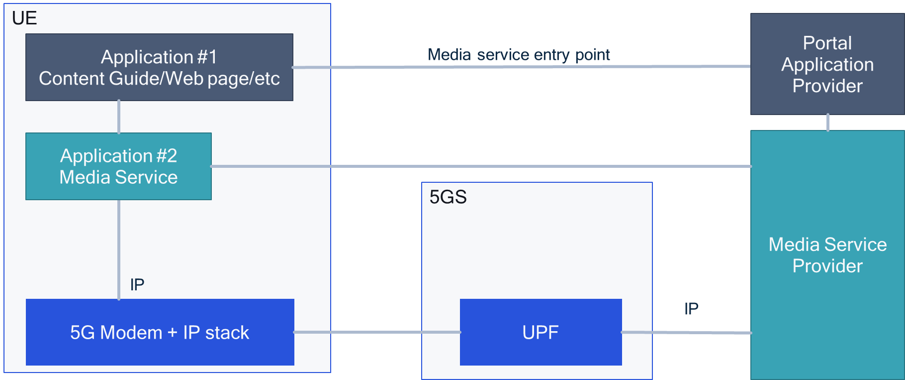
Figure 5.13.1-1 Baseline Architecture – Third-party Service Over-the Top
In this scenario, UE applications are not assumed to have knowledge of 5G Media Streaming, for example a DVB-I Client. Hence, the terms Media Service Application and Portal Application are used throughout this Key Issue instead of 5GMS-Aware Application.
NOTE: The case where a 5GMS-Aware Application translates a conventional media service entry URL to a 3GPP Service URL is not precluded.
In this context, a Media Service Provider refers to a party that makes use of the 5G System for media delivery, but uses only a subset of the functionalities provided by the 5G System.
The media service is announced in a Portal Application running in the UE, for example a portal web page or similar electronic service guide, as a link published on social media, or as an entry in a DVB-I service list [97]. In all cases, the service announcement includes a media service entry point URL. When a service is selected in the Portal Application, it launches the URL of the corresponding media service entry point.
In the general case, the media service entry point is consumed by a separate Media Service Application in the UE which takes responsibility for interacting with the UE modem to stream the media (downlink or uplink) of the selected media service.
NOTE: In some deployments, the functions of the Media Service Application are a system service provided by the UE Operating System, or the Portal Application and the Media Service Application are fused together and installed as a single application. In such cases, the Portal Service Provider and Media Service Provider are typically a single entity also.
The Android UE Operating System allows a URL to be used by one application to launch a specific other application on the same UE [98]. An application wishing to handle certain URI prefixes does so by declaring a suitable intent filter in its application manifest (a so-called web URI intent declaration).
Android recognises three different types of link:
- Deep links are URIs of any scheme that take users directly to a specific part of an application.
- Web links are deep links that use the HTTP and HTTPS schemes.
NOTE: On Android 12 and higher, clicking a web link (that is not an Android App Link) always shows content in a web browser.
- Android App Links, available from Android 6.0 onwards (API level 23 and higher), are web links that use the HTTP and HTTPS schemes and contain the autoVerify attribute. This attribute allows the application to designate itself as the default handler of a given type of link. Android App Links leverage HTTP URLs and association with a website. If no installed application has declared an intent for the trigger URL, the content at that URL is instead displayed in a web browser, from where the user may be invited to install the application.
iOS supports similar functionalities. Details are for future study.
A basic call flow for the general case (where the Media Service Application is separate from the Portal Application and the Media Service Provider is separate from the Portal Service Provider) is provided in Figure 5.13.1-2.
Figure 5.13.1-2 Baseline call flow – over-the-top third-party service
The call flow is as follows:
- The user installs the Portal Application.
- The user installs the Media Service Application. The manifest of the Media Service Application declares an Intent filter for one or more media entry point URL prefixes.
- The Portal Service Provider receives a media service entry point from the Media Service Provider.
- A UE establishes a connection to the 5G System.
- Through this connection (or by other means) the Portal Application discovers the set of currently available media services and their entry point URLs.
- The user selects a media service in the Portal Application's user interface.
- The Portal Application requests the media service entry point URL corresponding to the media service selected in the previous step.
- Because the media service entry point URL matches one of the declared Intent filters for the Media Service Application, the UE Operating System intercepts the request and instead launches the Media Service Application, passing the URL as a parameter.
- The Media Service Application now requests content from the Media Service Provider.

5.13.2 Collaboration Scenarios and Deployment Architectures
3GPP has developed several specifications whereby a third-party service may use additional 5G System functionalities, either as supporting functions (e.g. 5GMS Media Session Handler and 5GMS AF) or as essential functions (e.g. delivery via MBMS for which an MBMS Client is needed). Such 3GPP-defined functions may be in the UE, in the network, or both. This is shown in Figure 5.13.2-1.
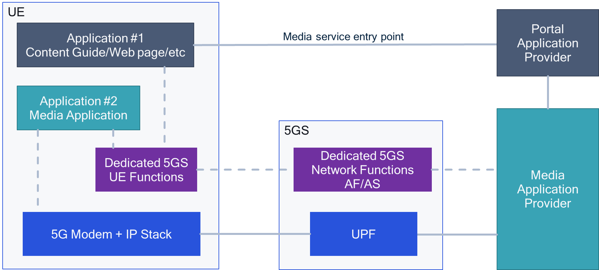
Figure 5.13.2-1 Architecture extended with 5GS functions
Examples of 3GPP-defined functions include, but are not limited to:
- DASH/HLS Service + using MBMS User Services.
- DASH/HLS Service + using 5G Broadcast Services (i.e. MBMS Receive-Only Mode).
- DASH/HLS Service + using MBS User Services.
- DASH/HLS Service + using 5G Media Streaming functionalities.
- XR Service using 5G Edge Enablers.
The third-party service may be served/supported through a 5G System. In order to do so, a dedicated client function needs to be initialized in order to carry out specific functions, for example:
- MBMS Client (UE) and BMSC (see TS 26.346 [54] and TS 26.347 [99]).
- MBS Client (UE) and MBSF/MBSTF (see TS 23.247 [101], TS 26.501 [15], TS 26.512 [16]).
- 5GMS Media Session Handler (UE) and 5GMS AF (see TS 26.501 [15], TS 26.512 [16]):
  - Consumption Reporting.
  - Metrics Reporting.
  - Dynamic Policies.
- 5G Broadcast Receiver (UE).
- Edge-Enabler Client (UE) and Edge Application Server.

5.13.3 Mapping to 5G Media Streaming and high-level call flows
Figure 5.13.3-1 provides the potential call flow for launching a dedicated 5G System function.
Figure 5.13.3-1 Call flows to launch dedicated 5G System functionalities
The call flow is as follows:
- The Portal Service Provider receives a media service entry point from the Media Service Provider.
- The Media Service Provider establishes a provisioning session with the 5G System for the service.
- A UE establishes a connection to the 5G System.
- Through this connection (or by other means) the Portal Application discovers the set of currently available media services and their entry point URLs.
- The user selects a media service in the Portal Application's user interface.
- The Portal Application requests the media service entry point URL corresponding to the media service selected in the previous step.
- Once the entry point is received, now by some magic, the device-centric dedicated 5GS UE function (e.g. 5GMS Media Session Handler, MBMS Client, MBS Client, etc.) is launched.
- Once launched, the UE connects to the peer network functions (e.g. 5GMS AF, BM-SC, MBSF, etc.) and establishes additional functionality.
- By another magic, the Media Service Application is automatically launched.
NOTE: If the Media Service Application is fused with the Portal Application, this launch step is an internal function call.
- The Media Service Application now requests content from the Media Service Provider and is supported by the 5G System function launched in step 7.
In particular, the magic execution in steps 7 and 9 have not been discussed in detail before now. Different implementation options may exist but may require changes to existing applications.

5.13.4 Potential open issues

5.13.4.1 Overview
As indicated in clause 5.13.3, the main open question in relation to the present document is how the dedicated 5G functions (e.g. 5GMS Media Session Handler, MBMS Client, MBS Client, etc.) are launched. A few options are considered in the following.
1: An API is created to the device function and the application initializes the function through these APIs – this is, for example, what TS 26.347 [99] assumes.
- Problem: the application on the device needs to have specific provisioning to establish this function.
- Unlikely to be broadly available.
2: Using a non-HTTP(S) URL as a Media Entry Point that resolves the link by specific handling.
- This option is, for example, done for MBMS User services in TS 26.347 [99].
- The URL contains sufficient information to access the service.
- However, the problem here is that the URL is not automatically handled by the UE Operating System (e.g. Android) or browser.
3: Using an HTTP(S) URL as a Media Entry Point that triggers some specific actions
- This allows the service to be activated by the user simply "clicking" it, or by advertising the link in some portal-based user experience. For example, HTTP URLs in SMS text messages are "clickable" in Android.
- Once the user has selected the link described by the URL, the service bootstraps by setting up the appropriate 3GPP functions and connects to the network.
In particular option 3 is attractive because it is aligned with existing application development practices. The main issue is to consult a UE-resident URL handler/resolver that bootstraps the service URL and does all the appropriate actions, for example:
- Enable MBMS reception,
- Set up a 5G Media Streaming session (Media Session Handler – 5GMS AF) and so on.
- In one specific case at least (MBMS Receive-Only Mode service) this needs to be done only on the UE.
The basic idea is to specify 3GPP-defined HTTP URLs that:
- Initiate execution of this service bootstrapping with a basic function on the UE to support:
- Initiating some pre-installed functions (e.g. Receive-Only Mode operation).
- Launching device functions.
- Allow additional network functions to support the resolution of the service URL, for example go to a specific AF providing more service-related information and launching network functions.
Until now, 3GPP has avoided the detailed question of how to bootstrap 5G Media Streaming and has deferred such aspects to implementation, device pre-configuration, and so on. We understand that device pre-configuration such as OMA Device Management (DM) is no longer broadly in operation.
Hence, candidate solutions for adding a 3GPP Service Handler in the UE and network for the purpose of 5GMS service launch are considered in the following clause, as shown in Figure 5.13.4-1.
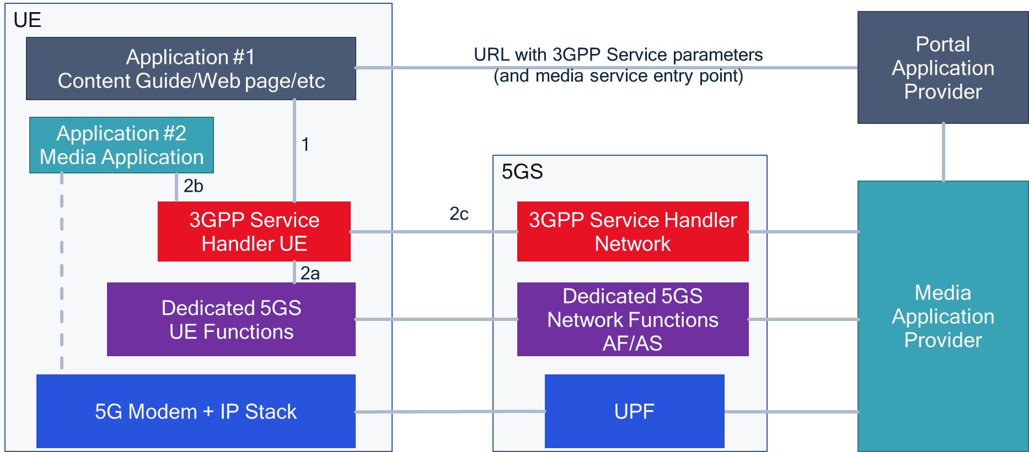
Figure 5.13.4-1 Architecture with 3GPP Service Handler
Based on the Figure 5.13.4-1, different potential solutions exist:
1: Network-only resolution:
- Request URL is constructed such that it is resolved in a dedicated 3GPP network function.
- Request URL resolves to a network function that triggers some support function in network.
- Network function returns media service entry point URL to the UE, for example in the form of an HTTP(S) redirection.
NOTE: This network functionality resembles that of the DVB-MABR Multicast rendezvous service when it is deployed in the network (see clause 6.1 of ETSI TS 103 769 [100]).
- Media Service Application is launched based on returned media entry point URL, for example by means of Android App Link intent.
2: UE-only resolution:
- Request URL is a 3GPP Service URL constructed to include service information, service parameters and media entry point URL.
- In this case, the 3GPP Service URL triggers the handling of the URL by:
- Launching the dedicated 5G System functions based on the URL parameters.
- Launching the Media Service Application using the media entry point URL extracted from the 3GPP Service URL, for example by means of Andoid App Link intent.
3: Combined UE- and Network-based resolution:
- Request URL is a 3GPP Service URL constructed to include service information as well as possibly service parameters and media entry point URL.
- In this case, the 3GPP Service URL triggers the handling of the URL by:
- Communicating with the network function to establish functions in the network (possibly getting additional service parameters and media entry point URL).
- Launching the dedicated 5G System functions based on the URL parameters in the UE.
- Launching the Media Service Application using the media entry point URL extracted from the 3GPP Service URL, for example by means of Android App Link intent.
All three solutions are valid and are discussed in more detail in the remainder of this clause.

5.13.4.2 Network-only resolution
If no handler is available for the media service entry point URL on the UE, it simply resolves to a 3GPP network function. This scenario is shown in Figure 5.13.4.2-1. The application provider’s media service entry point URL is directly handled in the UE.
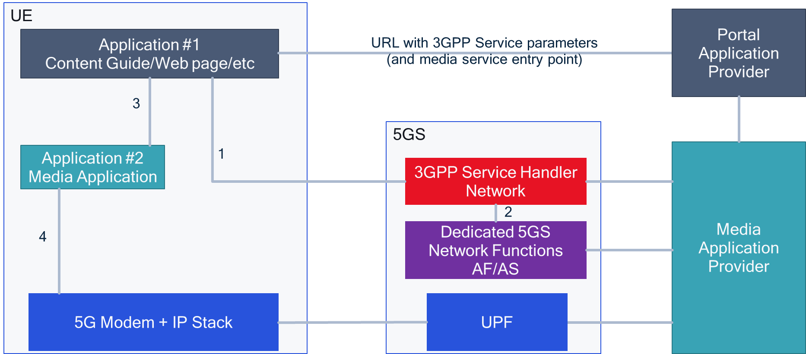
Figure 5.13.4.2-1 Architecture with 3GPP Service Handler in network only
Figure 5.13.4.2-2 provides the potential call flow for a network-only solution.
Figure 5.13.4.2-2 Call Flow with 3GPP Service Handler in network only
The call flow is as follows:
- The Portal Service Provider receives a media service entry point from the Media Service Provider.
- The Media Service Provider establishes a provisioning session with the 5G System for the service.
- A UE establishes a connection with the 5G System.
- Through this connection (or by other means) the Portal Application discovers the set of currently available media services and their entry point URLs.
- The user selects a media service in the Portal Application's user interface.
- The Portal Application requests the media service entry point URL corresponding to the service selected in the previous step. This points directly to the 3GPP Service Handler in the network.
- The 3GPP Service Handler in the network launches the relevant network function(s).
- The 3GPP Service Handler in the network redirectsthe Portal Application to the Media Service Application by returning a URL matching one of the declared intents of the Media Service Application.
- The Media Service Application is automatically launched based on the URL
- The Media Service Application now requests content from the Media Service Provider and is supported by the 5G System function.

5.13.4.3 UE-only resolution
In a second case, the URL is resolved by a 3GPP Service Handler function in the UE. This scenario is shown in Figure 5.13.4.3-1. The application provider URL is directly handled in the UE.
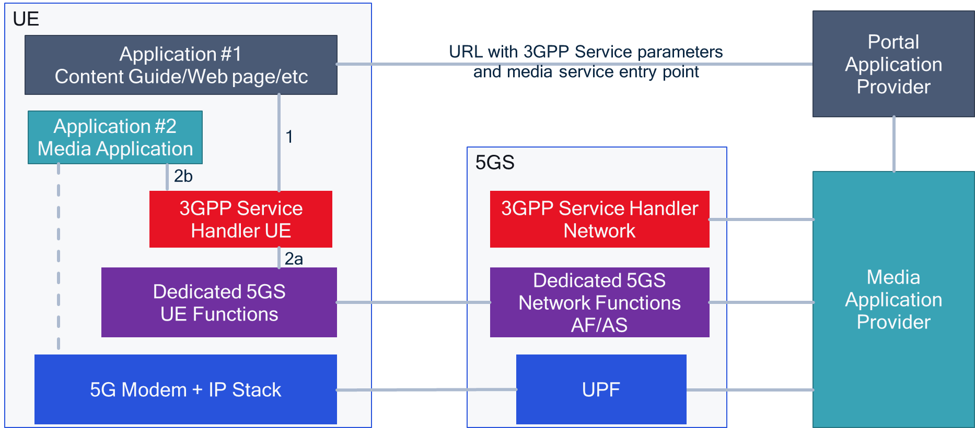
Figure 5.13.4.3-1 Architecture with 3GPP Service Handler in UE for launch
Figure 5.13.4.3-2 provides the potential call flow for a UE-centric solution.
Figure 5.13.4.3-2 Call flow with launch using UE-based 3GPP Service Handler
The call flow is as follows:
- The Portal Service Provider receives a media service entry point from the Media Service Provider.
- The Media Service Provider establishes a provisioning session with the 5G System for the service.
- A UE establishes a connection to the 5G System.
- Through this connection (or by other means) the Portal Appliction discovers the set of currently available media services and their entry point URLs.
- The user selects a media service in the Portal Application's user interface.
- The Portal Application requests the media service entry point URL corresponding to the media service selected in the previous step, which points to the UE-based 3GPP Service Handler.
- The Service Handler in the UE launches the relevant dedicated 5GS UE function (e.g. MBMS Client, MBS Client).
- The dedicated 5GS UE Function (e.g. MBMS Client, MBS Client) may collect information received over the network.
- The 3GPP Service Handler also launches the Media Service Application on the UE using the URL for the media service in the way described in clause 5.13.1, for example through Android app links.
- Inter-process communication is established between the Media Service Application, 3GPP Service Handler on the UE and the Dedicated 5GS UE Function (e.g. MBMS Client or MBS Client).
- The Media Service Provider sends content directly to the Dedicated 5GS UE Function (e.g. MBMS Client or MBS Client) via the Dedicated 5GS Network Function (e.g. BM-SC or MBSTF).
- The Media Service Application now requests content from the Dedicated 5GS UE Function (e.g. MBMS Client or MBS Client.

5.13.4.4 UE- and network-based resolution
In a third case, the URL is resolved in a 3GPP Service Handler function that is distributed between the UE and the network, as shown in Figure 5.13.4.4-1. The application provider URL is directly handled in the UE-based 3GPP Service Handler, but additional service parameters may be obtained by it from the network-based 3GPP Service Handler.
Figure 5.13.4.4-1 Architecture with 3GPP Service Handler combined in network and UE
Figure 5.13.4.4-2 provides the potential call flow for a combined solution.
Figure 5.13.4.4-2 Call flow with 3GPP Service Handler with combined solution
The call flow is as follows:
- The portal service provider receives a media service entry point from the Media Service Provider.
- The Media Service Provider establishes a provisioning session with the 5G System for the service.
- A UE establishes a connection to the 5G System.
- Through this connection (or by other means) the Portal Application discovers the set of currently available media services and their entry point URLs.
- The user selects a media service in the Portal Application's user interface.
- The Portal Application requests the media service entry point URL corresponding to the media service selected in the previous step, which points to the local 3GPP service handler.
- The UE-based 3GPP Service Handler may collect additional service parameters from its peer network-based 3GPP Service Handler.
- The UE-based 3GPP Service Handler launches the Dedicated 5GS UE Function (e.g. 5GMS Media Session Handler, MBMS Client, MBS Client, etc.). Launch may be achieved by invoking the defined APIs of the Dedicated 5GS UE function, for example those for the MBMS Client defined in TS 26.347 [?]. If these APIs do not exist, then the the UE-based 3GPP Service Handler and the Dedicated 5GS UE Function may be considered "one" functional block and this step is an function call internal to that block.
- The Dedicated 5GS UE Function may collect information from its peer Dedicated 5GS Network Function (e.g. 5GMS AS, BM-SC, MBSF, etc.).
- The UE-based 3GPP Service Handler also launches the Media Service Application on the UE.
- Inter-process communication between the Media Service Application, UE-based 3GPP Service Handler and the Dedicated 5GS UE Function is established.
- The Media Service Application now requests content from the Media Service Provider using the URL for the media service in the way described in clause 5.13.1, for example through Android app links, or by using the APIs defined by the Media Service Application to hand over the media URL.

5.13.5 Candidate Solutions – 3GPP Service and URL handler

5.13.5.1 Solution 1: 3GPP Service and HTTP URL handler
In order to address the cases in clause 5.13.4, it is proposed to:
- Register an Internet domain name for 3GPP services as part of 3GPP specifications such that they can be referenced under a controlled URL, e.g. http://services.3gpp.org and https://services.3gpp.org.
- Verify ownership of the domain through one of the Android website association methods.
- Create a website/redirection mechanism in case the application is not available on the device.
- The URL itself needs to be constructed in such a way that it can be resolved to the media service, for example by embedding the media entry point URL.
- Specify an application that realises the UE-based 3GPP Service Handler which declares an intent filter so that the application acts as the default handler for the 3GPPP Services domain name registered above. The intent filter includes the following declarations:
- The DEFAULT category to allow the application to respond to implicit intents.
- The BROWSABLE category in order for the intent filter to be invoked when clicking a link in a browser.
- <data> tags including the android:scheme attribute for both HTTP and HTTPS.
- A <data> tag including the android:host attribute with the registered 3GPP Services domain.
- Verify ownership details see here.
An example intent filter is provided below:
<intent-filter android:autoVerify="true">
<action android:name="android.intent.action.VIEW" />
<category android:name="android.intent.category.DEFAULT" />
<category android:name="android.intent.category.BROWSABLE" />
<data android:scheme="http" />
<data android:scheme="https" />
<data android:host="services.3gpp.org" />
</intent-filter>

Based on this setup, the following set of actions and calls happen:
1. A 3GPP Service Handler background service is pre-installed on the UE by the vendor or installed once by the user. The manifest includes an intent filter that declares an interest in the 3GPP Services domain.
2. The Media Service Provider has a service with an entry point URL.
3. The Media Service Provider negotiates all service parameters with the 5G Sytem (provisioning).
4. The Media Service Provider creates a bootstrapping URL (much like a landing page URL).
- http://services.3gpp.org/<service parameters>/<URL to application service>
Example service parameters could include:
- 5gms with a 5GMS Provisioning Session identifier to indicate the necessity to launch the 5GMS Media Session Handler.
- mbms with MBMS parameters for Receive-Only Mode operation to indicate the necessity to launch the MBMS Client.
- mbs with an MBS Service identifier to indicate the necessity to launch the MBS Client.
- ims to indicate use of the IP Multimedia Subsystem.
- etc.
5. The Media Service Provider provides:
- Only the 3GPP Service URL to a Portal Service Provider, search engine, etc., if the service requires 3GPP service launch. This may embed the the service entry point URL.
- Both the service entry point URL and the 3GPP Service URL, if the 3GPP service is only an enhancement to launch the third-party service.
6. The Portal Service Provider provides these URLs to the Portal Application running on the UE, e.g. as part of a script, for display in a web page etc..
When the service is selected by the user, the Portal Application requests the 3GPP Service URL:
7. If the 3GPP Service Handler is installed, the 3GPP Service Handler application is invoked in the background by the mobile Operating System via its registered intent filter to handle the URL and:
- Uses the service parameters to establish the 3GPP service in the background (if appropriate or available) and potentially connects to the network.
- Extracts the media service entry point URL from the 3GPP Service URL and uses it to the Media Service Application.
- Establish inter-process communication with other UE functions, as required.
- The Media Player may be launched by the service handler, if separate from the Media Service Application.
8. If the 3GPP Service Handler applicatiom is not yet installed:
- A network service is called and runs the 3GPP Service URL resolution. In the simplest case, this resolution redirects to the media service or
- a 404 is returned by the UE Operating System and the Portal Application either terminates the service or uses the alternate over-the-top entry point.

5.13.5.2 Solution 2: Extended Media Service Application URL
In this case the media service URL is extended with query parameters (or similar) of interest to the 3GPP Service Handler. This requires the Media Service Application to understand that it requires/benefits from a 3GPP service and requires it to launche the 3GPP Service Handler application. The Media Service Application needs to be specifically built for this, adding for example intent filters.
http://<media service application host and path>/?3GPP-service=<service parameters or URL>

5.13.5.3 Solution 3: Dedicated URL and DNS Resolution
In another option, at least the first option may be addressed with a DNS resolution. In this case
- A common 3gpp: URL scheme automatically launches a 3GPP resolver.
- The 3GPP resolver uses DNS service resolution to request SRV records.
- The resolution provides all required service parameters.
- In case of Receive-Only Mode operation, DNS service resolution may happen within the UE based on pre-configuration.
- Alternative or new record types may be defined.
- URI DNS record may be suitable for this use case.
mbs://netflux.com/series8 mbs URI-DNS DNS query URI dns://netflux.com
An example URI DNS record is provided as follows:
_mbs-rom._tcp IN URI 10 1 "http://www.example.com/path/service-announcement"
Figure 5.13.5.3-1 provides a service architecture with DNS functionality.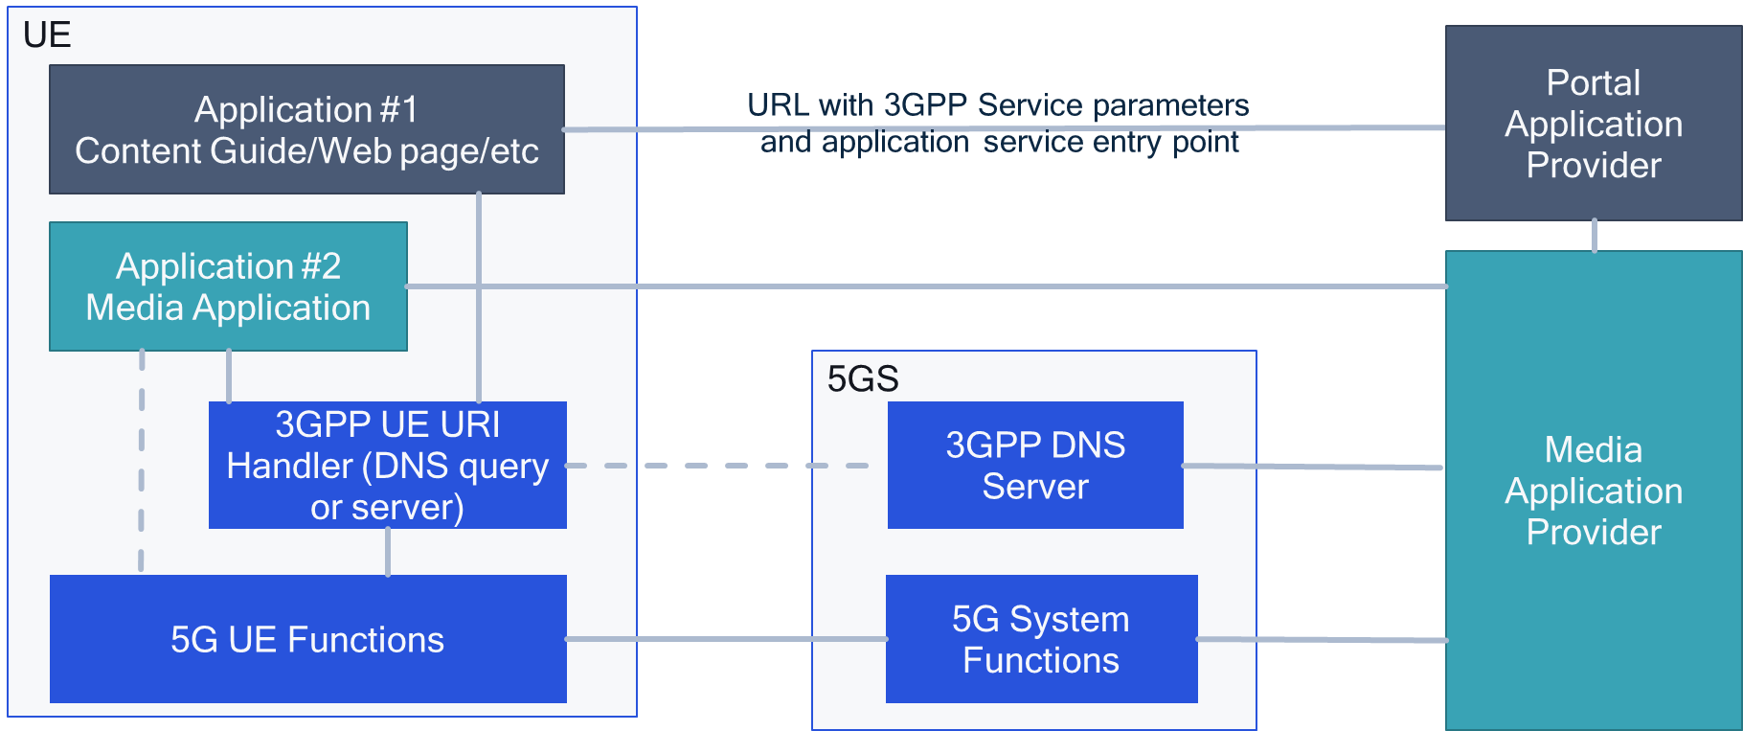
Figure 5.13.5.3-1 Service architecture with DNS functionality
The problem with such an approach is that the URL does not use the HTTP scheme and hence is not supported by the Android intent filter mechanism. A dedicated DNS query would have to be implemented.

5.13.5.4 Assessment of solutions
Solution 1, registering a 3GPP Service domain for use in URLs as described in clause 5.3.5.1, has multiple benefits in comparison with the other candidate solutions:
- URL is clickable, and can for example be added to web pages, text messages and so on. This is not the case for solution 3.
- If service is not found, this can be returned to portal and alternative URL may be used.
- Can be applied for any third-party application and does not require any changes to app. This is not the case for solution 2.
- Is likely extensible also to iOS to install a similar function on the device.
- Service can be launched including Interprocess Communication (IPC). Not the case for solution 2 and 3.

5.13.5.5 Open issues
A few open issues still exist, but may be left to implementation:
- It is unclear if the 3GPP Service Handler application can be launched as a background service on common UE Operating Systems.
- How could this model work for webRTC-based services?
- Does the service scale properly?
- What are security/authorization aspects?
- What are the implications of every MNO running its own 3GPP Service Handler as a background service?
- Can such a 3GPP Service Handler be pre-installed on a device by the UE vendor as a common UE Operating System function?
- API communication between 3GPP Service Handler and third party-application may not be established.
- How can the life-cycle of the 3GPP Service Handler background application managed and monitored?

5.13.6 Specific case: MBMS-ROM Service + CMAS-based launch of service
In this case, an Emergency Service Provider also wants to distribute the Emergency Alerts through LTE-based 5G Broadcast. This is for example relevant in at least two cases:
1. UE consumes service from broadcast network and hence is camped on the LTE-based 5G Broadcast ROM service and therefore receives the SIB messages from the MBMS ROM system.
2. MNO PLMN is not accessible and therefore the UE camps on the broadcast network because it is the only available system, for example in disaster situations during which the mobile network is not up and running, or in remote coverage areas.
In addition, an Emergency Media Broadcast Service may be provided. Assume the setup documented in Figure 5.13.6-1.
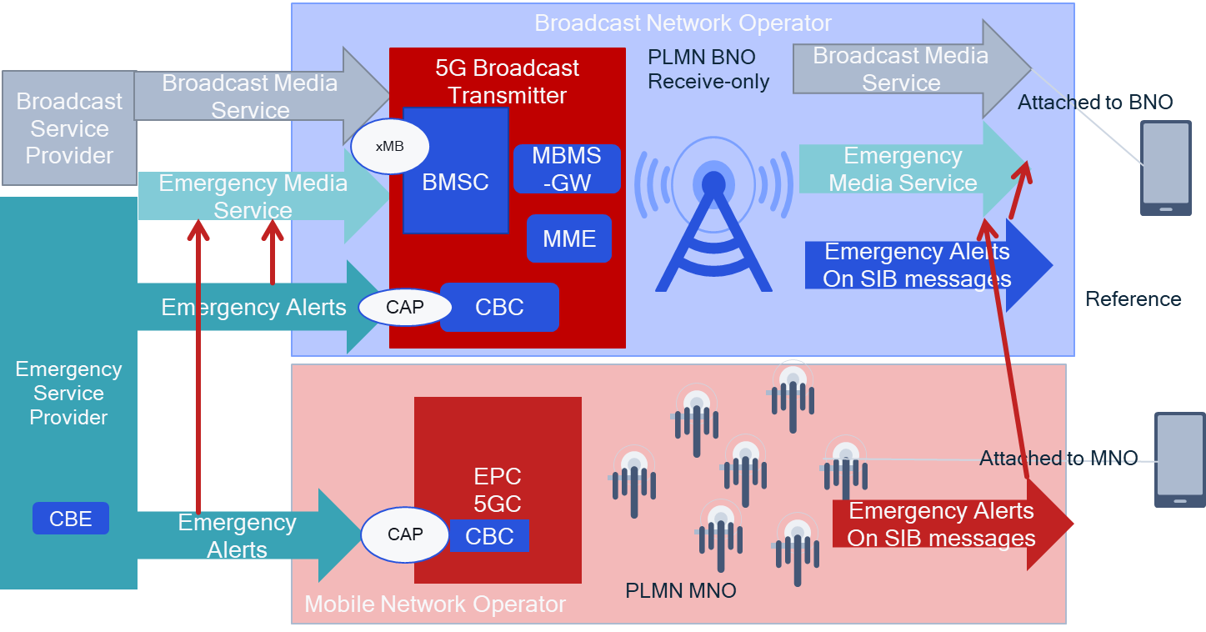
Figure 5.13.6-1 Potential Architecture for Emergency Warning through 5G Broadcast with pointers to media services
Using the principles of Solution 1,
- Define a URL for 3GPP services as part of 3GPP specifications, e.g. services.3gpp.org
- Define a service sub-domain mbms
- Add the relevant parameters from mbms-URL as defined in TS 26.347, clause 8.4 to the URL
- In operation,
- install a background app that handles the URL.
- Emergency media application provider has a service and wants to provide it through MBMS.
- The 3GPP System provides a URL to the Emergency service provider with all relevant parameter
- http://3gpp-services.com/mbms/<service parameters>/<URL to application service>
- The Emergency media application service provider provides to the CMAS provider.
- Only the 3GPP MBMS Service URL, if the service is only available over MBMS.
- Both URLs, the unicast and the 3GPP service URL, if the 3GPP service is available on both.
- The emergency service provider adds the URLs to a CMAS message as a textual description.
- The user reads the message and clicks on the 3GPP Service URL.
- The click deep-links to the 3GPP Service app and the service app.
- identifies MBMS and launches the MBMS client.
- Identifies the third-party entry point and launches the URL.
Figure 5.13.6-2 provides the architecture and messages exchanged for the above use cases.
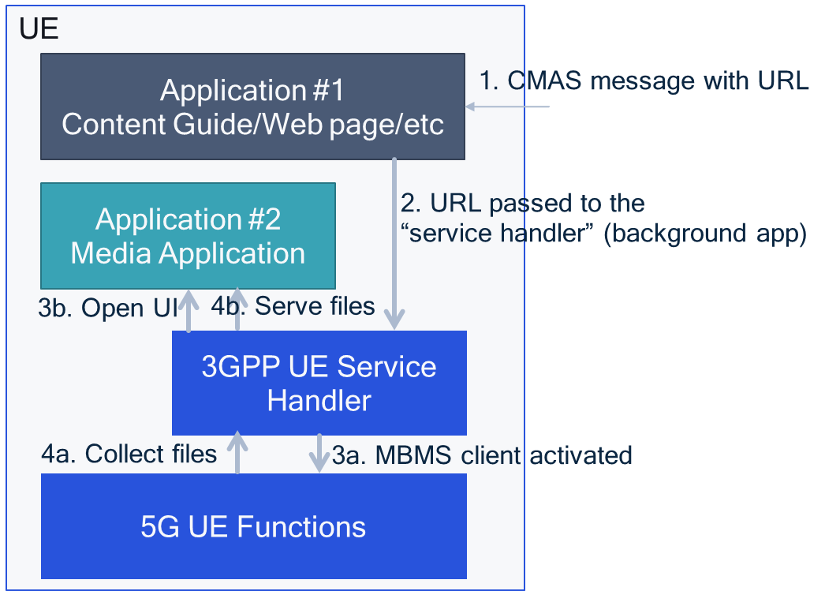
Figure 5.13.6-2 Architecture and messages to CMAS-based service launch
The following call flow and actions happen.
1. User gets emergency notifications, click on “registered” URL.
2. Android system sends the URL to the service handler (background app).
3. The service handler does two things:
a: Start the middleware based on part of the URL (e.g. frequency, TMGI).
b: Start the application and send a URL.
4. The “UE Service Handler” serves as an HTTP proxy for the Application#2.
a. Gets files from the MW.
b. Serves files to Media app.
In this case, it may not be necessary that the URL includes the application service entry point, but the entry point is included in a service announcement file related to the 5G UE functions. As an example, the service entry point is part of the MBMS User Service Description.

5.13.7 Conclusion
Until now, 3GPP specifications for 5G Media Streaming have avoided addressing the detailed question of how to bootstrap 3GPP-defined UE and network functions such as the Media Session Handler or the MBMS/MBS Client. This is deferred to implementation, device pre-configuration, and so on. However, the lack of specification covering this Key Issue is hindering adoption of 5GS-supported media services because today UE applications may have to be modified in order to support such services.
3GPP defines the ability to use DNS Resolution and non-HTTP URL handling. However, handling non-3GPP URLs in common devices is not broadly supported by commonly available high-level UE Operating Systems and HTTP-based URL handling is preferred. Of the candidate solutions studied in clause 5.13.5, Solution 1 (clause 5.13.5.1), namely creating an HTTP(S) URL that is 3GPP-owned, is preferred.
Based on this conclusion, it is proposed to:
- Extend the baseline 5G Media Streaming architecture to add a 3GPP Service and URL Handler in the UE and the network according to Figure 5.13.4-1.
- Address provisioning, message exchange and call flows in order to support different use cases, namely the case for which the URL is resolved in the network, the URL is resolved in the UE, and the case for which the URL is resolved in a combination of network and UE as discussed in clause 5.13.4.
- Specify a concrete URL format for 3GPP services and reserve a URL prefix (e.g. services.3gpp.org) for 3GPP Services as part of 3GPP specifications, and ensure that this can be used in the context of 3GPP-based services, namely:
- Verify ownership of the domain through one of the Android website association methods.
- Create a suitable website redirection mechanism in case the application is not available on the device.
The URL itself needs to be sufficiently unambiguous to resolve to the service entry point URL and may embed the service entry point URL as well.
- Specify 3GPP Service URL instantiations with parameters suitable for launching at least the Media Session Handler for 5G Media Streaming, MBMS Client (including Receive-Only Mode services) and MBS Client.
- Provide the ability for a 5GMS-Aware application to create a Service URL in order to bootstrap 5G Media Streaming.
- Investigate and study the application of 3GPP services and URL handling beyond 5G Media Streaming.
===== CHANGE (NEW Clause - changes compared to S4aV230016) =====

6.13 3GPP Service Handler and URLs
Until now, 3GPP specifications for 5G Media Streaming have avoided addressing the detailed question of how to bootstrap 3GPP-defined UE and network functions such as the Media Session Handler or the MBMS/MBS Client. This is deferred to implementation, device pre-configuration, and so on. However, the lack of specification covering this Key Issue is hindering adoption of 5GS-supported media services because today UE applications may have to be modified in order to support such services.
3GPP defines the ability to use DNS Resolution and non-HTTP URL handling. However, handling non-3GPP URLs in common devices is not broadly supported by commonly available high-level UE Operating Systems and HTTP-based URL handling is preferred. Of the candidate solutions studied in clause 5.13.5, Solution 1 (clause 5.13.5.1), namely creating an HTTP(S) URL that is 3GPP-owned, is preferred.
Based on this conclusion, it is proposed to:
- Extend the baseline 5G Media Streaming architecture to add a 3GPP Service and URL Handler in the UE and the network according to Figure 5.13.4-1.
- Address provisioning, message exchange and call flows in order to support different use cases, namely the case for which the URL is resolved in the network, the URL is resolved in the UE, and the case for which the URL is resolved in a combination of network and UE as discussed in clause 5.13.4.
- Specify a concrete URL format for 3GPP services and reserve a URL prefix (e.g. services.3gpp.org) for 3GPP Services as part of 3GPP specifications, and ensure that this can be used in the context of 3GPP-based services, namely:
- Verify ownership of the domain through one of the Android website association methods.
- Create a suitable website redirection mechanism in case the application is not available on the device.
The URL itself needs to be sufficiently unambiguous to resolve to the service entry point URL and may embed the service entry point URL as well.
- Specify 3GPP Service URL instantiations with parameters suitable for launching at least the Media Session Handler for 5G Media Streaming, MBMS Client (including Receive-Only Mode services) and MBS Client.
- Provide the ability for a 5GMS-Aware application to create a Service URL in order to bootstrap 5G Media Streaming.
- Investigate and study the application of 3GPP services and URL handling beyond 5G Media Streaming.
===== CHANGE =====

7 Recommendations
5G Media Streaming provides significant opportunities to integrate operator and third-party media streaming services into 5G Systems. The report provides at set of considered extensions to 5G Media Streaming as defined in TS 26.501, as well as the format and protocol specifications in TS 26.511 and TS 26.512, respectively. Advances in 5G System technologies, external enhancement and developments in other SDOs such as IETF, DASH-IF or MPEG, as well as initial experiences from deployments have led to a set of conclusions in clause 6.
Based on the details in the report, the following next steps are proposed.
1. Initiate stage 2 and stage 3 work on Network Event usage based on the conclusions in clause 6.8. Note that this is already addressed in TS 26.531 [94] and TS 26.532 [95], respectively.
2. Provide relevant extensions to the 5G Media Streaming architecture based on the conclusions in clause 6. Candidates for these extensions are:
a) Content preparation deployment scenarios and associated call flows in Stage 2 according to clause 6.2.
b) Inclusion of collaboration scenarios and associated call flows in Stage 2 for uplink media streaming according to clause 6.5.
c) Inclusion and extensions of procedures and call flows for end-to-end low latency live streaming based on the conclusions in clause 6.11.
d) Architecture for 3GPP Service Handler and 3GPP Service URLs including architecture extensions and call flows based on the conclusions in clause 6.13.
3. Provide relevant extensions to 5G Media Streaming protocols and formats based on the conclusions in clause 6. Candidates for these extensions are:
a) Stage-3 follow-up work from 5G Media Streaming architecture extensions referred to above based on conclusions in clauses 6.2, 6.5, or 6.11.
b) Extensions to 5GMS protocols to support traffic identification based on the conclusions in clause 6.3.
c) Addition of HTTP/3 to the 5GMS protocols as an optional alternative based on the conclusions in clause 6.4.
d) Addition of necessary parameter extensions to the M1, M5, and M6 reference points to provide access to Background Data Transfer based on the conclusions in clause 6.6.
e) Specification of the usage of OAuth 2.0 (according to the SA3 guidelines) for 5GMS protocols based on the conclusions in clause 6.9.
f) Specifications for the 3GPP Service Handler and 3GPP Service URL including the necessary UE functions to support automatic launch of 5G System services in the context of 5G Media Streaming based on the conclusions in clause 6.13.
4. Continue the study of additional extensions to 5G Media Streaming. Potential candidate topics based on this Technical Report are:
a) Content-aware streaming based on the initial considerations in clause 5.7.
b) Study even lower-latency streaming technologies based on the use cases and considerations of the DASH-IF WebRTC streaming report [94].
c) Distribution of encrypted and high-value content based on the considerations in clause 5.10.
d) Network slicing extensions for 5G Media Streaming based on the conclusions in clause 6.12.
All work topics will benefit from continuously checking relevance and support across 3GPP members. In addition, close coordination with other groups in 3GPP on 5G System and radio-related matters, edge computing, applications, operational management and security as well, in communication with experts in MPEG, DASH-IF, CTA WAVE on DASH, HLS and CMAF, as well as with IETF on new protocols.

