Source: Samsung Electronics Co., Ltd. (Rapporteur)
Title: [FS_AI4Media] Permanent Document v0.4
Version: 0.4
Agenda Item: 15.3
Document for: Agreement

1 Introduction
During SA4#117-e the New Study Item on “Artificial Intelligence (AI) and Machine Learning (ML) for Media” in S4-220226 was agreed and afterwards approved in by SA#95e in SP-220328.
The objective of this study item are primarily to identify the media service architectures and relevant service flows, model operation configurations, data components including available data formats, and the data traffic characteristics in AI/ML for media related services. Key performance indicators and performance metrics are also identified.
The concrete objectives are as follows:
- List and describe the use cases for media-based AI/ML scenarios, based on those defined in TR 22.874.
- Describe the media service architecture and relevant service flows for the scenarios, identifying for each use case the impacts on the architecture, including any potential gaps with existing 5G media service architectures. Also describe the model operation configurations for each use case, including split AI/ML operations, identifying where certain AI/ML operations occur.
- Identify and document the available data formats and suitable protocols for the exchange of different data components of various AI/ML models, such as model data, metadata, media data, and intermediate data necessary for such model operation configurations. Also investigate the data traffic characteristics of these data components for delivery over 5G system, including whether there are any needs and potentials for data rate reduction.
- Identify and study key performance indicators for such scenarios, based on the initial considerations in TS 22.261, with additional emphasis on the use cases, model operation configurations and data components as identified in earlier objectives, focusing on objective performance metrics considering the KPIs identified.
- Identify potential areas for normative work as the next phase and communicate/align with SA2 as well as other potential 3GPP WGs on relevant aspects related to the study.

2 AI/ML work in 3GPP WGs
This clause documents the 3GPP activity related to AI/ML in other Working Groups.
- SA1 has completed an initial study item on traffic characteristics and performance requirements for AI/ML model transfer in 5GS (FS_AMMT), documented in TR 22.874. This technical report describes a variety of different use cases for AI/ML in 5G, with many that are related to media services. The media related use cases described in TR 22.874 are used as a basis for those listed and described in clause 4.2 of this TR. Resulting from this study item, SA1 has completed related normative works by way of multiple CRs on TS 22.261 (AMMT), reflecting new service requirements and KPIs for AI/ML model transfer in 5GS. Leading from this initial work, SA1 has also subsequently established a Rel-19 study on AI/ML model transfer phase 2 (FS_AIML_MT_Ph2), the objectives of which are to study new use cases and potential service and performance requirements to support efficient AI/ML operations using direct device connection. This study avoids overlaps with stage-23 work ongoing in Rel-18.
- SA2 is in progress of a study item on system support for AI/ML-based services (AIMLsys). The scope of this study is based on requirements from SA1, including 7 key issues related to the training and inference processes of AI/ML applications, namely monitoring of network resources to support application AI/ML operations, 5GC information exposure to UE and authorized 3rd party, enhancing external parameter provisioning, QoS and policy enhancements, among others.
- SA3 has recently approved a study item on security and privacy of AI/ML-based services and applications in 5G (FS_AIML). The objectives are to identify what security and privacy management is needed for data transmission to application layer AIML, including authentication and authorization of data collection and sharing between UE, AF and the network, and securing of AIML-based services and operations.
- SA5 has a study item on AI/ML management (FS_AIML_MGMT), related to automation and intelligence in 5G, including management and orchestration (e.g. MDA), 5GC (e.g., NWDAF), and NG-RAN. The objectives are to provide validation/testing of models and AIML enable functions, deployment of these models and functions, and configuration and performance evaluation of AIML enabled functions. The study will also investigate what coordination is needed between AIML management capabilities and 5GC AIML capabilities.
- SA6 is in progress of a study on application data analytics enablement service (FS_ADAES), the goal is to study how to provide application layer data analytics as a possible new capability at the enablement layer for supporting the application specific layer to receive useful statistics/predictions for the application service, while complementing the analytics provided by the 5GS.
- RAN1 is in progress of a study on the 3GPP framework for AI/ML for NR air interface. The goal of this study is to explore the benefits of augmenting the air-interface with features enabling improved support of AI/ML based algorithms for enhanced performance and/or reduced complexity/overhead. Enhanced performance here depends on the use cases under consideration and could be, e.g., improved throughput, robustness, accuracy or reliability, etc.
- RAN3 has a study item on specify data collection enhancements and signalling support within existing NG-RAN interfaces and architecture (including non-split architecture and split architecture) for AI/ML-based Network Energy Saving, Load Balancing and Mobility Optimization (AIML_RAN). Normative work is expected to start in Q3 2022.

3 Definition of terms, symbols and abbreviations

3.1 Terms
For the purposes of the present document, the terms given in 3GPP TR 21.905 [1] and the following apply. A term defined in the present document takes precedence over the definition of the same term, if any, in 3GPP TR 21.905 [1].
AI/ML model: a trained AI/ML model.
Model inference: Process by which a deployed machine learning model generates a result [5].
Inference engine: Functionality that provides runtime environment for a machine learning
model and exposes corresponding machine learning model inference capability [5].
AI/ML model subset: an elementary element of an AI/ML model that can be inferred independently.
AI/ML model composition: the composition of an AI/ML Model into one or more AI/ML model subsets.
AI/ML model split points: the points in a DNN AI/ML model where it is split into multiple AI/ML model subsets.
AI/ML inference endpoint: UE or Network inference engine that infers a result from executing an AI/ML model, or a part of it.
Split AI/ML model: an AI/ML model composed of AI/ML subsets that is distributed to, and inferred on different inference endpoints.
Intermediate data: Output from the inference process of an AI/ML model that is not considered the final inference result.

4 Media-based AI/ML use cases and scenarios
TR 22.874 [1] has identified a set of use cases for AI/ML with the following key operations:
- AI/ML operation splitting between AI/ML endpoints;
- AI/ML model/data distribution and sharing over 5G system;
- Distributed/Federated Learning over 5G system.
These operations have been identified as they require exchange of ML and media data over 5G, and in some cases may have some requirements on the QoS for proper operation.
The use cases and scenarios listed in this technical report, which are described in this clause, are based on a selection of the media-based AI/ML use cases identified in TR 22.874 [1].

4.1 Object Recognition in Image and Video
Based on clause 5.1 and 5.2 of TR 22.874 [1], this set of use cases, images and video streams are processed to identify and recognize objects and extract some metadata, such as bounding boxes, object labels, movement counters, etc.
The uses cases are applicable for the different topologies described in clause 5.1, including UE inference only, network inference only and split inferences topologies.
The computationally intensive and memory and power consuming AI/ML inference used to perform this processing requires offloading some inference parts from the mobile device to the edge or a cloud data center.
Split inference of trained ML model(s) for object recognition is distributed between multiple endpoints, typically between the network and UE. Split points may depend on various factors including UE capabilities, network conditions, model characteristics, and user/task specific requirements:
- Device/UE capabilities on running whole or part of model such as the required memory, the processing capabilities, the energy consumption, and the inference latency.
- Network conditions for delivering media and/or the intermediate data. This may include, for example the amount of data to transfer in one shot for an image or at a specific frame rate for video, the required bandwidth in UL and/or DL with different impact on the network load and the related UL and DL network latencies. Network inference latency is also to be considered.
- Model characteristics include split inference with a task-specific model head running on the UE for object recognition. For example, in one UE, the task is to recognize pedestrians, whereas in another it is to recognize traffic signs. The core of the network model as well as the input image/video are the same, but the tasks (and their required task-specific models) in the UEs are different.
- User or task specific requirements. For example, it may be necessary to perform some processing tasks on end-device in order to preserve privacy or because they are delay sensitive operations.
Two main scenarios, both involving either image or video processing are proposed:
- The UE captures images or video and first feeds the input data to the UE inference model (e.g., to preserve privacy). The UE then uploads intermediate output data from the UE inference model to the network inference, which in turn executes the remaining part of the model (e.g., process the intensive computations) and finally returns the results or a processed image/video to the UE.
- Unlike the previous scenario, the UE uploads the captures image or video to the network where a network inference processes inputs video/image, then sends back the intermediate data to the UE inference executing the remaining layers of the model (e.g., task specific operations) and returning the final results.
These scenarios involve the key operation of AI/ML model/data distribution and require the delivery of trained ML model(s) for object recognition to the UE in 5GS, including the selection of models for different tasks or environments and the possible selection of the split points based on the various factors described above
These scenarios also involve the distribution of distributed online training of image and video recognition models based on input from different UEs. Depending on the configuration of the ML training framework, different data may need to be delivered between the UEs and the network. Typically, a shared model in the network is calibrated continuously based on the training results from all UEs. This scenario involves all the three key operations related to AI/ML model distribution, splitting, and distributed/federated learning.

4.2 Video Quality Enhancement in Streaming

4.2.1 Sender-receiver approaches

4.2.1.1 End-to-End neural network-based video coding
Based on clause 5.3 of TR 22.874 [1], in this use case, the sender and receiver apply parts of a DNN model (e.g. an autoencoder model) to enhance the quality of a video stream. An example of an autoencoder DNN is depicted in figure 4.2.1.1-1:
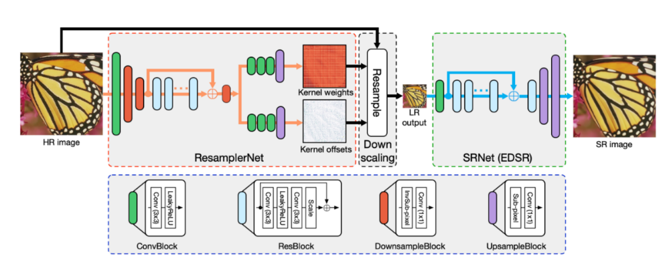
Figure 4.2.1.1-1
The sender is typically represented by various media functions in the network, which processes the high-fidelity video using the down-scaling part of a pre-trained DNN model to an intermediate data stream that is streamed together with a lower resolution encoding of the video. The receiver (UE) runs an inference algorithm (e.g. the up-scaling part of DNN model) on using the received intermediate data and video stream to produce a high-quality video for rendering.
The main scenario in this use case is about streaming intermediate data from the network for processing on the UE, involving AI/ML data distribution and operation splitting.
This use case covers all scenarios where intermediate data stream needs to be sent to the receiver, in addition to a low-resolution video.

4.2.1.2 Neural network based pose-processing for video coding
A neural network (NN) applies post-processing to a decoded video sequence to enhance the quality of the decoded frames. The post-processing is performed outside the coding loop and does not impact the decoding process of the video. Possible post-processing algorithms include:
- Post-filtering: where the output of the video decoder is provided as input to a NN to improve the quality of the decoded frames. Such improvements include removal of video coding artifacts, subjective quality enhancement, etc.
- Super resolution: where a NN is used to increase the resolution of the output video sequence when the resolution of the display is greater than the resolution of the decoded frames. The use of NN-based approaches in super resolution resampling process increases the quality of the resulting resampled frames.
- NN-based HDR enhancement: a NN is applied for example to enhance a SDR video into an HDR-looking video.

In contrast to 4.2.1.1, this approach does not use an intermediate data stream.

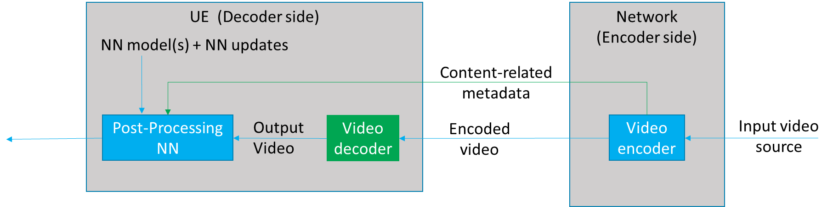
Figure 4.2.1.2-1 Neural network based post-processing for video coding use-case

Figure 4.2.1.2-1 depicts a neural-network-based post-processing use-case where pre-trained NN models are used at the receiver to post-process the decoded video to improve the quality. The video encoder processes the input video source to produce and send content-related metadata to the receiver, based on video/image or block, for example. The content-related metadata can be used to select a pre-trained NN model to be applied to a piece of content and to activate or not the selected NN model on it.

4.3 Crowd-Sourcing Media Capture
This use case and its corresponding scenarios are based on clause 6.2 of TR 22.874 [1]. A set of users attending a live concert and capturing the event on their UEs, use a shared (or a set of shared) DNN model(s) to process and improve their respective captured video and/or audio. Audio and video data may be captured in a noisy environment or an environment with poor lighting conditions. Multiple tasks may then be performed on the processed video and/or audio for media content analysis, e.g. to extract lyrics, annotate the video, improve audio and video quality, translate language, anonymize a face, etc.
This use case involves two different scenarios based on either a device inference or a network inference.

4.3.1 Device inference
The main scenario is to improve the media capture of each UE by using an up-to-date model adapted to the context event.
This scenario may involve the distribution of multiple models to a large number of UEs in a short period of time. The UEs are heterogeneous, running with different types of operating systems (e.g., Android or iOS), supporting different AI/ML engines/frameworks or having different GPU/CPU/NPU and RAM capabilities available for running the AI/ML service on the UE. This will need the distribution of a huge amount of various AI/ML models adapted to the different device capabilities. Depending on each user’s UE, the UE may request the download of a set of DNN models for device inference.
Moving or changing the environment (localization, energy, processing unit, memory, etc.) may need AI/ML model updates, where the DNN models stored in the network may be adapted or updated during the service.
The AI/ML application may optimize the end-to-end latency (e.g., to achieve latency below 1s) or the expected accuracy level of the inference result (e.g., to achieve image recognition precision of 99%) by modifying the model. The desired latency and/or accuracy level can therefore impact the size of the AI/ML model to be distributed. This can be done by:
- optimizing the model accuracy and latency for on-device execution. The model accuracy and execution latency are known, and the optimization may result in bandwidth saving.
- compressing the model for reducing the bandwidth usage and improving the delivery latency. This may affect the accuracy of the model.
If an uncompressed model is sent, accuracy is not affected but delivery latency would depend on the size of the model and the network bandwidth.
The distribution of the AI/ML models for a large number of UEs at the same time may also need to serve the models from different endpoints (e.g., cloud, edge, or other UEs), and may use several or different communication links (e.g. unicast, multicast or broadcast).

4.3.2 Network inference
The main scenario may be the sharing of the input media from multiple sources for network inference, as well as the selection of suitable DNN models according to the UE and/or task.
This scenario requests the UE to upload the media data for network inference. Similarly, to the UE inference, DNN models stored in the network may be adapted or updated during the service for network inferences.

4.4 NLP on Speech
Based on clause 6.3 of TR 22.874 [1], this set of use cases covers a wide range of speech processing use cases, e.g. to perform automatic speech recognition, voice translation, voice commands, speech synthesis, etc.
The AI/ML models for NLP are improved with distributed/federated training using multiple UEs. As more users make use of the service, the quality and accuracy of the models improves. The results of the local training of the models by the UEs are shared with the network.
The main scenario here is about UE downloading a partially trained model identified with its training state for local training, and then sharing the results with the network for distributed/federated learning.

5 Media service architecture for AI/ML

5.1 AI/ML model composition
Figure 5.1-1 depicts an AI/ML model composed of different AI/ML subsets based on various split points. Several compositions of the same AI/ML model are represented by the AI/ML subsets (M0, M1), (M’0, M’1), or (M “0, M “1, M “2) with split points highlighted in red. The same AI/ML subset may be used in different compositions depending on the configurations of the model composition (e.g. M’0 and M ’00 according to figure 5.1-1).

In figure 5.1-1, (a) and (b) are examples of AI/ML inference endpoints running an AI/ML model M composed of two subsets M0, M1. A endpoint (network/UE) may run the AI/ML model subset M0 while downloading the other subset M1.

Examples (c) and (d) demonstrate AI/ML split models where M0, M’0 run on the UE while M1, M1’ run on the network respectively.
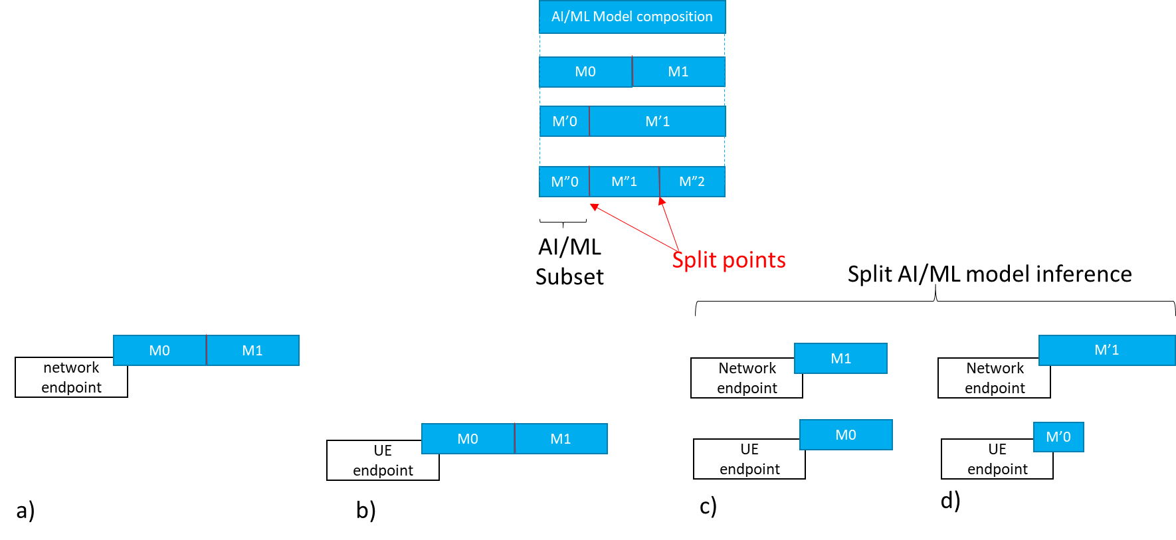
Figure 5.1-1 AI/ML model composition example

5.1.1 Split AI/ML model inference topologies

5.1.1.1 UE as media data source
Figure 5.1.1.1-1 depicts an example of split AI/ML model inference topology where the UE is the media data source and runs the first model subset M0 as described in scenario (a) of clause 4.1 (object recognition). Figure 5.1.1.1-2 depicts another example of a split AI/ML model inference topology where the UE is also the media data source but the network server runs the first subset M0 as described in scenario (b) of clause 4.1. Assuming that the necessary AI/ML model subsets are already available at each endpoint, figure 5.1.1.1-1 and figure 5.1.1.1-2 show the data exchanged between the different split inference endpoints, including input media data, intermediate data, and inference results.

The results can be a textual indication of the recognized object, an output score, a bounding box, enhanced media data, etc.
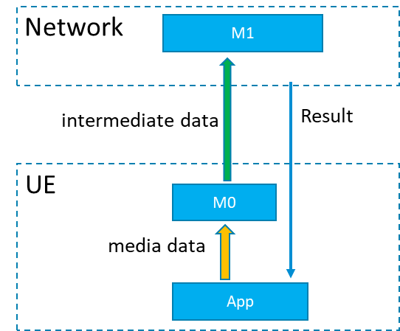
Figure 5.1.1.1-1: Split AI/ML model inference where the UE is the media data source with first inference endpoint on the UE

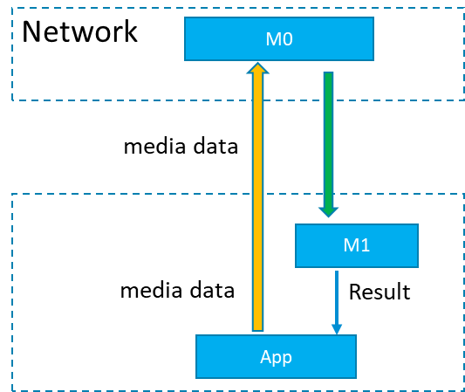
Figure 5.1.1.1-2: Split AI/ML model inference where the UE is the media data source with first inference endpoint on the network

5.1.1.2 Provider/network as media data source
Figure 5.1.1.2-1 depicts examples of split model topologies where the network or the AI/ML provider ingests the media data, such as in the use-case of clause 4.2 (video quality enhancement).
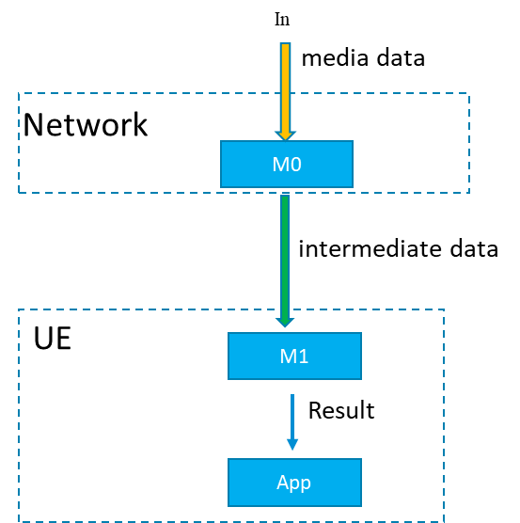
Figure 5.1.1.2-1: Split AI/ML Model inference where the network/ AI/ML service provider ingests the media data

5.2 Architectures and service flows

Considering the related use cases as documented in TR 22.874 and also as documented in the latest version of the Permanent Document, we can start from some basic scenarios for consideration of a basic architecture for AI/ML media services.
The basic starting scenarios are:
- Delivery of a pre-trained AI/ML model from network to UE, typically at the start of an AI media service, but may also require updates during the service. At the most basic level AI/ML models can be delivered as a file (e.g. TensorFlow SavedModel, PDF5, ONNX file, NNEF file etc.) containing all the necessary information required for the UE to perform on device inference using the delivered model. For split scenarios, a (partial) AI model to be used in the UE may be delivered.

- Split inference of a pre-trained AI/ML model(s) with two further sub-scenarios:

  - Basic scenario with an inference in the network or in the UE.
  - Split scenario with inferences between the network and the UE, where the intermediate data output from the network inference (resp. UE inference) is transferred to the UE (resp. network) to be used as the input for UE device inference (resp. network inference). Depending on the characteristics of the intermediate data, such as if the intermediate data is media content data, it may be practical to consider 5GMS architectures, procedures and/or protocols for the streaming delivery of such intermediate media data.

- Distributed/federated learning using multiple UE devices with local training sets, and a central server in the network. Typically a central model is distributed to UEs for local training. UEs use local data available to the device for local training, and training result updates are sent back to the central server, which aggregates and updates the central model. Global updates on the central model are then distributed to the UE devices for continuous training.
NOTE: Compression aspects will be addressed once the digital representation of AI/ML models will be identified together with their associated service requirements (eg. traffic flow characteristics, latency, bitrate…).

5.2.1 Complete/Basic AI/ML model distribution

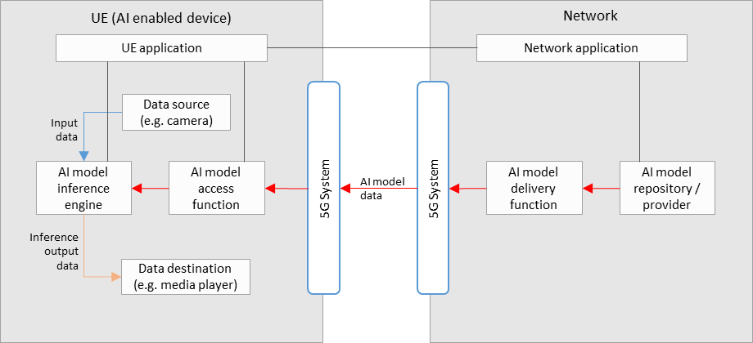
Figure 5.2.1-1: Basic architecture for AI/ML model delivery with inference in the UE
Figure 5.2.1-1 shows a simple basic architecture for AI/ML model delivery, as described in scenario 1) of clause 5.2, with an inference of a pre-trained AI/ML model in the UE, as described in scenario 2a) of clause 5.2.
In the network:
- An AI model in the repository is selected for the AI media service by the network application, and sent to the delivery function for delivery to the UE.
- The AI model delivery function sends the AI model data to the UE via the 5GS. This delivery function may also contain functionalities related to QoS requests and monitoring, as well as those related to the optimization or compression of AI model data.
In the UE:
- A UE application provides an AI media service using the AI model inference engine and AI model access function.
- The AI model access function receives the AI model data via the 5G system, and sends it to the AI model inference engine. Receiver side optimization or decompression techniques for AI model data may be included.
- The AI model inference engine performs inference by using the input data from the data source (e.g. a camera, or other media source) as the input into the AI model received from the AI model access function. The inference output data is sent to the data destination (e.g. a media player).
Depending on the exact service scenario, AI model updates may be necessary during the service, and different AI model data delivery pipelines may be considered for such purposes.

5.2.2 Split AI/ML operation

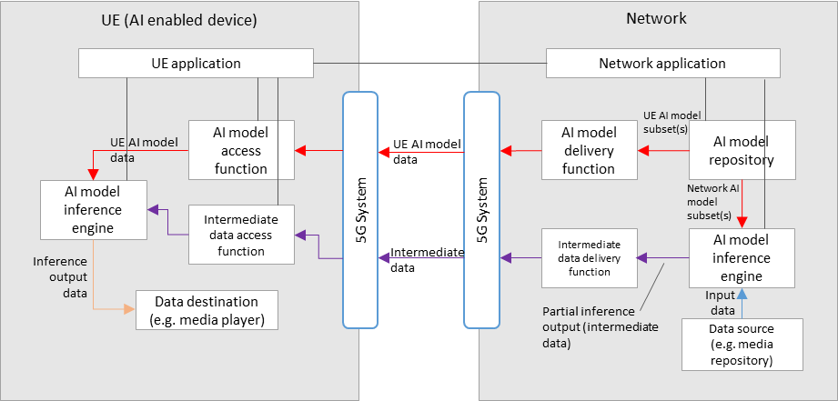
Figure 5.2.2-1: Basic architecture for split inference between the network and UE, with media data source in the network
Figure 5.2.2-1 shows a simple basic architecture for split inferences between the network and the UE, as described in scenario 2b) of clause 5.2, where the media data source is in the network, and the ordering of split inference is first performed in the network, then on the UE.
For the split inference (network-UE) scenario, additional components are required:
In the network:
- An AI model inference engine that receives both the network AI model subset(s), and input data, for network inference.
- An intermediate data delivery function receives the partial inference output (intermediate data) from the network inference engine, and sends it to the UE via the 5GS. This delivery function may also contain functionalities related to QoS requests and monitoring.
In the UE:
- An intermediate data access function receives the intermediate data from the network via the 5GS, and sends it to the UE inference engine for UE inference.
- The final inference output data is sent to the data destination (e.g. a media player).
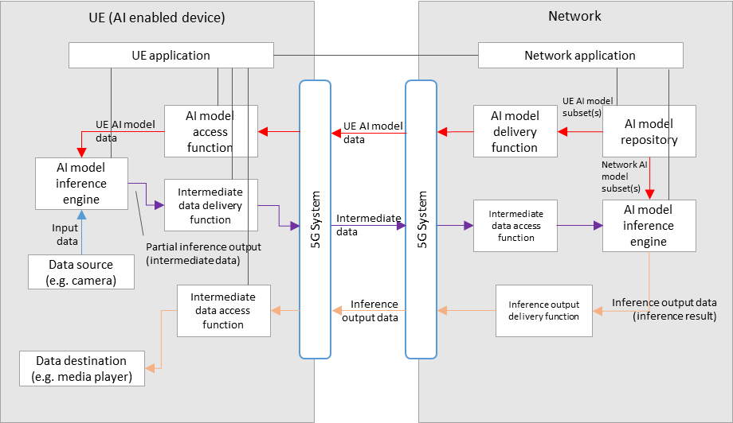
Figure 5.2.2-2: Basic architecture for split inference between the UE and network, with media data source in the UE
Figure 5.2.2-2 shows a simple basic architecture for split inferences between the UE and the network, as described in scenario 2b) of clause 5.2, where the media data source is in the UE, and the ordering of split inference is first performed in the UE, then in the network. The resulting inference output data is then sent back to the UE.
For the split inference (UE - network) scenario, additional components are required:
In the UE:
- An AI model inference engine that receives both the network AI model subset(s), and input data (from a UE data source), for UE inference.
- An intermediate data delivery function receives the partial inference output (intermediate data) from the UE inference engine, and sends it to the network via the 5GS. This delivery function may also contain functionalities related to QoS requests and monitoring.
- An inference output access function receives the inference output data from the network via the 5GS, and sends it to the relevant data destination according to the AI media service.
In the network:
- An intermediate data access function receives the intermediate data from the UE via the 5GS, and sends it to network inference engine for network inference.
The final inference output data is sent to the UE via the 5GS, through the inference output delivery function.

For both split inference scenarios, extra factors should be considered, including those such as:

- Configuration of the split inference between the network and UE. (e.g. definition and selection of the AI/ML model composition into “UE AI model subset” and “network AI model subset”)
- Resource allocation and management for network inference, including ingestion of network AI model data and media data
- Intermediate data delivery pipelines between the network and UE, in particular considering the use of 5GMS defined pipelines to stream intermediate data that is media content data.
- The functionalities of certain components in figure 5.2.1-1 and figure 5.2.2-1 may overlap, and depending on the use case a combined architecture may also be considered FFS.
- Certain components may also overlap with functions defined in 5GMS, clarifications FFS.

5.2.3 Distributed/federated learning
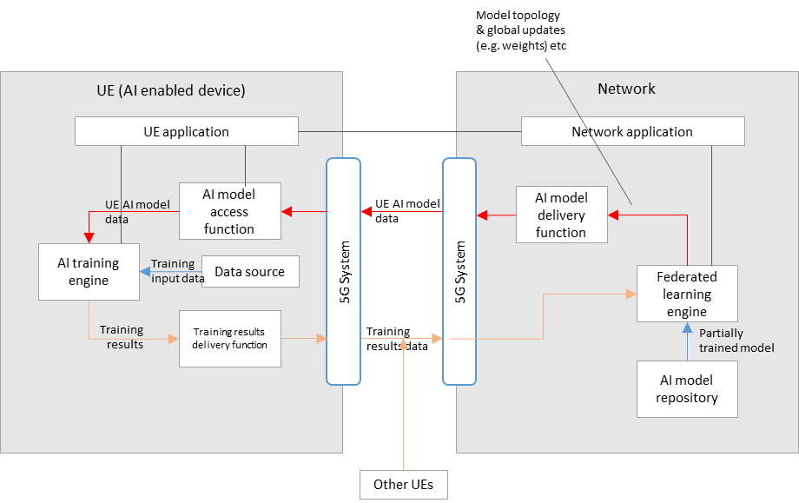
Figure 5.2.3-1: Basic architecture for distributed/federated learning between the network and multiple UEs
Figure 5.2.3-1 shows a simple basic architecture for distributed/federated learning between the network and UE(s), as described in scenario 3) of clause 5.2.
In the network:
- A federated learning engine receives a partially trained model from the AI model repository, that is passed to the AI model delivery function for delivery to multiple UEs via the 5GS.
- Training results data from multiple UEs is also received by the federated learning engine via the 5GS, which is then aggregated for the continuous training of the global model.
- Updates to the global model (e.g. in terms of topology or weights) are delivered to the UEs during the learning process.
In the UE(s):
- AI model data is received by an AI model access function via the 5GS, which then passes the data to the AI training engine.
- An AI training engine in the UE trains the AI model using local device data as the training input.
- Training results (e.g. in the form of updated weights) are delivered to the network via the training results delivery function.

6 Data components for AI/ML-based media services

6.1 Model data

6.1.1 Model optimization techniques
Trained models consist of a graph representation of the neural network as well as millions of parameters/weights that were learned during the training phase. Table 6.1.1-1 depicts the characteristics of some of the state-of-the-art DNNs as provided by [6].
Model | #Parameters (M) | Footprint (MB) | #FLOPs (B)
1.0 MobileNet-224 | 3.3 | 13.2 | 0.28
EfficientNet-B0 | 5.3 | 21.2 | 0.39
DenseNet-169 | 14 | 56 | 3.5
Inception-v3 | 24 | 96 | 5.7
ResNet-50 | 26 | 104 | 4.1
VGG-16 | 138 | 552 | 16
SSD300-MobileNet | 6.8 | 27.2 | 1.2
EfficientDet-D0 | 3.9 | 15.6 | 2.5
FasterRCNN-MobileNet | 6.1 | 24.4 | 25.2
SSD300-Deeplab | 33.1 | 132.4 | 34.9
FasterRCNN-VGG | 138.5 | 554 | 64.3
YOLOv3 | 40.5 | 122 | 71
Table 6.1.1-1: State-of-the-art DNN characteristics [6]
One of the main techniques to control the size of a network model or an update thereof is pruning. Pruning works by removing individual weights or complete structures of a pre-trained model. We differentiate between structured and unstructured pruning. In unstructured pruning, the goal is to reduce the number of non-zero weights in a layer while approximately preserving the output of that layer. The assumption behind these techniques is that only a small subset of the weights are dominant and impact the performance of the model. The rest of the weights may potentially be ignored/removed. The technique starts by assigning a saliency score to each parameter and then removing the weights with a score below a certain threshold. The resulting network may require retraining to regain the original accuracy. However, this type of technique introduces sparsity into the network, which may require special inference hardware or some pre-processing on the receiver side.
In structured pruning, the model graph is altered by completely removing certain structures such as neurons and filters. This may be done by assigning an importance score to each neuron/filter based on the current weight or based on inference data. The neurons/filters with a score below a threshold are removed. Compared to unstructured pruning, this approach does not introduce sparsity but may not yield the same compression results.
Another technique to reduce the size of a model is low-rank compression. In low-rank compression, a tensor, representing the weights of a layer in the DNN, is replaced by a product of two lower-rank tensors that perform approximately equally in the model. This technique speeds up the inference and also results in compression gains. Algorithms such as the Singular Value Decomposition (SVD) may be used to obtain the tensors of any desired rank.
Yet another very efficient compression technique is quantization. Quantization consists of decreasing the precision of the weights of a model, thus reducing the required memory footprint. The weights are mapped from a larger space of values into a smaller one, a concept widely used in image and video compression. Better performing quantization techniques may be context aware and operate in a non-linear manner to approximate the distribution of the weight values. Knowledge about the used quantization scale will be required to perform inverse quantization and recover the original weights. If non-linear quantization is used, the technique becomes non-transparent. The resulting weights may further be entropy coded, e.g. using Huffman coding for further size optimization.
Knowledge distillation takes a different approach to reducing model size. The goal is to transfer knowledge from the trained network into a smaller model for inference. During the distillation process, the smaller model learns to mimic the output of the larger trained model by minimizing a loss function that takes into account both the hard output values as well as the soft values into account (i.e. prior to filter application). Knowledge distillation techniques have in several cases surpassed the accuracy of the original model.
Most of the aforementioned techniques are sender-only techniques that do not require processing on the receiver side. The burden is on the creator of the model to apply these techniques to produce a more compact representation of the model. Some techniques may require processing at the receiver side. The complexity of that processing and the amount of information required to recover the model may vary by technique.

6.2 Intermediate data

6.3 Media data

6.4 Metadata

6.5 Existing formats for AI/ML models

6.5.6 ONNX format
The Open Neural Network Exchange (ONNX) format [2] is an open specification that was developed to facilitate the exchange of machine learning models between different AI frameworks. ONNX consists of the following components:
- A definition of an extensible computation graph model.
- Definitions of standard data types.
- Definitions of built-in operators.
The ONNX format is built around the Protocol Buffers (Protobuf) open-source cross-platform serialization format that was developed initially by Google.
The ONNX Graph is structured as a list of nodes that form an acyclic graph. Each node of the graph represents one of the built-in operators and its attributes. As an example, a node could be a Convolution operation, and its attributes would contain information regarding the padding and stride that must be used. Each edge of the graph represents input or output data tensors. The top-level ONNX construct is a ‘Model.’, and is represented in protocol buffers as the type onnx.ModelProto. It provides metadata that is necessary for the reader to determine if they are able to process the stored model. Each model must explicitly name the operator sets that it relies on for its functionality. Operator sets defines a set of operators and their versions. An operator is identified through its unique operator type (op_type), which is a case-sensitive operator name.
Built-in operators include a large list of widely used operators such as the following:
- Math operators such as Abs
- DNN operators such as Conv and LSTM
- Activation operators such Sigmoid and Relu
- Pooling operators such as MaxPool
- Other operators such as error computation and data reformatting operators
The following provides an example of an ONNX model in protobuf format:
ir_version: 5
producer_name: "skl2onnx"
producer_version: "1.11"
domain: "ai.onnx"
model_version: 0
graph {
node {
input: "X"
output: "Y"
name: "Pa_Pad"
op_type: "Pad"
attribute {
name: "mode"
s: "constant"
type: STRING
}
attribute {
name: "pads"
ints: 0
ints: 1
ints: 0
ints: 1
type: INTS
}
attribute {
name: "value"
f: 1.5
type: FLOAT
}
domain: ""
}
name: "OnnxPad"
input {
name: "X"
type {
tensor_type {
elem_type: 1
shape {
dim {
}
dim {
dim_value: 2
}
}
}
}
}
output {
name: "Y"
type {
tensor_type {
elem_type: 1
shape {
dim {
}
dim {
dim_value: 4
}
}
}
}
}
}
opset_import {
domain: ""
version: 10
}

6.5.6 NNEF format
The Neural Network Exchange Format (NNEF) [3] is a Khronos developed standard that defines a data format for facilitating the exchange of trained network models. The NNEF format enables the encapsulation of both the structure of the neural network model as well as the associated data. NNEF stores the data in structures that are independent of the training environment that was used for training the network, which will facilitate its consumption on any execution platform. NNEF offers itself as an intermediary between deep learning frameworks, which export into NNEF, and neural network accelerator libraries, which will import and compile the NNEF model for hardware-optimized inference.
The NNEF container consists of the following files:
- a textual file that describes the structure of the neural network
- a binary data file for each variable tensor. These files are structured hierarchically into sub-folders associated with the corresponding operation. Each tensor may have different representations, each matching a different quantized version.
- a quantization file that contains details about the quantization algorithm that is used for quantizing the exported tensors.
The NNEF network structure is described through a computational graph. The computational graph is a directed graph. The nodes of the graph may be data nodes or operation nodes. A directed edge from a data node to an operation node indicates the data is input to the operation. A directed edge from an operation node to a data node indicates the data node is an output.
Data nodes are tensors of different ranks and shapes and may be external, constant, variable, or intermediate/regular tensors. external, constant, and variable tensors all provide an explicit declaration of their shapes. Other tensors shapes will be determined based on the input and operation that is applied to them to produce that tensor. This is commonly known as shape propagation.
The NNEF operation nodes may have attributes that describe the exact computation that needs to be performed. Operations may be composed together to produce more compound operations. Primitive operations are operations that cannot be broken down into simpler operations.
The following is an excerpt from an NNEF graph representation of the VGG-16 network model:
version 1.0;

graph VGG_ILSVRC_16_layers(data) -> (prob)
{
variable_15 = variable<scalar>(label = 'conv4_1_blob2', shape = [1, 512]);
variable_14 = variable<scalar>(label = 'conv4_1_blob1', shape = [512, 256, 3, 3]);
variable_13 = variable<scalar>(label = 'conv3_3_blob2', shape = [1, 256]);
variable_31 = variable<scalar>(label = 'fc8_blob2', shape = [1, 1000]);
variable_30 = variable<scalar>(label = 'fc8_blob1', shape = [1000, 4096]);
variable_29 = variable<scalar>(label = 'fc7_blob2', shape = [1, 4096]);
variable_28 = variable<scalar>(label = 'fc7_blob1', shape = [4096, 4096]);
variable_27 = variable<scalar>(label = 'fc6_blob2', shape = [1, 4096]);
variable_26 = variable<scalar>(label = 'fc6_blob1', shape = [4096, 25088]);
variable_25 = variable<scalar>(label = 'conv5_3_blob2', shape = [1, 512]);
variable_24 = variable<scalar>(label = 'conv5_3_blob1', shape = [512, 512, 3, 3]);
variable_23 = variable<scalar>(label = 'conv5_2_blob2', shape = [1, 512]);
variable_22 = variable<scalar>(label = 'conv5_2_blob1', shape = [512, 512, 3, 3]);
variable_21 = variable<scalar>(label = 'conv5_1_blob2', shape = [1, 512]);
variable_20 = variable<scalar>(label = 'conv5_1_blob1', shape = [512, 512, 3, 3]);
variable_19 = variable<scalar>(label = 'conv4_3_blob2', shape = [1, 512]);
variable_18 = variable<scalar>(label = 'conv4_3_blob1', shape = [512, 512, 3, 3]);
variable_17 = variable<scalar>(label = 'conv4_2_blob2', shape = [1, 512]);
variable_16 = variable<scalar>(label = 'conv4_2_blob1', shape = [512, 512, 3, 3]);
variable_12 = variable<scalar>(label = 'conv3_3_blob1', shape = [256, 256, 3, 3]);
variable_10 = variable<scalar>(label = 'conv3_2_blob1', shape = [256, 256, 3, 3]);
variable_9 = variable<scalar>(label = 'conv3_1_blob2', shape = [1, 256]);
variable_8 = variable<scalar>(label = 'conv3_1_blob1', shape = [256, 128, 3, 3]);
variable_6 = variable<scalar>(label = 'conv2_2_blob1', shape = [128, 128, 3, 3]);
variable_11 = variable<scalar>(label = 'conv3_2_blob2', shape = [1, 256]);
variable_5 = variable<scalar>(label = 'conv2_1_blob2', shape = [1, 128]);
variable_4 = variable<scalar>(label = 'conv2_1_blob1', shape = [128, 64, 3, 3]);
variable_2 = variable<scalar>(label = 'conv1_2_blob1', shape = [64, 64, 3, 3]);
variable_1 = variable<scalar>(label = 'conv1_1_blob2', shape = [1, 64]);
variable_7 = variable<scalar>(label = 'conv2_2_blob2', shape = [1, 128]);
variable = variable<scalar>(label = 'conv1_1_blob1', shape = [64, 3, 3, 3]);
variable_3 = variable<scalar>(label = 'conv1_2_blob2', shape = [1, 64]);
data = external<scalar>(shape = [10, 3, 224, 224]);
conv = conv(data, variable, variable_1, border = 'constant', dilation = [1, 1], groups = 1, padding = [(1, 1), (1, 1)], stride = [1, 1]);
relu = relu(conv);
conv_1 = conv(relu, variable_2, variable_3, border = 'constant', dilation = [1, 1], groups = 1, padding = [(1, 1), (1, 1)], stride = [1, 1]);
relu_1 = relu(conv_1);
max_pool = max_pool(relu_1, border = 'ignore', padding = [(0, 0), (0, 0), (0, 0), (0, 0)], size = [1, 1, 2, 2], stride = [1, 1, 2, 2]);
conv_2 = conv(max_pool, variable_4, variable_5, border = 'constant', dilation = [1, 1], groups = 1, padding = [(1, 1), (1, 1)], stride = [1, 1]);
relu_2 = relu(conv_2);
conv_3 = conv(relu_2, variable_6, variable_7, border = 'constant', dilation = [1, 1], groups = 1, padding = [(1, 1), (1, 1)], stride = [1, 1]);
relu_3 = relu(conv_3);
max_pool_1 = max_pool(relu_3, border = 'ignore', padding = [(0, 0), (0, 0), (0, 0), (0, 0)], size = [1, 1, 2, 2], stride = [1, 1, 2, 2]);
conv_4 = conv(max_pool_1, variable_8, variable_9, border = 'constant', dilation = [1, 1], groups = 1, padding = [(1, 1), (1, 1)], stride = [1, 1]);
relu_4 = relu(conv_4);
conv_5 = conv(relu_4, variable_10, variable_11, border = 'constant', dilation = [1, 1], groups = 1, padding = [(1, 1), (1, 1)], stride = [1, 1]);
relu_5 = relu(conv_5);
conv_6 = conv(relu_5, variable_12, variable_13, border = 'constant', dilation = [1, 1], groups = 1, padding = [(1, 1), (1, 1)], stride = [1, 1]);
relu_6 = relu(conv_6);
max_pool_2 = max_pool(relu_6, border = 'ignore', padding = [(0, 0), (0, 0), (0, 0), (0, 0)], size = [1, 1, 2, 2], stride = [1, 1, 2, 2]);
conv_7 = conv(max_pool_2, variable_14, variable_15, border = 'constant', dilation = [1, 1], groups = 1, padding = [(1, 1), (1, 1)], stride = [1, 1]);
relu_7 = relu(conv_7);
conv_8 = conv(relu_7, variable_16, variable_17, border = 'constant', dilation = [1, 1], groups = 1, padding = [(1, 1), (1, 1)], stride = [1, 1]);
relu_8 = relu(conv_8);
conv_9 = conv(relu_8, variable_18, variable_19, border = 'constant', dilation = [1, 1], groups = 1, padding = [(1, 1), (1, 1)], stride = [1, 1]);
relu_9 = relu(conv_9);
max_pool_3 = max_pool(relu_9, border = 'ignore', padding = [(0, 0), (0, 0), (0, 0), (0, 0)], size = [1, 1, 2, 2], stride = [1, 1, 2, 2]);
conv_10 = conv(max_pool_3, variable_20, variable_21, border = 'constant', dilation = [1, 1], groups = 1, padding = [(1, 1), (1, 1)], stride = [1, 1]);
relu_10 = relu(conv_10);
conv_11 = conv(relu_10, variable_22, variable_23, border = 'constant', dilation = [1, 1], groups = 1, padding = [(1, 1), (1, 1)], stride = [1, 1]);
relu_11 = relu(conv_11);
conv_12 = conv(relu_11, variable_24, variable_25, border = 'constant', dilation = [1, 1], groups = 1, padding = [(1, 1), (1, 1)], stride = [1, 1]);
relu_12 = relu(conv_12);
max_pool_4 = max_pool(relu_12, border = 'ignore', padding = [(0, 0), (0, 0), (0, 0), (0, 0)], size = [1, 1, 2, 2], stride = [1, 1, 2, 2]);
reshape = reshape(max_pool_4, shape = [10, -1]);
linear = linear(reshape, variable_26, variable_27);
relu_13 = relu(linear);
linear_1 = linear(relu_13, variable_28, variable_29);
relu_14 = relu(linear_1);
linear_2 = linear(relu_14, variable_30, variable_31);
prob = softmax(linear_2, axes = [1]);
}

6.5.7 Neural Network Coding (NNC) format
The Neural Network Coding (NNC) standard [4] has been developed by ISO/IEC for transmission and storage of machine learning models for multimedia description and analysis. It specifies a compressed representation format for neural network data and processes for its decoding. As shown in Figure 6.5.7-1, NNC follows a toolbox approach: It offers a variety of options to represent and code neural network (NN) data, which can be flexibly selected based on the requirements of a particular use case. In particular, NNC defines data structures and syntax elements to support the following:
- Packaging of NN data of different types in neural network representation (NNR) units for access from a system or application layer.
- Signaling of metadata related to various methods of pre-processing for data reduction
- Compression of NN weights/tensor coefficients using quantization and entropy coding
- Interoperability with other exchange (e.g. NNEF [2], ONNX [3]) or native formats (PyTorch, TensorFlow).
For access from a systems or application layer, NNC packages the NN data in neural network representation (NNR) units. NNR units that can carry different types of NN data: NNR parameter set and NNR layer parameter set units convey metadata and information related to the entire NN and individual NN layers, respectively. NNR topology units contain information on the NN topology, e.g. the connections between layers/tensors. The actual tensor data is conveyed in NNR quantized information and NNR compressed data units. Finally, NNR aggregate units allow to combine several NNR units of different types that are related.
NNC allows to signal metadata related to typical pre-processing and parameter reduction methods in NNR parameter set units or NNR layer parameter set units. More specifically, NNC supports inclusion of parameters related to sparsification, pruning, low-rank decomposition, unification, batch norm folding, and local scaling.
NNC represents the NN weights/tensors in NNR compressed or NNR quantized information data units. Tensor/weight coefficients can be signaled as raw data or quantized with different methods, which are uniform, codebook, or dependent quantization. Furthermore, the quantized coefficients can be binarized and entropy coded using a context adaptive arithmetic coder, called DeepCABAC.
NNC can be used as complement to other native (e.g. PyTorch, TensorFlow) or exchange (e.g. NNEF, ONNX) representation formats. This can be done by two means: First, NNC allows to embed topology information of other formats into an NNR bitstream. More specifically, the byte sequences of other formats can be signaled in NNR topology units, which are then conveyed together with NNR compressed data or NNR quantized information units representing the coded or quantized tensors/weights. Second, NNR units representing coded tensors/weights can be embedded in the containers of other formats. Informative recommendations on how to use NNC in combination with PyTorch, TensorFlow, NNEF, and ONNX are given in the Annexes A to E of the standard [4].
SC29 WG04 is also already working on a second edition of ISO/IEC 15938-17, of which a Draft International Standard (DIS) has been completed. The second edition adds the functionality to compress incremental updates of neural networks, which can e.g. be applied to sending updates of neural networks or to federated learning scenarios.

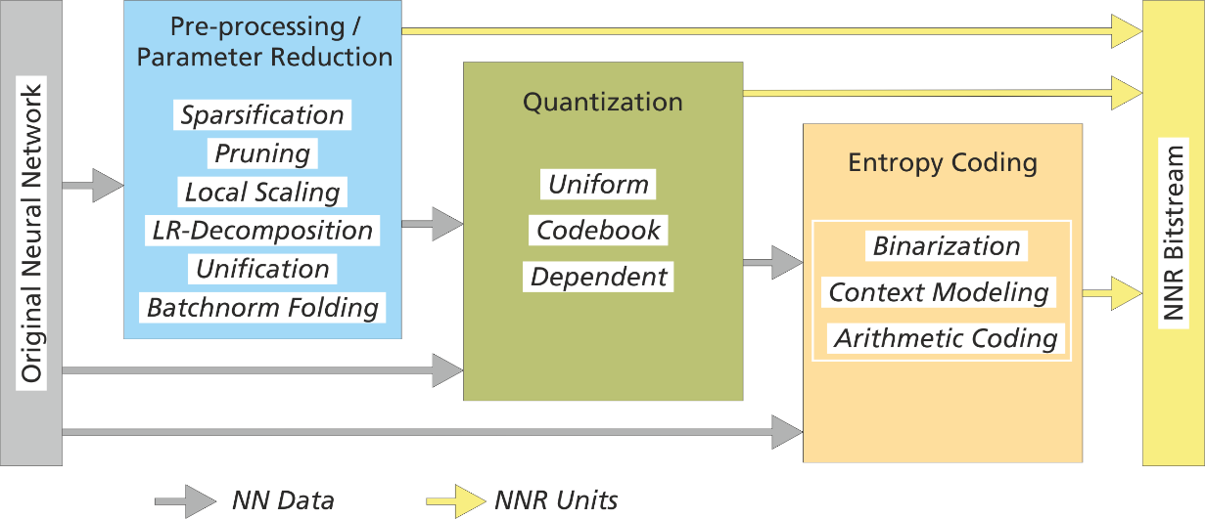
Figure 6.5.7-1: Generation of a neural network representation (NNR) bitstream consisting of NNR units. Tools for pre-processing, parameter reduction, quantization, and entropy coding can be selected based on the complexity and compression requirements of a given use case.

7 Traffic characteristics

7.1 Complete/Basic AI/ML model distribution

7.2 Split AI/ML operation

7.3 Distributed/federated learning

8 KPIs

9 References
[1] 3GPP TR 22.874, Study on traffic characteristics and performance requirements for AI/ML model transfer in 5GS
[2] Open Neural Network Exchange (ONNX), https://onnx.ai
[3] The Khronos NNEF Working Group, “Neural Network Exchange Format”, https://www.khronos.org/registry/NNEF/specs/1.0/nnef-1.0.5.html
[4] “Text of ISO/IEC FDIS 15938-17 Compression of Neural Networks for Multimedia Content Description and Analysis”, MPEG document N00080, ISO/IEC JTC 1/SC 29/WG 04, April 2021.
[5] Y.3179: Architectural framework for machine learning model serving in future networks including IMT-2020
[6] Agiollo A., et al., “Load Classification: A Case Study for Applying Neural Networks in Hyper-Constrained Embedded Devices” Journal of Applied Sciences, December 2021

