Source: Samsung Electronics Co., Ltd., Interdigital Finland Ory
Title: [FS_AI4Media] Updates to clause 4.2 on architectures
Agenda Item: 9.7
Document for: Agreement

1 Introduction

This is a merged contribution of S4-221024 and S4-221039. Updates include:
- Several text additions.
- Addition of a service architecture for split inference between the UE and network, with data source in the UE.
- Removal of square brackets.
- Changing of the terms “service architecture” to “basic architecture”.
- Removing colour association of functions in the architecture diagrams.

The next steps are to create call flows and procedures for the basic architectures, identifying the relevant functions and interfaces which are in scope of the study, and to perform gap analyses with current SA4 architectures.

2 Service architecture for split inference with uplink

4.2 Architectures and service flows

Considering the related use cases as documented in TR 22.874 and also as documented in the latest version of the Permanent Document (S4-220500), we can start from some basic scenarios for consideration of a basic architecture for AI/ML media services.

The basic starting scenarios are:
- Delivery of a pre-trained AI/ML model from network to UE, typically at the start of an AI media service, but may also require updates during the service. At the most basic level AI/ML models can be delivered as a file (e.g. TensorFlow SavedModel, PDF5, ONNX file, NNEF file etc.) containing all the necessary information required for the UE to perform on device inference using the delivered model. For split scenarios, a (partial) AI model to be used in the UE may be delivered.

- Split inference of a pre-trained AI/ML model(s) with two further sub-scenarios:

  - Basic scenario with an inference in the network or in the UE.
  - Split scenario with inferences between the network and the UE, where the intermediate data output from the network inference (resp. UE inference) is transferred to the UE (resp. network) to be used as the input for UE device inference (resp. network inference). Depending on the characteristics of the intermediate data, such as if the intermediate data is media content data, it may be practical to consider 5GMS architectures, procedures and/or protocols for the streaming delivery of such intermediate media data.

- Distributed/federated learning using multiple UE devices with local training sets, and a central server in the network. Typically a central model is distributed to UEs for local training. UEs use local data available to the device for local training, and training result updates are sent back to the central server, which aggregates and updates the central model. Global updates on the central model are then distributed to the UE devices for continuous training.

NOTE: Compression aspects will be addressed once the digital representation of AI/ML models will be identified together with their associated service requirements (eg. traffic flow characteristics, latency, bitrate…).

4.2.1 Complete/Basic AI/ML model distribution

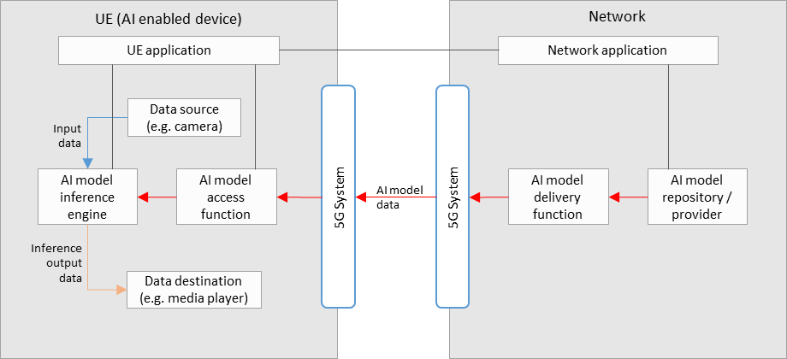

Figure 4.2.1-1: Basic architecture for AI/ML model delivery with inference in the UE

Figure 4.2.1-1 shows a simple basic architecture for AI/ML model delivery, as described in scenario 1) of clause 4.2, with an inference of a pre-trained AI/ML model in the UE, as described in scenario 2a) of clause 4.2.

In the network:
- An AI model in the repository is selected for the AI media service by the network application, and sent to the delivery function for delivery to the UE.
- The AI model delivery function sends the AI model data to the UE via the 5GS. This delivery function may also contain functionalities related to QoS requests and monitoring, as well as those related to the optimization or compression of AI model data.

In the UE:
- A UE application provides an AI media service using the AI model inference engine and AI model access function.
- The AI model access function receives the AI model data via the 5G system, and sends it to the AI model inference engine. Receiver side optimization or decompression techniques for AI model data may be included.
- The AI model inference engine performs inference by using the input data from the data source (e.g. a camera, or other media source) as the input into the AI model received from the AI model access function. The inference output data is sent to the data destination (e.g. a media player).

Depending on the exact service scenario, AI model updates may be necessary during the service, and different AI model data delivery pipelines may be considered for such purposes.

4.2.2 Split AI/ML operation

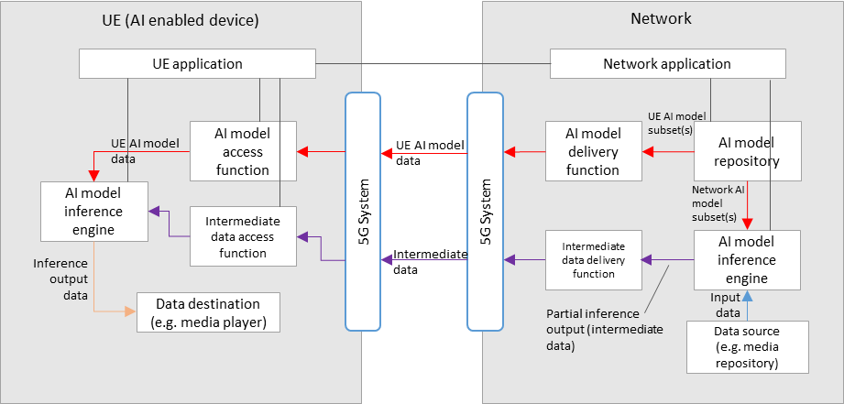

Figure 4.2.2-1: Basic architecture for split inference between the network and UE, with media data source in the network

Figure 4.2.2-1 shows a simple basic architecture for split inferences between the network and the UE, as described in scenario 2b) of clause 4.2, where the media data source is in the network, and the ordering of split inference is first perform in the network, then on the UE.

For the split inference (network-UE) scenario, additional components are required:

In the network:
- An AI model inference engine that receives both the network AI model subset(s), and input data, for network inference.
- An intermediate data delivery function receives the partial inference output (intermediate data) from the network inference engine, and sends it to the UE via the 5GS. This delivery function may also contain functionalities related to QoS requests and monitoring.

In the UE:
- An intermediate data access function receives the intermediate data from the network via the 5GS, and sends it to the UE inference engine for UE inference.
- The final inference output data is sent to the data destination (e.g. a media player).

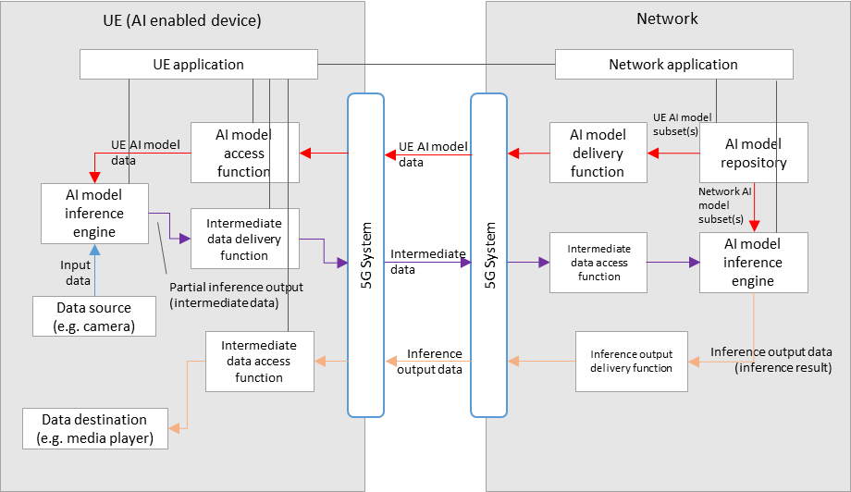
Figure 4.2.2-2: Basic architecture for split inference between the UE and network, with media data source in the UE

Figure 4.2.2-2 shows a simple basic architecture for split inferences between the UE and the network, as described in scenario 2b) of clause 4.2, where the media data source is in the UE, and the ordering of split inference is first performed in the UE, then in the network. The resulting inference output data is then sent back to the UE.

For the split inference (UE - network) scenario, additional components are required:

In the UE:
- An AI model inference engine that receives both the network AI model subset(s), and input data (from a UE data source), for UE inference.
- An intermediate data delivery function receives the partial inference output (intermediate data) from the UE inference engine, and sends it to the network via the 5GS. This delivery function may also contain functionalities related to QoS requests and monitoring.
- An inference output access function receives the inference output data from the network via the 5GS, and sends it to the relevant data destination according to the AI media service.

In the network:
- An intermediate data access function receives the intermediate data from the UE via the 5GS, and sends it to network inference engine for network inference.
- The final inference output data is sent to the UE via the 5GS, through the inference output delivery function.

For both split inference scenarios, extra factors should be considered, including those such as:
- Configuration of the split inference between the network and UE. (e.g. definition and selection of the AI/ML model composition into “UE AI model subset” and “network AI model subset”)
- Resource allocation and management for network inference, including ingestion of network AI model data and media data
- Intermediate data delivery pipelines between the network and UE, in particular considering the use of 5GMS defined pipelines to stream intermediate data that is media content data.
- The functionalities of certain components in figure 4.2.1-1 and figure 4.2.2-1 may overlap, and depending on the use case a combined architecture may also be considered FFS.
- Certain components may also overlap with functions defined in 5GMS, clarifications FFS.

4.2.3 Distributed/federated learning
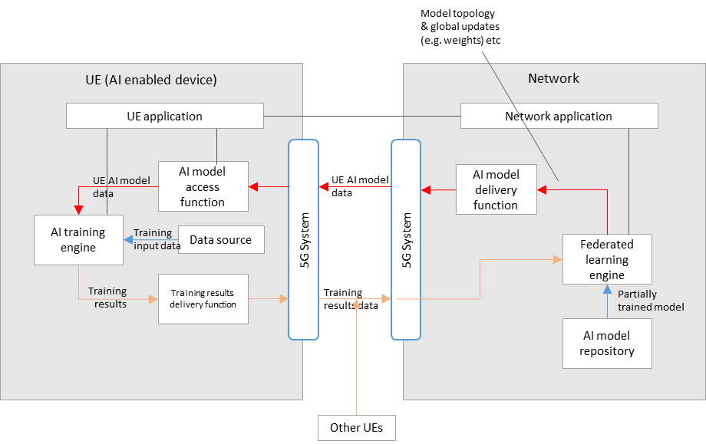

Figure 4.2.3-1: Basic architecture for distributed/federated learning between the network and multiple UEs

Figure 4.2.3-1 shows a simple basic architecture for distributed/federated learning between the network and UE(s), as described in scenario 3) of clause 4.2.

In the network:
- A federated learning engine receives a partially trained model from the AI model repository, that is passed to the AI model delivery function for delivery to multiple UEs via the 5GS.
- Training results data from multiple UEs is also received by the federated learning engine via the 5GS, which is then aggregated for the continuous training of the global model.
- Updates to the global model (e.g. in terms of topology or weights) are delivered to the UEs during the learning process.

In the UE(s):
- AI model data is received by an AI model access function via the 5GS, which then passes the data to the AI training engine.
- An AI training engine in the UE trains the AI model using local device data as the training input.
- Training results (e.g. in the form of updated weights) are delivered to the network via the training results delivery function.

3 Proposal
We propose to include the edits in section 2 of this contribution to the relevant clause 4.2 of the latest version of the Permanent Document.

