Source: Interdigital Finland Ory

Title: [FS_AI4Media] New Neural Network hybrid coding use-case

Agenda item: 9.7

Document for: Discussion and Agreement

1 Introduction

One objective for the Study Item on “Artificial Intelligence (AI) and Machine Learning (ML) for Media” is to address current MPEG work on Deep Neural Network (DNN) for Video Coding. This work investigates two potential approaches: hybrid block-based coding with DNN (or hybrid coding) and End to End learning based coding (or End to End coding).

A recent contribution (S4aV220901) introducing neural network-based post-processing for a video use case was presented at the video ad-hoc session on 12 July. This new contribution proposes a revision of S4aV220901.

2 Proposed changes
--------------------------------------------- Begin Change ----------------------------------------------------------------------------

3.2 Video Quality Enhancement in Streaming

3.2.1 End-to-End neural network-based video coding

In this use case, the sender and receiver apply parts of an DNN model (e.g. an autoencoder model) to enhance the quality of a video stream. An example of an autoencoder DNN is depicted in figure 3.2.1:
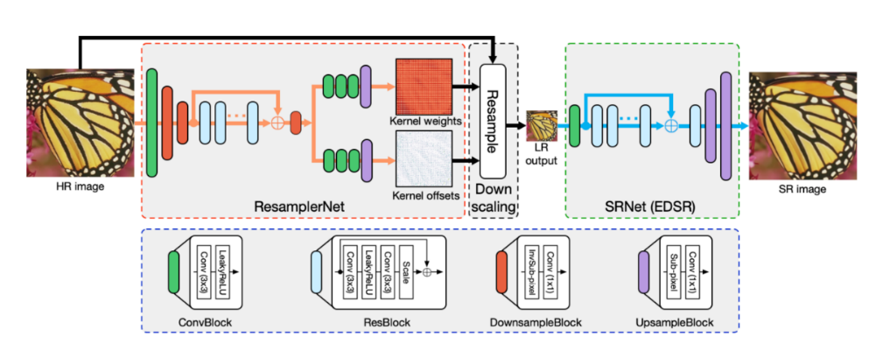
Figure 3.2.1
The sender is typically represented by various media functions in the network, which processes the high-fidelity video using the down-scaling part of a pre-trained DNN model to generate a metadata stream that is streamed together with a lower fidelity encoding of the video. The receiver (UE) runs an inference algorithm (e.g. the up-scaling part of DNN model) on the received metadata and video stream to produce a high-quality video for rendering.
The main scenario in this use case is about streaming intermediate model output data from the network for processing on the UE, involving AI/ML data distribution and operation splitting.
This use case covers all scenarios where a metadata stream needs to be sent to the receiver, in addition to a low-resolution video

3.2.2 Receiver-only NN based post-processing for video

A neural network (NN) applies post-processing to a decoded video sequence to enhance the quality of the decoded frames. The post-processing is performed outside the coding loop and does not impact the decoding process of the video. Possible post-processing algorithms include:
- Post-filtering: where the output of the video decoder is provided as input to a NN to improve the quality of the decoded frames. Such improvements include removal of video coding artifacts, subjective quality enhancement, etc.
- Super resolution: where a NN is used to increase the resolution of the output video sequence when the resolution of the display is greater than the resolution of the decoded frames. The use of NN-based approaches in super resolution resampling process increases the quality of the resulting resampled frames.
- NN-based HDR enhancement: a NN is applied for example to enhance a SDR video into an HDR-looking video.

The inference at the receiver side may or may not require some static configuration data, which is provided by the sender. A metadata stream is not used for this approach.

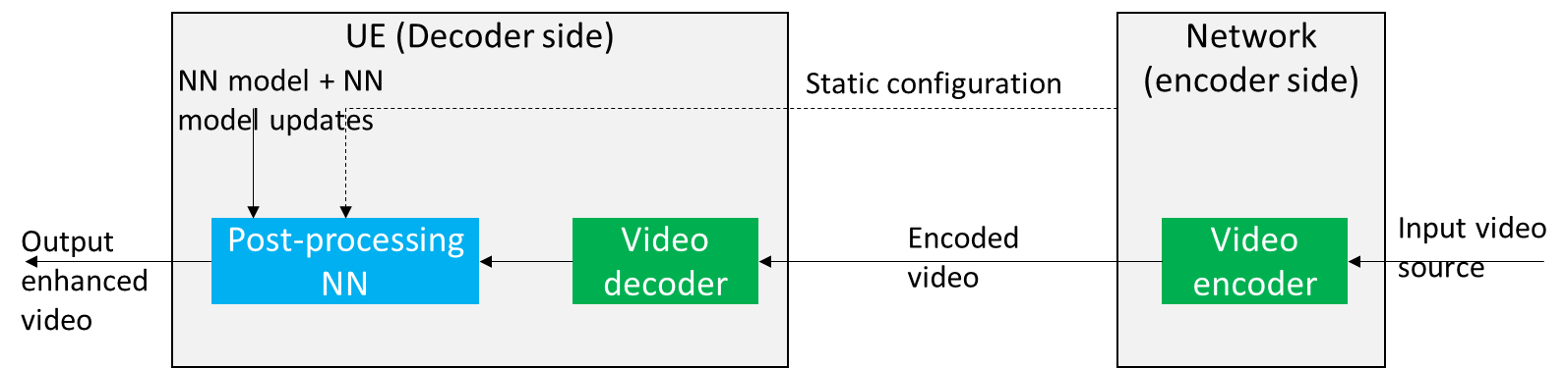
Figure 3.2.2 Receiver-only post-processing NN use-case

Figure 3.2.2 depicts a neural-network-based post-processing use-case where a pre-trained NN model is used at the receiver to post-process the decoded video to improve the quality. The DNN may require some static configuration information, which could be retrieved from the sender or provided by the receiver.

--------------------------------------------- End Change ----------------------------------------------------------------------------

3 Proposal
We propose to add the text of clause 3.2 of this contribution to the Permanent Document.

