Source: InterDigital Inc.
Title: Interest of transparency information in the context of Edge Architecture
Document for Discussion and agreement
Agenda item: 9.5 - MeCAR (Media Capabilities for Augmented Reality)

Introduction
This contribution takes place in the context of an edge architecture, where the rendering function is split between the Edge device, located in close network proximity, and the AR glasses. The principle of this architecture is to offload from the AR glasses the computationally intensive tasks to an edge device. The purpose is to decrease device heating and battery drain, which are two main concerns for the design of AR glasses.
In the context of the edge Architecture, it may be of interest to only rely on 2D encoding and decoding capabilities for the AR glasses. The 3D related-functions are ended in the Edge device and 3D rendering is propagated to the AR glasses thanks to a stereoscopic effect by the transmission of appropriate 2D videos. In that context, in addition to the 2D video, it may also be of interest to transmit transparency information to the AR glasses.

This contribution discusses the interest to transmit transparency information, introduces a discussion where it can be processed and documents various possibilities for its carriage.

Information on Transparency information

Interest of Transparency information
It is desirable to permit the transmission of transparency information (alpha_channel) in addition to the RGB information. Augmented reality may consist of an overlay of a virtual object on the real world which is accessed directly through the “optical-see through” glasses. The overlay is not a full picture but only part of it, the other pixels of the picture being transparent or partially transparent, in case of a shadow effect for instance.
The below pictures depict the overlay of a virtual dragon on the table of a real living room. If the whole video is overlayed, the dragon may appear in the middle of a rectangle corresponding to the video size.This is illustrated on the left picture. With additional transparency information, only the part of the video corresponding to the dragon is overlayed, as illustrated on the right picture.
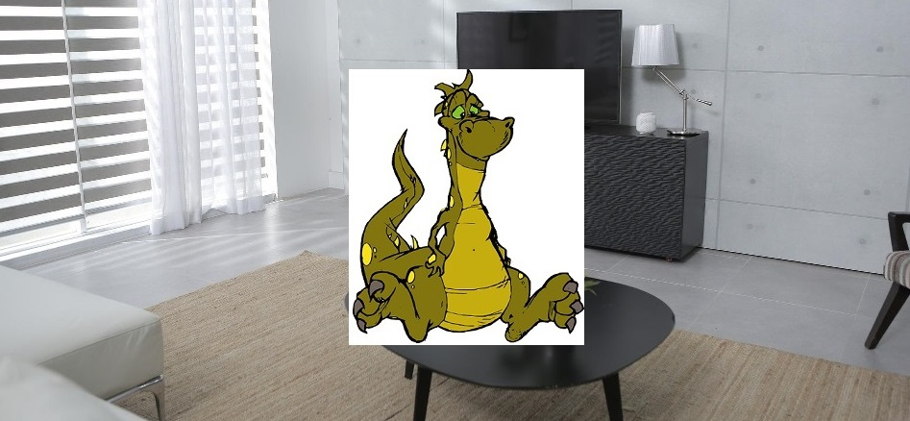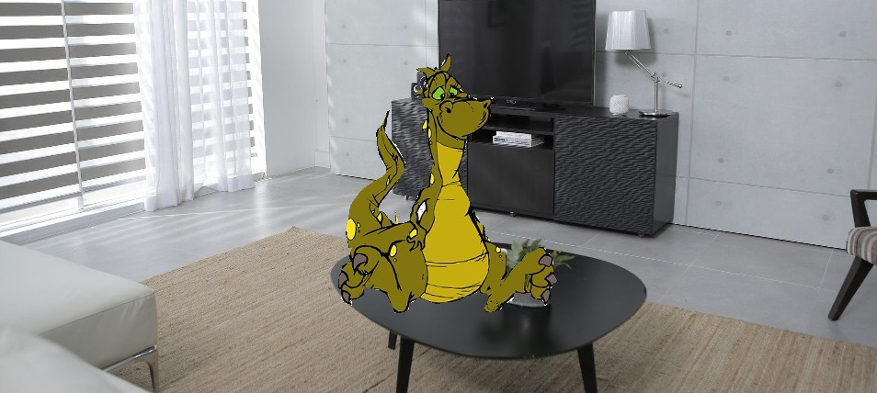
Figure 2 : video overlay without or with transparency information

Processing transparency information
This chapter is a preliminary draft. Further study is required on this topic.
We refer to the Edgar-type 1 architecture for MeCAR as depicted in figure 5 of the permanent document
Depending on how the transparency information is carried, it may be processed at different functional blocs.
Transparency information may be processed in the Media Access Function. This may be the case if transparency information is carried via a specific media track. This also includes the decoder if transparency information is carried via an auxiliary picture. Transparency information may also be processed by AR scene manager, when transparency information is carried via the scene description.
Wherever the processing is located, transparency information has to be forwarded to the display so that only the appropriate part of the picture is displayed.

Carrying transparency information

Carriage via auxiliary pictures in the video stream

The carriage of transparency information may be ensured by using the concept of auxiliary picture offered by both AVC and HEVC.

AVC
AVC specification (H.264) provides guidelines for carrying transparency information.
It defines the concept of alpha-blending in clause 3.5 : “A process not specified by this Recommendation | International Standard, in which an auxiliary coded picture is used in combination with a primary coded picture (…) the samples of an auxiliary coded picture are interpreted as indications of the degree of opacity (or, equivalently, the degrees of transparency) associated with the corresponding luma samples of the primary coded picture.” AVC specification precises in clause 3.7 that “An auxiliary coded picture must contain the same number of macroblocks as the primary coded picture. Auxiliary coded pictures have no normative effect on the decoding process.” It also mentions (clause 3.1) that “In addition to the primary coded picture, an access unit may also contain (…) one auxiliary coded picture”.

In clause 7.3.2.1.2 (Sequence parameter set extension RBSP syntax), it defines fields related to alpha blending (alpha_incr_flag, alpha_opaque_value and alpha_transparent _value) which semantics are detailed in clause 7.4.2.1.2 (Sequence parameter set extension RBSP semantics). The same clause also precises that “aux_format_idc equal to 1 indicates that exactly one auxiliary coded picture is present in each access unit of the coded video sequence, and that for alpha blending purposes the decoded samples of the associated primary coded picture in each access unit should be multiplied by the interpretation sample values of the auxiliary coded picture in the access unit in the display process after output from the decoding process.”

HEVC
HEVC also defines how to carry an alpha channel in the same video track as the base video.In this case, each frame contains two parts, one base layer containing the video, and one alpha layer containing the alpha channel. Both layers are compressed using the HEVC codec. The two layers are identified by a specific HEVC syntax: a specific Alpha channel information SEI message has to be added, so that the decoder knows how to interpret the auxiliary pictures. A decoder uncapable of handling this SEI message only decodes the base layer.
The concept of auxiliary picture is defined in annex F of HEVC specification (H.265) :
F.3.5 auxiliary picture: A picture that has no normative effect on the decoding process of primary pictures, and with a nuh_layer_id value such that AuxId[ nuh_layer_id ] is greater than 0.

In the same annex, Table F.2 details the different types of auxiliary pictures:
Table F.2 – Mapping of AuxId to the type of auxiliary pictures
AuxId | Name of AuxId | Type of auxiliary pictures | SEI message describing interpretation of auxiliary pictures
1 | AUX_ALPHA | Alpha plane | Alpha channel information
2 | AUX_DEPTH | Depth picture | Depth representation information
3..127 |  | Reserved
128..159 |  | Unspecified
160..255 |  | Reserved

Carriage in a separate media track

ISO/IEC 14496-12 (ISO Base Media file Formats) doesn’t mention anything specific for the transport of auxiliary pictures (which are supposed to be part of the elementary stream). However, it defines the concept of auxiliary video track in clause 12.1.1 (“An auxiliary video track is coded the same as a video track, but uses this different handler type, and is not intended to be visually displayed (e.g. it contains depth information, or other monochrome or color two-dimensional information)"). And in clause 8.3.3 (Track Reference box), it defines ‘auxl’ as specifi value for the reference_type field, with the following semantics : “this track contains auxiliary media for the indicated track (e.g. depth map or alpha plane for video).”

HEIF (HEVC Still Image file format, ISO/IEC 23008-12) also indirectly describes a possibility to carry an associated transparency image, by using the notion of item. It is for instance described in annex A.3 how to derive an image from three others.
MIAF (Multi Image Application Format, ISO/IEC 23000-22), which partly rely on HEIF, describes in its clause 7.3.5 how MIAF auxiliary image items can be used to carry alpha planes. In particular, it mentions that “MIAF renderers shall interpret alpha planes and should support alpha blending using alpha-plane auxiliary images. This is especially important for image overlays”. It also details in its clause 6.7 (MAIF renderer processing model) the interpretation of alpha planes.

Carriage via scene description
Possible carriage of transparency information or associated transparency information via the scene description has also to be considered. In particular, this may be a solution when an auxiliary picture carrying transparency information is available and not to rely on the SEI messages which not be decoded by all decoders (see HEVC chapter).
glTF specification in its clause 3.9 devoted to Materials has a subclause “additional-texture” and a subclause “alpha-coverage” which describe how to use the fourth component (if present) of a texture.

Proposal
We propose to include clause 2 of this contribution as an informative part in the permanent document.

References
- TS 26.511 “5GMS Profiles, Codecs and Formats”.
- H.264 “Advanced video coding for generic audio visual services”
- H.265 “High Efficiency Video Coding (HEVC) Recommandation ITU_T H.265”.
- ISO/IEC 14496 “Coding of audio-visual objects”
- ISO/IEC 23008-12 “HEVC Still Image file format”
- ISO/IEC 23000-22 “Multi Image Application Format »
- glTF 2.0 specification

