3GPP TSG-SA4 Meeting # 120 S4-221065

Online 17.Aug. - 26.Aug. 2022
CR-Form-v12.2
CHANGE REQUEST
 | 26.502 | CR | <CR#> | rev | <Rev#> | Current version: | 17.0.0
For HELP on using this form: comprehensive instructions can be found at
http://www.3gpp.org/Change-Requests.

Proposed change affects: | UICC apps |  | ME |  | Radio Access Network |  | Core Network

Title: | [FS_5GMS-EXT] Corrections of Traffic Identification sections
Source to WG: | Ericsson
Source to TSG: | S4
Work item code: | FS_5GMS-EXT |  |  |  |  |  | Date: |  |  | 11.8.2022
Category: | F |  |  |  |  |  | Release: |  |  | Rel-17
 | Use one of the following categories:  F (correction)  A (mirror corresponding to a change in an earlier release)  B (addition of feature),  C (functional modification of feature)  D (editorial modification)  Detailed explanations of the above categories can  be found in 3GPP TR 21.900. |  |  |  |  |  |  |  | Use one of the following releases:  Rel-8 (Release 8)  Rel-9 (Release 9)  Rel-10 (Release 10)  Rel-11 (Release 11)  …  Rel-16 (Release 16)  Rel-17 (Release 17)  Rel-18 (Release 18)  Rel-19 (Release 19)
Reason for change: |  | SA2 and CT3 provided some review feedback for the traffic identification spection, specifically around usage of the ToS/TC field. The CR corrects the TR according to the feedback.
Summary of change: |  | Text to clarify the need for an SLA between the 5GMS function hosting network and the MNO network is added. The list of potential open issues is updated reflecting the feedback from SA2 and CT3.
Consequences if not approved:
Clauses affected: |  | 5.3.2, 5.3.5
 |  | Y | N
Other specs |  |  | x | Other core specifications |  |  |  | TS/TR ... CR ...
affected: |  |  | x | Test specifications |  |  |  | TS/TR ... CR ...
(show related CRs) |  |  | x | O&M Specifications |  |  |  | TS/TR ... CR ...
Other comments:
This CR's revision history:

**** First Change ****

5.3.2 Collaboration Scenarios

5.3.2.1 General Collaboration Scenarios
The 5GMSd Application Provider negotiates with the MNO an SLA to provide differentiated treatment, including network QoS and charging for its 5GMSd-Aware Application. Depending on the QoS needs and the connectivity realization between the MNO network and the Data Network hosting the 5GMS function, additional transport-level arrangements need to be considered. The SLA and transport-level arrangements are outside the scope of 3GPP. The Application Provider provides the necessary information to the MNO to detect the traffic, to ensure its correct and exclusive identification. The MNO detects the traffic correctly and applies the agreed traffic treatment.
Due to privacy concerns, the content hosting is provided by the Application Provider in an external Data Network. However, the 5GMSd Application Provider leverages the network features either via a 5GMSd AF in the external Data Network (Figure 5.9.2-1) or via a 5GMSd AF in the trusted Data Network (Figure 5.9.2-2).
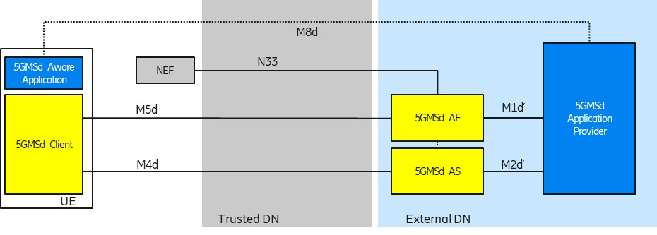
Figure 5.9.2-1: Collaboration 1 (Collaboration 3 of TS 26.501)
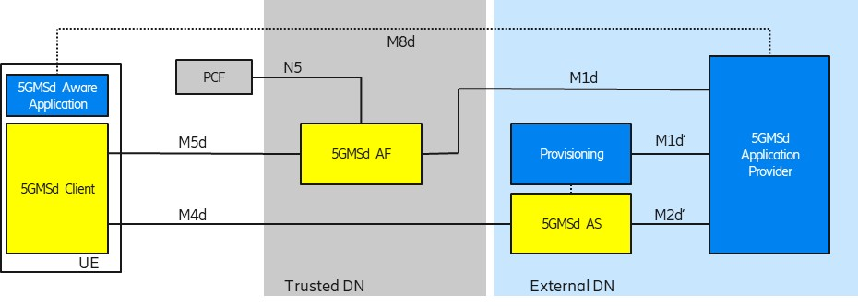
Figure 5.9.2-2: Collaboration 2 (Collaboration 4 of TS 26.501)
In order to use flow-based network features (such as different QoS classes or different charging policies), the 5G System needs to detect the relevant traffic.

5.3.2.2 Differentiated Services/ToS-enabled Collaboration Scenarios
Differentiated Services (DS) [76, 77] is a scalable scheme for managing application traffic by classifying the traffic into a set of coarse-grained traffic classes. A Differentiated Service (DS) domain is a continuous set of DS-capable routers, which are operated with a common set of configurations. Each IP packet in a DS domain is marked and conditioned according to its traffic class. A 6-bit DS Code Point (DSCP) of the 8-bit differentiated services field (DS field) is used for marking. The DS field replaces the ToS field in the IPv4 packet headers and the Traffic Class field in the IPv6 header.
End host systems may mark IP packets with a specific DSCP value prior to transmission. DS-enabled routers treat the packet according to the DSCP value when performing routing operations on it. Border gateway routers typically mark packets with a DSCP value based on some traffic policy, overriding any value set by hosts.
NOTE: Usage of Differentiated Services across administrative borders is technically possible. The preservation of the DSCP field by networks between the MNO network and the external Data Networks hosting the 5GMS functions is assumed to be governed by an SLA and by transport-level arrangements that are outside 3GPP scope. When the DSCP field is used only for traffic identification, preservation of the DSCP field could be achieved by using a tunnelling solution.
The RFCs defining Differentiated Services recommend a set of Per-Hop Behaviors (PHB), namely:
- Default Forwarding (DF) PHB, defined in section 4.1 of RFC 2474 [76], is used for traffic without special treatment.
- Class Selector PHB, defined in section 4.2.2.2 of RFC 2474 [76] is used for maintaining backwards compatibility with the IP precedence field of ToS.
- Expedited Forwarding (EF) PHB, defined by RFC 3246 [78], is dedicated to low loss or low latency traffic.
- Assured Forwarding (AF) PHB, defined by RFC 2597 [79], offers different levels of forwarding assurances.
The DS domain operator can also implement additional custom PHBs.
In the context of ToS-based traffic identification and separation, it is reasonable to assume the Data Network north of the UPF (N6) is DS-enabled. The 5G System is embedded in a larger DS domain, using same ToS values across multiple devices in order to provide Quality of Service Support like a DSCP-enabled link. However, it is not required to deploy DS capable routers for using in order to use the ToS field in the IP packet filter set for traffic identification.
According to clause 4.1 of TS 26.501 [15], the 5GMS functions may be deployed within the trusted Data Network or an external Data network. As noted above, DS Code Points are often reset at network domain borders, but not always. There may be deployments e.g., with localized Edge Computing or with direct peering realizations, where the DSCP values can be used up to the 5GMSd AF and/or 5GMS AS in an external Data Network. In this case, the logical DS domain is extended to include those externally-deployed 5GMS functions.
Figure 5.3.2.2-1 illustrates a deployment with a DS domain between the 5G System and the 5GMS functions deployed in the external DN. (The model is also valid for deployments in which the 5GMS functions both reside in the trusted DN.)
Figure 5.3.2.2-1: 5GMS deployment within a DS domain
Figure 5.3.2.2-2 illustrates a deployment with a DS domain between the 5G System and an externally deployed 5GMSd AS. The 5GMSd AF is deployed in the trusted DN.
Figure 5.3.2.2-1: 5GMS deployment within a DS domain
**** Next Change ****

5.3.5 Potential open issues
The exact behaviour and information that needs to be provided to and by the 5GMSd AF as well as the Media Session Handler need to be specified.
The following open issues have been identified:

1. The Nnef_AFsessionWithQOS and Nnef_ChargeableParty stage 3 APIs, as defined in TS 29.522 [43], only supports a Packet Flow Description (through the FlowInfo Type) or an Application Identifier for referencing one or more PFDs. Other information elements of the Service Data Flow Filter (like a ToS value) are not supported. Note, the FlowInfo type from TS 29.122 [44] is different from the FlowInformation type in TS 29.512 [45].
**** Last Change ****

