3GPP TSG-SA4 Meeting # 120 S4-221053

Online 17. Aug. - 26. Aug. 2022
CR-Form-v12.2
CHANGE REQUEST
 | 26.502 | CR | <CR#> | rev | <Rev#> | Current version: | 17.1.1
For HELP on using this form: comprehensive instructions can be found at
http://www.3gpp.org/Change-Requests.

Proposed change affects: | UICC apps |  | ME | x | Radio Access Network |  | Core Network | x

Title: | [5MBUSA] New Annex on Data Model example instantiations
Source to WG: | Ericsson
Source to TSG: | S4
Work item code: | 5MBUSA |  |  |  |  |  | Date: |  |  | 11.8.2022
Category: | F |  |  |  |  |  | Release: |  |  | Rel-17
 | Use one of the following categories:  F (correction)  A (mirror corresponding to a change in an earlier release)  B (addition of feature),  C (functional modification of feature)  D (editorial modification)  Detailed explanations of the above categories can  be found in 3GPP TR 21.900. |  |  |  |  |  |  |  | Use one of the following releases:  Rel-8 (Release 8)  Rel-9 (Release 9)  Rel-10 (Release 10)  Rel-11 (Release 11)  …  Rel-16 (Release 16)  Rel-17 (Release 17)  Rel-18 (Release 18)  Rel-19 (Release 19)
Reason for change: |  | The 5MBS Services and the MBS User Service Data Model contains a number of optional and conditional parameters. The intention of this annex is to give guidance for developers and also to stage 3 groups on the parameter usages.
Summary of change: |  | A new information annex is provided, which describes the data model instances for a set of content distribution use-cases (incl. location dependent services), using push and pull ingest.
Consequences if not approved: |  | Usage of the MBS User Services is error prone, due to high number of option variations.
Clauses affected: |  | 6.1, Annex C (New)
 |  | Y | N
Other specs |  |  | x | Other core specifications |  |  |  | TS/TR ... CR ...
affected: |  |  | x | Test specifications |  |  |  | TS/TR ... CR ...
(show related CRs) |  |  | x | O&M Specifications |  |  |  | TS/TR ... CR ...
Other comments:
This CR's revision history:

**** First Change ****

6.1 Object Distribution Method
The Object Distribution Method is used to deliver binary objects to the MBS Client over an MBS Session that have been received from the MBS Application Provider over reference point Nmb8.
The following Use Cases are supported:
- Single file delivery.
- Delivering a root object and its dependent objects as a collection, e.g. a web page and all the assets needed to render it.
- Object carouselling for file delivery, including updates of files.
- Real-time object streaming, for example for regular-latency or low-latency streaming delivery. In the latter case, the objects distributed may be CMAF segments as defined by the 5G Media Streaming DASH Interoperability Point specified in clause 7.3.11 of TS 26.247 [10].
The operating modes for the Object Distribution Method are summarised in table 6.1-1 below.
Table 6.1-1: Summary of operating modes for Object Distribution Method
Distribution method | Operating mode | Description
OBJECT | OBJECT_SINGLE | Each object ingested by the MBSTF is distributed once.
 | OBJECT_COLLECTION | A set of objects described by a manifest (see NOTE) is ingested by the MBSTF and distributed once.
 | OBJECT_CAROUSEL | A set of one or more objects described by a manifest (see NOTE) is ingested by the MBSTF and distributed according to a repetition pattern specified in the manifest.  Any change to an object during the course of the MBS Distribution Session is reflected in the distribution at the next available opportunity.
 | OBJECT_STREAMING | A sequence of objects is ingested by the MBSTF and streamed in real time, for example according to a schedule described in a presentation manifest (e.g. DASH MPD).
NOTE: The manifest format is specified in TS 26.517 [13].

Based on the configuration received from the MBSF via reference point Nmb2, the objects are ingested by the MBSTF from the MBS Application Provider via the pull-based or push-based object ingest method. As defined in clause 4, the MBSTF segments the objects into appropriate payloads, adds the FEC redundancy and schedule packet transmission to the MBS Client.
NOTE: Pull-based object ingest may occur once at the start of each active period of the associated MBS User Data Ingest Session, or the pulled objects may be revalidated (and possibly re-ingested) periodically, for example once per rotation of an object carousel.
File repair functionality may be utilized to repair object fragments transmitted by the MBSTF using the Object Distribution Method but lost or corrupted in transit. In such cases, the MBS Client may request the missing object fragments from the MBS AS. File repair may be done during an ongoing MBS User Services Session or after an MBS User Services Session.
**** Next Change ****

Annex C (informative):
Data model examples

C.1 General
This annex contains a set of examples of the MBS User Services data model as defined in clause 4.5.

C.2 Object Distribution Method with push-based ingest

C.2.1 DASH content distribution with push-based ingest
This example focuses on DASH content distribution with push-based ingest. The DASH segment packager continuously publishes media segments to the MBSTF as they become available. Media segments from all relevant DASH Adaptation Sets and Representations are multiplexed into the same MBS Distribution session. The data model parameters are provided in Figure C.2.1-1.
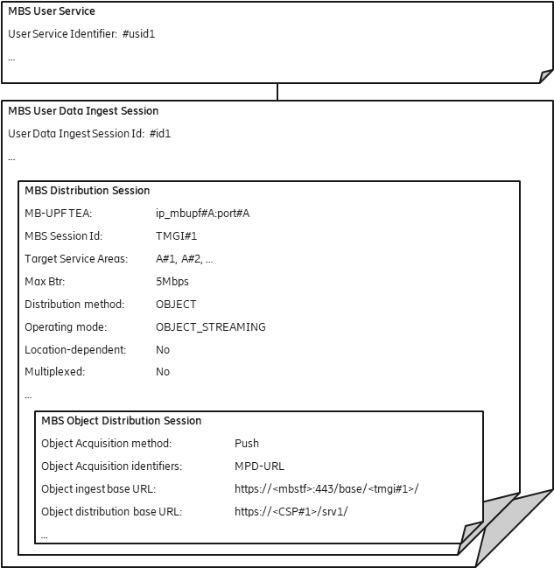
Figure C.2.1-1: DASH content distribution with push-based ingest
The DASH segment packager is configured to use the Object ingest base URL to upload media segments using HTTP. Each segment is identified by a unique URL relative to this base. The distribution URL generated by the MBSTF is formed by replacing the Object ingest base URL prefix with the value of Object distribution base URL.
EXAMPLE:
URL of ingested object: https://<mbstf>:443/base/<tmgi#1>/video/segment_1000.m4s
URL of distributed object: https://<CSP#1>/srv1/video/segment_1000.m4s
where:
- The string ip_mbupf#A:port#A refers to the IP address and port for the tunnel at which the MB-UPF expects the data for the MBS Session.
- The string <mbstf> refers to the IP address or the hostname of the MBSTF function.
- The string <tmgi#1> refers to the TMGI, which is assigned to the MBS Session.
NOTE: The TMGI of the MBS Session is used in this example to make the ingest URL uniqueue within the 5G System. Other solutions to ensure uniqueness are possible.
- The term <CSP#1> refers to a fully qualified domain name of the CSP.
The MBSF needs access to the MPD URL in order to compile the MBS Distribution Session Announcement. The MBSF may also modify the contents of the MPD ("conditioning") before compiling it into the Session Announcement and/or publishing it for retrieval at reference point MBS-4-UC.
The MBSTF does not need to inspect the contents of the DASH MPD.
The MBSTF uses a unicast tunnel to inject the generated MBS data into the MB-UPF at reference point Nmb9, using the Maximum bit rate parameter to pace these packets.

C.2.2 DASH content distribution with push-based ingest using separate MBS Distribution Sessions for audio and video
This example focuses on DASH content distribution with push-based ingest. The DASH segment packager continuously publishes media segments to the MBSTF as they become available. In this case, media segments from the video and audio Adaptation Sets are multiplexed into different MBS Distribution Sessions. In this case, the MBS User Service is provisioned to distribute the audio and video segments on separate MBS Distribution Sessions, with the two resulting MBS Distribution Sessions multiplexed onto the same MBS Session.
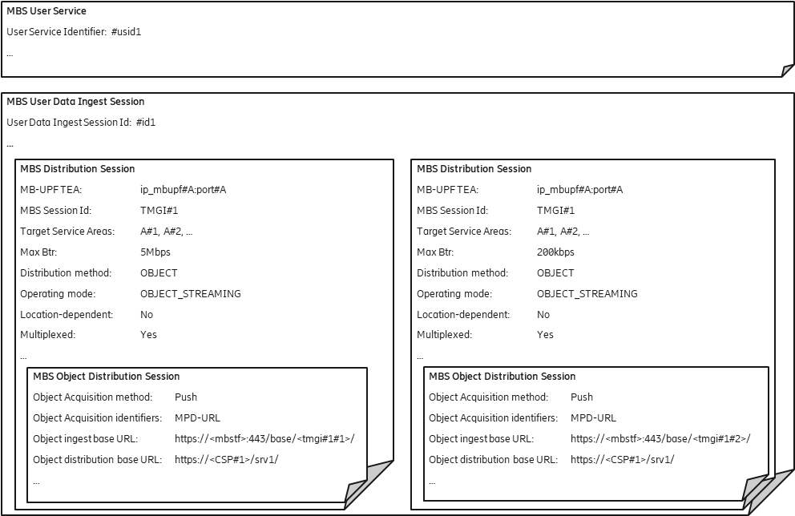
Figure C.2.2-1: DASH content distribution with push-based ingest
using separate MBS Distribution Sessions for audio and video
For each MBS Session, the MBSTF uses a specific Maximum bit rate parameter to pace the packets towards the MB-UPF (here 5 Mbps for video segments and 200 kbps for audio segments). For the ingest session, two separate Object ingest base URLs are provided, namely:
https://<mbstf>:443/base/<tmgi#1#1>/ and
https://<mbstf>:443/base/<tmgi#1#2>/
The strings <tmgi#1#1> and <tmgi#1#2> are used to make the ingest URLs unique within the 5G System. The last portion is a suffix for the individual MBS Distribution Session. The usage of the TMGI of the MBS Session is one example to make the ingest URL unique within the 5G System.
The MBSTF uses the same unicast tunnel to inject the data into the MB-UPF at reference point Nmb9, so that the data is distributed via the same MBS Session.

C.2.3 Generic object distribution with push-based ingest
This example focuses on generic object distribution using push-based ingest. In this case, a series of objects are pushed by the MBS Application Provider (AF/AS) into the MBSTF where an MBS Distribution Session is provisioned to use the OBJECT_SINGLE operating mode, which requires no manifest.
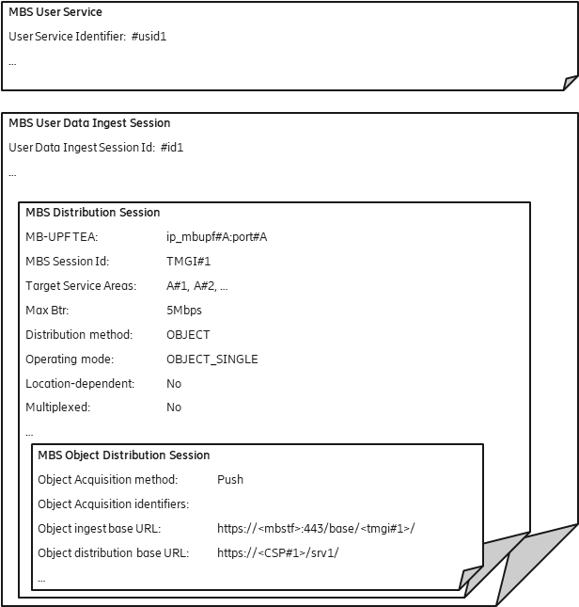
Figure C.2.3-1: Generic object distribution with push-based ingest
The case is very similar to the previous DASH content distribution cases, with the difference that no Object acquisition identifiers are provisioned. Any object pushed to the Object ingest base URL nominated by the MBSF is distributed in the MBS Distribution Session by the MBSTF after substituting the Object ingest base URL prefix with the Object distribution base URL.

C.3 Object Distribution Method with pull-based ingest

C.3.1 DASH content distribution with pull-based ingest
This example focuses on DASH content distribution with pull-based ingest. The DASH segment packager publishes media segments to an external origin server and the MBSTF pulls them according to the timing model of a DASH presentation specified in an MPD.
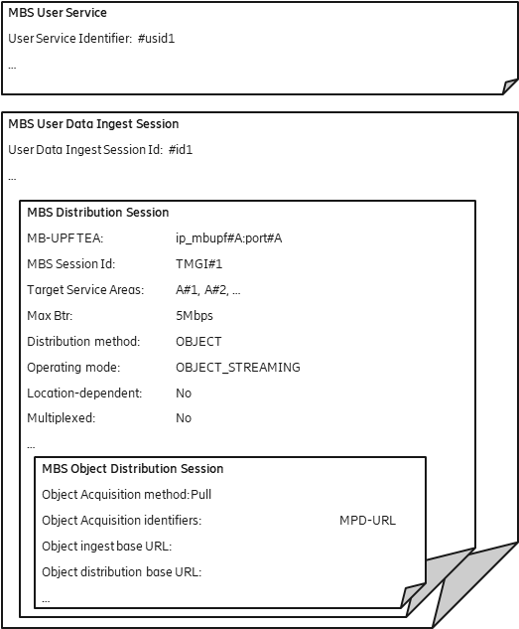
Figure C.3.1-1: DASH content with pull-based ingest
The Object ingest base URL remains empty, since the DASH media segments are fetched according to the DASH presentation manifest referenced by the Object Acquisition identifiers property.
In this example, the Object ingest base URL and Object distribution base URL are both omitted, resulting in the same URL used for fetching each media segment being used for its distribution.

C.3.2 DASH content distribution with pull-based ingest using separate MBS Distribution Sessions for audio and video
This example focuses on DASH content distribution with pull-based ingest. The DASH segment packager publishes media segments to an external origin server and the MBSTF pulls them according to the timing model of a DASH presentation specified in an MPD. In this case, the MBS User Service is provisioned to distribute the audio and video segments on separate MBS Distribution Sessions, which are multiplexed onto the same MBS Session.
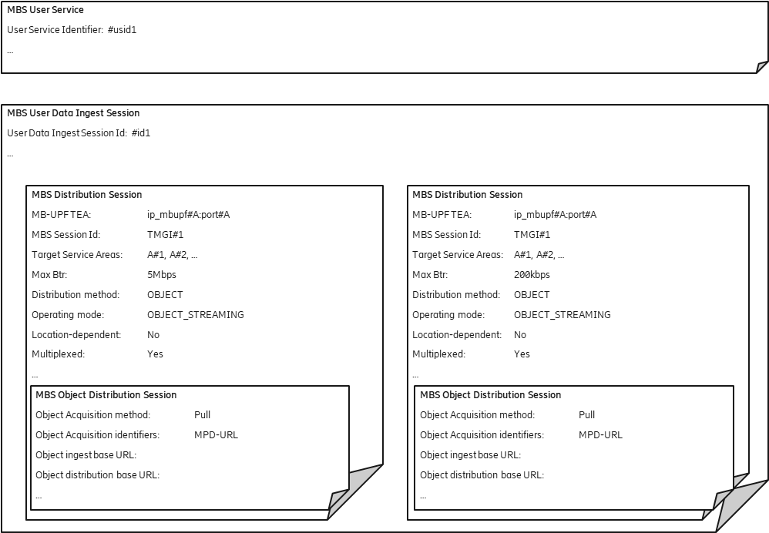
Figure C.3.2-1: DASH content distribution with pull-based ingest
using separate MBS Distribution Sessions for audio and video
The Object ingest base URL is ignored in this case because the media segments are fetched according to the DASH MPD referenced by the Object acquisition identifiers property.
In this example, the Object distribution base URL is also omitted, resulting in the same URL used for fetching each media segments being used for its distribution.

C.3.3 Generic object distribution with pull-based ingest
This example focuses on generic object distribution using pull-based ingest. In this case, objects are pulled into the MBSTF according to an object manifest.
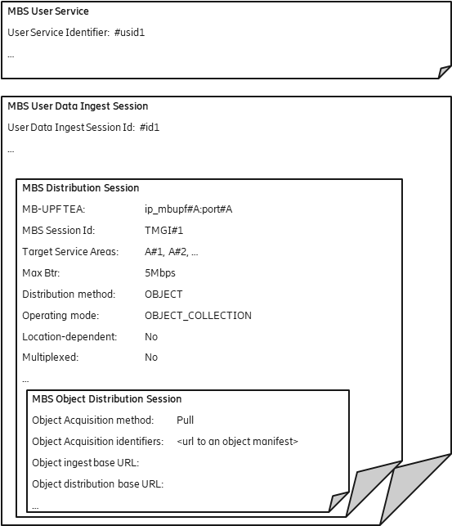
Figure C.3.3-1: Generic object distribution with pull-based ingest
The URL of the object manifest is provisioned by the MBS Application Provider using the Object acquisition identifiers parameter.
In this example, the Object ingest base URL and Object distribution base URL are both omitted, resulting in the same URL used for fetching each object being used for its distribution.

C.4 Location-dependent Object Distribution Method using push-based ingest

C.4.1 Location-dependent DASH content distribution using push-based ingest
A location-dependent MBS Serivce allows regional content variants to be distributed to different MBS Service Areas within the scope of a common MBS Session. The UE receives the content variant appropriate to its current location. This feature allows realization of MBS User Services such as local traffic information.
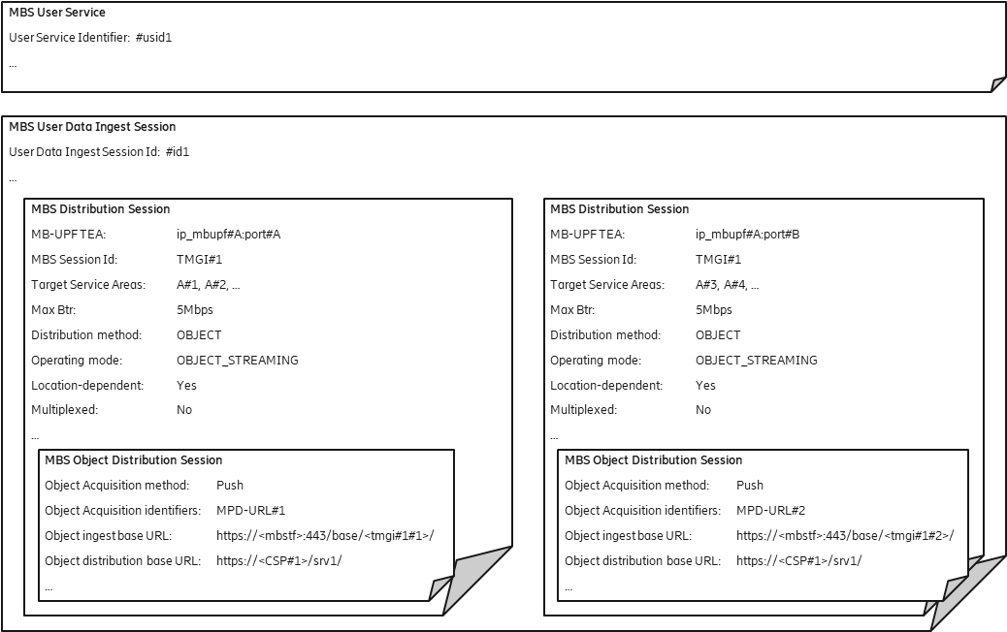
Figure C.4.1-1: Location-dependent DASH content distribution using push-based ingest
Two MBS Distribution Sessions with different Target service areas are provisioned. Each MBS Distribution Session has a different Object ingest base URL so that two content sources can push different media objects to the two MBS Distribution Sessions. Each content source uses a different DASH presentation manifest.
The MBSF provisions a different MBS Session in the MB-SMF for each MBS Distribution Session and arranges for the user plane traffic of each one to be distributed to the correct MBS Service Area.
The MBSTF uses a separate tunnel to inject the MBS data for each MBS Distribution Session into the MB-UPF.
The MB-UPF listens on two separate UDP ports (port#A and port#B) for the location-specific MBS data streams.

C.4.2 Location-dependent generic object distribution with push-based ingest
The location-dependent MBS Serivce described in this clause is very similar to that in clause C.4.1. The difference is the distribution of a generic object stream which is not described by a manifest.
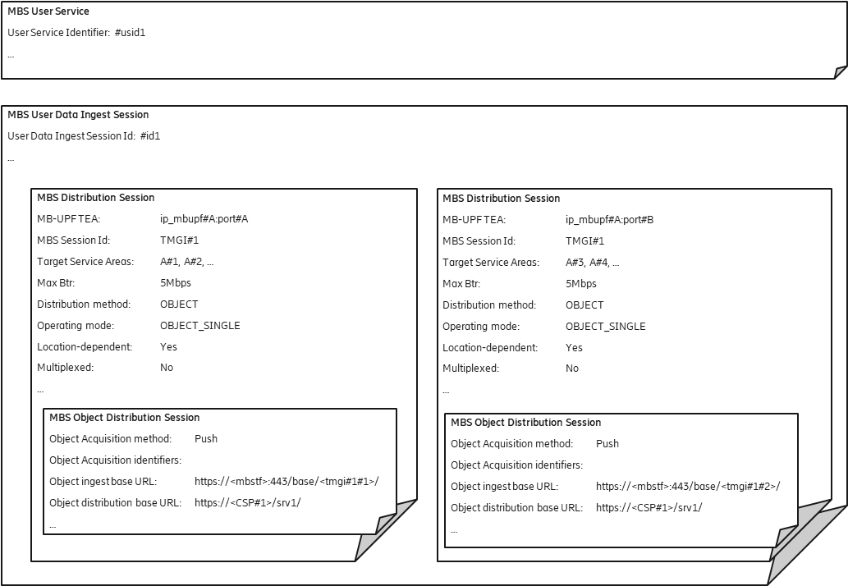
Figure C.4.2-1: Location-dependent generic object distribution with push-based ingest
As in clause C.2.3, no Object acquisition identifiers are provisioned. Any object pushed to one of the Object ingest base URLs nominated by the MBSF is distributed to the corresponding MBS Distribution Session by the MBSTF after substituting the relevant Object ingest base URL prefix with the corresponding Object distribution base URL.
**** Last Change ****

