3GPP TSG-SA4 Meeting # 120 S4-221053

Online 17. Aug. - 26. Aug. 2022
CR-Form-v12.2
CHANGE REQUEST
 | 26.502 | CR | <CR#> | rev | <Rev#> | Current version: | 17.1.1
For HELP on using this form: comprehensive instructions can be found at
http://www.3gpp.org/Change-Requests.

Proposed change affects: | UICC apps |  | ME |  | Radio Access Network |  | Core Network

Title: | [5MBUSA] New Annex on Data Model example instantiations
Source to WG: | Ericsson
Source to TSG: | S4
Work item code: | 5MBUSA |  |  |  |  |  | Date: |  |  | 11.8.2022
Category: | F |  |  |  |  |  | Release: |  |  | Rel-17
 | Use one of the following categories:  F (correction)  A (mirror corresponding to a change in an earlier release)  B (addition of feature),  C (functional modification of feature)  D (editorial modification)  Detailed explanations of the above categories can  be found in 3GPP TR 21.900. |  |  |  |  |  |  |  | Use one of the following releases:  Rel-8 (Release 8)  Rel-9 (Release 9)  Rel-10 (Release 10)  Rel-11 (Release 11)  …  Rel-16 (Release 16)  Rel-17 (Release 17)  Rel-18 (Release 18)  Rel-19 (Release 19)
Reason for change: |  | The 5MBS Services and the MBS User Service Data Model contains a number of optional and conditional parameters. The intention of this annex is to give guidance for developers and also to stage 3 groups on the parameter usages.
Summary of change: |  | A new information annex is provided, which describes the data model instances for a set of content distribution use-cases (incl. location dependent services), using push and pull ingest.
Consequences if not approved: |  | Usage of the MBS User Services is error prone, due to high number of option variations.
Clauses affected: |  | Annex C (New)
 |  | Y | N
Other specs |  |  | x | Other core specifications |  |  |  | TS/TR ... CR ...
affected: |  |  | x | Test specifications |  |  |  | TS/TR ... CR ...
(show related CRs) |  |  | x | O&M Specifications |  |  |  | TS/TR ... CR ...
Other comments:
This CR's revision history:

**** First Change ****

Annex C (informative):
Data Model Examples

C.1 General
This annex contains a set of examples of MBS User Service data model.

C.2 Object Distribution Method, Push Ingest

C.2.1 DASH Content Distribution with Push Ingest
This example focuses on DASH content distribution with Push Ingest. The DASH segmenter is pushing segments into the MBSTF, as media segments become available. The data model parameters are provided in Figure C.2.1-1.
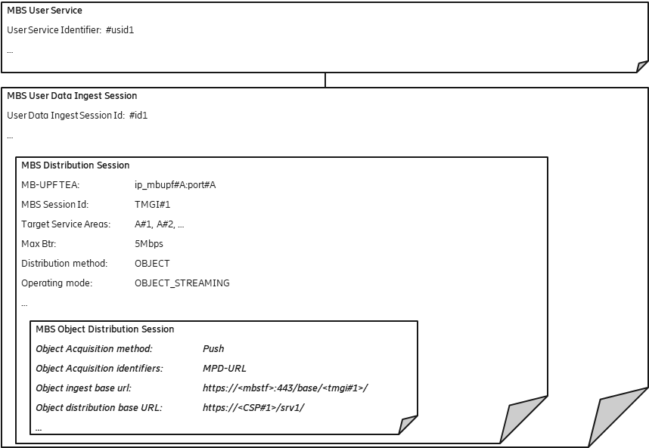
Figure C.2.1-1: DASH Content Distribution with Push Ingest
The DASH Segmenter is configured to use the Object ingest base url to upload segments using HTTP. Each segment is identified by a unique URL. The URL in the FLUTE FDT Content Location is created by replacing the “ingest base url” part with the “distribution base url”.
Example:
- URL of ingested object: https://<mbstf>:443/base/<tmgi#1>/video/segment_1000.m4s
- URL of distributed object: https://<CSP#1>/srv1/video/segment_1000.m4s
The MBSTF does not need to have the DASH MPD. The MBSF needs the MPD URL for service announcement
(incl potentially MPD conditioning).
The MBSTF uses the maximum bitrate parameter to pace the packets towards the MB-UPF. The MBSTF uses a tunnel to inject the data into the MB-UPF.
Since the target service areas value is present, this MBS User Service is operated as local MBS Service.

C.2.2 DASH Content Distribution using separate FLUTE Sessions for audio and video, Push ingest
This example focuses on DASH content distribution with Push Ingest. The DASH segmenter is pushing segments into the MBSTF, as media segments become available.
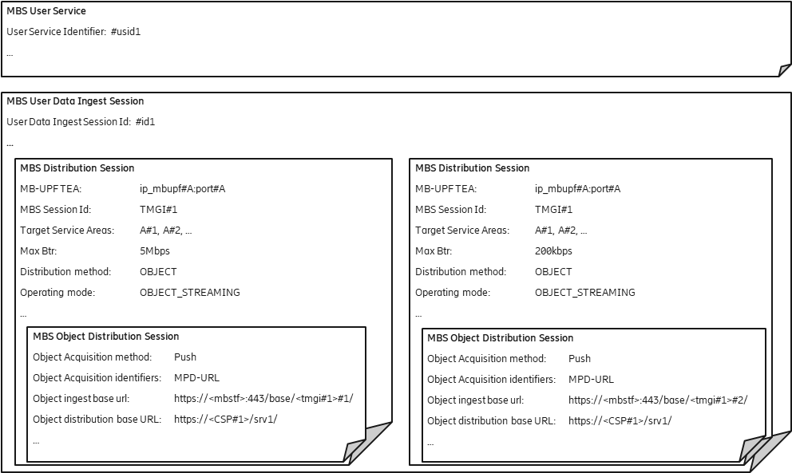
Figure C.2.2-1: DASH Content Distribution using separate FLUTE Sessions for audio and video, Push ingest
In this case, the MBS User Service is provisioned to distribute the audio and video segments as separate MBS Distribution Sessions, leveraging the same MBS Session, to UEs.
For each MBS Session, the MBSTF uses a specific the maximum bitrate parameter to pace the packets towards the MB-UPF, here 5Mbps for video and 200kbps for audio segments. The MBSTF uses the same tunnel to inject the data into the MB-UPF, so that the data is distributed via the same MBS Session.

C.2.3 Generic objects with push
This example focuses on a generic object distribution case with Push Ingest. In this case, object are pushed into the MBSTF, without usage of a manifest.
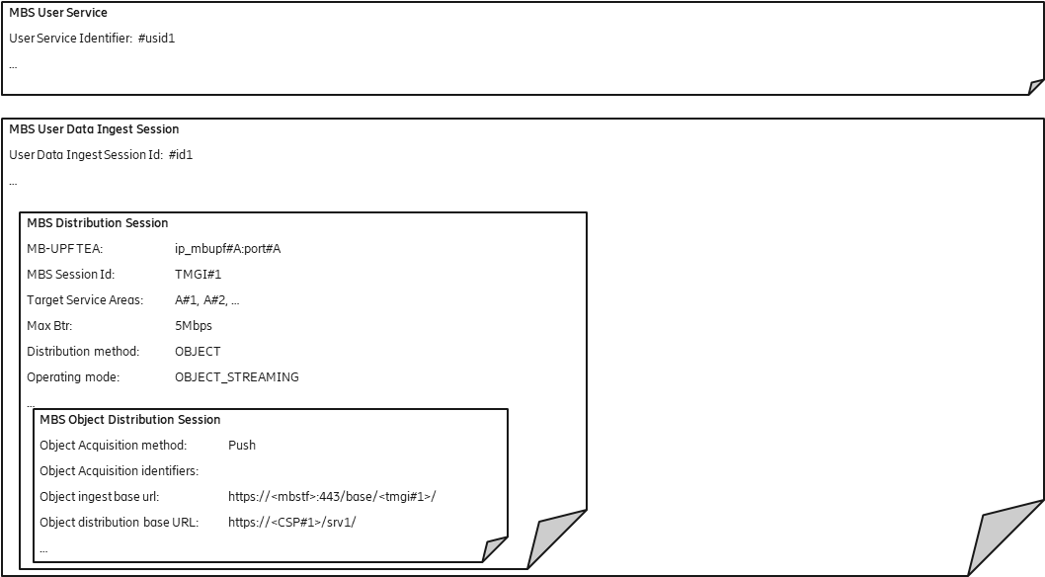
Figure C.2.3-1: Generic objects with push
The case is very similar to DASH Content delivery cases, with the difference, that the Object Acquisition identifiers remain empty.

C.3 Object Distribution Method, Pull Ingest

C.3.1 DASH Content with pull ingest
This example focuses on DASH content distribution with Pull Ingest. The DASH segmenter is publishing segments onto an external origin server and the MBSTF is pulling the available segments according to a DASH Manifest.

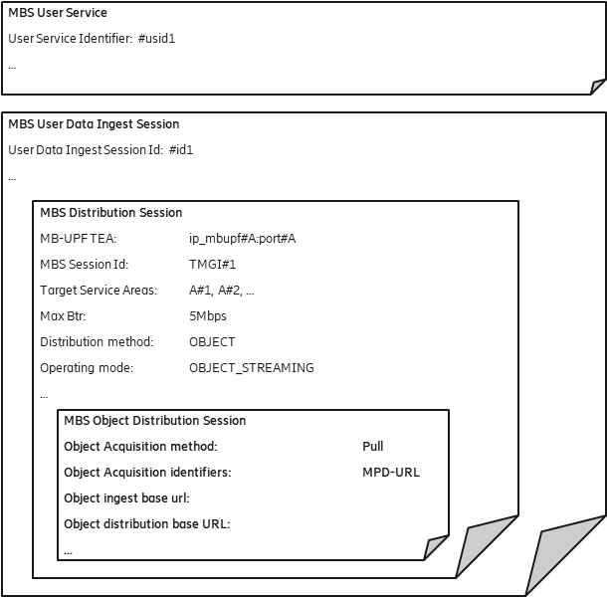
Figure C.3.1-1:
The Object ingest base url remains empty, since the segments are fetched according to the manifest provided with the Object Acquisition identifiers property.
The object distribution base url is here empty, resulting that the same url as used for fetching the media segments is also used for distribution within the Content-Location of the FLUTE FDT instance.

C.3.2 DASH Content Distribution using separate FLUTE Sessions for audio and video, Pull ingest
This example focuses on DASH content distribution with Pull Ingest. The DASH segmenter is publishing segments onto an external origin server and the MBSTF is pulling the available segments according to a DASH Manifest.
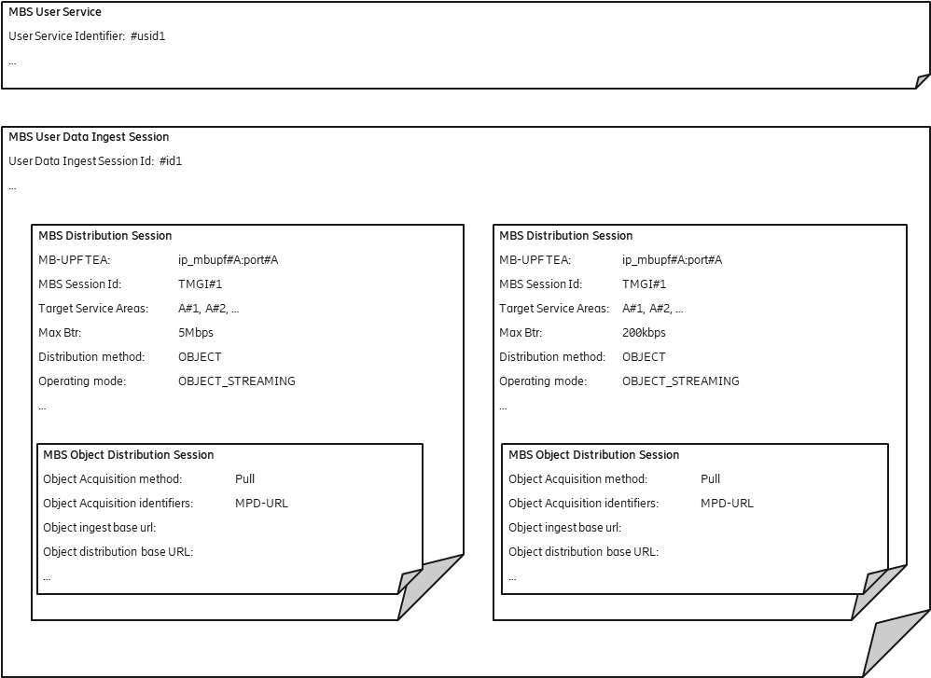
Figure C.3.2-1: DASH Content Distribution using separate FLUTE Sessions for audio and video, Pull ingest
The Object ingest base url remains empty, since the segments are fetch according to the manifest provided with the Object Acquisition identifiers property.
The object distribution base url is here empty, resulting that the same url as used for fetching the media segments is also used for distribution within the Content-Location of the FLUTE FDT instance.
Editor’s Note: The association between the adaptation set and the MBS distribution session is left to implementations.

C.3.3 Generic objects with Pull
This example focuses on a generic object distribution case with Pull Ingest. In this case, object are pulled into the MBSTF according to a object manifest.
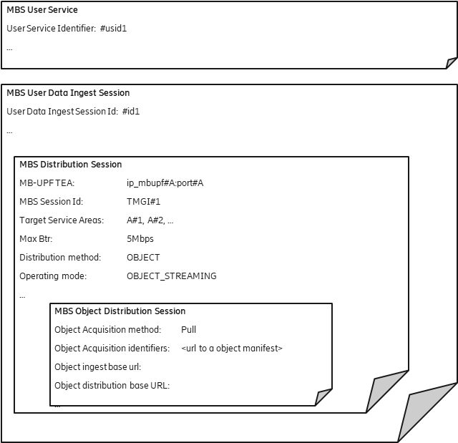
Figure C.3.3-1: Generic objects with Pull

C.4. Location Dependent Object Distribution Method, Push Ingest

C.4.1 Location Dependent DASH Content Distribution, Push Ingest
Location Dependent MBS Serivce allows distribution of different content within one MBS Session. Depending on the UE location, the UE receives the content. This feature allows realization like local traffic information.
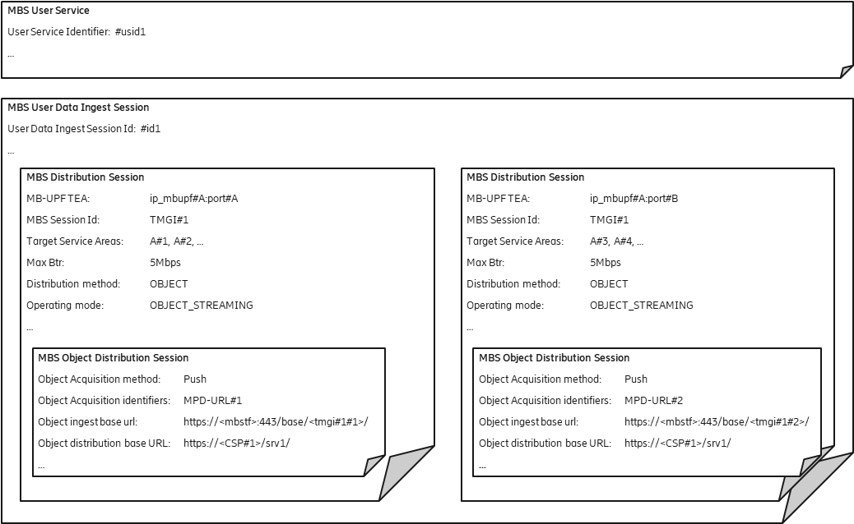
Figure C.4.1-1:
Two MBS distribution sessions with separate target service areas are defined. For each MBS distribution session, a separate Object ingest base url is provisioned, so that two content sources can push objects. Each content source uses their own DASH manifest.
The MBS-UPF is listening on two separate UDP ports (port#A and port#B) for the data streams for the separate area sessions.

C.4.2 Location Dependent Generic Object Distribution, Push ingest
This Location Dependent MBS Serivce described in this clause is very siumilar to the example in the previous clause. The difference is the distribution of generic object stream, which is not described by a manifest.

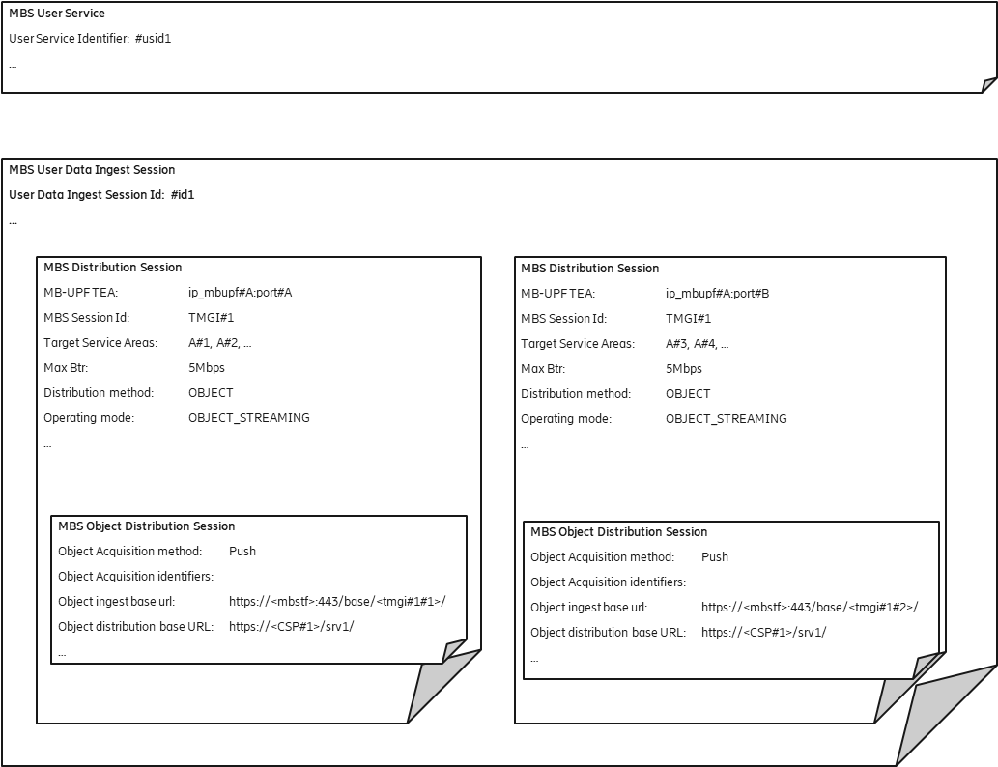
Figure C.4.2-1:

**** Last Change ****

