3GPPSA4 #120-e S4- 220990
E-meeting, 17-26 Aug 2022
CR-Form-v12.0
DRAFT CHANGE REQUEST
 | 26.501 | CR |  | rev | - | Current version: | 17.2.0
For HELP on using this form: comprehensive instructions can be found at
http://www.3gpp.org/Change-Requests.

Proposed change affects: | UICC apps |  | ME |  | Radio Access Network |  | Core Network

Title: | [5GMSA_PH2] Uplink collaboration scenarios
Source to WG: | Tencent
Source to TSG:
Work item code: | 5GMSA_PH2 |  |  |  |  |  | Date: |  |  | 8/09/2022
Category: | B |  |  |  |  |  | Release: |  |  | 19
 | Use one of the following categories:  F (correction)  A (mirror corresponding to a change in an earlier release)  B (addition of feature),  C (functional modification of feature)  D (editorial modification)  Detailed explanations of the above categories can  be found in 3GPP TR 21.900. |  |  |  |  |  |  |  | Use one of the following releases:  Rel-8 (Release 8)  Rel-9 (Release 9)  Rel-10 (Release 10)  Rel-11 (Release 11)  Rel-12 (Release 12)  Rel-13 (Release 13)  Rel-14 (Release 14)  Rel-15 (Release 15)  Rel-16 (Release 16)
Reason for change: |  | This document adds 6 collaboration scenarios for uplink streaming that are documented in TR 26.804 in Annex A. The order of collaboration scenarios are changed since the first collaboration scenario (collaboration scenario 5 in TR 26.804) is used for the baseline call flow in clause 6.1 of TS 26.501.
Summary of change: |  | - Collaboration scenarios for uplink streaming
Consequences if not approved:
Clauses affected:
 |  | Y | N
Other specs |  |  |  | Other core specifications |  |  |  | TS/TR ... CR ...
affected: |  |  |  | Test specifications |  |  |  | TS/TR ... CR ...
(show related CRs) |  |  |  | O&M Specifications |  |  |  | TS/TR ... CR ...
Other comments:
This CR's revision history:

CHANGE

A.10 Uplink, AF and AS in trusted domain
In this collaboration scenario, both the 5GMSu AS and 5GMSu AF are present and reside in the trusted domain, and thus its associated 3GPP-defined reference points and procedures apply. Additionally, the M2u API is used by the 5GMSu AS and the external 5GMSu Application Provider for content egest.
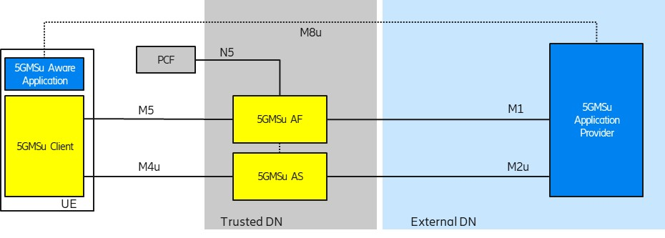
Figure A.10-1: Uplink, AF, and AS in trusted domain

Figure A.10-2 provides a high-level call flow for this collaboration scenario.
Figure A.10-2: Call flow for Uplink, AF, and AS in trusted domain
Steps:
1. The 5GMSu Application Provider creates a Provisioning Session with the 5GMSu AF.
2. The 5GMSu Application Provider requests the 5GMSu AF to create one Content Publishing Configuration that defines the instructions for content egest (M1u).
3. The 5GMSu AF, based on the received Content Publishing Configuration, requests the 5GMSu AS to confirm the availability of content resources for egest.
NOTE 1: M3u procedures between the 5GMS AF and the 5GMS AS are outside the scope of TS 26.501.
4. The 5GMSu AF acknowledges to the 5GMSu Application Provider the successful creation of the Content Publishing Configuration (M1u).
At some later point in time:
5. The 5GMSu Application Provider optionally provides Service Access Information to the 5GMS-Aware Application (M8u).
Alternatively:
6. The 5GMS-Aware Application requests the 5GMSu Client to start an uplink streaming session (M6u/M7u).
7. The 5GMSu Client requests Service Access Information from the 5GSMu AF (M5u).
Then:
8. The 5GMSu Client requests starting media session uplink streaming (M5u).
9. The 5GMSd AF requests initialisation of the content preparation process (M3u).
10. The 5GMSd AS initialises the content preparation process, if is not already running (M3u).
11. The 5GMSd AF acknowledges the initialisation of the content preparation process (M3u).
Next:
12. Uplink media streaming starts from the 5GMSu Client to the 5GMSu AS (M4u).
13. Media streaming egest starts from the 5GMSu AS to the 5GMSu Application Provider (M2u).
Finally:
14. The 5GMSu AS releases its resources after observing a period of interactivity.
NOTE: This step is implementation dependent.

A.11 Uplink, Media plane only, AF & AS in the trusted domain
This uplink collaboration scenario pertains to a media plane only collaboration for which the 5GMSu AS is deployed in the trusted Data Network. Here, the 5GMS System Provider is assumed to offer uplink streaming capabilities as a service to an external 5GMSu Application Provider.
NOTE: Although a Provisioning Session is shown in Figure A.11-1 between the (external) 5GMSu Application Provider and the 5GMSu AF, due to the absence of the M5u interface in this diagram, there is no control plane collaboration between the 5GMSu Application Provider and the 5GMS System Provider.
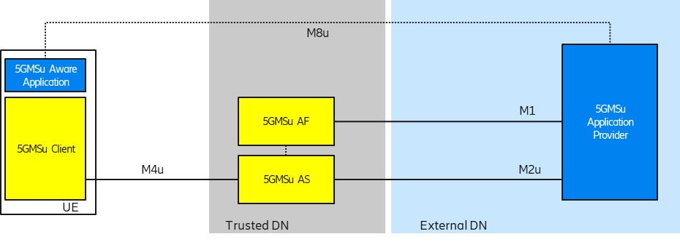
Figure A.11-1: Uplink, Media plane only, AF & AS in the trusted Data Network
Figure A.11-2 provides a high-level call flow for this collaboration scenario.
Figure A.11-2: Call flow for Uplink, Media plane only, AF & AS in the trusted domain
Steps:
1. The 5GMSu Application Provider creates a Provisioning Session for uplink streaming with the 5GMSu AF.
2. The 5GMSu Application Provider creates a Content Publishing Configuration as part of the Provisioning Session that defines the instructions for content egest (M1u).
3. The 5GMSu AF, based on the received Content Publishing Configuration, requests the 5GMSu AS to instantiate the content preparation process (M3u).
4. The 5GMSu AS initialises the content preparation process.
5. The 5GMSu AS acknowledges the initialisation of the required process (M3u).

6. The 5GMSu AF acknowledges the successful creation of the Content Publishing Configuration to the 5GMSu Application Provider (M1u).
At some later point in time:
7. The 5GMSu Application Provider optionally provides Service Access Information to the 5GMS-Aware Application (M8u).
8. Uplink media streaming starts from the 5GMSu Client to the 5GMSu AS (M4u).
9. Media streaming egest starts from the 5GMSu AS to the 5GMSu Application Provider (M2u).
Finally:
10. The 5GMSu AS releases its resources after observing a period of inactivity.
NOTE: Step 10 is implementation-dependent.

A.12 Uplink, Provisioning and AS in the external domain
This scenario pertains to a media plane only collaboration for which the 5GMSu AS is deployed in the external Data Network and the 5GMSu AF is not involved. Specifically, the M1′ and/or M2u′ protocols do not follow 3GPP specifications.
Figure A.12-1: Uplink, Provisioning and AS in the external Data Network
Figure A.12-2 provides a high-level call flow for this collaboration scenario.
Figure A.12-2: Call flow for Uplink, Provisioning and AS in the external Data Network
Steps:
1. The 5GMSu Application Provider creates a Provisioning Session for uplink streaming with the 5GMSu AF (M1u′).
2. The Provisioning function requests the 5GMSu AS to initialise the required content preparation process (M3u′).
3. The 5GMSu AS initialises the content preparation process.
4. The 5GMSu AS acknowledges the initialisation of the required process (M3u′).
5. The Provisioning function acknowledges the successful creation of the Provisioning Session to the 5GMSu Application Provider (M1u′).
At some later point in time:
6. The 5GMSu Application Provider provides Service Access Information to the 5GMS-Aware Application (M8, out of scope).
7. Uplink media streaming starts from the 5GMSu Client to the 5GMSu AS (M4u).
8. Media streaming egest starts from the 5GMSu AS to the 5GMSu Application Provider (M2u).
Finally:
9. The 5GMSu AS releases its resources after observing a period of inactivity.
NOTE: Step 9 is implementation-dependent.

A.13 Uplink, AF in the trusted domain and AS in the external domain
In this collaboration scenario, both the 5GMSu AS and 5GMSu AF are present. The 5GMSu AS resides in the external domain and does not employ 5GMS protocols and formats for uplink media reception from the 5GMSu Client, nor for content egest. The 5GMSu AF is used to interact with the 5G System, e.g., for dynamic policy invocation and/or other uplink streaming related network features such as metrics reporting and network assistance).
Figure A.13-1: Uplink, AF in the trusted domain and AS in the external domain
Figure A.13-2 provides a high-level call flow for this collaboration scenario.
Figure A.13-2: Call flow for Uplink, AF in the trusted domain and AS in external domain
Steps:
1. The 5GMSu Application Provider creates a Provisioning Session with its internal Provisioning function (M1u′).
2. The Provisioning function requests the 5GMSu-like AS to initialise the required content preparation process instantiation (M3u′).
3. The 5GMSu-like AS instantiates the content preparation process.
4. The 5GMSu-like AS acknowledges the Provisioning the instantiation of required process (M3u′).
5. The Provisioning function acknowledges successful provisioning to the 5GMSu Application Provider (M1u′).
6. The 5GMSu Application Provider creates a Provisioning Session for uplink streaming with the 5GMSu AF.
X. The 5GMSu Application Provider creates a Content Publishing Configuration as part of the Provisioning Session that defines the instructions for content egest (M1u).
At some later point in time:
7. The 5GMSu Application Provider optionally provides Service Access Information to the 5GMS-Aware Application (M8, out of scope).
8. The 5GMS-Aware Application requests the 5GMSu Client to start an uplink streaming session (M6u/M7u).
9. The 5GMSu Client optionally (and in the case step 5 was not performed) requests Service Access Information from the 5GSMu AF (M5u).10. Uplink media streaming starts from the 5GMSu Client to the 5GMSu-like AS (M4u′).
11. Media streaming egest starts from the 5GMSu-like AS to the 5GMSu Application Provider (M2u′).
Finally:
12. The 5GMSu AS releases its resources after observing a period of inactivity.
NOTE: This step is implementation dependent.

A.14 Uplink, AF and AS in the external domain
In this collaboration scenario, both the 5GMSu AS and 5GMSu AF are present and follow 3GPP specifications. Both the 5GMSu AS and 5GMSu AF reside in the external DN/domain.
Figure A.13-1: Uplink, AF and AS in the external domain
Figure A.14-2 provides a high-level call flow for this collaboration scenario.
Figure A.14-2: Call flow for uplink, AF and AS in the external domain
Steps:
1. The 5GMSu Application Provider creates a Provisioning Session for uplink streaming with the 5GMSu AF (M1u′).
2. The 5GMSu Application Provider creates a Content Publishing Configuration as part of the Provisioning Session that defines the instructions for content egest (M1u′).
3. The 5GMSu AF, based on the received publishing configuration, requests the 5GMSu AS to confirm the availability of content resources for egest (M3u).
NOTE: M3u procedures between the 5GMS AF and the 5GMS AS are outside the scope of TS 26.512 [16].
4. The 5GMSu AF acknowledges the successful creation of the Content Publishing Configuration to the 5GMSu Application Provider (M1u′).
At some later point in time:
5. The 5GMSu Application Provider requests that the 5GMSu AF initialises the content preparation process (M1u′).
6. The 5GMSd AF requests initialisation of the content preparation process (M3u).
7. The 5GMSd AS initialises the content preparation process, if is not already running (M3u).
8. The 5GMSd AS acknowledges the initialisation of the content preparation process (M3u).
9. The 5GMSu AF acknowledges the initialisation of the cotent preparation process (M1u′).
10. The 5GMSu Application Provider provides Service Access Information to the 5GMS-Aware Application (M8, out of scope).
11. The 5GMS-Aware Application requests the 5GMSu Client to start an uplink streaming session (M6u/M7u).
Alternatively:
12. The 5GMS-Aware Application requests the 5GMSu Client to start an uplink streaming session (M6u/M7u).
13. The 5GMSu Client requests Service Access Information from the 5GSMu AF (M5u).
14. The 5GMSd AF requests initialisation of the content preparation process (M3u).
15. The 5GMSd AS initialises the content preparation process, if is not already running (M3u).
16. The 5GMSd AF acknowledges the initialisation of the content preparation process (M3u).
17. The 5GMSMu AF provides Service Access Information to the 5GMSu Client (M5u).
Then:
18. Uplink media streaming starts from the 5GMSu Client to the 5GMSu AS (M4u).
19. Media streaming egest starts from the 5GMSu AS to the 5GMSu Application Provider (M2u′).
Finally:
20. The 5GMSu AS releases its resources after observing a period of inactivity.
NOTE: This step is implementation-dependent.

A.15 Hybrid uplink & downlink
This scenario represents a hybrid, i.e. end-to-end form of collaboration across uplink media streaming and downlink media streaming services. An external 5GMS Application Provider relies on the 5GMS System Provider to support both the uplink streaming media transmission by 5GMSu Clients and subsequent distribution of that content via downlink media streaming for reception by 5GMSd Clients.
Figure A.15-1: Hybrid uplink and downlink
Figure A.15-2 shows the call flow for this scenario. To simplify the call flow, the content preparation process is not defined.
Figure A.15-2: Call flow for hybrid uplink & downlink
Steps:
1. The 5GMSd Application Provider creates a Provisioning Session with the 5GMSd AF (M1d).
2. The 5GMSd Application Provider provisions the 5GMSD AF with a Content Hosting Configuration.
3. The 5GMSd AF, based on the received Content Hosting Configuration, requests the 5GMSd AS to confirm the availability of distribution resources (M3d, procedures not specified).
4. The 5GMSd AF acknowledges to the 5GMSd Application Provider the successful creation of the Content Hosting Configuration (M1d).
5. The 5GMS Application Provider creates a Provisioning Session with the 5GMSu AF (M1u).
6. The 5GMSu AF requests the 5GMSu AS to confirm the uplink resources availability. (M3u, procedures not specified).
7. The 5GMSu AF acknowledges to the 5GMSu Application Provider of the successful provisioning (M1u).
8. The 5GMS Application optionally provides the service access information to the 5GMSu-Aware Application (M8u, out of scope).
9. The 5GMS-Aware Application request the 5GMSu Client to start an uplink streaming session (M6/7u).
10. If Service Access Information was not provided in step 8, the 5GMSu Client requests this information from the 5GSMu AF (M5u).
11. The 5GMSu Client requests the start of the uplink streaming session from the 5GSMu AF (M5u).
12. The uplink media streaming starts (M4u).
13. The 5GMSu AS streams the content to the 5GMSd AS (I2, not specified).
14. The 5GMS Application Provider optionally provides the service access information to the 5GMSd-Aware Application (M8d, out of scope).
Steps 15-18 concern the 5GMS downlink streaming process:
15. The 5GMS-Aware Application request the 5GMSd Client to start an uplink streaming session (M6d/M7d).
16. If Service Access Information was not provided in step 14, the 5GMSd Client requests this information from the 5GSMd AF (M5d).
17. The 5GMSd Client requests the start of the downlink streaming session from the 5GSMd AF (M5d).
18. The downlink media streaming starts (M4d).
Finally:
19. The 5GMSu AS releases its resources after observing a period of interactivity.
20. The 5GMSd AS releases its resources after observing a period of interactivity.
NOTE 2: Steps 19 and 20 are implementation-dependent.
END OF CHANGES

