3GPPSA4#120-e S4-220958
E-meeting, 17 – 26 August 2022
CR-Form-v12.0
PSEUDO CHANGE REQUEST
 | 26.857 | CR | pseudo | rev | - | Current version: | 0.3.1
For HELP on using this form: comprehensive instructions can be found at
http://www.3gpp.org/Change-Requests.

Proposed change affects: | UICC apps |  | ME |  | Radio Access Network |  | Core Network

Title: | [FS_5G_MSE] Example Khronos OpenXR
Source to WG: | Qualcomm Incorporated
Source to TSG:
Work item code: | FS_5G_MSE |  |  |  |  |  | Date: |  |  | 11/08/2022
Category: | B |  |  |  |  |  | Release: |  |  | Rel-18
 | Use one of the following categories:  F (correction)  A (mirror corresponding to a change in an earlier release)  B (addition of feature),  C (functional modification of feature)  D (editorial modification)  Detailed explanations of the above categories can  be found in 3GPP TR 21.900. |  |  |  |  |  |  |  | Use one of the following releases:  Rel-10 (Release 10)  Rel-11 (Release 11)  Rel-12 (Release 12)  Rel-13 (Release 13)  Rel-14 (Release 14)  Rel-15 (Release 15)  Rel-16 (Release 16)  Rel-17 (Release 17)  Rel-18 (Release 18)
Reason for change:
Summary of change:
Consequences if not approved:
Clauses affected:
 |  | Y | N
Other specs |  |  |  | Other core specifications |  |  |  | TS/TR ... CR ...
affected: |  |  |  | Test specifications |  |  |  | TS/TR ... CR ...
(show related CRs) |  |  |  | O&M Specifications |  |  |  | TS/TR ... CR ...
Other comments: |  | This pCR assumes that S4-220954 is agreed
This CR's revision history:

===== CHANGE =====

2 References
The following documents contain provisions which, through reference in this text, constitute provisions of the present document.
- References are either specific (identified by date of publication, edition number, version number, etc.) or non-specific.
- For a specific reference, subsequent revisions do not apply.
- For a non-specific reference, the latest version applies. In the case of a reference to a 3GPP document (including a GSM document), a non-specific reference implicitly refers to the latest version of that document in the same Release as the present document.
[1] 3GPP TR 21.905: "Vocabulary for 3GPP Specifications".
[ISO-23090-8] ISO/IEC 23090-8:2020, Information technology — Coded representation of immersive media — Part 8: Network based media processing
[A] 3GPP TS 26.346: "Multimedia Broadcast/Multicast Service (MBMS); Protocols and codecs".
[B] 3GPP TS 26.347: "Multimedia Broadcast/Multicast Service (MBMS); Application Programming Interface and URL".
[C] 3GPP TS 26.479, "UE MBMS APIs for Mission Critical Services"
[D] 3GPP TS 26.501, "5G Media Streaming (5GMS); General description and architecture"
[E] 3GPP TS 26.511, "5G Media Streaming (5GMS); Profiles, codecs and formats"
[F] 3GPP TS 26.512, "5G Media Streaming (5GMS); Protocols"
[OpenXR] The Khronos Group, "The OpenXR Specification",
https://registry.khronos.org/OpenXR/specs/1.0/html/xrspec.html
===== CHANGE =====

3 Definitions of terms, symbols and abbreviations

3.1 Terms
For the purposes of the present document, the terms given in 3GPP TR 21.905 [1] and the following apply. A term defined in the present document takes precedence over the definition of the same term, if any, in 3GPP TR 21.905 [1].

eXtended Reality: A continuum of real-and-virtual combined environments generated by computers through human-machine interaction, including the technologies associated with Virtual Reality (VR), Augmented Reality (AR) and Mixed Reality (MR).

3.2 Symbols
For the purposes of the present document, the following symbols apply:
Symbol format (EW)
<symbol> <Explanation>

3.3 Abbreviations
For the purposes of the present document, the abbreviations given in 3GPP TR 21.905 [1] and the following apply. An abbreviation defined in the present document takes precedence over the definition of the same abbreviation, if any, in 3GPP TR 21.905 [1].
AR Augmented Reality
MSE Media Service Enabler
XR eXtended Reality
MR Mixed Reality
VR Virtual Reality
===== CHANGE =====

4.3 External Specifications

4.3.1 W3C HTML-5 APIs for Media
EDITOR#S Note.
W3C way
Significant testing environment
2 interoperable implementations
https://www.w3.org/developers/tools/
https://github.com/w3c/respec
CTA WAVE 5003 Device Playback specification
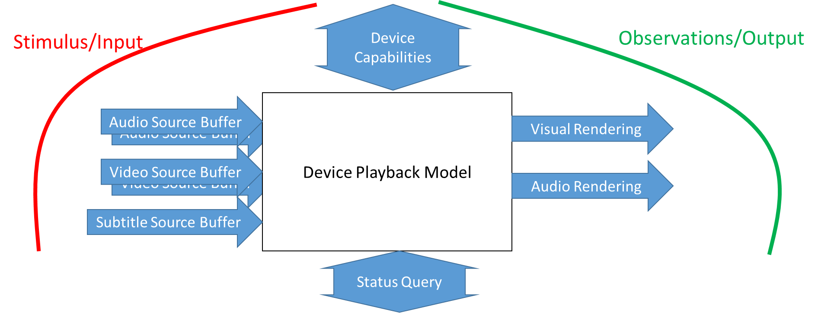

4.3.2 Khronos OpenXR
OpenXR [OpenXR] is an API (Application Programming Interface) for XR applications. It sits between an application and an in-process or out-of-process "XR runtime system" (just "runtime" hereafter). The runtime may handle such functionality as frame composition, peripheral management, and raw tracking information.
The OpenXR specification is intended to satisfy the needs of both programmers and runtime implementors:
- To the application programmer, OpenXR is a set of functions that interface with a runtime to perform commonly required operations such as accessing controller/peripheral state, getting current and/or predicted tracking positions, and submitting rendered frames.
- To the runtime implementor, OpenXR is a set of functions that control the operation of the XR system and establishes the lifecycle of an XR application.
However, the specification does not necessarily provide a model for implementation. A runtime implementation is expected to produce results conforming with those produced by the specified methods, but may carry out particular procedures in ways that are more efficient than the one specified.
A few fundamentals on API definitions:
- Version numbers 64 bit major, minor, patch.
- Threading, multiprocessing, runtime.
- Extensions.
- API Layering, which means that a user or application may insert API layers between the application and the runtime implementation.
- Return codes.
- Handles and Object Handling.
- Timing.
- Colors.
- Coordinate Systems.
- Events.
The specification is also supported by API Reference Pages [OpenXR] which are generated by automatic extraction from the specification source and document commands, object handles, structures, enumerations, flags, other types and all extensions.
For each command, the following information is provided:
- Name.
- C function call specification.
- Parameter descriptions.
- Valid usage.
- Return codes.
- Reference to OpenXR specification.
For the specification itself, the document sources are marked up in Asciidoctor format (https://asciidoctor.org/). Asciidoctor and related toolchain components are used to generate the output documents. A full overview of how the specification is developed is provided here: https://github.com/KhronosGroup/OpenXR-Docs/blob/main/specification/README.md.
Khronos has also released a Conformance Test Suite for OpenXR, published the tests as open source software on GitHub (https://github.com/KhronosGroup/OpenXR-CTS), and launched the OpenXR 1.0 Adopters Program so that implementations can be officially conformant for the first time. Any OpenXR implementer – Khronos member or not – is welcome to become an OpenXR Adopter and submit conformance test results for Working Group review and approval. If their implementation is approved as conformant, they will be able to use the OpenXR trademark on their implementation.

