3GPP TSG-SA4 Meeting #118-e S4-220376-rev1

Electronic meeting, 06th-14th April. 2022
CR-Form-v12.0
PSEUDO CHANGE REQUEST
 | 26.955 | CR |  | rev |  | Current version: | 1.5.1
For HELP on using this form: comprehensive instructions can be found at
http://www.3gpp.org/Change-Requests.

Proposed change affects: | UICC apps |  | ME |  | Radio Access Network |  | Core Network

Title: | Scenario S3-S4-S5
Source to WG: | InterDigital, Qualcomm, Ericsson, HHI
Source to TSG:
Work item code: | FS_5GVideo |  |  |  |  |  | Date: |  |  | 28th march. 2022
Category: |  |  |  |  |  |  | Release: |  |  | 17
 | Use one of the following categories:  F (correction)  A (mirror corresponding to a change in an earlier release)  B (addition of feature),  C (functional modification of feature)  D (editorial modification)  Detailed explanations of the above categories can  be found in 3GPP TR 21.900. |  |  |  |  |  |  |  | Use one of the following releases:  Rel-8 (Release 8)  Rel-9 (Release 9)  Rel-10 (Release 10)  Rel-11 (Release 11)  Rel-12 (Release 12)  Rel-13 (Release 13)  Rel-14 (Release 14)  Rel-15 (Release 15)  Rel-16 (Release 16)
Reason for change: |  | - Clarifying the reason for the second sub-scenario:  The second configuration files for S3 and S5 were provided with the goal of being used to evaluate the benefit of GDR techniques for each codecs. For that purpose, these configuration files were designed with no cascading QPs and one intra frame every second. GDR is used in Gaming (S5) anf in video conferencing/screen content (S3). This was never captured in the TR. It is proposed to add this information to the TR to explain the reason for the second configuration files. The config files, the bistreams and the results should be kept as necessary ground work.  - Second sub-scenario in S4.  When the S4 scenario was created the two configurations for S4 were replicated from S3/S5. However GDR is not used in user generated content scenario and that second configuration should preferably not be considered at all. As an alternative to the clarification proposed for S3/S5, it is proposed to remove the second sub-scenario for S4.  - Removing characterisation aspects related to these second configurations.  While the results, cfg and bistreams should be kept,it would be misleading to use them as comparison points between codecs. It is proposed to remove the comparison aspects related to this second configuration.
Summary of change: |  | Same as above
Consequences if not approved: |  | Codecs should not be compared based on the sub-scenario 2 for S3 (screen) and S5 (gaming) and sub-scenario 2 should not be used in S4 (User generated content) as it does not belong to this scenario. The potential comparison would be misleading and irrelevant to these scenarios
Clauses affected:
 |  | Y | N
Other specs |  |  |  | Other core specifications |  |  |  | TS/TR ... CR ...
affected: |  |  |  | Test specifications |  |  |  | TS/TR ... CR ...
(show related CRs) |  |  |  | O&M Specifications |  |  |  | TS/TR ... CR ...
Other comments:
This CR's revision history:

Start of first Change: Scenario 3

6.4.8.1 Overview
This clause provides details on how to generate the anchors for the Screen Content scenario.
The screen content configuration relies on low delay encoding modes with the optional use of Screen Content encoding tools when possible (for HEVC).
Two sets of anchors are defined. The second anchor denoted “JM-02” or “HM-02” are designed with no-cascading-QP and with regular Intra refresh period for evaluating Gradual Decoder Refresh (GDR) techniques.
This anchor is not meant for characterisation of the codec without GDR use, nor for comparison between codecs.

End of First Change

Start of Second Change: Scenario S4

6.5.8 Anchor Definition

6.5.8.1 Overview
This clause provides details on how to generate the anchors for the social sharing and messaging scenario.
The Social sharing and messaging scenario relies on relaxed delay encoding modes with limited encoding complexity.
Two sets of anchors are defined. The second anchor denoted “JM-02” or “HM-02” are designed with no-cascading-QP and with regular Intra refresh period for evaluating Gradual Decoder Refresh (GDR) techniques.
This anchor is not meant for characterisation of the codec without GDR use, nor for comparison between codecs.

End of Second Change

Start of Alternative Second Change

6.5.8 Anchor Definition

6.5.8.1 Overview
This clause provides details on how to generate the anchors for the social sharing and messaging scenario.
The Social sharing and messaging scenario relies on relaxed delay encoding modes with limited encoding complexity.

6.5.8.2 H.264/AVC Anchors

6.5.8.2.1 Overview
Table 6.5.8.2.1-1 provides an overview of the H.264/AVC anchor tuples. Keys are identified to refer to the anchors in the context of the scenario.
The details are also provided here: https://dash-large-files.akamaized.net/WAVE/3GPP/5GVideo/Bitstreams/Scenario-4-Sharing/264/streams.csv.
Table 6.5.8.2.1-1 Anchor Tuple generation with H.264/AVC for social sharing and messaging
Key | Clause | Reference Sequence | Reference Encoder | Config | Variations | Anchor Key
S4-A01-264 | 6.5.8.2.3 | S4-R01 | JM19.0 | S4-JM-01 | QP=[22,27,32,37] | S4-A01-264-<QP>
S4-A02-264 | 6.5.8.2.3 | S4-R02 | JM19.0 | S4-JM-01 | QP=[22,27,32,37] | S4-A02-264-<QP>
S4-A03-264 | 6.5.8.2.4 | S4-R03 | JM19.0 | S4-JM-01 | QP=[22,27,32,37] | S4-A03-264-<QP>
S4-A04-264 | 6.5.8.2.4 | S4-R04 | JM19.0 | S4-JM-01 | QP=[22,27,32,37] | S4-A04-264-<QP>

6.5.8.2.2 Common Parameters
To generate the anchor bitstreams, JM19.0 is used.
The same parameters as for scenario 5 as documented in clause 6.6.8.2.2 are used.
Note that the MaxMvsPer2Mb restriction is not matching the used level requirement from H.264/AVC due to use of inter 4x4 subpartitions. However, this is not considered a limiting factor in today’s implementations.

6.5.8.2.3 S4-JM-01: no Intra
The same parameters as for S5-JM-01 as documented in clause 6.6.8.2.3 are used.
The settings are defined in the attached configuration file s4-jm-01.cfg.

6.5.8.3 H.265/HEVC Anchors

6.5.8.3.1 Overview
Table 6.5.8.3.1-1 provides an overview of the H.265/HEVC anchor tuples. Keys are identified to refer to the anchors in the context of the scenario.
The details are also provided here: https://dash-large-files.akamaized.net/WAVE/3GPP/5GVideo/Bitstreams/Scenario-4-Sharing/265/streams.csv.
Table 6.5.8.3.1-1 Anchor Tuple generation with H.265/HEVC for Social sharing and messaging
Key | Clause | Reference Sequence | Reference Encoder | Config | Variations | Anchor Key
S4-A01-265 | 6.5.8.3.3 | S4-R01 | HM16.22 | S4-HM-01 | QP = [22,27,32,37] | S4-A01-265-<QP>
S4-A02-265 | 6.5.8.3.3 | S4-R02 | HM16.22 | S4-HM-01 | QP = [22,27,32,37] | S4-A02-265-<QP>
S4-A03-265 | 6.5.8.3.4 | S4-R03 | HM16.22 | S4-HM-01 | QP = [22,27,32,37] | S4-A03-265-<QP>
S4-A04-265 | 6.5.8.3.4 | S4-R04 | HM16.22 | S4-HM-01 | QP = [22,27,32,37] | S4-A04-265-<QP>
S4-A05-265 | 6.5.8.3.5 | S4-R01 | HM16.22 | S4-HM-02 | QP = [22,27,32,37] | S4-A05-265-<QP>
S4-A06-265 | 6.5.8.3.5 | S4-R02 | HM16.22 | S4-HM-02 | QP = [22,27,32,37] | S4-A06-265-<QP>
S4-A07-265 | 6.5.8.3.6 | S4-R03 | HM16.22 | S4-HM-02 | QP = [22,27,32,37] | S4-A07-265-<QP>
S4-A08-265 | 6.5.8.3.6 | S4-R04 | HM16.22 | S4-HM-02 | QP = [22,27,32,37] | S4-A08-265-<QP>

6.5.8.3.2 Common Parameters
To generate the anchor bitstreams, HM16.22 is used.
The same parameters as for scenario 5 as documented in clause 6.6.8.3.2 are used.
6.5.8.3.3 S4-HM-01: no Intra
The same parameters as for S5-HM-01 as documented in clause 6.6.8.3.3 are used.
The settings are defined in the attached configuration file s4-hm-01.cfg.

6.5.9 Anchor Results

6.5.9.1 H.264/AVC Anchors
AVC anchor streams are provided according to the key system here:
- https://dash-large-files.akamaized.net/WAVE/3GPP/5GVideo/Bitstreams/Scenario-4-Sharing/264/
AVC anchor results are provided with the appropriate keys as defined in Table 6.5.8.2.1-1
- in the attached csv files
- https://dash-large-files.akamaized.net/WAVE/3GPP/5GVideo/Bitstreams/Scenario-4-Sharing/264//Metrics/
Editor’s Note:
- Verification is still needed

6.5.9.2 H.265/HEVC Anchors
HEVC anchor streams are provided according to the key system here:
- https://dash-large-files.akamaized.net/WAVE/3GPP/5GVideo/Bitstreams/Scenario-4-Sharing/265/
HEVC anchor results are provided with the appropriate keys as defined in Table 6.5.8.3.1-1
- in the attached csv files
- https://dash-large-files.akamaized.net/WAVE/3GPP/5GVideo/Bitstreams/Scenario-4-Sharing/265/Metrics/
Editor’s Note:
- Verification is still needed

6.5.10 Additional Information and Performance Data
No additional performance data is available.

End of Alternative Second Change

Start of Third Change: Scenario S5

6.6.8.1 Overview
This clause provides details on how to generate the anchors for the Online gaming scenario.
Two sets of anchors are defined. The second anchor denoted “JM-02” or “HM-02” are designed with no-cascading-QP and with regular Intra refresh period for evaluating Gradual Decoder Refresh (GDR) techniques.
This anchor is not meant for characterisation of the codec without GDR use, nor for comparison between codecs..

End of Third Change

Start of fourth Change

7.2 Characterization against 3GPP Anchor Codecs
7.2.1 Characterization against H.264/AVC
For a codec to be fully characterized against H.264/AVC, the following information should be provided:
1. For scenario 1:
a) BD-Rate Gain table as defined in clause 5.8 for all H.264/AVC reference sequences and configuration S1-JM-01 as defined in clause 6.2.8.2 with a comparable configuration and all SDR metrics defined clause 6.2.5.
2. For scenario 2 no characterization possible.
3. For scenario 3:
a) BD-Rate Gain table as defined in clause 5.8 for all H.264/AVC reference sequences and configuration S3-JM-01 as defined in clause 6.4.8.2 with a comparable configuration and all SDR metrics defined clause 6.4.5.
b) BD-Rate Gain table as defined in clause 5.8 for all H.264/AVC reference sequences and configuration S3-JM-03 as defined in clause 6.4.8.2 with a comparable configuration and all SDR metrics defined clause 6.4.5.
4. For scenario 4:
a) BD-Rate Gain table as defined in clause 5.8 for all H.264/AVC reference sequences and configuration S4-JM-01 as defined in clause 6.5.8.2 with a comparable configuration and all SDR metrics defined clause 6.5.5.

5. For scenario 5:
a) BD-Rate Gain table as defined in clause 5.8 for all H.264/AVC reference sequences and configuration S5-JM-01 as defined in clause 6.6.8.2 with a comparable configuration and all SDR metrics defined clause 6.6.5.

Additional information such as Rate-Quality plots may be provided if considered insightful.
Partial characterization may be conducted as well.
7.3.2 Characterization against H.265/HEVC HM
For a codec to be fully characterized against H.265/HEVC HM, the following information should be provided:
1. For scenario 1:
a) BD-Rate Gain table as defined in clause 5.8 for all H.265/HEVC reference sequences and configuration S1-HM-01 as defined in clause 6.2.8.3 with a comparable configuration and all SDR metrics defined clause 6.2.5.
b) BD-Rate Gain table as defined in clause 5.8 for all H.265/HEVC reference sequences and configuration S1-HM-02 as defined in clause 6.2.8.3 with a comparable configuration and all HDR metrics defined clause 6.2.5.
2. For scenario 2:
a) BD-Rate Gain table as defined in clause 5.8 for all H.265/HEVC reference sequences and configuration S2-HM-01 as defined in clause 6.3.8.3 with a comparable configuration and all SDR metrics defined clause 6.3.5.
b) BD-Rate Gain table as defined in clause 5.8 for all H.265/HEVC reference sequences and configuration S2-HM-02 as defined in clause 6.3.8.3 with a comparable configuration and all HDR metrics defined clause 6.3.5.
3. For scenario 3:
a) BD-Rate Gain table as defined in clause 5.8 for all H.265/HEVC reference sequences and configuration S3-HM-01 as defined in clause 6.4.8.3 with a comparable configuration and all SDR metrics defined clause 6.4.5.

c) BD-Rate Gain table as defined in clause 5.8 for all H.265/HEVC reference sequences and configuration S3-HM-03 as defined in clause 6.4.8.3 with a comparable configuration and all SDR metrics defined clause 6.4.5.

4. For scenario 4:
a) BD-Rate Gain table as defined in clause 5.8 for all H.265/HEVC reference sequences and configuration S4-HM-01 as defined in clause 6.5.8.3 with a comparable configuration and all SDR metrics defined clause 6.5.5.

5. For scenario 5:
a) BD-Rate Gain table as defined in clause 5.8 for all H.265/HEVC reference sequences and configuration S5-HM-01 as defined in clause 6.6.8.3 with a comparable configuration and all SDR metrics defined clause 6.6.5.

Additional information such as Rate-Quality plots may be provided if considered insightful.
Partial characterization may be conducted as well.
7.3.3 Characterization against H.265/HEVC SCC
For a codec to be fully characterized against H.265/HEVC SCC, the following information should be provided:
1. For scenario 1 no characterization possible.
2. For scenario 2 no characterization possible.
3. For scenario 3:
a) BD-Rate Gain table as defined in clause 5.8 for all H.265/HEVC reference sequences and configuration S3-SCC-01 as defined in clause 6.4.8.3 with a comparable configuration and all SDR metrics defined clause 6.4.5.

c) BD-Rate Gain table as defined in clause 5.8 for all H.265/HEVC reference sequences and configuration S3-SCC-03 as defined in clause 6.4.8.3 with a comparable configuration and all SDR metrics defined clause 6.4.5.

4. For scenario 4 no characterization possible.
5. For scenario 5:
a) BD-Rate Gain table as defined in clause 5.8 for all H.265/HEVC reference sequences and configuration S5-HM-01 as defined in clause 6.6.8.3 with a comparable configuration and all SDR metrics defined clause 6.6.5.

Additional information such as Rate-Quality plots may be provided if considered insightful.
Partial characterization may be conducted as well.

End of Fourth Change

Start of Fifth Change

7.4.2.3 Scenario 3: Screen Content
This clause provides characterization of H.265/HEVC HM mode configurations against H.264/AVC JM for Scenario 3 Screen Content. In particular,
- Table 7.4.2.3-1 provides the BD rate gain of H.265/HEVC HM with S3-HM-01 against H.264/AVC JM with configuration S3-JM-01, i.e. with the screen content scenario reference sequences and no fixed intra.

Table 7.4.2.3-1 BD rate gain of H.265/HEVC HM with S3-HM-01 against H.264/AVC JM with configuration S3-JM-01, i.e. with the screen content scenario reference sequences and no fixed intra
Reference sequence | Name | psnr | y_psnr
S3-R02 | MovingText2-4K-8bit | 61.703 | 61.453
S3-R04 | MovingText2-FullHD-8bit | 63.913 | 64.630
S3-R06 | TextMixTransitions-4K-8bit | 55.819 | 51.844
S3-R08 | TextMixTransitions-FullHD-8bit | 42.347 | 39.995
S3-R10 | GraphicsMixSimple-4K-8bit | 57.481 | 56.712
S3-R12 | GraphicsMixSimple-FullHD-8bit | 40.475 | 39.754
S3-R14 | GraphicsMixTransitions-4K-8bit | 62.696 | 61.538
S3-R16 | GraphicsMixTransitions-FullHD-8bit | 54.673 | 53.486
S3-R17 | Mission-Control | 32.476 | 31.671
Minimum |  | 32.476 | 31.671
Maximum |  | 63.913 | 64.630
Average |  | 52.398 | 51.231

As an example, Figure 7.4.2.3-1 provides Rate-Quality curves and BD rate gain for psnr of H.265/HEVC HM with S3-HM-01 against H.264/AVC HM with configuration S3-JM-01 for reference sequence S3-R02.
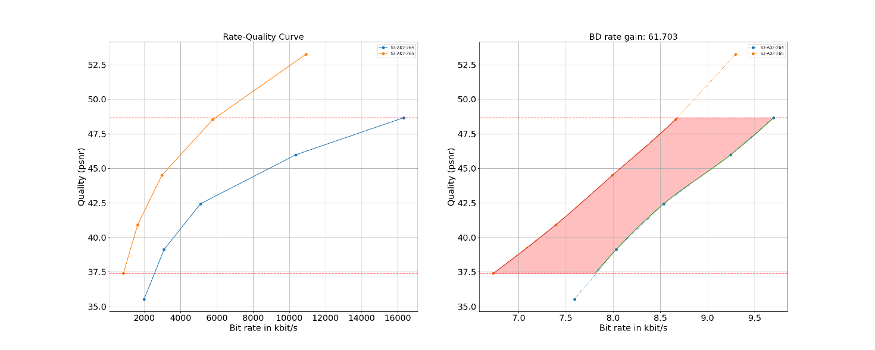
Figure 7.4.2.3-1 Rate-Quality curves and BD rate gain for psnr of H.265/HEVC HM with S3-HM-01 against H.264/AVC HM with configuration S3-JM-01 for reference sequence S3-R02

All Rate-Quality curves and BD rate gain plots are provided in the attachment as well as online here https://dash-large-files.akamaized.net/WAVE/3GPP/5GVideo/Bitstreams/Scenario-3-Screen/265/Characterization/.

7.4.2.4 Scenario 4: Messaging and Social Sharing
This clause provides characterization of H.265/HEVC HM mode configurations against H.264/AVC JM for Scenario 4 Messaging and Social Sharing. In particular,
- Table 7.4.2.4-1 provides the BD rate gain of H.265/HEVC HM with S4-HM-01 against H.264/AVC JM with configuration S4-JM-01, i.e. with the messaging and social sharing scenario reference sequences and no fixed intra.

Table 7.4.2.4-1 BD rate gain of H.265/HEVC HM with S4-HM-01 against H.264/AVC JM with configuration S4-JM-01, i.e. with the messaging and social sharing scenario reference sequences and no fixed intra
Reference sequence | Name | psnr | y_psnr | ms_ssim | vmaf
S4-R01 | Vertical-Bees | 60.076 | 60.044 | 64.245 | 62.218
S4-R02 | Vertical-Walking | 21.670 | 20.392 | 25.972 | 30.372
S4-R03 | Neon-4K | 33.438 | 31.700 | 34.273 | 38.009
S4-R04 | Skater-4K | 71.455 | 70.634 | 71.119 | 68.399
Minimum |  | 21.670 | 20.392 | 25.972 | 30.372
Maximum |  | 71.455 | 70.634 | 71.119 | 68.399
Average |  | 46.660 | 45.692 | 48.902 | 49.750

As an example, Figure 7.4.2.4-1 provides Rate-Quality curves and BD rate gain for vmaf of H.265/HEVC HM with S4-HM-01 against H.264/AVC HM with configuration S4-JM-01 for reference sequence S4-R01.
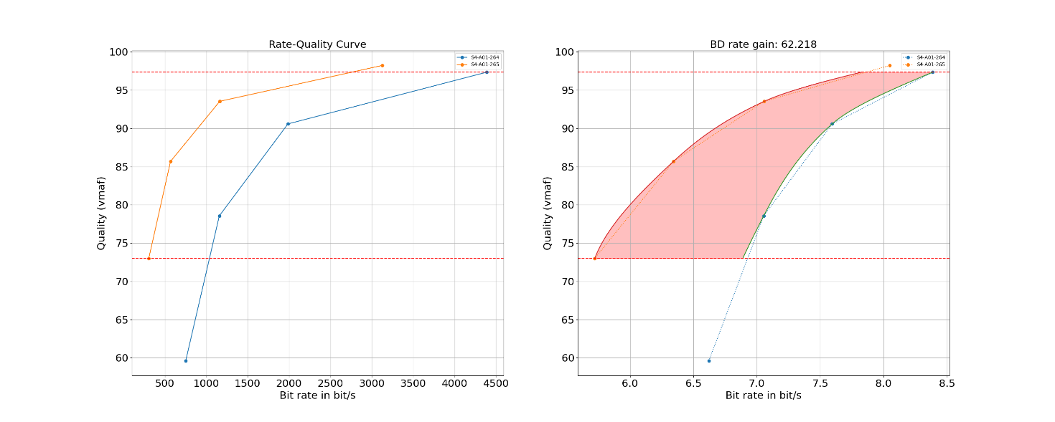
Figure 7.4.2.4-1 Rate-Quality curves and BD rate gain for vmaf of H.265/HEVC HM with S4-HM-01 against H.264/AVC HM with configuration S4-JM-01 for reference sequence S4-R01

All Rate-Quality curves and BD rate gain plots are provided in the attachment as well as online here https://dash-large-files.akamaized.net/WAVE/3GPP/5GVideo/Bitstreams/Scenario-4-Sharing/265/Characterization/.

7.4.2.5 Scenario 5: Online Gaming
This clause provides characterization of H.265/HEVC HM mode configurations against H.264/AVC JM for Scenario 5 Online Gaming. In particular,
- Table 7.4.2.5-1 provides the BD rate gain of H.265/HEVC HM with S5-HM-01 against H.264/AVC JM with configuration S5-JM-01, i.e. with the online gaming scenario reference sequences and no fixed intra.

Table 7.4.2.5-1 BD rate gain of H.265/HEVC HM with S5-HM-01 against H.264/AVC JM with configuration S5-JM-01, i.e. with the online gaming scenario reference sequences and no fixed intra
Reference sequence | Name | psnr | y_psnr
S5-R01 | AOV | 45.200 | 44.753
S5-R02 | Baolei-Man | 36.491 | 35.334
S5-R03 | Baolei-Woman | 44.702 | 44.013
S5-R04 | Baolei-Balloon | 52.256 | 52.305
S5-R05 | Baolei-Yard | 48.192 | 48.098
S5-R06 | Jianling-Temple | 23.436 | 23.029
S5-R07 | Jianling-Beach | 37.032 | 34.879
S5-R08 | Heroes-of-the-Storm | 31.909 | 31.808
S5-R09 | Project-CARS | 40.485 | 37.857
S5-R10 | World-of-WarCraft | 49.076 | 48.423
S5-R11 | MineCraft | 28.269 | 25.838
S5-R12 | CS-GO | 52.550 | 49.324
S5-R13 | StarCraft | 44.883 | 43.365
Minimum |  | 23.436 | 23.029
Maximum |  | 52.550 | 52.305
Average |  | 41.114 | 39.925

As an example,
- Figure 7.4.2.5-1 provides Rate-Quality curves and BD rate gain for psnr of H.265/HEVC HM with S5-HM-01 against H.264/AVC HM with configuration S5-JM-01 for reference sequence S5-R01

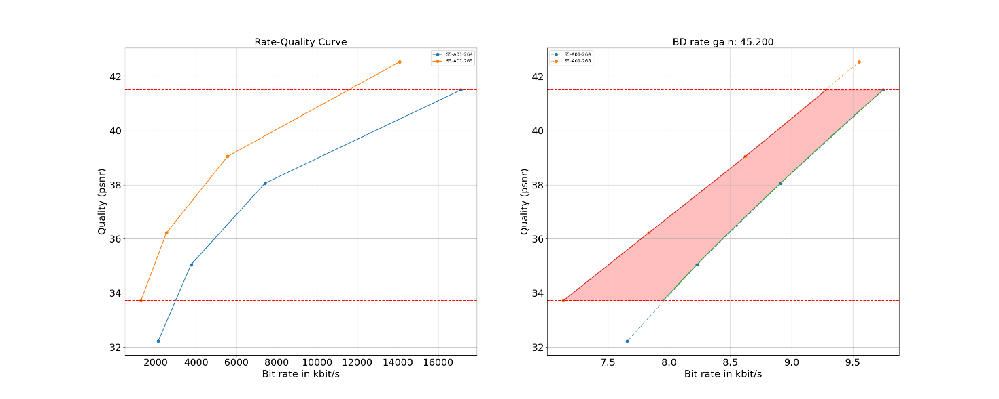
Figure 7.4.2.5-1 Rate-Quality curves and BD rate gain for psnr of H.265/HEVC HM with S5-JM-01 against H.264/AVC HM with configuration S5-JM-01 for reference sequence S5-R01

All Rate-Quality curves and BD rate gain plots are provided in the attachment as well as online here: https://dash-large-files.akamaized.net/WAVE/3GPP/5GVideo/Bitstreams/Scenario-5-Gaming/265/Characterization/.

7.4.2.6 Summary
Table 7.4.2.6-1 provides a summary of BD rate gain in psnr and vmaf of H.265/HEVC HM against H.264/AVC JM for different scenarios and configurations.
Table 7.4.2.6-1 Summary of BD rate gain in psnr and vmaf of H.265/HEVC HM against H.264/AVC JM for different scenarios and configurations
Scenario | average psnr | min psnr | max psnr | average vmaf | min vmaf | max vmaf
S1 | 34.601 | 19.184 | 55.723 | 39.940 | 28.095 | 57.538
S3 no intra | 52.398 | 32.476 | 63.913 | n/a | n/a | n/a
S4 no intra | 46.660 | 21.670 | 71.455 | 49.750 | 30.372 | 68.399
S5 no intra | 41.114 | 23.436 | 52.550 | n/a | n/a | n/a
Minimum | 30.980 | 20.840 | 42.559 | 39.940 | 28.095 | 57.538
Maximum | 52.398 | 32.476 | 63.913 | 49.750 | 30.372 | 68.399

7.4.3 H.265/HEVC SCC against H.264/AVC

7.4.3.1 Overview
This clause provides a partial characterization of H.265/HEVC SCC against H.264/AVC according to clause 7.2.1. The results provided in clause 6 are used for the characterization.

7.4.3.2 Scenario 3: Screen Content
This clause provides characterization of H.265/HEVC SCC mode configurations against H.264/AVC JM for Scenario 3 Screen Content. In particular,
- Table 7.4.3.2-1 provides the BD rate gain of H.265/HEVC SCC with S3-SCC-01 against H.264/AVC JM with configuration S3-JM-01, i.e. with the screen content scenario reference sequences and no fixed intra.

Table 7.4.3.2-1 BD rate gain of H.265/HEVC SCC with S3-SCC-01 against H.264/AVC JM with configuration S3-JM-01, i.e. with the screen content scenario reference sequences and no fixed intra
Reference sequence | Name | psnr | y_psnr
S3-R02 | MovingText2-4K-8bit | 68.967 | 67.813
S3-R04 | MovingText2-FullHD-8bit | 67.507 | 67.706
S3-R06 | TextMixTransitions-4K-8bit | 72.322 | 68.283
S3-R08 | TextMixTransitions-FullHD-8bit | 56.085 | 51.804
S3-R10 | GraphicsMixSimple-4K-8bit | 75.681 | 74.772
S3-R12 | GraphicsMixSimple-FullHD-8bit | 56.468 | 55.131
S3-R14 | GraphicsMixTransitions-4K-8bit | 68.336 | 66.839
S3-R16 | GraphicsMixTransitions-FullHD-8bit | 58.350 | 56.402
S3-R17 | Mission-Control | 55.334 | 54.947
Minimum |  | 55.334 | 51.804
Maximum |  | 75.681 | 74.772
Average |  | 64.339 | 62.633

As an example,
- Figure 7.4.3.2-1 provides Rate-Quality curves and BD rate gain for psnr of H.265/HEVC SCC with S3-SCC-01 against H.264/AVC HM with configuration S3-JM-01 for reference sequence S3-R10

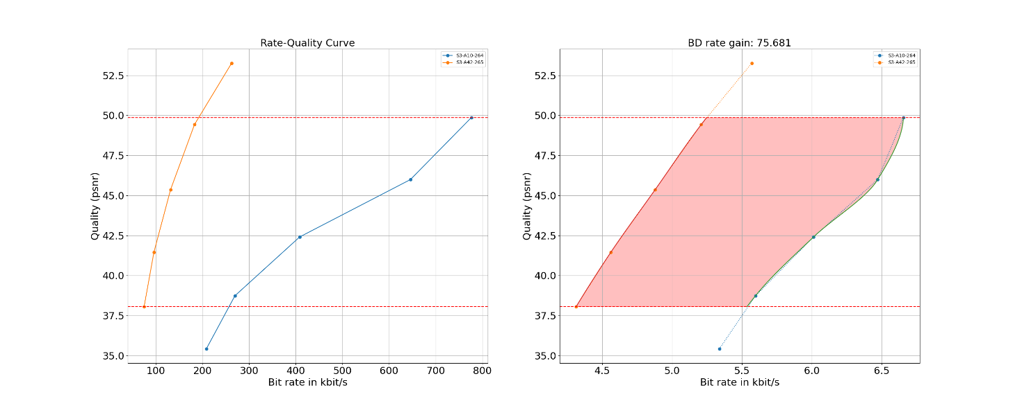
Figure 7.4.3.2-1 Rate-Quality curves and BD rate gain for psnr of H.265/HEVC SCC with S3-SCC-01 against H.264/AVC HM with configuration S3-JM-01 for reference sequence S3-R10

All Rate-Quality curves and BD rate gain plots are provided in the attachment as well as online here https://dash-large-files.akamaized.net/WAVE/3GPP/5GVideo/Bitstreams/Scenario-3-Screen/265/Characterization/.

7.4.3.3 Scenario 5: Online Gaming
This clause provides characterization of H.265/HEVC SCC mode configurations against H.264/AVC JM for Scenario 5 Online Gaming. In particular,
- Table 7.4.3.3-1 provides the BD rate gain of H.265/HEVC SCC with S5-SCC-01 against H.264/AVC JM with configuration S5-JM-01, i.e. with the online gaming scenario reference sequences and no fixed intra.

Table 7.4.3.3-1 BD rate gain of H.265/HEVC SCC with S5-SCC-01 against H.264/AVC JM with configuration S5-JM-01, i.e. with the online gaming scenario reference sequences and no fixed intra
Reference sequence | Name | psnr | y_psnr
S5-R01 | AOV | 45.708 | 45.150
S5-R02 | Baolei-Man | 36.948 | 35.522
S5-R03 | Baolei-Woman | 45.580 | 44.765
S5-R04 | Baolei-Balloon | 52.787 | 52.771
S5-R05 | Baolei-Yard | 48.412 | 48.248
S5-R06 | Jianling-Temple | 25.467 | 24.734
S5-R07 | Jianling-Beach | 39.934 | 37.326
S5-R08 | Heroes-of-the-Storm | 34.299 | 33.959
S5-R09 | Project-CARS | 42.514 | 39.485
S5-R10 | World-of-WarCraft | 50.940 | 49.847
S5-R11 | MineCraft | 39.491 | 34.397
S5-R12 | CS-GO | 56.979 | 52.977
S5-R13 | StarCraft | 47.862 | 45.578
Minimum |  | 25.467 | 24.734
Maximum |  | 56.979 | 52.977
Average |  | 43.609 | 41.905

As an example,
- Figure 7.4.3.3-1 provides Rate-Quality curves and BD rate gain for psnr of H.265/HEVC SCC with S5-SCC-01 against H.264/AVC HM with configuration S5-JM-01 for reference sequence S5-R04

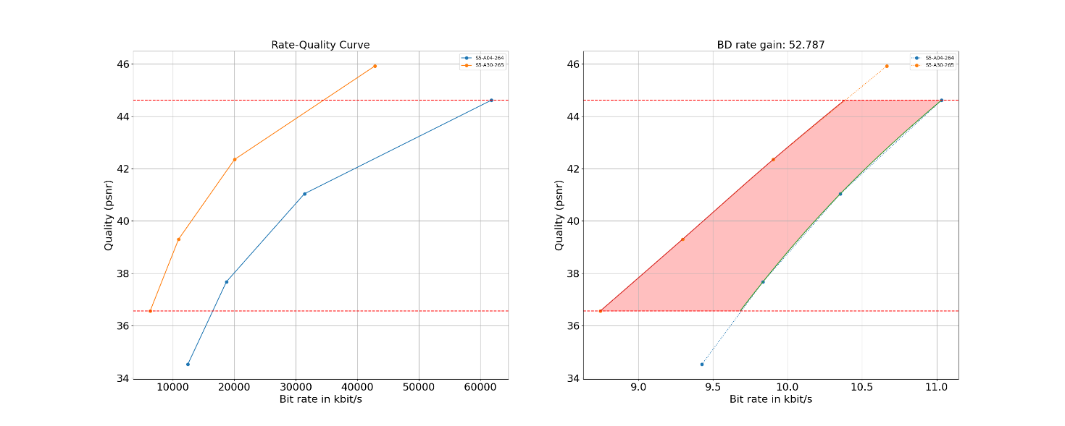
Figure 7.4.3.3-1 Rate-Quality curves and BD rate gain for psnr of H.265/HEVC SCC with S5-SCC-01 against H.264/AVC HM with configuration S5-JM-01 for reference sequence S5-R04

All Rate-Quality curves and BD rate gain plots are provided in the attachment as well as online here: https://dash-large-files.akamaized.net/WAVE/3GPP/5GVideo/Bitstreams/Scenario-5-Gaming/265/Characterization/.

7.4.3.4 Summary
Table 7.4.3.4-1 provides a summary of BD rate gain in psnr and vmaf of H.265/HEVC SCC against H.264/AVC JM for different scenarios and configurations.
Table 7.4.3.4-1 Summary of BD rate gain in psnr of H.265/HEVC SCC against H.264/AVC JM for different scenarios and configurations
Scenario | average psnr | min psnr | max psnr
S3 no intra | 64.339 | 55.334 | 75.681
S5 no intra | 43.318 | 25.467 | 56.979
Minimum | 43.318 | 22.977 | 43.805
Maximum | 64.339 | 55.334 | 75.681

End of Fift Change

Start of sixth Change: scenario 3 VTM

8.2.2.4.1 Overview
Table 8.2.2.4.1-1 provides an overview of the H.266/VVC test tuples. For provided bitstreams, reference H.266/VVC software implementation VTM available on the https://vcgit.hhi.fraunhofer.de/jvet/VVCSoftware_VTM branch, SHA 8159a6c72a770792b0bab4fee7445aa444821584 has been used. Utilized encoder configuration files are provided.
The details are also provided here: https://dash-large-files.akamaized.net/WAVE/3GPP/5GVideo/Bitstreams/Scenario-3-Screen/VTM/streams.csv.
Bitstreams generated in accordance with the configuration denoted “VTM-02” are designed with non-cascading-QP and with regular Intra refresh, for evaluating Gradual Decoder Refresh (GDR) techniques.

End of Sixth Change

Start of seventh Change: Scenario 4 VTM

8.2.2.5.1 Overview
Table 8.2.2.5.1-1 provides an overview of the H.266/VVC test tuples. For provided bitstreams, reference H.266/VVC software implementation VTM available on the https://vcgit.hhi.fraunhofer.de/jvet/VVCSoftware_VTM branch, SHA 8159a6c72a770792b0bab4fee7445aa444821584 has been used. Utilized encoder configuration files are provided.
The details are also provided here: https://dash-large-files.akamaized.net/WAVE/3GPP/5GVideo/Bitstreams/Scenario-4-Sharing/VTM/streams.csv.
Bitstreams generated in accordance with the configuration denoted “VTM-02” are designed with non-cascading-QP and with regular Intra refresh, for evaluating Gradual Decoder Refresh (GDR) techniques.

End of Seventh Change

Start of alternative seventh Change: Scenario 4 VTM

8.2.2.5.1 Overview
Table 8.2.2.5.1-1 provides an overview of the H.266/VVC test tuples. For provided bitstreams, reference H.266/VVC software implementation VTM available on the https://vcgit.hhi.fraunhofer.de/jvet/VVCSoftware_VTM branch, SHA 8159a6c72a770792b0bab4fee7445aa444821584 has been used. Utilized encoder configuration files are provided.
The details are also provided here: https://dash-large-files.akamaized.net/WAVE/3GPP/5GVideo/Bitstreams/Scenario-4-Sharing/VTM/streams.csv.
Table 8.2.2.5.1-1 Test Tuple generation with H.266/VVC for messaging and social sharing scenario
Key | Clause | Reference Sequence | Reference Encoder | Configuration | Variations | Anchor Key
S4-T01-VTM | 8.2.2.5.2.2 | S4-R01 | VTM | S4-VTM-01 | QP=[22, 27, 32, 37] | S4-T01-VTM-<QP>
S4-T02-VTM | 8.2.2.5.2.2 | S4-R02 | VTM | S4-VTM-01 | QP=[22, 27, 32, 37] | S4-T02-VTM-<QP>
S4-T03-VTM | 8.2.2.5.2.2 | S4-R03 | VTM | S4-VTM-01 | QP=[22, 27, 32, 37] | S4-T03-VTM-<QP>
S4-T04-VTM | 8.2.2.5.2.2 | S4-R04 | VTM | S4-VTM-01 | QP=[22, 27, 32, 37] | S4-T04-VTM-<QP>

8.2.2.5.2 Test Model and Configurations

8.2.2.5.2.1 Common Parameters
To generate the anchor bitstreams, the following is applied:
- VTM Main 10 in low delay B configuration is used with screen content tools enabled. In addition, to enable screen content tools, the following settings are set to 1: IBC, HashME, BDPCM.
- InternalBitDepth is 10 # codec operating bit-depth where all sequences (including 8 bit sequences) are coded with an internal bitdepth of 10 in accordance with [44] and metrics are calculated in 10 bits.
- Each source sequence is encoded with the following parameters: QP: [22, 27, 32, 37]

8.2.2.5.2.2 S5-VTM-01: Main 10 Profile with no fixed Intra
Each source sequence is encoded with the following configurations:
- The common parameters defined in clause 8.2.2.5.2.1.
- IntraPeriod with no fix interval
- GOPSize is equal to 8. Each B picture refers to up to 4 preceding pictures in display order within the GOP
The detailed settings are defined in the attached configuration file s4-vtm-01.cfg.

8.2.2.5.3 Test Results
VVC test streams are provided according to the key system here:
- https://dash-large-files.akamaized.net/WAVE/3GPP/5GVideo/Bitstreams/Scenario-4-Social/VTM/
VVC test metrics are provided with the appropriate keys as defined in Table 8.2.2.5.1-1
- in the attached csv files
- https://dash-large-files.akamaized.net/WAVE/3GPP/5GVideo/Bitstreams/Scenario-4-Social/VTM/Metrics/
Editor’s Note:
- Results are still missing

Start of eigth Change: scenario 5 VTM

8.2.2.6.1 Overview
Table 8.2.2.6.1-1 provides an overview of the H.266/VVC test tuples. For provided bitstreams, reference H.266/VVC software implementation VTM available on the https://vcgit.hhi.fraunhofer.de/jvet/VVCSoftware_VTM branch, SHA 8159a6c72a770792b0bab4fee7445aa444821584 has been used. Utilized encoder configuration files are provided.
The details are also provided here: https://dash-large-files.akamaized.net/WAVE/3GPP/5GVideo/Bitstreams/Scenario-5-Gaming/VTM/streams.csv.
Bitstreams generated in accordance with the configuration denoted “VTM-02” are designed with non-cascading-QP and with regular Intra refresh, for evaluating Gradual Decoder Refresh (GDR) techniques.

End of eigth Change: scenario 5 VTM

Start of ninth Change: scenario 3 ECM

8.3.2.4.1 Overview
Table 8.3.2.4.1-1 provides an overview of the EVC test tuples provided for this scenario. For provided bitstreams, reference EVC software implementation ETM7.5 and corresponding encoder configuration have been used.
The details are also provided here: https://dash-large-files.akamaized.net/WAVE/3GPP/5GVideo/Bitstreams/Scenario-3-Screen/ETM/streams.csv.
Bitstreams generated in accordance with the configuration denoted “ECM-02” are designed with non-cascading-QP and with regular Intra refresh, for evaluating Gradual Decoder Refresh (GDR) techniques.

End of ninth Change: scenario 3 ECM

Start of tenth Change: scenario 4 ECM

8.3.2.5.1 Overview
Table 8.3.2.5.1-1 provides an overview of the EVC test tuples provided for this scenario. For provided bitstreams, reference EVC software implementation ETM7.5 has been used.
The details are also provided here: https://dash-large-files.akamaized.net/WAVE/3GPP/5GVideo/Bitstreams/Scenario-4-Sharing/ETM/streams.csv.
Bitstreams generated in accordance with the configuration denoted “ECM-02” are designed with non-cascading-QP and with regular Intra refresh, for evaluating Gradual Decoder Refresh (GDR) techniques.

End of tenth Change: scenario 4 ECM

Start of Tenth Alternative Change: scenario 4 ECM
Table 8.3.2.5.1-1 provides an overview of the EVC test tuples provided for this scenario. For provided bitstreams, reference EVC software implementation ETM7.5 has been used.
The details are also provided here: https://dash-large-files.akamaized.net/WAVE/3GPP/5GVideo/Bitstreams/Scenario-4-Sharing/ETM/streams.csv.
Table 8.3.2.5.1-1 Test Tuple generation with EVC for Social sharing and messaging
Key | Clause | Reference Sequence | Reference Encoder | Configuration | Variations | Anchor Key
S4-T01-ETM | 8.3.2.5.2.1 | S4-R01 | ETM7.5 | S4-ETM-01 | QP = [22,27,32,37] | S4-T01-ETM-<QP>
S4-T02-ETM | 8.3.2.5.2.1 | S4-R02 | ETM7.5 | S4-ETM-01 | QP = [22,27,32,37] | S4-T02-ETM-<QP>
S4-T03-ETM | 8.3.2.5.2.1 | S4-R03 | ETM7.5 | S4- ETM-01 | QP = [22,27,32,37] | S4-T03-ETM-<QP>
S4-T04-ETM | 8.3.2.5.2.1 | S4-R04 | ETM7.5 | S4- ETM-01 | QP = [22,27,32,37] | S4-T04-ETM-<QP>

8.3.2.5.2 Test Model and configurations

8.3.2.5.2.1 S4-ETM-01: no intra
Prediction structure:
- Hierarchical QP structure is used.
- GOP size is equal to 8. Each B picture refers to up to 4 preceding pictures in display order.
- temporal filtering is disabled (temporal_filter = 0)
Additional settings (to be specified on the command line):
- QP: [22, 27, 32, 37].
- Only the first picture is intra, the rest of the pictures are of type B.
The detailed settings are defined in the attached configuration file S4-ETM-01.cfg.

8.3.2.5.3 Test Results
EVC test streams are provided according to the key system here:
- https://dash-large-files.akamaized.net/WAVE/3GPP/5GVideo/Bitstreams/Scenario-4-Sharing/ETM/
EVC test metrics are provided with the appropriate keys as defined in Table 8.3.2.5.1-1
- in the attached csv files
- https://dash-large-files.akamaized.net/WAVE/3GPP/5GVideo/Bitstreams/Scenario-4-Sharing/ETM/Metrics/

End of tenth Alternative Change: scenario 4 ECM

Start of Eleventh Change: scenario 5 ECM

8.3.2.6.1 Overview
Table 8.3.2.6.1-1 provides an overview of the EVC test tuples provided for this scenario. For provided bitstreams, reference EVC software implementation ETM7.5 has been used.
The details are also provided here: https://dash-large-files.akamaized.net/WAVE/3GPP/5GVideo/Bitstreams/Scenario-5-Gaming/ETM/streams.csv.
Bitstreams generated in accordance with the configuration denoted “ECM-02” are designed with non-cascading-QP and with regular Intra refresh, for evaluating Gradual Decoder Refresh (GDR) techniques.

End of Eleventh Change: scenario 5 ECM

Start of Twelth Change: scenario 3 AV1

8.4.2.4.1 Overview
Table 8.4.2.4.1-1 provides an overview of the AV1 test tuples. For provided bitstreams, the AV1 encoder aomenc is built from the libaom libraries using the tag provided in the introduction. Keys are identified to refer to the bitstreams in the context of the scenario.
The details are also provided here: https://dash-large-files.akamaized.net/WAVE/3GPP/5GVideo/Bitstreams/Scenario-3-Screen/AV1/streams.csv.
Bitstreams generated in accordance with the configuration denoted “AV1-02” are designed with non-cascading-QP and with regular Intra refresh, for evaluating Gradual Decoder Refresh (GDR) techniques.

End of Twelth Change: scenario 3 AV1

Start of Thirteenth Change: scenario 4 AV1

8.4.2.5.1 Overview
Table 8.4.2.5.1-1 provides an overview of the AV1 test tuples. For provided bitstreams, the AV1 encoder aomenc is built from the libaom libraries using the tag provided in the introduction. Keys are identified to refer to the bitstreams in the context of the scenario.
Bitstreams generated in accordance with the configuration denoted “AV1-02” are designed with non-cascading-QP and with regular Intra refresh, for evaluating Gradual Decoder Refresh (GDR) techniques.

End of Thirteenth Change: scenario 4 AV1

Start of Alternative Thirteenth Change: scenario 4 AV1

8.4.2.5.1 Overview
Table 8.4.2.5.1-1 provides an overview of the AV1 test tuples. For provided bitstreams, the AV1 encoder aomenc is built from the libaom libraries using the tag provided in the introduction. Keys are identified to refer to the bitstreams in the context of the scenario.
Table 8.4.2.5.1-1 Test Tuple generation with AV1, Messaging and Social Sharing Scenario
Key | Clause | Reference Sequence | Reference Encoder | Config | Variations | Anchor Key
S4-T01-AV1 | 8.4.2.5.3 | S4-R01 | aomenc <tag> | S4-AV1-01 | QP=[27,39,49,59] | S4-T01-AV1-<QP>
S4-T02-AV1 | 8.4.2.5.3 | S4-R02 | aomenc <tag> | S4-AV1-01 | QP=[27,39,49,59] | S4-T02-AV1-<QP>
S4-T03-AV1 | 8.4.2.5.3 | S4-R03 | aomenc <tag> | S4-AV1-01 | QP=[27,39,49,59] | S4-T03-AV1-<QP>
S4-T04-AV1 | 8.4.2.5.3 | S4-R04 | aomenc <tag> | S4-AV1-01 | QP=[27,39,49,59] | S4-T04-AV1-<QP>

8.4.2.5.2 Common Parameters and Settings
The following common Scenario 4 command line options are provided in Table 8.4.2.5.2-1.
Table 8.4.2.5.2-1 Common Scenario 4 command line options
--lag-in-frames=0 | No future frame is used as reference in low delay configuration.  Key-frame-filtering is a motion compensated temporal filtering. It is only enabled in random access configuration. When --lag-in-frames=0, key frames will not be filtered.
--deltaq-mode=0 | disable block based adaptive quantization, so all blocks within a frame use the same quantization parameter
--max-reference-frames=4 | restrict number of reference frames to 4
--enable-intrabc=0 | Disable the intra block copy prediction mode.
--enable-palette=0 | Disable the palette prediction mode.

8.4.2.5.3 S4-AV1-01: no Intra
For these clips the following additional command line options are provided in Table 8.4.2.5.3-1.
Table 8.4.2.5.3-1 Additional Scenario 4 command line options for S4-AV1-01
--kf-min-dist=9999  --kf-max-dist=9999 | Only the first frame is encoded as Intra (Key) frame.  --kf-min/max-dist are used only in closed GOP cases to specify the Intra Period. When kf-min-dist and kf-max-dist have the same value, the key frame is only inserted at a fixed interval.
--use-fixed-qp-offsets=1 | use fixed ratios to determine the QP for frames at different hierarchical layers. In av1 encoder, cq-level specified is only used for the frames at the highest temporal layer (non-reference frames), for Key frames and Inter frames at other layers, a fixed ratio is used to determine the quantization parameter.
--min-gf-interval=8 --max-gf-interval=8 | Set the GOPSize to 8.
The following command line is used for all encodes:
S4-AV1-01.sh <num_frame> <fps_norm> <fps_denom> <width> <height> <cq-level> <input> <output>

8.4.2.5.5 Test Results
Editor’s Note: to be completed.

End of Alternative Thirteenth Change: scenario 4 AV1

Start of Fourteenth Change: scenario 5 AV1

8.4.2.6.1 Overview
Table 8.4.2.6.1-1 provides an overview of the AV1 test tuples. For provided bitstreams, the AV1 encoder aomenc is built from the libaom libraries using the tag provided in the introduction. Keys are identified to refer to the bitstreams in the context of the scenario.
Bitstreams generated in accordance with the configuration denoted “AV1-02” are designed with non-cascading-QP and with regular Intra refresh, for evaluating Gradual Decoder Refresh (GDR) techniques.

End of Fourteenth Change: scenario 5 AV1

