3GPP TSG SA WG4#117e S4-220043
E-meeting, 14th – 23rd February 2022
CR-Form-v12.0
PSEUDO CHANGE REQUEST
 | 26.955 | CR | pseudo | rev | - | Current version: | 1.4.6
For HELP on using this form: comprehensive instructions can be found at
http://www.3gpp.org/Change-Requests.

Proposed change affects: | UICC apps |  | ME |  | Radio Access Network |  | Core Network

Title: | [FS_5G_Video] Other Updates
Source to WG: | Qualcomm Incorporated
Source to TSG:
Work item code: | FS_5GVideo |  |  |  |  |  | Date: |  |  | 08/02/2022
Category: | B |  |  |  |  |  | Release: |  |  | 17
 | Use one of the following categories:  F (correction)  A (mirror corresponding to a change in an earlier release)  B (addition of feature),  C (functional modification of feature)  D (editorial modification)  Detailed explanations of the above categories can  be found in 3GPP TR 21.900. |  |  |  |  |  |  |  | Use one of the following releases:  Rel-8 (Release 8)  Rel-9 (Release 9)  Rel-10 (Release 10)  Rel-11 (Release 11)  Rel-12 (Release 12)  Rel-13 (Release 13)  Rel-14 (Release 14)  Rel-15 (Release 15)  Rel-16 (Release 16)
Reason for change: |  | This update provides a fix for the HDR Convert that has impact on the metrics computation for 8 bit sequences. The SCaleOnly needs to be set in HDR Convert. By this, metrics are updated for anchors as well as the characterization results. Many updates to the attachments as well.
Summary of change:
Consequences if not approved:
Clauses affected:
 |  | Y | N
Other specs |  |  |  | Other core specifications |  |  |  | TS/TR ... CR ...
affected: |  |  |  | Test specifications |  |  |  | TS/TR ... CR ...
(show related CRs) |  |  |  | O&M Specifications |  |  |  | TS/TR ... CR ...
Other comments:
This CR's revision history:

===== CHANGE =====

5.5.7 Reference computation of SDR metrics
Clause 5.5.3 specifies that all metrics are computed with 10-bit precision. 8-bit to 10 bit up-conversion is performed with HDRConvert tool [67] using the attached script HDRConvert_8bto10b.cfg. Note that ScaleOnly is set to 1 to address sequences with pixel values that are not within standard video range.
Computation of PSNR(Y), PSNR(U) and PSNR(V) metrics as defined in clause 5.5.3 is performed with HDRMetrics tool as included in HDRTools version 0.23 [67] with the following parameters specified:
- EnablePSNR=1
- EnableJVETPSNR=1
- MaxSampleValue=1020.0
Computation of MS-SSIM metric as defined in clause 5.5.4 is performed with HDRMetrics tool with the following parameters specified:
- EnableJVETMSSSIM=1
- MaxSampleValue=1020.0
For the computation of VMAF, the C++ executable "vmafossexec" [59], open source provided by Netflix is used (https://github.com/Netflix/vmaf/releases/tag/v2.1.1).
Here is the command line:
vmafossexec $VMAF_FMT $WIDTH $HEIGHT ref.yuv test.yuv $VMAFMODEL --thread 1 --log metrics.vmaf
$VMAF_FMT: describe yuv subsampling (yuv420p10le as all metrics are computed in 10 bit domain)
$VMAFMODEL: vmaf_v0.6.1.pkl
thread: 1 (no threads used)
Additional libvmaf parameters phone_model and enable_transform are set to 0.
===== CHANGE =====

7.4.2.2 Scenario 1: Full HD
This clause provides characterization of H.265/HEVC HM mode configurations against H.264/AVC JM for Scenario 1 Full HD. In particular, Table 7.4.2.2-1 provides the BD rate gain of H.265/HEVC HM with S1-HM-01 against H.264/AVC JM with configuration S1-HM-01, i.e. with the Full HD SDR scenario reference sequences.
Table 7.4.2.2-1 BD rate gain of H.265/HEVC HM with S1-JM-01 against H.264/AVC HM with configuration S1-JM-01, i.e. with the Full HD SDR scenario reference sequences

Reference sequence | Name | psnr | y_psnr | ms_ssim | vmaf
S1-R01 | Brest-Sedof-FHD | 32.082 | 30.383 | 29.719 | 36.382
S1-R02 | Rain Fruits-FHD | 39.327 | 41.448 | 43.211 | 45.182
S1-R03 | Park Joy-FHD | 22.333 | 21.425 | 26.250 | 29.556
S1-R04 | Soccer-FHD | 55.723 | 56.078 | 56.040 | 57.538
S1-R05 | Tunnel Flag-FHD | 43.287 | 43.673 | 47.438 | 47.884
S1-R06 | Boat-FHD | 30.424 | 31.060 | 32.543 | 36.866
S1-R07 | Fountain-FHD | 19.184 | 20.408 | 20.356 | 28.095
S1-R08 | Riverbank-FHD | 34.445 | 32.541 | 29.372 | 38.015
Minimum |  | 19.184 | 20.408 | 20.356 | 28.095
Maximum |  | 55.723 | 56.078 | 56.040 | 57.538
Average |  | 34.601 | 34.627 | 35.616 | 39.940

As an example, Figure 7.4.2.2-1 provides Rate-Quality curves and BD rate gain for psnr of H.265/HEVC HM with S1-JM-01 against H.264/AVC HM with configuration S1-JM-01 for reference sequence S1-R01.
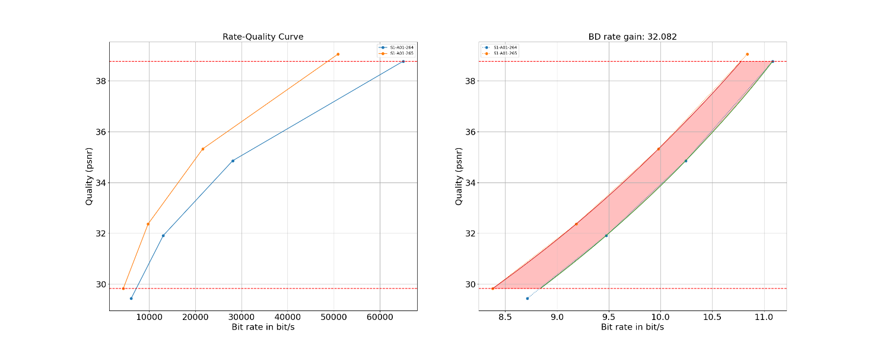
Figure 7.4.2.2-1 Rate-Quality curves and BD rate gain for psnr of H.265/HEVC HM with S1-JM-01 against H.264/AVC HM with configuration S1-JM-01 for reference sequence S1-R01
All Rate-Quality curves and BD rate gain plots are provided in the attachment as well as online here https://dash-large-files.akamaized.net/WAVE/3GPP/5GVideo/Bitstreams/Scenario-1-FHD/265/Characterization/.
===== CHANGE =====

7.4.2.3 Scenario 3: Screen Content
===== CHANGE =====

7.4.2.4 Scenario 4: Messaging and Social Sharing
This clause provides characterization of H.265/HEVC HM mode configurations against H.264/AVC JM for Scenario 4 Messaging and Social Sharing. In particular,
- Table 7.4.2.4-1 provides the BD rate gain of H.265/HEVC HM with S4-HM-01 against H.264/AVC JM with configuration S4-JM-01, i.e. with the messaging and social sharing scenario reference sequences and no fixed intra.
- Table 7.4.2.4-2 provides the BD rate gain of H.265/HEVC HM with S4-HM-02 against H.264/AVC JM with configuration S4-JM-02, i.e. with the messaging and social sharing scenario reference sequences with fixed Intra every second.
Table 7.4.2.4-1 BD rate gain of H.265/HEVC HM with S4-HM-01 against H.264/AVC JM with configuration S4-JM-01, i.e. with the messaging and social sharing scenario reference sequences and no fixed intra

Reference sequence | Name | psnr | y_psnr | ms_ssim | vmaf
S4-R01 | Vertical-Bees | 60.076 | 60.044 | 64.245 | 62.218
S4-R02 | Vertical-Walking | 21.670 | 20.392 | 25.972 | 30.372
S4-R03 | Neon-4K | 33.438 | 31.700 | 34.273 | 38.009
S4-R04 | Skater-4K | 71.455 | 70.634 | 71.119 | 68.399
Minimum |  | 21.670 | 20.392 | 25.972 | 30.372
Maximum |  | 71.455 | 70.634 | 71.119 | 68.399
Average |  | 46.660 | 45.692 | 48.902 | 49.750
Table 7.4.2.4-2 BD rate gain of H.265/HEVC HM with S4-HM-02 against H.264/AVC JM with configuration S4-JM-02, i.e. with the messaging and social sharing scenario reference sequences and fixed Intra every second
Reference sequence | Name | psnr | y_psnr | ms_ssim | vmaf
S4-R01 | Vertical-Bees | 41.962 | 43.618 | 47.661 | 47.354
S4-R02 | Vertical-Walking | 15.854 | 14.521 | 18.352 | 23.221
S4-R03 | Neon-4K | 23.866 | 22.640 | 26.499 | 34.791
S4-R04 | Skater-4K | 63.230 | 63.622 | 62.967 | 60.847
Minimum |  | 15.854 | 14.521 | 18.352 | 23.221
Maximum |  | 63.230 | 63.622 | 62.967 | 60.847
Average |  | 36.228 | 36.100 | 38.870 | 41.553

As an example, Figure 7.4.2.4-1 provides Rate-Quality curves and BD rate gain for vmaf of H.265/HEVC HM with S4-HM-01 against H.264/AVC HM with configuration S4-JM-01 for reference sequence S4-R01.
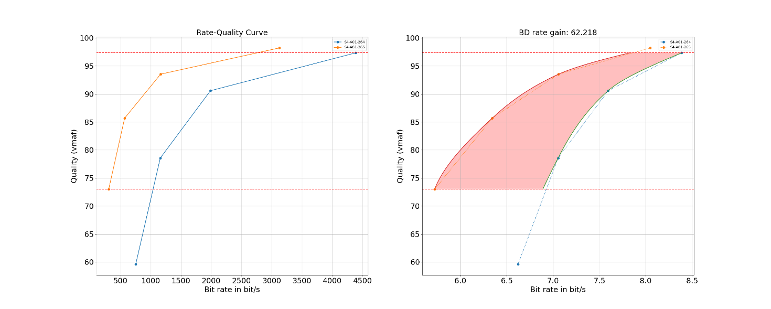
Figure 7.4.2.4-1 Rate-Quality curves and BD rate gain for vmaf of H.265/HEVC HM with S4-HM-01 against H.264/AVC HM with configuration S4-JM-01 for reference sequence S4-R01
As a another example, Figure 7.4.2.4-2 provides Rate-Quality curves and BD rate gain for vmaf of H.265/HEVC HM with S4-HM-02 against H.264/AVC HM with configuration S4-JM-02 for reference sequence S4-R01.
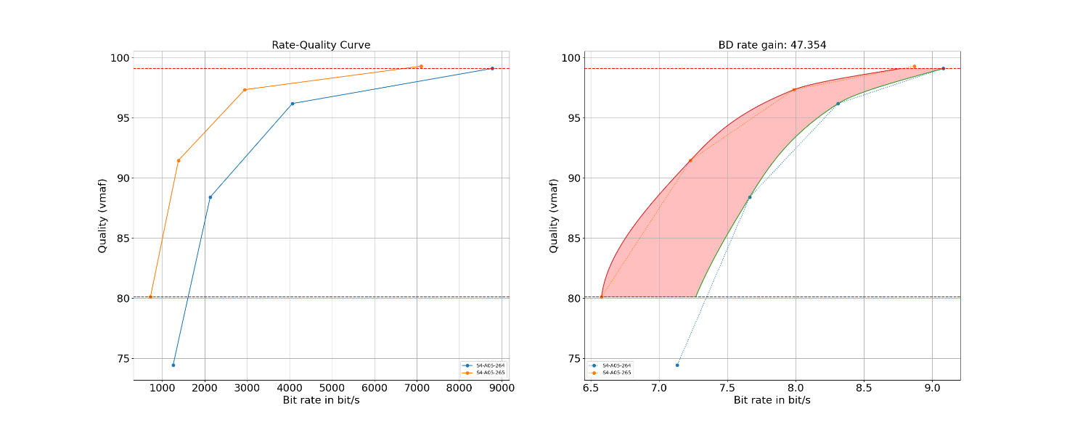
Figure 7.4.2.4-2 Rate-Quality curves and BD rate gain for vmaf of H.265/HEVC HM with S4-HM-02 against H.264/AVC HM with configuration S4-JM-02 for reference sequence S4-R01
All Rate-Quality curves and BD rate gain plots are provided in the attachment as well as online here https://dash-large-files.akamaized.net/WAVE/3GPP/5GVideo/Bitstreams/Scenario-4-Sharing/265/Characterization/.
===== CHANGE =====

7.4.2.5 Scenario 5: Online Gaming

===== CHANGE =====

7.4.2.6 Summary
===== CHANGE =====

7.4.3.2 Scenario 3: Screen Content
===== CHANGE =====

7.4.3.3 Scenario 5: Online Gaming
===== CHANGE =====

7.4.3.4 Summary
===== CHANGE =====

7.5.2.2 Scenario 3: Screen Content
===== CHANGE =====

7.5.2.3 Scenario 5: Online Gaming
===== CHANGE =====

7.5.2.4 Summary
===== CHANGE =====

D.3.1 Hosting
All anchor test bitstreams are hosted at:
https://dash-large-files.akamaized.net/WAVE/3GPP/5GVideo/Bitstreams/.
Below this folder, a hierarchy is created
- Scenario
- Codec
- Anchor/Test Tuple
- Anchor/Test Bitstream

The folder includes at least the following information:
- JSON file for binary video according to schema in clause B.3.2.
- binary video bitstream
The basic structure is as follows
Anchors
Scenario-1-HD/ 05-May-2021 19:06 -
Scenario-2-4K/ 05-May-2021 19:07 -
Scenario-3-Screen/ 10-May-2021 21:18 -
Scenario-4-Sharing/ 05-May-2021 19:07 -
Scenario-5-Gaming/ 06-May-2021 00:38 -

===== CHANGE =====

E.1 Introduction
The development of anchors, tests and metrics is supported by a software package provided here: https://github.com/haudiobe/5GVideo. The software packager permits the following functionalities:
- to produce anchors and test bitstreams.
a) Input
- a reference sequence csv according to the format in this document. It includes the key and the reference to the online repository
- a stream csv file according to the format provided in this document. It includes the tuple key, the reference sequence, the reference encoder, the configuration files, the variations and the anchor keys.
b) Output
- the set of anchors in an anchor tuple in json according to the agreed naming convention
- to produce metrics. The following information is needed.
a) Input
- a reference sequence csv according to the format in this document. It includes the key and the reference to the online repository
- a stream csv file according to the format provided in this document. It includes the tuple key, the reference sequence, the reference encoder, the configuration files, the variations and the anchor keys.
- the set of anchors in an anchor tuple in json according to the agreed naming convention
b) Output
- a metrics json file for each anchor tuple according to the definition in clause 5.5.
- to verify reconstruction and metrics. The following information is needed.
a) Input
- a reference sequence csv according to the format in this document. It includes the key and the reference to the online repository
- a stream csv file according to the format provided in this document. It includes the tuple key, the reference sequence, the reference encoder, the configuration files, the variations and the anchor keys.
- the set of anchors in an anchor tuple in json according to the agreed naming convention
b) Output
- a list of verification report entries according to the definition in Annex B.4.
- to verify bitstreams. The following information is needed.
a) Input
- a reference sequence csv according to the format in this document. It includes the key and the reference to the online repository
- a stream csv file according to the format provided in this document. It includes the tuple key, the reference sequence, the reference encoder, the configuration files, the variations and the anchor keys.
- the set of anchors in an anchor tuple in json according to the agreed naming convention
b) Output
- a list of verification report entries according to the definition in Annex B.4.
- to create characterization results. The following information is needed.
a) Input
- the configuration of the anchor and the test
- the metrics for which characterization is done.
b) Output
- Characterization reports.
- Plots for the characterizations
The software is currently hosted here: https://github.com/haudiobe/5GVideo
Editor’s Note: needs update for final scripting details
===== CHANGE =====

E.2 README

E.2.1 Overview
these script can be used to produce / verify specific encoders and scenarios according to TR26.955.

E.2.2 Installation
git clone https://github.com/haudiobe/5GVideo
cd 5GVideo
Please use a python virtual environment to install dependencies and run the scripts.
install dependencies:
pip3 install -r src/requirements.txt

E.2.3 working directory
the scripts are meant to work on local directory containing data organized as in: https://dash-large-files.akamaized.net/WAVE/3GPP/5GVideo/
the VCC_WORKING_DIR environment variable is used to configure the location of that directory.

E.2.4 download content from server
downloads anchor bitstreams, metrics, encoder config, and reference sequence list for a given scenario:
python3 download.py streams https://dash-large-files.akamaized.net/WAVE/3GPP/5GVideo/Bitstreams/Scenario-1-FHD/264/streams.csv $VCC_WORKING_DIR/Bitstreams/Scenario-1-FHD/264
downloads anchor reference sequences for a csv list:
python3 src/download.py sequences https://dash-large-files.akamaized.net/WAVE/3GPP/5GVideo/Bitstreams/Scenario-1-FHD/264/streams.csv $VCC_WORKING_DIR/Bitstreams/Scenario-1-FHD/reference-sequences.csv

E.2.5 characterization
The characterization script is meant to compare test data to an anchor. For instance, to compare sequences JM and HM for Scenario-1-FHD, you should have the following data:
$VCC_WORKING_DIR/Bitstreams/Scenario-1-FHD/
$VCC_WORKING_DIR/Bitstreams/Scenario-1-FHD/264/S1-A01-264.json
$VCC_WORKING_DIR/Bitstreams/Scenario-1-FHD/264/streams.csv
$VCC_WORKING_DIR/Bitstreams/Scenario-1-FHD/264/Metrics/S1-A01-264.csv
[...]
$VCC_WORKING_DIR/Bitstreams/Scenario-1-FHD/
$VCC_WORKING_DIR/Bitstreams/Scenario-1-FHD/264/S1-A01-265.json
$VCC_WORKING_DIR/Bitstreams/Scenario-1-FHD/265/streams.csv
$VCC_WORKING_DIR/Bitstreams/Scenario-1-FHD/265/Metrics/S1-A01-264.csv
[...]
To compare and plot psnr, y_psnr, and ms_ssim for these 2 sequences:
python3 src/compare.py --plot -s S1-A01-264 S1-A01-265 psnr y_psnr ms_ssim
Assuming you have all the anchors for encoder config S1-JM-01 and S1-HM-01, you can process them at once:
python3 src/compare.py --plot -c S1-JM-01 S1-HM-01 psnr y_psnr ms_ssim

E.2.6 encode, decode, convert, metrics commands
src/vcc.py provides the commands to encode, decode, and compute metrics.
All the commands described below support processing a single anchor …
python3 src/metrics.py -s S1-A11-265 csv-metrics
a single sequence (QP) …
python3 src/metrics.py -s S1-A11-265-22 csv-metrics
or batch all anchors oif a given encoder config.
python3 src/metrics.py -c S1-HM-02 csv-metrics

encode
JM19_0_ENCODER=~/deps/JM/bin/lencod_static
python3 src/vcc.py -s S1-A01-264 encode [--dry-run]
dry-run mode prints the command used to encode to stdout but doesn’t run it, but it does compute existing bitstream md5.

decode
JM19_0_DECODER=~/deps/JM/bin/ldecod_static
python3 src/vcc.py -s S1-A01-264 decode [--dry-run]
dry-run mode prints the command used to encode to stdout but doesn’t run it, but it does compute existing reconstruction md5.

convert
HDRCONVERT_TOOL=~/deps/HDRTools/build/bin/HDRConvert
python3 src/vcc.py -s S1-A11-265 decode --reference [--dry-run]
python3 src/vcc.py -s S1-A11-265 decode --reconstructions [--dry-run]
Performs conversion needed before metrics computation using HDRTools’ HDRConvert.
when –reconstructions is specfied, the reconstructions for all QPs are processed. when –reference is specified, the reference sequence is processed instead.
Conversion is either be 8 to 10 bit YUV, or YUV to EXR. When conversion is not needed for a given sequence, the script does nothing.
The converted sequences are stored in a tmp subfolder for each anchor.
dry-run mode prints the command used to convert to stdout but doesn’t run it.

metrics
HDRMETRICS_TOOL=~/deps/HDRTools/build/bin/HDRMetrics
VMAF_EXE=~/deps/vmaf/libvmaf/build/tools/vmafossexec
VMAF_MODEL=/home/deps/vmaf/model/vmaf_v0.6.1.json
python3 src/vcc.py -s S1-A11-265 metrics [--dry-run]
Computes metrics for the given sequence. This step also computes bitrate after removing SEI.
HDRTOOLS or VMAF can be enabled / disabled through environment variables.
DISABLE_HDRMETRICS=1
DISABLE_VMAF=1
This step is meant to run after successfull conversion. It uses the converted sequence where appropriate, and raise an error if it doesn’t exist.
dry-run mode doesn’t run HDRTools or vmaf, but it does parse existing logs.

metrics csv export
Metrics are saved on the anchors JSON file. A script can be used to export them to .csv:
python3 src/metrics.py -s S1-A11-265 csv-metrics
python3 src/metrics.py -c S1-HM-02 csv-metrics
For the above commands, the metrics .csv files can then be found in: $VCC_WORKING_DIR/Bitstreams/Scenario-1-FHD/265/Metrics

