Source: Samsung Electronics Co. Ltd
Title: Potential Open Issues for Network Slicing Enhancements
Agenda Item: 8.9
Document for: Discussion and Agreement

Introduction
In 3GPP SA4#115-e meeting, a set of initial findings and problem scope for network slicing extensions for 5G media streaming were approved and included in clause 5.12 of TR 26.804. As part of this work, standardization efforts in different 3GPP groups for network slicing was presented. Further potential areas for network slicing extensions in SA4 were proposed. The number of potential areas identified for study are many. In this contribution, presented are three problem areas that SA4 can start specifying while the group investigates further on other problem areas.

Problem areas for Initial Specification related to Network Slicing
This clause presents three problem areas for initial specification related to network slicing.

2.1 Service Provisioning
When a media service is provisioned by application service provider as part of a network slice, it is expected that the network operator creates a network slice within which the media service is to be provisioned. In this case, the following aspects for service provisioning have to be studied.
- Inclusion of network slicing identification information as part of the service provisioning information (M1). Slice identification has to be included in the provisioning information to indicate to AF which slice will the service be provisioned in.
- Impact to QoS related information because of network slicing. Clause 6.4.3 of TS 26.512 describes structured data types as part of common API data types. One of the structured data types defined is the M1QoSSpecification type as shown below:
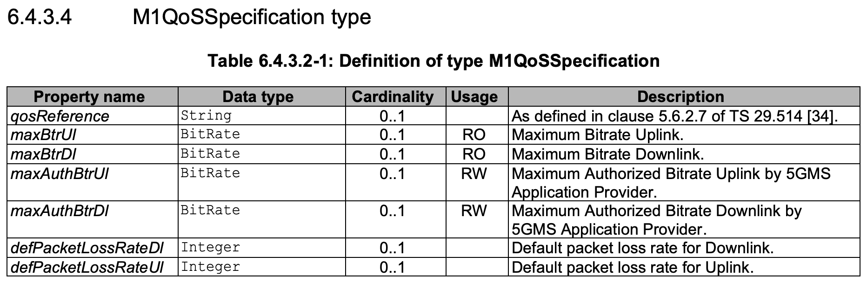
It is to be studied that when a media service is provisioned as part of a network slice, how does the application service provider indicate QoS parameters as part of service provisioning. The impact of network slicing on the above M1QoSSpecification is to be studied.

Open Questions:
- Usage of network slicing identification information as part of service provisioning information (M1)
- Applicable stage 2 and stage 3 aspects related to impact to QoS specification during service provisioning because of network slicing

2.2 Dynamic Policy
TS 26.501 and 26.512 define dynamic policy procedures using the M5 interface. When a media service is operating within a network slice, following aspects for dynamic policy have to be studied.
- Inclusion of network slicing identification information as part of the dynamic policy procedures (M5). There may be benefits of performing dynamic policy per network slice, so indicating slice identification information as part of dynamic policy procedures may be needed
- Inclusion of QoS related information because of network slicing. Clause 6.4.3 of TS 26.512 describes structured data types as part of common API data types. One of the structured data types defined is the M5QoSSpecification type as shown below:
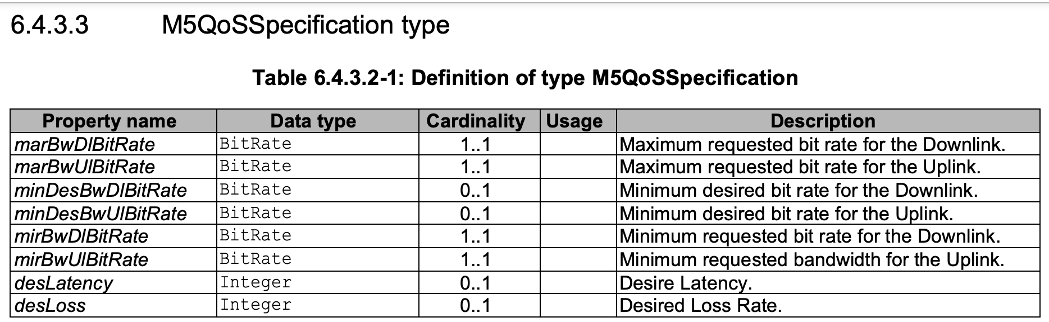
It is to be studied that when a media service is provisioned as part of a network slice, how does the dynamic policy procedures have to be enhanced to support slicing. The impact of network slicing on the above M5QoSSpecification is to be studied.

Open Questions:
- Usage of network slicing identification information during dynamic policy procedures (M5)
- Applicable stage 2 and stage 3 aspects related to impact to QoS specification because of network slicing in dynamic policy procedures

2.3 Media Services with Multiple Network Slices
In TS 28.530 and 28.531, 3GPP SA5 has specified that a communication service can be provided using multiple network slices as shown in Figure 1 below:
Figure 1: Communication services with multiple network slice instances

Further, clause 5.12.1.2 of TR 26.804 lists the following as one of the aspects for study related to network slicing in Table 5.12.1.2-1 (5G Media Streaming Work Items):
“Aspects related to realization of media services with multiple network slices, and multi-network slice scenarios.”
To study this topic, use cases for media services that may need multiple network slices are to be identified. Towards this, following are two scenarios for media services with multiple network slices:
- Scenario 1: Multiple network slices for use cases with uplink and downlink streaming
[1] is a document that describes a number of media and content use cases that cover most of the common media and content situations from production to consumption. In this document, the two technology groups present 9 use cases and have identified 12 parameters to adapt the network to application requirements. Following is the set of 9 use cases, along with a mention of those use cases having strict QoS requirements for uplink and downlink direction.

Use Case | Uplink Slice | Downlink Slice
Ultrahigh fidelity imaging for medical applications | ✓
Immersive and Interactive Media | ✓ | ✓
Audio Streaming in Live Productions | ✓ | ✓
Remote, Cooperative and Smart Media Production incorporating UGC | ✓
Professional Content Production | ✓
Machine generated content | ✓
Collaborative design including immersive communication | ✓ | ✓
Dynamic and Flexible UHD Content Distribution over 5G CDNs |  | ✓
Smart Education | ✓ | ✓

The two groups make a case for different design choices using number of slices for media use cases. An extract from the document:

Other use cases, identified in Chapter 2, requiring a combination of both uplink and downlink traffic, often with strong latency requirements, are the following:
- Immersive and Interactive media
- Audio Streaming in Live productions
- Collaborative Design including Immersive Communication
- Smart Education

For these use cases the uplink traffic needs to be synchronised or correlated to the downlink traffic. In order to support these use cases, the 5G system should provide one of the following:
- a new type of slice with support for downlink and uplink at the same time
- the ability to link an uplink slice to a downlink slice in order to synchronise or correlate the uplink traffic and the downlink traffic running through them, respectively

From the above, one way to realize use cases that require a combination of uplink and downlink traffic is to run them in different network slices.

A current use case in clause 5.2 of TR 26.804 – “Content Preparation” describes a collaboration option of content preparation for an uplink ingested stream from one UE before downlink streaming to other UEs as shown in below figure:
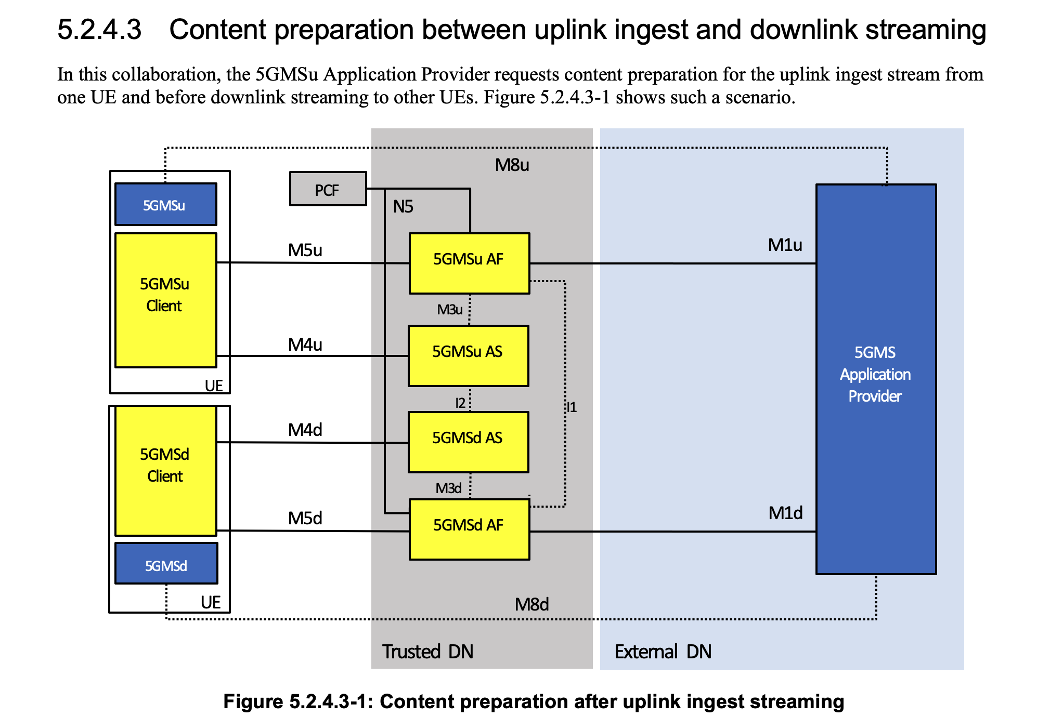

This use case can also take advantage of network slicing by running uplink and downlink streams in two different network slices.

- Scenario 2: Media service optimization
Media services can be optimized by running them in different network slices. For example, a simple upscaling use case can generate two different video quality streams (e.g., HD, 4K) in the network and distribute those video quality streams to UEs in two different network slices. QoS treatment for those two network slices could be different based on UE subscription to media distribution service.
Given that media services can use multiple network slices for their operation, following are the open questions to be studied.

Open Questions:
- Will one AF be sufficient to interact with all network slices? Or, is there a separate AF for each slice?

- Provisioning of media services with multiple network slices – Enhancements to M1 interface
- QoS Management for network slices – will the QoS be provisioned and managed separately for each slice by the ASP?

Open Issues
- Usage of network slicing identification information as part of service provisioning information (M1)
- Applicable stage 2 and stage 3 aspects related to impact to QoS specification during service provisioning because of network slicing
- Usage of network slicing identification information during dynamic policy procedures (M5)
- Applicable stage 2 and stage 3 aspects related to impact to QoS specification because of network slicing in dynamic policy procedures
- Will one AF be sufficient to interact with all network slices? Or, is there a separate AF for each slice?

- Provisioning of media services with multiple network slices – Enhancements to M1 interface
- QoS Management for network slices – will the QoS be provisioned and managed separately for each slice by the ASP?

Proposal
We propose that the questions described in clauses 3 be added to clause “5.12.5 Potential open issues” of TR 26.804. A pCR against TS 26.804 will be submitted with this list of questions.

References
- “5G Media Slice Definition”, version 1.2, Joint outcome between New European Media and Networld2020 technology platforms, https://5genesis.eu/wp-content/uploads/2019/10/NEM_Networld2020-5GPPP-5G-Media-Slice-White-Paper-V1.pdf

