3GPP TSG SA WG4#116e S4-211350
E-meeting, 10th – 19th November 2021
CR-Form-v12.0
DRAFT CHANGE REQUEST
 | 26.501 | CR | draft | rev |  | Current version: | 16.8.0
For HELP on using this form: comprehensive instructions can be found at
http://www.3gpp.org/Change-Requests.

Proposed change affects: | UICC apps |  | ME | X | Radio Access Network |  | Core Network | X

Title: | [5MBUSA] Collaboration Model for 5GMS via eMBMS
Source to WG: | Qualcomm Incorporated
Source to TSG:
Work item code: | 5MBUSA |  |  |  |  |  | Date: |  |  | 03/11/2021
Category: | B |  |  |  |  |  | Release: |  |  | 17
 | Use one of the following categories:  F (correction)  A (mirror corresponding to a change in an earlier release)  B (addition of feature),  C (functional modification of feature)  D (editorial modification)  Detailed explanations of the above categories can  be found in 3GPP TR 21.900. |  |  |  |  |  |  |  | Use one of the following releases:  Rel-8 (Release 8)  Rel-9 (Release 9)  Rel-10 (Release 10)  Rel-11 (Release 11)  Rel-12 (Release 12)  Rel-13 (Release 13)  Rel-14 (Release 14)  Rel-15 (Release 15)  Rel-16 (Release 16)
Reason for change: |  | See work item
Summary of change:
Consequences if not approved: |  | Work Item objectives not complete
Clauses affected: |  | 2, 5.10 (new)
 |  | Y | N
Other specs |  | X |  | Other core specifications |  |  |  | TS/TR ... CR
affected: |  |  |  | Test specifications |  |  |  | TS/TR ... CR ...
(show related CRs) |  |  |  | O&M Specifications |  |  |  | TS/TR ... CR ...
Other comments:
This CR's revision history:

===== CHANGE =====

A.10 Collaboration 10: 5GMS content via 5G System and eMBMS
The basic idea is that a content provider offers content via eMBMS, for example using a broadcast network in receive only mode, but also distributes content via a 5G System. The general idea is to use broadcast in cases where locally high demand on media services occur. Looking on the provided graph a common one video/audio source provides the 5G System and the (BM-SC) with the same HLS/DASH/CMAF-content, conforming to 5GMS media formats. Thus, the media service is available via eMBMS and 5G System.
Note that the collaboration model may also be suitable for the case where only the eMBMS network is available without the 5G System support.
The 5GMS AF is operated by the content provider. It uses 5GMS such that the UE continuously reports back metrics and consumption reporting. During time with low demand, all users are consuming the media service via 5GMS unicast. If a defined threshold is reached in one area (e.g., more than 100.000 people are watching the media service in urban area of Vienna), the “Control” unit automatically checks (via xMB) available resources and – if available – automatically provisions the media service via 5G Broadcast on that area (i.e., specific transmitter stations/MBMS service area) static carrier configuration via xMB API. It is expected that most (not all) of the users are switching from the CDN to 5G Broadcast thus lowering the demand on the CDN. If another defined threshold is reached in that area (e.g. less than 80.000 people are watching the media service in urban area of Vienna), the “Control” unit automatically deprovisions the 5G Broadcast service and mobiles change to OTT. (5G Broadcast resources for other media services with high demand are now available). It is expected that changing between OTT and 5G Broadcast is transparent to the user (and probably to the application of the content provider). Metrics and consumption reporting can be further used for more advanced (real-time) analysis (e.g. for targeted ad services,…). The basic idea is shown in Figure A.10-1
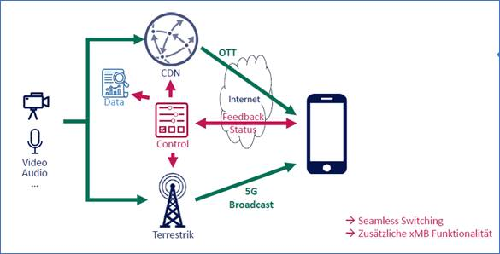
Figure A.10-1 Broadcast on Demand use case.
While this can be supported through MooD as defined in TS 26.346, the use of 5G Media streaming as the service layer is beneficial, because
- The Media AF and AS can be hosted externally by the broadcast operator. You can have two different networks, a BNO and MNO.
- The 5G MS functionalities such as consumption and metrics reporting are great functions for the operation.
- 5GMS provides a modern and extensible architecture, both from the client (using MSH to network) using REST-based calls as defined in 5GMS
- 5GMS provides a modern architecture on the client for 5G Media Streaming
- eMBMS is more naturally integrated into the 5G Media Streaming without having to deal with core network interworking.
A rough sketch how the interfaces match ongoing work on the 5G-MAG reference tools is provided in Figure A.10-2 documenting the collaboration models. Note that the collaboration models also have similarity on what is provided in A.1, A.3, A.9 and to some extent in A.8.
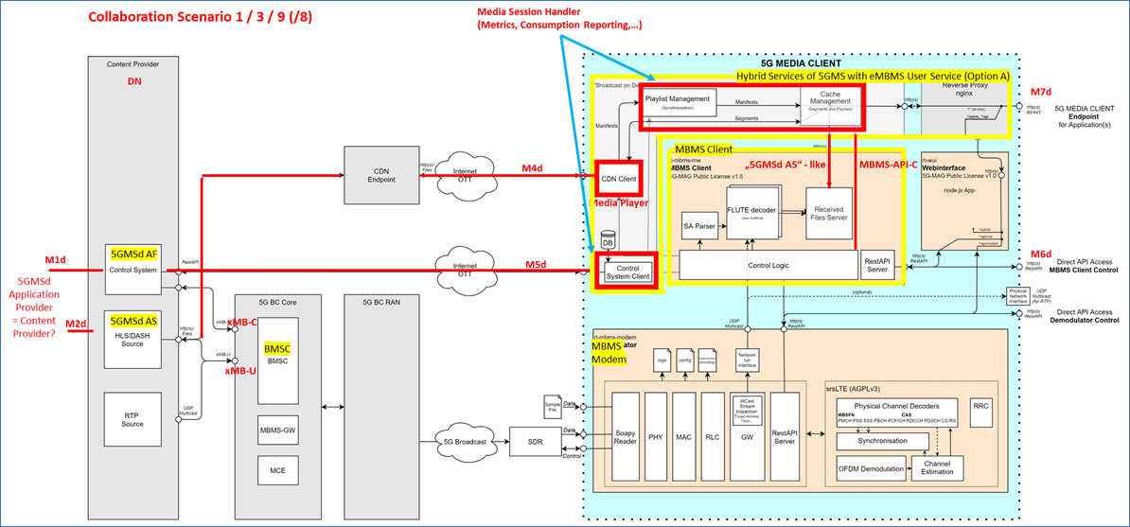
Figure A.10-2 Broadcast on Demand use case.

