3GPP TSG-SA4 Meeting #114-e S4-210754

19th – 28th May 2021
CR-Form-v12.1
pseudo CHANGE REQUEST
 | 26.998 | CR |  | rev | 1 | Current version: | <Version#>
For HELP on using this form: comprehensive instructions can be found at
http://www.3gpp.org/Change-Requests.

Proposed change affects: | UICC apps |  | ME |  | Radio Access Network |  | Core Network

Title: | [FS_5GSTAR] Proposed Updates to Architectures
Source to WG: | Qualcomm Incorporated
Source to TSG: | S4
Work item code: | FS_5GSTAR |  |  |  |  |  | Date: |  |  | <Res_date>
Category: | <Cat> |  |  |  |  |  | Release: |  |  | <Release>
 | Use one of the following categories:  F (correction)  A (mirror corresponding to a change in an earlier release)  B (addition of feature),  C (functional modification of feature)  D (editorial modification)  Detailed explanations of the above categories can  be found in 3GPP TR 21.900. |  |  |  |  |  |  |  | Use one of the following releases:  Rel-8 (Release 8)  Rel-9 (Release 9)  Rel-10 (Release 10)  Rel-11 (Release 11)  …  Rel-15 (Release 15)  Rel-16 (Release 16)  Rel-17 (Release 17)  Rel-18 (Release 18)
Reason for change: |  | [FS_5GSTAR] Proposed Updates to Architectures
Summary of change:
Consequences if not approved:
Clauses affected:
 |  | Y | N
Other specs |  |  |  | Other core specifications |  |  |  | TS/TR ... CR ...
affected: |  |  |  | Test specifications |  |  |  | TS/TR ... CR ...
(show related CRs) |  |  |  | O&M Specifications |  |  |  | TS/TR ... CR ...
Other comments:
This CR's revision history:

First Change

6 Mapping to 5G System Architecture

6.1 General
Based on the identified use cases in clause 5, this clause documents how AR/MR service scenarios can be supported in 5G system architecture.
There already exists developed 5G system architectures relevant to deliver immersive media depending on the underlying functionalities, such as real-time communications, adaptive delivery, QoS guarantee, and a support of network node processing. An architecture of 5G Media Streaming (5GMS) for both downlink and uplink is specified in TS26.501[6.1.a] and is being further extended to support the edge media processing in TR26.803[6.1.b]. In addition, MTSI architecture extended to 5G system [4.4.d] may be applied to AR/MR conversational scenarios to guarantee the specific service QoS. In the following clauses, these relevant architectures will be analysed to identify potential standardisation areas for each scenario.
Note that only STAR UE and EDGAR UE in Table 4.1 are taken into account, as WLAR UE as well as WTAR UE have similar functionalities with STAR UE from a 5G system perspective. Specifically, STAR UE (and WLAR/WTAR UEs) possibly has an on-device decoding and rendering capability for immersive media and may rely on support from 5G cloud/edge for a certain condition. On the other hand, EDGAR UE always requires 5G cloud/edge for immersive media decoding and rendering, and the conventional 2D media is exchanged in Uu interface.
Table 6.1 provides a list of AR/MR service scenarios and the associated use cases for each. Note that some use cases may be duplicated as they address multiple features.
Table 6.1. List of service scenario mapping to use cases
Service Scenario | Clause | Relevant Use Case
Immersive media downlink streaming | 6.2 | 2. AR Sharing¹⁾  14. AR Streaming with Localization Registry  17. AR remote advertising  18. Streaming of volumetric video for glass-type MR  Devices
5G interactive immersive service | 6.3 | 1. 3D Image Messaging  2. AR Sharing¹⁾  4. AR guided assistant at remote location (industrial  services) ¹⁾  5. Police Critical Mission with AR¹⁾  15. 5G Shared Spatial Data  16. AR remote cooperation¹⁾
5G cognitive immersive service | 6.4 | 5. Police Critical Mission with AR¹⁾  14. AR Streaming with Localization Registry¹⁾  20. AR IoT control
AR two-party calls | 6.5 | 3. Real-time 3D Communication  4. AR guided assistant at remote location (industrial  services) ¹⁾  7. Real-time communication with the shop assistant  11. AR animated avatar calls  16. AR remote cooperation¹⁾
AR conferencing | 6.6 | 8. 360-degree conference meeting  9. XR Meeting  10. Convention / Poster Session  12. AR avatar multi-party calls  13. Front-facing camera video multi-party calls  19. AR Conferencing
1) may be duplicated into multiple scenarios

6.2 Immersive media downlink streaming

6.2.1 Introduction
This clause introduces the case where immersive AR/MR media is streamed to a 5G AR UE using basic functionalities as defined in 5G Media Streaming for downlink (5GMSd).

6.2.2 Relevant use cases
<Thomas, Samsung>

6.2.3 Architectures

6.2.3.1 STAR-based
Figure 6.2.3.1-1 provides a basic extension of 5G Media Streaming for immersive media downlink using a STAR UE, when all essential AR/MR functions in an UE are available for typical media processing use cases. In addition to media delivery, also scene description data delivery is included.
Figure 6.2.3.1-1: STAR-based 5GMS Downlink Architecture
Figure 6.2.3.1-2 provides a basic extension of 5G Media Streaming for immersive media when the STAR UE may be assisted by an edge for part of essential AR/MR functions.
Figure 6.2.3.1-2: Edge-assisted STAR 5GMS Downlink Architecture

6.2.3.2 EDGAR-based
Figure 6.2.3.2-1 provides a basic extension of 5G Media Streaming download for immersive media using an EDGAR UE. In this context, it is expected that the edge will pre-render the media based on pose and interaction information received from the 5G EDGAR UE. It is also highlighted, that the 5G EDGAR UE may consume the same media assets from a Immersive media server as the STAR UE according to Figure 6.2.3.1-1, but the communication of the edge server to this immersive server is outside of the considered 5G Media Streaming architecture.
Figure 6.2.3.2-1: EDGAR-based 5GMS Download Architecture

6.2.4 Typical Procedures and call flows

6.2.4.1 STAR-based media streaming
Figure 6.2.4.1-1 illustrates the procedure diagram for 5G immersive media downlink streaming using a STAR-based UE when all essential AR/MR functions in an UE are available without an assist by an edge.
Figure 6.2.4.1-1: STAR-based 5GMS Downlink Procedure
Prerequisites:
- AR/MR Application Provider has established a Provisioning Session and its detailed configurations has been exchanged.
- AR/MR Application Provider has completed to set up ingesting immersive contents.
Procedures:
1. Service Announcement is triggered by AR/MR Application. Service Access Information including Media Player Entry or a reference to the Service Access Information is provided through M8d interface.
2. Desired media content is selected.
3. AR/MR Application sends the Media Player Entry to Media Player.
4. The Media Player establishes the transport session to acquire manifest information (e.g., MPD for DASH streaming)
5. The Media Player requests the MPD.
6. 5GMSd AS provides the MPD.
7. The Media Player processes the MPD to acquire the necessary information for accessing media content.
8. The Media Player notifies the necessary information acquired from the MPD to the Media Session Handler.
9. The Media Player configures the media playback pipeline.
10. The Media Player establishes the transport session(s) to acquire the media content.
11. The Media Player notifies to the Media Session Handler that the playback is ready.
12. The Media Player requests the immersive media segments according to the MPD processed, possibly taking into account pose information for further processing (e.g., viewport dependent streaming)
13. The Media Player receives the immersive media segments and triggers the media rendering pipeline.
Figure 6.2.4.1-2 further illustrates the procedure diagram for 5G immersive media downlink streaming using an Edge-assisted STAR UE.
[
Editor’s Note: The architecture is missing functionalities for edge-enabling (e.g. EEC). It needs to be aligned with FS_EMSA work.
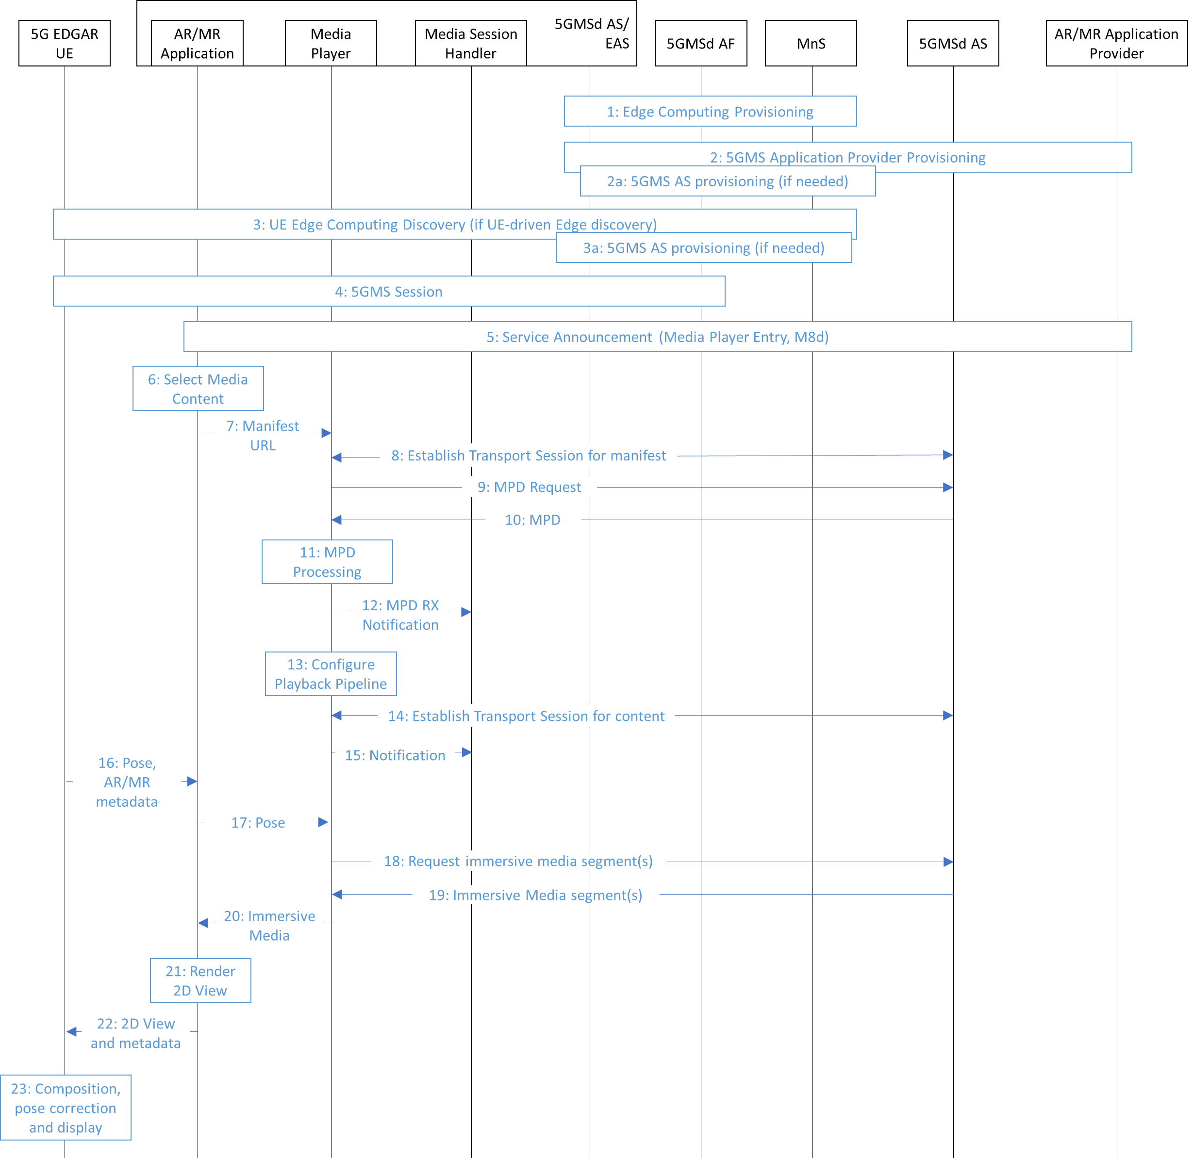
Figure 6.2.4.1-2: Edge-assisted STAR-based 5GMS Downlink Procedure
Prerequisites:
- AR/MR Application Provider has established a Provisioning Session and its detailed configurations has been exchanged.
- AR/MR Application Provider has completed to set up ingesting immersive contents.
Procedures:
1. Edge Computing provisioning phase as described in TR 26.803.
2. 5GMS Application Provider Provisioning phase as described in TR 26.803.
2a. Optional 5GMS Application Provider Provisioning phase as described in TR 26.803.
3. UE Edge Computing Discovery phase as described in TR 26.803.
3a. Optional 5GMS Application Provider Provisioning phase as described in TR 26.803.
4. The 5GMS Session phase starts as described in TR 26.803 with further steps below.
5. Service Announcement is triggered by AR/MR Application. Service Access Information including Media Player Entry or a reference to the Service Access Information is provided through M8d interface.
6. Desired media content is selected.
7. AR/MR Application sends the Media Player Entry to Media Player.
8. The Media Player establishes the transport session to acquire manifest information (e.g., MPD for DASH streaming)
9. The Media Player requests the MPD.
10. 5GMSd AS provides the MPD.
11. The Media Player processes the MPD to acquire the necessary information for accessing media content.
12. The Media Player notifies the necessary information acquired from the MPD to the Media Session Handler.
13. The Media Player configures the media playback pipeline.
14. The Media Player establishes the transport session(s) to acquire the media content.
15. The Media Player notifies to the Media Session Handler that the playback is ready.
16. The 5G EDGAR UE provides the AR/MR application with pose information and potentially AR/MR metadata for rendering (e.g., position of the object to be inserted into the real world in MR scenarios)
17. The MR/AR application provide the Media Player with pose information.
18. The Media Player requests the immersive media segments according to the MPD (possibly taking into account the pose information)
19. The Media Player receives the immersive media segments and triggers the media rendering pipeline.
20. The Media Player sends the decoded immersive media to the AR/MR application for rendering.
21. The AR/MR application renders the 2D View(s) with the pose information and potentially AR/MR metadata for rendering provided by the 5G EDGAR UE.
22. The AR/MR application sends rendered 2D View(s) and metadata (e.g., pose for which the 2D View is generated and the plane position at which it is rendered) to the 5G EDGAR UE.
23. The 5G EDGAR UE processes the received 2D Views, performs composition, applies pose correction and displays the viewport.
]

6.2.4.2 EDGAR-based media streaming
[TBD]

6.2.5 Content formats and codecs

6.2.6 KPIs and relevant quality of experience parameters

6.2.7 Potentially required QoS

6.2.8 Standardization areas

6.3 Interactive immersive services
<Yago, Eric, Samsung>

6.3.1 Introduction
This clause introduces the case where interactive immersive service. In this case, pose and other interactions are sent uplink in order for the Interactive Server to render the scene accordingly.

6.3.2 Relevant use cases

6.3.3 Architectures

6.3.3.1 STAR-based
Figure 6.3.3.1-1 provides an architecture for immersive interactive media distribution using a STAR UE.
Figure 6.3.3.1-1: STAR-based 5G interactive immersive service architecture

6.3.3.2 EDGAR-based
Figure 6.3.3.2-1 provides an architecture for immersive interactive media distribution using a EDGAR UE. In this case, similar as before, most of the rendering needs to accomplished on the server.

Figure 6.3.3.2-1: EDGAR-based 5G interactive immersive service architecture

6.3.4 Procedures and call flows

6.3.5 Content formats and codecs

6.3.6 KPIs and relevant quality of experience parameters

6.3.7 Potentially required QoS

6.3.8 Standardization areas

6.4 5G cognitive immersive service
<Thomas, Yago, ML, Samsung>
<Cognitive means that I am sending environment data>
<Yago, Eric, Samsung>

6.4.1 Introduction
This clause introduces the case of cognitive immersive service. In this case, media and other interactions are sent uplink in order for the Cognitive Server to create semantical perception.

6.4.2 Relevant use cases

6.4.3 Architectures

6.4.3.1 STAR-based
Figure 6.4.3.1-1 provides an architecture for immersive interactive media distribution using a STAR UE.
Figure 6.4.3.1-1: STAR-based 5G cognitive immersive service architecture

6.4.3.2 EDGAR-based
Figure 6.4.3.2-1 provides an architecture for immersive cognitive media distribution using a EDGAR UE. In this case, similar as before, most of the rendering needs to be accomplished on the server.
Figure 6.4.3.2-1: EDGAR-based 5G cognitive immersive service architecture

