3GPP TSG-SA4 Meeting #111-e S4-20XXXX

Electronic meeting, 11th-20th Nov. 2020
CR-Form-v12.0
PSEUDO CHANGE REQUEST
 | 26.955 | CR |  | rev |  | Current version: | 0.3.2
For HELP on using this form: comprehensive instructions can be found at
http://www.3gpp.org/Change-Requests.

Proposed change affects: | UICC apps |  | ME |  | Radio Access Network |  | Core Network

Title: | Integration of 4K-TV scenario sequences agreements
Source to WG: | VIDEO SWG chair and Rapporteur
Source to TSG:
Work item code: | FS_5GVideo |  |  |  |  |  | Date: |  |  | 15th Sept. 2020
Category: |  |  |  |  |  |  | Release: |  |  | 17
 | Use one of the following categories:  F (correction)  A (mirror corresponding to a change in an earlier release)  B (addition of feature),  C (functional modification of feature)  D (editorial modification)  Detailed explanations of the above categories can  be found in 3GPP TR 21.900. |  |  |  |  |  |  |  | Use one of the following releases:  Rel-8 (Release 8)  Rel-9 (Release 9)  Rel-10 (Release 10)  Rel-11 (Release 11)  Rel-12 (Release 12)  Rel-13 (Release 13)  Rel-14 (Release 14)  Rel-15 (Release 15)  Rel-16 (Release 16)
Reason for change: |  | Missing agreements from VIDEO SWG Adhoc telco
Summary of change: |  | S4aV200552
Consequences if not approved:
Clauses affected: |  | 2; 6.3.4; 6.3.7; Annex C.3 (NEW)
 |  | Y | N
Other specs |  |  |  | Other core specifications |  |  |  | TS/TR ... CR ...
affected: |  |  |  | Test specifications |  |  |  | TS/TR ... CR ...
(show related CRs) |  |  |  | O&M Specifications |  |  |  | TS/TR ... CR ...
Other comments:
This CR's revision history:

Start of first Change:

2 References
(…)
[48] Recommendation ITU-T P.910 (04/2008): "Subjective video quality assessment methods for multimedia applications".
[49] Ultra HD Forum Guidelines, https://ultrahdforum.org/wp-content/uploads/UHD-Guidelines-V2.3-final.pdf

End of First Change

Start of Second Change

6.3.4 Encoding and Decoding Constraints
Table 6.3-2 provides an overview of encoding and decoding constraints for 4K-TV category using legacy codec HEVC. This will support the definition of detailed test conditions. It is noted that no relevant profiles exist in TS26.116 and TS26.511 for HFR 4K-TV content.
Table 6.3-2 Encoding and Decoding Configurations for 4K-TV with legacy HEVC codec
Encoding and Decoding Constraints | H.265/HEVC 4K-TV | H.265/HEVC 4K-TV HFR
Relevant Codec and Codec Profile/Levels according to TS26.116 and TS26.511. | H.265/HEVC Main-10 Profile  Level 5.1 [8] | No relevant 3GPP profiles, should be aligned with H.265/HEVC Main-10 Profile Level 5.2 [8]
RAP period | 3.84sec, 1sec | 3.84sec, 1sec
Bit rate parameters (CBR, VBR, CAE, HRD parameters) | B = {10,20,30,40} Mbps [49]  CBR and capped-VBR | B = {10,20,30,40} Mbps [49]  CBR and capped-VBR
Latency requirements and specific encoding settings | No latency requirements beyond RAP so picture reordering allowed | No latency requirements beyond RAP so picture reordering allowed
Encoding complexity context | real-time encoding, cloud-based encoding, offline encoding, etc. | real-time encoding, cloud-based encoding, offline encoding, etc.
Required decoding capabilities | H.265/HEVC Main-10 Profile  Level 5.1 [8] | H.265/HEVC Main-10 Profile  Level 5.2 [8]

End of Second Change

Start of Third Change

6.3.7 Test Sequences
The Annex C.3 describes in details the selection process conducted to build the test sequences considered for this scenario, the outcome of this process is reported in the table below.
Table 6.3-3 : Selected test material for 4K-TV scenario
Name | Resolution | Frame-rate | ColorGamut | Number of Frames / Duration | Scene Cut
4EVER_Brest_Sedof | 3840 x 2160 | 60 | BT.2020 | 600 | 0
Rain_fruits | 3840 x 2160 | 50 | BT.709 | 600 | 0
ParkJoy | 3840 x 2160 | 50 | BT.709 | 500 | 0
Indoor Soccer | 3840 x 2160 | 23.98 | BT.709 | 17s | 4
Netflix_ToddlerFountain | 4096 x 2160 | 59.94 | BT.709 | 1199 | 0
Netflix_TunnelFlag | 4096 x 2160 | 59.94 | BT.709 | 600 | 0
RiverBank | 3840 x 2160 | 50 | BT.709 | 12s | 0
Netflix_Boat | 4096 x 2160 | 59.94 | BT.709 | 300 | 0

End of Third Change

Start of 4th Change

C.3 4K-TV Test Sequences

C.3.1 SDR Category

C.3.1.1 Candidate Test Sequences
In this Annex, a wide range of SDR test material is reported. The candidate sequences are extracted from test material used in video processing community. The following sections describe the test material in terms of format characteristics and copyright.

C.3.1.1.1 Ultra Video Group Sequences
The Ultra Video Group (UVG) sequences are publicly available, and can be used under CC BY-NC 3.0 license. The sequences are available for download at https://github.com/ultravideo/UVG-4K-Dataset and an overview is provided in the table below.
Table C.3-1 : UVG test material description
Name | Resolution | Frame-rate | ColorGamut | duration
CityAlley | 3840 x 2160 | 50 | BT.709 | 12s
FlowerFocus | 3840 x 2160 | 50 | BT.709 | 12s
FlowerKids | 3840 x 2160 | 50 | BT.709 | 12s
FlowerPan | 3840 x 2160 | 50 | BT.709 | 12s
RaceNight | 3840 x 2160 | 50 | BT.709 | 12s
RiverBank | 3840 x 2160 | 50 | BT.709 | 12s
SunBath | 3840 x 2160 | 50 | BT.709 | 6s
Twilight | 3840 x 2160 | 50 | BT.709 | 12s

C.3.1.1.2 JVET Sequences
The JVET test material for UHD SDR sequences is composed by six sequences described in the table below. The licensing information referenced in the table is described below:
- CC BY-NC-ND 4.0
- Our dataset is available for free and academic research only, no commercial use. Please cite our paper (L. Song, X. Tang, W. Zhang, X. Yang, P. Xia, The SJTU 4K Video Sequence Dataset, the Fifth International Workshop on Quality of Multimedia Experience (QoMEX2013), Klagenfurt, Austria, July 3rd-5th, 2013) in any published work if you use those video sequences.
- Please note that this test material remains the property of the Institute of Research & Technology b<>com and is solely provided “as is" to ITU-T SG16 Q6 and ISO/IEC JTC1/SC29/WG11, on a non-transferable and non-exclusive basis, and solely for the purpose of development, testing and promulgation of video coding standards. Any disclosure to third parties, exhibition, broadcast, distribution, public display or other exploitation of the test material is strictly prohibited.
- The proposed test sequences in this document and all intellectual property rights therein remain the property of Huawei Technologies Co., Ltd., and National Engineering Research Center.
Table C.3-2 : JVET test material description
Name | Resolution | Frame-rate | ColorGamut | Number of frames | License
Tango2 | 3840 x 2160 | 60 | BT.709 | 294 | See 1.
FoodMarket4 | 3840 x 2160 | 60 | BT.709 | 300 | See 1.
Campfire | 3840 x 2160 | 30 | BT.709 | 300 | See 2.
Catrobots1 | 3840 x 2160 | 60 | BT.709 | 300 | See 3.
Daylightroad2 | 3840 x 2160 | 60 | BT.709 | 300 | See 4.
Parkrunning3 | 3840 x 2160 | 50 | BT.709 | 300 | See 4.

C.3.1.1.3 Netflix Sequences
The Netflix dataset is composed by eighteen 4K sequences described in the table below. The sequences can be used under the CC BY-NC-ND 4.0 license restriction.
Table C.3-3 : Netflix test material description
Name | Resolution | Frame-rate | ColorGamut | Number of frames
Netflix_Aerial | 4096 x 2160 | 59.94 | BT.709 | 1199
Netflix_DinnerScene | 4096 x 2160 | 59.94 | BT.709 | 1199
Netflix_RollerCoaster | 4096 x 2160 | 59.94 | BT.709 | 1199
Netflix_DrivingPOV | 4096 x 2160 | 59.94 | BT.709 | 1199
Netflix_BarScene | 4096 x 2160 | 59.94 | BT.709 | 1199
Netflix_ToddlerFountain | 4096 x 2160 | 59.94 | BT.709 | 1199
Netflix_Dancers | 4096 x 2160 | 59.94 | BT.709 | 1199
Netflix_PierSeaside | 4096 x 2160 | 59.94 | BT.709 | 1199
Netflix_WindAndNature | 4096 x 2160 | 59.94 | BT.709 | 1199
Netflix_Boat | 4096 x 2160 | 59.94 | BT.709 | 300
Netflix_FoodMarket | 4096 x 2160 | 59.94 | BT.709 | 600
Netflix_Tango | 4096 x 2160 | 59.94 | BT.709 | 294
Netflix_BoxingPractice | 4096 x 2160 | 59.94 | BT.709 | 254
Netflix_Narrator | 4096 x 2160 | 59.94 | BT.709 | 300
Netflix_TunnelFlag | 4096 x 2160 | 59.94 | BT.709 | 600
Netflix_RitualDance | 4096 x 2160 | 59.94 | BT.709 | 600
Netflix_FoodMarket2 | 4096 x 2160 | 59.94 | BT.709 | 300
Netflix_SquareAndTimelapse | 4096 x 2160 | 59.94 | BT.709 | 600
Netflix_Aerial | 4096 x 2160 | 59.94 | BT.709 | 1199
Netflix_DinnerScene | 4096 x 2160 | 59.94 | BT.709 | 1199
Netflix_RollerCoaster | 4096 x 2160 | 59.94 | BT.709 | 1199

C.3.1.1.4 EBU Sequences
The EBU dataset is composed by two sequences described in the table below. The sequences can be used under the CC BY-NC-ND 4.0 license restriction.
Table C.3-4 : EBU test material description
Name | Resolution | Frame-rate | ColorGamut | Number of frames
Rain_fruits | 3840 x 2160 | 50 | BT.709 | 600
Lupo_candlelight | 3840 x 2160 | 50 | BT.709 | 600

C.3.1.1.5 SVT Sequences
The SVT dataset is composed by five sequences described in the table below. The sequences can be used under the license available at https://tech.ebu.ch/webdav/site/tech/shared/hdtv/svt-multiformat-conditions-v10.pdf .
Table C.3-5 : SVT test material description
Name | Resolution | Frame-rate | ColorGamut | Number of frames
CrowdRun | 3840 x 2160 | 50 | BT.709 | 500
ParkJoy | 3840 x 2160 | 50 | BT.709 | 500
DucksTakeOff | 3840 x 2160 | 50 | BT.709 | 500
IntoTree | 3840 x 2160 | 50 | BT.709 | 500
OldTownCross | 3840 x 2160 | 50 | BT.709 | 500

C.3.1.1.6 4ever Sequences
The 4ever dataset is composed by two sequences described in the table below. The sequences can be used under the license described below:
The proposed test sequences Brest_Sedof_3840x2160p60_10b.yuv and Paris_Montmartre_3840x2160p60_10b, and all intellectual property rights therein remain the property of 4EVER consortium partners: Orange, AMP Visual TV, ATEME, France Télévisions, GlobeCast, InterDigital, Highlands Technologies Solutions, INSA Rennes, TeamCast and Télécom ParisTech
  - The following uses are allowed for the proposed sequences:
    - Can be published in technical papers, played at technology research and development events.
    - Can be used in 3GPP SA4.
  - The following uses are not allowed for the proposed sequences:
    - Do not publish snapshots in product brochures.
    - Do not redistribute video with a commercial product.

Table C.3-6 : 4ever test material description
Name | Resolution | Frame-rate | ColorGamut | Number of frames
4EVER_Brest_Sedof | 3840 x 2160 | 60 | BT.2020 | 600
4EVER_Paris_Montmartre | 3840 x 2160 | 60 | BT.2020 | 600

C.3.1.1.7 CableLabs Sequences
The CableLabs dataset is composed by eight sequences described in the table below. The sequences can be used under the CC BY-NC-ND 3.0 license restriction.
Table C.3-7 : CableLabs test material description
Name | Resolution | Frame-rate | ColorGamut | duration | Comment on selected intervals
Lifting Off | 3840 x 2160 | 23.98 | BT.709 | 3:21 | Nice colored pictures, som burned in text, scene cuts (2)
Seconds that count | 3840 x 2160 | 23.98 | BT.709 | 5:22 | Not critical
Unspoken Friend | 3840 x 2160 | 23.98 | BT.709 | 4:17 | Not critical
Indoor Soccer | 3840 x 2160 | 23.98 | BT.709 | 4:12 | Fast motion, scene cuts (4)
Skateboarding | 3840 x 2160 | 23.98 | BT.709 | 4:36 | Not critical
Eldorado | 3840 x 2160 | 23.98 | BT.709 | 3:02 | Panning up/down on a tree (oak), no scene cut
Moment of Intensity | 3840 x 2160 | 59.94 | BT.709 | 3:10 | Skate board, no scene cuts
Ancient Thought | 3840 x 2160 | 23.98 | BT.709 | 3:08 | Not critical

All of the sequences are not of interest for compression evaluation. A selection of some critical time intervals have been conducted based on experience on compression. Especially intervals with fast or complex motion, some including scene cuts, representative of TV contents have been selected. Static pictures, or pictures with artistic intent with few spatial details have been discarded. To remain in the scope of the scenario, the following sub sequences have been selected as final candidates:
- Lifting off : from 00:05 to 00:22
- Indoor Soccer : from 01:06 to 01:23
- Eldorado : from 01:33 to 01:50
- Life Untouched : from 00:00 to 00:22
The extraction of subpart from original ProRes sequences is realized with FFmpeg release 4.3.1 using the following commandline:
./ffmpeg.exe -i $IN.mov -vcodec rawvideo -ss $START_TIME -t $DURATION -pix_fmt yuv420p10le $OUT.yuv
Where $IN and $OUT are respectively the input and output sequences, $START_TIME and $DURATION respectively the start time and duration in hh:mm:ss format.

C.3.1.2 Selected Test Sequences
In order to decide wich sequences should be used in this specification, the following process has been used:
- Run informative encoding using x265 on the candidate sequences
- Run SI-TI metrics computation on the candidate sequences
- Select two diverse datasets based on R-D and SI-TI information.

C.3.1.2.1 x265 Encoding
To represent candidate sequences in the R-D plane, fixed QP encodings are carried out for QPs [12, 17,22,27,32,37,42] using ffmpeg release 4.3.1, with the following command line:
./ffmpeg.exe -pix_fmt yuv420p10le -s $Wx$H -framerate $FR -i $IN -vcodec libx265 -qp $QP -preset fast -x265-params “psnr=1:ssim=1” $OUT.mp4
Where $W and $W are respectively the sequence width and height, $FR the sequence frame-rate, $QP the selected quantization parameter. $IN and $OUT are respectively the input and output files.
From the obtained log, the overall bitrate and PSNR are extracted to be used for plotting. The encoding result are presented below, all sequences being represented in the targeted [10-40] Mbps range (red box).

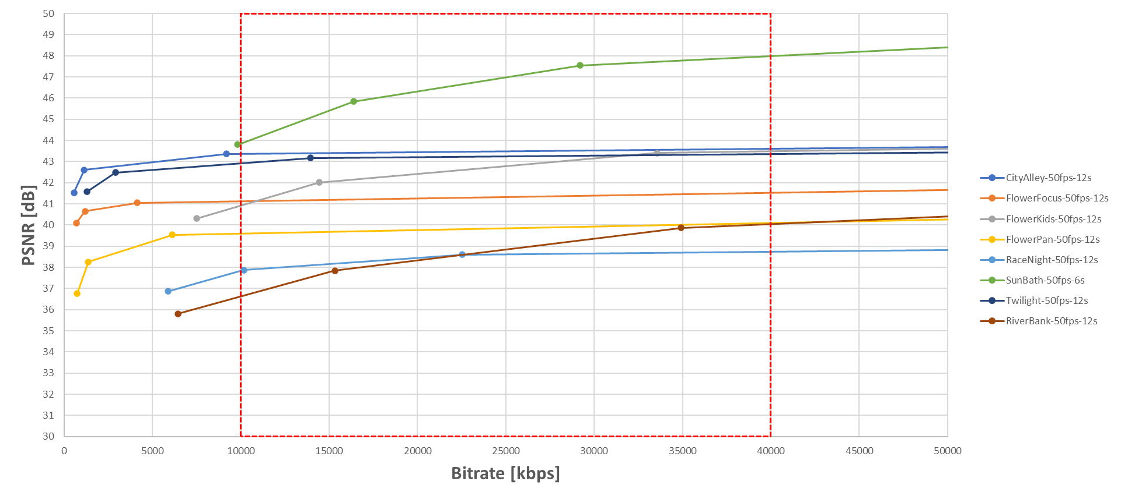
Figure C.3-1 : R-D curves for the UVG dataset

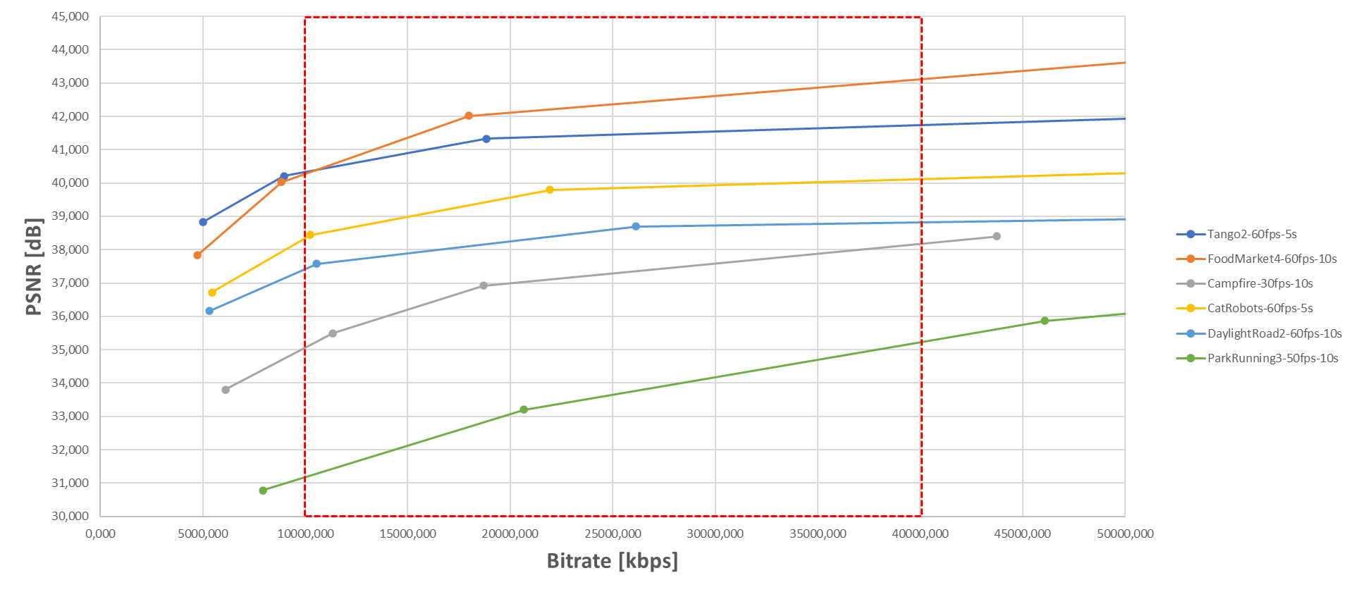
Figure C.3-2 : R-D curves for the JVET dataset

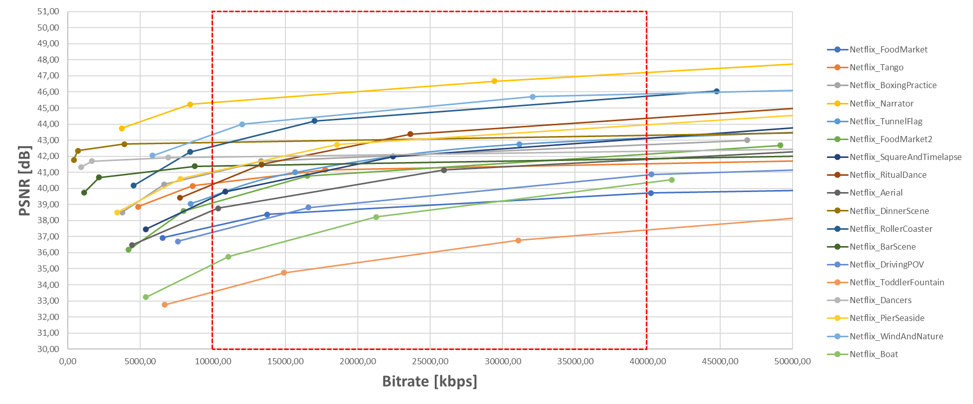
Figure C.3-3 : R-D curves for the Netflix dataset

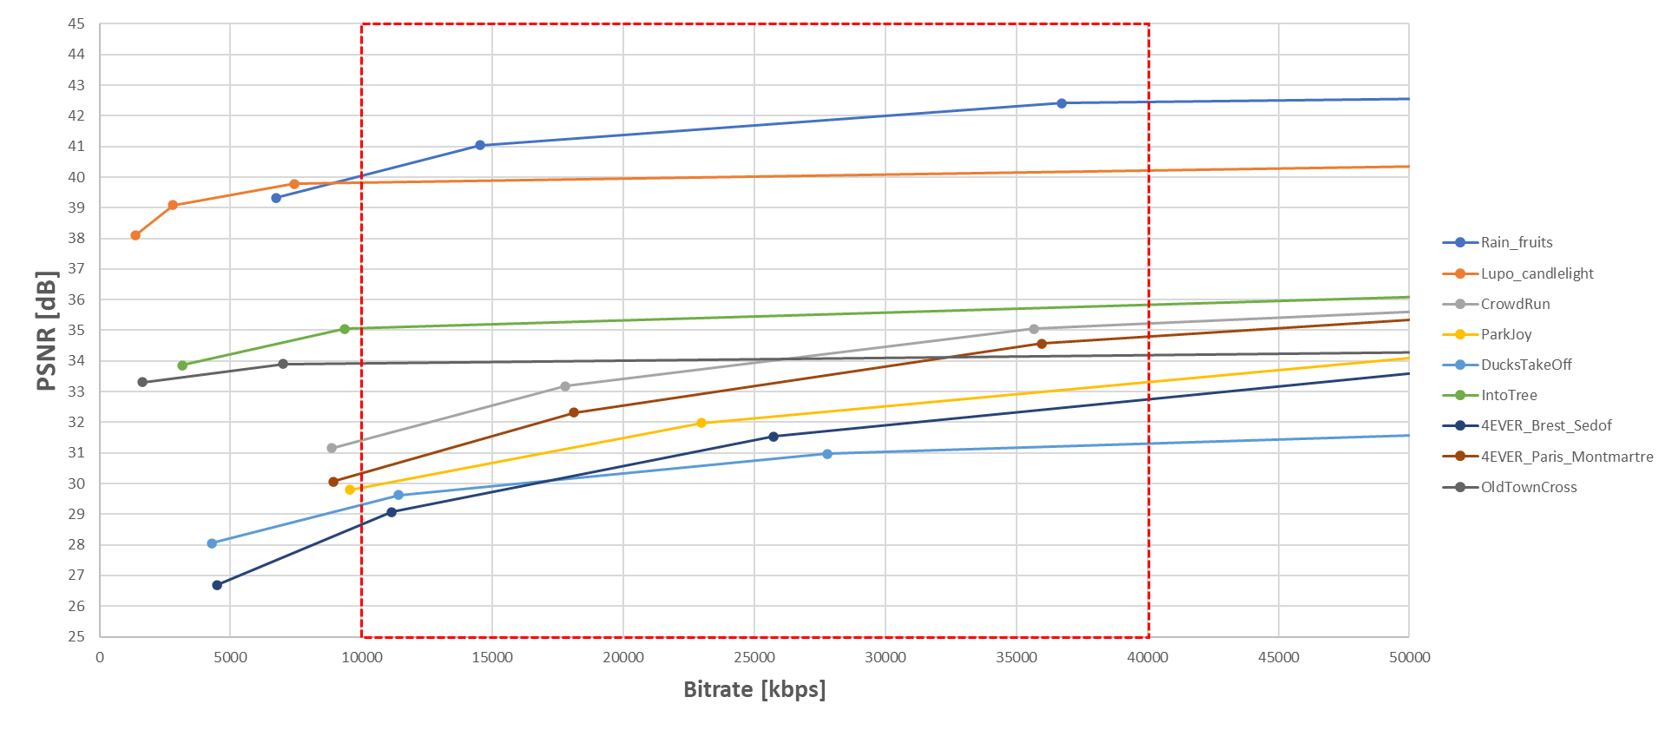
Figure C.3-4 : R-D curves for the EBU, SVT and 4ever datasets
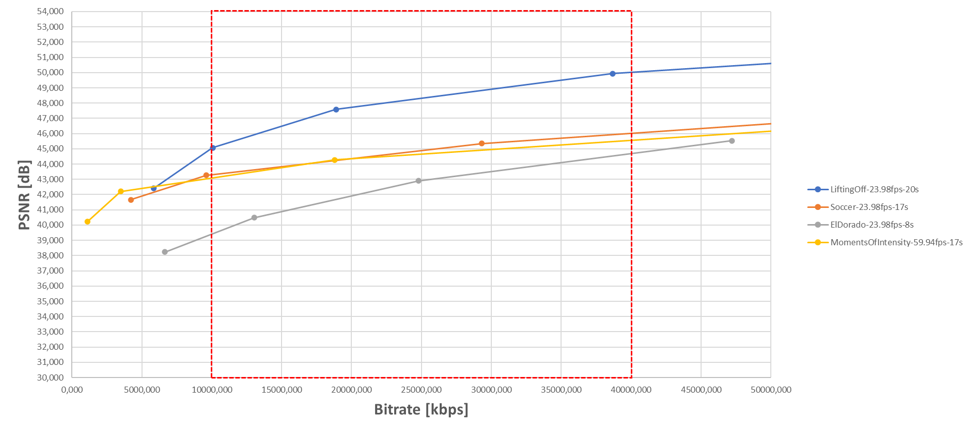
Figure C.3-5 : R-D curves for the CableLabs dataset

C.3.1.2.2 SI-TI Metrics
The analysis is based on spatial perceptual information (SI) and temporal perceptual information (TI) metrics calculated as defined in ITU-P.910 recommendation [40]. In order to reduce the bias introduced by scene-cuts in TI metric computation, the TI at scene-cut boundaries are removed from computation.
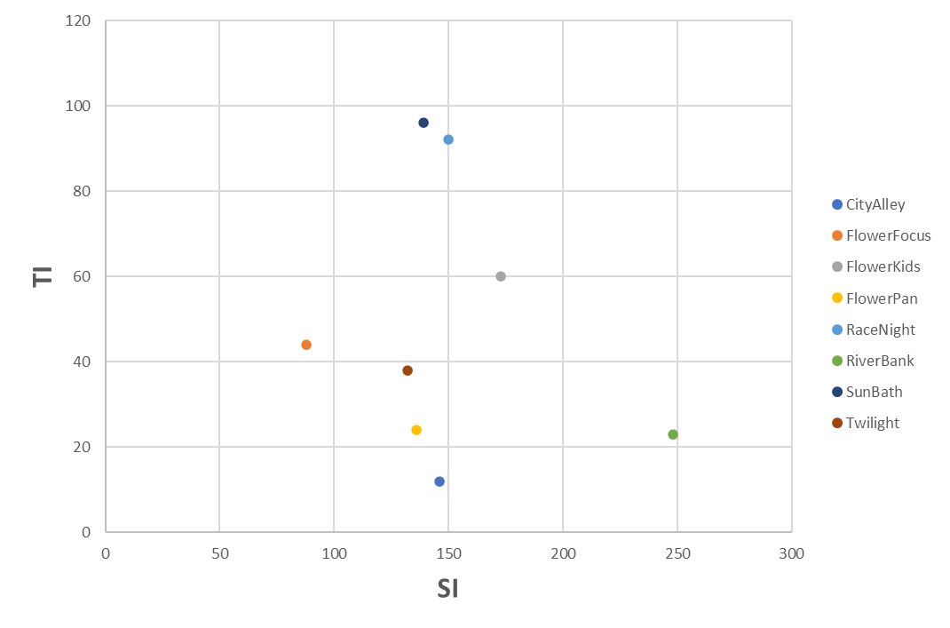
Figure C.3-6 : SI-TI for the UVG dataset
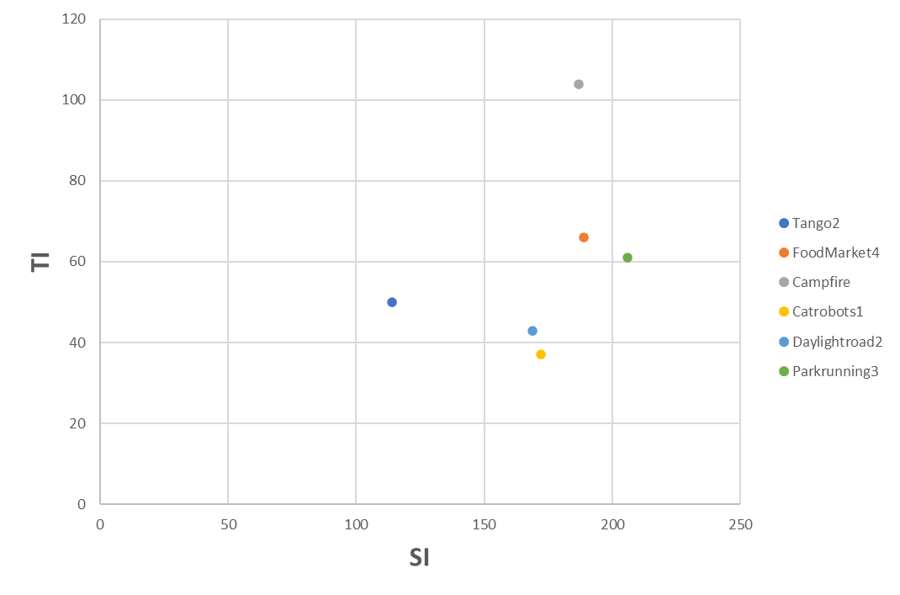
Figure C.3-7 : SI-TI for the JVET dataset
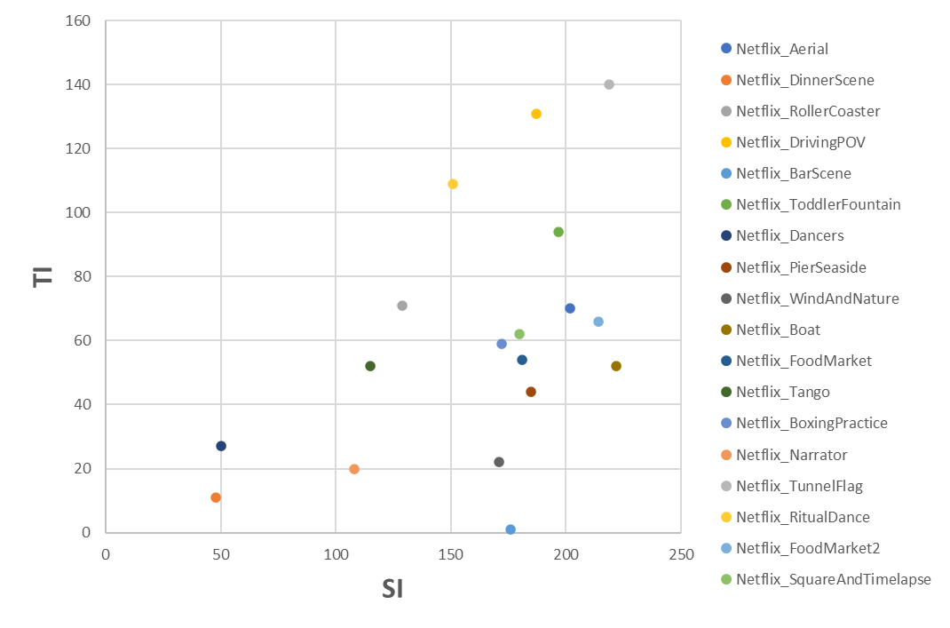
Figure C.3-8 : SI-TI for the Netflix dataset
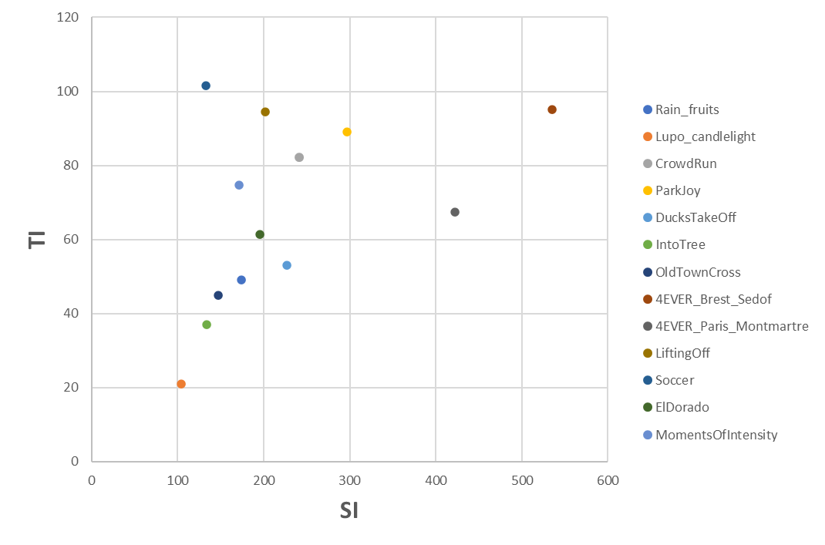
Figure C.3-9 : SI-TI for the EBU, SVT, 4ever and CableLabs dataset

To be added later: reference to the SI-TI scripts will be available (ETSI git)

C.3.1.2.3 Sequence Selection
The first step consists in classifying the sequences in two categories : easy and challenging. This reflects the complexity of the sequences from an encoding perspective. Based on the R-D data, the QP points covering the application range [10-40]Mbps are identified. For the lower (10Mbps) and higher (40Mbps) boundaries, a linear interpolation is achieved between the two closest QP points to estimate the distortion at the boundaries: D_10 and D_40. If the distortion difference D_DIFF=(D_40-D_10) is less than or equal to a threshold Thr=1.5, then the sequence is classified as follows:
- Low-dynamic: the PSNR dynamic on the application bitrate range is limited
- High-dynamic: the PSNR dynamic on the application bitrate range is high

The results of this first classification step is reported in the table below.
Table C.3-8 : Sequence classification based on R-D information in the [10-40] Mbps range, Thr=1.5
 | Name | D_10 | D_40 | D_DIFF | Dynamic
JVET | Tango2 | 40,33 | 41,44 | 1,12 | Low
JVET | FoodMarket4 | 40,28 | 42,37 | 2,09 | High
JVET | Campfire | 35,06 | 37,29 | 2,23 | High
JVET | Catrobots1 | 38,36 | 39,85 | 1,50 | Low
JVET | Daylightroad2 | 37,42 | 38,61 | 1,19 | Low
JVET | Parkrunning3 | 31,17 | 33,65 | 2,48 | High
UVG | CityAlley | 43,37 | 43,49 | 0,12 | Low
UVG | FlowerFocus | 41,13 | 41,33 | 0,20 | Low
UVG | FlowerKids | 40,92 | 42,78 | 1,86 | High
UVG | FlowerPan | 39,60 | 39,85 | 0,25 | Low
UVG | RaceNight | 37,82 | 38,62 | 0,79 | Low
UVG | RiverBank | 36,62 | 38,84 | 2,22 | High
UVG | SunBath | 43,85 | 46,98 | 3,13 | High
UVG | Twilight | 42,92 | 43,24 | 0,33 | Low
Netflix | Netflix_Aerial | 38,62 | 41,00 | 2,37 | High
Netflix | Netflix_DinnerScene | 42,85 | 43,08 | 0,23 | Low
Netflix | Netflix_RollerCoaster | 42,61 | 44,73 | 2,11 | High
Netflix | Netflix_DrivingPOV | 37,27 | 39,54 | 2,27 | High
Netflix | Netflix_BarScene | 41,39 | 41,62 | 0,23 | Low
Netflix | Netflix_ToddlerFountain | 33,56 | 36,01 | 2,45 | High
Netflix | Netflix_Dancers | 41,96 | 42,14 | 0,18 | Low
Netflix | Netflix_PierSeaside | 41,05 | 43,10 | 2,06 | High
Netflix | Netflix_WindAndNature | 43,35 | 45,09 | 1,75 | High
Netflix | Netflix_Boat | 35,27 | 38,64 | 3,37 | High
Netflix | Netflix_FoodMarket | 37,62 | 38,95 | 1,32 | Low
Netflix | Netflix_Tango | 40,31 | 41,27 | 0,97 | Low
Netflix | Netflix_BoxingPractice | 40,97 | 42,14 | 1,17 | Low
Netflix | Netflix_Narrator | 45,33 | 46,36 | 1,03 | Low
Netflix | Netflix_TunnelFlag | 39,47 | 42,06 | 2,59 | High
Netflix | Netflix_RitualDance | 40,25 | 43,46 | 3,21 | High
Netflix | Netflix_FoodMarket2 | 39,11 | 41,27 | 2,16 | High
Netflix | Netflix_SquareAndTimelapse | 39,43 | 42,15 | 2,72 | High
EBU | Rain_fruits | 40,04 | 41,69 | 1,65 | High
EBU | Lupo_candlelight | 39,81 | 40,01 | 0,20 | Low
SVT | CrowdRun | 31,41 | 33,94 | 2,53 | High
SVT | ParkJoy | 29,86 | 32,13 | 2,27 | High
SVT | DucksTakeOff | 29,31 | 30,75 | 1,44 | Low
SVT | IntoTree | 35,06 | 35,45 | 0,39 | Low
SVT | OldTownCross | 33,93 | 34,06 | 0,13 | Low
4ever | 4EVER_Brest_Sedof | 28,66 | 31,42 | 2,76 | High
4ever | 4EVER_Paris_Montmartre | 30,33 | 33,19 | 2,86 | High
CableLabs | LiftingOff | 45,01 | 48,31 | 3,30 | High
CableLabs | Soccer | 43,31 | 44,89 | 1,58 | High
CableLabs | ElDorado | 39,41 | 44,29 | 4,88 | High
CableLabs | MomentsOfIntensity | 43,09 | 44,66 | 1,57 | High

It is observed that 26 sequences are classified as “High” while 19 are “Low”. In order to keep sequences that are relevant for a codec characterization, the low-dynamic sequences are removed. Then, the next step consists in removing sequences having some similarities, using SI-TI information computed in Section C.3.1.2.2. The sequences are represented below in the SI-TI plane with a k-means clustering to help the decision.
Figure C.3-9 : SI-TI clustering for the Challenging sequences (10 clusters)

In order to remain representative in the sense of sources origin, format, and SI-TI values, the following approach was taken:
- 1 sequence (out of 6) from the C2 cluster (EBU: Rain-fruits)
- 1 sequence (out of 4) from the C3 cluster (CableLabs: Soccer)
- 2 sequences (out of 8) from the C4 cluster (Netfllix: ToddlerFountain, Boat)
- 1 sequence (out of 1) from the C5 cluster (UVG: Riverbank)
- 1 sequence (out of 2) from the C6 cluster (Netflix: TunnelFlag)
- 1 sequence (out of 1) from the C8 cluster (SVT: ParkJoy)
- 1 sequence (out of 1) from the C10 cluster (4ever: Brest-Sedof)

The following eight sequences are selected:
- 1 From 4ever: Brest-Sedof (3840x2160p 60fps)
- 1 From EBU: RainFruits (3840x2160p 50fps)
- 1 From SVT: ParkJoy (3840x2160p 50fps)
- 1 From CableLabs: Soccer (3840x2160p 23.98fps)
- 3 From Netflix:, TunnelFlag, Boat and Toddlerfountain (4096x2160p 59.94fps)
- 1 From UVG: RiverBank (3840x2160p 50fps)

C.3.2 HDR Category
tbd

C.3.3 HFR Category
tbd

End of 4th Change

