3GPP TSG-SA4 Meeting SA4#111-e S4-201614

Telco, Online, 11 Nov 2020 - 20 Nov 2020 revision of S4-201308
CR-Form-v12.0
CHANGE REQUEST
 | 26.132 | CR | 0000 | rev | - | Current version: | 16.2.0
For HELP on using this form: comprehensive instructions can be found at
http://www.3gpp.org/Change-Requests.

Proposed change affects: | UICC apps |  | ME | X | Radio Access Network |  | Core Network

Title: | Headset Interface Description
Source to WG: | HEAD acoustics GmbH
Source to TSG: | S4
Work item code: | HInT |  |  |  |  |  | Date: |  |  | 2020-09-14
Category: | B |  |  |  |  |  | Release: |  |  | Rel-17
 | Use one of the following categories:  F (correction)  A (mirror corresponding to a change in an earlier release)  B (addition of feature),  C (functional modification of feature)  D (editorial modification)  Detailed explanations of the above categories can  be found in 3GPP TR 21.900. |  |  |  |  |  |  |  | Use one of the following releases:  Rel-8 (Release 8)  Rel-9 (Release 9)  Rel-10 (Release 10)  Rel-11 (Release 11)  Rel-12 (Release 12)  Rel-13 (Release 13)  Rel-14 (Release 14)  Rel-15 (Release 15)  Rel-16 (Release 16)
Reason for change: |  | Within the scope of the work item HInT, it is intended to add new test methods to TS 26.132 for analogue and digital interfaces of UE. As a preparation for these, a detailed specification and description of the introduced interfaces has to be included.
Summary of change: |  | Introduction of new clauses for analogue and digital interfaces, editorial changes in the existing clauses regarding measurement equipment.
Consequences if not approved: |  | Testing of the electric (headset) interface not considered. Evaluation of a mobile phone without an associated headset not possible.
Clauses affected: |  | Introduction, 1, 2, 3.1, 4, 4.1 (new), 4.2 (new), 4.3 (new), 5.1.6 (new), 5.2, 7.2.6 (new), 7.3.3 (new), 7.3.4 (new), 7.4.7 (new), 7.4.8 (new), 7.5.3a (new), 7.5.4, 7.7.5 (new), 7.8.3 (new), 7.8.4 (new), 7.10.1b (new), 7.10.2b (new), 7.10.3b (new), 7.11.1, 7.12.3 (new), 7.13.1, 7.13.2, Annex D.1
 |  | Y | N
Other specs |  |  | X | Other core specifications |  |  |  | TS/TR ... CR ...
affected: |  | x |  | Test specifications |  |  |  | TS/TR 26.131 CR NNNN
(show related CRs) |  |  | X | O&M Specifications |  |  |  | TS/TR ... CR ...
Other comments:
This CR's revision history:

------------------------- START OF CHANGE 1 -------------------------

Introduction
The present document specifies test methods to allow the minimum performance requirements for the electro-acoustic characteristics of GSM, 3G, LTE, NR and WLAN terminals when used to provide narrowband, wideband, super-wideband or fullband telephony to be assessed.
The objective for narrowband services is to reach a quality as close as possible to ITU-T standards for PSTN circuits. However, due to technical and economic factors, there cannot be full compliance with the general characteristics of international telephone connections and circuits recommended by the ITU-T.
The performance requirements are specified in TS 26.131; the test methods and considerations are specified in the main body of the text.

1 Scope
The present document is applicable to any terminal capable of supporting narrowband, wideband, super-wideband or fullband telephony, either as a stand-alone service or as the telephony component of a multimedia service. The present document specifies test methods to allow the minimum performance requirements for the electro-acoustic characteristics of GSM, 3G, LTE, NR and WLAN terminals when used to provide narrowband, wideband, super-wideband or fullband telephony to be assessed.

------------------------- END OF CHANGE 1 -------------------------

------------------------- START OF CHANGE 2 -------------------------

2 References
The following documents contain provisions which, through reference in this text, constitute provisions of the present document.
- References are either specific (identified by date of publication, edition number, version number, etc.) or non-specific.
- For a specific reference, subsequent revisions do not apply.
- For a non-specific reference, the latest version applies. In the case of a reference to a 3GPP document (including a GSM document), a non-specific reference implicitly refers to the latest version of that document in the same Release as the present document.
[…]
[53] ITU-T Recommendation P.381: "Technical requirements and test methods for the universal wired headset or headphone interface of digital mobile terminals".
[54] ISO 3: "Preferred numbers — Series of preferred numbers".

------------------------- END OF CHANGE 2 -------------------------

------------------------- START OF CHANGE 3 -------------------------

3 Definitions, symbols and abbreviations

3.1 Definitions
For the purposes of the present document the terms narrowband, wideband, super-wideband and fullband refer to signals associated with the corresponding operating modes of the speech codecs specified in 5.2.
For the purposes of the present document, the terms dB, dBr, dBm0, dBm0p and dBA, shall be interpreted as defined in ITU-T Recommendation G.100 [51]; the term dBPa shall be interpreted as the sound pressure level relative to 1 pascal expressed in dB (0 dBPa is equivalent to 94 dB SPL).
A 3GPP softphone is a telephony system running on a general purpose computer or PDA complying with the 3GPP terminal acoustic requirements (TS 26.131 and 26.132).
For the purposes of the present document the term clock skew is defined as the difference between the clock of the device under test (C_{DUT}) and the clock of the reference client (C_{REF}). The skew of C_{DUT} relative to C_{REF} is defined in parts per million (PPM) as: (C_{DUT} -C_{REF}).10⁶/ C_{REF}.
For the purposes of the present document, the term electrical interface is defined as an analogue or digital access to an UE, which allows injecting and capturing signals electrically instead of through an acoustical interface. The interface can be either wired (analogue, digital) or wireless (digital). The purpose of this interface is to connect a separate device (typically a headset), which provides a receiver and transmitter for telephony.

3.2 Abbreviations
For the purposes of the present document, the abbreviations given in 3GPP TR 21.905 [47] and the following apply. An abbreviation defined in the present document takes precedence over the definition of the same abbreviation, if any, in 3GPP TR 21.905 [47].
[...]
TCL Terminal coupling loss
TCLw Terminal coupling loss (weighted)

[...]
------------------------- END OF CHANGE 3 -------------------------

------------------------- START OF CHANGE 4 -------------------------

4 Interface definitions

4.1 General
The interfaces required to define terminal electro-acoustic characteristics are the acoustical interfaces, the air interface and the point of interconnect (POI), see Figure 1.
MTSI speech aspects are specified by TS 26.114 [17].

4.2 Air interfaces
The Air Interfaces for GSM, 3G, LTE and NR are specified by GSM 05, 3GPP 45, 3GPP 25, 3GPP 36 and 3GPP 38 series specifications, and the Air Interface for WLAN access to EPC is specified by WLAN access to EPC as defined in 3GPP TS 23.402 [48] and TS 24.302 [49].
Measurements can be made using a system simulator (SS) comprising the appropriate radio terminal equipment and speech transcoder. The delays, losses and gains introduced by the test equipment shall be accounted for.

4.3 Acoustical interfaces
The POI with the public switched telephone network (PSTN) is considered to have a relative level of 0 dBr.
Five classes of acoustical interface are considered in this specification:
- Handset UE including softphone UE used as a handset;
- Headset UE including softphone UE used with headset;
- Vehicle Mounted Hands-free UE including softphone UE mounted in a vehicle;
- Desktop-mounted hands-free UE including softphone UE with external loudspeaker(s) used in hands-free mode;
- Hand-held hands-free UE including softphone UE with internal loudspeaker(s) used in hands-free mode.
(See definition of softphone in Clause 3.1)
NOTE: The test setup for a softphone UE shall be derived according to the following rules:
- When using a softphone UE as a handset: the test setup shall correspond to handset mode.
- When using a softphone UE with headset: the test setup shall correspond to headset mode.
- When a softphone UE is mounted in a vehicle: the test setup shall correspond to vehicle-mounted hands-free mode.
- When using a softphone UE in hands-free mode:
- When using internal loudspeaker(s), the test setup shall correspond to hand-held hands-free.
- When using external loudspeaker(s), the test setup shall correspond to desktop-mounted hands-free.

4.4 Electrical interfaces
An electrical interface is considered in this specification and details on standardized analogue (wired) and digital (wired and wireless) headset interfaces can be found in TS 26.132. For the electrical interface, the POI in sending / receiving direction is respectively defined as the input / output of the reference speech coder of the system simulator.
Any of the UE types mentioned in clause 4.3 providing an electrical interface can be considered as Electrical Interface UE.

------------------------- END OF CHANGE 4 -------------------------

------------------------- START OF CHANGE 5 -------------------------

5.1.6 Test setup for electrical interfaces

5.1.6.1 Wired analogue connection
UE testing via analogue connection shall be carried out with a universal wired headset interface, which complies with the electrical and physical characteristics described in clause 6 of ITU-T P.381 [53]. Different types of socket designs can be used as well. Other implementations of analogue electrical interfaces (wired or wireless) are out of scope.

Figure 15a5b illustrates the setup required for testing analogue electrical interfaces. The electric output impedance of the reference interface of the test equipment shall be in the range of 1 Ω and 10 kΩ. The corresponding electric input impedance shall be 32 Ω +/- 2 Ω. The common ground impedance (between sending and receiving sides) for the test system shall be ≤ 0.05 Ω.

If not specified otherwise, the nominal average signal level in send direction (output of the interface) is -60 dBV, which corresponds to a typical acoustic level of -4.7 dBPa at the MRP (default sensitivty of ~55 dBV/Pa). In receive direction, the average signal level for a nominal volume setting (if present) is expected to be -39 dBV (for an electrical interface providing stereo/diotic output).

For testing echo and double talk scenarios, an artificial feedback of the receive signal into the sending path shall be used. This echo path can be realized in an analogue (e.g, a stand-alone device) or digital (e.g., part of the test system) way. For measurements without artificial echo loss, the feedback path is disabled.

NOTE: It is assumed that mainly passive third-party devices are connected via analogue electrical interface to the UE, which do not contain any typical signal processing capabilities (like e.g., echo cancellation or noise reduction). Thus, all tests specified for this interface are comparable to handset UE or headset UE, i.e. they expect that any possible signal processing is applied in the UE.
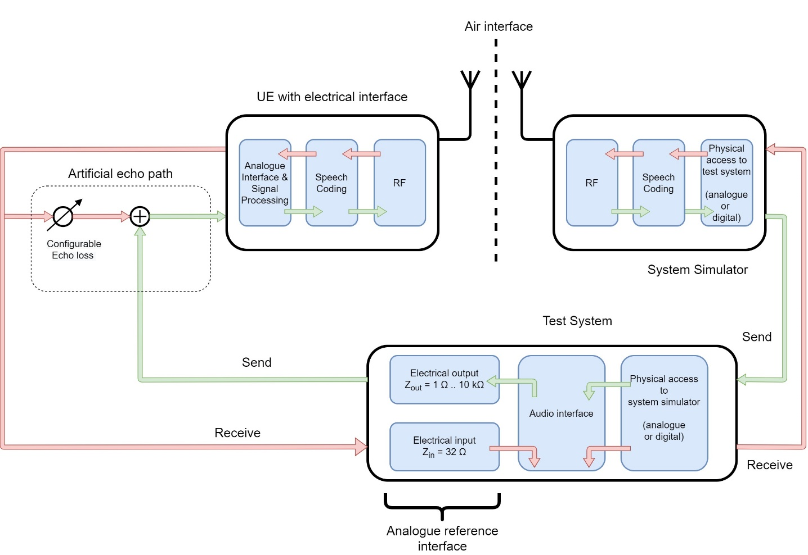
Figure 15a5b: Test setup for analogue electrical headset interface

5.1.6.2 Digital connection
Figure 15a5c illustrates the setup required for testing digital electrical interfaces of a UE. Such testing is possible with different types of wired and wireless technologies and requires a digital reference interface in the test system. The present document is only applicable to USB and Bluetooth interfaces, other digital interfaces are out of scope.

For testing echo and double talk scenarios, an artificial feedback of the receive signal into the sending path shall be used. This echo path shall be realized as part of the test system. The received and decoded signal from the UE is fed back into the sending direction, in advance to the encoding/protocol/hardware layer. For measurements without artificial echo loss, the feedback path is disabled.

Digital levels for send and receive direction are specified in dBm0, referring to the same definition as for the input/output of the terminal and the system simulator (see clause 5.2).
In contrast to the analogue interface, devices connected to the UE via digital interface may either provide active (includes signal processing for send and/or receive direction) or passive (comparable to analogue headsets, see clause 5.1.6.1) functionalities. Tests are only applicable in case of typical signal processing for telecommunication (e.g., noise reduction, echo cancellation) takes places only in the UE and not in the connected equipment.
However, in some cases, the digital interface and its protocol supports the exchange of commands/meta-information. A connected device may communicate that it provides capabilities to perform its own signal processing. In this case, the UE shall behave as a transparent gateway, i.e. shall not apply any signal processing.
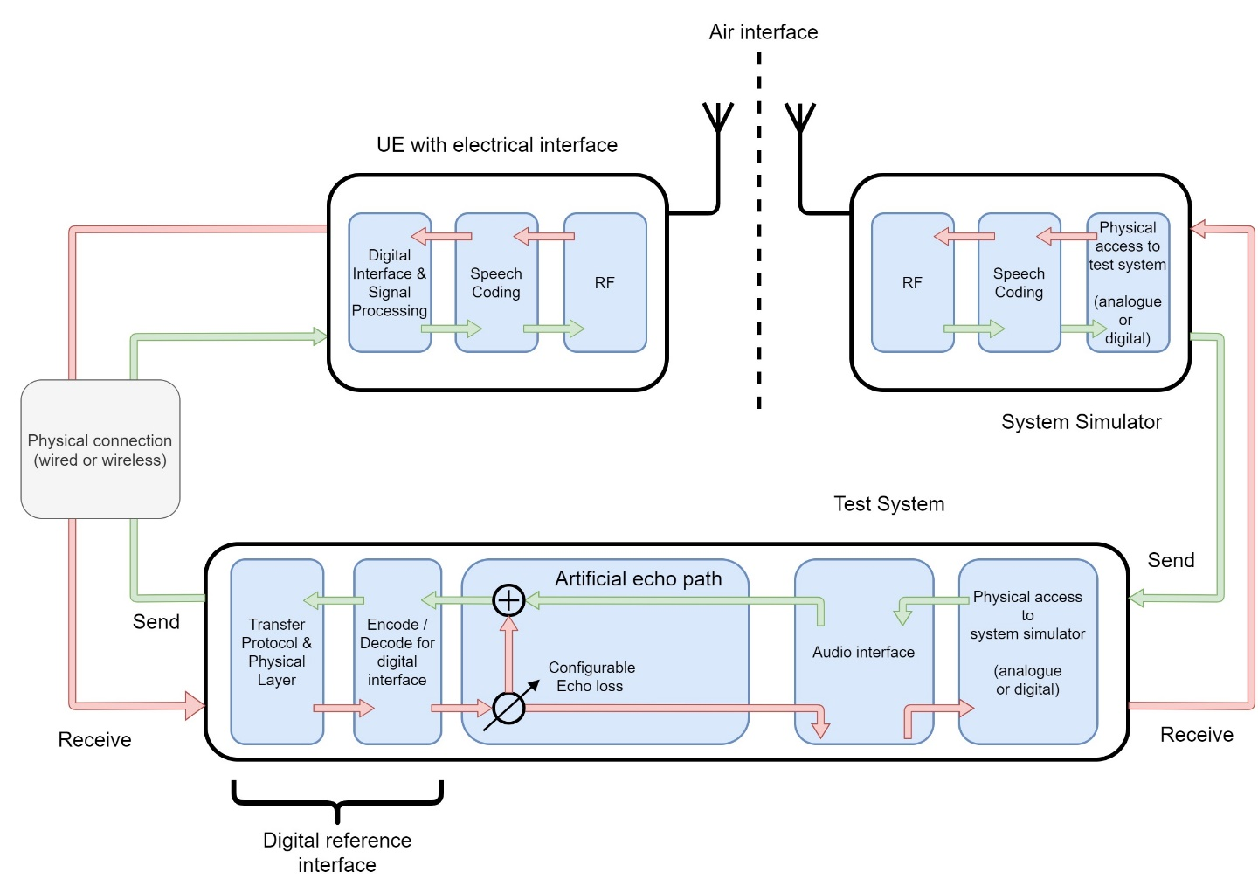
Figure 15a5c: Test setup for digital electrical headset interface

------------------------- END OF CHANGE 5 -------------------------

------------------------- START OF CHANGE 6 -------------------------

5.2 Setup of the electrical interfaces of test equipment

5.2.1 Codec approach and specification
In this approach, a codec is used to convert the digital input/output bit-stream of the system simulator to the equivalent analogue values. With this approach a system simulator simulating the radio link to the terminal under controlled and error-free conditions is required, unless otherwise specified for the respective test. The system simulator has to be equipped with a high-quality codec with characteristics as close as possible to ideal.
Definition of 0 dBr point:
D/A converter - a Digital Test Sequence (DTS) representing the codec equivalent of an analogue sinusoidal signal with an RMS value of 3,14 dB below the maximum full-load capacity of the codec shall generate 0 dBm across a 600 ohm load;
A/D converter - a 0 dBm signal generated from a 600 ohm source shall give the digital test sequence (DTS) representing the codec equivalent of an analogue sinusoidal signal with an RMS value of 3,14 dB below the maximum full-load capacity of the codec.

Rename of clause 5.2 just to be confused with the electrical (headset) interface.
------------------------- END OF CHANGE 6 -------------------------

------------------------- START OF CHANGE 7 -------------------------

7.2 Overall loss/loudness ratings

7.2.1 General
The SLR and RLR values for GSM, 3G, LTE, NR or WLAN networks apply up to the POI. However, the main determining factors are the characteristics of the UE, including the analogue to digital conversion (ADC) and digital to analogue conversion (DAC). In practice, it is convenient to specify loudness ratings to the Air Interface. For the normal case, where the GSM, 3G, LTE, NR or WLAN network introduce no additional loss between the Air Interface and the POI, the loudness ratings to the PSTN boundary (POI) will be the same as the loudness ratings measured at the Air Interface.

7.2.2 Connections with handset UE
[...]

7.2.3 Connections with desktop and vehicle-mounted hands-free UE
[...]

7.2.4 Connections with hand-held hands-free UE
[...]

7.2.5 Connections with headset UE
Same as for handset.

[7.2.6 Connections with electrical interface UE]
[Typical LRs cannot be used (or only with restrictions); ITU-T P.381 uses absolute level acc. to P.56 ASL. Proposal here is to use JLR]

7.2.6.1 Sending junction loudness rating (SJLR)
a) The test signal to be used for the measurements shall be the British-English single talk sequence described in ITU-T Recommendation P.501 [22]. For electrical interface UE, the active speech level of the signal shall be calibrated to -60 dBV for analogue and to -16 dBm0 for digital connections. The test signal level is calculated over the complete test signal sequence.
NOTE: The specified electrical levels correpond to an acoustic level of -4.7 dBPa at MRP.
b) The reference signal to be used for the calculation shall be the same as the test signal and is calibrated to -16 dBm0 (independent of analogue or digital connection).
c) The terminal is setup as described in clause 5.1.6 and the test signal is transmitted in sending direction. For the calculation, the averaged measured level at each frequency band is referred to the averaged reference signal level measured in each frequency band.
d) The sensitivity is expressed in dB. The sending junction loudness rating (SJLR) is calculated according to equation A-23d of ITU-T Recommendation P.79 [16], bands 4-17, m = 0.175 and the weighting factors for JLR according to Table A.2 of ITU-T Recommendation P.79 [16]. For the calculation, the average measured level at the output of system simulator for each frequency band is referred to the reference signal.
[For WB/SWB/FB, only d) is modified:
The sensitivity is expressed in dB. The sending junction loudness rating (SJLR) is calculated according to equation A-23d of ITU-T Recommendation P.79 [16], bands 1-20, m = 0.175 and the weighting factors for JLR according to Table A.2 of ITU-T Recommendation P.79 [16]. For the calculation, the average measured level at the output of system simulator for each frequency band is referred to the reference signal.]

7.2.6.2 Receving junction loudness rating (RJLR)
a) The test signal to be used for the measurements shall be the British-English single talk sequence described in ITU-T Recommendation P.501 [22]. The test signal level shall be -16 dBm0 measured at the digital reference point or the equivalent analogue point. The test signal level is calculated over the complete test signal sequence.
b) The reference signal to be used for the calculation shall be the same as the test signal and is calibrated to -39 dBV for analogue and to -16 dBm0 for digital connections.
c) The terminal is setup as described in clause 5.1.6 and the test signal is transmitted in receiving direction. For the calculation, the averaged measured level at each frequency band is referred to the averaged reference signal level measured in each frequency band.
d) The sensitivity is expressed in dB. The receiving junction loudness rating (RJLR) is calculated according to equation A-23d of ITU-T Recommendation P.79 [16], bands 4-17, m = 0.175 and the weighting factors for JLR according to Table A.2 of ITU-T Recommendation P.79 [16]. For the calculation, the average measured level at the output of the electrical interface UE for each frequency band is referred to the reference signal.

[For WB/SWB/FB, only d) is modified:
The sensitivity is expressed in dB. The receiving junction loudness rating (RJLR) is calculated according to equation A-23d of ITU-T Recommendation P.79 [16], bands 1-20, m = 0.175 and the weighting factors for JLR according to Table A.2 of ITU-T Recommendation P.79 [16]. For the calculation, the average measured level at the output of the electrical interface UE for each frequency band is referred to the reference signal.]

------------------------- END OF CHANGE 7 -------------------------

------------------------- START OF CHANGE 8 -------------------------

7.3 Idle channel noise (handset, headset and electrical interface UE)

7.3.0 Overview
For idle noise measurements in sending and receiving directions, care should be taken that only the noise is windowed out by the analysis and the result is not impaired by any remaining reverberation or by noise and/or interference from various other sources. Some examples are air-conducted or vibration-conducted noise from sources inside or outside the test chamber, disturbances from lights and regulators, mains supply induced noise including grounding issues, test system and system simulator inherent noise as well as radio interference from the UE to test equipment such as ear simulators, microphone amplifiers, etc.
The following steps shall be followed in advance to both measurement directions:
a) The test environment shall comply with the conditions described in subclause 6.1.
b) The terminal should be configured to the test equipment as described in subclause 5.1.
c) A test signal may have to be intermittently applied to prevent ‘silent mode’ operation of the MS. This is for further study.

d) An optional activation sequence may be used, to e.g., override a voice activity detection. In this case, the additional test signal shall be suitable regarding level and bandwidth, like e.g., the composite source signals described in clause 7.10.
To improve repeatability, the test sequence (optional activation followed by the noise level measurement) may be contiguously repeated one or more times.

7.3.1 Sending
In advance to the measurement, the general steps listed in clause 7.3.0 shall be followed.
a) In advance to the noise level measurement, an optional activation sequence may be used.

b) The noise level at the output of the SS is measured with psophometric weighting. The psophometric weighting filter is described in ITU-T Recommendation O.41 [23].
c)
The measured part of the noise shall be 170,667 ms (which equals 8192 samples in a 48 kHz sample rate test system). The spectral distribution of the noise is analyzed with an 8k FFT using windowing with ≤ 0,1 dB leakage for non bin-centered signals. This can be achieved with a window function commonly known as a "flat top window". Within the specified frequency range, the FFT bin that has the highest level is searched for; the level of this bin is the maximum level of a single frequency disturbance.
d)
The total noise powers obtained from such repeats shall be averaged. The total result shall be 10 * log₁₀ of this average in dB.
e) The single frequency maximum powers obtained from such repeats shall be averaged. The total result shall be 10*log₁₀ of this average in dB.

7.3.2 Receiving
In advance to the measurement, the general steps listed in clause 7.3.0 shall be followed.
a) In advance to the noise level measurement, an optional activation sequence may be used.

b) The noise level shall be measured with A-weighting at the DRP with diffuse-field correction. The A-weighting filter is described in IEC 60651 [12].

c) The measured part of the noise shall be 170,667 ms (which equals 8192 samples in a 48 kHz sample rate test system). The spectral distribution of the noise is analyzed with an 8k FFT using windowing with ≤ 0.1 dB leakage for non bin-centred signals. This can be achieved with a window function commonly known as a "flat top window". Within the specified frequency range, the FFT bin that has the highest level is searched for; the level of this bin is the maximum level of a single frequency disturbance.

d) The total noise powers obtained from such repeats shall be averaged. The total result shall be 10*log₁₀ of this average in dB.

e) The single frequency maximum powers obtained from such repeats shall be averaged. The total result shall be 10*log₁₀ of this average in dB.

[7.3.3 Sending (electrical interface UE)]
Same method as in clause 7.3.1.

[7.3.4 Receiving (electrical interface UE)]
Same method as in clause 7.3.1, except that the idle noise signal is captured at the receive output of the electrical reference interface.

------------------------- END OF CHANGE 8 -------------------------

------------------------- START OF CHANGE 9 -------------------------

7.4 Sensitivity/frequency characteristics

7.4.1 Handset and headset UE sending
[...]

7.4.2 Handset and headset UE receiving
[...]

7.4.3 Desktop and vehicle-mounted hands-free UE sending
[...]

7.4.4 Desktop and vehicle-mounted hands-free UE receiving
[...]

7.4.5 Hand-held hands-free UE sending
[...]

7.4.6 Hand-held hands-free UE receiving
[...]

[7.4.7 Electrical interface UE sending]
a) The test signal to be used for the measurements shall be the British-English single talk sequence described in ITU-T Recommendation P.501 [22]. The active speech level of the signal shall be calibrated to -60 dBV for analogue and to -16 dBm0 for digital connections. The test signal level is calculated over the complete test signal sequence.
b) The reference signal to be used for the calculation shall be the same as the test signal and is calibrated to -4.7 dBPa (independent of analogue or digital connection).
c) The electrical interface is setup as described in clause 5.1.6. Measurements shall be made at 1/12-octave intervals as given by the R.40 series of preferred numbers in ISO 3 [54] for frequencies from 100 Hz to 4 kHz inclusive. For the calculation, the averaged measured level at the electrical reference point for each frequency band is referred to the averaged reference signal level measured in each frequency band.
d) The sensitivity is expressed in terms of dB.

[7.4.8 Electrical interface UE receiving]
a) The test signal to be used for the measurements shall be the British-English single talk sequence described in ITU-T Recommendation P.501 [22]. The test signal level shall be -16 dBm0 measured at the digital reference point or the equivalent analogue point. The test signal level is calculated over the complete test signal sequence.
b) The reference signal to be used for the calculation shall be the same as the test signal and is calibrated to -39 dBV for analogue and to -16 dBm0 for digital connections.
c) The handset terminal is setup as described in clause 5. Measurements shall be made at 1/12-octave intervals as given by the R.40 series of preferred numbers in ISO 3 [54] for frequencies from 100 Hz to 4 kHz inclusive. For the calculation, the average measured level at the output of the electrical interface UE for each frequency band is referred to the reference signal.
d) The sensitivity is expressed in terms of dB.
------------------------- END OF CHANGE 9 -------------------------

------------------------- START OF CHANGE 10 -------------------------

7.5 Sidetone characteristics

7.5.1 Connections with handset UE

7.5.1.0 General
The test signal to be used for the measurements shall be the British-English single talk sequence described in ITU-T Recommendation P.501 [22]. The spectrum of the acoustic signal produced by the artificial mouth is calibrated under free-field conditions at the MRP. The test signal level shall be -4,7 dBPa measured at the MRP. The test signal level is calculated over the complete test signal sequence.

7.5.1.1 void

7.5.1.2 Connections with handset UE – HATS method
a) The handset UE is setup as described in clause 5. The application force shall be 13 N on the Type 3.3 artificial ear.
b) Where a user operated volume control is provided, the measurements shall be carried out at the nominal setting of the volume control. In addition the measurement is repeated at the maximum volume control setting. It is expected that for other positions of the volume control setting a consistent behaviour to that of the nominal and maximum settings should be observed. Additional measurements for these positions are not required.
c) Measurements shall be made at 1/12-octave intervals as given by the R.40 series of preferred numbers in ISO 3 [54] for frequencies from 100 Hz to 8 kHz inclusive. The averaged measured level at DRP in each frequency band is referred to the averaged test signal level measured in each frequency band.
d) The sidetone path loss (LmeST), as expressed in dB, shall be calculated from each 1/3rd-octave band (ITU-T Recommendation P.79 [16], table B.1, bands 4 to 17). The Sidetone Masking Rating (STMR), expressed in dB, shall be calculated from formula B-4 of ITU-T Recommendation P.79 [16], using m = 0.225 and the weighting factors in table B.2 (unsealed condition) of ITU-T Recommendation P.79 [16]. No leakage correction (L_{E}) shall be applied. DRP-ERP correction is used.
e) In case the STMR is below the limit, the measurement shall be repeated with the electrical sidetone path disabled and both sets of results shall be reported. In case the STMR is below the limit also with the electrical sidetone path disabled, the result shall not be regarded as a failure. Disconnecting the call is normally disabling the electrical sidetone path; otherwise the UE can be switched off to enter the wanted state.

7.5.2 Headset UE
a) The test signal to be used for the measurements shall be the British-English single talk sequence described in ITU-T Recommendation P.501 [22]. The spectrum of the acoustic signal produced by the artificial mouth is calibrated under free-field conditions at the MRP. The test signal level shall be -4,7 dBPa measured at the MRP. The test signal level is calculated over the complete test signal sequence.
b) Where a user operated volume control is provided, the measurements shall be carried out at the nominal setting of the volume control. In addition the measurement is repeated at the maximum volume control setting. It is expected that for other positions of the volume control setting a consistent behaviour to that of the nominal and maximum settings should be observed. Additional measurements for these positions are not required.
c) Measurements shall be made at 1/12-octave intervals as given by the R.40 series of preferred numbers in ISO 3 [54] for frequencies from 100 Hz to 8 kHz inclusive. The averaged measured level at DRP in each frequency band is referred to the averaged test signal level measured in each frequency band.
d) The sidetone path loss (LmeST), as expressed in dB, shall be calculated from each 1/3rd-octave band (ITU-T Recommendation P.79 [16], table B.1, bands 4 to 17). The STMR (in dB) shall be calculated from formula B-4 of ITU-T Recommendation P.79 [16], using m = 0.225 and the weighting factors in table B.2 (unsealed condition) of ITU-T Recommendation P.79 [16]. No leakage correction (L_{E}) shall be applied. DRP-ERP correction is used.
e) In case the STMR is below the limit, the measurement shall be repeated with the electrical sidetone path disabled and both sets of results shall be reported. In case the STMR is below the limit also with the electrical sidetone path disabled, the result shall not be regarded as a failure. Disconnecting the call is normally disabling the electrical sidetone path; otherwise the UE can be switched off to enter the wanted state.

7.5.3 Hands-free UE (all categories)
[...]

[7.5.3a Electrical interface UE]
a) The test signal to be used for the measurements shall be the British-English single talk sequence described in ITU-T Recommendation P.501 [22]. The active speech level of the signal shall be calibrated to -60 dBV for analogue and to -16 dBm0 for digital connections. The test signal level is calculated over the complete test signal sequence.
b) The reference signal to be used for the calculation shall be the same as the test signal and is calibrated to -4.7 dBPa (independent of analogue or digital connection).
c) Where a user operated volume control is provided, the measurements shall be carried out at the nominal setting of the volume control. In addition, the measurement is repeated at the maximum volume control setting. It is expected that for other positions of the volume control setting a consistent behaviour to that of the nominal and maximum settings should be observed. Additional measurements for these positions are not required.
d) Measurements shall be made at 1/12-octave intervals as given by the R.40 series of preferred numbers in ISO 3 [54] for frequencies from 100 Hz to 8 kHz inclusive. The averaged measured level at the electrical receiving reference interface in each frequency band is referred to the averaged reference signal level measured in each frequency band.
e) The measured sidetone sensitivity is corrected by a default sensitivity of 22.9 dBPa/V for analogue and 2.1 dBPa/V for digital connections (corresponding both to a binaural RLR of 8 dB). This correction transfers the measured electrical sensitivity via an ideal headset (assuming a flat transfer function regarding ERP) to the acoustical domain.
NOTE: The difference in dB between nominal receiving levels of analogue (-39 dBV) and digital (-16 dBm0 = -18.2 dBV) connection equals 20.8 dB. This offset is taken into account for the default sensitivity of the analogue connection (22.9 dBPa/V - 20.8 dBPa/V = 2.1 dBPa/V).
f) The sidetone path loss and the STMR (in dB) shall be calculated from formula 5-1 of ITU-T P.79 [16], using m=0.225 and the weighting factors in Table 3 of ITU-T P.79 [16]. Leakage correction shall not be applied.

[7.5.4 Sidetone delay for handset, headset or electrical interface UE]
a) The handset or headset terminal is setup as described in clause 5.
b) The test signal is a CS-signal complying with ITU-T Recommendation P.501 using a PN-sequence with a length, T, of 4 096 points (for a 48 kHz sample rate test system). The duration of the complete test signal is as specified in ITU-T Recommendation P.501. The level of the signal shall be -4,7 dBPa at the MRP for handset or headset UE. For electrical interface UE, the level of the signal shall be -60 dBV for analogue and to -16 dBm0 for digital connections.
c) The cross-correlation function Φxy(τ) between the input signal Sx(t) generated by the test system in send direction and the output signal Sy(t) measured at the artificial ear (handset/headset UE) or at the electrical reference interface is calculated in the time domain:
d) The measurement window, T, shall be identical to the test signal period, T, with the measurement window synchronized to the PN-sequence of the test signal.
e) The sidetone delay is calculated from the envelope E(τ) of the cross-correlation function Φxy(τ).The envelope E(τ) is calculated by the Hilbert transformation H{xy(τ)} of the cross-correlation:
f) For handset/headset UE:
The first maximum of the envelope function occurs in correspondence with the direct sound produced by the artificial mouth; the second one occurs with a possible delayed sidetone signal. The difference between the two maxima corresponds to the sidetone delay.
For electrical interface UE:
Since there is no direct sound produced by the artifical mouth and captured by the artifical ear, the maximum of the envelope function directly corresponds to the sidetone delay.

NOTE: It is assumed that the measured sidetone delay is less than T/2.

------------------------- END OF CHANGE 10 -------------------------

------------------------- START OF CHANGE 11 -------------------------

[7.7 Acoustic echo control]

7.7.1 General
The echo loss (EL) presented by the GSM, 3G, LTE or NR networks at the POI should be at least 46 dB during single talk. This value takes into account the fact that UE is likely to be used in a wide range of noise environments.
The calculation of weighted terminal coupling loss (TCLw) is based on the attenuation from reference point input to reference point output versus frequency bands. The following common measurement steps are applicable for all types of UE described below:
a) The attenuation from reference point input to reference point output shall be measured using the compressed real speech signal described in clause 7.3.3 of ITU-T P.501 Amendment 1 [33]. The test signal level shall be -10 dBm0.
b) The first 17,0 s of the test signal (6 sentences) are discarded from the analysis to allow for convergence of the acoustic echo canceller. The analysis is performed over the remaining length of the test sequence (last 6 sentences).
c) The analysis shall be conducted in 1/3-octave band intervals as given by the R.10 series of preferred numbers in ISO 3 [54]. For the calculation, the averaged measured echo level at each frequency band is referred to the averaged test signal level measured in each frequency band.
d) The TCLw is calculated according to ITU-T Recommendation G.122 [8], annex B, clause B.4 (trapezoidal rule).

7.7.2 Acoustic echo control in a hands-free UE
The hands-free UE is setup in a room with acoustic properties similar to a typical "office-type" room; a vehicle-mounted hands-free UE should be tested in a vehicle or vehicle simulator, as specified by the UE manufacturer (see also 3GPP TS 03.58 [11]). The ambient noise level ≤ 70 dBPa(A).
The TCLw is measured and calculated according to clause 7.7.1.

7.7.3 Acoustic echo control in handset UE
The handset UE is set up according to clause 5. The ambient noise level shall be ≤ -64 dBPa(A).

The TCLw is measured and calculated according to clause 7.7.1.

7.7.4 Acoustic echo control in a headset UE
The headset UE is set up according to clause 5. The ambient noise level shall be ≤ -64 dBPa(A).

The TCLw is calculated according to clause 7.7.1.

7.7.5 Acoustic echo control in a electrical interface UE
The electrical interface UE is setup according to clause 5.1.6. In order to simulate an acoustic echo, the electrical reference interface shall introduce an echo loss of [30] dB.
The TCLw is measured and calculated according to clause 7.7.1.

------------------------- END OF CHANGE 11 -------------------------

------------------------- START OF CHANGE 12 -------------------------

7.8 Distortion

7.8.1 Sending distortion (excluding electrical interface UE)
[...]

7.8.2 Receiving distortion (excluding electrical interface UE)
[...]

7.8.3 Sending distortion (electrical interface UE)
TBD

7.8.4 Receiving distortion (electrical interface UE)
TBD

------------------------- END OF CHANGE 12 -------------------------

------------------------- START OF CHANGE 13 -------------------------

7.10 Delay

7.10.0 UE Delay Measurement Methodologies
[...]

7.10.1 Delay in sending direction (Handset UE)
[...]

7.10.1a Delay in sending direction (headset UE)
[...]

7.10.1b Delay in sending direction (electrical interface UE)
TBD

7.10.2 Delay in receiving direction (handset UE)
[...]

7.10.2a Delay in receiving direction (headset UE)
[...]

7.10.2b Delay in receiving direction (electrical interface UE)
TBD

7.10.3 Delay in sending + receiving direction using "echo" method (handset UE)
[...]

7.10.3a Delay in sending + receiving direction using "echo" method (headset UE)
[...]

7.10.3b Delay in sending + receiving direction using "echo" method (electrical interface UE)
[...]

7.10.4 Delay and speech quality in conditions with packet arrival time variations and packet loss
[...]

7.10.5 UE send clock accuracy
[...]

7.10.6 UE receiving with clock skew
For further study.

------------------------- END OF CHANGE 13 -------------------------
------------------------- START OF CHANGE 14 -------------------------

7.11 Echo control characteristics

7.11.1 Test set-up and test signals
The device is set up according to clause 5. The ambient noise level shall be ≤ -64 dBPa(A).
The test shall be performed with the British-English "long" double-talk and conditioning speech sequences from ITU-T Recommendation P.501 [22], with the signals in the receiving direction band limited according to clause 5.4.
A description of the test stimuli is presented in Table 2a and Table 2b. The test sequence is composed of an initial conditioning sequence of 23,5 s and a double talk sequence of 35 s. For the analysis, the double talk sequence is divided into two segments, a first double-talk sequence with single short near-end words (0 – 20 s), and a second double-talk sequence with continuous double talk (20 – 35 s).
The sending speech during double-talk and the "near-end speech only" are recorded individually, with the "near-end speech only" sequence recorded with silence in the receiving direction. The time-alignment of the two recorded sequences is performed off-line during the analysis.
Table 2a: Test stimuli for recording of Echo Canceller operation
 | Conditioning | Single words (segment 1) and full sentence (segment 2) double talk
Far-end signal | FB_female_conditioning_seq_long.wav | FB_male_female_single-talk_seq.wav
Artificial mouth signal | FB_male_conditioning_seq_long.wav | FB_male_female_double-talk_seq.wav

Table 2b: Test stimuli for reference "near-end speech only" recording.
 | Conditioning | Single words (segment 1) and full sentence (segment 2) double talk
Far-end signal | FB_female_conditioning_seq_long.wav | silence
Artificial mouth signal | FB_male_conditioning_seq_long.wav | FB_male_female_double-talk_seq.wav

The level of the signal of the artificial mouth shall be -4,7 dBPa measured at the MRP. For electrical interface UE, the level of the signal shall be calibrated to -60 dBV for analogue and to -16 dBm0 for digital connections. In order to obtain a reproducible time alignment as seen by the UE, the send signal (artificial mouth, electrical reference interface output) shall be delayed by the amount of the receiving direction delay. For the purpose of this alignment, the receiving direction delay for handset and headset modes is defined from the system simulator input to the artificial ear or the electrical reference interface, respectively. For hands-free modes, the downlink delay is defined from the system simulator input to the acoustic output from the UE loudspeaker.
The level of the downlink signal shall be -16 dBm0 measured at the digital reference point or the equivalent analogue point.
For electrical interface UE, an echo loss of [30] dB as described in clause 5.1.6 shall be simulated in the electrical reference interface.
[...]

------------------------- END OF CHANGE 14 -------------------------

------------------------- START OF CHANGE 15 -------------------------

7.12 Quality (speech quality, noise intrusiveness) in the presence of ambient noise

7.12.1 Handset UE
[...]

7.12.2 Hand-held hands-free UE
[...]

7.12.3 Electrical interface UE
TBD

Usage of pre-recorded noisy signals is necessary. We can re-use the recordings HEAD acoustics GmbH provided for the recent update of ITU-T P.381.

------------------------- END OF CHANGE 15 -------------------------

------------------------- START OF CHANGE 16 -------------------------

7.13 Jitter buffer management behaviour

7.13.0 General
[...]

7.13.1 Delay histogram
[...]
[Measurement description needs slight adaptation for electrical interface UE]
[...]

7.13.2 Speech quality loss histogram
[...]
[Measurement description needs slight adaptation for electrical interface UE]
[...]

------------------------- END OF CHANGE 16 -------------------------

------------------------- START OF CHANGE 17 -------------------------

Annex D (normative):
Clock skew measurement
This Annex describes a method to measure the clock skew between the reference client and the device under test.

D.1 Test procedure
As speech test signal, the second sentence of the first female speaker (female1.wav) of the English test sentences according to ITU-T P.501 is used. When measuring in receiving direction the signal is pre-filtered according to the used bandwith and normalized to an active speech level of -16dBm0. When measuring in sending direction the signal is calibrated to an active speech level of -4.7 dBPa at MRP. For electrical interface UE, the active speech level is calibrated to -60 dBV for analogue and to -16 dBm0 for digital connections. The sequence is centered within a 4.0s time window and repeated 40 times, resulting in a test file of 160.0s length. Alternatively CSS signals may be used with the corresponding adaptation of the step size to 333ms. The test signal used shall be reported.

