clean version of v0.0.4; outcome TC LI Rap#26
Draft ETSI DTR 101 567 V0.0.5 (2012-04)

Lawful Interception (LI);
Cloud/Virtual Services (CLI)
Work Item: DTR/LI-00084

Draft Technical Report
Reference
DTR/LI-00084
Keywords
cloud/virtual services lawful interception
ETSI
650 Route des Lucioles
F-06921 Sophia Antipolis Cedex - FRANCE

Tel.: +33 4 92 94 42 00 Fax: +33 4 93 65 47 16

Siret N° 348 623 562 00017 - NAF 742 C
Association à but non lucratif enregistrée à la
Sous-Préfecture de Grasse (06) N° 7803/88

Important notice
Individual copies of the present document can be downloaded from:
http://www.etsi.org
The present document may be made available in more than one electronic version or in print. In any case of existing or perceived difference in contents between such versions, the reference version is the Portable Document Format (PDF). In case of dispute, the reference shall be the printing on ETSI printers of the PDF version kept on a specific network drive within ETSI Secretariat.
Users of the present document should be aware that the document may be subject to revision or change of status. Information on the current status of this and other ETSI documents is available at http://portal.etsi.org/tb/status/status.asp
If you find errors in the present document, please send your comment to one of the following services:
http://portal.etsi.org/chaircor/ETSI_support.asp
Copyright Notification
No part may be reproduced except as authorized by written permission.
The copyright and the foregoing restriction extend to reproduction in all media.

© European Telecommunications Standards Institute 2012.
All rights reserved.
DECTTM, PLUGTESTSTM, UMTSTM and the ETSI logo are Trade Marks of ETSI registered for the benefit of its Members.
3GPPTM and LTETM are Trade Marks of ETSI registered for the benefit of its Members and
of the 3GPP Organizational Partners.
GSM® and the GSM logo are Trade Marks registered and owned by the GSM Association.
Contents
Intellectual Property Rights 4
Foreword 4
1 Scope 5
2 References 5
2.1 Normative references 5
2.2 Informative references 5
3 Definitions and abbreviations 6
3.1 Definitions 6
3.2 Abbreviations 8
4 Lawful Interception Requirements 10
4.1 LEA Requirements to the C(L)SP 10
4.2 CSP / Cloud Provider Requirements 10
4.3 Requirements Challenges 11
5 Cloud/Virtual Services 12
5.1 Perspectives on cloud/virtual services 12
5.2 Cloud infrastructure and reference architectures 14
5.3 Lawful Interception security considerations 14
5.4 Implementation scenarios 14
5.4.1 Cloud based provider outside LEA jurisdiction. Service is carried within jurisdiction 15
5.4.2 Cloud based provider within the LEA jurisdiction with service carried internally 15
5.4.3 Cloud based provider inside LEA jurisdiction but user outside 15
6 Legacy LI models and methods applied to the Cloud environment 16
6.1 Legacy LI models 16
6.2 Adaptation to the Cloud environment 16
6.3 Architectures and interfaces for non-legacy services 17
6.4 Hybrid Services 17
6.4.1 VoLTE 17
6.4.2 Peer to Peer Services 17
7 Lawful Interception as a Cloud Service (LIaaS) 17
7.1 Applicability of existing reference models 17
7.2.2 LI Law Enforcement Monitoring Facility (LEMF) as a cloud service 18
7.2.3 Other LI tools as cloud services 18
8 Security in the Cloud LI environment 18
8.1 Potential LI vulnerabilities in the Cloud services ecosystem 18
8.1.1 The encryption problem 18
8.1.2 Multiple copies of intercepted traffic 18
8.1.3 Nomadism 18
8.1.4 Location 18
8.2 Continuous Security Monitoring for Cloud LI 18
9 LI – Cloud gaps and challenges 18
Annex A: Use cases 19
A.1 Telepresence use case 1: TSP offers Telepresence and all participants are subscribers of the TSP 19
A.2 Telepresence use case 2: Telepresence is offered by a Third Party provider. Participants are subscribers of the same or different TSP(s) 20
Annex B: Change Request History 22
History 22

Intellectual Property Rights
IPRs essential or potentially essential to the present document may have been declared to ETSI. The information pertaining to these essential IPRs, if any, is publicly available for ETSI members and non-members, and can be found in ETSI SR 000 314: "Intellectual Property Rights (IPRs); Essential, or potentially Essential, IPRs notified to ETSI in respect of ETSI standards", which is available from the ETSI Secretariat. Latest updates are available on the ETSI Web server (http://ipr.etsi.org).
Pursuant to the ETSI IPR Policy, no investigation, including IPR searches, has been carried out by ETSI. No guarantee can be given as to the existence of other IPRs not referenced in ETSI SR 000 314 (or the updates on the ETSI Web server) which are, or may be, or may become, essential to the present document.

Foreword
This Technical Report (TR) has been produced by ETSI Technical Committee Lawful Interception (LI).
This Technical Report does not in any matter establish or imply legal obligations to meet specified LI/RD capability requirements for cloud/virtual service providers.

1 Scope
The present document provides an overview on requests for handover and delivery of real-time information associated with cloud/virtual services. The report identifies Lawful Interception needs and requirements in the converged cloud/virtual service environment, the challenges and obstacles of complying with those requirements, what implementations can be achieved under existing ETSI LI standards, and what new work may be required to achieve needed Lawful Interception capabilities. Cloud Services in whichever forms they take (Infrastructure, Software, Platform or combinations of these) are often trans border in nature and the information required to maintain Lawful Interception (LI) capability or sufficient coverage for LI support may vary in different countries, or within platforms of different security assurance levels. This work aims to ensure capabilities can be maintained while allowing business to utilise the advantages and innovations of Cloud Services and was undertaken cooperatively with relevant cloud security technical bodies.

2 References
References are either specific (identified by date of publication and/or edition number or version number) or non-specific. For specific references, only the cited version applies. For non-specific references, the latest version of the reference document (including any amendments) applies.
Referenced documents which are not found to be publicly available in the expected location might be found at http://docbox.etsi.org/Reference.
NOTE: While any hyperlinks included in this clause were valid at the time of publication, ETSI cannot guarantee their long term validity.

2.1 Normative references
The following referenced documents are necessary for the application of the present document.
Not applicable.

2.2 Informative references
The following referenced documents are not necessary for the application of the present document but they assist the user with regard to a particular subject area.
[i.1] ETSI TS 101 331: "Lawful Interception (LI); Requirements of Law Enforcement Agencies".
[i.2] ETSI TS 101 671: "Lawful Interception (LI); Handover interface for the lawful interception of telecommunications traffic.
NOTE: Periodically TS 101 671 is published as ES 201 671. A reference to the latest version of the TS as above reflects the latest stable content from ETSI/TC LI.
[i.3] ETSI TS 102 232-2: "Lawful Interception (LI); Handover Interface and Service-Specific Details (SSD) for IP delivery; Part 2: Service-specific details for messaging services".
[i.4] ETSI TS 102 232-3: "Lawful Interception (LI); Handover Interface and Service-Specific Details (SSD) for IP delivery; Part 3: Service-specific details for internet access services".
[i.5] ETSI TS 101 232-4: "Lawful Interception (LI); Handover Interface and Service-Specific Details (SSD) for IP delivery; Part 4: Service-specific details for Layer 2 services".
[i.6] ETSI TS 101 232-5: "Lawful Interception (LI); Handover Interface and Service-Specific Details (SSD) for IP delivery; Part 5: Service-specific details for IP Multimedia services".
[i.7] Special Publication 800-145, The NIST Definition of Cloud Computing, Sept 2011

3 Definitions and abbreviations

3.1 Definitions
[Editorial note: some definitions are not used in the text, but are kept for the moment for possible future use.]
For the purposes of the present document, the following terms and definitions apply:
appliance: A self-contained IT system that can be plugged into an existing IT infrastructure to carry out a single purpose.
application virtualization: A virtual implementation of the application programming interface (API) that a running application expects to use.
Authentication: Verifying the identity of a user, process, or device, often as a prerequisite to allowing access to resources in an information system.
broad network access: Capabilities are available over the network and accessed through standard mechanisms that promote use by heterogeneous thin or thick client platforms (e.g. mobile phones, tablets, laptops, and workstations).
cloud communication centre: A cloud communication centre is a service that enables advanced features for the customer-enterprise interaction using the communication and management capabilities provided by a cloud based telecommunication infrastructure (managed by the cloud service provider).
cloud computing: A model for enabling service user’s ubiquitous, convenient, on-demand network access to a shared pool of configurable computing resources (e.g. networks, servers, storage, applications, and services), that can be rapidly provisioned and released with minimal management effort or service provider interaction. Cloud computing enables cloud services.
cloud federation: Cloud federation is a manner to implement inter-cloud computing in which mutually trusted clouds logically join together by integrating their resources. Cloud federation allows a cloud service provider to dynamically outsource resources to other cloud service provider in response to demand variations.
cloud infrastructure: The basis of a cloud, which provides capabilities for computing, storage and network resources, including resource orchestration, virtualization and sharing. It also provides relevant cross layer supporting functions to support the upper layer cloud services as well.
Cloud Infrastructure as a Service (IaaS): A category of cloud services where the capability provided by the cloud service provider to the cloud service user is to provision processing, storage, intra-cloud network connectivity services (e.g. VLAN, firewall, load balancer, application acceleration), and other fundamental computing resources of the cloud infrastructure where the cloud service user is able to deploy and run arbitrary applications.
Cloud Platform as a Service (PaaS): A category of cloud services where the capability provided to the cloud service user is to deploy user-created or acquired applications onto the cloud infrastructure using platform tools supported by the cloud service provider.
cloud platform: A set of capabilities to develop and enable Cloud Services utilizing IT and CT Resources. Some combinations of platform functionalities can be provided as cloud services. Editor’s note: it should be checked if current text is aligned with the components diagram in clause 6.
cloud service: A service that is delivered and consumed on demand at any time, through any access network and using any connected devices using cloud computing technologies.
Cloud Software as a Service (SaaS): A category of cloud services where the capability provided to the cloud service user is to use the cloud service provider’s applications running on a cloud infrastructure.
EXAMPLE: All applications have all the common characteristic to be non real time and may be of different kinds, including IT and business applications, and may be accessible from different user devices. The cloud service user does not manage or control the underlying cloud infrastructure with the possible exception of limited user-specific application configuration settings.
Cloud service partner (CSN): A person or organization who provides support to cloud service provider’s service offer building (e.g. service integration). [to be checked for use]
CLoud Service Provider (C(L)SP): A provider that provides and/or maintains cloud services.
Cloud Service User (CSU): A person or organization that consumes cloud services. End-users can be persons, machines, applications.
Communications as a Service (CaaS): A category of cloud services where the capability provided to the cloud service user is to use real time communication and collaboration services (this includes voice over IP, instant messaging, video conferencing, for different user devices).
community cloud: The cloud infrastructure is provisioned for exclusive use by a specific community of consumers from organizations that have shared concerns (e.g. mission, security requirements, policy, and compliance considerations). It may be owned, managed, and operated by one or more of the organizations in the community, a third party, or some combination of them, and it may exist on or off premises.
compliance: The act of adhering to, and demonstrating adherence to, a standard or regulation.
control: the ability to decide, with high confidence, who and what is allowed to access subscriber data and programs, and the ability to perform actions.
Desktop as a Service (DaaS): The capability provided to the cloud service user to use virtualized desktops from a cloud service provider in the form of outsourcing.
hybrid cloud: The cloud infrastructure is a composition of two or more clouds (private, community, or public) that remain unique entities but are bound together by standardized or proprietary technology that enables data and application portability (e.g. cloud bursting for load-balancing between clouds).
NOTE: It should be noted that the cloud deployment models do not reflect where services, platforms, applications, resources are actually hosted. For example, a private cloud can be hosted internally (on-site) or externally (outsourced).
hypervisor: The virtualization component that manages the guest OSs on a host and controls the flow of instructions between the guest OSs and the physical hardware.
Infrastructure as a Service (IaaS). The capability provided to the consumer is to provision processing, storage, networks, and other fundamental computing resources where the consumer is able to deploy and run arbitrary software, which can include operating systems and applications. The consumer does not manage or control the underlying cloud infrastructure but has control over operating systems, storage, and deployed applications; and possibly limited control of select networking components (e.g. host firewalls).
inter-cloud computing: Inter-cloud computing allows on-demand reassignment of cloud resources including compute, storage and network, and transfer of workload through interworking of cloud systems.
Inter-cloud federation: A manner to implement inter-cloud computing in which mutually trusted clouds logically join together by integrating their resources. Inter-cloud federation allows a C(L)SP to dynamically outsource resources to other C(L)SPs in response to demand variations.
Inter-cloud peering: direct inter-connection between two C(L)SPs.
Inter-cloud service broker (ISB): An indirect interconnection between two (or more) C(L)SPs achieved through an interconnecting C(L)SP which, in addition to providing interworking service functions between the interconnected C(L)SPs, also provides brokering service functions for one (or more) of the interconnected C(L)SPs. ISB also covers the case in which one (or more) of the interconnected entities receiving brokering service is a cloud service user (CSU). [FFS]
NOTE: Brokering service functions generally include, but are not limited to, the following three categories: service intermediation, service aggregation and service arbitrage.
measured service: Cloud systems automatically control and optimize resource use by leveraging a metering capability at some level of abstraction appropriate to the type of service (e.g. storage, processing, bandwidth, and active user accounts). Resource usage can be monitored, controlled, and reported, providing transparency for both the cloud service provider and cloud service user of the utilized service.
multi-tenancy: A characteristic of cloud in which resources are shared amongst multiple cloud tenants.
Network as a Service (NaaS): A category of cloud services where the capability provided to the cloud service user is to use transport connectivity services and/or inter-cloud network connectivity services.
NOTE: NaaS services include flexible and extended VPN, Bandwidth on demand etc.
on-demand self-service: A cloud service user can unilaterally provision computing capabilities, such as server time, network storage and communication and collaboration services, as needed automatically without requiring human interaction with each service’s cloud service provider.
partitioning: Managing guest operating system access to hardware so that each guest OS can access its own resources but cannot encroach on the other guest OSs’ resources or any resources not allocated for virtualization use.
Platform as a Service (PaaS): The capability provided to the consumer is to deploy onto the cloud infrastructure consumer-created or acquired applications created using programming languages, libraries, services, and tools supported by the provider. The consumer does not manage or control the underlying cloud infrastructure including network, servers, operating systems, or storage, but has control over the deployed applications and possibly configuration settings for the application-hosting environment.
private cloud: The cloud infrastructure is operated solely for exclusive use by a single organization comprising multiple consumers (e.g. business units). It may be owned, managed, or operated by the organization, a third party, or some combination of them.
public cloud: The cloud infrastructure provisioned for open use by the general public. It may be owned, managed, or operated by a business, academic, or government organization, or some combination of them.
resource: any kinds of resources to be shared to compose cloud services including computing power, storage, network, database, and applications.
service aggregation: This capability combines and integrates multiple services into one or more new services. It ensures that data are modelled across all component services and integrated, as well as ensures the movement and security of data between the cloud service user and multiple cloud service providers.
service arbitrage: This capability is similar to the service aggregation capability. The difference between them is that the services being aggregated aren’t fixed. Indeed, the goal of arbitrage is to provide flexibility and opportunistic choices for the service aggregator, e.g. providing multiple e-mail services through one cloud service provider or providing a credit-scoring service that checks multiple scoring agencies and selects the best score.
Service Delivery Platform: A system architecture or environment that enables the efficient creation, deployment, execution, orchestration and management of one or more classes of services.
service intermediation: This capability provides a service that directly enhances a given service delivered to one or more cloud service users, essentially adding value on top of a given service to enhance some specific capability.
Software as a Service (SaaS): The capability provided to the consumer is to use the provider’s applications running on a cloud infrastructure. The applications are accessible from various client devices through either a thin client interface, such as a web browser (e.g. web-based email), or a program interface. The consumer does not manage or control the underlying cloud infrastructure including network, servers, operating systems, storage, or even individual application capabilities, with the possible exception of limited user-specific application configuration settings.
Virtual Data Centre (VDC): The “virtual data centre” is an evolutionary computing model that presents the data centre as a service view to a single computer, which virtualizes all hardware and software resources behind it.
virtual hardware: The hardware (incuding the CPU, controllers, Ethernet devices, and disks) that is seen by the guest software.
virtual machine: The complete environment that supports the execution of guest software. A virtual machine is a full encapsulation of the virtual hardware, virtual disks, and the metadata associated with it. Virtual machines allow multiplexing of the underlying physical machine through a software layer called a hypervisor.
virtualization: The simulation of the software and/or hardware upon which other software runs.

3.2 Abbreviations
[Editorial note: some abbreviations are not used in the text, but are kept for the moment for possible future use.]
For the purposes of the present document, the following abbreviations apply:
AAA Authentication, Authorization, and Audit
API Applications Programming Interface
ASP Application Service Provider
BCP Business Continuity Plan
BI Business Intelligence
BSS Business Support System
CaaS Communications as a Service
CDMI Cloud Data Management Interface
CIM Common Information Model
CLIF Cloud Lawful Interception Function
C(L)SP Cloud Service Provider
CPU Central Processing Unit
CSA Cloud Security Alliance
CSB Cloud Service Broker
CSN Cloud Service Partner
CSP Communication Service Provider
CSR Cloud Service Requester
CSU Cloud Service User
DaaS Desktop as a Service
DRAM Dynamic random-access memory
DSaaS Data Storage as a Service
DT Dynamic Triggering
DSL
HSS
IaaS Infrastructure as a Service
ICT Information and Communication Technologies
IDC Internet Data Centre
IdM Identity management
IMS IP Multimedia Subsystem
IoT Internet of Things
IPTV Internet Protocol Television
ISB Inter-cloud Service Broker
ISP Internet Service Provider
LEA Law Enforcement Agency
LEMF Law Enforcement Monitoring Facility
LIaaS Lawful Interception as a Cloud Service
M2M Machine to Machine
NaaS Network as a Service
NIST
OCCI Open Cloud Computing Interface
OSS Operations Support System
OVF Open Virtualization Format
PaaS Platform as a Service
PC Personal Computer
QoS Quality of Service
RDaaS Retained Data as a Cloud Service
RDBMS Relational Database Management System
SaaS Software as a Service
SAS Statements on Auditing Standards
SDP Service Delivery Platform
SDPaaS SDP as a Service
SLA Service Level Agreement
TAS
TSP (in annex A)
TTP Trusted Third Party
VDC Virtual Data Centre
VLAN Virtual Local Area Network
VM Virtual Machine
VNO Virtual Network Operator
VoLTE
VPN Virtual Private Network

4 Lawful Interception Requirements

4.1 LEA Requirements to the C(L)SP
Requirements for different cloud resource aspects
Because the imposition of LI requirements is largely oriented around national jurisdiction and geography, significant complications can occur when access to cloud facilities and services occurs by a target subject in another country. These requirements may impose cloud resource constraints or require the use of Trusted Third Parties that facilitate legally sufficient LI handovers among all the national jurisdictions involved.
Requirements for different cloud services
A substantial diversity exists among cloud facilities and services that affect the nature and implementation of Law Enforcement Agency (LEA) requirements.
If a Communication Service Provider (CSP) elects to implement a cloud service and becomes a Cloud Service Provider (C(L)SP), their legal obligation to support LI is unchanged; the requirements defined in ETSI TS 101 331 [i.1] still apply. What may be impacted are the technical solutions outlined in ETSI LI standards as the underlying architecture may be changed by the implementation of cloud services.
The specific telecommunications traffic that is to be intercepted is subject to national laws. National laws may require different levels of capabilities and procedures for LI in public and private networks. Additionally, there may also be different definitions or criteria to determine what defines a private network in the different jurisdictions.
The list below defines the telecommunications services for which there are LI solutions.
- Voice, conferencing;
- E-mail/Messaging;
- Internet Access.
NOTE: This list is subject to further extension.
Other services which may be of interest to the LEA but a standardized LI solution does not currently exist:
- Social networks;
- What would we expect to receive? Updates/changes to the subject’s social network user space? Or the whole thing each time a change is made? Or both; or something else entirely?
- Telepresence (e.g. Video Teleconferencing);
- File sharing;
- Virtual activities.

4.2 CSP / Cloud Provider Requirements
CSPs have a number of responsibilities which can be roughly summarised into two areas:
- Provision and Maintenance of lawful interception capability.
- Protection of information and activities pursuant to this responsibility.
In accordance to national law, CSPs are still responsible to provide the “access” interception capability and “service” interception capability for those services which they offer.
National regulations may determine if and which type of cloud providers (e.g. Communications as a Service (CaaS), Infrastructure as a Service (IaaS), Platform as a Service (PaaS), Software as a Service (SaaS)) will be considered CSPs for the purposed of lawful interception requirements. National regulations may determine other means to identify which cloud providers have lawful interception obligations (e.g. by specific service provided). Some cloud providers may have an obligation because they offer a particular user service identified in that nation as required to be intercepted but other cloud providers would not have a similar obligation if they do not offer services specifically identified.
Cloud Service Providers (C(L)SPs) and cloud facility operators are subject to many legal and regulatory requirements that vary among the jurisdictions in which they have physical presence or offer service. Service agreements among Cloud Service providers and with Communication Service Providers may also impose additional requirements. Trusted Third Parties (TTPs) may also by service agreement and local/national law assume responsibilities for some of those requirements.
[Ed. NOTE: both paragraphs above could be merged or moved.]
In most jurisdictions, CSPs or their designated Trusted Third Party (TTP) must support in a timely fashion law enforcement requests for lawful interception in a manner that complies with the law and other requirements of that jurisdiction.
Some lawful interception implementations my require some kind of Dynamic Triggering (DT) capabilities. A generic overview of how CSP's view interception responsibilities is described below.
[Ed NOTE: a split of the diagram needs to be investigated]
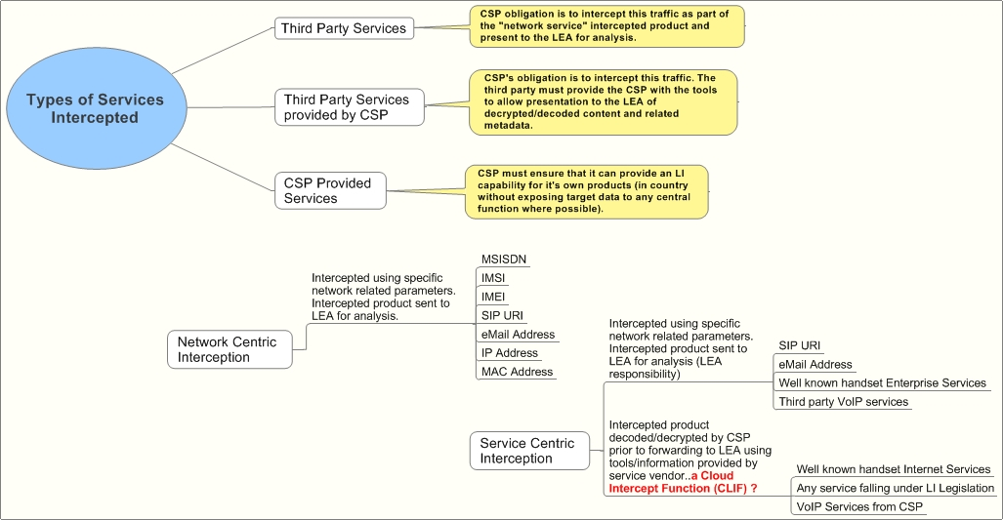
Figure 1:

4.3 Requirements Challenges
Due to the nomadic access to cloud services, no one provider (as described in the diagram in figure ??) is likely to be capable of dealing with all warrants/intercept requests. Because the imposition of LI requirements is largely oriented around national jurisdiction and geography, it is unlikely that LEAs can serve a warrant on a cloud provider directly unless that cloud provider has an “in country” presence.
The specific cloud resources are generally not important nor should their geographical location – as long as they are within the jurisdiction of the LEA. For the CSP to intercept the traffic on the (local) LEA’s behalf the following tests must be passed:
- The warrant must be legal in that country.
- The traffic must be present i.e. it must be routed or handled in the same country. Duplication is permitted as is rerouting as long as the user or any other interested party remains unaware of LEA interest.
- It must be possible to clearly distinguish this traffic from others i.e. no collateral interception.
- If the traffic is encrypted, the entity responsible for key management must ensure it can be decrypted by the CSP or LEA.
In order to maintain LI coverage the cloud service provider must implement a Cloud Lawful Interception Function (CLIF). This can be by way of Applications Programming Interface (API) or more likely ensuring presentation of information in a format recognisable to interception mechanisms. Deep packet inspection is likely to be a constituent part of this system.
ETSI/TC LI is not trying to centralise LI capability – it is harmonising the capability so that it can be implemented in a cloud based environment.

5 Cloud/Virtual Services
[the text below appeared as NOTEs of the indicated definitions and is kept for possible use in section 5]
[cloud communication centre]
Communication and management capabilities include for example: management in the cloud of communication centre relevant resources, such as customer resources, enterprise agent resources, media storage resources, content resource, transport resources and communication resources; access of fixed and mobile customers and enterprise agents via unified client, such as a Web browser; sharing of enterprise applications which are common among different enterprises; application charging to enterprises on a per-resource usage basis.
[Cloud Infrastructure as a Service (IaaS)]
The cloud service user does not manage or control the resources of the underlying cloud infrastructure but has control over operating systems, deployed applications, and possibly limited control of select networking components (e.g. host firewalls).
[Cloud Platform as a Service (PaaS)]
Platform tools may include programming languages and tools for application development, interface development, database development, storage and testing. The cloud service user does not manage or control the underlying cloud infrastructure, but has control over the deployed applications and possibly application hosting environment configurations.
[inter-cloud computing]
From the view point of a C(L)SP, Inter-cloud computing can be implemented in different manners, including inter-cloud peering, inter-cloud service broker and inter-cloud federation. These manners correspond to distinct possible roles that a C(L)SP can play when interacting with other C(L)SPs.

5.1 Perspectives on cloud/virtual services
Cloud computing, including distributed virtual services, is an evolving paradigm that is fundamentally and rapidly changing communication services and infrastructure.
The diversity of these services and the underlying infrastructure has itself produced different perspectives.
In general, most of the many forums dealing with cloud computing have found common ground in the following description (Special Publication 800-145, The NIST Definition of Cloud Computing, Sept 2011 [i.7]).
“Cloud Computing is a model for enabling ubiquitous, convenient, on-demand network access to a shared pool of configurable computing resources (e.g. networks, servers, storage, applications, and services) that can be rapidly provisioned and released with minimal management effort or service provider interaction. This cloud model promotes availability and is composed of five essential characteristics, three service models, and four deployment models.”
General characteristics of cloud services
On-demand self-service. A consumer can unilaterally provision computing capabilities, such as server time and network storage, as needed automatically without requiring human interaction with each service provider.
Broad network access. Capabilities are available over the network and accessed through standard mechanisms that promote use by heterogeneous thin or thick client platforms (e.g. mobile phones, tablets, laptops, and workstations).
Resource pooling. The provider’s computing resources are pooled to serve multiple consumers using a multi-tenant model, with different physical and virtual resources dynamically assigned and reassigned according to consumer demand. There is a sense of location independence in that the customer generally has no control or knowledge over the exact location of the provided resources but may be able to specify location at a higher level of abstraction (e.g. country, state, or datacentre). Examples of resources include storage, processing, memory, and network bandwidth.
Rapid elasticity. Capabilities can be elastically provisioned and released, in some cases automatically, to scale rapidly outward and inward commensurate with demand. To the consumer, the capabilities available for provisioning often appear to be unlimited and can be appropriated in any quantity at any time.
Measured service. Cloud systems automatically control and optimize resource use by leveraging a metering capability at some level of abstraction appropriate to the type of service (e.g. storage, processing, bandwidth, and active user accounts). Resource usage can be monitored, controlled, and reported, providing transparency for both the provider and consumer of the utilized service.
Service models
Software as a Service (SaaS). The capability provided to the consumer is to use the provider’s applications running on a cloud infrastructure. The applications are accessible from various client devices through either a thin client interface, such as a web browser (e.g. web-based email), or a program interface. The consumer does not manage or control the underlying cloud infrastructure including network, servers, operating systems, storage, or even individual application capabilities, with the possible exception of limited user-specific application configuration settings.
Platform as a Service (PaaS). The capability provided to the consumer is to deploy onto the cloud infrastructure consumer-created or acquired applications created using programming languages, libraries, services, and tools supported by the provider. The consumer does not manage or control the underlying cloud infrastructure including network, servers, operating systems, or storage, but has control over the deployed applications and possibly configuration settings for the application-hosting environment.
Infrastructure as a Service (IaaS). The capability provided to the consumer is to provision processing, storage, networks, and other fundamental computing resources where the consumer is able to deploy and run arbitrary software, which can include operating systems and applications. The consumer does not manage or control the underlying cloud infrastructure but has control over operating systems, storage, and deployed applications; and possibly limited control of select networking components (e.g. host firewalls).
Deployment models
Private cloud. The cloud infrastructure is provisioned for exclusive use by a single organization comprising multiple consumers (e.g. business units). It may be owned, managed, and operated by the organization, a third party, or some combination of them, and it may exist on or off premises.
Community cloud. The cloud infrastructure is provisioned for exclusive use by a specific community of consumers from organizations that have shared concerns (e.g. mission, security requirements, policy, and compliance considerations). It may be owned, managed, and operated by one or more of the organizations in the community, a third party, or some combination of them, and it may exist on or off premises.
Public cloud. The cloud infrastructure is provisioned for open use by the general public. It may be owned, managed, and operated by a business, academic, or government organization, or some combination of them. It exists on the premises of the cloud provider.
Hybrid cloud. The cloud infrastructure is a composition of two or more distinct cloud infrastructures (private, community, or public) that remain unique entities, but are bound together by standardized or proprietary technology that enables data and application portability (e.g. cloud bursting for load balancing between clouds).

5.2 Cloud infrastructure and reference architectures
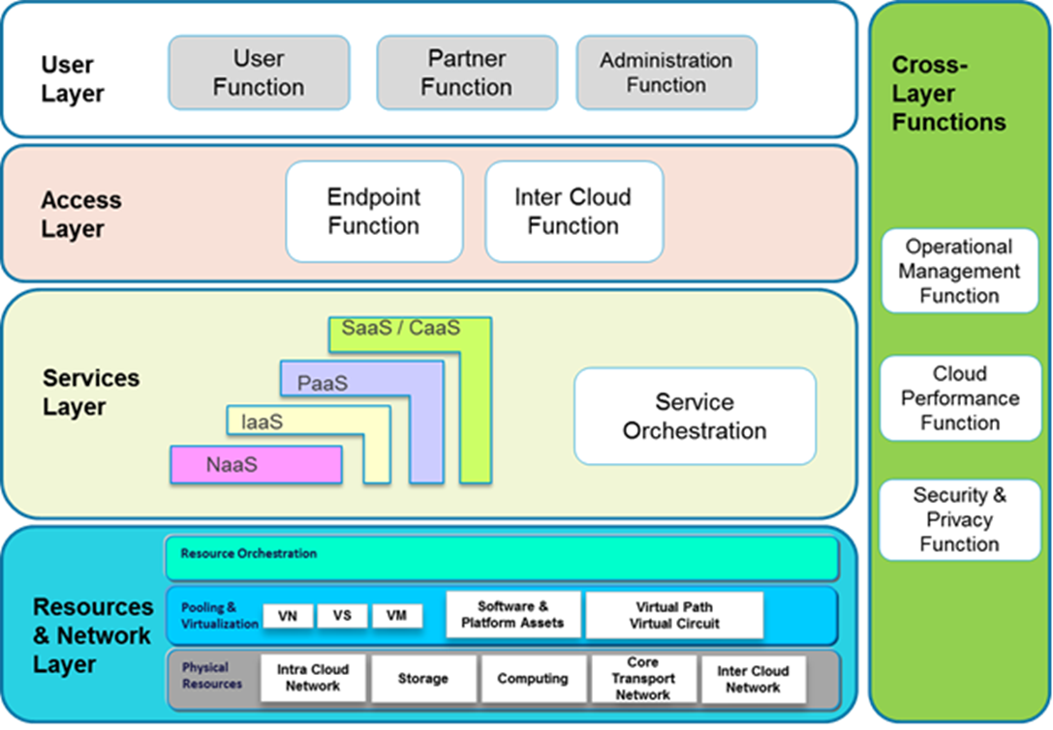
Source: ITU-T Focus Group on Cloud Computing Technical Report, Part 2: Functional requirements and reference architecture (02/2012)
Figure 2:

5.3 Lawful Interception security considerations

5.4 Implementation scenarios
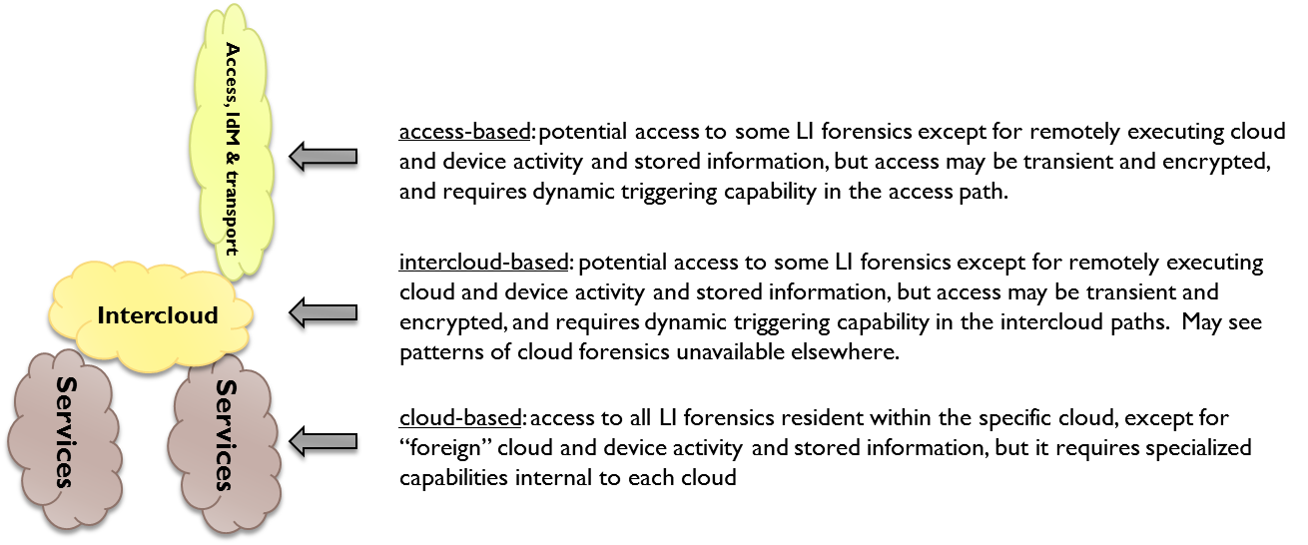Figure 3:
[ed. NOTE: These scenarios material seems redundant as it is covered in at least two other sections.]

5.4.1 Cloud based provider outside LEA jurisdiction. Service is carried within jurisdiction
In this case a CLIF is required to enable the CSP intercept the traffic on the LEA’s behalf.

5.4.2 Cloud based provider within the LEA jurisdiction with service carried internally
The LEA may be able to force the cloud based provider to intercept within it’s own infrastructure. However it may be better to also use the CLIF thus maintaining common interfaces, capabilities and coverage.

5.4.3 Cloud based provider inside LEA jurisdiction but user outside
A bit political….?

6 Legacy LI models and methods applied to the Cloud environment

6.1 Legacy LI models
The diagrams of Annex E (informative) of TS 101 331 [i.1] may provide a conceptual foundation for cloud services LI.
LI models for telecommunications services are currently found in:
- ETSI TS 101 671, "Lawful Interception (LI); Handover interface for the lawful interception of telecommunications traffic [i.2];
- ETSI TS 101 232-2, Lawful Interception (LI); Handover Interface and Service-Specific Details (SSD) for IP delivery; Part 2: Service-specific details for Messaging services [i.3];
- ETSI TS 101 232-3, Lawful Interception (LI); Handover Interface and Service-Specific Details (SSD) for IP delivery; Part 3: Service-specific details for internet access services [i.4];
- ETSI TS 101 232-4, Lawful Interception (LI); Handover Interface and Service-Specific Details (SSD) for IP delivery; Part 4: Service-specific details for Layer 2 services [i.5];
- ETSI TS 101 232-5, Lawful Interception (LI); Handover Interface and Service-Specific Details (SSD) for IP delivery; Part 5: Service-specific details for IP Multimedia services [i.6].

6.2 Adaptation to the Cloud environment
The LEA requirements remain – to intercept traffic of interest in a secure and (potentially) evidential manner within as small a timescale as possible.
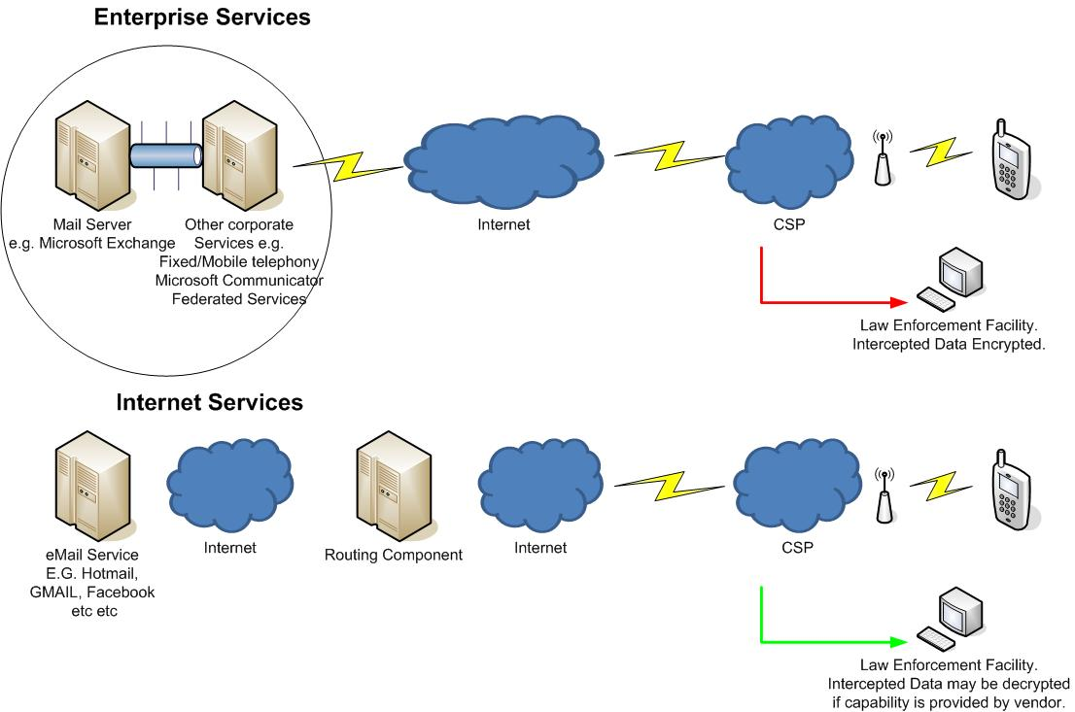 Figure 4:

6.3 Architectures and interfaces for non-legacy services

6.4 Hybrid Services

6.4.1 VoLTE
Given the options in how certain network elements can be deployed and how they may be geographically shared it is possible that a combination of legacy and cloud LI techniques may be required e.g. centralised HSS or TAS.

6.4.2 Peer to Peer Services
Some peer to peer services only contact a centralised point to ensure they know what IP address to contact another user – the media is not routed via any easily predictable infrastructure. However this setup information may, if structured correctly and unencrypted (?) allow the various CSPs intercept the traffic.
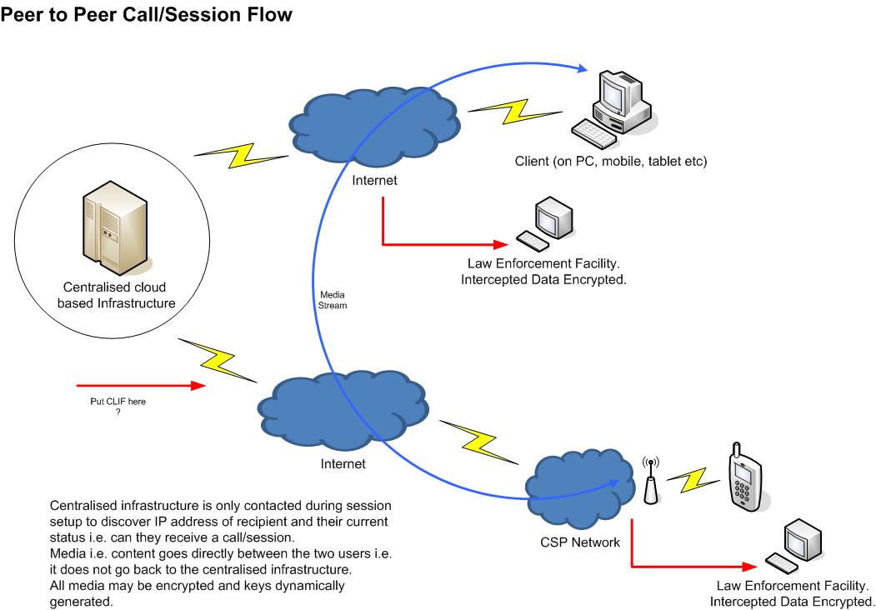

7 Lawful Interception as a Cloud Service (LIaaS)

7.1 Applicability of existing reference models
Applicability of the following services is likely to be highly restrictive due to security or legislative requirements.
The services below are for discussion as part of an alignment with Tony’s strategy for non LEA related data retention.

7.2.2 LI Law Enforcement Monitoring Facility (LEMF) as a cloud service

7.2.3 Other LI tools as cloud services

8 Security in the Cloud LI environment

8.1 Potential LI vulnerabilities in the Cloud services ecosystem

8.1.1 The encryption problem
Media and/or metadata may be encrypted.

8.1.2 Multiple copies of intercepted traffic
The traffic may be intercepted in more than one location or on more than one CSP network.

8.1.3 Nomadism
Services can already move between WiFi, DSL and mobile access networks relatively seamlessly.

8.1.4 Location
It may be difficult to discern in an assured manner the location at which users are using cloud based services.

8.2 Continuous Security Monitoring for Cloud LI

9 LI – Cloud gaps and challenges

Annex A:
Use cases

A.1 Telepresence use case 1:
TSP offers Telepresence and all participants are subscribers of the TSP
- Overview
- This use case describes basic telepresence service. A TSP offers Telepresence and all the participants are subscribers to that TSP.
- Actors
- The users are Jean (the subject of the lawful interception), and her two associates: Greg and Peter.
- McCloud is the mobile TSP/cloud service provider providing a Telepresence Service.
- Preconditions
- Jean, Greg and Peter all are subscribers of the McCloud Telepresence services.
- McCloud has been provided a lawful authorization to assist Law Enforcement in intercepting Jean’s communications, which includes Telepresence.
- McCloud, being a good corporate citizen and a responsible TSP, has an LI solution for Telepresence implemented in their network.
- Actions
- Jean initiates Telepresence (conference) session with Greg and Peter.
- Jean, not having extensive video administration experience, relies heavily on the McCloud Help Desk Service for assistance in using the service (e.g. to initiate and troubleshoot problems) while Peter and Greg join her in the Telepresence meeting.
- The three cohorts meet in a virtual face-to-face meeting via McCloud’s Telepresence Service. They are discussing criminal activities, showing maps and pictures of the criminal venue (e.g. bank and surrounding streets for their “get-away”). Greg shows a short silent movie clip of the bank guards to show their routine and guard positions.
- Peter’s video and audio are not up to the quality specified in the Service Level Agreement (SLA) with McCloud. He troubleshoots with McCloud during the Telepresence session.
- The Telepresence session ends.
- Results
- McCloud is hosting/managing a Telepresence (i.e. conference) session operating on behalf of Jean which is supporting the purposes of the illegal activity.
- McCloud is a TSP providing that service to Jean (and her associates).
- McCloud provides LE with Jean’s intercepted communications for the duration of the lawful authorization per their LI solution(s). This includes separate delivery for her voice communications (to include VoIP and conferencing/Telepresence), SMS, and packet data/broadband services.
- LI Discussion/Challenges
- McCloud has a legal obligation to provide LI for the Telepresence session. Whether the video is provided to Law Enforcement is a national option. At a minimum, the audio of this conference, as well as the IRI is required to be reported, as Telepresence is a conference per 3GPP definition. The exact set of events and information is outside the scope of this use case (as SA3-LI has not yet discussed/agreed/defined LI for Telepresence).
- The identities of the participants are known to McCloud, as they are all subscribers to McCloud’s Telepresence service. The McCloud Telepresence Service has the service logic for Jean’s Telepresence session, the identities of the participants, and access to the media.
- As with any other service lawfully intercepted, if McCloud provides encryption for the Telepresence Service, McCloud is responsible for either decrypting or providing the keys to law enforcement to decrypt.

A.2 Telepresence use case 2:
Telepresence is offered by a Third Party provider. Participants are subscribers of the same or different TSP(s)
- Overview
- This use case describes basic telepresence service. The mobile TSP acts as a “cloud carrier” for the cloud provider’s Telepresence service.
- Actors
- The users are Jean (the subject of the lawful interception), and her two associates: Gabor and Terry.
- McCloud is the mobile TSP/cloud carrier. Jean and Terry are subscribers of McCloud.
- ExcellAlex Mobile is a mobile TSP. Gabor is a subscriber of ExcellAlex Mobile.
- TellyServ is a (third party) cloud service provider providing the Telepresence Service. TellyServ is NOT offering Telepresence Service on McCloud’s behalf nor does TellyServ have any business relationship with McCloud.
- Preconditions
- Jean, Terry and Gabor all subscribe to TellyServ’s Telepresence Service.
- McCloud has been provided a lawful authorization to assist Law Enforcement in intercepting Jean’s communications, to include Telepresence. McCloud, being a good corporate citizen and a responsible TSP, has an LI solution for Telepresence implemented in their network.
- TellyServ has also been provided a lawful authorization for Jean’s communications, but the only service of Jean’s that they provide is the Telepresence Service. They are waiting for a specific LI solution for Telepresence to be developed, but in the meantime, they have “adapted” the 3GPP IMS Conferencing LI solution for their interim Telepresence LI solution.
- ExcellAlex Mobile has not been served a lawful authorization on Jean as it is not providing a service to her (the Subject).
- Actions
- Jean initiates a Telepresence (conference) session with Gabor and Terry.
- Jean, not having extensive video administration experience, relies heavily on the TellyServ’s Help Desk Service for assistance in using the service (e.g. to set-up the meeting and troubleshoot problems) while Gabor and Terry join her in the Telepresence meeting.
- The three cohorts meet in a virtual face-to-face meeting via TellyServ’s Telepresence Service. They are discussing criminal activities, showing maps and pictures of the criminal venue (e.g. bank and surrounding streets for their “get-away”). Gabor shows a short silent movie clip of the bank guards to show their routine and guard positions.
- Terry’s video and audio are not up to the quality specified in the Service Level Agreement (SLA) with TellyServ. He troubleshoots with TellyServ during the Telepresence session.
- The telepresence session ends.
- Results
- TellyServ is hosting/managing a Telepresence (i.e. conference) session operating on behalf of Jean which is supporting the purposes of the illegal activity.
- McCloud is a TSP providing Jean’s connectivity to TellyServ’s Telepresence service. McCloud is also providing Jean’s voice and Internet access.
- McCloud provides LE with Jean’s intercepted communications for the duration of the lawful authorization per their LI solution(s). This includes separate delivery for her voice communications (to include VoIP and conferencing), SMS, and packet data/broadband services. McCloud provides LE with Jean’s Telepresence communications as part of their packet data/broadband services delivery. McCloud does not have access to the Telepresence service logic nor is it required to deliver the intercepted Telepresence communications separately.
- TellyServ delivers IRI on Jean’s Telepresence session per TS 33.108. Luckily, their implementation also gives them access to the media, so they also report the intercepted content. Whether the video is provided to Law Enforcement is a national option. At a minimum, the audio of this conference, as well as the CII, is required to be reported.
- LI Discussion/Challenges
- McCloud has a legal obligation to provide LI for the services that they offer the target. In this use case, they do not offer the Telepresence Service, so they are not obligated to provide separate delivery of this service. Since it is “available” in Jean’s packet data stream, it is delivered as part of McCloud’s packet data interception. McCloud isolates and reports Jean’s intercepted voice, SMS, and packet data/broadband services per their LI solutions.
- TellyServ has the legal obligation to provide LI for the services that they offer the target. In this use case, this is only the Telepresence Service. They provide the CII and CC for the Telepresence service per their LI solution. TellyServ knows the identities of the participants; they have the service logic and access the media.
- As with any other service lawfully intercepted, if TellyServ provides encryption for the Telepresence Service, TellyServ is responsible for either decrypting or providing the keys to law enforcement to decrypt.

Annex B:
Change Request History
Status of the present document
TR 101 567 LI Could/Virtual services
TC LI approval date | Version | Remarks
 | 1.1.1 | First publication of the TR after approval by ETSI/TC LI#?? ( , )  Version 1.1.1 prepared by Gerry McQuaid (Vodafone Group) (Rapporteur)

History
Document history
 |  | Initial Draft
V0.0.2 | January 2012 | input to TC LI#29
V0.0.3 | April 2012 | lay-out corrections, input to TC LI Rap#26, 4-5 April Mainz
V0.0.4 | April 2012 | output of TC LI Rap#26 with agreed modifications in revMarks
V0.0.5 | April 2012 | clean output of TC LI Rap#26 (with some editorials)

