3GPP TSG-SA3 Meeting #108Adhoc-e draft_S3-222508-r1

e-meeting, 10th – 14th October, 2022

Source: Huawei, HiSilicon

Title: Authentication mechanism selection between the EEC and EES

Document for: Approval
Agenda Item: 5.9

1 Decision/action requested
This contribution proposes a solution defining authentication mechanism neogitition between the EEC and EES.

2 References
[1] 3GPP TS33.558 Security aspects of enhancement of support for enabling edge applications.
[2] 3GPP TR33.739 v0.2.0 Study on Security Enhancement of Support for Edge Computing — Phase 2.
[3] 3GPP TS 33.535 "Authentication and Key Management for Applications (AKMA) based on 3GPP credentials in the 5G System (5GS)".
[4] 3GPP TS 33.222 “Generic Authentication Architecture (GAA); Access to network application functions using Hypertext Transfer Protocol over Transport Layer Security (HTTPS)”

3 Rationale
This contribution proposes a solution to key issue #2.2 on authentication mechanism selection between EEC and EES.

4 Detailed proposal
*************** Start of 1st Change ****************

6.X Solution #X: Authentication algorithm selection procedure between EEC and EES

6.X.1 Solution overview
This solution addresses security requirement for authentication algorithm selection between EEC and EES in key issue #2.2.
In this solution, the UE first retrieves the supported Authentication mechanism (s) of the network during registration, and optionally get the EES Authentication mechanism capability from ECS. When the EEC intend to connect to EES, the EEC determines the used authentication mechanism or candidate authentication mechanism.

6.X.2 Solution details
This solution assumes that:
- Home network and/or Serving network, UE(EEC), EES (as NAF in GBA, or AF in AKMA) may support one or multiple mechanisms (e.g., TLS with AKMA, TLS with GBA).
- EEC and EES shall support TLS with certificates by default.
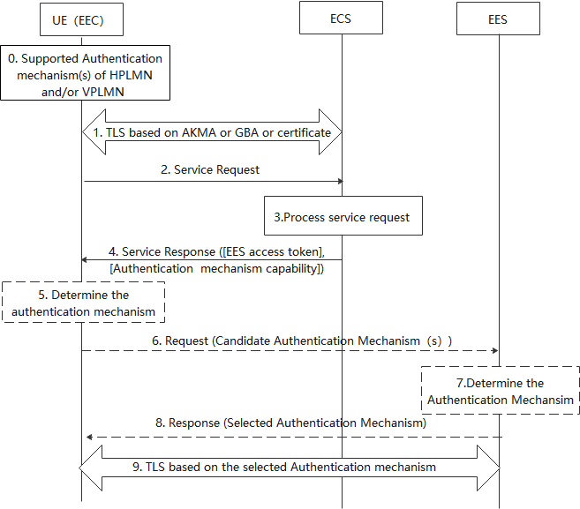
Figure 1 Authentication mechanism selection between the EEC and EES
- During the registration procedure, the UDM obtains the supported Authentication method(s) based on the PLMN Id provided by AMF. In non-roaming case, the UDM obtains the supported Authentication method(s) of UE HPLMN, if the UE is in roaming case, the UDM also obtains the supported authentication mechanism (s) of the UE’s VPLMN. The UDM provides to UE via AMF using UCU procedure or registration response.
- EEC establishes TLS connection with ECS based on the AKMA or GBA or certificate.
- The EEC sends the service request to the ECS.
- The ECS should authorize the EEC by its local authorization policy, if the authentication and authorization is successful, then the ECS processes the request.
- The ECS decides whether access tokens are required for the candidate EESes using the configuration information and issues separate EES access tokens to be used for each candidate EESes that use token-based authorization. The ECS sends the EES access tokens to the EEC. Optionally, the Authentication mechanism capability is included. The Authentication mechanism capability indicates the authentication mechanism the EES support.
When the EEC would like to connect with EES, if the Authentication mechanism capability received, performs step 5, skip steps 6 to 8. Otherwise, performs steps 6 to 8 and skip step 5.
- [Conditional]The UE determines the available network authentication mechanism based on the received supported authentication mechanism (s) and the PLMN Id of network the EES located. Then the EEC determines the target authentication mechanism based on EEC authentication capability, authentication mechanism capability and the available network authentication mechanism.
- [Conditional] The UE determines the available network authentication method based on the received supported authentication mechanism (s) and the PLMN Id of network the EES located. Then the EEC determines the candidate authentication mechanism (s) based on EEC authentication capability and the available network authencation mechanism. The EEC sends request to EES with candidate authentication mechanism (s).
- [Conditional]The EES determines selected authentication mechanism based on the received candidate authentication mechanism.
Editor’s Note: It is FFS whether EES needs to check if it can obtain AKMA/GBA keys from network during the authentication mechanism selection procedure.
- [Conditional]The EES sends response with selected authentication mechanism to EEC.
- EEC and ECS establish the TLS base on the selected authentication mechanism.

6.X.3 Solution evaluation
TBD
*************** End of Changes ****************

