3GPP TSG-SA3 Meeting #108Adhoc-e draft_S3-222501-r1

e-meeting, 10th – 14th October, 2022

Source: Huawei, HiSilicon

Title: Authentication mechanism selection between the EEC and ECS

Document for: Approval
Agenda Item: 5.9

1 Decision/action requested
This contribution proposes a solution defining authentication mechanism neogitition between the EEC and ECS.

2 References
[1] 3GPP TS33.558 Security aspects of enhancement of support for enabling edge applications.
[2] 3GPP TR33.739 v0.2.0 Study on Security Enhancement of Support for Edge Computing — Phase 2.
[3] 3GPP TS 33.535 "Authentication and Key Management for Applications (AKMA) based on 3GPP credentials in the 5G System (5GS)".
[4] 3GPP TS 33.222 “Generic Authentication Architecture (GAA); Access to network application functions using Hypertext Transfer Protocol over Transport Layer Security (HTTPS)”

3 Rationale
This contribution proposes a solution to key issue #2.2 on authentication mechanism selection between EEC and ECS.

4 Detailed proposal
*************** Start of 1st Change ****************

6.X Solution #X: Authentication algorithm selection procedure between EEC and ECS

6.X.1 Solution overview
This solution addresses security requirement for authentication algorithm selection between EEC and ECS in key issue #2.2.
In this solution, the UE first retrieves the supported Authentication mechanism (s) of the network during registration, and optionally get the ECS Authentication mechanism capability. When the EEC intend to connect to ECS, the EEC determines the used authentication mechanism or candidate authentication mechanism.

6.X.2 Solution details
This solution assumes that:
- Home network and/or Serving network, UE (EEC), ECS (as NAF in GBA, or AF in AKMA) may support one or multiple mechanisms (e.g., TLS with AKMA, TLS with GBA).
- EEC and ECS shall support TLS with certificates by default.
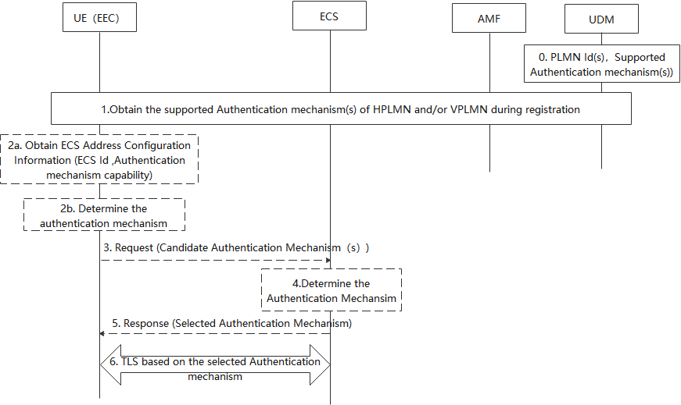
Figure 1 Authentication mechanism selection between the EEC and ECS
0. Supported Authentication method(s) per network (e.g. GBA, AKMA) of PLMN(s) is stored in UDM.
1. During the registration procedure, the UDM obtains the supported Authentication method(s) based on the PLMN Id provided by AMF. In non-roaming case, the UDM obtains the supported Authentication method(s) of UE HPLMN, if the UE is in roaming case, the UDM also obtains the supported authentication mechanism (s) of the UE’s VPLMN. The UDM provides to UE via AMF using UCU procedure or registration response.
2a. [Optional] During PDU Session Establishment, the SMF may provide ECS Address Configuration Information (ECS ID (e.g. FQDN or IP address(es) of ECS), [Authentication mechanism capability]) to the UE. The Authentication mechanism capability indicates the authentication mechanism the ECS support. When the UE would like to connect with ECS, if the Authentication mechanism capability received, performs step 2b, skip steps 3 to 5. Otherwise, performs steps 3 to 5 and skip step 2b.
2b. [Conditional] The UE determines the available network authentication mechanism based on the received supported authentication mechanism (s) and the PLMN Id of network the ECS located. Then the EEC determines the target authentication mechanism based on EEC authentication capability, authentication mechanism capability and the available network authentication mechanism.
3. [Conditional] The UE determines the available network authentication method based on the received supported authentication mechanism (s) and the PLMN Id of network the ECS located. Then the EEC determines the candidate authentication mechanism (s) based on EEC authentication capability and the available network authention mechanism. The UE sends request to ECS with candidate authentication mechanism (s).
4. The ECS determines selected authentication mechanism based on the received candidate authentication mechanism.
5. The ECS sends response with selected authentication mechanism to EEC.
6. EEC and ECS establish the TLS base on the selected authentication mechanism.

6.X.3 Solution evaluation
TBD
*************** End of Changes ****************

