3GPP TSG-SA3 Meeting #105-e S3-214000-r1

e-meeting, 8 – 19 November 2021 Revision of S3-21xxxx

Source: Huawei, HiSilicon

Title: Address EN and add evaluation for solution 4

Document for: Approval
Agenda Item: 5.11

1 Decision/action requested
This contribution proposes to address ENs and update evaluation in solution 4 in TR 33.867.

2 References

3 Rationale
There are 2 editor’s note in the solution 4:
“Editor’s note: how does the NEF know the purpose from API invocation is ffs.”
“Editor’s Note: Further information elements to uniquely define a purpose are FFS.”
For the 1st EN, it is proposed to add an example for clarification. But it is NEF implementation.
For the 2nd EN, it is proposed to re-define the purpose of data processing to address user consent issue related to data exposure.

4 Detailed proposal
*************** Start of 1st Change ****************

7.4 Solution #4: Check of User Consent for 3GPP Service Exposure

7.4.1 Solution overview
The solution addresses key issue #1 “User Consent for Exposure of information to Edge Applications”.

7.4.2 Solution details

7.4.2.1 Check of user consent on NEF/CAPIF
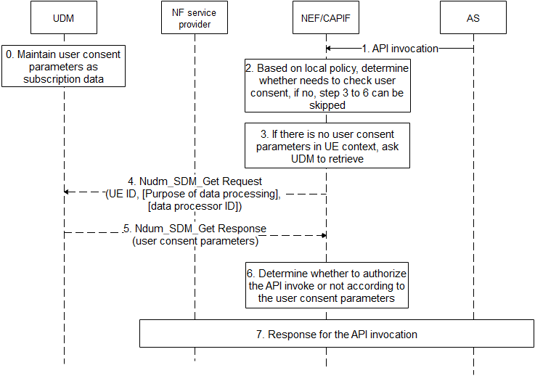
Figure 7.4.2.1-1 Check of User Consent on NEF/CAPIF
- UDM maintains user consent parameters as subscription data as depicted in 7.4.2.2.
- AS sends API invocation to NEF/CAPIF, requesting for processing user’s data, e.g. if the invocated service is “Nnef_Location_LocationUpdateNotify” with inputs with AF ID, and GPSI, it means that the AF asks NEF/CAPIF to retrieve location of UE identified by the GPSI.
- The NEF/CAPIF determines whether the invocated service needs to check user consent based on operator’s local policy, e.g. whether regulation is required, whether the invocated service is to process user’s personal information, etc.. If there is no need to check user consent, step 3-6 can be skipped.

- If there is no related user consent parameters in UE context, the NEF/CAIPF invokes Nudm_SDM_Get Request service to retrieve related user consent parameters. Otherwise, step 4-5 can be skipped.
- The NEF/CAPIF sends Nudm_SDM_Get Request message to the UDM, the message shall include UE ID, and may include purpose of data processing, data processor ID. The UE ID can be SUPI which is resolved with the GPSI by NEF/CAPIF using existing mechanism. The purpose of data processing refers to which actions are done with the data to achieve which goal. The data processor ID can be AF ID or more generic which is resolved from the AF ID in the API invocation.

- The UDM returns requested user consent parameters, which includes user consent result.
- The NEF/CAPIF determines whether to authorize the API invocation or not according to the user consent parameters based on implementation. For example, if the API invocation is for inquiring user’s privacy information, the NEF/CAPIF identifies the user consent result using the AF ID and purpose “sharing”. If the user consent result of the purpose of data process is not allowed, the NEF/CAPIF rejects the AF’s request with specific cause. If the user consent result of the purpose of data process is allowed, the NEF/CAPIF accepts the AF’s request. If there is no explicit user consent results, the NEF/CAPIF can decide to reject or accept the AF’s request based on operator’s local policy. Besides, if the user consent result of the purpose of data process is allowed, the NEF/CAPIF uses Nudm_SDM_Subscribe service to subscribe the change of user consent parameters event on the UDM to maintain the non-outdated user consent parameters.
- The NEF/CAIPF response for the API invocation based on determination in step 6.

7.4.2.2 User Consent Parameter
The UDM maintains the following user consent parameters:
- UE ID: can be SUPI.
- Data Processor ID: refers to a data processor who process data for the UE, can be AF ID, or more generic, e.g. “3rd party” or “all”.
- Purpose of data processing: the goal that processing the data ultimately achieves, refers to which actions are done with the data to achieve which goal.

- User Consent Result: whether there is consent for data processor to process the data according to purpose of data processing.

7.4.3 Solution evaluation

The solution addresses the key issue #1 when the 3rd EES uses 3GPP exposure capability to retrieve user’s personal data.
*************** End of 1st Change ****************

