3GPP TSG-SA3 Meeting #102-e draft_S3-210244-r1

e-meeting,18- 29 Janury 2021 Revision of S3-21xxxx Revision of S3-20xxxx e-meeting, 18 – 29 January 2021

Source: Huawei, HiSilicon

Title: Address ENs in solution 15

Document for: Approval
Agenda Item: 5.9

1 Decision/action requested
This contribution proposes to resolve the ENs in solution 15

2 References
[1] 3GPP TR 33.847 "Study on Security Aspects of Enhancement for Proximity Based Services in 5GS".

3 Rationale
This contribution proposed to address the Editor’s Notes in solution 15.
Editor’s note: The role of relay-AUSF is unclear. I.e. step11 could be invoked directly towards home NF, e.g. remote AUSF.
Editor’s note: The role of the PKMF is unclear. If AUSF of Remote UE is responsible for generating the key, then what is the role of PKMF.
Editor’s note: Whether PKMF can interface with the Remote UDM or Remote AUSF, in particular in the roaming case, is FFS.
For the above three ENs about the role of relay-AUSF and PKMF, according to the existing methanism, the AMF can interact with UDM and AUSF directly. We proposes to update the solution without introducing the relay-AUSF and PKMF.
Editor’s note: how the DSMC messages are being protected is FFS.
For the DSMC message protection, we proposes reuse the security mechanism defined in 33.536.

4 Detailed proposal
*************** Start of 1st Change ****************

6.15 Solution #15: Key management in UE-to-Network Relay based on primary authentication

6.15.1 Introduction
This solution addresses the KI #3, KI#4 and KI#9. This solution provides a mechanism setup a PC5 link security between a remote UE and UE-to-network relay based on primary authentication.
Editor’s note: whether this solution supporting out of coverage being FFS.

6.15.2 Solution details
The procedure for key management in UE-to-Network relay using primary authentication is depicted in Figure 6.15.2-1.

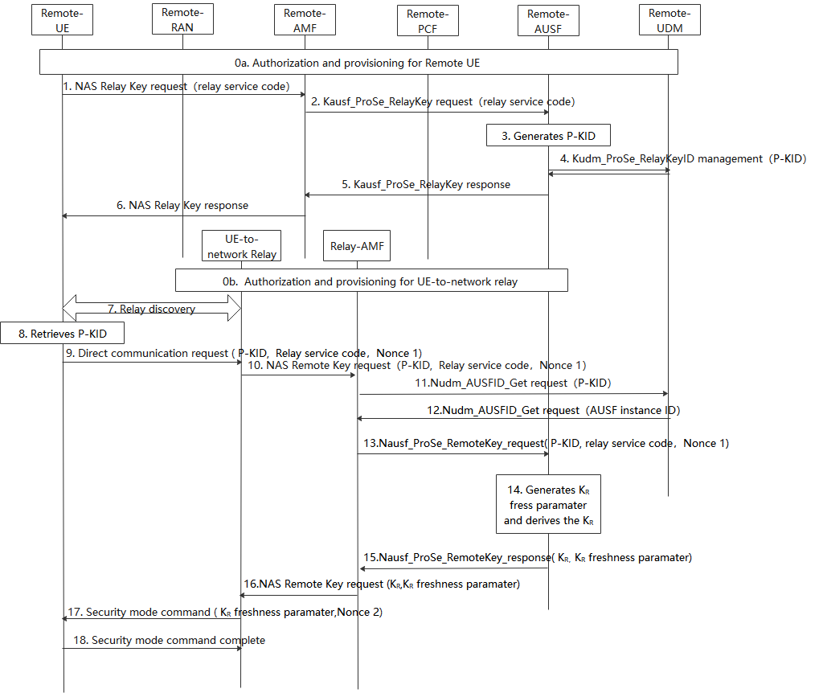
Figure 6.15.2-1: Procedures for key management in ProSe UE-to-Network Relay based on primary authentication
0. During Registration procedure, authorization and provisioning is performed for the Remote UE (0a) and ProSe UE-to-NW relay (0b).
1. The Remote UE sends a NAS relay Key request message with relay service code for PC5 communication with a UE-to-network relay.
2. After receiving the NAS relay key request from UE, the Remote AMF that serves the remote UE first checks whether the UE is authorized to be as a remote UE. If it is authorized, the Remote AMF further sends Nausf_ProSe_RelayKey request with relay service code.
3. The Remote AUSF that serves the remote UE generates P-KID for the relay service code in the Nausf_ProSe_RelayKey request.
Editor’s note: The generation of the P-KID in AUSF is FFS.
4. The Remote AUSF further stores P-KID in UDM via Kudm_ProSe_RelayKey service.
5. The Remote AUSF sends Nausf_ProSe_RelayKey response to the AMF.
6. The Remote AMF sends NAS relay Key response to the UE.
Editor’s note: how the procedure (i.e step 1~6 ) works in Kausf change (e.g., due to reauthentication) is FFS.
7. The Remote UE discovers the UE-to-network Relay using either model A or model B discovery.
8. The Remote UE retrieves P-KID based on the relay service code the Remote UE would like to access.
Editor’s note: The retrieval of the P-KID in UE is FFS.
9. The Remote UE sends a Direct Communication Request. The Direct Communication Request contains the Relay Service Code, P-KID and Nonce1.
Editor’s note: It’s FFS whether P-KID or other user ID e.g. SUCI should be used in PC5.
10. The UE-to-Network relay triggers the PC5 root key (i.e PC5 root key for communicating with the remote UE) retrieval procedure. The Relay sends NAS remote Key request with P-KID, Relay service code, Nonce 1.
11. The relay AMF that serves the relay UE first check whether the relay UE is authorized to be a relay. If authorized, The AMF discovers the UDM based on the P-KID, the relay AMF sends Nudm_AUSFID_Get request with P-KID to the UDM.
12. UDM response to relay AMF via Nudm_AUSFID_Get with AUSF instance ID of the AUSF serving remote UE.

13. AMF further sends Nausf_ProSe_RemoteKey request with P-KID, Relay service code, Nonce 1 to the remote AUSF.
14. The remote AUSF generates K_{R} freshness parameter and derives K_{R} using at least Kausf, relay service code,K_{R} freshness parameter and Nonce 1 as input.

15. The remote AUSF sends Nausf_ProSe_RemoteKey response with K_{R}, K_{R} freshness parameter to the relay AMF.
16. The relay AMF sends NAS remote Key response K_{R}, K_{R} freshness parameter to the UE-to-network relay.
17. The UE-to-network relay sends a Direct Security Mode Command message to the Remote UE, K_{R} freshness parameter and Nonce 2 are included in the message.
Editor’s note: The parameters included in Direct Security Mode Command message are FFS.
18. The Remote UE derives K_{R} key in the same way as the remote AUSF in step 14. The DSMC message is integrity and confidentiality protected as in TS 33.536[8].

6.15.3 Evaluation
TBD.

